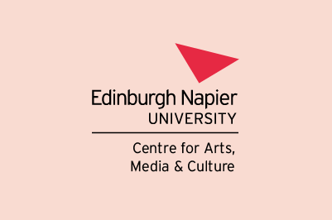

Research Talk – All Welcome

Wednesday 12th October 2022, 3.30-5pm
E14
Merchiston Campus, 10 Colinton Road, Edinburgh EH10 5DT

Dr Arianna Introna,

‘Crip Enchantments: Autonomist Narratives of Disability in Scottish Writing and Culture’

Disorienting effects erupt when non-normative bodies and minds clash with the structures of capitalist normalcy. Arianna Introna’s Autonomist Narratives of Disability in Modern Scottish Writing: Crip Enchantments brings into conversation Scottish studies, disability studies and autonomist Marxism to explore the ways in which these ‘crip enchantments’ are imagined in modern Scottish writing, and the ‘autonomist’ narratives of disability by which they are evoked. In this talk Arianna will discuss the encounter between crip and class imaginaries in Scottish writing that Crip Enchantments is primarily concerned with as a starting point for a wider reflection on how disability and class politics meet (or clash) in Scottish cultural imaginaries and beyond.

Biography
Dr Arianna Introna received her MLitt and PhD in Scottish Literature from the University of Stirling and is now Associate Lecturer with the Open University. Her research interests range from Scottish literature, disability studies and the medical humanities to Marxist autonomist theory, critical theory and the social history of the welfare state. She is the author of Autonomist Narratives of Disability in Modern Scottish Writing: Crip Enchantments (Palgrave Macmillan 2022).

