**Structural design with Accoya® wood**

Ferry Bongers1, John Alexander2, Julian Marcroft3, David Crawford4 and Robert Hairstans

1Accsys Technologies, PO Box 2147, NL-6802 CC Arnhem, The Netherlands [email: [ferry.bongers@accsysplc.com](mailto:ferry.bongers@accsysplc.com)]

2Accsys Technologies, Sheet Street, Windsor, London SL4 1BE, United Kingdom [email: [john.alexander@accsysplc.com](mailto:john.alexander@accsysplc.com)]

3TimberSolve, Suite 5, 4 Lenten Street, Alton, Hants, GU34 1HG, United Kingdom [email: [julian@timbersolve.co.uk](mailto:julian@timbersolve.co.uk)]

4 Edinburgh Napier University’s - Centre for Offsite Construction & Innovative Structures, 42 Colinton Rd, Edinburgh, EH10 5BT, United Kingdom [email: [d.crawford@napier.ac.uk](mailto:d.crawford@napier.ac.uk)]

5 Edinburgh Napier University’s - Centre for Offsite Construction & Innovative Structures, 42 Colinton Rd, Edinburgh, EH10 5BT, United Kingdom [email: [R.Hairstans@napier.ac.uk](mailto:R.Hairstans@napier.ac.uk)]

**Keywords:** acetylated wood, mechanical properties, *Pinus radiata*, strength grading, structural application, structural design

abstract

The benefits from acetylation of wood to enhance resistance against fungal decay and dimensional stability have been known for many years. Since 2007 Accsys Technologies has been commercially producing Accoya® wood that is based on acetylation of Radiata pine. Accoya® has shown its potential for many applications, even for structural use. However, due to limited engineering data each project had to be evaluated on a case-by-case basis. Based on research at various universities and institutes, Accsys Technologies has in combination with TimberSolve and ARUP, developed a handbook to assist designers and structural engineers produce reliable, durable and consistent designs utilising Accoya® wood in structural applications.

**TABLE OF FIGURES**

Figure 1: Microtec Viscan MOE prediction based on average density compared with actual MOE 3

Figure 2: Correlation of bending stiffness (MOE) with bending strength (MOR) 3

Figure 3: Tension perpendicular to the grain sample 4

Figure 4: Set-up for shear tests on notched beams 6

Figure 5: General arrangement at notched support 6

introduction

Acetylation of wood to enhance its resistance against wood decaying fungi, as well as improving its dimensional stability under varying moisture conditions, has been studied extensively over the last decades (Hill 2006, Homan and Jorissen 2004, Jones 2007, Rowell 2006). Accsys Technologies introduced acetylated wood, named Accoya® wood ([www.accoya.com](http://www.accoya.com)), into the market in 2007. Accoya® wood is based on the acetylation of radiata pine (*Pinus radiata* D. Don) and is mainly used for non-structural applications such as joinery, cladding, decking and (light) civil works in the Netherlands, UK and Germany (Alexander 2007, Bongers *et al*. 2009, Kattenbroek 2005).

On account of the aforementioned properties there is much interest in using acetylated wood for structural applications, particularly in view of the success of a heavy load-bearing traffic bridge constructed using Accoya® wood at Sneek in the Netherlands (Tjeerdsma *et al*. 2007, Tjeerdsma and Bongers 2009, Jorissen and Lüning 2010).

A summary of the extensive research on the structural properties of acetylated wood was given by Bongers *et al.* (2010). It was concluded that, in spite of the extensive scientific research on physical and mechanical properties of acetylated wood, further testing and model development is required to take the product forward through to an accepted structural approval.

This paper describes the new research conducted at SHR Timber Research, Edinburgh Napier University’s Centre for Offsite Construction & Innovative Structures, University of Brighton and collaboration with TimberSolve and ARUP to establish products of Accoya® Radiata pine and Accoya® SYP equivalent to strength class C24. This paper reports the results for Accoya® Radiata pine, but the testing program for Accoya® SYP has been rather similar (see Crawford *et al*. 2012).

strength grading

For the study machine strength graded Radiata pine (*Pinus radiata* D. Don) specified for application within the second Sneek bridge was used. Timber of the dimensions 38 x 138 mm (thickness x width) was cut out of specially selected logs based on acoustic grading by the sawmill in New Zealand. After processing and drying the timber was graded with a Microtec Viscan to produce timber with a modulus of elasticity of 8000 N/mm2 and more. The initial settings for the Microtec Viscan were developed in conjunction of SHR, Microtec, Van Wessem and Ingenieursbureau Evan Buytendijk.

Forty-eight boards of structural sizes (4-5 m length) untreated Radiata pine of different bundles, were measured by a Microtec Viscan without density measurement and a Brookhuis MTG. The bending strength (MOR) and stiffness (local shear free MOE) was determined according to EN 408. A correlation coefficient R2 of 0.79 was found between the modulus of elasticity (MOE) determined by EN 408 and the Microtec Viscan MOE prediction based on average density (470 kg/m3). By using actual board density the correlation could be improved to R2 of 0.91. Similar correlations were found for the Brookhuis MTG. For the grading of the Sneek bridge the initial Microtec Viscan settings were obtained by using the 95% confidence interval of the regression between prediction (based on average density) and actual MOE (see Figure 1). At this MOE level a bending strength of circa 40 N/mm2 is found (see Figure 2). During the grading for the Sneek bridge (circa 600 m3), in total 50 boards were randomly tested for bending stiffness and strength. The results confirmed the correctness of the grading; all boards had a MOE of 8000 N/mm2 or more.



Figure 1: Microtec Viscan MOE prediction based on average density compared with actual MOE



Figure 2: Correlation of bending stiffness (MOE) with bending strength (MOR)

Mechanical properties

Test set-up

Sixty strength graded boards of the dimension of 38 x 138 mm x 4500 mm (thickness x width x length) were cut in half. Half of each board (2.25 m) was acetylated in Accsys Technologies factory in Arnhem. The bending stiffness (MOE) and strength (MOR) were determined according to EN 408 for the untreated and acetylated paired boards. After the bending test, the boards were used to prepare samples for compression and tension tests according to BS 373. Of each “Test Type” an amount between 15 samples and 35 samples was tested. Dimensions of the samples are shown in Table 1.

Table 1: Compression and tension sample dimensions and loading rate according with BS 373

|  |  |  |  |  |  |
| --- | --- | --- | --- | --- | --- |
| **Test Type** | **Length [mm]** | **Width [mm]** | **Depth [mm]** | **Diameter [mm]** | **Loading rate [in/min]** |
| Compression parallel | 60 | 20 | 20 | - | 0.025 |
| Compression perpendicular | 60 | 20 | 20 | - | 0.025 |
| Tension parallel | 300 | 20 | 10 | - | 0.05 |
| Tension perpendicular* | 138 | - | - | 15 | 0.01 |
| *\*sample details as shown in Figure 3* | | | | | |

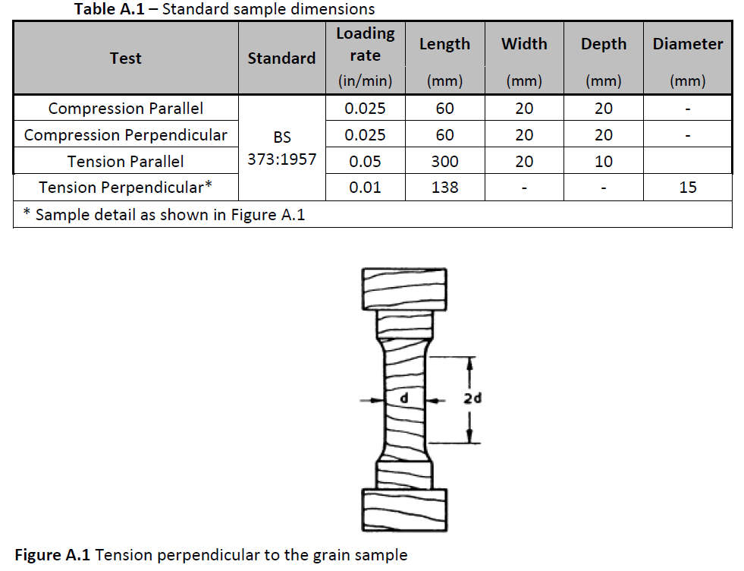

Figure 3: Tension perpendicular to the grain sample

The shear modulus of untreated (48 samples) and acetylated (43 samples) Radiata pine with MSG8 strength grade was determined using the Torsion test method in accordance with EN 408. In order that the samples were not stressed beyond their elastic limit each specimen was tested to a maximum load of 0.4fmax,est - the test apparatus used in this instance was Tinius Olsen.

Results

A summary of the results of acetylated Radiata pine compared with the values for strength class C24 defined in EN 338 is shown in Table 2. Not all values for Accoya wood (marked with asterisk) are determined according to EN 408 and making it difficult to perform a comparison, but in general the mechanical properties of acetylated Radiata pine comply at least with the values mentioned for C24.

Table 2: Mechanical properties of Accoya Structural

|  |  |  |  |
| --- | --- | --- | --- |
|  |  | **C24 values (EN 338)** | **Test values Accoya structural** |
| **Characteristic strength properties (in N/mm2)** | | | |
| Bending | fm,k | 24 | 28.6 |
| Tension parallel | ft,0,k | 14 | 19.9* |
| Tension perpendicular | ft,90,k | 0.4 | 0.9* |
| Compression parallel | fc,0,k | 21 | 40.2 |
| Compression perpendicular | fc,90,k | 2.5 | 5.9 |
| Shear | fv,k | 4.0 | n.m. |
| **Stiffness properties (in kN/mm2)** | | | |
| Mean modulus of elasticity parallel | E0,mean | 11 | 11.3 |
| 5% modulus of elasticity parallel | E0,05 | 7.4 | 8.3 |
| Mean modulus of elasticity perpendicular | E90,mean | 0.37 | n.m. |
| Mean shear modulus | Gmean | 0.69 | 0.79** |
| **Density (in kg/m3)** | | | |
| Characteristic density | ρk | 350 | 475 |
| Average density | ρmean | 420 | 540 |

*\*based on another test method than EN 408*

*\*\*based on MSG8 graded Radiata pine prior to the acetylation, which has lower mechanical properties compared to the Accoya structural Radiata pine.*

STUDY TO COMPARE STRENGTH PROPERTIES OF ACCOYA WOOD UNDER SERVICE CLASS 1 AND SERVICE CLASS 3 CONDITIONS

Test arrangements

At Brighton University the following mechanical properties were determined on paired samples of Accoya® radiata pine under service class 1 (65% RH / 20°C) and service class 3 (immersed under water for 4 to 6 weeks) conditions:

* Embedment strength parallel to grain according to EN 383 of 15 paired samples. The specimen’s parallel to grain dimension was nominally 150 mm with the dowel projecting from the centre-point of the 150 x 100 mm specimen face. The 10 mm diameter bolt was inserted into a pre-drilled 11mm diameter hole.
* Embedment strength perpendicular to grain according to EN 383 of 15 paired samples. The specimen’s parallel to grain dimension was nominally 400 mm with the dowel projecting from the centre-point of the 400 x 100 specimen face. The 10 mm diameter bolt was inserted into a pre-drilled 11 mm diameter hole.
* Compression strength parallel to the grain according to EN 408 of 15 samples of nominally 240mm long and 38 x 89 mm in cross-section
* Compression strength perpendicular to grain of 15 samples of 38 x 89 mm in cross-section and 70 mm length. Although the test specimen size deviates slightly from that stipulated in EN 408, the test procedure of EN408 was followed.
* Shear strength of a notched end of Accoya determined from a central 3-point load test on short-span beam (see Figure 4) of 38 x 89 mm in cross section. Details of the support arrangement at the end notch are shown in Figure 5. 16 paired samples were utilised.

Determination of characteristic values was carried out according to EN 14358 and, in the case of the embedment strengths and shear strength at the notched end, calculations were made in conjunction with EN 1995-1-1.

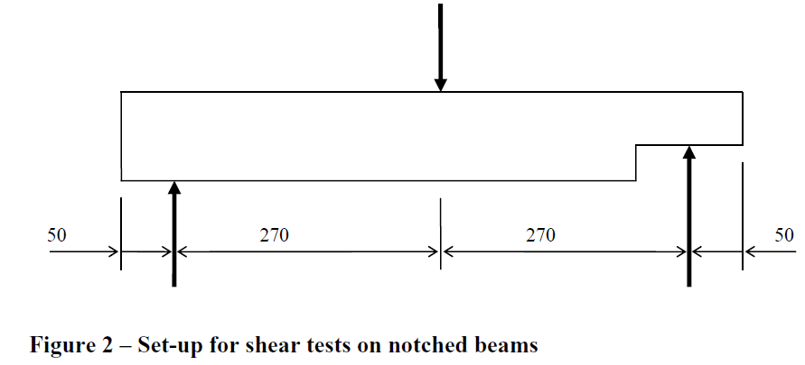

Figure 4: Set-up for shear tests on notched beams

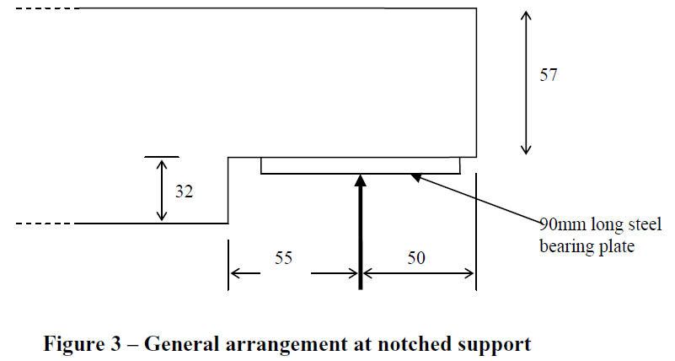

Figure 5: General arrangement at notched support

Results

In Tables 3-5 the results of the tests at Service Class 1 condition (65% RH / 20°C) and Service Class 3 condition (immersed under water for 4 to 6 weeks) are given for the embedment, compression and shear strength respectively.

Table 3: Embedment strengths Service Class 1 and Service Class 3

|  |  |  |  |  |  |
| --- | --- | --- | --- | --- | --- |
| **Type of test** | **Characteristic strength [N/mm2]** | | **Mean ratio of SC3 strength to SC1 strength for matched pairs of specimens** | **Embedment strength (N/mm2) calculated using procedures of EN 1995-1-1 based on:** | |
|  | **Service Class 1** | **Service Class 3** | **Char. density for strength class C24** | **Char. density of Accoya test spec.** |
| Embedment strength [N/mm2] |  |  |  |  |  |
| * parallel to grain | 49.0 | 30.6 | 0.70 | 25.8 | 34.2 |
| * perpendicular to grain | 22.1 | 17.2 | 0.80 | 17.2 | 23.8 |

Table 4: Compression strengths Service Class 1 and Service Class 3

|  |  |  |  |  |
| --- | --- | --- | --- | --- |
| **Type of test** | **Characteristic strength [N/mm2]** | | **Mean ratio of SC3 strength to SC1 strength for matched pairs of specimens** | **Characteristic strength from EN 338**  **[N/mm2]** |
|  | **Service Class 1** | **Service Class 3** |
| Compression strength [N/mm2] |  |  |  |  |
| * parallel to grain | 40.2 | 31.2 | 0.79 | 21 |
| * perpendicular to grain | 5.9 | 4.5 | 0.73 | 2.5 |

Table 5: Shear strengths at notched end Service Class 1 and Service Class 3

|  |  |  |  |  |
| --- | --- | --- | --- | --- |
| **Type of test** | **Characteristic strength [kN]** | | **Mean ratio of SC3 strength to SC1 strength for matched pairs of specimens** | **Characteristic strength calculated using EN 1995-1-1**  **[kN]** |
|  | **Service Class 1** | **Service Class 3** |
| Shear strength at notched end | 2.3 | 2.8 | 1.20 | 2.0 |

The overall mean ratio between service class 3 **embedment strengths** and service class 1 embedment strengths is 0.80 for specimens loaded perpendicular to grain and 0.70 for specimens loaded parallel to grain. This is similar to ratios of kmod given in

EN 1995-1-1, which range from 0.78 to 0.83 depending on the load-duration class being considered. When it is considered that, unlike in some National Codes (e.g. – BS 5268-2), EN 1995-1-1 gives a single set of kmod values for all stress types it is concluded that the modifications embodied in the solid timber kmod factor to account for service class are appropriate also for modifying Accoya embedment strengths.

The characteristic embedment strengths output by EN 1995-1-1 pertain to service class 1 condition and have been calculated by using 1) the characteristic density given by EN 338 for strength class C24 and 2) the actual density of the Accoya test specimens. Higher actual characteristic embedment strengths are found compared to calculation values by EN 1995-1-1 for characteristic densities of strength class C24. When the EN 1995-1-1 characteristic embedment strengths are calculated using measured characteristic densities from the Accoya test specimens, whilst the characteristic value from embedment tests parallel to grain remained greater than the corresponding calculated characteristic value, the characteristic value from the embedment tests perpendicular to grain was slightly (7%) less than the corresponding calculated characteristic value.

The overall mean ratio between service class 3 **compression strengths** and service class 1 compression strengths is 0.79 and 0.73 for specimens loaded parallel and perpendicular to grain respectively. Again this is thought to be in acceptable agreement with the ratios of kmod described in EN 1995-1-1. The characteristic compression strengths found by test for Accoya® radiata pine comfortably exceed the characteristic compression strengths (parallel and perpendicular to grain) given in EN 338 for strength class C24.

Unlike for most strength properties of Accoya® or solid timber, no decrease in **shear strength** was found for saturated Accoya relative to the shear strength of Accoya conditioned in a service class 1 environment. For Radiata pine Accoya in service class 1 conditions the characteristic shear strength of a beam at a notched support found from test was in reasonable agreement (+15%) with the equivalent characteristic shear strength calculated in accordance with EN 1995-1-1 and utilising the solid timber values for the factors kcr (0.67) and kn (5).

Structural design

Effect of acetylation on strength and stiffness

Any chemical modification process that affects the chemistry of the wood cell wall polymers and/or their interactions will also affect the physical and mechanical properties of the wood. The key effects of acetylation are:

* Accoya**®** has a lower equilibrium moisture content than the parent wood;
* Accoya**®** has a higher density than the parent wood due to the weight of the added acetyl groups; however because the wood swells during acetylation, there are actually fewer fibres per cross section compared with the unmodified wood;
* Accoya**®** has a slightly lower tensile and bending strength than the parent wood.

Solid Accoya® members

Solid Accoya**®** members may be designed in accordance with EN 1995-1-1:

* The characteristic strength and stiffness properties given for C24 in EN 338 may be assumed;
* These shall be modified in accordance with the factors for solid wood in EN 1995-1-1 to obtain appropriate design values;
* Since Accoya® will mainly be used in external applications, the *kmod* and *kdef* values for solid timber in service class 3 will generally apply;
* Note that in Service Class 3 under instantaneous or short-term load-duration, the characteristic values for modulus of elasticity and shear modulus should be multiplied by 0,9.

Laminated Accoya® members

Thephysical and chemical changes associated with acetylation, can affect the strength of the glue line; in particular adhesives which require moisture for hardening can be affected by the particularly low moisture content of Accoya**®**. Testing has so far been undertaken by two large multi-national wood adhesive manufacturers, in accordance with EN 302-1 and EN 301 (PRF adhesives) or EN 15425 (PU adhesives), to confirm that their adhesives are suitable for gluing Accoya. It may be possible to use other adhesives, but these would need to be confirmed by the relevant manufacturers.

Laminated Accoya**®** members may be designed in accordance with EN 1995-1-1

* The characteristic strength and stiffness properties given for GL24h in EN 1194 (shortly to be replaced by EN 14080) may be assumed;
* These shall be modified in accordance with the factors for laminated wood in EN 1995-1-1 to obtain appropriate design values;
* Since Accoya® will mainly be used in external applications, the *kmod* and *kdef* values for solid timber in service class 3 will generally apply;
* Note that in Service Class 3 under instantaneous or short-term load-duration, the characteristic values for modulus of elasticity and shear modulus should be multiplied by 0,9.

Design of connections

Connections may be designed in accordance with EN 1995-1-1. Advantage may be taken of the higher density of Accoya**®** due to the weight of the added acetyl groups. For dowel type fasteners (nails, screws, dowels and bolts) this will generate higher embedment, and where applicable withdrawal and head pull-through, strengths. The following characteristic densities (ρk) may be assumed:-

Solid Accoya**®** 380 kg/m3

Laminated Accoya® 410 kg/m3

The dimensional stability of Accoya**®** will also be of advantage when using large bolt groups. Many other species have risk of splitting due to the restraint provided by the steel plate or cross-grain timber to which the bolts are often connected.

Fixings and steel flitch plates shall be stainless steel minimum grade A2 and A4 (304 and 316) since Accoya® contains a small amount of residual acetic acid from the modification process that can impact corrosion rate of metals.

acknowledgements

The authors are very grateful of the pleasant cooperation with University of Brighton (Dr. Dave Pope), SHR (Prof. Dr. André Jorissen) and ARUP (Andrew Laurance) to develop a Structural Design Guide for Accoya® Wood.

references

Alexander, J. 2007. Accoya™. An Opportunity for Improving Perceptions of Timber Joinery, in *Proceedings of the Third European Conference on Wood Modification*, pp 431-438.

Bongers, F., Alexander, J., Jorissen, A., Blaß, H.J. and Hill, C. 2010. Acetylated Wood in Structural Applications, in *Proceedings of the 5th European Conference on Wood Modification*.

Bongers, F., Roberts, M., Stebbins, H. and Rowell, R. 2009. Introduction of Accoya® wood on the market – technical aspects, in *Proceedings of the Forth European Conference on Wood Modification*, pp 301-310.

BS 373:1957. Methods of testing small clear specimens of timber.

BS 5268-2:2002. Structural use of timber – Code of practice for permissible stress design, materials and workmanship.

Crawford, D., Hairstans R., Alexander J. and Bongers, F. 2012. Assessment of structural performance of Accoya® wood for GluLam fabrication, in *Proceedings of the 12th* *World Conference on Timber Engineering*.

EN 338:2009. Structural timber - Strength classes.

EN 383:2007. Timber structures - Test methods - Determination of embedment strength and foundation values for dowel type fasteners.

EN 408:2010. Timber structures - Structural timber and glued laminated timber - Determination of some physical and mechanical properties.

EN 1995-1-1:2005. Eurocode 5 - Design of timber structures - Part 1-1: General - Common rules and rules for buildings.

prEN 14080:2011. Timber structures - Glued laminated timber and glued laminated solid timber – Requirements.

EN 14081-2:2010. Timber structures - Strength graded structural timber with rectangular cross section - Part 2: Machine grading; additional requirements for initial type testing.

EN 14358:2007. Timber structures - Calculation of characteristic 5-percentile values and acceptance criteria for a sample.

Jorissen, A. and Lüning, E. 2010. Wood modification in relation to bridge design in the Netherlands, in *Proceedings of 11th World Conference on Timber Engineering*.

Kattenbroek, B. 2005. How to introduce acetylated wood from the first commercial production into Europe, in *Proceedings of the Second European Conference on Wood Modification,* pp 398-403.

Tjeerdsma, B., Kattenbroek, B. and Jorissen, A. 2007. Acetylated wood in exterior and heavy load-bearing constructions. Building of two timber traffic bridges of acetylated radiata pine, in *Proceedings of the Third European Conference on Wood Modification*, pp 403-411.

Tjeerdsma, B. and Bongers, F. 2009. The making of a traffic timber bridge of acetylated Radiata pine, in *Proceedings of the Forth European Conference on Wood Modification,*  pp 15-22.