# Edinburgh Napier University

# Mental Health Strategy (2021-2024)

**Edinburgh Napier University - Mental Health Strategy (2021-2024)**

1. **Purpose**

The purpose of the Strategy is to ensure that the University is recognised as an organisation that safeguards and promotes the mental health and wellbeing of its students and staff and that it treats all members of its community equitably and with respect, kindness and empathy.

1. **Overview**

The Strategy sets out the University’s response to the UUK StepChange Framework and to the Student Minds Charter and sets out the University’s vision, aims and high-level objectives for student and staff mental health, for the next 3 years.

1. **Scope**

The Strategy applies to all students and staff at the University.

1. **Vision**

*Edinburgh Napier University is taking a collaborative institution-wide approach to mental health and wellbeing so that we provide the best possible experience for all our students and staff. We are committed to mental health permeating every aspect of our culture and it being part of the experience of learning and teaching.*

*Our approach celebrates and reflects the diversity of our student and staff community and seeks to ensure that everyone feels respected, valued and our students supported to realise their potential.*

*Our vision is for a University community that is healthy, supportive, inclusive, and well-informed; to be known as a community that promotes wellbeing and positive mental health; and a University that supports staff and students by providing excellent support services.*

*Professor Andrea Nolan*

*Principal*

*Edinburgh Napier University*

1. **Background and context**

Universities UK published their updated [StepChange: Mentally Healthy Universities Framework](https://www.universitiesuk.ac.uk/stepchange-mhu) in 2020. This expressed a shared vision for universities to be places that promote mental health and wellbeing, enabling students and staff to thrive and succeed to their best potential. The framework recommended that all universities should adopt mental health as a strategic priority and to take a whole university approach. UUK also noted that the framework was co-developed with Student Minds’ as they produced the University Mental Health Charter and that as such this provides to universities a shared framework for change.

We have adopted the framework and the Charter as our guides in the production of this strategy and will continue to reference both over the coming years as we implement our actions and reflect and adapt our objectives.

The framework encourages us to centre our work in relation to the metal health continuum – an idea core to our vision and understanding and which reminds us that just as we have physical health that can change over time, that we all also have mental health that fluctuates over time and in response to our environment.

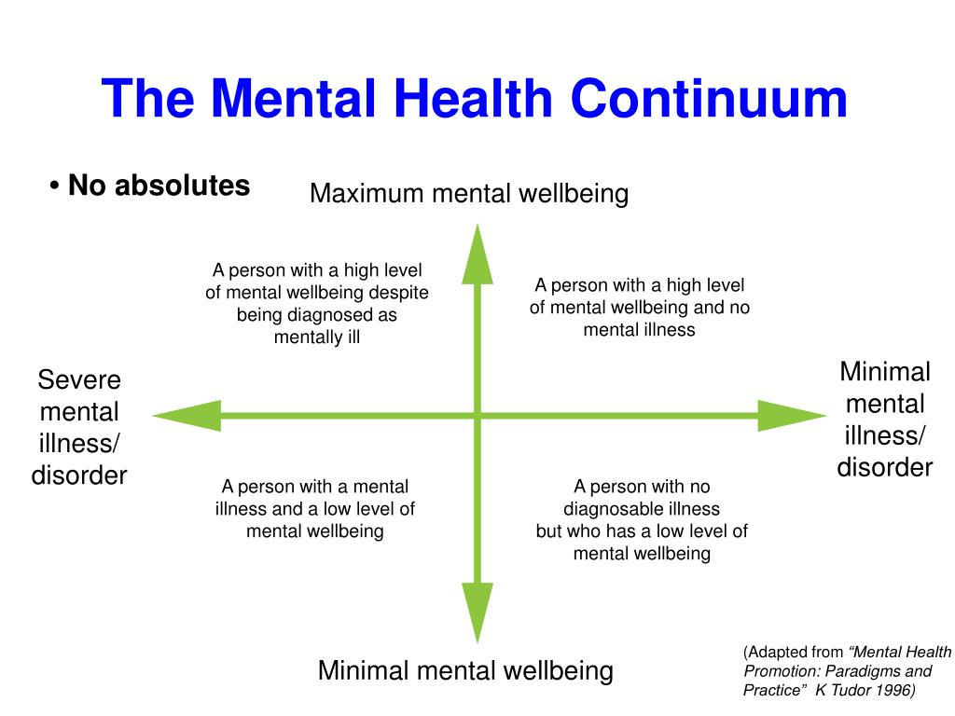

The framework also argues that universities are spaces and communities which offer a setting within which health can be promoted or impacted negatively.

Health is created and lived by people within the settings of their everyday life; where they learn, work, play and love.

WHO, Ottawa Charter for Health Promotion, 1986

We have framed our thinking and objectives in relation to these ideas and have also referenced our objectives around the case for action and key themes addressed within the framework.

**Case for action (adapted from UUK StepChange Framework)**

We agree with the arguments made within the framework that taking a whole university and strategic approach is key.

*Students Attainment*: there is strong evidence that good mental health has a positive impact on students’ learning, creativity, ability to concentrate and overall performance levels. The link between health and learning gain also continues beyond graduation into employment and life afterwards. Just as employees expect healthy workplaces, employers want graduates who are health and wellbeing literate.

*Thriving at work*: employers who invest in employee wellbeing see enhanced performance, reduced costs from sickness absence, lower staff turnover and higher levels of creativity.

*Responsibility*: we have a responsibility to the health and safety of students, staff and visitors and a duty of care to our students and staff. This is set out in health and safety, employment and consumer legislation.

*Impact on mental illness*: Poor mental health has negative consequences for the learning, work and lives of students and staff. Suicide and serious mental illness have a devastating impact on families, friends and university communities. Students experiencing mental illness are more likely to withdraw from courses, or to underachieve, and are less likely to progress. The direct and hidden costs of staff experiencing poor mental health are less documented in universities but are likely to be substantial.

We have embraced the case for action noted here and the wider points made within the framework and we will continue to refer to the framework and to the Student Minds’ Charter as we develop our actions. In addition, we agree with the framework that we should bring particular focus to the inter-related themes of ‘transitions’ and to our relationship and partnerships with the NHS.

Finally, we are strongly aware of the evidenced impact on mental health arising from the Covid 19 pandemic – on both students and staff. We aim to develop our actions framed by reference to this and it is likely to have a bearing on our work for the full duration of our strategy.

1. **Underpinning principles (adapted from StepChange)**

We have adopted the following as the underpinning principles that have enabled us to identify our key actions and approach to delivery:

* Strategic: We understand that sustained effort is needed, now and in the long-term, across our whole institution and led by senior staff.
* Aligned: We recognise that working together in partnership across our University and with key partners including our Student Association, to a shared vision and approach is essential.
* Shared: We recognise that this strategy and our efforts are not the responsibility of any one University service or area but represent an agreed collaborative approach to realise an agreed vision.
* Adaptable: We understand that as we work to deliver this strategy that services, resources and partnerships will need to flex and adapt as our understanding of our context and priorities evolves. This will be shaped by regular efforts to benchmark our actions, services and outcomes with comparator universities in the sector.
* Impactful: We understand that this Strategy needs to be impactful and relevant KPI’s will be identified to demonstrate and measure the changes we bring about through our work.

1. **Aims**

**Learning**: Universities transform lives through learning. Higher education involves challenge and new ways of thinking - it can have a positive impact on a person’s mental health and wellbeing over a lifetime. **We aim to ensure our students have a positive learning, teaching and assessment experience, that is supportive and creates opportunities for students to perform to the best of their abilities**.

**Support:** Nationally the demand for mental health support among students and staff has increased significantly. Universities currently resource a wide range of services to support those experiencing impaired mental health. **We aim to deliver excellent support services to staff and students.**

**Work**: Good mental health is central to staff engagement, productivity and creativity. **We aim to engage effectively with our staff to understand the impact of our policies on the staff experience and to deliver change and improvements when we identify this is necessary to deliver our vision.**

**Live:** **We aim to support our students by creating healthy places to live** and will foster this though a range of actions including targeted health promotion projects; supporting the development of healthy cultures; building a healthy environment; and supporting a healthy community.

1. **Strategy:**

This three-year strategy is owned by the University’s Leadership Team and responsibility for its delivery sits with a wide range of teams from across the University, working in partnership with our Student Association (ENSA). The services and teams best able to deliver the aims and objectives of the strategy have been central to the production of the strategy and have committed to work collaboratively in its delivery.

Our overarching ambitions include:

* Informed leadership to foster a whole University approach;
* Promoting positive mental health and wellbeing by communicating and engaging effectively with the whole University community;
* Focussing on prevention, early intervention, particularly where there is an identification of risk, and building healthy communities;
* Responding to the national increase in expressed mental ill-health – particularly during this period of the Covid pandemic by ensuring that our services are well-resourced, easy to access and delivering a wide range of effective interventions (including individual work, group-work and on-line/digital support);
* Ensuring that we have in place impact measures, evaluation activities and undertake and benefit from ongoing research to track the impact of our activities on the University community.

**Our key objectives:**

* 1. We coordinate and deliver effective communications and engagement activities to staff and students (and to their key supporters and families) from first point of contact and throughout the staff/student journey that aim to highlight the importance of good mental health and how to foster and maintain this; secondly, to tackle the stigma that is often connected to mental ill health; and thirdly, to promote a culture of kindness and compassion amongst the university community **(Live, Work).**
  2. We actively consider the impact of our academic policies and practices, including academic regulations, on student and staff mental health. This is particularly important in the first year of this Strategy as we seek to mitigate impacts of Covid 19 on the staff and student experience and to understand how best to support the mental wellbeing of our communities. The impacts of Covid and our response is likely to last for the duration of this Strategy. **(Learning)**
  3. We always consider the impact of our estate use and development on mental health and the opportunities provided to promote, as a core function, the wellbeing of staff and students. **(Live, Work)**
  4. We will engage with staff and students to develop their awareness of wellbeing, to promote ownership of positive mental health and to foster and promote the key message that recovery from impaired mental health is possible and common. We will adopt a health promoting approach and deliver campaigns and communication actives on issues such as the misuse of drugs and alcohol, gambling, safe use of online environments and social media, and safe sex. **(Live)**
  5. We deliver effective support services to staff and students and offer access to resources and activities which support good mental health. We will reflect on our current models of support in our Student Accommodation settings and how we offer support to students and staff out with 9-5 and at weekends. **(Support)**
  6. We deliver a training programme to staff and students to assist them to understand the enablers of good mental health and sources of further support and guidance; understand the risk of suicide and to develop confidence and skills to make a positive intervention **(Live, Work, Support).**
  7. All students and staff know how to access support if they experience impaired mental health. **(Support)**
  8. All key groups of staff who work with students are confident to support and where relevant, effectively refer on students who experience mental health difficulties. A safeguarding framework will ensure that all staff understand their safeguarding responsibilities and know how to escalate urgent concerns. Managers are confident to support and where relevant, effectively refer their staff onto appropriate support services. **(Support)**
  9. Students supporting other students can access advice, guidance and where relevant training. **(Support)**
  10. We will focus activities and promote support services and resources at key transition points as students join and move through our learning community. In addition, students transitioning to and moving through the University with pre-existing mental health conditions will be supported to:
* navigate local NHS support and receive joined up care;
* receive timely, effective support from the University, including access to specialist support if needed;
* be referred to and supported to access other forms of support (eg from the NHS) where necessary. **(Live, Support)**
  1. We will develop and implement a Suicide Safer Plan. **(Support)**
  2. We will consider how best to incorporate the lived experience of students/staff in the on-going development and refinement of this Strategy. **(Live, Work, Support)**
  3. We will seek to support and, where appropriate, work jointly with ENSA to deliver their own mental health objectives. **(Live, Support, Learning)**
  4. We will continue to work with appropriate third sector organisations and with NHS Lothian and the other Edinburgh HEI’s to support students who experience mental health difficulties. **(Support)**
  5. We gather and use data effectively to monitor, evaluate and

inform the impact and development of this strategy, and of the services and resources delivered in support of staff and student mental health. **(Learning, Support, Live, Work)**

* 1. We will ensure that activities relating to Equality, Diversity and Inclusion designed to tackle discrimination also support mental health and wellbeing and ensure that we examine mental health and wellbeing through the ‘lens’ of the Equality Act and protected characteristics. We will ensure that all the actions taken to deliver this strategy focus on the particular experience and needs of staff and students with protected identities. **(Live, Learning, Support, Work)**