BA International Tourism Management
Honours Dissertation

Academic Year 2024 - 2025

Title
Challenging Traditional Tourist Typologies through the Digital Nomad Lens

Author
Claudio Pigozzo

Supervisor
Dr Alexandra Witte

Word count
13,182



Abstract
Digital nomadism represents a rapidly growing lifestyle that blends remote work with long-term travel. While often associated with tourism, digital nomads (DNs) differ significantly from traditional tourist types due to their continuous mobility, work–leisure integration, and evolving concept of home. This study examines how DNs fit existing tourist typologies by exploring their motivations, behaviours, and personalities. Addressing a gap in tourism literature, the research aims to propose a new typology that captures the diversity and complexity of DNs experiences.
This study used a qualitative, exploratory approach to interview thirteen DNs from different backgrounds. The data were analysed using a grounded theory approach to analysis. Key themes, such as motivations, mobility patterns, cultural engagement, work-leisure integration, and the concept of home, were identified using open and axial coding. The findings led to the development of a typology comprising five DN types: Flash Nomads, Cultural Immersive Nomads, Seasonal Nomads, Settled Sojourners, and Rooted Roamers. Each type reflects a unique combination of motivations, cultural engagement, mobility, and spatial attachment while sharing common traits such as reliance on digital infrastructure, cost-of-living awareness, and adaptive coping strategies. This research contributes to tourism theory by expanding conventional tourist classifications to account for digitally enabled, work-integrated mobility. It demonstrates how DNs blur the traditional boundaries between being a tourist and a resident, between work and leisure, and between permanence and transience. Practically, the findings offer insights for destination planners and policymakers on better supporting diverse DN lifestyles through infrastructure, visa policy, and community integration. Future research is encouraged to explore cultural motivations, identity formation, and the evolving transitions between DNs types over time.

Acknowledgements
I want to express my deepest gratitude to everyone who supported me throughout this dissertation.
Special thanks to my supervisor, Dr. Alexandra Witte, for her invaluable guidance, encouragement, and constructive feedback. From the start, she inspired me with her deep knowledge and pushed me to think deeper and aim higher, always in a supportive and motivating way. Her timely feedback and support kept me focused and confident throughout the process.
I am also grateful to all my lecturers at Edinburgh Napier University for creating a learning environment that encouraged me to grow personally and academically.
I am thankful to the thirteen participants who generously shared their time and insights, making this research possible. Without their willingness to contribute, this study would not have been achievable, and I am genuinely grateful for the depth and authenticity they brought to the findings.
And lastly, to my family, thank you for your patience, motivation, and the constant belief you had in me. Your support has been my anchor throughout this journey, especially during the more challenging moments. I am especially grateful for your encouragement, understanding during long study hours, and the many ways you helped me stay on track. This accomplishment would not have been possible without your love and steady reassurance.

Table of Contents
1 Introduction 6
1.1 Background 6
1.2 Rationale 8
1.3 Research Aims and Objectives 9
1.3.1 Aim 9
1.3.2 Objectives 9
1.4 Overview of methodology 9
1.5 Summary of chapters 10
2 Literature Review 11
2.1 Tourist Typologies 11
2.2 The Evolution of Mobility Patterns and Concept of Home 14
2.3 Digital Nomads 20
2.4 Chapter Summary 24
3 Research Design 25
3.1 Research Philosophy 25
3.2 Research Approach 25
3.3 Method of data collections 26
3.4 Sampling approach 27
3.5 Participant Recruitment 27
3.6 Method of analysis 28
3.7 Ethics 28
3.8 Chapter Summary 29
4 Analysis of Core Themes and Patterns 30
4.1 Motivations 30
4.2 Mobility Patterns 31
4.3 Social and Cultural Engagement 33
4.4 Work and Leisure Integration 35
4.5 Concept of Home 38
4.6 Chapter Summary 39
5 Presentation of the Proposed Typology 40
5.1 Overview of the Typology 40
5.2 Detailed Typology 41
5.2.1 Flash Nomads 41
5.2.2 Culturally Immersive Nomads 41
5.2.3 Seasonal Nomads 41
5.2.4 Settled Sojourners 42
5.2.5 Rooted Roamers 42
5.3 Universal Characteristics 43
5.4 Chapter Summary 44
6 Discussion and Comparison with Existing Literature 45
6.1 Comparison with Existing Typologies 45
6.2 Comparison with DNs Typologies 48
6.3 Chapter Summary 49
7 Conclusion 50
7.1 Theoretical Implications 51
7.2 Practical Implications 52
7.3 Future Research Directions 52
7.4 Limitations 53
8 References 54
9 Appendices 60

List of Figures
Figure 1. How digital nomads self-identified before the pandemic (Cook, 2023). 7
Figure 2. Tourist typologies based on behaviour, motivation and personality traits. 11

List of Tables
Table 1 - Mapping of characteristics of archetypes in behaviour-based typologies 17
Table 2 - Mapping of characteristics of archetypes in personality-based typologies 18
Table 3 - Mapping of characteristics of archetypes in motivation-based typologies 19
Table 4 - Mapping of Digital Nomads Typologies 23
Table 5 - Digital Nomads Proposed Typology 40

Introduction
This study aims to explore the behaviours, personalities, and motivations of digital nomads (DNs), and to critically examine their conceptual fit within existing tourist typologies. This chapter provides key background information on the study by outlining the evolution of digital nomadism and its growing relevance within the context of tourism. It introduces the research aims and objectives, which focus on exploring the motivations, behaviours, and identities of DNs and examining their conceptual fit within existing tourist typologies. It also offers a brief overview of the methodological approach and limitations. Finally, it presents a structural outline of the dissertation, summarising the focus and content of each chapter.

Background
Lifestyles and technological advancements have significantly influenced the travel and tourism industry in the post-modern era, shaping distinct tourism and traveller typologies (Arslan, 2024). Scholars have long argued that developing such typologies is essential for understanding tourist motivations (Wickens, 2002) and improving tourism planning, marketing, and management (Hvenegaard, 2002; Paulino et al., 2021). In this context, digital nomadism has emerged as a rapidly growing lifestyle phenomenon (Shawkat et al., 2021), characterised by the integration of remote work, mobility, and leisure (Chevtaeva & Denizci-Guillet, 2021; Reichenberger, 2018; Šímová, 2023). While elements of this lifestyle overlap with those of other mobile groups, DNs uniquely blend work and travel in ways that distinguish them from traditional tourists and nomads (Mancinelli, 2020; Schlagwein & Jarrahi, 2020).
This change is driven by broader shifts in the job market due to socioeconomic factors, wireless technology, and better transportation (Müller, 2016). These elements have enabled new work styles in the digital economy, leading many digital workers to adopt mobile lifestyles marked by rootlessness and adaptability (Orel, 2019). These individuals have been variously labelled neo-nomads (Naz, 2016), lifestyle migrants (Rana, 2018), and most widely, DNs (Cook, 2020; Hannonen, 2020; Reichenberger, 2018; Richards, 2015), reflecting a growing trend of combining work and leisure as a cohesive lifestyle. Compared to other mobile identities, such as backpackers or global nomads (Richards, 2015), DNs are typically older, more financially stable, and embed remote work as a continuous part of their mobility (Bozzi, 2024). In addition, DNs adopt hypermobile practices shaped by their “free choice” rather than their job, unlike journalists, military personnel, and international tour guides (Mancinelli, 2020).
Digital nomadism is closely linked to travel and tourism (Bozzi, 2024), but DNs should not be mistaken for leisure-seeking tourists. While tourists may seek emotional or cultural novelty in temporary ways (Orel, 2019), DNs are motivated by the ability to work from any location, minimising geographic constraints through digital connectivity (Reichenberger, 2018; Schlagwein, 2018; Tiberius et al., 2024). Despite the connection to tourism, digital nomadism is underexplored in studies and remains a fragmented area of research due to its recent emergence (Hannonen, 2020; Wang et al., 2018). Current research on DNs tends to focus on either the work or leisure aspects of their lifestyle (Hannonen, 2020). Studies often explore their work practices, professional identities, and challenges in working life or examine how to attract DNs to specific destinations (Tiberius et al., 2024). Other research focuses on coworking experiences (Chevtaeva & Denizci-Guillet, 2021) or attempts to position them along a mobility and work focus axis (see Figure 1), lacking a more holistic approach that considers all the key elements that distinguish them.
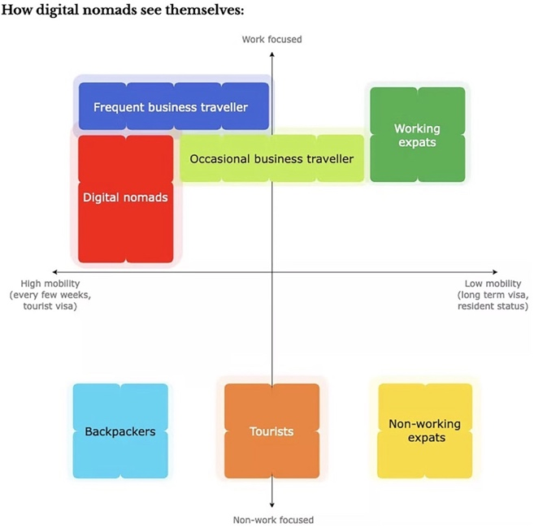
Figure 1. How digital nomads self-identified before the pandemic (Cook, 2023).

Rationale
The emergence of digital nomadism marks a significant shift in global mobility, work culture, and lifestyle, yet its position within tourism theory remains underdeveloped. While DNs engage in travel and cultural experiences like those of tourists (Reichenberger, 2018; Schlagwein, 2018; Tiberius et al., 2024), their integration of remote work and long-term mobility challenges traditional typologies that separate leisure from work. Both theoretical and empirical studies underscore the growing importance of lifestyle, independence, and mobility in shaping contemporary travel behaviours, but a comprehensive review reveals a clear gap in understanding digital nomadism within the context of tourism studies (Hannonen, 2020; Wang et al., 2018).
DNs represent a hybrid profile making it difficult to categorise them within existing frameworks. As their numbers increase globally, driven by technological advancements and flexible work arrangements (Müller, 2016), there is a need to examine how they fit, or don’t fit, within established tourism classifications.
This dissertation addresses that gap by critically analysing existing tourist typologies and exploring the DN lifestyle through their motivations, behaviours, and personalities. Understanding DNs more deeply holds considerable value from an academic standpoint, as it challenges long-standing binaries in tourism theory, such as work versus leisure, or tourist versus resident, and invites the development of new models that better reflect hybrid, fluid identities. These insights can advance theoretical debates on mobility, identity, and lifestyle migration. From a practical perspective, this knowledge is equally relevant for multiple stakeholders. Destination marketers and tourism planners can use it to better accommodate DNs by improving digital infrastructure, facilitating community integration, or tailoring promotional strategies to align with DNs values. Policymakers may benefit from recognising the economic and cultural contributions of DNs, which could inform more flexible visa systems, taxation frameworks, and urban development policies. Businesses, particularly in the hospitality, coworking, travel, and real estate sectors, also stand to gain by designing services and products tailored to the lifestyle and expectations of this increasingly influential group. Therefore, this research not only contributes to academic discourse and future scholarship but also provides actionable insights for those looking to attract, support, or regulate DNs in a rapidly evolving global landscape.

Research Aims and Objectives

Aim
This dissertation aims to critically examine DNs’ conceptual fit with established tourist typologies by exploring their motivations, personalities, and behaviours.

Objectives
To develop a conceptual framework by mapping existing tourist typologies and their key characteristics.
To explore DNs’ core characteristics, including motivations, behaviours and personalities, based on the developed framework.
To critically assess how DNs align with or diverge from established tourism archetypes.
To propose a new typology of DNs, based on their motivations, personalities, and behaviours.

Overview of methodology
The research adopted a qualitative, exploratory approach grounded in interpretivism and abductive reasoning. Thirteen semi-structured online interviews were conducted with DNs, recruited through purposive and snowball sampling. The data were analysed using grounded theory methods supported by MAXQDA software, with open and axial coding used to identify core themes such as motivations, mobility patterns, cultural engagement, work–leisure integration, and the concept of home. Ethical guidelines were strictly followed, ensuring informed consent and participant anonymity. The findings from the primary research were then compared with insights from the literature review, allowing for a critical evaluation of DNs’ conceptual fit within existing tourist typologies and enabling the researcher to effectively meet the study's objectives.

Summary of chapters
Chapter 1 – Introduction
The introduction chapter provides the background and context of the study, clearly outlines its aims and objectives, and briefly introduces the research design.

Chapter 2 – Literature review
This chapter discusses existing tourist typologies, explores the evolution of mobility patterns and the concept of home, and provides an overview of the DNs phenomenon.

Chapter 3 – Research design
This chapter outlines the research design, including the research approach, data collection and analysis methods, ethical considerations, and study limitations.

Chapter 4 – Analysis of the core themes
This chapter presents the findings from the interviews, outlining the key themes and subthemes that informed the classification of DNs.

Chapter 5 – Presentation of the proposed typology
This chapter presents the DNs typology, outlining the distinct characteristics of each type based on recurring patterns in motivations, behaviours, and personalities.

Chapter 6 – Discussion and comparison with existing typologies
This chapter compares the findings with existing tourist typologies, analysing the extent to which the identified DN types align with or diverge from established classifications.

Chapter 7 - Conclusion
The concluding chapter will summarise the overall findings of the study, reflect on the research, and provide recommendations for future research on the topic.

Literature Review

Tourist Typologies
Tourist typologies play a vital role in effective tourism planning (Coccossis & Constantoglou, 2008), allowing destination managers to make informed decisions about the development of attractions, accommodations, activities, and transport infrastructure. They also support the creation of targeted marketing strategies tailored to the needs and preferences of diverse visitor segments (Hvenegaard, 2002; Paulino et al., 2021). Over the years, researchers have tried to classify tourists into different groups based on different criteria, such as behaviour (Cohen, 1972; McKercher et al., 2002; Paris, 2012; Smith, 1989), motivations (Cohen, 1979; Cohen, 2011; McKercher, 2002; Pearce, 1990; Tan et al., 2014; Uriely, 2001; Wickens, 2002), and personality traits (Perreault et al., 1977; Plog, 1974; Seery & Paris, 2015). These categories are summarised in Figure 2, which provides a visual overview of how existing typologies align with each group. Understanding these broad groupings helps frame the deeper analysis that follows. In the next sections, each category will be examined in detail, starting with behaviour-based typologies such as Cohen’s (1972) classification.
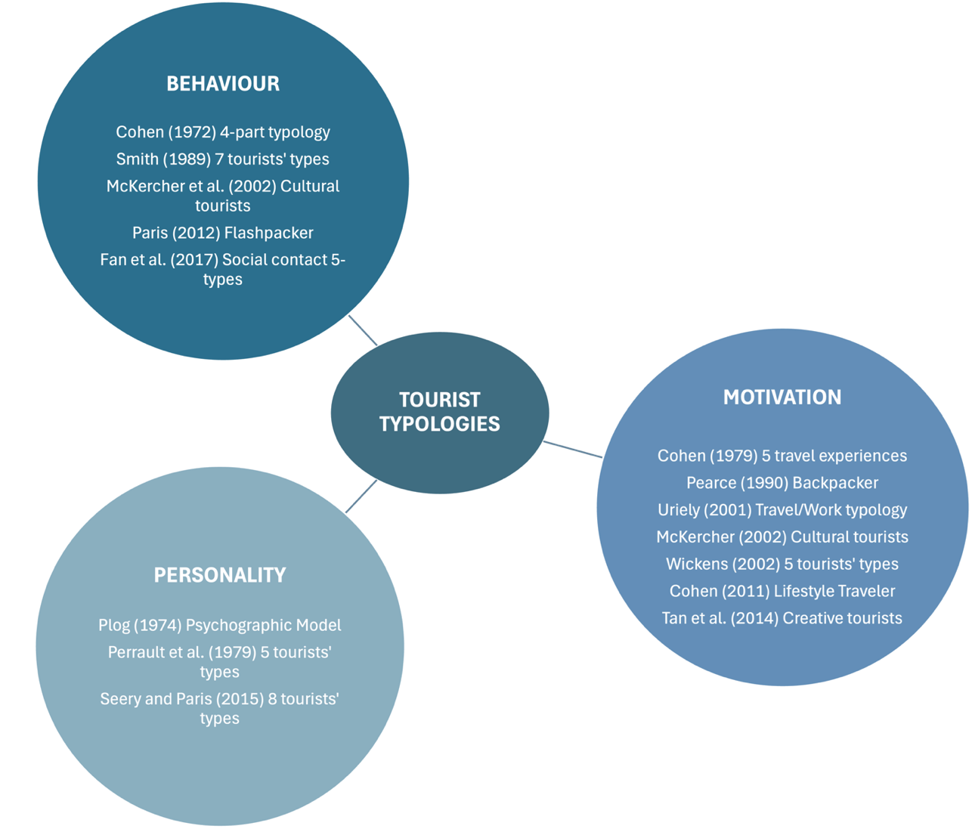
Figure 2. Tourist typologies based on behaviour, motivation and personality traits.
Cohen (1972) distinguished four types of tourists based on their travel preferences, placing on one side of the spectrum tourists seeking familiarity, the organised and the individual mass tourists, and on the other side those seeking novelty and authentic experiences, the explorers and the drifters. This classification was developed as a direct response to Boorstin’s (1964) flawed view of tourists as a uniform group. However, it has faced criticism for focusing primarily on behaviour while neglecting the underlying motivations of tourists and overlooking the shifts in their behaviour over time (Mehmetoglu, 2004). Furthermore, it fails to account for the complexities of global homogenization (Mehmetoglu, 2004), which refers to the process by which cultures, products, and lifestyles become increasingly similar across different regions, often driven by globalization and the influence of mass media and multinational corporations (Abdullahi, 2024). This trend even challenges the validity of the drifter archetype (Mehmetoglu, 2004), as travellers may encounter the same experiences and offerings in diverse locations, diminishing the uniqueness and authenticity sought by this type of tourist. Smith (1989), building on Cohen’s (1972) classification, similarly identified seven tourist types, the charter tourists, the mass tourists, the incipient mass tourists, the unusual tourists, the off-beat tourists, the explorers and the elites. Mehmetoglu (2004) contends that this typology is even less relevant than those mentioned above. This is due to its dependence on specific tourist behaviour observations and the challenges in differentiating between categories, such as the charter and the mass tourists who share the same characteristics (Mehmetoglu, 2004), a preference for familiarity, reliance on packaged tours, and minimal interaction with local communities (Smith, 1989). These critiques emphasize the difficulty of categorising tourists due to the evolving nature of society and behaviour, soliciting a revaluation of existing tourist typologies.
More recently, other researchers have sought to classify tourists based on their observed behaviours. McKercher et al. (2002) identified differentiation through the level of motivation for cultural activities and the depth of immersion, proposing a segmentation of cultural tourists into seven distinct types. Fan et al. (2016) instead concentrated on the amount, quality, and kind of contact between tourists and hosts, recognizing five categories that share many characteristics with Cohen’s (1972) typology. These two classifications provide valuable insights, the former for understanding and marketing the cultural tourism market (McKercher et al., 2002) and the latter for offering a basis to measure social contact in future research (Fan et al., 2016). Although these studies may be limited by their context, as both focus exclusively on the cultural landscape of Hong Kong, China, they excel in their specificity and practical application to the investigated market. This localised approach restricts the applicability of their findings, making it challenging to draw broad generalisations about tourist behaviour across different destinations (McKercher et al., 2002), but allows for a deeper understanding of the unique dynamics at play. To facilitate a clearer understanding of how behaviour-based tourist typologies relate to each other, Table 1 summarises their key similarities and differences.
Plog (1974) developed a comparable framework to that of Cohen (1972), focusing on psychological traits rather than sociological dimensions. In Plog's (1974) model, tourists are classified as allocentric (adventure-seeking) and psychocentric (familiarity-seeking), giving valuable insights into destination preferences and travel patterns suggesting a relationship between personality and tourist behaviour (Mehmetoglu, 2004). Although Cohen's (1972) and Plog’s (1974) work provided complex theoretical frameworks and addressed the gap between tourism studies and social theory (Mccabe, 2005), they overlook and oversimplify the intricate tourist identities and travel behaviours (Fan et al., 2016), limiting research on Western culture. Another attempt at a psychographic classification of tourists was made by Perreault et al. (1977), who classified tourists based on their vacation lifestyles, identifying the budget travellers, the adventurous, the homebody, the vacationers and the moderates. This typology, in contrast to Cohen’s (1972) work, does not delve into how tourists engage with the host population but finds common ground in the concept of adventurous tourists, as proposed by both Cohen (1972) and Plog (1974) (Charity, 2018). In a more recent paper, Seery & Paris (2015) propose a three-dimensional tourist typology that assesses individuals based on their venturesomeness, interactiveness, and level of sensation seeking, identifying eight tourist types. Despite the increased depth of their analysis compared to earlier typologies (Perreault et al., 1977; Plog, 1974), their findings resonate with Plog’s (1974) psychocentric, mid-centric, and allocentric model. Table 2 summarises the key points of personality-based tourist typologies, focusing on how personal traits shape travel behaviour.
In 1979, Cohen further investigated his work, inspired by MacCannell (1976), who focused on authenticity as a key motive for tourists, identifying five distinct types of experiences that tourists pursue: recreational, diversionary, experiential, experimental and existential (Cohen, 1979). This classification introduced a fresh perspective for examining tourists, but didn't encompass entirely the range of potential tourist experiences (Mehmetoglu, 2004). Moreover, it lacks contemporary relevance on the progress of technology (Arslan, 2024; Kozak et al., 2024) and on mobility patterns, such as increased international accessibility, greater geographical mobility, affordable airfare, and growing income levels in numerous countries (Matias et al., 2007). These considerations are crucial in understanding the evolving landscape of travel and migration in today's world.
Building on the exploration of tourists' motivations, scholars like McKercher (2002), Tan et al. (2014), and Wickens (2002) have respectively identified distinct tourist typologies. McKercher (2002) analysed five types of cultural tourists based on the degree of experience sought and the significance of cultural tourism in their choice of destination, enriching the industry's understanding of cultural tourism. Wickens (2002) and Tan et al. (2014) recognised five types of tourists based on their desired experiences, offering a more contemporary view that includes tourists drawn to nightlife and parties and environmentally and socially conscious travellers. While DNs may engage in these elements, their overarching drive lies in creating a hybrid lifestyle that redefines work, home, and identity through continuous mobility. Table 3 provides a comparative overview of tourist typologies based on motivations, highlighting both classical and contemporary approaches to understanding tourist desires.
The classification of tourist typologies has experienced significant evolution, reflecting the diverse motivations, behaviours, and preferences that influence travel experiences. Over the years, researchers such as Cohen and Plog have established foundational frameworks that contribute to a deeper understanding of tourism diversity. More recent studies emphasize the importance of integrating contemporary factors, including cultural motivations and the quality of interactions between tourists and hosts, thereby highlighting the limitations of earlier models. Furthermore, the evolution of tourist typologies requires ongoing research to address modern issues, such as technological advancements and changing mobility patterns, which are essential for understanding the current landscape of travel and migration.

The Evolution of Mobility Patterns and Concept of Home
From the perspective of this research, it is notable that the idea of drifter (Cohen, 1972) has been a recurrent theme across various typologies, albeit employing different terminologies. These terms include nomad, youthful traveler, wanderer, hitchhiker, tramping youth, long-term budget traveler (Uriely et al., 2002), backpacker (Pearce, 1990), and young budget traveler (Loker-Murphy & Pearce, 1995). Despite the variation in terms, researchers generally agree that this type of tourist differs from conventional mass tourists, seeking adventure and authentic experiences, inclined to social interaction and without space-time constraints (Loker-Murphy & Pearce, 1995; O’ Regan, 2018; Pearce, 1990; Uriely et al., 2002).
Furthermore, Cohen (2011) elaborated on a sub-category of backpackers called Lifestyle Travellers. This group is characterized by the continuous mobility of the subjects, different work motivations, complex relationships with cultural assimilation, and a critical perspective on the concept of “home” (Cohen, 2011). Unlike Noy & Cohen’s (2005) findings that backpackers easily readjust to their home societies, lifestyle travellers often struggle with conflicting social norms and cultural confusion when they return home (Hottola, 2004) due to the assimilation of the backpacker subculture into their identities (Cohen, 2011). Hence, defining “home” has become arduous in an era marked by significant mobility and global employment opportunities (Tran & Weaver, 2019). Several factors contribute to the development of a sense of home, including physical exposure to the place (Prentice, 2004), social relationships (Philipp & Ho, 2010), a sense of belonging (Moran-Taylor & Menjívar, 2005), and employment (Tran & Weaver, 2019). In a tourism context, however, the concepts of "home" and "away" are not strictly separated but somewhat intertwined experiences (Ashtar et al., 2017; Huang et al., 2017; Shani, 2013; Tran & Weaver, 2019). While there are similarities with other tourist typologies, lifestyle travellers also possess unique attributes that differentiate them, as highlighted in Table 3. As will be discussed, these frameworks struggle to encapsulate the fluidity of modern travel and the rise of digital transformation, especially when it involves perpetual travel, extended stays, and remote working or working on vacation.
Paris (2012) attempted to capture the advancement of technology and the hypermobility of individuals in the flashpacker concept. Emerging from traditional backpacking, flashpackers are characterized by high mobility and strong integration with technology (Paris, 2012), with the latter helping them to overcome isolation and physical distance (Mascheroni, 2007), blurring the line between home and away as the lifestyle traveller proposed by Cohen (2011). As observed by Pearce et al. (2009), however, the effects of technology on backpacking are quite unclear, from one side, flashpackers effectively leverage these digital tools (Paris, 2012), while "authentic" backpackers may feel alienated due to a decrease in genuine social interactions (Burns & O’regan, 2008). These findings offer a novel perspective on the characteristics of backpackers and raise essential questions about the future intersection of connected lives, travel, and tourism experiences (Paris, 2012), highlighting the need for further exploration into how these elements may increasingly combine.

Table 1 - Mapping of characteristics of archetypes in behaviour-based typologies
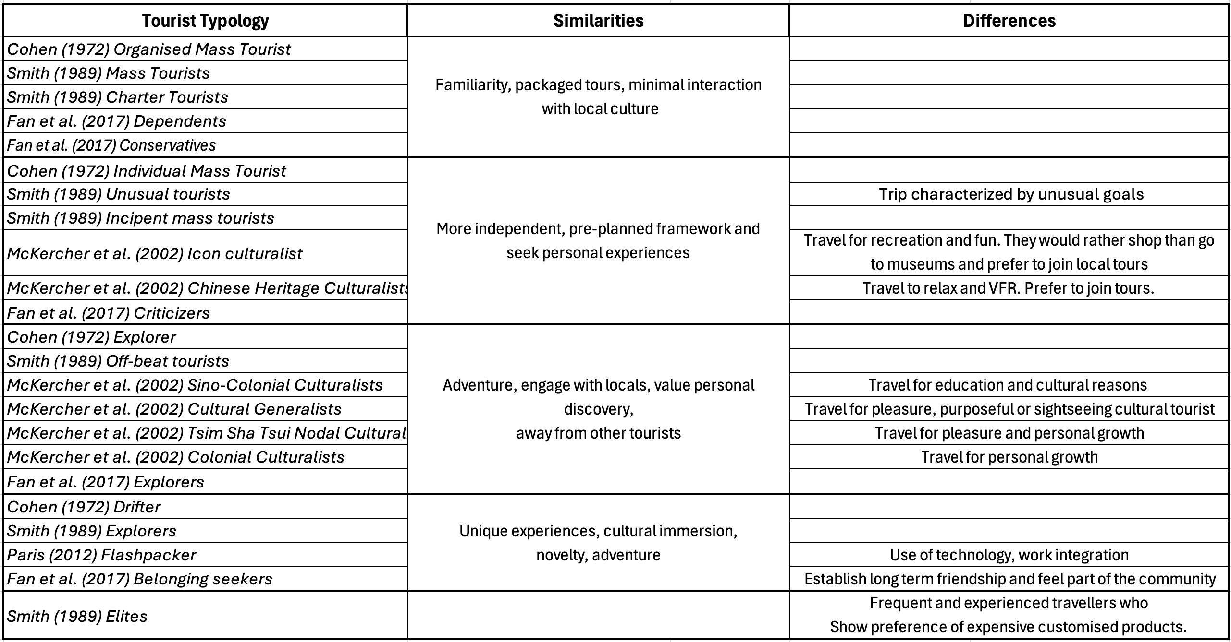

Table 2 - Mapping of characteristics of archetypes in personality-based typologies
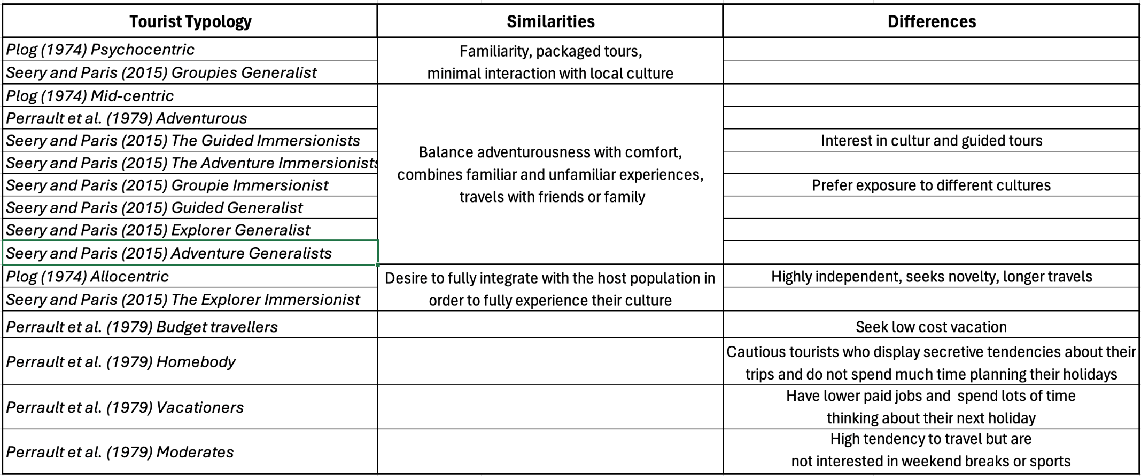

Table 3 - Mapping of characteristics of archetypes in motivation-based typologies
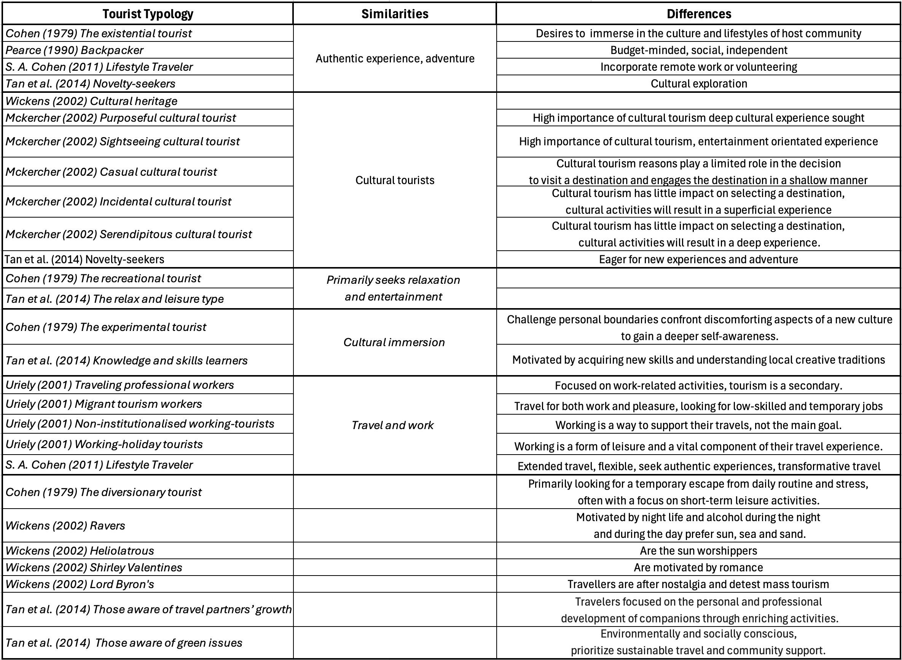

Digital Nomads
The term Digital Nomad came to light in 1997 with the publication of the homonymous book by Tsugio Makimoto and David Manners, which laid the foundations for this futuristic lifestyle movement (Thompson, 2018), which will be recognised as a significant social trend two decades later (Müller, 2016).
Digital nomadism is a lifestyle phenomenon characterised by individuals who work while travelling and travel while working (Cook, 2020; Hannonen, 2020; Thompson, 2018). The rapid growth of this mobility trend stems from advancements in wireless technology, improved transportation systems, greater work flexibility, and socio-political factors like globalization and increased international mobility (Benson & O’Reilly, 2009; Hannonen, 2020; Kozak et al., 2024; Müller, 2016; Richter & Richter, 2020). Compared to the original figure of nomads, who move from one place to another in search of a better life, often driven by needs such as access to resources and survival (Engebrigtsen, 2017), DNs have the freedom and flexibility to explore different destinations and immerse themselves in the local culture, while maintaining their remote employment (Chevtaeva & Denizci-Guillet, 2021). In an early paper, Pape (1964) introduced the term “touristry”, defining a type of travel in which the journey is more important than the destination and where young people seek personal development through cultural and work experiences. Since then, several scholars have addressed this concept by challenging the dichotomy between work and leisure, highlighting situations in which work and tourism activities are combined (Cohen, 1973; Unger et al., 2016; Uriely, 2001). Cohen (1973) suggested the term “working holidays”, referring to travellers who perform occasional and non-routine work during their trip, and Uriely (2001) presented four typologies of working travellers, “traveling professional workers” (business travellers), “migrant tourism workers”, “non-institutionalised working-tourists” and “working-holiday tourists”. While these categories touch on aspects of the DNs lifestyle, they fall short in several ways. For example, DNs have the freedom to choose their destinations and work activities, they engage more with local elements and tend to stay longer in a location compared to traditional business travellers.
Although digital nomadism is a relatively new phenomenon (Bozzi, 2024), academics have attempted to define them based on their motivation (Reichenberger, 2018; Schlagwein, 2018; Tiberius et al., 2024), behaviour (Cook, 2023), values (Chevtaeva & Denizci-Guillet, 2021) and characteristics (Nash et al., 2018), which are summarised in Table 4. The following table maps out key DNs typologies from existing literature, categorising them according to core motivations, characteristics, values, and behaviours. This visual framework helps contextualise how various DN types align or contrast with one another, offering insight into shared trends and unique distinctions. DNs aim to achieve an overall sense of freedom (spatial, professional, and personal) (Reichenberger, 2018), focusing on promoting personal growth, seeking authentic experiences, immersing in diverse cultures (Reichenberger, 2018; Schlagwein, 2018; Tiberius et al., 2024), and embracing adventure and exploration (Tiberius et al., 2024), all while being guided by economic considerations (Schlagwein, 2018). Nash et al. (2018) suggest that the concept of digital nomadism is a blend of digital work, gig work, nomadic work, and adventure and global travel, whilst Cook (2023) identifies five distinct types of DNs based on their behaviour: freelancers, business owners, salaried workers, experimental nomads, and armchair DNs. Chevtaeva & Denizci-Guillet (2021), instead, sought to define digital nomadism within the context of tourism and hospitality research, from the perspective of coworking spaces, focusing on their intrinsic values. This study highlights the potential for these spaces to attract DNs, and addresses the challenges faced by this group in fitting into traditional tourism frameworks, due to their long-term engagement, high mobility, and location-independent work, calling for a more institutional recognition of this unique travel type (Chevtaeva & Denizci-Guillet, 2021).
Their unique identity, compared to traditional tourist typologies, presents similarities, the engagement with tourism activities (Nash et al., 2018), the interest in exploring new cultures and the contribution to local economies (Reichenberger, 2018; Schlagwein, 2018; Tiberius et al., 2024), and divergences, the interrelation with work and travel (Cook, 2023), the prolonged stays, and the reliance on digital infrastructure and coworking spaces (Chevtaeva & Denizci-Guillet, 2021). Bozzi (2024) also adds that the identity of DNs is multifaceted, as they hold different views on the concept of home, with some opting to travel more frequently and other embracing slow travelling, allowing them to explore locations more deeply and to balance work and travel more effectively (Aroles et al., 2020). Furthermore, DNs select a destination based on warm climates, community and infrastructure presence (Lee et al., 2019), high-speed internet (Hong, 2023), lower cost of living (Mancinelli, 2020), and the availability of tourism-related and recreational activities (Bonneau & Aroles, 2021).
These features make their classification complicated and in need of further research, asking to what extent they align or diverge from existing tourist archetypes and how their core characteristics shape their existence.

Table 4 - Mapping of Digital Nomads Typologies
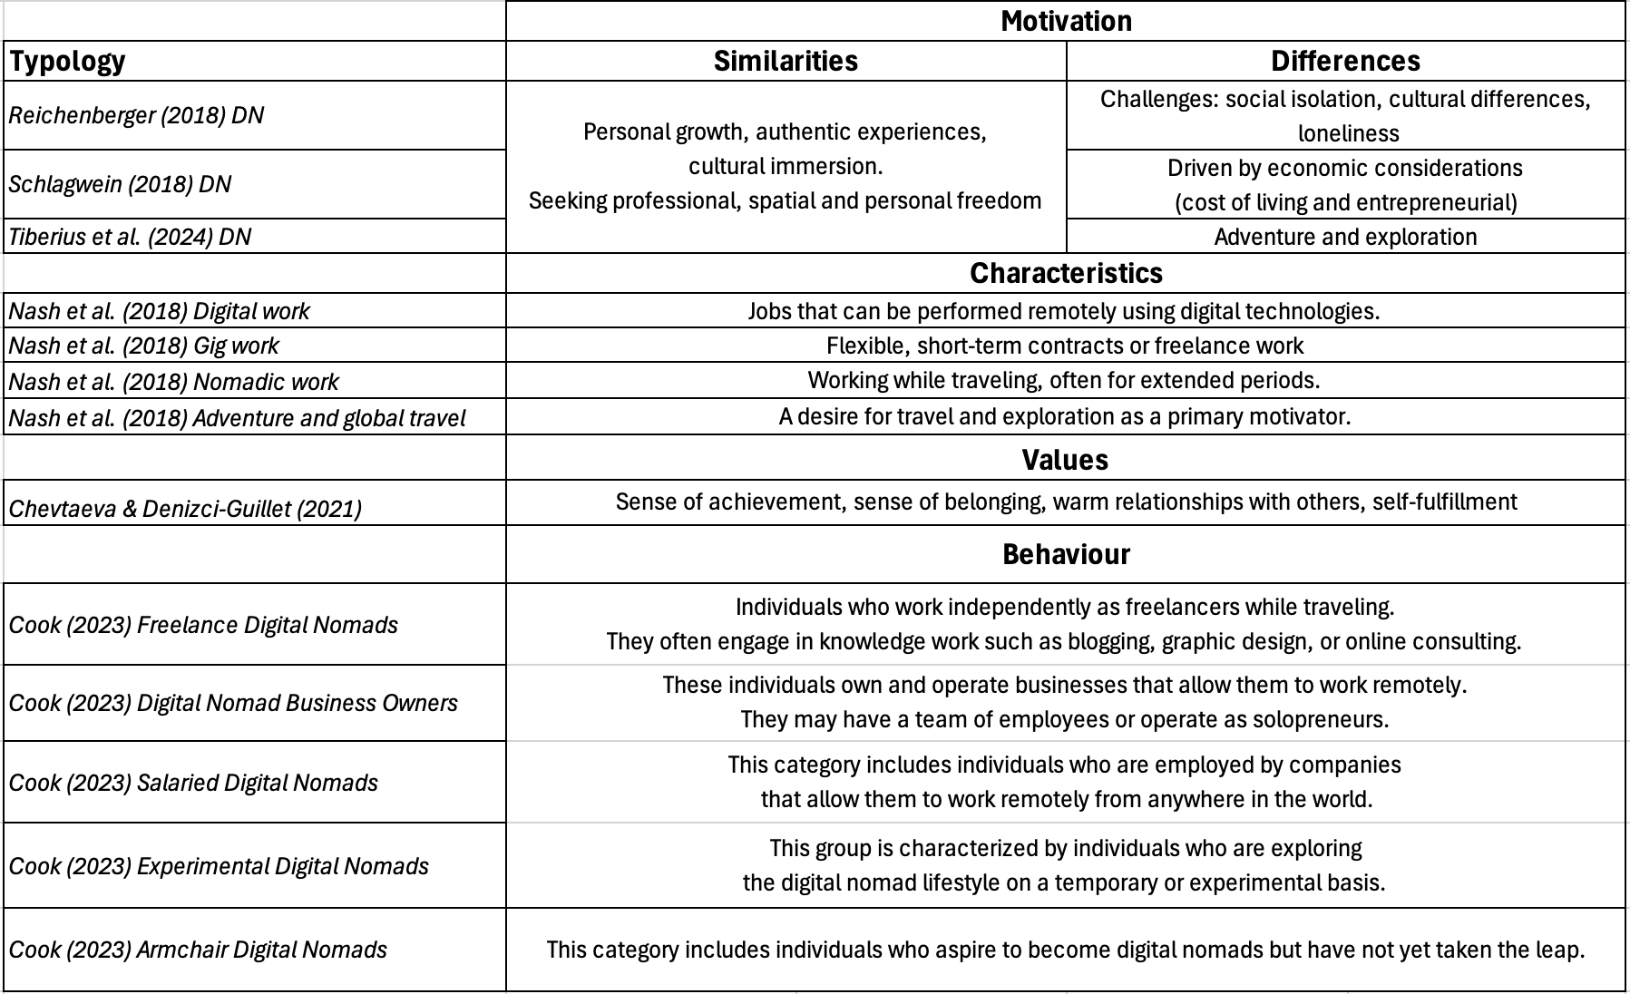

Chapter Summary
This chapter examined the evolution of tourist typologies based on behaviour, motivation, and personality, highlighting how newer models have added complexity through factors like cultural immersion and social interaction. It also explored changes in mobility patterns and concepts of home, particularly for travellers with long-term or tech-enabled lifestyles. Traditional frameworks often fall short in capturing the hybrid identity of DNs, who blur the lines between work, leisure, and mobility. Key elements like digital infrastructure, flexible work structures, and shifting notions of belonging are frequently overlooked. The chapter then reviewed recent attempts to define DNs through emerging taxonomies based on their motivations, behaviours, and values. However, their integration of remote work and travel continues to challenge existing models, highlighting the need for updated frameworks in tourism studies. This study addresses that gap by investigating how DNs align with or diverge from established tourist typologies.

Research Design

Research Philosophy
Mauthner (2020) asserts that research philosophies provide theories that help researchers understand the nature of the reality under investigation and the processes through which knowledge is generated and validated. Among the many philosophies, interpretivism and positivism will be discussed. Interpretivism is a research philosophy that focuses on understanding the subjective meanings and people's experiences, employing qualitative methods (Chowdhury, 2014), such as interviews, focus groups or observations to gather detailed information (Tenny et al., 2022). Positivism, on the contrary, assesses reality in an objective way and uses, but is not limited to, quantitative methods, such as surveys, statistical analysis or experiments, to collect and analyse data (Park et al., 2020). For this research, interpretivism research was more suitable for conceptualizing the phenomenon of DNs and understanding the intrinsic characteristics that distinguish them from other types of tourists, analysing their lives and how they experience the world. It also adopted subjective epistemology, delving into the individual's unique perspective, focusing on their thoughts, feelings and experiences (Ma & Ma, 2022).

Research Approach
Qualitative research explores and offers a deeper understanding of real-world issues (Busetto et al., 2020; Tenny et al., 2022). Rather than collecting numerical data and statistics like quantitative research, qualitative research gathers participants’ motivations, behaviours, and perceptions by focusing on their life experiences, which could help understand phenomena (Rynes & Gephart, 2004). Given the exploratory nature of this study and its aim to develop a deeper understanding of DNs’ behaviours, motivations, and personalities, a qualitative approach was most appropriate. Qualitative research is particularly suited to inductive or abductive reasoning and is commonly used in exploratory studies where the goal is to build theory based on lived experiences (Charmaz, 1996), making it well aligned with the objectives of this research from a tourism perspective.
Soiferman (2010), refers to two methods of reasoning while undertaking research, inductive, in which researchers collect data, analyse patterns, and then develop theories, and deductive, in which researchers start with a theory and then collect data to test it. Another approach is abductive reasoning, which begins with real-life observations, similar to inductive reasoning, but also incorporates existing theories (Dubois & Gadde, 2002; Kovács & Spens, 2005). It focuses on cases where observations contradict these theories, prompting a creative process called "theory matching" or "systematic combining" to develop new frameworks or extend existing ones (Dubois & Gadde, 2002; Kovács & Spens, 2005). Additionally, researchers can introduce new theories to reinterpret known phenomena promoting a deeper understanding and exploration of complex issues (Kovács & Spens, 2005). This study adopted an abductive reasoning to conceptualize the DNs phenomenon, which allowed to explore unexpected findings, develop a new theoretical framework, and generate hypotheses for further investigation into this evolving lifestyle.
Furthermore, research can be exploratory, to explore a topic or phenomenon that is not well-understood (Hunter et al., 2019), explanatory, to explain the causes and effects of a particular phenomenon (Priya, 2020), or descriptive, to describe a particular phenomenon or population (Koh & Owen, 2000). Hunter et al. (2019) argue that exploratory research is useful for understanding underdeveloped phenomena, with limited existing research, by allowing participants to contribute to new knowledge. For this reason, this research took an exploratory approach, exploring the phenomenon of DNs from a point of view that has not yet been addressed academically, that is, finding a position for DNs in existing tourism typologies.

Method of data collections
Qualitative research can be accomplished through interviews, focus groups (usually 6-8 participants), or observations (Busetto et al., 2020). Online interviews were the most influential research method for this dissertation, as participants were spread across various locations, in different time zones and had different schedules, which made it challenging to organize focus groups, observations or in-person interviews.
The most common types of interviews are structured, semi-structured or unstructured (Adhabi & Anozie, 2017; DiCicco-Bloom & Crabtree, 2006; Edwards & Holland, 2013; Gill et al., 2008). Briefly, interview formats can be categorized as structured, with a fixed set of questions and little flexibility, unstructured, where the interviewer adapts questions based on responses for a more open discussion, and semi-structured, which combines predetermined questions with open-ended follow-ups to explore specific areas of interest (Edwards & Holland, 2013). This research employed semi-structured interviews that enabled participants to answer questions (see Appendix 1) and express their thoughts and emotions to build a richer argument based on their life experiences. They assisted in examining the DN’s characteristics and in developing their conceptualisation, allowing the researcher greater flexibility and range across topics, bringing out original notions (Edwards & Holland, 2013). Semi-structured interviews also enabled unanticipated but relevant themes to emerge, enriching the depth and authenticity of the findings (DiCicco-Bloom & Crabtree, 2006). The online interviews were conducted via Microsoft Teams, recorded and transcribed (see Appendix 2) to facilitate the data analysis process.

Sampling approach
The participants for this study were thirteen DNs, with different backgrounds and nationalities, from the author’s network and dedicated Facebook and LinkedIn groups. A post was shared on these platforms to invite eligible individuals to participate in the research (see Appendix 3). The number of interviews was in line with the concept of theoretical saturation (Low, 2019) and determined by the time constraints for the completion of the project, leaving enough time for data analysis and writing of the dissertation. Theoretical saturation, as explained by Low (2019), occurs when data collection and analysis have reached a point where no new themes or insights emerge, and the developed theory is robust and comprehensive. The participants were selected using purposive sampling, with clear inclusion criteria to ensure relevance to the research aims. Individuals were eligible if they self-identified as DNs and could demonstrate a lifestyle that combined remote work and travel. Additional criteria required engagement in tourism-related activities and a minimum stay of one month at each destination, thereby excluding short-term travellers and remote workers without nomadic mobility. To expand the sample, snowball sampling (Ilker et al., 2015) was also employed by asking participants to recommend others who fit these criteria.

Participant Recruitment
The initial recruitment took place via dedicated DN communities on Facebook and LinkedIn. A post was shared outlining the purpose of the study and the desired participant profile. Interested individuals either commented publicly or contacted the researcher directly through private messages on Messenger or LinkedIn. Once initial contact was made, communication moved to email for further clarification, sharing of the participant information sheet, consent form, and arranging interview logistics. Microsoft Teams was used for the interviews, with invitations and reminders also sent via email. This process enabled efficient coordination and allowed participants to engage at their convenience, regardless of their location or time zone.

Method of analysis
In qualitative research, data analysis involves organizing interview transcripts through coding and categorizing to reveal patterns and derive meaningful insights (Lester et al., 2020; Wong, 2008). There are various methods for analysing data. For example, thematic analysis is designed to examine broader themes and patterns connected to an event or phenomenon (Lester et al., 2020), whereas a grounded theory approach to analysis seeks to generate concepts and categories directly from the data itself through iterative coding and comparison (Charmaz, 1996; Glaser & Strauss, 2017; Lester et al., 2020; Tarozzi, 2020). While grounded theory is a full methodological framework, this study adopts its analytical principles to guide coding and theory development around behaviours, motivations and personalities of DNs.
It assisted in recognising recurring patterns within qualitative data, including familiarising with the data, coding it, and generating categories and themes to comprehend participants’ experiences, behaviours, and beliefs (Lester et al., 2020). The data were analysed using a qualitative research software, MAXQDA. Open coding was first applied to identify key concepts in participants’ responses (see Appendix 4), followed by axial coding to group related codes and explore connections between them (see Appendix 5). This process led to different themes related to motivations, mobility patterns, work–leisure integration, social and cultural engagement, economic considerations, and the concept of home. These themes informed the development of a proposed typology, offering a structured understanding of the DN lifestyle.

Ethics
Ethical considerations must be considered when conducting qualitative research to ensure participants’ well-being and findings validity (Mirza et al., 2023). This research adhered to Edinburgh Napier University’s guidelines in the “Code of Practice on Research Integrity” (Barkess & Ramage, 2022), as documented in the Research Integrity form (see Appendix 6). Notably, the research paid special attention to the participants, who participated voluntarily and signed the consent form (see Appendix 7). Their privacy was protected by maintaining anonymity and keeping the information confidential. The researcher was also honest and precise during the collection and analysis of data, transparent and treated the participants impartially. During the research, sensitive topics arose, such as loneliness and emotional challenges associated with prolonged mobility and disconnection from familiar support networks, all of which were approached with empathy and respect. The author ensured that participants understood the risks and benefits associated with the research and that they had the right to withdraw at any time during the process. While this option was clearly communicated, none of the participants chose to withdraw. Considering all these ethical aspects, the participants were protected, and the research contributed to knowledge and benefit society.

Chapter Summary
This chapter outlined the research philosophy and approach used to explore the DNs lifestyle. Data were collected through semi-structured online interviews with thirteen DNs, selected via purposive and snowball sampling. The interviews were then analysed using a grounded theory approach, with open and axial coding supported by MAXQDA, leading to the identification of key themes. Ethical standards were adhered to throughout the research process.

Analysis of Core Themes and Patterns
This chapter presents the core themes and patterns that emerged from the analysis of DNs interviews. By applying a grounded theory approach and coding the raw data, key dimensions that capture the complex nature of DNs were identified. These dimensions include motivational drivers, mobility patterns, cultural engagement, work–leisure integration, and the concept of home.

Motivations
Understanding what drives individuals to pursue a DN lifestyle is key to interpreting their patterns of mobility, work, leisure and identity. The interviews revealed several recurring motivations: a desire to break free from conventional routines, the pursuit of freedom and flexibility, a passion for cultural immersion, and the intention to build lasting connections. The following section explores these themes, illustrating how personal goals and values shape the DN experience.
One of the most widely shared motivations was freedom and a strong need to break free from the constraints of conventional routines and traditional office jobs, as illustrated in the following quotes:
“The main reason was freedom […] freedom from the 9-to-5 routine, freedom to explore Europe, and freedom to choose when and how to work.” (Participant 12)
“The thought of being confined to one city, paying the rent, and having limited travel opportunities didn’t sit well with me.” (Participant 7)
This attitude reflects a fundamental rejection of traditional living and propels individuals toward a life of flexibility and adventure. Many also emphasised the pursuit of authenticity and personal reinvention, as shown in the following quote:
“I wanted more flexibility and the chance to live life on my own terms […] and digital nomadism offered me a way to combine work, personal growth, and travel.” (Participant 12)
These insights strongly reflect the drifter archetype proposed by Cohen (1972), which is characterised by a relentless quest for novelty and a desire to escape standard social constraints. They also align with the allocentric type described by Plog (1974), where individuals actively seek diverse and unfamiliar experiences.
Another common theme among participants was the importance of freedom and flexibility in choosing where to live and work. This is demonstrated in the quotes that follow:
“We wanted to relocate somewhere that better suited our lifestyle and values […] and to provide an international, diverse experience for our children.” (Participant 5)
Finally, a frequent theme was the importance of deep cultural immersion and fostering lasting bonds within each destination, as illustrated in the subsequent quote:
“I stay in one place for several months to get to know the area, and that allows me to build a deeper connection.” (Participant 10)
The focus on exploration and level of engagement resonates with McKercher’s (2002) examination of cultural tourists who seek immersive and authentic engagements with their environments. Moreover, it shares similarities with the concept of “Lifestyle Traveller” introduced by Cohen (2011), where individuals embody a dynamic journey that blends personal transformation with cultural enrichment.
These perspectives reveal that digital nomadism is a lifestyle driven by a profound desire to redefine work, home, and identity through continuous exploration and self-reinvention. This aligns with existing literature that positions DNs as individuals seeking autonomy, authenticity, and personal growth (Reichenberger, 2018; Tiberius et al., 2024). However, the findings here extend these understandings by showing how their life transformation is an ongoing process embedded in daily decision-making, where destination choices, work routines, and social connections are all consciously shaped to support a reimagined way of living.

Mobility Patterns
Examining mobility patterns is essential for understanding how DNs organise their lifestyles and engage with the places they inhabit. The interviews revealed a range of mobility strategies, from fast-paced and continuous movement to slow and immersive stays in specific cultures. Others followed seasonal cycles, aligning travel with weather or local events, while some maintained a fixed base and travelled periodically to satisfy their desire for novelty and inspiration. The following section explores these diverse patterns and how they influence identity, place attachment, and the overall DN experience. Some DNs embrace fast travel as a core aspect of their lifestyle, allowing them to sample a variety of cultures quickly, as shown in the subsequent quotes:
“I’m always on the move […] if a place doesn’t feel right, I’m off to the next adventure.” (Participant 4)
“I usually stay in one place around two months […] then I’m ready for change.” (Participant 2)
This perspective aligns with Pearce’s (1990) notion of the backpacker and Cohen’s (2011) concept of the Lifestyle Traveller, albeit without a specific timeframe for each stay. However, these DNs integrate remote work into their travel rhythm, allowing them to maintain mobility without pausing their careers. A unique feature that blends professional continuity with a fast-moving lifestyle.
The pattern around seasonal changes and environmental factors was less commonly cited but still present among several participants. This is highlighted in the quote provided below:
“Our choices are influenced by weather conditions […] we prefer warm climates in winter and cooler places in summer.” (Participant 11)
This insight illustrates how some DNs strategically align their mobility with seasonal preferences, using environmental conditions as a guide for planning their movements. While not universal, this approach shows a deliberate and cyclical rhythm to travel, where comfort, productivity, and lifestyle preferences are shaped by natural patterns throughout the year.
Another pattern shared by a few DNs was the preference to maintain a fixed base while retaining the freedom to travel, as shown in the following quotes:
“We’ve been living in Thailand for several years now, which gives us the stability we need, though we still take occasional trips for work or to explore new places.” (Participant 5)
“We’ve built a life here […] our daughter goes to school, we have routines. But every so often, we take a short break to travel, just to reset.” (Participant 6)
This statement underscores the advantage of having a stable, fixed base supporting long-term living while accommodating the desire for periodic travel. It highlights how some DNs prioritise continuity, routine, and a strong sense of place, often for family, work, or well-being, while still retaining the flexibility to break away occasionally. These short trips offer a mental reset and a creative recharge without disrupting the core structure of their daily lives. While this may resemble traditional lifestyle patterns, it differs in its intentional flexibility. Mobility is not a break from routine but part of a self-guided rhythm, reflecting a reconfiguration of lifestyle that blends structure with autonomy.
Similarly, other participants expressed an attachment to a base but positioned travel as more central to their identity, not as an occasional break but as a consistent and deliberate rhythm. The quotes that follow further exemplify this:
“I have a base in Bali, but I regularly travel for a few weeks at a time […] it keeps life interesting” (Participant 8)
“I feel anchored in Athens, but I make it a point to go somewhere new every few months. It helps me stay creative and refreshed.” (Participant 3)
These reflections highlight that rootedness and movement can coexist, supporting a balanced lifestyle. A steady base offers structure and consistency, while systematic travel brings variety, creativity, and renewal. This pattern exemplifies how DNs actively shape a hybrid lifestyle that blends the security of a home base with the energising effect of intentional mobility. These findings illustrate that mobility among DNs is not uniform but instead represents a difficult balance between the desire for constant novelty and the need for stability and deeper connections.

Social and Cultural Engagement
Understanding how DNs engage with the social and cultural environments of their host destinations is key to interpreting the depth of their mobility. Such engagement shapes their experience of place, identity, and community. The findings reveal a spectrum, from brief, surface-level encounters to deeper, seasonal or long-term integration. While some nomads move quickly through destinations, others immerse themselves in local life, forming relationships and participating in community activities. This section explores these varied patterns and what influences the extent of their connection to place. Some DNs experience multiple cultural snapshots without the commitment of long-term immersion, keeping their travel dynamic and ever-changing. This is demonstrated in the quote that appears next:
“I love jumping into different cultural settings, each place offers a burst of colour and history, even if it’s just for a short time.” (Participant 2)
This pattern closely resembles the behaviour of Flashpackers (Paris, 2012), who also seek flexible, experience-rich travel with a preference for comfort, connectivity, and mobility. Like Flashpackers, these DNs combine adventure with digital tools and infrastructure that support a fast-paced, curated travel experience, prioritising novelty over deep cultural engagement. On the other hand, some DNs seek to form deeper connections with the communities they visit, as shown in this quote:
“For me, building lasting bonds is essential. I’m involved in local school activities and community groups because I want to be a part of this place.” (Participant 6)
Such a strategy of deep local integration enables these DNs to foster a sense of belonging and contribute meaningfully to their host communities, even if their stay is temporary. This approach closely aligns with Fan et al.’s (2017) typology of the “belonging seeker”, a tourist motivated by the desire to establish long-term friendships, immerse in local culture, and feel part of a community. These individuals are drawn to novel and authentic experiences aiming to develop a lived connection with the place. Similarly, their behaviour resonates with McKercher’s (2002) concept of the “purposeful cultural tourist”, who places high importance on cultural engagement and actively seeks deep, meaningful experiences rather than passive consumption. For these nomads, travel is not merely an escape or leisure pursuit but a transformative and participatory process.
Seasonal opportunities offer a rich context for experiencing authentic local traditions and celebrations, and these DNs seek seasonal opportunities that allow them to connect deeply with the rhythm of the communities they visit. This is exemplified in the subsequent quote:
“I always try to time my trips with local festivals or events. It’s the best way to feel the seasonal vibe of a community.” (Participant 11)
These DNs exhibit patterns of cyclical movement, aligning their travel with seasonal changes, climate preferences, or local events. While other tourists may also plan trips around festivals or seasonal attractions, these nomads differ in that they blend such experiences with remote work and extended stays. Their mobility is not just about visiting at the right time but about temporarily embedding themselves in a place, allowing for cultural participation and sustained professional activity.
Furthermore, cultivating lasting cultural bonds through extended engagement became a frequent theme. This concept is highlighted in the quote that follows:
“I don’t just pass through a place […] I take the time to live it. I learn the language, participate in local traditions, and participate in community projects. That deep immersion allows me to build genuine, lasting connections.” (Participant 1)
This reflection illustrates a deliberate effort to move beyond surface-level cultural encounters, embracing prolonged stays and active participation in local life. By immersing themselves in the everyday rhythms of their host communities through language learning, local traditions, and community involvement, these DNs foster meaningful relationships at the destination. Others pointed out the importance of balancing local connection with continued exploration, as observed in the quote below:
“I connect regularly with local friends, and I also plan trips that let me experience new cultural scenes.” (Participant 8)
This hybrid approach reflects what Reichenberger (2018) and Mancinelli (2020) describe as a fluid form of mobility, where DNs consciously merge elements of tourism, work, and residence into a single, flexible way of living, distinct from traditional tourist or expat models.
Overall, these insights align with McKercher et al. (2002), who argued that the depth of cultural interaction significantly shapes how travellers experience place and construct their identity. In the case of DNs, those who engage in sustained cultural immersion through language learning, community involvement, and long-term relationships are not merely adapting to a new environment but actively reshaping their sense of self in relation to place. Identity becomes increasingly fluid and situational, informed by repeated experiences of belonging and participation across diverse cultural contexts. This suggests that cultural integration is not just about external engagement but also about internal transformation, as DNs negotiate who they are in response to where they are and how deeply they connect. Additionally, they reflect Chevtaeva & Denizci-Guillet’s (2021) observation that DNs often alternate between brief cultural experiences and more substantial community involvement, depending on their personal goals and flexibility. These suggest that DNs have a personalised approach to cultural engagement, ranging from quick, curiosity-driven encounters to intentional, long-term integration within local communities.

Work and Leisure Integration
Understanding how DNs integrate work and leisure is key to exploring the sustainability and appeal of their mobile lifestyles. Unlike traditional travel or remote work models, digital nomadism requires constant negotiation between professional productivity and the desire for exploration and personal enrichment. The findings reveal various patterns: some nomads structure work in short, intense bursts followed by extended leisure, others build daily routines that balance both, and some align their workload with seasonal rhythms or specific travel goals. This section explores these varied strategies and how they shape the practical aspects of mobility and broader experiences of autonomy, fulfilment, and identity.
Participants often illustrated how leisure precedes how they organise their time, with work deliberately arranged around opportunities for exploration. This can be seen in the quotes that follow:
“I structure my work around my adventures. Some days I’m in deep focus, and other days I take the day off to wander, it all feeds into my creativity.” (Participant 12)
“Work funds the travel, but it’s the leisure moments, morning walks, hikes, local meals, that keep me inspired.” (Participant 13)
Rather than balancing the two equally, these approaches suggest that leisure is the central pillar of the lifestyle, with professional tasks adjusted to accommodate and complement personal experiences. In this case, creativity and productivity are sustained not by rigid scheduling but by allowing inspiration to emerge through exploration. This is supported by Cook (2020) and Nash et al. (2018), who found that DNs often prioritise travel and exploration, shaping their professional routines around these experiences rather than conforming to conventional work structures. Furthermore, they share similarities with Reichenberger’s (2018) argument that integrating personal and professional life is central to the nomadic identity, with leisure as a catalyst for innovative thinking.
Another typical pattern among participants was the intentional blending of routine work with meaningful leisure and cultural engagement. This is evident in the following quotes:
“I have a reliable home office where I work every day, but I always take few months every year to travel [...] The routine and regular escapes give me a constant flow of fresh ideas.” (Participant 9)
“I build a daily routine that lets me work while dedicating significant time to immerse myself in local traditions. It’s this balance that fuels my creativity during long stays.” (Participant 10)
These accounts illustrate how some DNs create structure not to restrict freedom but to support a sustainable rhythm that enables productivity and personal growth.
A less dominant theme in the data related to how some DNs align their work patterns with local cultural rhythms and seasonal shifts, as shown below:
“I usually take on more work in the off-season when it’s quieter, then relax when festivals or cultural events are happening. That way, I get the best of both worlds.” (Participant 7)
This quote illustrates a strategic approach to work and leisure integration, where productivity is maximised during quieter periods, allowing for greater freedom and engagement during culturally rich times. While not widely expressed among participants, this approach reflects a deeper awareness of place and seasonality, blending professional efficiency with meaningful cultural participation.
A less common finding was the adoption of a highly flexible daily routine that prioritises exploration alongside minimal but focused working hours, as illustrated in the following quote
“I usually work for about three hours a day, and then I spend the rest of my day exploring, whether it’s relaxing on the beach, trying out local cuisine, or chatting with new friends. This balance keeps me productive and inspired.” (Participant 2)
This approach reflects a lifestyle where work is deliberately limited to allow for a more immersive and leisure-driven experience. Blending work and leisure for DNs is more than a time management strategy. It’s a core part of a lifestyle where structured work and spontaneous exploration support each other, leading to ongoing productivity and creativity.
These patterns align with existing literature (Cook, 2020; Nash et al., 2018; Orel, 2019; Reichenberger, 2018), highlighting how DNs intentionally blur the boundaries between work and leisure to support personal fulfilment and flexibility. However, what appears more distinct here is the extent to which mobility, leisure and cultural immersion are consciously integrated into their professional routines, making exploration an active component of their working life rather than a break from it.

Concept of Home
Understanding the concept of home is key to exploring how DNs relate to place, routine, and identity. Rather than a single fixed location, home is often shaped by movement, emotional connection, or personal routine. The findings reveal different patterns: home as a stable base, as a fluid and ever-changing idea, or as a balance between both. This section explores how DNs define and experience home in diverse and dynamic ways. Home as a fluid concept was frequently mentioned in the interviews, and it is captured in the following quotes:
“For me, home is wherever I feel drawn to next. I don’t have a fixed definition […] it’s more about where I feel at peace.” (Participant 2)
Her words emphasise that home can be an ever-changing destination, shaped by the emotions and experiences of each new environment. This idea is echoed in another participant’s reference to a song lyric:
“I have a harmless habit of being fine wherever I am.” (Participant 13, referencing Jason Boland & The Stragglers – Comal County Blue)
This lyrical reference reflects a sense of adaptability and emotional resilience, suggesting that, for some DNs, home is not tied to place but to a mindset of contentment and flexibility. A common finding throughout the interviews is that DNs embrace the fluidity of home, discovering comfort and stability within themselves rather than relying on their physical environment.
Another frequently cited theme was the concept of home found in local relationships and networks, as illustrated below:
“I’ve built a network of friends and colleagues here in Athens that makes me feel at home, even if I’m not there all the time. It’s not about the house, it’s about the people and community you create.” (Participant 3)
This quote reflects a relational understanding of home, where the sense of belonging is rooted not in physical space but in meaningful social connections. The mention of Athens as a place that "feels like home", despite not always being physically present, reinforces the idea that emotional ties and social bonds can anchor a sense of home across time and space. This aligns with transnational understandings of home (Ralph & Staeheli, 2011), where place attachment is shaped by relationships and community rather than fixed location.
Further adding to this complexity, one participant compared his sense of home to:
“A collage of memories and emotions […] a collection of moments where I’ve felt both joy and sorrow, even though I never settle permanently.” (Participant 10)
This poetic reflection underscores the gradual, cumulative process through which “home” is built over time, shaped not by permanence or routine but by affective ties, lived moments, and personal transformation.
A less common perspective on the concept of home, expressed by a few participants, reflected a more rooted understanding, as illustrated in the following quote:
“Home is where my family is and where I feel a real sense of belonging.” (Participant 6)
This sentiment aligns with traditional notions of place attachment, where stability and enduring relationships form the core of home (Moran-Taylor & Menjívar, 2005; Philipp & Ho, 2010). These diverse viewpoints illustrate that the concept of home among DNs is a blend of stability and fluidity, challenging traditional definitions of home.

Chapter Summary
This chapter presented the core themes and patterns that emerged from the interviews with DNs. It explored five key dimensions: motivations, mobility patterns, social and cultural engagement, work–leisure integration, and the concept of home. The findings revealed a variety of strategies, driven by a desire for freedom, cultural immersion, flexibility, and personal growth. DNs actively shape their identities and routines through conscious choices about where they live, how they work, and how they engage with local environments. These themes provide a foundation for a potential DN typology.

Presentation of the Proposed Typology

Overview of the Typology
The proposed typology classifies DNs based on interconnected patterns observed in the data, where specific motivational drivers were consistently linked with particular mobility patterns, behaviours, forms of social and cultural engagement, approaches to work and leisure integration, and concepts of home. The typology reflects how they interact to shape distinct DNs types, emerging organically through recurring combinations across participants’ narratives. It identifies five different types: (1) Flash Nomad, (2) Cultural Immersive Nomad, (3) Seasonal Nomad, (4) Settled Sojourner, and (5) Rooted Roamer (Table 5).

Table 5 - Digital Nomads Proposed Typology
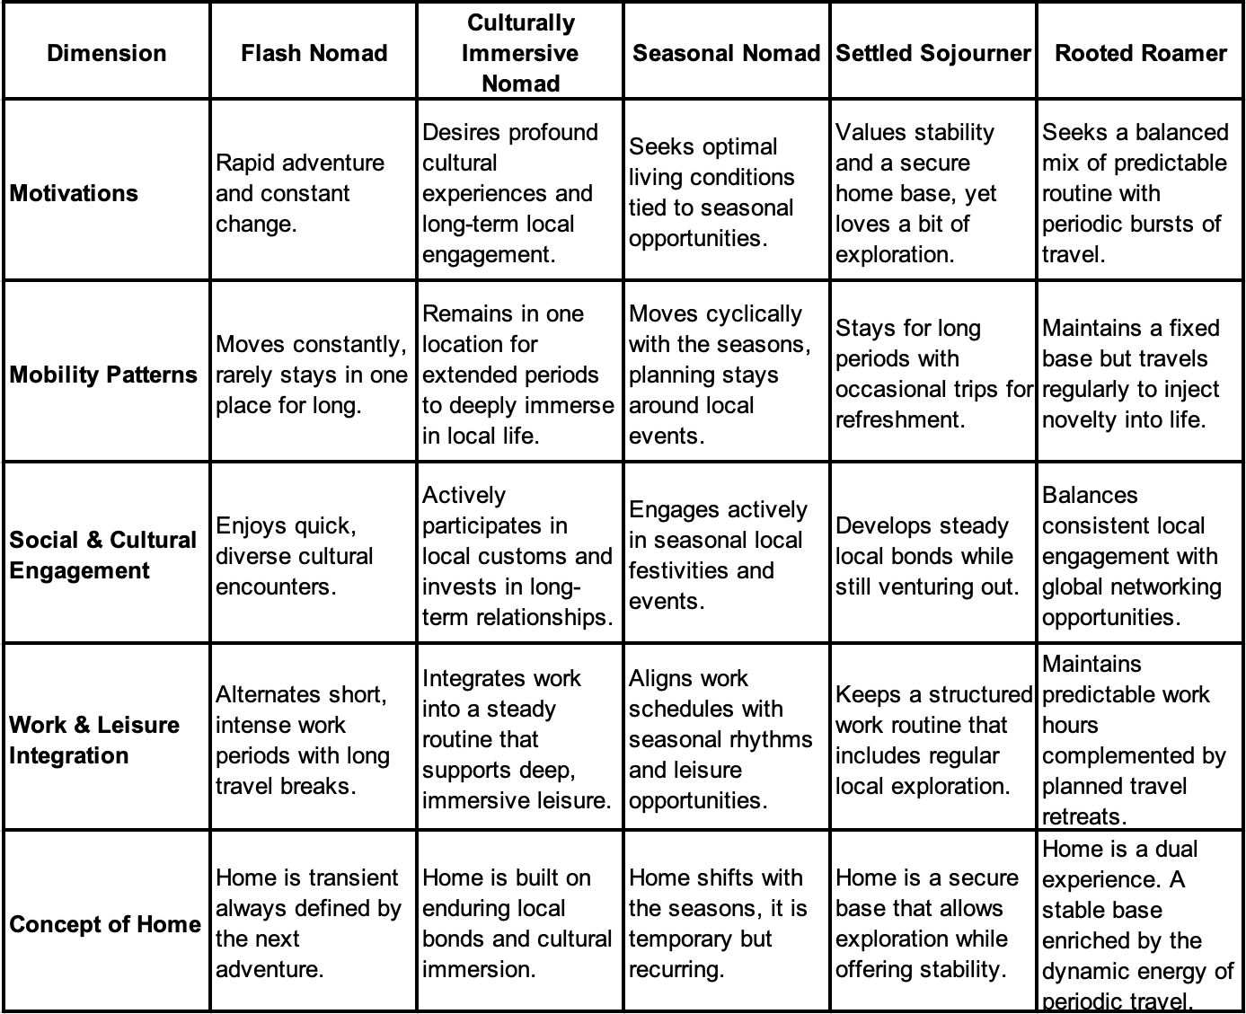

Detailed Typology

Flash Nomads
Flash Nomads represent constant movement and an insatiable appetite for rapid adventure. These DNs thrive on quick cultural encounters and an ever-changing environment. Their lifestyles are marked by short, intense work bursts combined with extended periods of travel. For them, the idea of “home” is transient and always defined by what comes next. The thrill of new experiences drives this type of DN, and they prefer to sample diverse settings rather than settle down for prolonged periods. Their work routines are flexible enough to be executed anywhere, allowing them to take advantage of spontaneous opportunities. Their hyper-mobility is justified by the temptation of quick discoveries that fuel their creativity and personal growth but can hinder the chance to form lasting local relationships. Their approach aligns with a mindset that values novelty over permanence and is supported by a digital infrastructure that ensures they remain connected, no matter how short their stay at a given destination.

Culturally Immersive Nomads
Culturally Immersive Nomads are distinguished by their commitment to staying in one place for extended periods to develop deep, meaningful connections with local cultures. They deliberately slow the pace of their travel, choosing quality over quantity in their cultural encounters. Their work is integrated into a steady routine that supports immersive leisure, allowing them to learn the language, participate in community events, and develop long-term relationships with locals. For these nomads, the concept of home evolves gradually, built on enduring bonds and a thorough understanding of the local way of life. Their temporary location is a learning ground where professional productivity and cultural engagement coexist. This approach deepens their sense of belonging and enhances personal growth and self-awareness. While their mobility is lower than other DNs, their strong local connections create a strong identity. Engaging deeply in one place challenges the idea that digital nomadism must involve constant movement, showing that meaningful cultural integration can be a valuable and enriching way to experience the nomadic lifestyle.

Seasonal Nomads
Seasonal Nomads plan their travel in close harmony with nature’s rhythms and the cultural calendar of their destinations. They are characterised by a deliberate, cyclic pattern of movement that aligns with favourable weather conditions, local festivals, and environmental opportunities. These DNs choose destinations based on optimal living conditions during specific times of the year, creating a predictable and seasonal lifestyle. Their work schedules are adapted around these seasonal patterns, enabling them to engage in local festivities and focus on work during off-peak periods. For Seasonal Nomads, the concept of home is temporary and fluid, shifting with the cycles of nature defined by the season. This cyclic approach encourages unique cultural and social engagements as they participate in seasonal events that enrich their understanding of local customs.

Settled Sojourners
Settled Sojourners reflect a lifestyle grounded in long-term stability, with exploration as a secondary, occasional feature. These DNs establish a secure and consistent home base, providing the structure needed to maintain predictable work routines, local relationships, and a strong daily rhythm. Economic factors such as affordability and quality of life play an important role in choosing their base, as it is not only a living space but a foundation for personal and professional well-being. While they remain open to new experiences, travel is typically viewed as a short-term escape to refresh perspectives rather than define their identity. Trips are generally infrequent and short, often planned around holidays or brief leisure opportunities. Their concept of home is closely tied to routine, familiarity, and local social networks, reinforcing a sense of belonging within one consistent place. In this way, Settled Sojourners embody a stable, rooted lifestyle with occasional outward movement that adds variation without disrupting their core structure.

Rooted Roamers
Rooted Roamers similarly maintain a fixed base, valuing its continuity and security for professional stability and personal grounding. However, unlike Settled Sojourners, they integrate mobility more systematically and deliberately into their routines. Travel is not just an occasional escape but a central element of their lifestyle, planned regularly to bring inspiration, creativity, and balance. These individuals structure their work schedules to accommodate frequent travel, making room for extended stays in new locations without compromising their commitments at home. For Rooted Roamers, the concept of home is dual, it encompasses both the familiarity of their base and the sense of renewal that comes with exploration. Their identity is shaped by a pattern of going back and forth between their home base and new places, where routine gives them structure and travel keeps them motivated and refreshed. While they share the Settled Sojourner’s appreciation for stability, Rooted Roamers emphasise movement as a defining and continuous feature of their lifestyle.
It is crucial, however, to acknowledge the significant overlap between these two types, and further research would be valuable to determine whether Settled Sojourners and Rooted Roamers represent distinctly separate categories or subtle variations within a broader lifestyle that balances stability with periodic mobility.

Universal Characteristics
While each type exhibits unique characteristics, several universal themes emerged in the interviews. First, all kinds rely on robust digital infrastructure and affordable, accessible services to sustain their work and travel lifestyles, a finding consistent with previous research (Chevtaeva & Denizci-Guillet, 2021; Hong, 2023; Lee et al., 2019). The following quotes provide insight into this:
“I need a fast internet connection […] the practical tools I need are available almost everywhere.” (Participant, 7)
“I look for good internet and coworking spaces, because without it I can’t work effectively.” (Participant, 8)
“Wi-Fi speed is essential […] without reliable internet, I simply cannot stay.” (Participant, 13)
Second, financial and economic considerations, such as cost of living and income stability, consistently influence destination choices, as Mancinelli (2020) and Schlagwein (2018) observed. The following examples further illustrate this:
“I always balance the excitement of new places with their affordability, ensuring I can maintain a healthy budget.” (Participant 4)
“Singapore’s cost of living was restrictive, and I felt that I wasn’t able to save or enjoy life the way I wanted. Moving to Bali allowed me to reduce expenses while exploring the world.” (Participant 8)
Even if motivations differ, every DN must balance the financial aspects of mobility with their personal and professional goals.
Finally, adaptation and coping strategies, such as building local networks or maintaining flexible routines, are common across all types, as captured in the excerpts below:
“Cultural differences can be challenging […] adjusting to local norms requires patience and openness, but it’s never easy.” (Participant 1)
“It’s easy to isolate yourself, to accept solitude as normal, and to fall into depression. Staying connected with friends and community online helps immensely.” (Participant 10)
“Loneliness has been a real challenge […] it is hard to relate to friends back home. Connecting with other DNs helps me overcome this.” (Participant 13)
These strategies help DNs manage challenges like loneliness (Chevtaeva & Denizci-Guillet, 2021; Lee et al., 2019), cultural adjustment, and the pressures of constant change. These universal aspects reveal that while DNs differ in their approaches to mobility, social engagement, work and leisure balance, and the concept of home, they all share a foundational reliance on practical enablers and adaptive strategies. This common foundation sustains their lifestyle and provides a basis for future research into the evolving nature of digital nomadism.

Chapter Summary
This chapter introduced the proposed typology of DNs, identifying Flash Nomads, Cultural Immersive Nomads, Seasonal Nomads, Settled Sojourners, and Rooted Roamers. Each type reflects unique motivations, configurations of mobility, cultural engagement, work–leisure integration, and concepts of home. In addition, the chapter also outlined several universal characteristics shared across all types, including the need for digital infrastructure, cost-of-living considerations, and coping strategies for challenges such as isolation and adaptation. Together, these insights provide a more nuanced understanding of the diversity within digital nomadism while highlighting common threads.

Discussion and Comparison with Existing Literature
This section will compare the proposed typology to existing tourist and DNs typologies to highlight similarities and differences.

Comparison with Existing Typologies
This chapter discusses how the proposed DN typology compares to existing classifications within traditional tourism literature. While several overlaps emerged, the findings here also reveal important distinctions that reflect the evolving nature of mobility, work, and identity in digitally connected lifestyles. Flash Nomads align with novelty-seeking types such as Cohen’s (1972) “Drifter”, Plog’s (1974) “Allocentric Tourist”, and Paris’s (2012) “Flashpacker”. Culturally Immersive Nomads reflect deeper engagement, echoing Cohen’s (2011) “Lifestyle Traveler” and McKercher’s (2002) “Purposeful Cultural Tourist”. Seasonal Nomads resemble Cohen’s (1972) “Individual Mass Tourist”, combining independence with structured plans. Settled Sojourners show parallels with Perrault et al.’s (1979) “Homebody”, while Rooted Roamers are closest to Plog’s (1974) “Mid-Centric Traveller”, balancing routine with moderate adventure. The following sections explore these similarities and differences in more depth, outlining how the present study both builds on and extends previous typological frameworks
Flash Nomads share similarities with Cohen’s (1972) concept of “Drifters” and Smith’s (1989) “Explorers,” as both types pursue independence, novelty, and cultural immersion without forming long-term attachments. Additionally, they align with the “Flashpacker” archetype Paris (2012) described, emphasising the use of technology and the integration of work into travel. Characterised by their high mobility and frequent changes in location, Flash Nomads adopt a transient notion of home that resonates with Plog’s (1974) depiction of allocentric tourists, who prioritise adventurousness, independence, and immersive experiences. However, a key distinction lies in how Flash Nomads integrate work into their continuous travel lifestyle, diverging from the idea of travel as solely leisure or a short-term escape. This integration creates a unique dynamic, allowing them to maintain a productive lifestyle while fully engaging in their explorations.
Culturally Immersive Nomads echo Cohen’s (1979) “Existential tourists” and Cohen’s (2011) “Lifestyle Travelers” typologies characterised by deep cultural immersion, personal transformation, and authentic experiences. These nomads seek profound transformations through prolonged engagements with their destinations. Their approach also aligns with Fan et al.’s (2017) “Belonging Seekers”, who actively establish long-term friendships and embed themselves in local life to create a sense of home and identity, and their drive for cultural exploration resonates with Tan et al.’s (2014) “Novelty Seekers”. They differ, however, by explicitly integrating professional responsibilities into these experiences, making their cultural immersion not merely an existential search but also a professional strategy. Although “Lifestyle Travellers” often incorporate elements of remote work or volunteer opportunities to support their travels, Culturally Immersive Nomads take this further by focusing on a comprehensive work-leisure balance. Uriely’s (2001) classification supports this notion but primarily discusses short-term stays or temporary employment. In contrast, Culturally Immersive Nomads choose deliberate, long-term professional integration, making their approach to travel uniquely holistic in blending work and cultural exploration.
The Seasonal Nomad aligns partly with Cohen’s (1972) “Individual Mass Tourist”, who exhibits independence and pursues personalised experiences within a pre-planned framework. Seasonal Nomads are similarly organised, structuring their travel around predictable cycles like seasons, festivities or local events. Nonetheless, their travel idea goes beyond the recreation or leisure orientation typical in traditional typologies. McKercher et al. (2002), who discuss “Cultural generalists” seeking purposeful cultural interactions, similarly capture elements of the Seasonal Nomad’s motivations. However, the integration of seasonal living, work routines, and shifting conceptions of home sets Seasonal Nomads apart from these earlier classifications.
Settled Sojourners maintain a secure home base but remain open to periodic exploration, balancing stability with a sense of curiosity. This approach aligns not only with Perrault et al.’s (1979) “Homebody”, who displays cautious but persistent interest in travel, but also echoes the spirit of Cohen’s (1972) “Explorer”, Smith’s (1989) “Off-beat Tourist”, McKercher et al.’s (2002) “Colonial Culturalist”, and Fan et al.’s (2017) “Explorer” types. These classifications describe individuals who seek adventure, value personal discovery, and actively engage with local cultures while maintaining a connection to comfort and routine. However, Settled Sojourners differ as they integrate work seamlessly into their leisure experiences. This highlights that stability can still allow for meaningful cultural exploration and personal growth, a theme often overlooked in traditional tourism literature.
Rooted Roamers share surface-level similarities with several existing tourist types, particularly in balancing familiarity with exploration and blending structure with spontaneity. They resemble Cohen’s (1972) “Individual Mass Tourist” and Smith’s (1989) “Incipient Mass Tourist,” who travel independently within a pre-planned framework and seek meaningful personal experiences. Similarly, McKercher et al.’s (2002) “Icon Culturalists” engage with cultural elements in a structured yet personally significant way. Rooted Roamers also align with Plog’s (1974) mid-centric travellers and Perrault et al.’s (1979) “Adventurous” type, who seek comfort while embracing moderate novelty. Seery and Paris’s (2015) typology, which blends routine with occasional adventure, also reflects this balance between familiar and unfamiliar experiences. However, Rooted Roamers differ in two keyways. First, they integrate work into their lifestyle, second, they treat travel as a consistent and intentional element of their routine, rather than a temporary escape. Their identity is shaped by a cycle of staying and travelling, where routine provides stability, and travel brings fresh ideas and personal growth.

Comparison with DNs Typologies
The proposed typology aligns closely with contemporary research into digital nomadism, particularly the findings of Reichenberger (2018), Schlagwein (2018), and Tiberius et al. (2024). Across these frameworks, DNs are characterised by their pursuit of personal growth, authentic experiences, cultural immersion, and a clear desire for professional, spatial, and individual freedom. Flash Nomads and Culturally Immersive Nomads strongly resonate with this classification, each prioritising authentic experiences and flexibility. The refined differentiation of types such as Settled Sojourners, Seasonal Nomad and Rooted Roamers expands on existing definitions, identifying varied mobility patterns, home and professional routines. Reichenberger (2018) also underlines the significance of overcoming challenges such as isolation, loneliness, and cultural differences. These insights align with the experiences outlined in the proposed typology of DNs, who engage with host communities to build deep connections and alleviate feelings of isolation through meaningful local interactions.
Furthermore, the economic motivations Schlagwein (2018) described correspond to universal characteristics noted in the current typology, such as carefully balancing income stability, affordability, and lifestyle sustainability. All DNs types identified consider economic factors in their destination choices and mobility strategies. Additionally, the pursuit of adventure and exploration described by Tiberius et al. (2024) particularly aligns with Flash Nomads and Seasonal Nomads, whose travel decisions are strongly influenced by the desire for novelty, exploration, and cultural involvement. Finally, the proposed typology finds common ground with Chevtaeva and Denizci-Guillet’s (2021) overview of DNs values, which focus on a sense of achievement, belonging, warm relationships, and self-fulfilment. These values are particularly evident among Culturally Immersive Nomads, whose extended stays in one location enable the development of meaningful social relationships and personal growth, fulfilling their desire for deeper community engagement.
Nash et al. (2018) highlight digital nomadic practices, capturing flexible, short-term professional arrangements common to DNs, aligning with the Flash Nomads’ intensive short-term work arrangements. However, this framework focuses less explicitly on how these practices shape social and cultural engagement or the concept of home.
Finally, Cook (2023) provides distinct DN categories reflecting varying work modalities. The typologies presented in the current research offer deeper insights by integrating work with cultural engagement, mobility patterns, and home conceptualisations. For example, Rooted Roamers might span multiple categories proposed by Cook (2023), maintaining fixed employment or freelancing while balancing a steady home base with frequent travel, thus enriching the framework by introducing complexity related to place attachment, cultural involvement and mobility.

Chapter Summary
This chapter compared the proposed digital nomad typology with existing tourist and DNs typologies. It explored how each of the five DNs types aligns or differs from traditional tourist models, highlighting shared traits as well as key distinctions such as the integration of work and long-term mobility. The chapter also examined how the typology expands on current DNs classifications by introducing dimensions like cultural engagement and the evolving concept of home. Overall, the discussion demonstrated that while there are overlaps with existing frameworks, the diversity and hybridity of DNs lifestyles require new, more inclusive models.

Conclusion
This dissertation set out to critically examine how DNs conceptually align with or diverge from established tourist typologies by exploring their motivations, behaviours, and personalities. Through a qualitative study based on thirteen semi-structured interviews with DNs from diverse backgrounds, the research not only fulfilled this aim but exceeded it by proposing a new typology that better reflects the lived experiences of this growing mobile population and responds to an underexplored gap in tourism literature.
The first objective, to develop a conceptual framework by mapping existing tourist typologies, was addressed through a comprehensive literature review. This review identified traditional typologies structured around behaviour, motivation, and personality, ranging from novelty-familiarity continuum to more recent perspectives that incorporate cultural immersion and lifestyle patterns. However, these models proved limited in accounting for hybrid identities like those of DNs, who blend work and leisure, mobility and rootedness, in ways that defy simple categorisation.
The second objective was to explore DNs’ core characteristics. This was achieved through qualitative analysis, which revealed five key dimensions shaping the DN lifestyle: motivational drivers, mobility patterns, cultural engagement, work–leisure integration, and concept of home. These dimensions varied across individuals but collectively revealed a distinctive profile. They illustrate how DNs consciously design their lifestyles around autonomy, cultural depth, and flexible routines, traits not typically found among traditional tourists. The third objective, to assess how DNs align with or diverge from existing tourist archetypes, uncovered partial overlaps. For example, Flash Nomads share traits with Drifters (Cohen, 1972) and Flashpackers (Paris, 2012), while Cultural Immersive Nomads align with Lifestyle Travellers (Cohen, 2011) and Purposeful Cultural Tourists (McKercher, 2002). However, a major divergence lies in the integration of remote work and long-term mobility, which existing models largely overlook. These findings challenge conventional binaries such as tourist and resident, work and leisure, advocating for more inclusive typological frameworks.
Finally, the research introduced a new typology of DNs, an objective that developed organically through the analysis and ultimately enhanced the study's contribution. The typology comprises five distinct DN types: Flash Nomads, Cultural Immersive Nomads, Seasonal Nomads, Settled Sojourners, and Rooted Roamers. Each represents a unique combination of motivations, values, and lifestyle strategies, ranging from fast-paced travel to deep-rooted living with periodic mobility. Despite their diversity, all types share common traits such as reliance on digital infrastructure, cost-of-living awareness, and emotional resilience strategies. This typology provides a meaningful lens to understand how different nomads live out similar values in varied ways.
Taken together, these outcomes demonstrate that the dissertation's aim was not only met but significantly expanded. The findings contribute conceptually to tourism studies, and practically by informing tourism stakeholders about the varied needs of DNs.

Theoretical Implications
The typology expands on existing models by including work-leisure integration, the concept of home and cultural engagement, essential aspects of DNs identity. While traditional tourist typologies focused on travel motivations, individuals’ behaviour and personality, or cultural experiences, this research illustrates that DNs holistically combine all these elements. This results in a fluid and complex identity that challenges the idea of a fixed self and accentuates the balance between stability and mobility, blending professional responsibilities with personal exploration.
This research further contributes to tourism theory by expanding traditional typologies for digitally enabled, work-integrated mobility. Unlike classic models centred on short-term, leisure-focused travel, DNs move through spaces while sustaining ongoing professional activity, shifting notions of home, and building long-term connections. Their identities are shaped by motivations and movement and their capacity to anchor themselves emotionally, socially, and professionally across different places.
Furthermore, by distinguishing between types, this classification clarifies how DNs manage constant travel while maintaining a home base and how they interact with the destination. This detailed approach opens new opportunities for theorising global mobility and remote work, particularly concerning evolving concepts of home and the sense of belonging. Future research could investigate how DNs shift between these types over time as their personal and professional situations change, adding further nuance to the understanding of contemporary mobile lifestyles.

Practical Implications
The research highlights the importance of reliable internet and affordable living for DNs, implying that infrastructure development is crucial for supporting their lifestyle. Investing in high-speed internet, coworking spaces, and affordable housing in key destinations can benefit DNs and local economies. Businesses can also take advantage of this trend by offering flexible coworking options or travel packages that combine work and leisure, potentially attracting DNs seeking productivity and adventure.
The typology also presents implications from a policy perspective. DNs visas and flexible immigration policies could be customised to meet the needs of the different types. For example, Flash Nomads may benefit from quick short-term entry options, while Settled Sojourners and Rooted Roamers might need longer-term arrangements to maintain their base. Acknowledging the diversity within the DNs community can help governments and local authorities create more inclusive and supportive regulations.

Future Research Directions
Although the proposed typology provides a comprehensive framework, several areas require further investigation. One promising area is the intersectionality of DNs experiences, specifically how gender, socioeconomic status, and cultural background influence the formation of DNs identities. Additionally, conducting a longitudinal study to track DNs over time could provide insights into how their mobility patterns, concepts of home, and work–leisure integrations evolve.
Another area for future research is cultural motivations and their impact on destination choice. Some insights emerged from the interviews, but the data did not establish clear and consistent patterns. For example, one participant indicated a preference to avoid Muslim countries because the cultural environment did not align with his personal values. Such observations appeared isolated among the motivational factors rather than representative of a broader trend. Given the complex nature of cultural influences and the limitations of the current dataset, these preliminary findings are not integrated into the proposed typology. Instead, they are identified as a focus for future research.
Further research could also help clarify the distinction between closely related types within the proposed typology. In particular, the Settled Sojourner and Rooted Roamer categories share many overlapping features, such as a preference for a stable base, predictable work routines, and occasional travel. While this study highlights subtle yet meaningful differences in how travel is integrated into each lifestyle, additional research is needed to determine whether these types represent distinct identities or simply variations within a broader category that balances stability with mobility. Perhaps a larger, more diverse sample could offer valuable insight into whether these profiles evolve differently over time or reflect the same lifestyle expressed with varying intensity.

Limitations
This study, while offering valuable insights into the DNs lifestyle, encountered several limitations that should be acknowledged. The reliance on online interviews and recruitment through social media may have unintentionally excluded individuals who are not part of dedicated DN communities, resulting in a smaller and potentially unrepresentative sample. Although the original plan was to conduct in-depth interviews lasting one to two hours, many participants were only available for 20 to 45 minutes, limiting the depth of exploration and potentially affecting the richness of the data. Additionally, the dynamic nature of digital nomadism means that motivations, behaviours, and identities are likely to shift over time, making it difficult to capture a fixed or fully representative picture of this group. Language barriers and the researcher’s limited familiarity with some cultural contexts may have introduced interpretive challenges. Some participants may have offered incomplete or imprecise responses, and subtle cultural meanings may have been missed or misunderstood. Interviews conducted in English, rather than participants’ native languages, also introduced the potential for translation bias or altered expressions. Finally, while abductive reasoning and qualitative methods are ideal for developing concepts and generating new frameworks, they do not support statistical generalisation. Nevertheless, this approach was well-suited for uncovering the layered, emergent nature of DN lifestyles and lays a strong foundation for future testing and refinement.

References
Abdullahi, I. (2024). Globalization and Cultural Homogenization: A Historical Perspective in Nigeria. International Journal of History Research, 4(1), 51–63. https://doi.org/10.47604/IJHR.2485
Adhabi, E. A. R., & Anozie, C. B. lash. (2017). Literature Review for the Type of Interview in Qualitative Research. International Journal of Education, 9(3), 86–97. https://doi.org/10.5296/IJE.V9I3.11483
Aroles, J., Granter, E., & de Vaujany, F. X. (2020). ‘Becoming mainstream’: the professionalisation and corporatisation of digital nomadism. New Technology, Work and Employment, 35(1), 114–129. https://doi.org/10.1111/NTWE.12158
Arslan, E. (2024). From tourists to nomads: unveiling the transformative potential of digital nomads in travel and tourism. Worldwide Hospitality and Tourism Themes, 16(3), 269–281. https://doi.org/10.1108/WHATT-03-2024-0046/FULL/PDF
Ashtar, L., Shani, A., & Uriely, N. (2017). Blending ‘home’ and ‘away’: young Israeli migrants as VFR travelers. Tourism Geographies, 19(4), 658–672. https://doi.org/10.1080/14616688.2016.1274775
Barkess, G., & Ramage, L. (2022). Code of Practice on Research Integrity. In Code of Practice on Research Integrity (Vol. 2).
Benson, M., & O’Reilly, K. (2009). Lifestyle migration: escaping to the good life? Lifestyle Migration: Expectations, Aspirations and Experiences, 1–168. https://doi.org/10.1177/0094306110386902a
Bonneau, C., & Aroles, J. (2021). Digital nomads: A new form of leisure class? Experiencing the New World of Work, 157–178. https://doi.org/10.1017/9781108865814.011
Boorstin, D. J. (1964). The Image: A Guide to Pseudo-events in America. Harper & Row.
Bozzi, A. (2024). Digital nomadism from the perspective of places and mobilities: a literature review. European Transport Research Review, 16(1), 1–15. https://doi.org/10.1186/S12544-024-00663-Z/TABLES/2
Burns, P. M., & O’regan, M. (2008). Techno-social Devices in Everyday Travel Life 9 Everyday Techno-social Devices in Everyday Travel Life: Digital Audio Devices in Solo Travelling Lifestyles.
Busetto, L., Wick, W., & Gumbinger, C. (2020). How to use and assess qualitative research methods. Neurological Research and Practice, 2(1), 1–10. https://doi.org/10.1186/S42466-020-00059-Z/TABLES/1
Charity, M. (2018). Tourists’ Taxonomy as a Management Tool for Destination Competitiveness.
Charmaz, K. (1996). The search for Meanings - Grounded Theory. In J. A. Smith, R. Harré, & L. Van Langenhove (Eds.), Rethinking Methods in Psychology (pp. 27–49). London: Sage Publications. http://www.sxf.uevora.pt/wp-content/uploads/2013/03/Charmaz_1996.pdf
Chevtaeva, E., & Denizci-Guillet, B. (2021). Digital nomads’ lifestyles and coworkation. Journal of Destination Marketing & Management, 21, 100633. https://doi.org/10.1016/J.JDMM.2021.100633
Chowdhury, M. F. (2014). Interpretivism in Aiding Our Understanding of the Contemporary Social World. Open Journal of Philosophy, 4(3), 432–438. https://doi.org/10.4236/OJPP.2014.43047
Coccossis, H., & Constantoglou, M. E. (2008). The use of typologies in tourism planning: Problems and conflicts. Contributions to Economics, 273–295. https://doi.org/10.1007/978-3-7908-2086-7_14
Cohen, E. (1972). Toward a Sociology of International Tourism. Social Research, 39(1), 164–182. http://www.jstor.org/stable/40970087
Cohen, E. (1973). Nomads from Affluence: Notes on the Phenomenon of Drifter-Tourism1. International Journal of Comparative Sociology, XIV, 1-2.
Cohen, E. (1979). A Phenomenology of Tourist Experiences. Https://Doi.Org/10.1177/003803857901300203, 13(2), 179–201. https://doi.org/10.1177/003803857901300203
Cohen, S. A. (2011). Lifestyle travellers. Backpacking as a way of life. Annals of Tourism Research, 38(4), 1535–1555. https://doi.org/10.1016/j.annals.2011.02.002
Cook, D. (2020). The freedom trap: digital nomads and the use of disciplining practices to manage work/leisure boundaries. Information Technology and Tourism, 22(3), 355–390. https://doi.org/10.1007/S40558-020-00172-4/FIGURES/6
Cook, D. (2023). What is a digital nomad? Definition and taxonomy in the era of mainstream remote work. World Leisure Journal, 65(2), 256–275. https://doi.org/10.1080/16078055.2023.2190608
DiCicco-Bloom, B., & Crabtree, B. F. (2006). The qualitative research interview. Medical Education, 40(4), 314–321. https://doi.org/10.1111/J.1365-2929.2006.02418.X
Dubois, A., & Gadde, L. E. (2002). Systematic combining: an abductive approach to case research. Journal of Business Research, 55(7), 553–560. https://doi.org/10.1016/S0148-2963(00)00195-8
Edwards, R., & Holland, J. (2013). What is Qualitative Interviewing? What Is Qualitative Interviewing?, 128. https://doi.org/10.5040/9781472545244
Engebrigtsen, A. I. (2017). Key figure of mobility: the nomad. Social Anthropology, 25(1), 42–54. https://doi.org/10.1111/1469-8676.12379
Fan, D. X. F., Zhang, H. Q., Jenkins, C. L., & Tavitiyaman, P. (2016). Tourist typology in social contact: An addition to existing theories. https://doi.org/10.1016/j.tourman.2016.12.021
Gill, P., Stewart, K., Treasure, E., & Chadwick, B. (2008). Methods of data collection in qualitative research: interviews and focus groups. British Dental Journal 2008 204:6, 204(6), 291–295. https://doi.org/10.1038/bdj.2008.192
Glaser, B. G., & Strauss, A. L. (2017). Discovery of grounded theory: Strategies for qualitative research. Discovery of Grounded Theory: Strategies for Qualitative Research, 1–271. https://doi.org/10.4324/9780203793206
Hannonen, O. (2020). In search of a digital nomad: defining the phenomenon. Information Technology and Tourism, 22(3), 335–353. https://doi.org/10.1007/s40558-020-00177-z
Hong, R. (2023). Road warriors to digital nomads: portable computers, habitats, and remote work. Cultural Studies, 37(3), 508–535. https://doi.org/10.1080/09502386.2021.1992462
Hottola, P. (2004). CULTURE CONFUSION: Intercultural Adaptation in Tourism. Annals of Tourism Research, 31(2), 447–466. https://doi.org/10.1016/J.ANNALS.2004.01.003
Huang, W. J., King, B., & Suntikul, W. (2017). VFR Tourism and the Tourist Gaze: Overseas Migrant Perceptions of Home. International Journal of Tourism Research, 19(4), 421–434. https://doi.org/10.1002/JTR.2104
Hunter, D., McCallum, J., & Howes, D. (2019). Defining Exploratory-Descriptive Qualitative (EDQ) research and considering its application to healthcare. https://doi.org/10.5176/2345-7198_4.1.202
Hvenegaard, G. T. (2002). Using tourist typologies for ecotourism research. Journal of Ecotourism, 1(1), 7–18. https://doi.org/10.1080/14724040208668109
Ilker, E., Rukayya, A., & Sulaiman, A. (2015). Comparision of Snowball Sampling and Sequential Sampling Technique. Biometrics & Biostatistics International Journal, 3(1). https://medcraveonline.com/BBIJ/BBIJ-03-00055.php
Koh, E. T., & Owen, W. L. (2000). Descriptive Research and Qualitative Research. Introduction to Nutrition and Health Research, 219–248. https://doi.org/10.1007/978-1-4615-1401-5_12
Kovács, G., & Spens, K. M. (2005). Abductive reasoning in logistics research. International Journal of Physical Distribution and Logistics Management, 35(2), 132–144. https://doi.org/10.1108/09600030510590318/FULL/XML
Kozak, M., Cetin, G., & Alrawadieh, Z. (2024). Repositioning Work and Leisure: Digital Nomads Versus Tourists. International Journal of Tourism Research, 26(4). https://doi.org/10.1002/JTR.2732
Lee, A., Toombs, A. L., & Erickson, I. (2019). Infrastructure vs. Community: Co-spaces Confront Digital Nomads’ Paradoxical Needs. Conference on Human Factors in Computing Systems - Proceedings. https://doi.org/10.1145/3290607.3313064
Lester, J. N., Cho, Y., & Lochmiller, C. R. (2020). Learning to Do Qualitative Data Analysis: A Starting Point. Https://Doi.Org/10.1177/1534484320903890, 19(1), 94–106. https://doi.org/10.1177/1534484320903890
Loker-Murphy, L., & Pearce, P. L. (1995). Young budget travelers: Backpackers in Australia. Annals of Tourism Research, 22(4), 819–843. https://doi.org/10.1016/0160-7383(95)00026-0
Low, J. (2019). Sociological Focus A Pragmatic Definition of the Concept of Theoretical Saturation. https://doi.org/10.1080/00380237.2018.1544514
Ma, J., & Ma, Y. (2022). The Discussions of Positivism and Interpretivism. Global Academic Journal of Humanities and Social Sciences, 4(1), 10–14. https://www.gajrc.com/media/articles/GAJHSS_41_10-14.pdf
MacCannell, Dean. (1976). The tourist : a new theory of the leisure class. 214. https://books.google.com/books/about/The_Tourist.html?id=n58YAQAAMAAJ
Mancinelli, F. (2020). Digital nomads: freedom, responsibility and the neoliberal order. Information Technology and Tourism, 22(3), 417–437. https://doi.org/10.1007/S40558-020-00174-2/METRICS
Mascheroni, G. (2007). Global Nomads’ Network and Mobile Sociality: Exploring New Media Uses on the Move. Information, Community and Society, 10(4), 527–546. https://doi.org/10.1080/13691180701560077
Matias, Á., Nijkamp, P., & Neto, P. (2007). Advances in modern tourism research: Economic perspectives. Advances in Modern Tourism Research: Economic Perspectives, 1–370. https://doi.org/10.1007/978-3-7908-1718-8/COVER
Mauthner, N. S. (2020). Research philosophies and why they matter. How to Keep Your Doctorate on Track. https://doi.org/10.4337/9781788975636.00018
Mccabe, S. (2005). “Who is a tourist?” A critical review. https://doi.org/10.1177/1468797605062716
McKercher, B. (2002). Towards a classification of cultural tourists. International Journal of Tourism Research, 4(1), 29–38. https://doi.org/10.1002/JTR.346
McKercher, B., Ho, P. S. Y., Cros, H. Du, & So-Ming, B. C. (2002). Activities-Based Segmentation of the Cultural Tourism Market. Journal of Travel & Tourism Marketing, 12(1), 23–46. https://doi.org/10.1300/J073V12N01_02
Mehmetoglu, M. (2004). Tourist or traveller? A typological approach. Tourism Review, 59(3), 33–39. https://doi.org/10.1108/EB058441
Mirza, H., Bellalem, F., & Mirza, C. (2023). Ethical Considerations in Qualitative Research: Summary Guidelines for Novice Social Science Researchers. Social Studies and Research Journal. https://www.researchgate.net/publication/370838199
Moran-Taylor, M., & Menjívar, C. (2005). Unpacking Longings to Return: Guatemalans and Salvadorans in Phoenix, Arizona1. International Migration, 43(4), 91–121. https://doi.org/10.1111/J.1468-2435.2005.00334.X
Müller, A. (2016). The digital nomad: Buzzword or research category? Transnational Social Review, 6(3), 344–348. https://doi.org/10.1080/21931674.2016.1229930
Nash, C., Jarrahi, M. H., Sutherland, W., & Phillips, G. (2018). Digital nomads beyond the buzzword: Defining digital nomadic work and use of digital technologies. Lecture Notes in Computer Science. https://www.researchgate.net/publication/322923942_Digital_nomads_beyond_the_buzzword_Defining_digital_nomadic_work_and_use_of_digital_technologies
Naz, A. (2016). Interactive Living Space Design for Neo-Nomads: Anticipation Through Spatial Articulation. https://doi.org/10.1007/978-3-319-22599-9_23
Noy, C., & Cohen, E. (2005). Introduction: Backpacking as a rite of passage in Israel. In Israeli Backpackers: From Tourism to Rite of Passage. State University of New York Press.
O’ Regan, M. (2018). Backpacking’s future and its drifter past. Journal of Tourism Futures, 4(3), 193–204. https://doi.org/10.1108/JTF-04-2018-0019/FULL/PDF
Orel, M. (2019). Coworking environments and digital nomadism: balancing work and leisure whilst on the move. World Leisure Journal, 61(3), 215–227. https://doi.org/10.1080/16078055.2019.1639275
Pape, R. H. (1964). Touristry: A Type of Occupational Mobility. Social Problems, 11(4), 336–344. https://doi.org/10.2307/799189
Paris, C. M. (2012). FLASHPACKERS: An Emerging Sub-Culture? Annals of Tourism Research, 39(2), 1094–1115. https://doi.org/10.1016/J.ANNALS.2011.12.001
Park, Y. S., Konge, L., & Artino, A. R. (2020). The Positivism Paradigm of Research. Academic Medicine, 95(5), 690–694. https://doi.org/10.1097/ACM.0000000000003093
Paulino, I., Lozano, S., & Prats, L. (2021). Identifying tourism destinations from tourists’ travel patterns. Journal of Destination Marketing & Management, 19, 100508. https://doi.org/10.1016/J.JDMM.2020.100508
Pearce, P. L. . (1990). The backpacker phenomenon : preliminary answers to basic questions.
Pearce, P. L. ., Murphy, Laurie., & Brymer, Eric. (2009). Evolution of the backpacker market and the potential for Australian tourism. CRC for Sustainable Tourism.
Perreault, W. D., Darden, D. K., & Darden, W. R. (1977). A Psychographic Classification of Vacation Life Styles. Journal of Leisure Research, 9(3), 208–224. https://doi.org/10.1080/00222216.1977.11970330
Philipp, A., & Ho, E. (2010). Migration, Home and Belonging: South African Migrant Women in Hamilton, New Zealand. New Zealand Population Review, 36(1), 81–101.
Plog, S. C. (1974). Why Destination Areas Rise and Fall in Popularity. Cornell Hotel and Restaurant Administration Quarterly, 14(4), 55–58. https://doi.org/10.1177/001088047401400409/ASSET/001088047401400409.FP.PNG_V03
Prentice, R. (2004). Tourist familiarity and imagery. Annals of Tourism Research, 31(4), 923–945. https://doi.org/10.1016/J.ANNALS.2004.02.008
Priya, A. (2020). Case Study Methodology of Qualitative Research: Key Attributes and Navigating the Conundrums in Its Application. Https://Doi.Org/10.1177/0038022920970318, 70(1), 94–110. https://doi.org/10.1177/0038022920970318
Ralph, D., & Staeheli, L. A. (2011). Home and Migration: Mobilities, Belongings and Identities. Geography Compass, 5(7), 517–530. https://doi.org/10.1111/J.1749-8198.2011.00434.X
Rana, S. (2018). The Micropolitics and Metaphysics of Mobility and Nomadism: A Comparative Study of Rahul Sankrityayan’s Ghumakkaṛ Śāstra and Gilles Deleuze / Félix Guattari’s “Nomadology.” Social Theory and Asian Dialogues: Cultivating Planetary Conversations, 249–270. https://doi.org/10.1007/978-981-10-7095-2_12
Reichenberger, I. (2018). Digital nomads – a quest for holistic freedom in work and leisure. Annals of Leisure Research, 21(3), 364–380. https://doi.org/10.1080/11745398.2017.1358098
Richards, G. (2015). The new global nomads: Youth travel in a globalizing world. Tourism Recreation Research, 40(3), 340–352. https://doi.org/10.1080/02508281.2015.1075724
Richter, S., & Richter, A. (2020). Digital Nomads. Business & Information Systems Engineering, 62. https://doi.org/10.1007/s12599-019-00615-1
Rynes, S., & Gephart, R. P. (2004). Qualitative research and the Academy of Management Journal. Academy of Management Journal, 47(4), 454–462. https://doi.org/10.5465/AMJ.2004.14438580
Schlagwein, D. (2018). “Escaping the Rat Race”: Justifications in Digital Nomadism. Association for Information Systems AIS Electronic Library (AISeL). https://aisel.aisnet.org/ecis2018_rip
Seery, P., & Paris, C. M. (2015). A Three Dimensional Tourist Typology. African Journal of Hospitality, Tourism and Leisure, 4(2). http//:www.ajhtl.com
Shani, A. (2013). The VFR experience: ‘home’ away from home? Current Issues in Tourism, 16(1), 1–15. https://doi.org/10.1080/13683500.2011.643859
Smith, V. L. (1989). Hosts and Guests : The Anthropology of Tourism: Vol. Sec. Edition. University of Pennsylvania Press. https://web-p-ebscohost-com.napier.idm.oclc.org/ehost/ebookviewer/ebook/bmxlYmtfXzE3NDQzX19BTg2?sid=79b27332-9de8-47b3-a2a6-66daae6433da@redis&vid=0&format=EB&rid=1
Soiferman, L. K. (2010). Compare and Contrast Inductive and Deductive Research Approaches. Online Submission.
Tan, S. K., Luh, D. B., & Kung, S. F. (2014). A taxonomy of creative tourists in creative tourism. Tourism Management, 42, 248–259. https://doi.org/10.1016/J.TOURMAN.2013.11.008
Tarozzi, M. (2020). What is grounded theory? What Is Grounded Theory?, 1–172. https://doi.org/10.5040/9781350085275.0007
Tenny, S., Brannan, J. M., & Brannan, G. D. (2022). Qualitative Study. StatPearls. https://www.ncbi.nlm.nih.gov/books/NBK470395/
Thompson, B. Y. (2018). Digital Nomads Employment in the Online Gig Economy. Glocalism, 1. https://doi.org/10.12893/GJCPI.2018.1.11
Tiberius, V., Chen, N., Bartels, M., & Oelsnitz, D. von der. (2024). Breaking out! A netnography study on motives of a digital nomad lifestyle. Technology in Society, 78, 102678. https://doi.org/10.1016/J.TECHSOC.2024.102678
Tran, M. N. D., & Weaver, A. (2019). What is Home? The Perspectives of Traveling Professional Workers in Vietnam. Tourism, Culture and Communication, 19(3), 183–194. https://doi.org/10.3727/194341419X15542140077684
Unger, O., Uriely, N., & Fuchs, G. (2016). The business travel experience. Annals of Tourism Research, 61, 142–156. https://doi.org/10.1016/J.ANNALS.2016.10.003
Uriely, N. (2001). `Travelling Workers’ and `Working Tourists’: Variations across the Interaction between Work and Tourism. International Journal of Tourism Research, 1–8.
Uriely, N., Yonay, Y., & Simchai, D. (2002). Backpacking experiences: A Type and Form Analysis. Annals of Tourism Research, 29(2), 520–538. https://doi.org/10.1016/S0160-7383(01)00075-5
Wang, B., Schlagwein, D., Cecez-Kecmanovic, D., & Cahalane, M. C. (2018). Digital Work and High-Tech Wanderers: Three Theoretical Framings and a Research Agenda for Digital Nomadism.
Wickens, E. (2002). The sacred and the profane: A Tourist Typology. Annals of Tourism Research, 29(3), 834–851. https://doi.org/10.1016/S0160-7383(01)00088-3
Wong, L. P. (2008). Data Analysis in Qualitative Research: A Brief Guide to Using Nvivo. Malaysian Family Physician : The Official Journal of the Academy of Family Physicians of Malaysia, 3(1), 14. https://pmc.ncbi.nlm.nih.gov/articles/PMC4267019/

Appendices
Appendix 1
Below is the interview guide used to explore the motivations, behaviours, and personalities of digital nomads. As the interviews were semi-structured, questions were not asked in a fixed order but followed the natural flow of the conversation. Additionally, some questions not included in the original guide emerged during the interviews, based on the direction of the discussion and the individual participant’s experiences.

- Introduce yourself and the research topic. Emphasize confidentiality and voluntary participation.
- Age, gender, nationality, education level, current location, occupation, marital status.
- What were you doing before you became a digital nomad?
- Why did you choose to become a digital nomad?
- What are the main reasons you choose to travel to a particular place as a digital nomad?
- How do you choose your accommodation?
- How do you get around in a new place?
- How long do you stay in one location?
- How do you typically spend your time in a new location?
- What kind of experiences do you seek when you travel?
- How far do you interact with the local community?
- How would you describe your travel style? (
- What do you prioritize in the destinations?
- To what degree do your work influences your travel decisions?
- What is the role of work and leisure in your life as a digital nomad?
- How do you stay motivated?
- How do you overcome challenges?
- How do you develop new relationships, how do you maintain them, and how important are they at the destination?
- What are the most important things in your life? How do you integrate them into your digital nomad lifestyle?
- How do you seek to connect to the places you go?
- What is your concept of "home"? What is your concept of "away"? How does the digital nomad lifestyle fit in with these concepts?
- How do you try, if at all, to adapt to new situations and cultures?
- How do you think your travel experiences compare to other experiences that you had in the past?
- What are the benefits you experience from this lifestyle?

Appendix 2
Below is a sample transcript representing the format and structure used in all interviews conducted for this study.

00:09 - Speaker 1
Hello,
00:13 - Speaker 1
Hi, I think your microphone is off. Now okay. Hi, thanks for messaging me and participating in the research.
00:30 - Speaker 2
It's all good. Always good to connect with people. So yeah,
00:36 - Speaker 1
How are you?
00:39 - Speaker 2
Doing well, doing well.
00:44 - Speaker 1
You're in Mexico just now?
00:47 - Speaker 2
Yeah, correct, correct. We're on the west coast of Mexico. We've been here in Mexico in general for about a month. We have two more weeks to go, and then we actually head back to Europe.
01:00 - Speaker 1
Okay, wow. Where are you from originally?
01:03 - Speaker 2
Texas.
01:06 - Speaker 1
Texas, great! I've just been to Texas for two weeks.
01:09 - Speaker 1
Yeah, because my university is partnered up with Texas A&M. Do you know it? In Houston. So just went there to do a presentation. It was really cool. Very cool. Everything is huge.
01:26 - Speaker 2
That's very true. The scale is yeah, they always say everything in Texas is bigger. I think I saw a thing the other day that the airport in Dallas is the size of Paris.
01:56 - Speaker 1
Where are you planning to go in Europe?
02:00 - Speaker 2
This time around—Slovenia and Croatia, Italy, and then actually back to England.
02:12 - Speaker 1
Okay, I'm from Italy, by the way. Are you from Milan? From the north?
02:16 - Speaker 2
Ah, okay. We haven’t made it to Milan yet. We were in Rome and Sardinia last year, and then we’re actually going to go explore Turin this time around. But after we leave England, we don’t know where we’re going maybe back to the Balkan states.
02:36 - Speaker 1
I've quite settled in Edinburgh in Scotland, and so I’m just working on this project about digital nomads. And it would be good if you could answer some questions.
03:11 - Speaker 1
Okay, to start, what were you doing before becoming a digital nomad, and why did you choose to become one?
03:20 - Speaker 2
Well, when I became one, I guess I was doing the same thing that I was doing before. I worked in operations for a real estate company. So I helped real estate companies work better and whatnot.
03:32 - Speaker 2
And the company I was working for at the time, we had been moving more towards a work from anywhere type of mentality.
03:45 - Speaker 2
COVID and all that stuff really fast-tracked everything, like it did for a lot of companies. Once that happened, there was no putting the toothpaste back in the tube, as they say. There was no going back.
03:57 - Speaker 2
Luckily, our company performed really well in a remote scenario. And the boss he liked working from anywhere too. So we just kept it going.
04:14 - Speaker 1
And how do you choose your next destination?
04:20 - Speaker 2
Wi-Fi speed? No well, yeah. That’s a part of it. Partially where we want to go my partner and I where we want to explore.
04:32 - Speaker 2
Wi-Fi has a lot to do with it. Time zone has a lot to do with it. And cost, a lot of the times, has a lot to do with it.
04:43 - Speaker 2
For instance, we spent some time at the end of last year in Eastern Europe, primarily Hungary and Serbia, over in that neck of the woods, because staying there was a lot more affordable than Western Europe, as I’m sure you can relate.
05:03 - Speaker 1
That's great, because I’ve been interviewing a lot of people, and they're more like from Bali, that kind of part, because the cost of living is really low. So it's really cool to hear something new from you. You’re traveling a lot in Europe and Slovenia and these countries that not a lot of people, I think, visit as digital nomads.
05:24 - Speaker 1
How do you choose your accommodation?
05:29 - Speaker 2
Again, my partner and I both work, and so ideally, if we find a good two-bedroom, that way we each have a place where we can go and work we have a little bit of extra space.
05:43 - Speaker 2
At the bare minimum, there has to be two desks or two tables, two reasonable sized working spaces for each.
05:55 - Speaker 2
Positioning in Europe in the summertime is a very big plus but it’s not a necessity. Working space is primary.
06:05 - Speaker 2
And it has to be close to good markets and grocery stores. Food is very important. Quality of food. So to be near a good outdoor market, or a good grocery store that has good quality ingredients is really important.
06:21 - Speaker 1
Yeah, I think that’s what’s missing here in Edinburgh, a good grocery store or a market, because there’s nothing really.
06:28 - Speaker 1
And how long do you stay in one location? Do you have a set time, or does it vary?
06:34 - Speaker 2
Our last six months maybe eight months we only stay most of the time for a month.
06:43 - Speaker 2
Our first destination on this trip, I guess we'll call it, was one month in Bolivia. And then we did our longest stay two months in Belgrade, Serbia.
06:58 - Speaker 2
Sometimes it'll be two weeks depending on the cost. Sometimes three, depending on meeting schedules and flights and all that stuff. It really depends.
07:09 - Speaker 2
But we try to stay a little bit longer-term just so that we can get the accommodation for cheaper.
07:18 - Speaker 2
And the longer you stay, you can integrate with the culture of the community around you, which is also really important to us. So we try to stay longer so we can do that.
07:34 - Speaker 1
Okay, so you try to interact with the local community in the places where you go?
07:40 - Speaker 2
Yeah, yeah. Again, it’s very important for us to go to the market and shop, go pick up the vegetables from the outdoor market.
07:52 - Speaker 2
Very important that we also learn a little bit of the language, if we can. When we were in Budapest—Hungarian is like one of the top five hardest languages to learn so we didn’t learn too much.
08:03 - Speaker 2
But very important, at least for us, to learn “please,” “thank you,” “hello,” “goodbye.” “My friend” is a big term.
08:11 - Speaker 2
I feel like if you know those very simple things, you can integrate pretty well and really become part of the community and get to know people.
08:20 - Speaker 1
Yeah, I get it.
08:34 Speaker 1
To what degree does your work influence your travel decisions?
08:40 Speaker 2
Pretty big, yeah. I would say again, time zones specifically, because we continue to work US hours.
08:48 Speaker 2
So when we're in Europe, for instance, if we're in the UK, we don't stop working till probably nine or ten o'clock local time. But that’s the end of the workday in America.
09:02 Speaker 2
The further east you go, for instance, we were in Istanbul and that got really hard because you’re working until midnight or 1 AM local time.
09:16 Speaker 2
So yeah, work has a lot to do with it. I would also say the seasons too, we were talking recently that in wintertime, the sun goes down earlier, and that affects your mentality.
09:28 Speaker 2
If you're working until 10 o’clock at night, and it’s already dark at 4 PM, it’s very hard to get through your workday. Conversely, in summertime, the sun’s out till 9 PM, it’s not that big of a deal.
09:44 Speaker 2
But work, I mean, we wouldn't be able to do what we're doing without it. So it has to be front of mind.
09:57 Speaker 1
Yeah, so when I was traveling, I was trying I think I was finding it difficult to keep motivated. You know, you're traveling to beautiful places, and then you need to get back to work.
10:10 Speaker 1
So how do you stay motivated?
10:12 Speaker 2
We try to go and do touristy or traveller things in the morning.
10:16 Speaker 2
Again, our workday doesn't really start till probably 3 PM local time in most of Europe, maybe 4 PM.
10:28 Speaker 2
So we have that whole morning to go out and explore, or go to a café, or do any of those kinds of things.
10:36 Speaker 2
And then the weekends are very busy. We're always out sightseeing and what have you.
10:43 Speaker 2
Although, again, sometimes we just need a break. So we go to a place that doesn’t have a lot to do. For instance, when we went to Sardinia,
10:52 Speaker 2
little town of Alghero I don't know if you're familiar or not it’s not hard to see everything in Alghero. You know, the historic centre is very small, and that’s about it.
11:06 Speaker 2
So we go to places like that to recharge for a little bit, because places like Rome wear you out, as you know.
11:14 Speaker 2
So yeah, that’s kind of how we balance things.
11:20 Speaker 1
Yeah, that’s great. And I know you travel with your partner, if I understood. But do you, how do you overcome challenges?
11:36 Speaker 2
Yeah. Cultural differences, I’ll start there, because that’s the easy one we both embrace them.
11:41 Speaker 2
You know, America doesn’t know it all, as we all can tell lately in the news.
11:50 Speaker 2
But we embrace the cultural differences that’s what makes the world go round, and that’s what makes it a beautiful place. So we try to learn and understand and embrace them.
12:04 Speaker 2
Loneliness is actually something I've been talking to my partner a lot about lately. She had travelled for, I think, three years before we met, so this is very familiar to her.
12:16 Speaker 2
But the loneliness really started to get to me lately. You can always call somebody on the phone, but it's very hard to talk to them.
12:24 Speaker 2
Because if you're traveling, your life is much different than somebody who's living the American dream, let's say. In our case, they’ve got two kids, and the most exciting thing that happened was they went to the post office that week.
12:40 Speaker 2
So your relatability becomes very hard. I think that’s what makes it lonely, on one hand, for all your friends that you left behind.
12:50 Speaker 2
But at the same time, you're also making all of these new friends. So it’ I don’t know it’s a very weird thing.
12:59 Speaker 2
So if we get lonely, we just go and meet new people. And we have each other as well for that.
13:10 Speaker 1
Yeah, true. And I guess it’s easier to stay in touch with other digital nomads, they maybe share similar values to you, no?
13:18 Speaker 2
Yeah, yeah. Our relationship has done that.
13:23 Speaker 1
Now my favourite question, what is your concept of home?
13:30 Speaker 2
Well, that is I guess that’s a two-part answer. Number one, for me, Texas will always be home in some form or fashion.
13:40 Speaker 2
But I also think home is wherever you make it, you know? So for us, here in Mexico where we’re sitting right now has been home for the last month.
13:52 Speaker 2
We'll be happy to move on to a new home. Our space wasn’t the greatest this go-around, but yeah.
14:02 Speaker 2
There’s a song lyric from an artist in Texas that says, “I have a harmless habit of being fine wherever I am.” And I think for my partner and I, that’s really true for us.
14:16 Speaker 2
So again, everywhere is home if you let it be. I think people get homesick because they’re afraid to really be away from what they know.
14:27 Speaker 2
And again, we’re embracing everything that we don’t know. So we are working a little bit to travel, but we’re traveling to learn, for sure. And there’s so much to learn in this world.
14:42 Speaker 1
Wow, that’s amazing. Yeah. And great, great quote from the song.
14:46 Speaker 1
So how do you think your travel experiences compare to other experiences that you had in the past? Like, for example, you probably were a tourist before maybe traveling one week.
15:00 Speaker 1
And you know that when you’re a tourist, you need to see everything. In this way, because then you’re leaving. But for a digital nomad, it’s a bit different. It’s slow travel. You enjoy more of the culture. So how do you think it compares?
15:16 Speaker 2
We often talk about that too.
15:18 Speaker 2
I think there’s a difference between traveling and vacationing.
15:27 Speaker 2
Most people vacation, especially in the US.
15:31 Speaker 2
In Europe, it’s so easy to take a weekend trip to a different country because it’s an hour away.
15:36 Speaker 2
In Texas, you can fly in an airplane for an hour and still be in Texas. Or fly for four hours in America and still be in America.
15:52 Speaker 2
It doesn’t really change. And it’s also very expensive to travel—not only within America but even out.
16:02 Speaker 2
The most expensive part of traveling, if you're an American, is leaving America and coming back.
16:10 Speaker 2
So previously, being a vacationer was because it was so expensive.
16:16 Speaker 2
But again, to your point, being a traveller, I don’t think there is much of a comparison. Most people who vacation don’t want to learn the language.
16:26 Speaker 2
They don’t go shopping at the local market.
16:31 Speaker 2
So I don’t know that there is much of a comparison outside of both involving an airplane or train or something.
16:37 Speaker 1
Fair enough, yeah.
16:44 Speaker 1
What are the benefits you experience from this lifestyle?
16:48 Speaker 2
I would say for me personally, first and foremost, was a change in my health.
16:51 Speaker 2
My body feels better. I don’t have because the quality of food is better, it seems like everywhere else but America.
17:00 Speaker 2
So digestion and all that kind of internal stuff feels completely, completely different.
17:12 Speaker 2
Chemicals.
17:16 Speaker 2
One thing that I think is worth noting is I look for a bottle of Fanta.
17:21 Speaker 2
And you can find it in every grocery store that we’ve been to. And if you look at the label
17:29 Speaker 2
Every country we go to, I compare the list of ingredients. In America, it’s very long. But if you look at the Fanta in Italy, or the UK, it’s very short.
17:46 Speaker 2
Same thing with Sprite.
17:48 Speaker 2
So again—
17:54 Speaker 2
Feeling...
17:56 Speaker 2
I guess for lack of a better term, it’s, you know, when you stay in one spot, it's very easy to feel crazy.
18:04 Speaker 2
And in America, being crazy is just a lifestyle.
18:08 Speaker 2
You know? Things are slower elsewhere.
18:12 Speaker 2
Community, I think, is much, much better abroad. One of my favourite things to do is to go to the plaza, the piazza, the medina, whatever you want to call it, in the evening.
18:24 Speaker 2
And just see everybody hanging out there. And the kids are playing. And it’s such a beautiful thing.
18:30 Speaker 2
So I think that really does a lot for your mentality to be around that.
18:38 Speaker 2
Again, in America, everybody has their house, and they go to work. They might stop by the grocery store on the way home. Then they go home. And they’re like cut off from everybody else.
18:52 Speaker 2
You don’t really go hang out in those places. That doesn't happen, you know?
18:56 Speaker 2
So again, physical health, mental health, for sure.
19:02 Speaker 1
Wow, that’s amazing. Well, I’ve covered all the questions. Thank you very much. It was really good talking to you.
19:09 Speaker 1
If your next trip is the Balkans, I think the Balkans are great. I’ve been to Macedonia, Montenegro, Croatia. It’s just ,it’s amazing. Really amazing.
19:25 Speaker 2
Basically, little Italy.
19:27 Speaker 1
Yeah, that’s great..
19:33 Speaker 2
Yes, yeah.
19:35 Speaker 1
Well, thank you so much for taking the time to do this. I will share the results if you want once I’ve completed the project.
19:43 Speaker 2
Yeah, that would be great.
19:47 Speaker 1
Thank you very much. Enjoy your trips. Enjoy your life.
19:52 Speaker 2
Thanks. Bye.

Appendix 3
Below is the post that was shared on Facebook and LinkedIn to recruit participants for the interviews.

🎓 University Research 🌴
Hey digital nomads! I am a 4th-year student in International Tourism Management at Edinburgh Napier University. I am currently working on my dissertation, and I’d love your help!
My research explores how digital nomads like you fit (or don’t fit!) within existing tourist typologies. I’m looking to chat with nomads from all walks of life to better understand your experiences, motivations, and lifestyle.
If you're open to participating in an interview, your insights would be incredibly valuable. Everything you share will be kept completely confidential and anonymous. You’ll also have the option to review your interview transcript if you wish, and I’d be happy to share the final results with you once the study is complete.
This project has been approved by my university and is supervised by Dr Alexandra Witte. Any volunteers would be hugely appreciated, and please feel free to share this with anyone you think might be interested.
Thanks so much, and I look forward to hearing from you!

Appendix 4
Short extract of open coding using MAXQDA software.

Appendix 5
Example of axial coding using MAXQDA software: grouping open codes such as “short-term stay” and “travel flexibility” under the broader category Mobility Patterns.

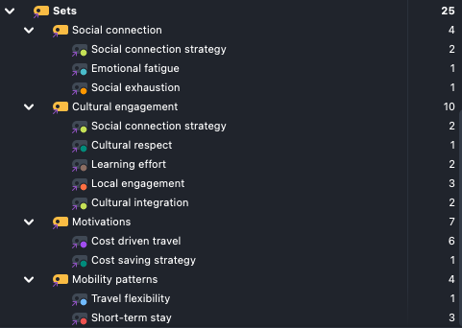

Appendix 6
Below is the Research Integrity Form completed in accordance with the university’s ethical guidelines.
RESEARCH INTEGRITY FORM
TBS10130 2024-25 UNDERGRADUATE DISSERTATION

Your Name: Claudio Pigozzo
Matriculation Number: 40582091
Supervisor’s Name: Dr Alexandra Witte

I confirm that my dissertation project DOES NOT include any of the following. Double click on each box and select ‘ticked’ to confirm.
A | Primary research involving vulnerable groups e.g., children, young  people under 18 years of age, adults with incapacity, or individuals in a dependent or unequal relationship
B | Primary research involving sensitive topics e.g., participants’ sexual  behaviour, their involvement in criminal activities, their political views, their experience of violence, abuse or exploitation or their mental health
C | Research involving deception which is conducted without the participants’ full and informed consent
D | Research involving access to records of personal or confidential  information which enables individuals to be identified, or research involving the use of the Edinburgh Napier University Email System
E | Research which would induce psychological stress, anxiety or humiliation or cause pain
F | Research which would potentially cause harm to participants’ esteem, career prospects and/or future employment opportunities.
G | Research involving intrusive interventions which participants would not encounter during their everyday lives
H | Research where there is a possibility that the safety of the researcher may be in question

I understand that if my research includes points A or B above, then I cannot proceed with my proposed research, and must amend my proposal such that my research does not include points A and B.
If my research is likely to involve any of points covered in C to H, then I must discuss further with my supervisor and seek approval from the School Research Integrity Committee if required before I can proceed with my proposed research. Details of the Research Integrity and Ethics procedures and forms are available at
https://www.napier.ac.uk/research-and-innovation/research-environment/research-integrity

It is my responsibility to follow the University’s Code of Practice on Ethical Standards and any relevant academic or professional guidelines in the conduct of my study. This includes providing appropriate information sheets and consent forms and ensuring confidentiality in the storage and use of data. If there is any significant change in the question, design or conduct over the course of the research I should consult with my supervisor and complete another Research Integrity Form.

Student Signature: Date: 14/11/2024

Supervisor Signature:  Date: 18/12/2024

Appendix 7
Below the information and consent form sent to participants.
Edinburgh Napier University (ENU) Research Consent Form
International Tourism Management
Edinburgh Napier University requires that all persons who participate in research studies give their written consent to do so. Please read the following and sign it if you agree with what it says.
1. I freely and voluntarily consent to be a participant in the research project on the topic of “Digital Nomads” to be conducted by Claudio Pigozzo, who is an undergraduate student at Edinburgh Napier University Business School.
2. The broad goal of this research study is to explore Digital Nomads motivations, behaviour, and personality, and analyse their conceptual fit with established tourist typologies. Specifically, I have been asked to attend a semi structured interview, which should take between 1 and 2 hours to complete.
3. I have been told that my responses will be anonymised. Specifically, I will be allocated a pseudonym and all identifiable features (including where I refer to others) will be removed from the data. My name will not be linked with the research materials, and I will not be identified or identifiable in any report subsequently produced by the researcher.
4. The researcher has confirmed that personal data and anonymised data will be stored securely in separate password protected folders on the researcher’s ENU H-drive and all data will be destroyed immediately after the end of the examination/assessment process – usually within three months of the completion of the project.
5. I also understand that if at any time during the interview I feel unable or unwilling to continue, I am free to leave. That is, my participation in this study is completely voluntary, and I may withdraw from it without negative consequences. However, after data has been anonymised or after publication of results it will not be possible for my data to be removed as it would be untraceable at this point.
6. In addition, should I not wish to answer any particular question or questions, I am free to decline.
7. I have been given the opportunity to ask questions regarding the interview and my questions have been answered to my satisfaction.
8. I have read and understand the above and consent to participate in this study. My signature is not a waiver of any legal rights. Furthermore, I understand that I will be able to keep a copy of the informed consent form for my records.

Participant’s Signature Date
I have explained and defined in detail the research procedure in which the respondent has consented to participate. Furthermore, I will retain one copy of the informed consent form for my records.
Researcher’s Signature Date

