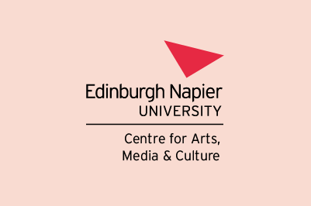

Research Talk – All Welcome

Wednesday 25 October 2023, 3.30-5pm
E13 (with online joining option)
Merchiston Campus, 10 Colinton Road, Edinburgh EH10 5DT

Professor Nacim Pak-Shiraz
(University of Edinburgh)

‘Exploring Gender and Space in Iranian Cinema’

Abstract

This talk explores the challenges women face in Iranian society, as depicted in contemporary Iranian cinema. By examining a selection of Iranian films, the presentation highlights the complex interplay of legal, social, and political barriers that women grapple with when seeking access to various spaces. These cinematic narratives, inspired by real-life experiences, challenge conventional assumptions about male and female spaces, as well as public and private domains within Iranian society. It will scrutinise the complex set of structures that either hinder or facilitate movement and access for both men and women in Iranian society.

Biography
Professor Nacim Pak-Shiraz holds the Personal Chair of Cinema and Iran at the University of Edinburgh. Her research focuses on visual culture, religion and gender. Pak-Shiraz also serves as a governor at the Royal Conservatoire of Scotland. In addition to her academic work, she is a film festival curator and has served as jury member and speaker at numerous film festivals in Asia, Africa and Europe.

Organiser: Professor Anne Schwan (a.schwan@napier.ac.uk)

