9335 words

'An otherness that cannot be sublimated': Shades of Frankenstein in Penny Dreadful and Black Mirror

Abstract: This article traces some of the legacies of the Frankenstein narrative as it appears in the television series Penny Dreadful and Black Mirror. Both series deploy Frankenstein themes to explore the relationship between gender and technology. Drawing on the work of Julia Kristeva and others, I argue that the hybrid bodies of Lily in Penny Dreadful and Ash in the Black Mirror episode 'Be Right Back' are powerful examples of abjection and how it works differently across genders. Both series are part of a continuous reworking of Shelley's text that demonstrates we are still living in the age of Frankenstein: a period of fascination with the body, gender, and scientific innovation epitomised by the themes of Shelley's story.

Frankenstein (1818) has always been a dangerous story, and it is one that continues to fascinate. Danger in this context means the following: the consequences of creating a gendered body through deliberate technological invention, and how that body is then subjected to narratives of abjection and monstrosity. The dangerous bodies depicted in Frankenstein narratives are frequently feminised, though not always coded as female. Margaret Homans suggests that "The horror of the demon that Frankenstein creates is that it is the literalization of its creator's desire for an object." (1986: 101) Homans's phrasing is useful here in thinking through the gendered treatment of the beings who becomes their creators's desired object in Penny Dreadful and Black Mirror. as Frankenstein adaptations. Endlessly adapted and reworked across a range of media, Shelley's story offers a rich set of possibilities for exploring the gendered cyborg or resurrected body as dangerous terrain. In a recent issue of Critical Survey, Dragoş Manea comments on Frankenstein's ubiquity on screen:
...from January 2010 to December 2015 there were no fewer than thirty-two films, television shows, or videos that have in one way or another included the character of Victor Frankenstein and fifty-six have portrayed Frankenstein's Monster...the sheer number testifies to the characters' enduring presence in cultural memory. (2016 42)
While in these examples, portrayals of a male creator and his male creature are commonplace, stories which offer a female creature or creator are more unusual and thus worth attending to because they present a particularly ‘dangerous' reworking of a specific element of Mary Shelley's novel, namely, the male creature's request for a female mate and the gendered consequences of this action. This article will examine two recent instances of Frankenstein adaptation and appropriation in the television series Penny Dreadful (US/UK 2014-16) and the Black Mirror (UK 2011-) episode 'Be Right Back' (11 February 2015). My analysis will focus on two distinct pairings of creator and creature; Penny Dreadful's Victor Frankenstein (Harry Treadaway) and his third creation, Lily Frankenstein (Billie Piper) and Black Mirror's Martha (Hayley Atwell) and the cyborg double she purchases to resemble her deceased husband Ash (Domhnall Gleeson).
Julia Kristeva's theory of abjection forms an important framework for examining Frankenstein's dangerous qualities and the ways in which it is reworked in these two examples. In Powers of Horror, Kristeva writes of particular female characters that appear in Céline's work as "the two facets of an otherness that cannot be sublimated--the sexual and the repressed, the marginal and the social." (emphasis added 169) In the texts under discussion here, I wish to assert that Frankenstein functions in a similar way: it is the story that cannot be sublimated, just as the abject nature of Lily and Ash as Frankenstein creatures cannot be sublimated.
Benjamin Poore remarks that Penny Dreadful "forces us...to consider how Victor Frankenstein might have behaved if he had come to adulthood at the end of the century upon which he was such an imaginative influence, the century that Eve Kosofsky Sedgewick has called 'the Age of Frankenstein' (x)" (73) I would like to argue that Penny Dreadful and Black Mirror confirm that we are still very much living in the age of Frankenstein: a period of fascination with the body, gender, and scientific innovation epitomised by the themes of Mary Shelley's story. Over its three seasons, Penny Dreadful engages in the still dangerous cultural work of exploring what it means to be a woman under patriarchy. 'Be Right Back' questions current cultural assumptions regarding gendered behaviours and expectations with regard to heterosexual relationships and domestic life. Drawing on the work of Kristeva, Mary Ann Doane, and Linda Williams, this article will examine the various ways in which Penny Dreadful experiments with representations of abjection via the bodies of Lily and Ash. . The hybrid figure of Brona Croft/Lily Frankenstein occupies a range of narrative positions: victim, monster, champion, and sympathetic prisoner; she forces us to consider our position on consent (sexual or otherwise) and what it means to have real agency. Brona/Lily's trajectory suggests that a woman's power cannot be sustained under patriarchy, and if she steps outside her designated role she will be deemed a dangerous, monstrous threat.
In "Be Right Back", the new Ash is the hybrid figure whose status is never entirely clear: he is in possession of a fleshy exterior and we might imagine he has a robotic or cybernetic core, yet this is never confirmed. This uncertainty around Ash's physical status is reflected in the use of a range of terms to describe him: android, cyborg, and creature. Drawing on the work of Jason Lee, Kristeva, and Eve Kosofsky Sedgewick, the analysis of "Be Right Back" focuses on the different ways in which this episode takes up concerns around bodily autonomy and consent, and what this might mean in the context of heterosexual domestic partnerships. What Lily and Ash demonstrate is that in these Frankenstein stories, the female body is expected to comply, and the male body is expected to act independently; yet Lily is unruly, and Ash is too compliant and it is these unexpected scenarios that create ethical dilemmas for Victor and Martha in their roles as creators.
Creation and Consent
"We are bound on a wheel of pain, you and I. I ask you, what is Dr. Frankenstein without his creature?" (Caliban (Rory Kinnear) in "Fresh Hell" S2 E1). In Penny Dreadful Victor is defined through the actions of his creations, though he becomes most concerned about the actions of the woman he creates in Season Two, Lily Frankenstein. Lily becomes Victor's triumph and his nemesis.
Where Penny Dreadful portrays its creatures as complex beings resurrected through experiments with anatomy and electricity, Black Mirror offers a tender but infuriating version of the creature as synthetic, fleshly male android. Ash, the android creation, does not share the anguish or vengeful desires of Penny Dreadful's creatures. Ash's short-comings, particularly his inability to fully embody all the qualities of the human upon which he is based, privilege the private self as unique from the version that may be projected via social media. Each television text reworks aspects of the Frankenstein narrative for its own ends, exploring the consequences of creating gendered, technological bodies. . In Penny Dreadful, Victor smothers the consumptive prostitute Brona Croft when she is near death at the end of Season One. He resurrects her at the start of Season Two as Lily Frankenstein, in order to meet John's demand for a female companion. Initially, Victor and John are delighted with Lily, who appears both beautiful and compliant. Lily is the most aesthetically successful of Victor's creatures, but she has been radicalised by poverty and survival sex work in her former existence, and uses everything at her disposal to achieve power.
In 'Be Right Back', Martha is wife, widow, and creator. She becomes the operator of a male android, while also pregnant by her recently deceased husband Ash. Shortly after the human Ash has died in a car crash, Martha is encouraged to make use of an invitation-only service that uses a deceased person's digital footprint to create a simulacrum of their personality. She accesses technology that permits increasingly embodied incarnations of Ash: the software she accesses replicates his tone of writing, then mimics his voice, and finally offers her the full body, synthetic flesh version. Martha journeys through layers of intimacy, progressing from instant messaging, to voice conversations. When she discovers she is pregnant a few weeks after the original Ash's death, she enlists the support of the new, digital Ash in celebrating the preparations for birth. Lured by the promise of the full-body prototype that will re-create a physical presence like her husband, Martha makes the ultimate in unwise online purchases. An enormous package arrives, and she then assists in the birth of the cyborg body by unpacking it, giving it nutrients, and placing it in the bath tub. Once android Ash is fully embodied, Martha soon realises he is not fully autonomous. In these examples, Lily and Ash are presented as creations that matter, who cannot be unmade by their creators. While Martha conceals and confines Ash as we see in the conclusion of 'Be Right Back', she cannot bring herself to destroy him. Though Victor wishes to 'unmake' Lily in the penultimate episodes of Penny Dreadful, he cannot do it at the last and he releases her.
The fates of Lily and Ash are intertwined with those of those of their creators, and therefore the pairings in Penny Dreadful and Black Mirror are of particular interest in terms of intersections between technology, gender, and power that may be explored via inventive appropriations of the Frankenstein story. As Mary Ann Doane notes "...the conjunction of technology and the feminine is the object of fascination and desire but also of anxiety--a combination of affects that makes it the perfect field of play for the science fiction/horror genre." (189) Both texts explore this terrain in their creator/creation pairings by revisiting the novel's 'bride plot'. In Shelley's novel, Victor Frankenstein briefly maintains a second workshop near Orkney and comes close to carrying out his creature's request for a female companion. But, Victor destroys the nearly complete female creature, fearing that she will be "...ten thousand times more malignant than her mate...delight[ing], for its own sake, in murder and wretchedness." (Shelley 138) This fear of a female monster corresponds with Barbara Creed's remarks in The Monstrous Feminine: " Why is the femme castatrice one of the more deadly personae adopted by the monstrous feminine, almost always represented as fulfilling a stereotypical image of female beauty? (Creed 128) This correlation between monstrosity, beauty and femininity reflects Lily's portrayal in Penny Dreadful and is part of her rebellion against gendered expectations of feminine compliance.
In Shelley's novel, Victor has also attempted to construct a physically attractive figure. Only when the creature has come to life does Victor realise with horror that he has not succeeded:
I had selected his features as beautiful. Beautiful!--Great God! His yellow skin scarcely covered the work of muscles...these luxuriances only formed a more horrid contrast with his watery eyes...his shrivelled complexion, and straight black lips. (39)
This unsettling combination of features, such as proportional limbs, 'lustrous' black hair and good teeth, only serves to reinforce Shelley's creature as an abject force that Victor cannot control. His attempts to create a pleasing figure have failed, and the Creature's unusual appearance is in part responsible for his rejection by society. In Penny Dreadful, it takes Victor three attempts before he creates the physically attractive Lily, who proves highly dangerous, expressing the fears articulated in Shelley's novel and Creed's monstrous feminine. This fear of a non-compliant female monster leads directly to Lily's confinement and near destruction in Season Three of Penny Dreadful, as she plots to overthrow society, proving her to be more destructive than any of her potential mates in the narrative. In order to fully explore the consequences of this characterisation, a fuller examination of abjection and the hybrid body as portrayed in these examples is necessary.

Hybridity and Abjection
In these re-workings of Frankenstein, it is the hybrid bodies of Lily and Ash that become abject. For Kristeva, "[t]he corpse, seen without God and outside of science, is the utmost of abjection. It is death infecting life. Abject." (4) This phrase perfectly describes the conditions of Lily Frankenstein's creation, and the scenario where Martha purchases a synthetic being that mimics her deceased husband. In these texts, the re-animated bodies display 'death infecting life' in their unsettling creation scenes.
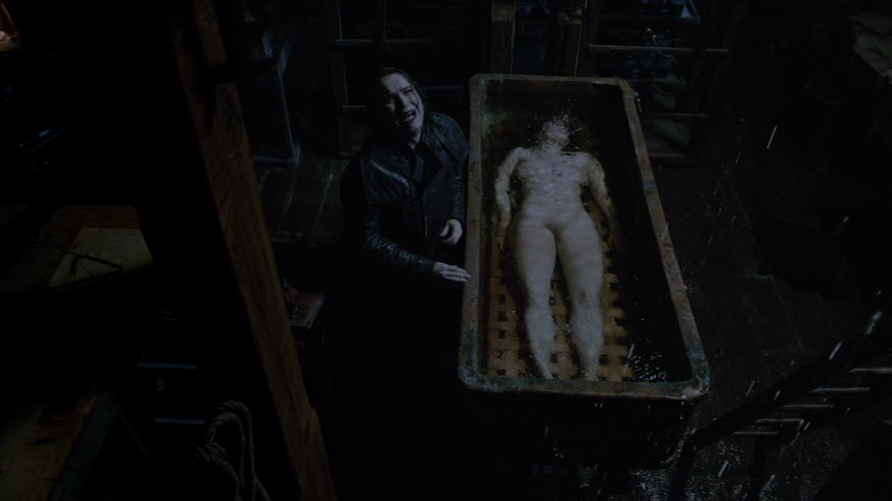
Figure 1: John beside the corpse that will become Lily Frankenstein in "Fresh Hell" (S2 E1)
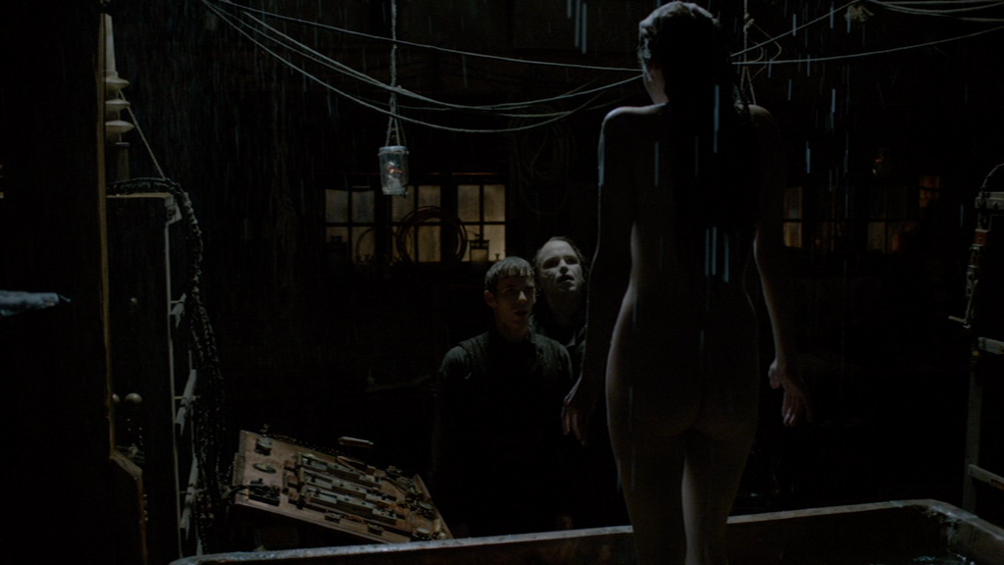
Figure 2: Lily is infused with life as Victor and his first creation John look on in "Fresh Hell" (S2 E1)
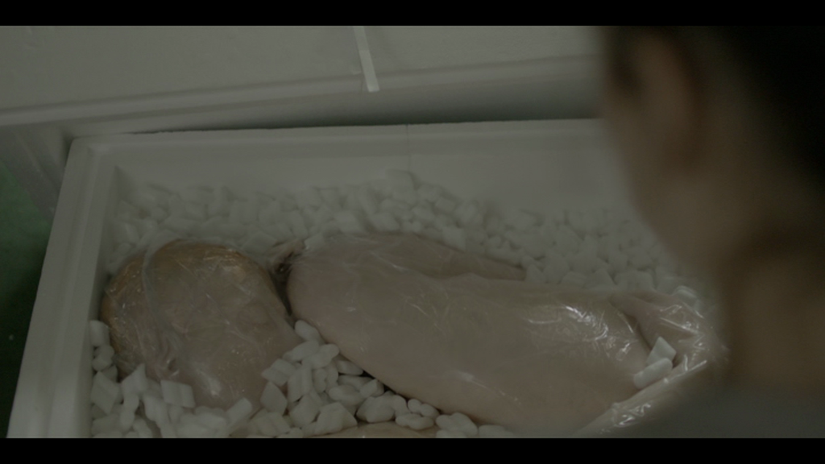
Figure 3: Martha unpacks the blank android body in "Be Right Back".

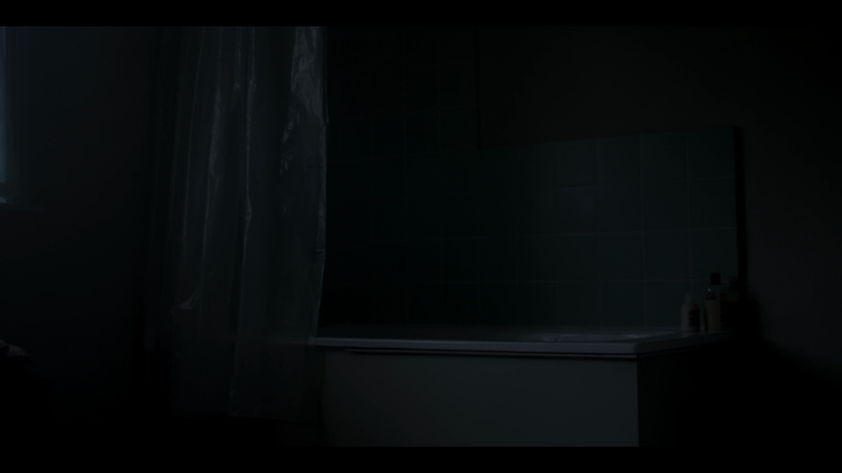
Figure 4: Martha's bathroom during the blank body's activation period, where it is infused with Ash's personality.

These sequences display similar imagery, with inanimate bodies lying in large containers or bathtubs, before they are fully animated. In terms of abjection, the use of the bathtub, an object normally used to rid the body of dirt, but here used as the place to reanimate lifeless bodies, is significant. Just as beauty and evil may be combined, purity and impurity merge in these creation scenes. It is therefore unsurprising that bathtubs appear frequently in Frankenstein screen adaptations as liminal spaces between life and death. In Penny Dreadful the tub in Victor's lab contains the body of the dead prostitute Brona Croft who is then resurrected as Lily (see Figure 1); in "Be Right Back" the tub in Martha's bathroom contains a synthetic blank body which is resurrected as Ash when Martha activates it, infusing it with the dead Ash's details and features (see Figures 3 and 4). Both Lily and Ash emerge from their tubs and display their nude bodies to their creators. (See Figures 2 and 5)

Figure 5: The new Ash emerges from the bathtub, startling Martha.
John Berger's famous assertion that "men act and women appear" (47) is worth considering in examining the different positioning of these nude bodies. Ash is able to tell Martha that her staring at him is "creepy", retaining his verbal ability to deflect and acknowledge Martha's gaze. But Lily is entirely mute when confronted by the stares of Victor and his first creation John Clare. Although Lily ultimately gains more agency than Ash, her mute, helpless beginning serves as an undeniable comment on the silencing qualities of patriarchy--while both she and Ash "appear," Lily's appearance echoes depictions of Pygmalion and Galatea, she is the statue come to life who her creators hope will be an ideal, compliant woman. That said, Ash puts forth only a simulacrum of agency, whereas at the same time the episode works hard to disavow any objectification of his body, something that Penny Dreadful makes readily apparent in the eroticised gazes directed at Lily (see Figure 6).

Figure 6: Victor contemplates the female corpse that will become Lily in S2 E1
This disavowal of Ash's objectification comments on the privilege accorded to the white male body, as Calvin Thomas notes "...it is...the straight white male figure who cannot bear the burden of sexual objectification" (2008: 7). "Be Right Back"offers up Ash as a body that must be seen to be beyond exploitation even though that is what is happening Gradually we learn Martha is in total control in her designation as Ash's 'administrator, and that Ash's personality has been wholly populated by his digital discourse, and therefore lacks both independent agency and the hidden idiosyncrasies of the individual. This becomes a source of Martha's frustration, her attempts to get rid of Ash, and finally his banishment to the attic.
Rina Arya expands Kristeva's work on abjection to include contemporary art and film and their depictions of abject monsters:
Monsters are typically impure and unclean--they are in between different physical, psychological, ontological states. Some are composite in that they are made up of different parts from different orders. Such ambivalence contributes to their deviance because we are not able to define or characterize them. (Arya 133)
This speaks to the core of the creature's dilemma as we encounter him in Shelley's novel--there is no model by which he can be known and characterized. Penny Dreadful and "Be Right Back" present us with further experiments in characterizing hybrid bodies that nonetheless remain gendered: Lily is Victor's third creation, so he knows that she will need to be carefully tended in her first weeks of existence. Victor expects early compliance from Lily and is confident he can control her. Ash is more like a beta version--when he is still only a voice speaking to Martha through her smart phone, he tells her "There's another level to this available. Kind of experimental. And I won't lie, it's not cheap." The next level is the full body prototype, an inanimate fleshly figure that arrives shrink-wrapped and curled inside a box of styrofoam packing: "it's blank until you activate it," he tells Martha. In spite of these conditions of service, Martha expects Ash to be independent and does not wish to control him. As Lily develops, she gains characterization and an understanding of her role in the social order. Ash gains a body, but remains at best a flat imitation of the human upon which he is based. While Lily is initiated into her role as compliant feminine creation, Ash is simply expected to know how to be, to step into the place left vacant by the deceased. Both shows demonstrate scenarios without protocols for dealing with technological bodies and instead gender expectations become a template for behaviour, Victor does not question his right to instruct Lily in how to be feminine, but Martha does not at first realise that she must teach Ash how to act like her husband.
Gendering Abjection
Kristeva, Arya, Creed, and Kelly Hurley all discuss depictions of the abject as instances where the body's borders and margins break down, as Creed notes: "The place of the abject is 'the place where meaning collapses' (p.2)" (252) Penny Dreadful and Black Mirror explore the different ways that abjection and monstrosity function across genders. This has particular significance in relation to Lily as a body that is socially marginal, and whose borders are less than solid. As the human prostitute Brona Croft in Season One, Lily's body was frequently made accessible to men who used her without consideration. This sense of Lily's body as something to be used renders her abject. In Season Three, Lily acquires a young accomplice Justine (Jessica Barden), a former child prostitute, who articulates what it means to be abject and female in even blunter terms: "I've never known a man who didn't want to fuck me or beat me." ('Good and Evil Braided Be' S3 E3) The margins of the prostitute bodies of Brona/Lily and Justine in Penny Dreadful are doubly abject because they are in public space, and because the sex worker is perceived as 'renting out' the body. Lily is not only the monstrous, composite creation of Victor Frankenstein, she is already an abject body even before her resurrection. Her rebirth adds yet another layer to her abjection. However, through this transformation comes power, a kind of twist on Barbara Creed's notion of the femme castratrice. Lily claims back her body's borders after her rebirth. Her immense physical strength and apparent immortality, along with passing as a member of the upper class, are what allow for this. Rather than remain an abject body--a body that should be a corpse--Lily fights to preserve her bodily autonomy, choosing when to make use of her sexuality to manipulate others to her own ends.
Initially, Victor constructs a narrative for Lily, telling her she is his cousin, and John is her fiancé. She appears to accept this, and Victor's instruction, relying on him completely, exclaiming: "Cousin! Teach me, I am at your mercy" ('Verbis Diablo' S2 E2). Victor enjoys his role as Lily's guide to society, crafting her into his fantasy woman. Victor falls in love with Lily, but she soon reveals her true nature. At first, both John and Victor are utterly taken in by Lily's cunning performance of fragile femininity. Lily's manipulation of Victor can be traced to the first time she puts on the clothes he has bought for her ('Evil Spirits in Heavenly Places' S2 E4).
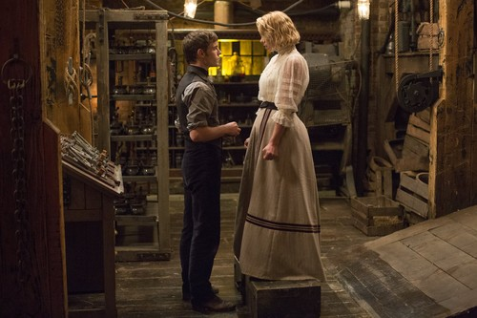
Figure 7: Lily gets dressed in S2 E4
Noting the tightness of her corset and the difficulty of walking in high heels, Lily observes "all we do is for men isn't it?...flatter them with our pain." She persuades Victor to allow her to remove the corset, but she keeps the shoes on, she says, to please him. Mary Ann Doane observes "Hollow in itself, without substance, femininity can only be sustained by its accoutrements, decorative veils, and inessential gestures." (34) Here, Lily's performance of fragility and innocence via the accoutrements of late 19th century feminine fashion, is openly acknowledged. She convinces Victor she is prepared to participate in this masquerade to please him, yet she indicates a profound understanding of this cultural role with her incisive comment, "flatter them with our pain." This is a prelude to a fuller articulation of Lily's views in the episode "Memento Mori" (S2 E8). In this episode Lily's masquerade is shattered when she confronts John. John has grown impatient and frustrated, as Victor has been limiting his access to Lily, claiming he needs more time to teach her, and that she and John must get to know one another gradually; actions that have concealed Victor's own sexual attraction to Lily. John turns up suddenly to confront Lily. She attempts to deflect his questions and advances, but soon realises he will not be bought off with propriety. Forced to reveal her true nature and capabilities, Lily throws him to the ground with her impressive physical strength, and proceeds to deliver a blistering critique of patriarchy:
We lose our dignity in corsets and high shoes and gossip and the slavery of marriage! And our reward for this service? Back of the hand, the face turned to the pillow, the bloody, aching cunt as you force us onto to your beds to take your fat, heaving bodies!
She tries to convince John to help her kill Victor, promising him passion and love, and declaring her mission in no uncertain terms: "Never again will I kneel to any man. Now they will kneel to me. As you do, monster. My beautiful monster, my beautiful corpse." She then enacts a very troubling sequence where she seems to simultaneously seduce and assault John. He appears repulsed, shocked, but also briefly in thrall to Lily, reflecting Arya's assertion that "we are both repelled by the the abject (because of fear) and yet attracted to it (through our desire)." (Arya 5) The scene concludes with Lily's plan for world domination: "we are the next thousand years, we are the dead." These lines constitute a reification of the abject as a rich source of power. The monstrous, outsider, female body is now frighteningly powerful, combining the allure of the femme fatale's sexuality with that of the abject. Doane's words are useful for making sense of this key sequence:
The very fact that we can speak of a woman 'using' her sex or 'using' her body for particular gains is highly significant--it is not that a man cannot use his body in this way but that he doesn't have to. The masquerade doubles representation; it is constituted by a hyperbolization of the accoutrements of femininity...this type of masquerade, an excess of femininity, is aligned with the femme fatale and...is necessarily regarded by men as evil incarnate. (Doane 26)
Lily's feminine masquerade is combined with her position as a former sex worker as shorthand to signal an ability to manipulate and deceive, but her sex worker status is also the source of her hardened pragmatism in her quest to achieve autonomy. In "Memento Mori", she reveals her status as a sexual mercenary, driven by anger and revenge, and her ability to reclaim her abject body as a source of power.

Lily's attempts to seize power in Season Three are so terrifying that Victor enlists the help of his friend and colleague Dr. Henry Jekyll (Shazad Latif) to subdue or kill her, though he still hopes to make Lily into a suitable companion for himself. Unlike Shelley's novel, where the creature must die, in Penny Dreadful the dangerous, female creature must be rendered compliant and biddable. This is reinforced by Victor's declaration to Lily in the episode "Ebb Tide" (S3 E7). Victor has imprisoned Lily in Jekyll's laboratory inside the Bedlam asylum. Confined and restrained, Lily is re-victimised when Victor tells her of his plan to experiment on her further: "we're going to make you into a proper woman". This naked misogyny forms part of the show's sustained exploration of the non-compliant female body via Lily. Her radical defiance in the face of her creator is what renders her story such a satisfying reworking of Frankenstein's bride plot. .
However, Victor's final actions towards Lily in "No Beast So Fierce" (S3 E6 ) are compassionate, recognizing her individuality and humanity. Victor begins this episode still under the illusion that he will be curing Lily by injecting her with a serum that will remove her painful memories of her previous life, and that this will enable them to be happy together as a couple. Lily argues passionately for her autonomy:
I shall be unmade, become a non-person. I would rather die where I am than live as your demure little wife...even if you keep me locked in the attic, render me with the mind of an obliging child, I will always see that dark little space that yearns to be a soul.
She then tells him about her deep love for her dead infant daughter, and Victor lays down his syringe and releases her. Unsurprisingly, it is maternity that softens the previously resolute, powerful, monstrous woman. This alignment with maternal tenderness might also be construed as what Arya describes as the "purification rites in order to restore harmony" (143) which she argues are common to depictions of abject girls in horror cinema. Lily demonstrates she has been capable of caring, nurturing and selflessness: qualities that all too often coded as specifically feminine.. Like many other female protagonists that no one can deal with, Lily exits the narrative without a clear conclusion. While she has not been unmade by Victor, she has occupied a range of roles and positions throughout the three seasons, much like the female protagonist in the erotic thriller: "To paraphrase Simone de Beauvoir, one is not born, but rather becomes, a (fatale) woman--and one can unbecome her too." (Williams 121) While Lily escapes death or further punishment, her exit is understated and without dramatic focus or momentum Lily has been able to argue her way out of Bedlam, but this also means being shut out of the story.
Bodily Autonomy and Maternity
Like Penny Dreadful "Be Right Back" also offers up images of abject bodies whose borders break down. However, what renders Ash abject is quite different from Lily. From the start, the software that leads Martha towards the cyborg is a service, and the cyborg body is also presented in this way: as a device to be used. In this sense, the cyborg Ash is hardly different from the creation as object as suggested by Homans. Martha takes the voice and text-based electronic simulacrum that stands in for the dead Ash and purchases a body to house it, thereby giving the ghost its machine. Once this new Ash is embodied, Martha becomes uncomfortable with his lack of autonomy--there isn't "enough of him" and she has clearly expected that this new Ash will behave in the same way as the previous one. Yet, Martha is also pregnant by her dead husband; she orders the full body prototype, while also growing a human from her own body, making her a creator many times over; while Martha is ambivalent about her android, she is delighted about her pregnancy. Just as Martha's bodily autonomy is overtaken by pregnancy, she has acquired responsibility for the new Ash. While she is now subject to ungovernable symptoms such as morning sickness, Martha discovers she has complete control over the cyborg body, something she finds distinctly unsettling. Martha's frustration with new Ash may be read as her apprehension about becoming a single parent, while being unable to fully rely on her dependent cyborg husband, who requires her to give him instruction. This calls into question current discourses around the burden of domestic responsibilities, and how it often still falls to women to fulfil the bulk of these duties. Even with what some might cynically imagine as an ideal, a figure that can provide physical help on command, this soon turns out to be no more than an additional burden. Martha is alone in coping with these acts of creation: her pregnancy and her cyborg .
A work like Frankenstein is often examined as a text that suggests creation without the mother. Therefore, to see it reworked with the creator figure as a woman and a mother poses new challenges. Eve Kosofsky Sedgewick writes that "...in a novel like Frankenstein a critical meditation on the emergence of a technological subject...can be appropriately embodied only, although never seamlessly, in a narrative that takes the maternal work of embodiment as its manifest subject." (Kosofsky-Sedgewick vii-viii) Much like Victor with Lily, Martha is excited at the prospect of the sensual pleasure her creation brings her when he becomes her lover. However, Martha's horror and revulsion begins when she realises the new Ash's limitations. As his administrator, she has certain responsibilities not unlike that of a parent, such as when she discovers he cannot venture more than twenty-five metres from his activation point without her. Victor, on the other hand, enjoys Lily's dependence, but is disturbed when she becomes less biddable and more independent in her tastes. Martha is soon frustrated by the constant presence of of a robotic slave, and she seems to suffer from an extreme version of buyer's remorse when she attempts to force android Ash to kill himself by jumping off a cliff. Only when she prompts him by saying that the real Ash would be frightened and would not just agree to this, does she relent and he ends up living in her attic, un-ageing, imprisoned, in a state of limbo. He is the secret Martha and her daughter must live with forever.
"Be Right Back" also presents a different take on Frankenstein's bride plot. Here, Martha is the creator but instead of fearing her creature, she grows frustrated that Ash is not a sufficiently detailed or nuanced replica of her husband. Her responses to the presence of this new Ash are more guarded, but she follows a path of action disturbingly similar to that of Victor Frankenstein. Her expectations for and use of Ash's body suggests underlying expectations about the male technological body. Martha expects the new Ash to be independent, and to defy her will, such as when she tries to have an argument with him, and he refuses to engage with her. Yet, one of Martha's first acts is to have sex with her new cyborg. The sex is portrayed as highly enjoyable for Martha, (in distinct contrast to the lacklustre sex that results in her pregnancy), and she exclaims "where did you learn to do that?" She then discovers the uncanny gap between what we might term the original and the new Ash during this first sexual encounter, when he tells her that there's no record of Ash's sexual response because "I didn't share that part of myself online", but he is nonetheless a highly skilled lover because he has been programmed with various techniques. Jason Lee's exploration of some of the issues around sex robots are pertinent here:
Asking whether you would have sex with a robot is assuming a robot would have sex with you. Just as we may question what it means to be human, we can question what sex actually is. One might assume a sex robot is pre-programmed to be accommodating to your sexual needs, but what if a sex robot was programmed to have its own individual preferences that overcome yours? (Lee 2017: 8)
Martha discovers that the new Ash does indeed accommodate her sexual needs in the absence of his own, as he explains he can simply switch his erection on and off. Initially Martha seems intrigued by this capability but soon discovers she is not content with this singular function, and this becomes part of the episode's melancholy tone that suggests technology can never replace the human. This characterisation of the male technological body as passive and subject to command is part of what renders Ash abject, and his lack of anything resembling independent will is what troubles Martha. Lee goes on to suggest that "the well-made sex robot challenges all our pre-conceived conceptions of what is human and what makes us humans." (9) Lee's assertion here is more applicable to Penny Dreadful's Lily as she develops into a fully-autonomous individual. Originally intended as a reward to John, Victor grooms Lily for himself. Neither of the men seem prepared for the possibility of Lily as a fully-rounded person with her own preferences that do indeed overcome any plans they have for her. Some weeks after her creation, Victor and Lily have sex, but this is initiated by Lily in a deliberate move to begin manipulating Victor, moving towards her own greater agency. In "Be Right Back" Ash is not deliberately making use of his erotic skills to manipulate Martha, but the fact that both creators have sex with their creations reinforces the fact that both texts are concerned with the agency we might accord to gendered technological bodies . Both Martha and Victor have dangerous desires, dangerous in the sense that they are operating in scenarios unchecked by ethics, and driven by powerful, overwhelming emotions: they lust after their creations, they want to radically change them, and they try to kill them. In Martha's case, her grief overrides good judgement, she ignores her creation, and tries to force the new Ash to commit suicide. Victor grooms Lily to be his ideal companion, imprisons her, and threatens to wipe out her memories. While initially regarded as blank slates who must be instructed, Lily and Ash are groomed for certain activities, but with markedly different narrative outcomes: Ash remains in Martha's attic, while Lily exits the narrative entirely.

Melancholia of the outsider: the consequences for gendered bodies

Mourning and melancholia are qualities which tend to permeate many Frankenstein narratives. But, just as abjection and monstrosity work differently in relation to gender, so do mourning and melancholia. In Shelley's novel, both Victor and his creature experience profound melancholia. For the creature this begins with Victor's rejection and feeds his desire for vengeance, and for the possibility of solace in a female companion. For Victor, this begins with the realisation that he has created a figure he finds physically repulsive, who fails to "bless...[him] as its creator and source" (Shelley 36) , and the ways in which the creature takes his revenge. Penny Dreadful and "Be Right Back" also explore these themes. For Kristeva, melancholia and mourning are an important aspect of the abject: "the abject is the violence of mourning for an 'object' that has always already been lost." (Kristeva 15) In Penny Dreadful the object that has always already been lost is the woman's bodily autonomy in patriarchy, as exemplified by Lily's trajectory throughout the three seasons. What Victor desires and expects is a compliant female object, but Lily refuses to fulfil this and demonstrates that resistance to this scenario is possible. We can also interpret Kristeva's words in light of the way technology is permitted to function in "Be Right Back". Here, we see Martha mourning for the lost object of her husband. From the beginning of the episode, the human Ash is depicted as particularly absorbed by social media through his smart phone handset. While not exactly lost, we see Martha reprimanding him for his overuse of technology and how it either distracts him or causes him to ignore her. Yet, this behaviour is not presented as a source of tension, but simply an ordinary behaviour for which the couple have developed a strategy. Ash's overt absorption in technology means he is presented as already somewhat lost to Martha, when she tells him "you keep vanishing down there", indicating his phone is the rabbit hole into which he regularly disappears. Martha is accustomed to the idea that Ash has agency, even if he uses that agency to ignore her in favour of interacting with technology. His sudden death represents a true and total loss, but even this painful tragedy can be softened with other technology. Martha's widowed friend Sara suggests the software, which she acknowledges is not 'him', "but it helps" to ease the pain of mourning. This suggests that the valued parts of Ash can be replicated by technology, and therefore that what Martha might value in her husband is something less tangible than a cyborg body. This is in marked difference to Victor's project in making Lily, where a physical body has always been a crucial aspect to the compliant comforts offered by a technological body coded as female. Ash can exist as a bodiless presence and still have value, where Lily is tied to her body and its possibilities for performance and display, as well as resistance.

If we trace the narrative trajectory of Brona/Lily throughout the three seasons of Penny Dreadful, we can see she is clearly marked out as a figure of melancholy in multiple ways--we are even told that the name Brona means "sadness". She has advanced consumption, and her death is imminent. She resides in a grubby riverside inn, engaging in sex work to survive. Far from her family, she dies, cared for with great tenderness by her lover Ethan Chandler (Josh Hartnett). Brona's resignation and her weary narration of the brutality she has experienced at the hands of men renders her a tragic figure in Season One. Her early melancholia is explicitly gendered, and grounded in her experiences of violence and inequality. She is then transformed when Victor resurrects her in Season Two, renaming and remaking her as Lily Frankenstein. Now passing as an elite woman, Lily is still saddled with the memories of her former life, and her new position as a strong, immortal figure allows her to become radicalised. Lily seizes power but her melancholia returns to the surface in Season Three when she must elicit sympathy from her captors Victor and Jekyll, and when she reveals to Dorian Gray (Reeve Carney) that she remembers her mistreatment as a prostitute. As Lily, her melancholia is less obvious, but remains the driving force behind her anger, and her desire for greater autonomy. For Lily, it is only through access to power and bodily autonomy that she can evade melancholia.
In "Be Right Back" technology does not just ease mourning, but tries to circumvent it altogether. Alongside this, we also encounter a melancholia peculiar to science fiction (and particularly prevalent in the series Black Mirror). This is the melancholia we see dramatised in relation to technology that is seen as helpful. In the world of Black Mirror all technology that offers the possibility of solace or connection is 'already lost' and humanity is in thrall to it as a distraction. This idea appears consistently across episodes in all three seasons, including "The National Anthem", "The Entire History of You" and "Play/Test". The only exception to this view of technology is the Season Three episode "San Junipero", where elderly patients on life-support can inhabit a thrilling virtual world of pleasure even after they die. The technology on offer in "San Junipero" fosters the possibility of genuine connection, as evidenced in the lesbian romance at the centre of the narrative. This more optimistic view of technology is the exception in the world of Black Mirror.
Very often, in Black Mirror, it is technology that causes monstrous and frequently misogynistic behaviour. In "Be Right Back" Martha is permitted to side step mourning by engaging with the digital recreation of Ash. She is allowed to simply continue speaking to him, acting as if he is still with her. When she is presented with his cyborg double, she begins to realise what she has done, that there are consequences to attaching a gendered body to this technology. It is her unthinking interaction with a particular kind of technology that has placed Martha in this position, and has brought this new Ash into existence, a being for whom she is now entirely responsible, in a way that goes against her previous expectations for the relationship she experienced with her deceased husband. Martha finds herself incapable of killing this new Ash and her entire future existence becomes thoroughly uneasy, not unlike Victor Frankenstein in Penny Dreadful, or indeed in Shelley's novel, constantly anxious that he is being pursued by his creations. In the final moments of "Be Right Back", we flash forward to see Martha as lone parent to a young girl. She is clearly uncomfortable with the bond that has developed between android Ash and her school-age daughter, a bond she cannot share, as she wearily and hesitatingly climbs the ladder into the attic of her house, where Ash now resides. This Ash, the android in the attic, is shut away and brought out only at weekends and holidays, possibly unaware or not programmed to care about his life-long imprisonment. While he is able to beg Martha to spare his life, he cannot argue for his separate autonomy the way that Lily is able to in Penny Dreadful, nor can he provide Martha with the experience of a partner who has his own independent thoughts and desires. In Shelley's novel, Victor imagines a grateful creature owing him more devotion that any parent. Here, Martha has that devotion but the connection offered by the new Ash is a troublesome burden, indicating that her desire has never been for a service, but instead, for a fulfilling, equal relationship that she can never have with the new Ash. Ash's behaviour corresponds to the idea of a robot as a good servant, but goes against gendered expectations for a male body.
In "Be Right Back" we focus on Martha's melancholia, perhaps because we have no access to Ash's interiority. We do not know if the new, synthetic Ash experiences melancholia. With Martha, it is melancholy that drives her decision to become a creator in the first place, by engaging with mimicking software. But, the consolation she has previously derived from the voice-only version of Ash soon disappears as the uncanny and frustrating reality of living with an android sets in.Like Victor in Penny Dreadful, Martha also carries with her the too late realisation that "when you transform a life, you are making it anew." ('Resurrection' S1 E3) She has transformed her own life, that of the new Ash, and that of her young daughter. In the end, Martha must live with the lonely secret of what she has done in her act of creation.

Conclusion

"Be Right Back", alongside much of the plot surrounding Lily in Season Three explore the idea that technology, full of promise, has not liberated us from anything. As Camil Ungureanu notes "[Charlie] Brooker's declared intention is not to demonize technology, but [to explore] the perverse effects of technology and mass media." (2015: 23) Brooker's series often suggests that technology has turned us into guilty bystanders, salacious voyeurs and jaded spectators, to the extent that nearly every episode of its three seasons offers up an implicit warning that we should all be more guarded in our interactions with technology. Both Penny Dreadful and Black Mirror ask us to reflect on how we use technologyand whether we might choose to use it differently in narratives where the ethics of creation and consent are frequently called into question. Ungureanu notes that Black Mirror does not "convey a total truth about technology and mass media, but an anxiety about the specific problem they pose." (25) Penny Dreadful also quite clearly frames these questions in terms of gendered bodies and expectations as we follow Lily's trajectory from compliance to rebellion.
The desire for a compliant creature in Penny Dreadful proves impossible to fulfil. In "Be Right Back" Martha, discovers the problem of a creation that is too compliant. Neither text suggests a clear solution to the problems surrounding the ethics of creation when it comes to gendered bodies but they offer explorations of its two poles. Kohlke and Gutleben note that "...the cyborg in neo-Victorian as well as wider Gothic is inextricably connected to issues concerning the limits of subjects' power, self-control and self-knowledge." (Kohlke and Gutleben 24) While Lily in Penny Dreadful can achieve autonomy, and even force her creator to acknowledge her right to self-determination, the new Ash in "Be Right Back" is fundamentally incapable of these things because he has been designed not to want them. Lily's terror at being made into a "non-person" is reimagined in Black Mirror as a different kind of resurrection. The horror of creation comes not from being a blank slate, but a creation populated only with the thoughts and experiences deemed fit to be articulated in email and social media. This performance of the self through 'technological impression' (see Ungureanu 26) becomes the new Ash's core personality. These uncanny gaps in Ash's personality and abilities become as problematic for Martha as Lily's wilfulness is for Victor.
What these two reworkings of the Frankenstein story suggest is that we are still very much living in the age of Frankenstein, an age in which we as creators and users, have an ethical responsibility towards each other and towards the way we choose to use technology. The texts also suggest that the gendering of bodies, and their status as outside or abject must be eradicated if true equality is to be achieved. Frankenstein's textual richness continues to lend itself to debates about science and personhood, sexuality and individuality.
Works Cited

Akıllı, Sinan and Seda Öz. 2016. "'No more Let Life Divide...': Victorian Metropolitan Confluence in Penny Dreadful." Critical Survey. 28:1. 15-29

Artt, Sarah. 2015. 'Not Enough of Him:Technology and Melancholia in 'Be Right Back' In Media Res Black Mirror Theme Week: http://mediacommons.futureofthebook.org/imr/2015/05/06/not-enough-him-technology-and-melancholia-be-right-back [accessed 28 February 2017]

Arya, Rina. 2014. Abjection and Representation: An Exploration of Abjection in the Visual Arts, Film, and Literature. Palgrave Macmillan: London.

Berger, John. 1973. Ways of Seeing. Viking Press: New York.

Botting, Fred. 2008. Limits of Horror. Manchester University Press: Manchester.

Byrnes, Alicia. 2015. "Alienating the Gaze: The Hybrid Femme Fatale of Under the Skin" Deletion Episode 9: Deviation: The Perversions of Science Fiction. http://www.deletionscifi.org/episodes/episode-9/alienating-the-gaze-the-hybrid-femme-fatale-of-under-the-skin/ [accessed 28 October 2016]

Creed, Barbara. 1999 [1986] "Horror and the Monstrous Feminine" in Feminist Film Theory: A Reader. edited by Sue Thornham. Edinburgh University Press. 251-266.

--. 1993. The Monstrous Feminine: Film, Feminism, Psychoanalysis. Routledge: London.

Doane, Mary Ann. 2004. "Technophilia: Technology, Representation and the Feminine."
Liquid Metal: The Science Fiction Film Reader. edited by Sean Redmond. Wallflower Press: London. 182-190.

Gordon, Charlotte. 2015. Romantic Outlaws: The Extraordinary Lives of Mary Wollstonecraft and Mary Shelley. Penguin Random House: London.

Homans, Margaret. 1986. Bearing the Word: Language and the Female Experience in Nineteenth-Century Women's Writing Chicago: Univ. of Chicago Press.

Hurley, Kelly. 1996. The Gothic Body: Sexuality, Materialism and Degeneration in the Fin-de-siècle. Cambridge University Press: Cambridge.

Kohlke, Marie-Luise and Christian Gutleben (eds). 2012. Neo-Victorian Gothic: Horror, Violence and Degeneration in the Re-Imagined Nineteenth Century. Rodopi: New York and Amsterdam.

Kosofsky-Sedgewick, Eve.1976.The Coherence of Gothic Conventions. Methuen: London and New York.

Kristeva, Julia. 1982. Powers of Horror: an essay on abjection. Columbia University Press: New York.

Lee, Jason. 2017. Sex Robots: The Future of Desire. Palgrave Macmillan: London.

Levine, George and U.C. Knoepflmacher (eds). 1979. The Endurance of Frankenstein: Essays on Mary Shelley's Novel. University of California Press.

Louttit, Chris. 2016. "Victorian Redux: Adapting the Gothic Metropolis." Critical Survey. 28:1. 2-14.

Manea, Dragoş. 2016. "A Wolf's Eye View of London: Dracula, Penny Dreadful and the Logic of Repetition." Critical Survey. 28:1. 40-50.

Moers, Ellen. 'The Female Gothic' in The Endurance of Frankenstein: Essays on Mary Shelley's Novel. George Levine and U.C. Knoepflmacher (eds). University of California Press: Berkley and Los Angeles. 1979. pp 77-87

Poore, Benjamin. 2016. "The Transformed Beast: Penny Dreadful, Adaptation and the Gothic. Victoriographies. 6.1. 62-81.

Rocha, Lauren. 2016. "Angel in the House, Devil in the City: Explorations of Gender in Dracula and Penny Dreadful." Critical Survey. 28:1. 30-39.

Shelley, Mary. 1818. [1993] Frankenstein or The Modern Prometheus. Oxford University Press: Abingdon.

Thomas, Calvin. 2008. Masculinity, Psychoanalysis, Straight Queer Theory: Essays on Abjection in Literature, Mass Culture, and Film. Palgrave Macmillan: London.

Ungureanu, Camil. 2015. "Aestheticization of politics and ambivalence of self-sacrifice in Charlie Brooker's The National Anthem." Journal of European Studies. 45:1. 21-30.

Williams, Linda Ruth. 2005. The Erotic Thriller in Contemporary Cinema. Edinburgh University Press: Edinburgh.

See Ellen Moers 'The Female Gothic' in The Endurance of Frankenstein: Essays on Mary Shelley's Novel. George Levine and U.C. Knoepflmacher (eds). University of California Press. 1979. pp77-87.
Many Mary Shelley biographies as well as biographical readings of Frankenstein suggest a strong correlation between Shelley's experiences with miscarriage and child death and the themes of Frankenstein. In Romantic Outlaws Charlotte Gordon writes of Mary Shelley just after she had begun writing Frankenstein: "But Mary was ambivalent about the prospect of men creating life. She had given birth to a toddler she loved, but she had also lost a baby, and lost her own mother as a result of childbirth. If men could control life (and death), then she would not have suffered these tragedies. On the other hand, she wondered what would happen to the special role of women if it was possible to create life via artificial methods." (2015 194)
Black Mirror is an anthology sf series, with self-contained episodes. Black Mirror was first broadcast in the UK in 2011 and commissioned by Channel 4. Since 2015, the series has been produced by Netflix and all episodes have been broadcast in North America and the UK. Penny Dreadful was a three season television serial co-produced by Showtime and Sky and broadcast between 2014 and 2016. Both shows may be considered part of the current trend in high-end, auteurist television productions, with the presence of high profile creators: Charlie Brooker for Black Mirror and John Logan for Penny Dreadful.
In Penny Dreadful's debut episode we see Victor Frankenstein create Proteus, a gentle individual whom Victor patiently tends and teaches. Proteus is soon destroyed by the vengeful first creature, Caliban/John Clare. The character Brona Croft is introduced in Season One, before being 'resurrected' as Lily Frankenstein at the beginning of Season Two.
The first creature is initially unnamed, and is then given Caliban as a 'nom de theatre' in Season One. Later, he chooses to go by the name John Clare.
The first creature is initially unnamed, and is then given Caliban as a 'nom de theatre' in Season One. Later, he chooses to go by the name John Clare.
The creations of 'Be Right Back' and Penny Dreadful may also be seen as the immediate antecedents of the cyborg hosts of HBO's recent success Westworld (2016-)
Penny Dreadful's John is very like the creature of Mary Shelley's novel, in that he sees himself as a rejected abomination, permanently barred from human companionship due to his unusual appearance. He demands that Victor create an eternal female companion for him as compensation for the traumatic circumstances of his birth (as in the novel, he is created, and immediately abandoned). These moments are not simply a case of adaptive fidelity--these are the aspects upon which this version of Frankenstein stakes its gender politics.
This choice of setting evokes imagery of a home or water birth, as well as a strong correlation with the history of Frankenstein screen adaptations.
Three of the more well-known cinematic iterations of Frankenstein's 'bride plot' are James Whale's Bride of Frankenstein (1933), Georges Franju's Eyes Without A Face (1959), and Alex Garland's Ex_Machina (2015). Franju's and Garland's films both explore this fear of a malignant and bewitching feminine
The Rocky Horror Picture Show (1975) and Mary Shelley's Frankenstein (1994) also contain creation scenes where the creature emerges from a large tub or water tank.
For an example of a typically sensuous depiction of Galatea see Jean-Léon Gérôme's painting Pygmalion and Galatea (1890) http://www.metmuseum.org/art/collection/search/436483
Series such as Channel 4's Humans also trades on this ambiguity with regard to its 'synths'.
In an eerily similar scenario, Fred Botting remarks on the practices of the French performance artist Orlan who has repeatedly undergone plastic surgery as part of her art practice. "Orlan sells her body...in 1992 at the Sydney Biennale, her exhibition included vials of her liquified flesh, and blood drained from her body during operations. These were sold to raise money for further surgical procedures." (Limits of Horror, 2008: 146)
Creed notes "...the castrating woman--usually a sympathetic figure--is rarely punished." (Monstrous Feminine 123)
In Season Three, Lily consolidates this plan further with her proposal to make an army of prostitutes that will help her overthrow society: "all those invisible women who move unseen through this great city: our soldiers." ('Good and Evil Braided Be' S3E3 )
There is a disturbing resonance with the fate of other disruptive cinematic women, such as the femme castratrice protagonist of Under the Skin (2014) who is immolated by her attacker at the film's conclusion, showing a narrative where "to inhabit the image of woman is to live in peril," (Byrnes 2015) A statement which might also be used used to sum up what it means to be a woman in public .For more on this see the Dangerous Women Project: http://dangerouswomenproject.org
See the mysterious exits of Kara Thrace/Starbuck in the conclusion of Battlestar Galactica, and the dramatic frame exits of the female protagonists of Bande des Filles/Girlhood and Il Sono Amore/I Am Love. The exits in the latter two films suggest a kind of energy and possibility of escape, qualities that do not characterise Lily's exit from Penny Dreadful or the puzzling, anti-climatic disappearance of Starbuck.
Prevenge (Alice Lowe, 2016) is a brilliant, satirical exploration of the anxieties and ambivalences surrounding pregnancy and bodily autonomy.
In this sense, Martha's story differs considerably from that of Victor Frankenstein in Shelley's novel, who is at least accorded the privilege of being able to relate his story to Robert Walton, or in Penny Dreadful, John Clare knows all Victor's secrets but this is not a source of comfort. When theVictor of Penny Dreadful does reveal something of his work to his compatriot Dr. Jekyll, in Season Three, it is in the service of attempting to subdue the monstrous, immortal Lily.
Brona reveals the meaning of her name to Ethan Chandler (Josh Hartnett) when she is first introduced in Season One Episode Two "Séance".
Victor's confrontation with his first creation Caliban/John Clare in Season One makes him a much more wary practitioner and when he is called upon by Malcolm Murray to conduct various experiments on a captured vampire. He reiterates the responsibility they bear: "when you transform a life you're making it anew" ('Resurrection' S1 E3)

