Estimating degradation-related settlement in two landfill-reclaimed soils by sand-salt analogues

J.R. McDougall1, I.R. Fleming2, R.Thiel3, P. Dewaele4, D.Parker2 & D.Kelly5

1Edinburgh Napier University, United Kingdom

2University of Saskatchewan, Saskatoon, Canada.

3R.Thiel, Thiel Engineering, Oregon House, United States

4Golder Associates, Barrie, Canada

*5SWECO, Edinburgh, United Kingdom*

Words 5070 (excl abstract & refs)

**Corresponding Author**

Dr JR McDougall

School of Engineering & Built Environment,

Edinburgh Napier University,

10 Colinton Road,

Edinburgh, UK

EH10 5DT

j.mcdougall@napier.ac.uk

T: +44 131 455 2533

Estimating degradation-related settlement in two landfill-reclaimed soils by sand-salt analogues.

J.R. McDougall1, I.R. Fleming2, R.Thiel3, P. Dewaele4, D.Parker2 & D.Kelly5

1Edinburgh Napier University, United Kingdom

2University of Saskatchewan, Saskatoon, Canada.

3R.Thiel, Thiel Engineering, Oregon House, United States

4Golder Associates, Barrie, Canada

*5-SWECO, Edinburgh, United Kingdom*

Words 5070 (excl abstract & refs)

KEYWORDS

Landfill; settlement; degradation; laboratory testing; field comparison; landfill reclamation

ABSTRACT

Landfill reclaimed soil here refers to largely degraded materials excavated from old landfill sites, which after processing can be reinstated as more competent fill, thereby restoring the former landfill space. The success of the process depends on the presence of remaining degradable particles and their influence on settlement. Tests on salt-sand mixtures, from which the salt is removed, have been used to quantify the impact of particle loss on settlement. Where the amount of particle loss is small, say 10% by mass or less, settlements are small and apparently independent of lost particle size. A conceptual model is presented to explain this behaviour in terms of nestling particles and strong force chains. At higher percentages of lost particles, greater rates of settlement together with some sensitivity to particle size were observed. The conceptual model was then applied to two landfill reclaimed soils, the long-term settlements of which were found to be consistent with the conceptual model suggesting that knowledge of particle content and relative size are sufficient to estimate the influence of degradable particles in landfill reclaimed soils.

# Introduction

The disposal of waste to landfill poses both short- and long-term challenges originating in the interaction of hydraulic, biodegradation and mechanical phenomena. In the short-term, the presence of organic matter commonly leads to high compressibility of the waste body. In the long-term, mass loss due to biodegradation is the main challenge, the mechanical consequences of which are not well understood. The factors that control the interaction between biodegradation and mechanical consequences reside in different academic disciplines – biochemistry and geotechnics – which are difficult to combine. Nevertheless, a number of landfill models, e.g. HBM, LDAT, Moduelo, (see McDougall (2011) for a summary) account for the impact of biodegradation on volume change. These models either (i) use a secondary compression coefficient calibrated according to the degradable content of the waste or (ii) account directly for mass loss. In the former, time is the controlling variable, sometimes in the guise of a gas production model; in the latter, some means of coupling mass loss to volume change is required.

The impact of mass loss on volume change is complex but it might be expected that the amount, relative size of material to be lost and grading of the host (inert) soil are significant controlling factors. With this in mind, a programme of dissolution testing of sand-salt mixtures in the oedometer (McDougall et al, 2013) has been undertaken to explore the effect of physical factors, such as void ratio and particle size ranges, on volume change. A parallel investigation has been done at the University of Saskatchewan (Fleming et al, 2012), and is combined with the Edinburgh Napier tests to obtain a more comprehensive insight..

The Saskatchewan tests were commissioned as part of a project to reclaim fill from old landfills in the US and Canada, as reported by Dewaele et al (2011). The reclamation process begins with excavation of degraded waste from a landfill site. Screening then separates large items from the smaller (<50 mm) residual materials (see Fig.1). If the old waste contains a substantial amount of concrete, especially for construction and demolition debris dumps, a crushing plant may be used in conjunction with the screening plant to reduce the particle size of the concrete and brick material so that it may also be re-used as controlled backfill.

Depending on the original waste composition and screening process, an amount of contamination is encountered in the soil reclamation effort. Contamination, in this regard, is defined as the carryover of undesirable waste components, such as wood, paper, plastic, metals, glass, etc., into the reclaimed soil. While the inclusion of some glass, metal, or other non-degradable materials is probably not a problem from a geotechnical point of view (all of these could legitimately be considered a soil material), the residual organic fraction may be of concern because of the potential for degradation and its effect on settlement. Considering that residential and commercial developments have septic leach fields, water lines, sewer lines, storm-water drainage, or other environmental features that may leak or overflow into the underlying soil, it would have to be assumed that any degradable organic fraction in the soil mass would eventually degrade. There is then the question of the long-term performance of the reclaimed soil as a geotechnical foundation soil. What will be the impact of the loss of an amount of (degradable) particles of known size on the settlement of foundations built over this reclaimed soil?

Field investigations show that the screened reclaimed soil is very homogeneous (Dewaele et al, 2011), and the distribution of contaminants is likewise so. Laboratory testing, presented in this paper, has shown for one case study (site 2), that degradation-induced settlement is well under 0.5%, suggesting that this material is suitable as structural fill assuming good compaction control. It is a rationale for this behaviour that this paper seeks to elucidate.

# Previous work & Aims

There is a history of work related to particle loss, in relation to internal stability, in the field of dam engineering (e.g. Sherard, 1979; Kenney and Lau, 1985; ICOLD, 2013). However, it is important to distinguish this work from that presented in this paper. Internal erosion, commonly characterised by processes of suffusion and suffosion (Moffat et al, 2011), describes the movement of intact fine particles through a coarser (host) soil matrix. This movement is driven by hydraulic gradient and constrained by pore geometry and intergranular stress states. Under dissolution, the ‘unstable’ particle gradually disappears (at least as a solid phase component) so hydraulic gradients are not necessary nor is pore geometry a constraint and particle removal is then not limited to fines.

Studies of particle dissolution in coarse-grained soils have been done by Fam et al. (2002), Shin and Santamarina (2009) and Truong et al. (2010). They all report a change in soil structure and fabric manifest as void ratio change but with relatively little settlement. However, these studies focused primarily on the amount of particle loss in mixes with a relatively narrow range of sand to salt particle size ratios. The diameter ratio, given by the ratio of d50 values of sand to salt, i.e.d50 sand/d50 salt is fundamental to the tests reported on here. Fam et al (2002), who conducted tests on salt-sand particle mixtures with a diameter ratio of 2.30, noted virtually no settlement. Shin and Santamarina (2009) measured settlement between 1.2% and 8.2% for salt-sand mixtures with diameter ratios of 2.33 at contents of 5% to 15%. Truong et al. (2010), tested mixes with diameter ratios of 1.44, showed settlements of 2% and less for mixes containing up to 10% of salt particles.

There is little experimental data and hence understanding of the influence of particle size on fabric changes due to particle loss. Hence, in this paper are presented the findings of experimental investigations undertaken at Edinburgh Napier University and University of Saskatchewan into the volumetric consequences of both the amount and size of particles lost and host particle size distributions under oedometric conditions. A total of 158 salt-sand mixtures were tested: 118 at University of Saskatchewan, the remaining 40 at Edinburgh Napier University. In addition, two reclaimed landfill soil tests were tested at Saskatchewan. The results are brought together firstly, to explore the influences of particle amount, size and grading of the host sand on volume change and secondly, to provide an early benchmark for the long-term performance of reclaimed landfill soils. A comparison is also made with a test on aged refuse in a consolidating anaerobic reactor at University of Southampton (Ivanova et al, 2008)

# A CONCEPTUAL MODEL FOR THE VOLUMETRIC CONSEQUENCES OF PARTICLE LOSS.

Before the experimental programme and results are presented, it is instructive to consider, from a conceptual standpoint, the likely consequences of particle loss, where the particles in question differ in both amount and size relative to the inert soil fraction. The main physical properties of the mixtures are captured by (i) the amount of soluble particles, expressed as a percentage of the total solid mass and (ii) particle size, expressed as a diameter ratio. For the purposes of this conceptual outline, the inert fraction is taken to be a uniform soil, i.e. CU ≈ 1.0. A well-graded soil is considered in the experimental programme and will be discussed later.

Consider the four salt sand mixture amount and size combinations shown in Fig. 2. The values given to the amounts and diameter ratios are approximately those of the sample mixtures of the experimental programme.

*Mixture A: small amounts of small particles*

In this mixture, the small salt particles ‘nestle’ within the assembly of larger inert sand particles. From a mechanical standpoint, the salt particles are effectively shielded by the sand and their loss has no measurable impact on overall soil volume, dVT = 0.

*Mixture B: small amounts of large particles*

Here salt particles are similar size to, and will interact with, the sand particles. The impact of particle loss on the mixture is largely dependent on whether or not the salt particle bridges are part of a strong force chain (grey particles in Fig. 2). With a small amount of salt particles it is likely that salt particle bridges are not part of a strong force chain and can be removed with little impact on overall volume. In other words, the volumetric response of this type of mixture to particle loss will be similar to mixture A.

*Mixture C: large amounts of small particles*

This mixture is one of sand particles contained within a matrix of small salt particles. It is generally recognised that a matrix state will exist when small particles (*diameter ratio* > 7.0; McGeary, 1961) reach amounts of about 15% (Lade et al, 1998). Removal will trigger measurable overall volume change and a change in void ratio, neither of which are easy to predict but which can be measured in laboratory tests.

*Mixture D: large amounts of large particles*

More large particles means the likelihood of strong force chains containing a soluble particle is high. A measurable response to dissolution/degradation is much more likely than is postulated for mixture B. However, as with mixture C, overall volume and void ratio changes depend on inert particle rearrangement.

Indeed, it is the inert particle response that the following experimental programme aims to reveal by measuring the volumetric response to particle loss over a range of particle amounts and sizes. The results will then be used to characterise the potential for long-term settlement in landfill reclaimed soils.

# Experiments

## Test programmes, materials and mixture proportions

At Edinburgh Napier, 40 oedometric dissolution tests in 2 groups of 20 were performed. In each group of 20 tests, 5 different single size salt particles (retained on sieves: 0.063, 0.125, 0.25, 0.50 and 1.00 mm) were added to Leighton Buzzard sand in 4 different proportions (2%, 5%, 10% and 15%, of total dry mass). Leighton Buzzard is a poorly graded quartz sand with CU values = 1.4. In one group, dissolution was under a vertical stress of 62 kPa; in the other group, vertical stress was 250 kPa. Figure 3 shows the relative sizes of the sand and salt particles for two of the test gradings: Leighton Buzzard with 1mm salt particles in Fig. 3(a) and with 0.063 mm particles in Fig 3(b).

At Saskatchewan, 3 different single size salt particles (0.36, 2.36 and 11.2 mm) were added to Ottawa sand (d50 = 2.36 mm), in 5 different mixture proportions (2%, 5%, 10%, 13% and 21%, of total dry mass), all under a vertical stress of 60 kPa. Ottawa sand is a poorly graded material with Cu = 1.18. Fifty-five tests were performed.

A summary of the main physical properties of both test programmes is given in Table 1. Table 2 provides a breakdown of the poorly graded sand fraction (SP) test schedule by salt particle amount and diameter ratio. The largest diameter ratio is 9 – Leighton Buzzard sand (d50 = 0.85 mm) with 0.063 mm salt particles (median d50 for soil retained on the 0.063 sieve = 0.094 mm). The smallest diameter ratio is 0.25 – Ottawa sand (d50 = 2.36 mm) with and coarse salt particles (d50 = 9.42 mm).

A second suite of 63 tests was performed at the University of Saskatchewan using a well-graded Ottawa sand (SW) fraction, d50 = 2.36 mm but with CU = 6.98. Table 3 summarises the percentage and diameter ratio characteristics of the well-graded salt-sand mixtures.

## Equipment – Edinburgh Napier University – dissolution tests

Edinburgh Napier dissolution tests were performed in a modified oedometer cell, diameter = 100 mm, connected to an external reservoir to allow for circulation of water, see Fig. 4. The oedometer has an extended confining ring to accommodate a sample height of up to 30 mm and to maintain a level of water above the loading cap and sample. The Perspex loading cap has a number of small (1 mm) holes to improve the flow of water into the sample. Circulation is important to avoid the accumulation of ion-saturated solution in the pores and to encourage an even distribution of particle dissolution within the sample. Complete dissolution is usually obtained in 30 – 60 minutes, as confirmed by electrical conductivity measurements and final sample masses. Pore fluid exits the cell through two small ports in the oedometer base passing to an external 4 litre reservoir, which is continuously stirred. A peristaltic pump transfers solution from the external reservoir back to the oedometer. Both reservoir and cell are open to atmosphere so pump flow rate is used to control the level in the oedometer and reservoir against the hydraulic conductivity of soil in the cell.

## Equipment – University of Saskatchewan – dissolution tests

The Saskatchewan tests used a sealed cylindrical load cell, diameter =159 mm and height = 82 mm. This cell and the extended oedometer used at Edinburgh Napier have aspect ratios (height to diameter) of 0.51 and 0.30 respectively, raising a question about the influence of side wall friction. However, Shin & Santamarina (2009) showed that lateral stresses reduce during dissolution (and subsequently recover), which will hinder the mobilisation of side wall shear forces, hence we have not attempted to account for sidewall friction in these tests

Permeable filter paper on the bottom and a porous stone at the top allow the flow of pore fluid in/out of the sample without the loss of solid material. A pneumatic consolidation system applies a vertical load to the sample via a sealed piston on the top of the sample (Fig. 5). Water can be circulated through the cell through ports in the piston and cell bottom.

Water is initially pumped upwards and intermittently at a rate of ~ 30 mL/min in alternating intervals of 3 minutes pumping with 3 minutes rest until the cell is saturated. Once saturated, the hoses are switched so that fresh water enters from the top of the cell. Pumping continues in 3-minute intervals. Each pumping cycle produces a mass of solution, which is collected and the mass of solute determined from the volume of effluent collected and the known relationship between total dissolved solids and electrical conductivity (NIST, 2007).

The monitoring of the dissolution process used in the Edinburgh Napier tests differs from that in the Saskatchewan tests but in both cases, the dissolution process is allowed to run until settlement has ceased and effluent conductivity measurements indicate complete dissolution. In the case of the Saskatchewan tests complete dissolution is indicated by zero solute concentration in the effluent. In the Edinburgh Napier tests it is by stabilisation of solute concentrations at some non-zero value. Final, i.e. post-dissolution, masses are checked by drying and weighing of the remaining sand samples.

## Equipment – University of Saskatchewan – degradation of landfill-reclaimed soils

For the testing of the landfill-reclaimed soils, a degradation consolidometer was used as shown in Fig. 6. The consolidometer is 442 mm in internal diameter and the maximum sample height is 564 mm. The material is loaded using a pneumatic ram system that maintains constant load while allowing volume change. Degradation of the organic fraction of the sample is encouraged by inoculation with spent anaerobic digestate (from biochemical methane potential tests for MSW) and subsequent circulation of water to enable degradation processes to occur. The total applied load is measured using a load cell placed on the pneumatic ram that loads the sealed piston assembly on top of the sample. The piston assembly seals to the consolidometer walls, its hollow construction allowing for recirculation through the top of the sample with simultaneous biogas collection. The consolidometer and test method are similar to apparatus and tests on aged and fresh waste residues performed by Ivanova et al (2008) and at a very similar scale – their cell diameter was 480 mm with sample height equal to 420 mm.

# Results - Settlement

## Poorly- graded sand samples

Vertical settlements induced by dissolution for each of the poorly-graded salt-sand mixtures tested here are shown in Fig. 7. For reference, settlement at constant void ratio, i.e. the settlement that would occur if solid volume loss and corresponding void volume change maintain a constant void ratio, is shown together with the Shin and Santamarina (2009) settlement data.

Two principal observations can be made from the settlement data: the first relates to the influence of the amount of soluble particles, the second to the size of the soluble particles. Settlement appears to be directly related to the amount of soluble material but not in a simple linear manner. Small percentages of soluble particles, less than about 7%, produce a relatively small amount of settlement, as exemplified by mixtures A and B in Fig. 2. Above this percentage, the settlement by soluble particle mass lost relationship steepens. It is in this higher range of percentage of soluble mass that the second feature becomes apparent, i.e. particles with diameter ratios of 2 or greater tend to occupy the upper part of the settlement bandwidth, i.e. there is little settlement, as typified by mixture B in Fig. 2. For example, less than 2% vertical strain was observed during dissolution from samples containing 10% of 0.063 mm salt particles. Larger particles, i.e. diameter ratios of 1 or less, occupy the lower part of the bandwidth. In this case settlement is greater, as postulated for mixture D.

One more conclusion that stands out is evident inthe Shin and Santamarina (2009) data, obtained from glass bead-salt mixtures with a diameter ratio of 2.33, all of which settle more than the poorly-graded salt-sand mixtures shown here. This may be due to the lower frictional resistance and shape of the glass beads (Proctor & Barton, 1974) facilitating particle rearrangement. It is well recognised from experimental and DEM studies that both lower inter-particle friction and more rounded particle shape facilitate rearrangement of granular materials (e.g. Iwashita & Oda, 1998; Powrie et al, 2005). All settlements are, however, significantly less than the settlement occurring under a constant void ratio condition. Hence particle dissolution, for the amounts and sizes of the soluble particles in these poorly-graded sands, lead to an increase in void ratio.

## Well-graded sand samples

Consider now the settlement data for the well-graded soils shown in Fig. 8. The data points for the poorly-graded mixtures shown in Fig. 7 have been removed although the bandwidth for these data has been retained, shown by the grey broken lines. The bandwidth for the well-graded sand data is shown by the solid lines. The muted settlement response to small amounts of salt particle loss, regardless of salt particle size, is still evident although the switch to a steeper settlement response occurs at a lower percentage of soluble particles. Moreover, the steeper settlement bandwidth is narrower and points to greater settlement although the distribution of particle sizes within the bandwith lacks the separation of the poorly-graded samples. It appears then that the response of a well-graded host soil to particle loss is likely to result in greater settlement than that observed in a poorly-graded host.

# Results - Void ratio

## Initial void ratio

The initial (pre-dissolution) salt-sand mixture void ratios are shown in Fig. 9. The void ratio calculation is the conventional one, *e = Vv/Vs* where *Vs* is the sum of the sand and salt volumes. Binary mixtures such as these poorly graded sand-salt mixtures can be characterised using an intergranular void ratio, where volume of salt is counted as part of the void phase volume (Georgiannou et al, 1990). However, by not distinguishing between salt and void volumes, the intergranular void ratio is unaffected by the transfer of matter from the solid salt to the void phase volume and is thus unhelpful in the context of the mechanics of dissolution. In the case of poorly-graded sands, the addition of fine salt particles brings about a reduction in void ratio as the fine particles occupy the voids surrounding the coarser sand particles. The addition of coarse salt grains serves only to displace sand particles with little change in the pre-existing sand-only void ratio. In the case of the well-graded sand samples there is no opportunity for ‘nestling’ so the addition of salt particles, either fine or coarse has little impact on the initial void ratios, all of which are significantly lower than the poorly-graded sand with coarse particle mixes.

## Vertical load

Recall that the Saskatchewan tests were performed under a vertical stress of 60 kPa. The Edinburgh Napier tests were performed at two different vertical stresses: 62.5 kPa and 250 kPa. The initial void ratios for both Napier test loads are shown in Fig. 10. It would appear that there is no discernible difference between the 62.5 and 250 kPa load test results, hence the two test groups have been treated as one in the remaining sections of this paper. Figure 10 does, however, reiterate the effect on initial void ratios of the addition of particles of different sizes and by different amounts, as described in the previous section.

## Poorly-graded sand samples

The settlement data presented earlier indicate that particle loss leads to an increase in void ratio. Figure 11 shows the increase in void ratio with diameter ratio for each percentage salt amount. It is striking that in the poorly-graded sands the increase in void ratio is almost independent of diameter ratio (or particle size), but clearly influenced by the amount of added salt. Dissolution induced void ratio changes may be explained by the kind of behaviours set out in Fig. 2. To recap, small salt particle mixtures, which have a large diameter ratio, correspond to Models A & C (which differ by the amount of salt particles), whereas larger salt particle mixtures correspond to Models B & D (again differing by amount of salt particles). If salt particles are small in both amount and size, Model A is applicable. Alternatively, for a small number of large particles, Model B applies. In both cases, there is little host sand particle rearrangement on dissolution and void ratios are predominantly controlled by the amount of solid mass loss. Void ratio increases that are independent of particle size when salt particles are large may be attributable to the existence of strong force chains and the likelihood that at salt contents of up to 10%, there are relatively few strong force chains containing salt particles. Dissolution has little effect on the host particle network. At salt contents of 15% and greater, there is less consistency in the individual data although the fitted lines hint at an insensitivity of void ratio to particle size.

## Well-graded sand samples

Compare now the increases in void ratio due to dissolution in the well-graded sands (Fig. 12). Where salt contents are in the range 2% to 5%, insensitivity to diameter ratio is again evident and void ratio increases are similar in magnitude to those observed in poorly-graded sand mixes. However at 10% salt content and above, void ratio increases are markedly less than in the poorly-graded sands. With fewer data for tests at higher salt contents, interpretation is more difficult and the models referred to above do not provide as simple an explanation for void ratio changes in well-graded soils. However, it has already been observed that settlement is greater in well-graded samples so for any given amount of particle removal, the increase in void ratio will be less in a well-graded host.

# landfill-reclaimed soil samples

In the remaining part of this paper, the behaviour of two real landfill-reclaimed soils is assessed in the context of the salt-sand analogue test results. The samples were obtained from two quite different municipal waste disposal sites: one in Canada and one in the United States. The samples were characterized in terms of waste composition, physical properties, potential for degradation and subsequently monitored for long-term settlement in the pneumatic consolidation cell at the University of Saskatchewan. From the data in Table 4, it can be seen that the two soils are different materials: the soil from site 1 has a narrower particle size range (CU=10), high degradable content (nearly 20%) and a diameter ratio of degradable to inert material that is in the main less than one. In contrast, site 2 soils have a much wider particle size range (CU = 200) and 5% degradable content. The diameter ratio is more difficult to determine as a single value but given a well-graded soil with a high CU it has been assumed to be between 1.0 and 12. In summary, site 1 soils have a sizeable degradable fraction of predominantly large particles, whereas at site 2 soils are comprised of a small amount of predominantly small particles.

Figure 13-2 shows the observed settlement of site 1 & 2 soils superimposed on the settlement data from the well-graded soil samples. It should, however, be noted that after 628 days the compression apparatus housing the sample from Site 1 developed a corrosion-induced leak and it was necessary to terminate the test. At the time that the test was terminated, the cumulative biogas production was 2.5 ml/g dry mass. With a biochemical methane potential of at least 4.7 ml/g, potential for degradation remained and it is likely that settlement would have continued. Biogas production and settlement, shown in Fig.14, appear to be ongoing. So, the trajectory of the site 1 settlement data marker, plotted in Fig.13 according to the settlement data at the time of the equipment failure, may be expected to continue as shown, projected to the midpoint of the bandwidth.

Site 2 has a quite different combination of physical and degradation characteristics. It plots as shown in Fig. 13, lying in the upper part of the settlement bandwidth for a 5% degradable content. At this magnitude of degradable content, the settlement trajectory lies within the flatter narrow part of the settlement bandwidth, which predicts a small amount of settlement, regardless of diameter ratio. This material exhibited little measurable settlement.

It is also interesting to note long-term settlement observations in aged waste made by Ivanova et al (2008) in their consolidating anaerobic reactor cell. The aged waste had 16% degradable material (by dry mass), maximum particle size of 40 mm and a CU value of 39. Biodegradation-related settlement of 5.1% over 338 days was reported (Ivanova, 2007), which can be seen from Fig. 13 to be consistent with our landfill reclaimed soils.

Although the data are few, the two landfill-reclaimed soils appear to follow patterns of settlement behavior that are consistent with the conceptual models based on the amount of degradable material and its relative size, and with behaviour observed in the salt-sand analogues.

# Conclusions

Particle loss experiments, where the particle in question is a degradable organic material, require days or months to run. In contrast, salt-sand mixtures, which can be dissolved in less than an hour, have quickly provided insights into the mechanics of particle loss and the importance of a number of factors controlling volume change. This paper has shown that in salt-sand analogues, three factors combine to control settlement and void ratio changes. These factors are: a) the amount of removable matter, b) its size relative to the host material and c) the grading of the host soil. A conceptual model has been presented to elucidate the influence of these factors on the two volumetric measures.

From the model and the experimental data for poorly-graded host soils, we see that settlement is small or even unlikely to occur at low percentage soluble particle contents, up to about 10% - 15%. At higher percentages of soluble matter, settlements are greater and demonstrate some sensitivity to soluble particle size. This behaviour can be attributed to the presence of strong force chains and the incidence of soluble particles within these chains, which is likely to be small when the percentage of soluble particles is low. Strong force chains also explain the observed changes in void ratio. Void ratio changes are a direct consequence of particle loss but if strong force chains maintain the overall volume regardless of soluble particle size, the change in void ratio will be insensitive to soluble particle size, which we have observed at soluble contents up to about 10 or 15%.

Well-graded host soils appear to follow some of the behavioural patterns observed in poorly-graded hosts. They show settlement to be bilinear with amount of soluble matter although there is a narrower bandwidth than occurring in poorly-graded soils. Changes in void ratio are not as great as in well-graded soils, as would be the case if overall volume change is greater. In this case, particle loss does not leave behind the open void spaces, the well-graded host material appearing to be more likely to rearrange than the poorly graded soils.

This paper has also shown that the postulated particle loss behaviour, evidenced by a large number of laboratory tests on salt-sand analogues from two institutions’ test programmes, can provide a conceptual framework in which to interpret the behaviour of landfill reclaimed soil.

# Practical Application

The ultimate goal is to provide an evidence-based standard for geotechnical engineers to follow when faced with the option of using this type of reclaimed fill. As green construction practices increasingly become a societal goal and indeed an economic benefit, the authors suggests that geotechnical engineers may wish to reconsider the age-old (safe and cautious) practice of bulldozing away poor-quality soil to be replaced only with high quality imported granular fill. The research programme of which some first steps are described in this paper represents an effort to provide industry with such evidence and guidance.

For example, the settlement potential of landfill-reclaimed soil comprising some degradable content can be estimated by a relatively straightforward two-stage process. First establish the amount of degradable material by LOI or biochemical methane assay. For the soils tested here, two scenarios are encountered:

* If the amount of degradable material is small, say less that 10% then expected settlement is read directly from the initial part of the settlement with percentage degradable matter curve. Neither particle size nor host soil influences the settlement prediction.
* If the amount of degradable matter is large, say greater than 10% then a combination of host soil grading and size of lost particles combine to influence settlement. In the data shown here, the greatest settlement occurs where lost particles are large (small diameter ratio) in a poorly graded host soil.

Of course further practical insight and reliability in the proposed method of predicting settlement in landfill-reclaimed soils will only be gained by the accumulation of laboratory test results such as those obtained from the degrading consolidometer and ultimately field monitoring.

# References

Dewaele, P.J., Fleming, I.R. & Coulter, S. (2011). Waste excavation and screening for reclamation and re-engineering of a municipal landfill site. *13th Intl Waste Management & Landfill Symposium*, Cagliari, Italy.

Fleming, I.R., Hammerlindl, A.R. & Parker, D.J. (2012) Geotechnical properties of soil-like material derived from processed waste and the potential for degradation-induced settlement. 65th Canadian Geotechnical Conference, Winnipeg, Paper 365, Session M3, 5 pages. Oct.1-3, 2012.

Fam, M.A., Cascante, G. &Dusseault, M.B. (2002) Large and small strain properties of sands subjected to local void increase. J. Geotechnical and Geoenvironmental Eng. 128(12):1018-1025

Georgiannou, V. N., Burland, J. B. & Hight, D. W. (1990) The undrained behaviour of clayey sands in triaxial compression and extension. Géotechnique, 40(3), 431-449.

ICOLD (2013) Bulletin on internal erosion of dams, dikes and their foundations: Volume 1. Paris: ICOLD.

Ivanova, L.K. (2007) Quantification of factors affecting rate and magnitude of secondary settlement of landfills. *Submitted in partial fulfilment of requirements of PhD*, University of Southampton, UK

Ivanova, L.K., Richards, D. J. & Smallman, D.J. (2008) The long-term settlement of landfill waste. Proceedings of the Institution of Civil Engineers - Waste and Resource Management. ISSN 1747-6526. 161(3), 121-133. doi/10.1680/warm.2008.161.3.121

Iwashita, K. & Oda, M. (1998) Rolling resistance at contacts in simulation of shear band development by DEM. *J. Engrg. Mech.*, 124(3):285–292.

Kenney, T.C., & Lau, D. (1985) Internal stability of granular filters. Canadian Geotechnical Journal, 22(2): 215–225. doi:10.1139/t85-029.

Lade, P.V., Liggio, C.D. & Yamamuro, J.A. (1998) Effects of non-plastic fines on minimum and maximum void ratios of sand, Geotechnical Testing J., Vol. 21, No. 4, 336-347.

McDougall, J.R. (2011) Settlement: the Long and the Short of it. Geotechnical Special Publication 209, ASCE, Virginia**,** ed. Zekkos, 76-111**.**

McDougall, J.R., Barreto, D., & Kelly, D. (2013) Particle loss and volume change on dissolution: experimental results and analysis of particle size and amount effects. Acta Geotechnica. doi: 10.1007/s11440-013-0212-0

McDougall, J.R., Fleming, I.R., Thiel, R., Dewaele, P., Parker, D. & Kelly, D. (2013) Mass loss and volume change: From sand-salt analogues to MSW. Proc. Int’l. Symp. Coupled Phenomena in Environmental Geotechnics, CRC Press, eds Manassero et al, 189-198

McGeary, R.K. (1961) Mechanical packing of spherical particles, J.Am. Ceramic Soc., Vol. 44, No. 10, 513-522.

Moffat, R., Fannin, R.J. & Garner, S.J. (2011) Spatial and temporal progression of internal erosion in cohesionless soil. Can. Geotech. J., 48 (3), pp. 399-412

NIST. (2007, 12 6). *IUPAC-NIST Solubilty Database*. Retrieved 8 21, 2012, from http://srdata.nist.gov/solubility/index.aspx

Powrie, W., Ni, Q., X., Harkness, R.M. & Zhang, X. (2005) [Numerical modelling of plane strain tests on sands using a particulate approach](https://www.icevirtuallibrary.com/doi/abs/10.1680/geot.2005.55.4.297). Géotechnique 55(4), 297-306

Procter, D.C. & Barton, R.R. (1974) Measurements of the angle of interparticle friction. Géotechnique 24(4):581-604

Sherard, J.L. 1979. Sinkholes in dams of coarse, broadly graded soils. In Transactions, 13th International Congress on Large Dams, New Delhi, India. Vol. 2, 25–35.

Shin, H. & Santamarina, J.C. (2009) Mineral dissolution and the evolution of k0. J. Geotechnical and Geoenvironmental Eng. 135(9):1141-1147

Truong, Q.H., Eom, Y.H. & Lee, J.S. (2010) Stiffness characteristics of soluble mixtures. Géotechnique 60(4): 293-298

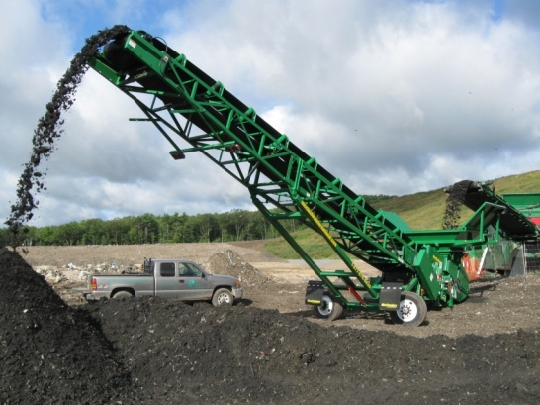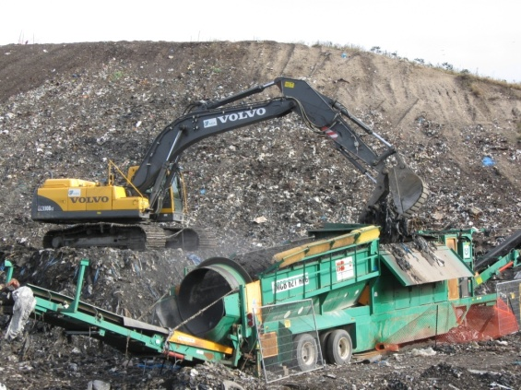

Fig. 1. Photographs showing the landfill soil reclamation process: material post screening (left) and screening plant (right).

|  |  |  |  |
| --- | --- | --- | --- |
|  |  | Soluble Particles | |
|  |  | Small  DR = 9.0 | Large  DR = 1.0 |
| Amounts | Small  ~2%  by mass | Nestling | Occasional force chain |
| A dVT = 0.0 | B dVT → 0 |
| Large  ~20%  by mass | Matrix | Frequent force chain |
| C dVT > 0 | D dVT > 0 |

Fig. 2: Conceptual model of soluble particle disposition within uniform inert particle assembly showing key indicators of phase volume changes due to particle loss.

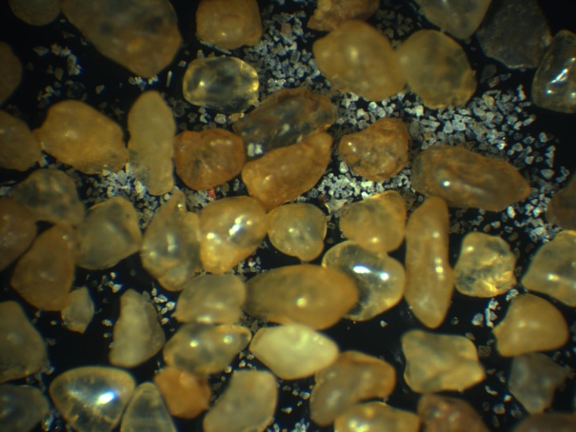

(a) (b)

Fig. 3. Photographs of sand-salt (Leighton Buzzard) mixes showing relative sizes and shapes: (a) 1.0 mm salt particles; (b) 0.063 mm salt particles

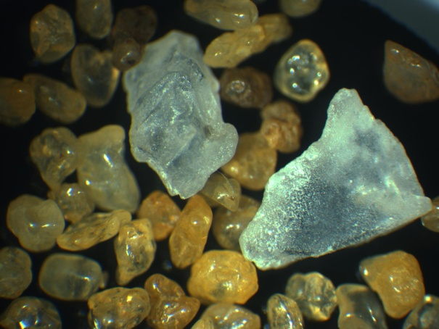

Fig. 4. Schematic diagram of modified oedometer allowing for circulation of pore fluid through sample and large (4 litre) external reservoir (not shown to scale), Edinburgh Napier University

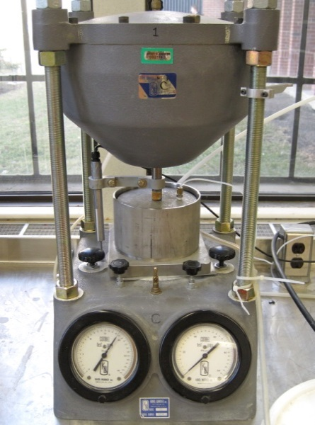

Fig. 5. Sample cell seated in pneumatic consolidation cell at University of Saskatchewan

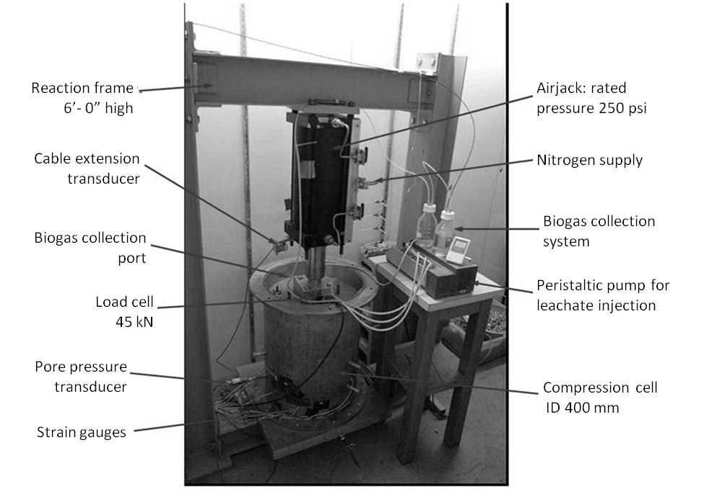

Fig.6. .Accelerated-degradation-gas-collecting consolidometer, University of Saskatchewan

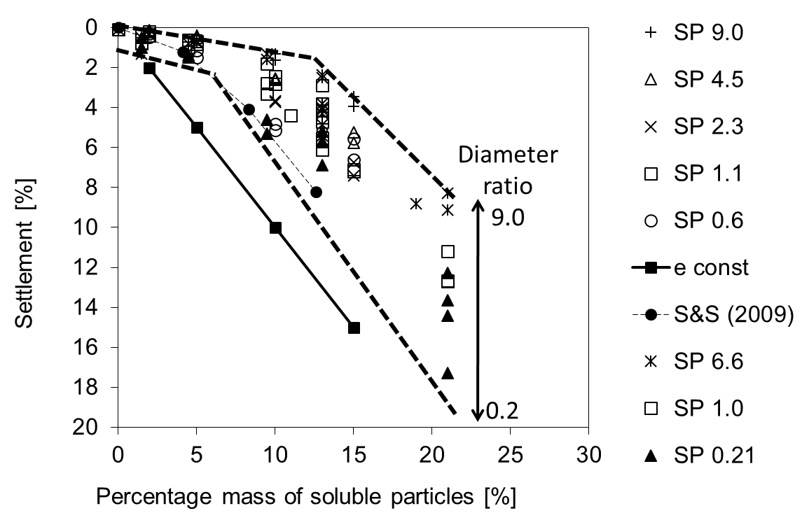

Fig. 7. Settlement of sand-salt (poorly-graded sand) mixtures by particle size (as diameter ratio) and percentage (by mass) of soluble salt.

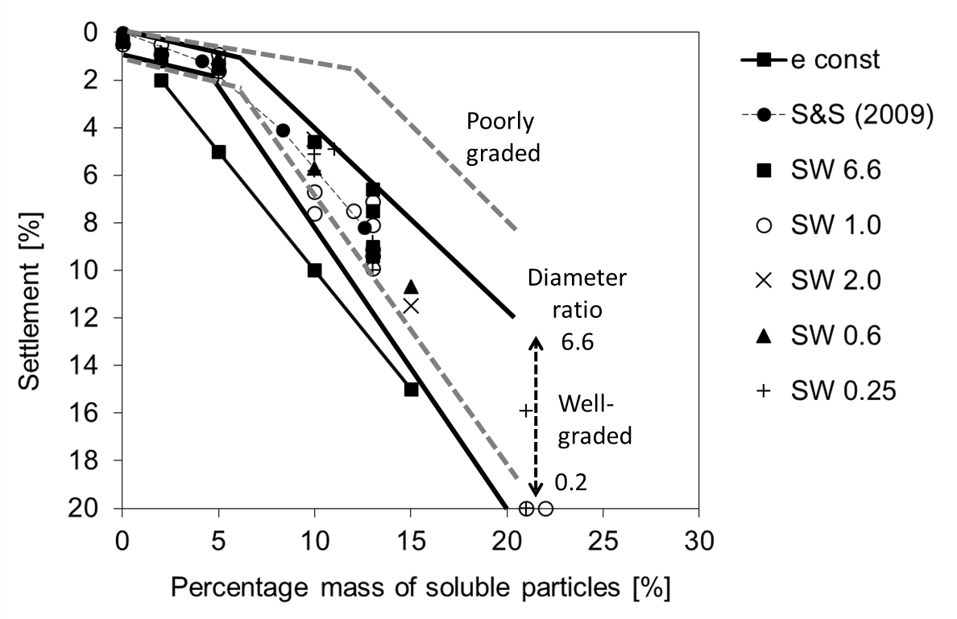

Fig. 8. Settlement of sand-salt (well-graded sand) mixtures by particle size (as diameter ratio) and percentage (by mass) of soluble salt. Bandwidth for poorly-graded mixtures data in Fig 6 is shown by the broken lines



Fig. 9. Initial void ratios for poorly-graded and well-graded sand-salt mixtures where the symbol × denotes poorly graded sand samples with diameter ratio < 4.6, i.e. predominantly large salt particles, symbol + denotes well graded samples, and solid diamond ♦ denotes poorly graded sands with small salt particles, which clearly show the influence of the addition of small particles on void ratio.

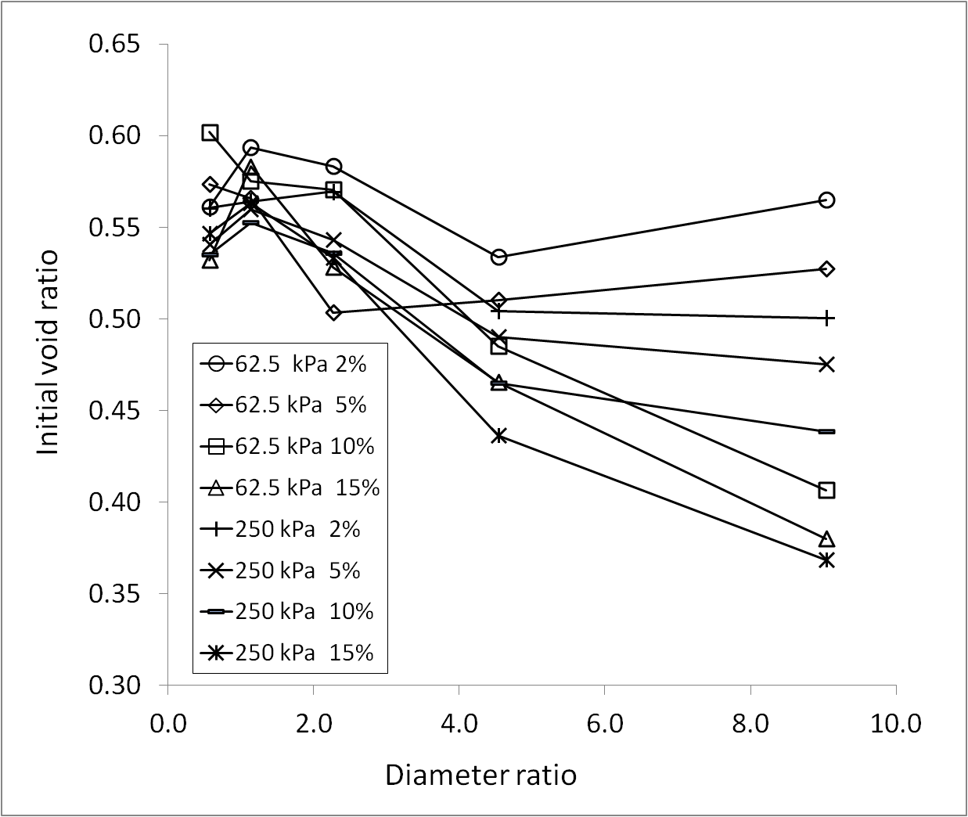

Fig. 10. Comparison of initial void ratios for Edinburgh Napier sand-salt mixtures separated by percentage (by mass) of soluble particles and vertical load.

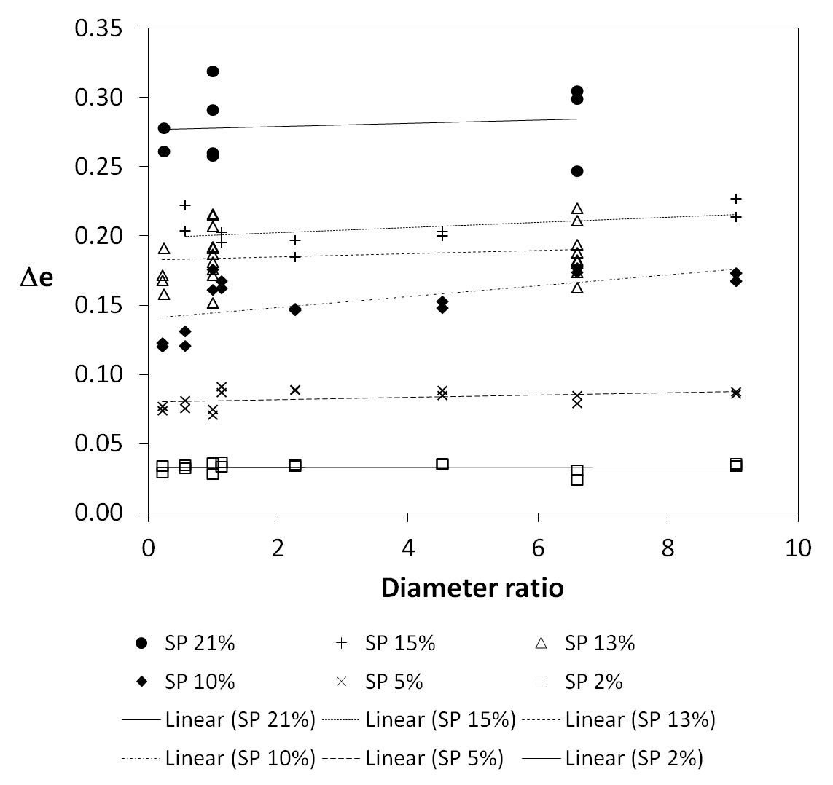

Fig. 11. Change in void ratio due to dissolution in (poorly-graded) sand-salt mixtures by particle size (as diameter ratio) and percentage (by mass) of salt.

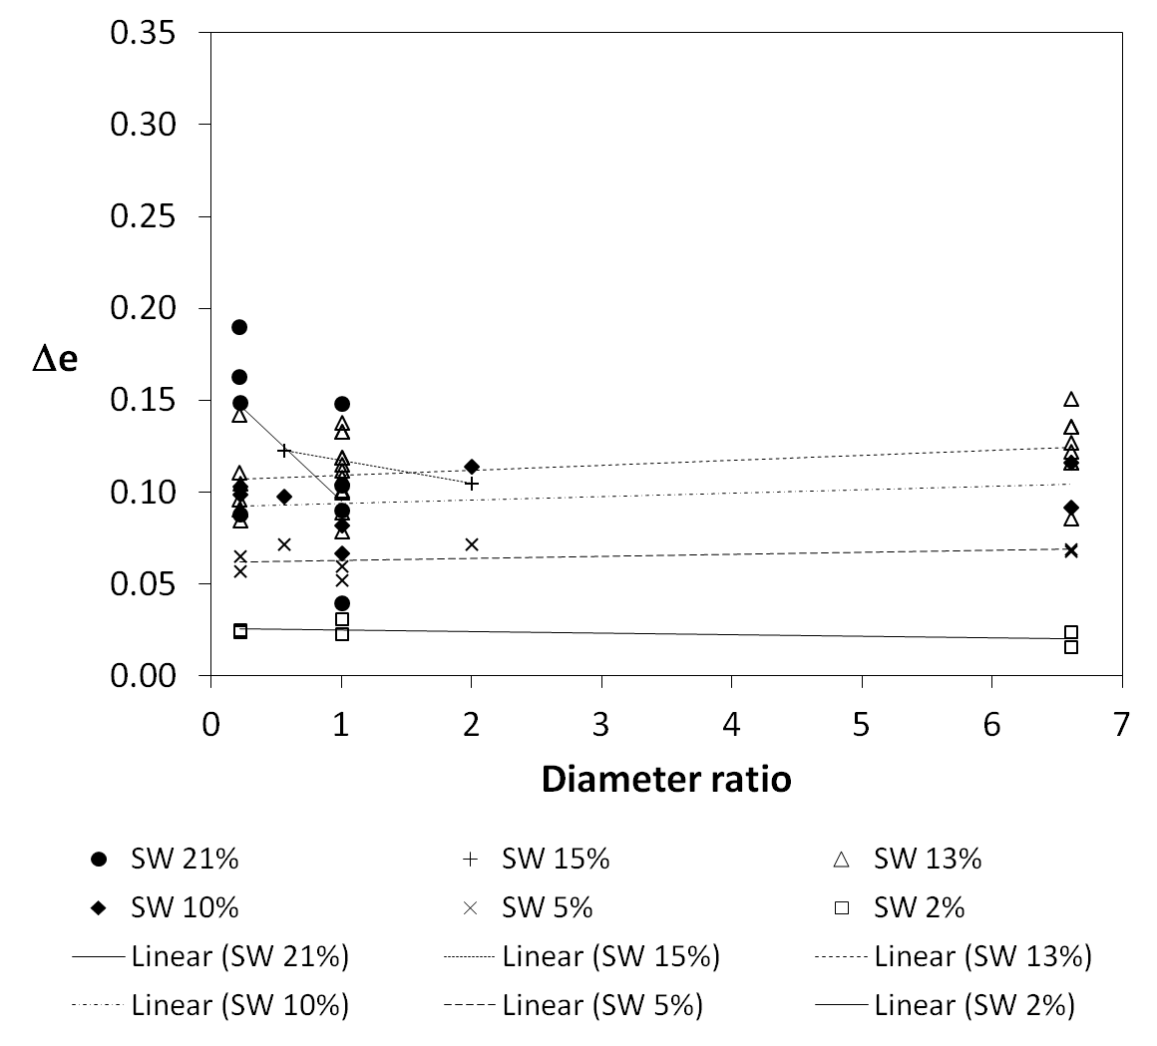

Fig. 12. Change in void ratio due to dissolution in (well-graded) sand-salt mixtures by particle size (as diameter ratio) and percentage (by mass) of salt.

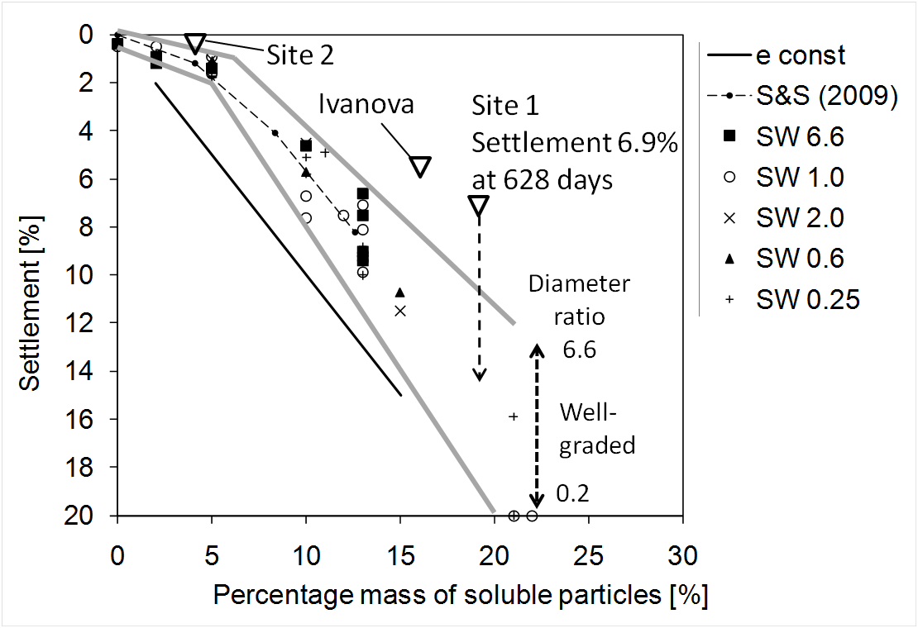

Fig. 13. Comparison of current and predicted settlement of landfill reclaimed soil samples with (well-graded) sand-salt mixtures. Also showing biodegradation-related settlement from Ivanova (2007) at 338 days.

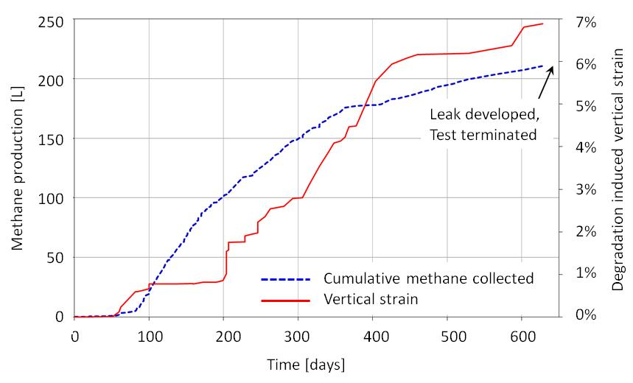

Fig. 14. Settlement and gas production monitoring in Site 1 landfill-reclaimed soil.

|  |  |  |
| --- | --- | --- |
|  | ***Edinburgh Napier*** | ***Saskatchewan*** |
| Sand | Leighton Buzzard | Ottawa |
| Form | Sub-rounded quartz | Sub-rounded quartz |
| D50 | 0.85 mm | 2.36 mm |
| CU | 1.4 | 1.18 (SP) 6.98 (SW) |
| Added amounts (by mass) | 2%, 5%, 10%, 15% | 2%, 5%, 10%, 13%, 21% |
| Salt particle sizes [mm] | 0.063, 0.125, 0.25, 0.5, 1.0 | 0.36, 2.36, 11.2 |
| Diameter ratios | 9, 4.5, 2.3, 1.1, 0.6 | 6.6, 1.0, 0.25 |
| Gs (sand) | 2.65 | 2.65 |
| Gs (salt, NaCl) | 2.165 | 2.165 |
| Vertical stress [kPa] | 62.5, 250 | 60 |
| Number of tests | 40 | 55 (SP), 63 (SW) |

Table 1. Main physical properties of the sand-salt mixtures tested in the combined programme.

Table 2. Summary of number of tests performed at Edinburgh Napier (ENU) and University of Saskatchewan (UoS) by diameter ratio and amount of salt in each of tests – poorly-graded sand fraction.

|  |  |  |  |  |  |  |  |  |  |
| --- | --- | --- | --- | --- | --- | --- | --- | --- | --- |
| Percentage salt (by mass) |  | Diameter ratio = D50 sand/D50 salt | | | | | | | |
| Amount | 9 | 6.6 | 4.5 | 2.3 | 1.1 | 1 | 0.6 | 0.25 |
| 0 |  | 1 UoS |  |  |  |  |  |  |
| 2 | 2 ENU | 2 UoS | 2 ENU | 2 ENU | 2 ENU | 2 UoS | 2 ENU | 2 UoS |
| 5 | 2 ENU | 2 UoS | 2 ENU | 2 ENU | 2 ENU | 2 UoS | 2 ENU | 2 UoS |
| 10 | 2 ENU | 2 Uos | 2 ENU | 2 ENU | 2 ENU | 4 UoS | 2 ENU | 2 UoS |
| 13 |  | 8 UoS |  |  |  | 10 UoS |  | 4 UoS |
| 15 | 2 ENU |  | 2 ENU | 2 ENU | 2 ENU |  | 2 ENU |  |
| 21 |  | 4 Uos |  |  |  | 4 UoS |  | 4 UoS |

Table 3. Summary of number of tests performed at University of Saskatchewan (UoS) by diameter ratio and amount of salt in each of tests – well-graded sand fraction.

|  |  |  |  |  |  |  |  |  |  |
| --- | --- | --- | --- | --- | --- | --- | --- | --- | --- |
| Percentage salt (by mass) |  | Diameter ratio = D50 sand/D50 salt | | | | | | | |
| Amount | 9 | 6.6 | 4.5 | 2.0 | 1.1 | 1 | 0.6 | 0.21 |
| 0 |  | 1 UoS |  |  |  | 1 UoS |  | 1 UoS |
| 2 |  | 2 UoS |  |  |  | 2 UoS |  | 2 UoS |
| 5 |  | 2 UoS |  | 1 UoS |  | 2 UoS | 1 UoS | 2 UoS |
| 10 |  | 2 UoS |  | 1 UoS |  | 2 UoS | 1 UoS | 3 UoS |
| 13 |  | 8 UoS |  |  |  | 12 UoS |  | 7 UoS |
| 15 |  |  |  | 1 UoS |  |  |  | 1 UoS |
| 21 |  |  |  |  |  | 4 UoS |  | 4 UoS |

Table 4. Comparison of key characteristics and measured behavior of two landfill reclaimed soil samples

|  |  |  |
| --- | --- | --- |
| PROPERTY | SITE 1 | SITE 2 |
| D50 | 2.0 mm | 1.0 mm |
| Cu | 10 | 200 |
| Inert fraction (by dry mass) | 81.1% | 95% |
| Degradable fraction* (by dry mass) | 18.9% | 5% |
| Loss on ignition | 8.2% - 12.4% | 4.2% |
| Size range of degradable fraction | 90% >0.85 mm | 78% <1.2 mm |
| Diameter ratio* | 0.2−0.8 | 0.8−12 |
| Biochemical methane potential | 4.7 – 9.3 ml/g | <1 ml/g |
| Initial compression | 1.0 mm | 2.6 mm |
| Compression (after 65 days) | 2.6 mm | 3.5 mm |
| Biogas production (L/kg dry mass) | 2.5 | 0.02 |
| Total monitored compression | 19.9 mm at 628 days |  |
| Degradation-induced long term settlement | 6.9% | 0.18% |

* Degradable fraction was determined by manually removing all organic, degradable material (e.g. fragments of wood and other such materials). This value exceeds the LOI as the degradable fraction includes a portion of ash.

** Degradable fraction size range spans several sieves complicating determination of diameter ratio.