A Case of Academic Fraud
Business Case Studies Paid for Solutions

J.G. Gallagher, E. Fordyce and D.P. Stevenson
In 2004 Jay Cross (16) wrote; “Learning isn’t content. Learning isn’t infrastructure. Learning is a process of forging neural links. It’s new thought being wired into the brain’s network.” More than a decade later we still appear to have missed this point especially in business case study analysis and this would appear to be reinforced by the paid for case solution providers.

The rewards to students who successfully complete an MBA with the aid of undetected plagiarism are substantial. The high cost of the programme can be recouped with interest in the form of the enhanced lifetime earnings of those procuring a fraudulently obtained freshly minted MBA.

Lecturers who use case studies as their course assessment vehicle have until recently been far too complacent about that form of assessment. Cases have often, unlike course essays, been seen as being, to a great extent, plagiarism proof. Normally, cases have no published solution; they are constructed to provide complex unstructured problems and aimed at both individual and group learning and assessment. They are generally written to reflect real life situations and like life, do not supply perfect information. Instead, they require that the reader engages in active paralipsis by reading between the lines, making assumptions after re-ordering and combining the information provided, and by drawing on experience, generate solutions. As Gallagher (19) argues it is, therefore, “through this combination of stimuli, this marriage of theory, practice, and experience that conclusions are generated. These conclusions provide the key to good case solution generation for it is they that provide the underpinning and justification for the actions and solutions chosen.” To some extent the case user had a myopic view of the power of case studies as an armoured examination vehicle as the examination case did not have a readily identifiable underlying body of theory whose specificity and application was as obvious as its generalisability.

This illusion of security was further enhanced when the case study was developed in-house or obtained from a case repository which does not issue case solutions to students. The false belief in the security of such cases has led to their use for assessment in an examination situations.

In addition when juxtaposed with the case author’s provided solution the quality of the paid for answer and its analysis was sadly lacking.

In addition to the significant threat of plagiarism posed to educational institutions by paid for case solutions the quality of the purchased solutions and their analyses, being offered in this expanding market, is also questionable.

Expanding Opportunities for Market Led Plagiarism

For more than a decade or more the duration of class contact on courses has been declining. Where, in the past, a course (module) could cover a year or two years today class contact is likely to be around twelve weeks. Furthermore, as a consequence of this diminution in class contact there has been a corresponding diminution in coursework requirements. Coursework (per module) is less likely to be based on the traditional two to three essays of 3,000 words and more likely to be two pieces of work of 1,000 to 1,500 words or some other form of assessment such as multiple choice etc.

The simple truth is that if you do not have depth of study then correspondingly assessment cannot be based on that which has not been taught and assessment cannot have the rigour expected of case analysis.

Furthermore, “as developed economies moved towards the provision of ‘mass’ higher education, they inevitably attracted many more working-class students who did not necessarily have the family income support that has for generations sustained many middle-class students through their university years.” (7) A situation that at post graduate level is exacerbated with the introduction of overseas students whose cultural norms, on the question of plagiarism and course completion, differs from domestic students putting them at a distinct disadvantage.

For our MBA courses we developed our own case studies and teaching guides. We used the case study for final examination purposes, handing it out to the students three weeks before the examination, which was an open-book examination with un-sighted questions under invigilated examination conditions. After this usage the case could be further used for coursework purposes in the following session and subsequently for general tutorial purposes.

Having produced these business case studies, from our own research, for use on our courses with fully developed case solutions, or more appropriately, teaching guides they were then submitted to competition e.g. The European Foundation for Management Development (efmd) case writing competition and then The Case Centre (formerly The European Case Clearing House) for other academics and professionals throughout the globe to use.
Unfortunately, the environment had changed, in particular university students were resorting more and more to ‘contract cheating’ by accessing websites that offered to produce cheap and not-so-cheap “paid for” course assignments for them. These burgeoning “essay mills” were in essence threatening the quality of a British university degree. In response the Department of Education announced it was consulting with universities over how to crackdown on cheating students with new guidance due to be implemented in September 2017.
It was against this background that it recently came to our attention that a website, ‘caseforest.com’, was offering paid business case study solutions. This was an interesting development and certainly one that required some investigation. Caseforest.com, are not the only site offering this service but it was one we thought we could examine.

Our first step was to contextualise why this development occurred. Part of the reason is that we humans are a problem solving species with genetically coded desire to progress through resolving challenges. However, for some e.g. student plagiarists, a quick fix for academic problems i.e. assessment/coursework/examinations, is recourse to the web for solutions that shortcut both effort and grading.

Against this, paid for business case solutions, like paid for essays, are both educationally corrosive and fraudulent. In February 2017, the Guardian newspaper wrote that:

“University students could be fined or handed criminal records for plagiarised essays, new proposals suggest…”

Black's Law Dictionary (20) comments that, “Fraud consists of some deceitful practice or willful device, resorted to with intent to deprive another of his right, or in some manner to do him an injury.” The Quality Assurance Agency (QAA) which maintains standards in higher education (UK) stated that “In a 2014 study from Saudi Arabia, 22 per cent of students reported having paid someone to complete an assignment for them.” (7). Other figures showing the level of plagiarism may only pointers as they tend to be based on only those being caught plagiarising. Moreover, a Channel 4 Dispatches (21) programme revealed that nearly 60,000 students at UK universities were accused of plagiarism over a four year period with 40,000 being disciplined, over 400 excluded and 12,000 had marks deducted.
The UK Government estimated that more than 100 online essay services are now in operation but Newton (12) estimates that it is more than a 1,000 sites. The Daily Telegraph’s investigation of Jan 2017, revealed that more than 20,000 students were buying pre-written essays and dissertations from the internet. The costs ranged from “B-grade GCSE coursework (£106 on UK Essays) to a 100,000-word PhD in criminal law (£82,238)” (11). Moreover, figures from two of the UK’s largest essay-writing services (also referred to as contract writing, ghost writing or essay mills) revealed that more than 20,000 students were purchasing professional essays every year, with more than a third enrolled at Russell Group and Oxbridge Universities.(9) Lord Storey, who is leading efforts to make the practice illegal, said that the consequences of plagiarism must be made clear, adding that many “rich students” are now effectively “paying their way” to a top honours degree (6).

The QAA further commented that “Essay writing services go to great lengths to promote their products as consisting of original content that is guaranteed to be plagiarism-free. They are more circumspect when it comes to stating what the products can be used for. Generally, only an in-depth search of the website will reveal any exhortation that their products should not be submitted as if they were the student’s own.” (7)

Unfortunately, contract cheating provides students with original work which universities are not equipped to detect. These bespoke essay submissions circumvent universities who in the main use text matching, cut-and-paste plagiarism software such as Turnitin, which claims it is “Trusted by 15,000 Institutions and 30 Million Student in 140 Countries” (13) Turnitin flags up passages it identifies in existing sources. But it cannot detect an ‘original work’ essay written by someone else. Part of the solution may be as the QAA suggested that there should be a ban on advertising contract essay sites, and an examination of the role of search engines in the provision of access to essay mills.(7)

The Telegraph, Jan 2017, quoted ‘All Answers Ltd’ a bespoke essay provider that international students and the heavy workloads required by top universities were fueling the company’s rapid expansion with bespoke essays increasing by about 2000 students a year and earning the company £5million in 2016 (8). Furthermore, Dr Thomas Lancaster (1) estimated that, based on quoted UK Essay figures, the industry was worth £200 million a year and of this 1.5% of all invoices were in excess of £5,000 (2) We're delighted to have procured a whopping £9 million in fees for researchers since 2009. With 1 in 10 writers working with us full time, and 1.5% of our researcher’s invoices being over £5000 a month (2).
Whereas UK students pay in excess of £9,000 in tuition fees, international students in the UK pay between £15,000 and £40,000 a year. It is easy therefore, to see essay mills as exploiting vulnerable students, particularly international students, whose financial expenditure is negated if they fail their course assessment. Essay mills in turn accuse universities of turning a blind eye to the problem of overseas students with poor written English, of seeking bums-on-seats as institutional financial pressure overcomes any academic doubts and erode academic standards.
The QAA (7) quote “Newton and Lang, giving the example of New Zealand’s approach where changes were made to the law in August 2011 to make it illegal to advertise or provide third-party assistance to cheat. Powers were given to the New Zealand Qualifications Authority (NZQA) to prosecute anyone providing or advertising such services.” Newton and Lang also reported that “in the USA 17 states had some form of law addressing custom essay writing services (at October 2014)”(12). Moreover, Newton and Lang pointed out that in New Zealand, where essay mills are illegal, there had been a considerable reduction in contract cheating.

The Quality of Custom case solution writing services

In order to test the efficacy of the claims and quality standards made on such sites an unpublished, though class tested, case study was submitted to one of the sites with its accompanying questions and when the answer received it was juxtaposed with the one that we had already developed. The case study chosen for this comparison was Tyrrells Chips as yet unpublished but scheduled to be submitted to the Case Centre by mid, 2017.

On searching the web three prominent websites, showing how cheap and easy it is to have one of their writers work on a business case study assessment, stood out. The first was ‘caseforest.com’ (FreeCaseStudySolutions), the second, ‘elizabethhall.co.uk’ and the third was ‘essayfactory.uk’. These three sites offered similar services but were at different points of the spectrum in terms of price and depth of provision.

Common elements to all were encapsulated in EssayFactory.UK’s statement:

“You can request a personalized quote based on your essay writing requirements from our support team, or get an instant quote online. At EssayFactory.uk the price you pay includes necessary revisions and the cost of formatting. All the completed essays are delivered in a printable digital format instantly after completion, and we also check the content for plagiarism, spelling mistakes, grammatical errors, and formatting, to make sure the final version is perfect……The cost of editing, proofreading, and plagiarism check is included in our final price.” (15)

Elizabeth Hall Associates’ web site offers further inducements:

“Elizabeth Hall Associates sets the standard for academic ghost writers and customised writing services. The original and premier UK ghost writer service prepares scripts from undergraduate through to master’s and doctoral level. We specialise in all aspects of higher degrees.”
We give you:
• | Plagiarism proof scripts. Unique, customised writing prepared for you to your specifications. We never re-use work, the copyright is yours. We do not need to offer you a payment guarantee of ‘£1000 if caught’ – we know if you are caught you lose your degree. In fifteen years our work has never been detected.
• | Safety. Our unique Registration System ensures best match between you and your writer and gives you both complete security.
• | Quality assurance. We submit every commission for verification before despatch.
• | Delayed payment. You have 14 days to pay (longer if a returning client)
• | You see before you pay. We ask for no money upfront.
• | Free amendments if not meeting your brief. See FAQs
• | Your own personalised contact .Your Personal Academic Liaison Officer (PALO) to liaise with your writer/researcher and make sure your experience with us is smooth, problem free and highly satisfactory. (14)

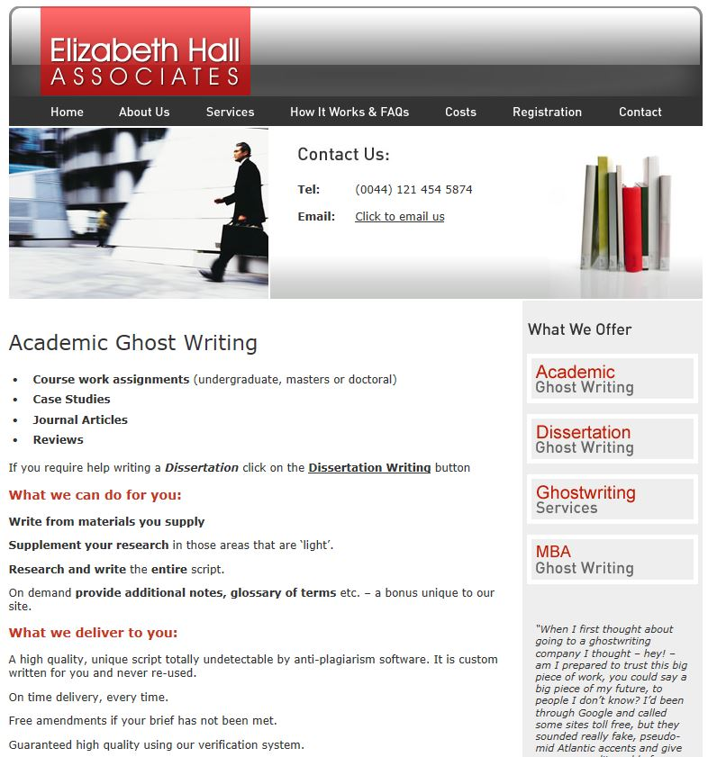
Diagram 1 Elizabeth Hall

Inevitably, for the authors, just as with students, choosing a solution provider came down to price and affordability. At one end of the scale was the low priced Caseforest costing less than £100 whilst at the other end Elizabeth Hall associates charging around £2070 whilst, as diagram 2 shows, for EssayFactory the price
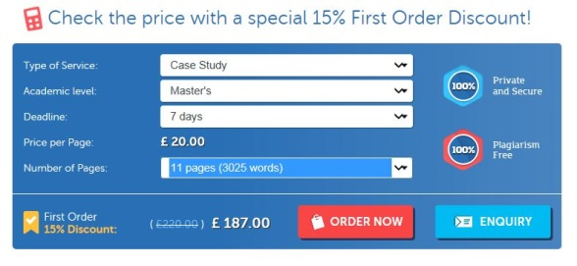
Diagram 2: EssayFactory

is dependent upon a number of factors including level e.g. undergraduate, postgraduate, assignment length - number of words - and the date by which the work is returned.

For our quality test the cheapest option, CaseForest was selected as this would be affordable for the widest cohort of students - even those on a tight budget, and the commission was set up.

How custom case solution writing services operate

The ‘Welcome message’ for caseforest.com (Diagram 3) gives the following reasons why students resort to paid for case solutions e.g.

- Case study contains large number of pages
- Not able to devote enough time from their busy schedule to solve a case study
- Case study requiring higher level of understanding (18)

The focus of this study is on the third of these.

The remaining paragraphs claim that the site provides all that an MBA student needs for their MBA coursework and assessment.

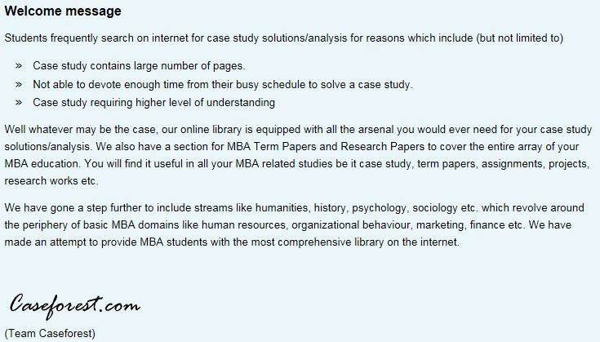
Diagram 3

However, claiming to equip students with an arsenal of academic weapons does not mean that the student will comprehend their use and application especially when applied to case study analysis. The contention here is that students will tend towards buying a full case study solution rather than the tools that would help them build one.
The case method aims to develop individual and peer research and as Gallagher (19) points out “The business case study as pedagogy is, to some extent, founded on the notion of experiential learning where students direct their own learning by formulating questions and taking responsibility for their study.” However, paid for solutions circumvent this learning process to the detriment of the student by negating the process of research, thinking, peer discussion, analysis and writing. Moreover, it weakens the institution and defrauds future employers when they engage and pay for skills the student does not possess.
The caseforest.com web page (Diagram 4) highlights some interesting aspects of what is on offer. Most of what is said in the page is self-evident. However, elements such as ‘Need a brand new solution of the case study already available on freecasestudysolutions?’ and ‘Need a solution of the case study NOT available on freecasestudysolutions?’ speaks to the bespoke nature of the service being provided - but, not, as yet, for finance and accountancy case studies.

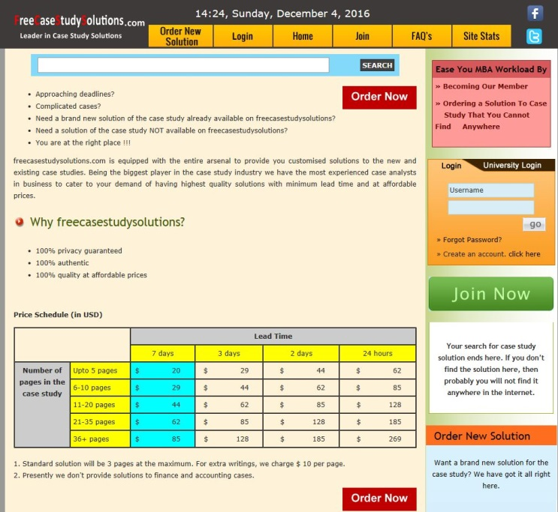
Diagram 4

There seems to be a dichotomy between the website title FreeCaseStudySolutions.com and the concept of paid for solutions given the price schedule. Nevertheless, as the site states its about 100% quality at affordable prices where a standard solution comprises three pages 275 words per page with a seven day lead time. The key questions are how good is the provided solution and its analysis and will it pass muster in an examination situation?

If it is not standard then the ‘Order New Solution’ button gives access to Diagram 5 where a soft copy (word, pdf) of the case study may be uploaded to caseforest.com site. Pricing is based on the number of pages comprising the case study and the lead time requested.

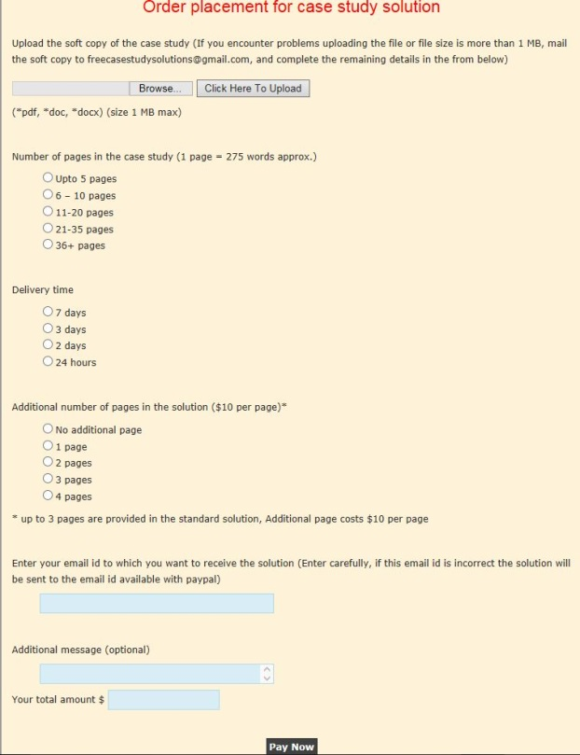
Diagram 5

We uploaded Tyrrells Chips clicking the 21-35 pages button, the 7 day delivery time and no additional pages at a total cost of $62 and waited for the solution to be sent. However, this action raises some issues for example, is this website all it seems to be? At first sight FreeCaseStudySolutions appears to be, to all intents and purposes, a normal British web site for a British company selling branded products. But on examination they are actually based in India. Visiting their website and clicking on Terms & Conditions the following was found:

“This agreement is governed by the laws of the Government of India and you hereby irrevocably consent to the exclusive jurisdiction and venue of the courts in Ranchi, Jharkhand, India in all disputes arising out of or relating to the use of caseforest.com's services.”

Likewise, the domain, caseforest.com, was found to be registered in India.

There is nothing wrong, per se, with an Indian organisation operating as a British one. However, the solution when received contained grammatical and idiomatic errors which if left unchanged and handed in as course assessment would flag a problem of potential plagiarism, irrespective of whether text recognition software was used by the solution supplier or not. Contract cheating will not provide a plagiarised source document as this is original work, but not by the enrolled student. It is, however, misrepresentation and in plain terms blatant cheating.

The steps in the process of buying a case study solution are shown in diagram 6. However, the key point in the diagram lies in the third segment where the company commissions a writer and or specialists to complete the work. Case study analysis is more than just writing an essay. It requires a holistic approach to problem solving that not all (commission) writers will possess in enough depth to guarantee a given grade.
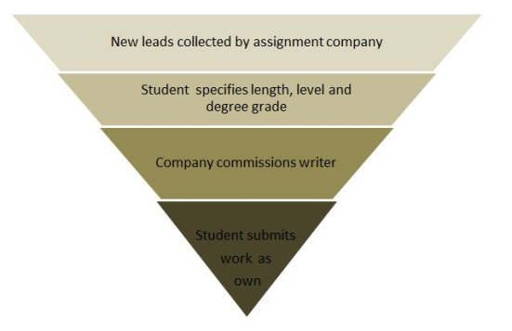
Diagram 6

Correspondence with CaseForest

CaseForest
Thanks for placing the order with us. You have selected 7 days delivery for the solution. To enable our team proceed with the solution, you are requested to let us know the following:

1. The attached file mentions that 2 questions need to be answered. Which of the 2 questions out of the 3 you want us to answer?
2. What will be the length of each answer like 400 words / 2 pages etc.
3. Any specific topic(s) that you want us to include in the analysis like 5- forces, SWOT etc.

Customer
Thanks for getting back to me so quickly.
1. It doesn't matter. I have no preference.
2. Answers are to be approx 1500 words each
3. Needs to include at least PESTL, SWOT, Five Forces, USPs

CaseForest
1. Thank you for your below message. We understood every part of your message except USPs, we believe it's Unique Selling Proposition. In case, you meant something else, please let us know.

2. As mentioned on our website, the case study order includes only 3 pages of writing which is approx 1500 words (calculated as 500 words per page). However, you would be needing a total of 3000 words or 6 pages in the solution.

Additional pages are charged at a discounted rate of $7.5 per page (original cost is $10 per page as mentioned on website). So, for 3 additional pages, the additional amount payable would be $22.5.

Please confirm your acceptance for payment of additional $22.5 so that we can send you the invoice accordingly. Alternatively you also have the option to reduce the number of words that you need in the solution. Please let us know your decision to enable us proceed further.

Customer
USP are indeed Unique Selling Point.
Yes, I am happy with the extra charge.

Process for Solution Production

Normally, case analysis would follow the stages in diagram 6 starting with reading the case study and following through to the case analysis and submitted answers.

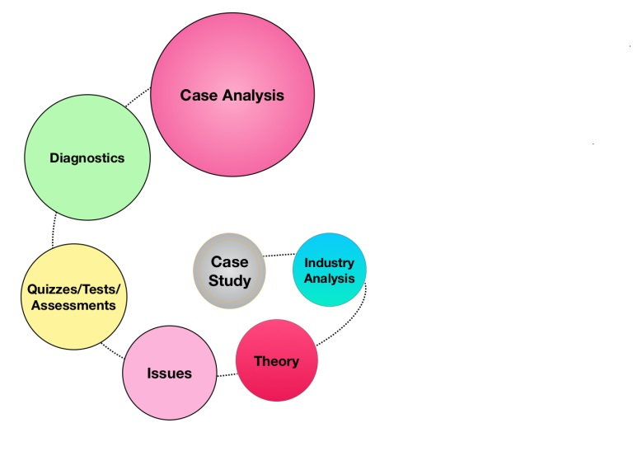
Diagram 7

1: The Case Study

A case study is a story which generally speaks to the actions of the key players in response to environmental change, opportunities and threats. It has a beginning, middle and an end. There is no definitive solution to the case study only a guide. This might make it a little difficult to promise a specific grade associated with a contract solution unless all the elements of diagram 7 are examined.

2: Industry Analysis

Case studies are generally based within a specific industry and most often in an industry with only a few dominant players. Numerically there are likely to be four or less who control 80% or more of the market. It is against this that the target company is measured. Consequently, it is against these that the solution is measured.

3: Theory

Within any individual case study there are a number of theory bases that underpin the case. Knowledge of theory is therefore essential to understanding what is going on in the case. Moreover, when setting the case the lecturer will be aware of the theory he or she expects to be addressed in the solution.

4/5: Issues/Assessment

A question set by a lecturer and sent by a student to a solution provider is generally straight forward in terms of what is called for in solution generation. The parameters of the question are generally quite obvious to the expert in the field. It is probable that the expert will have answered this question before or a variation of it.

Case study assessment is more complex. A case study has embedded in it multiple issues any of which can be the focus for an individual question. The lecturer using the case study will be influenced when setting his assessment questions by a variety of elements such as:
a: what theory he or she has been focussing on in lectures/
b: what diagnostic tools have students been introduced to?
c: what analytical techniques have been stressed?
d: is the assessment individual or group based?
e: is it essay or report format?

Moreover, the case study is by its nature a complex, unstructured body of work with no definitive solution. Questions set on this body of work are embedded in an interlinked matrix where any single action will impact upon multiple elements and result in multiple interpretations of the result from this single action. In addition, exploration of the impact on other players and an appreciation of their motivation is a pre-requisite to good case answer development.

6: Diagnostics

Diagnostic tools help explain the significance of the issued identified in the case and the inter-relatedness of the factors within the case. However, not all tools of analysis are appropriate to every case. Consequently, choosing the right diagnostic tools to help explain what is going on in the case is fundamental to achieving clear analysis.

7: Case Analysis
The primary problem that confronts everyone who reads a case is that they don't know what to look for in that case. Overcoming this dilemma can be achieved by a adopting a step by step process.
This process of case analysis begins by understanding the context in which the case is being analyzed or discussed. However, context also encapsulates the use the case is being put to e.g. what is the topic being discussed in this part of the course and how does this case relate to the topic under examination? Answering these will provides a clear insight to elements of the broad theory base and diagnostic tools that may aid in developing both an analysis and a solution to the case questions set. In addition, students need to be prepared to observe the situation from multiple perspectives for example, how would each of the key players in the case study view the situation?
The implication for the person who writes a paid for answer is that they must of necessity read and understand the individual case study and its contextualisation. CaseForest simply required submission of the case study, the questions associated with it and what diagnostic tools should be used. Elizabeth Hall on the other hand offers the availability of supplying the case, the questions, access to student portal, course materials, more in-depth analysis through assigned specialists plus back-up materials e.g. glossary of terms and additional notes but all at a cost.

The stress point in this process is – company commission writer.
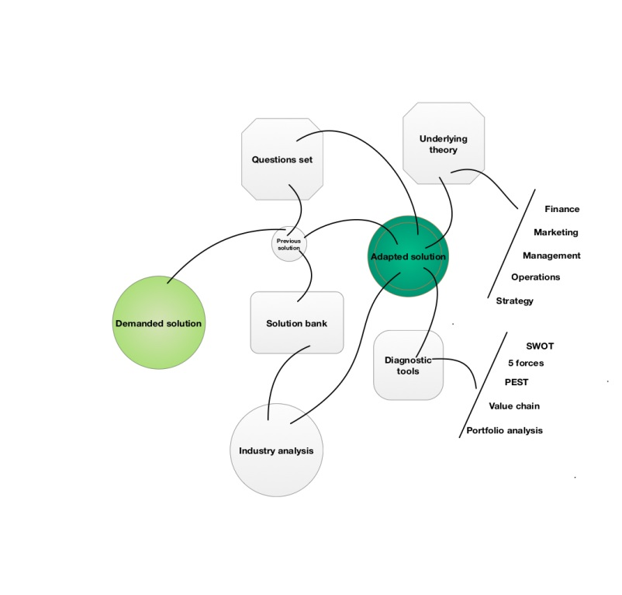
Diagram 8

For the paid-for-solution writer this work is not simply the application of learned theory but rather it should be the application of applied theory. Even if there is a pre-existing case study as Caseforest suggests (diagram 4) it will still have to be adapted to satisfy the demanded solution as shown in diagram 8.
Moreover, are these case solutions sold on the basis of already published cases or are they custom tailored to individually submitted cases?

If the former, then this is a limited market for a number of reasons:

1: if the case solution is held in a solution bank then it will be generic and will be unlikely to satisfy the case questions set
2: cases themselves have a limited shelf-life both in terms of the student expectation and curriculum development.

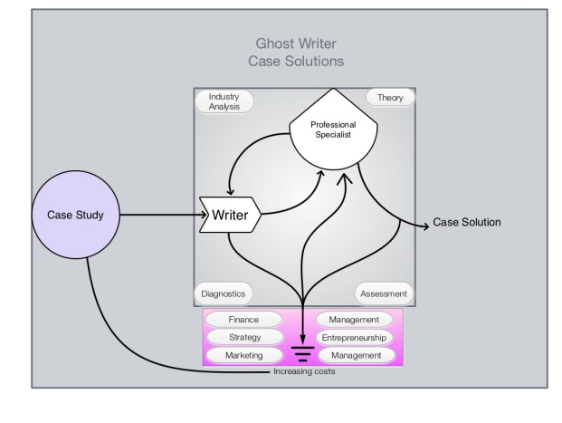
Diagram 9
If the latter then they may (diagram 9) require a ghost writer (Elizabeth Hall) drawing on greater resources and more in-depth analysis as:

1: cases are a snapshot in time
2: cases cover a variety of theory bases where any one could be the focus for examination.
3: cases are unique to the time and context of their time-line.
Moreover, costs will be high for bespoke solutions on unpublished cases
as the work involved in solution generation will be high as one size does not fit all and a variety of writers drawing on wider theory base is required.

However, as the QAA points out “If students submit work that is not their own, this compromises the fairness of the assessment process, brings the validity of their qualification into question - in particular by presenting an inaccurate account of their knowledge, skills and attributes - and poses a threat to the reputation of UK higher education.” (Ref 7)
These case solution sites devalue the work of honest students and risk making degrees worthless.

The Solution
Due to space restriction the following hypertext link will give access to the Tyrrells Chips interactive case study

http://www2.napier.ac.uk/depts/imp/case/index.html

Within the case study is the teaching guide where a copy of the Caseforest solution is held. This may easily be juxtaposed with the teaching guide. Unfortunately, access to the teaching guide is restricted to accredited teaching staff. If you require access please send an e-mail to j.gallagher@napier.ac.uk.

The CaseForest solution duly arrived and was promptly juxtaposed with the one that we had developed for the Tyrrells Chips case. The process of assessment was straightforward, take the bought solution and mark it as though it were a submitted piece of coursework from an MBA class. The result form this was that it was marked as a fail. Moreover, as with most coursework, it was given out for additional blind review - second marked. Again it was marked as a fail. It was also put through Turnitin and was found to have only 1% plagiarism.

When juxtaposed with the case author’s solution the quality of the paid for answer and its analysis was poor. The paid for solution was superficial. The author skated over the surface without digging deep and creating illuminating linkages and depth of analysis. At no point did the paid for solution author show initiative. The diagnostic tools addressed in the communications with CaseForest were the only ones addressed in the solution. No reference was given to other factors such as leadership, finance, managerial resources, critical success factors, value chain and so on. Essentially, the solution concentrated on diagnosis with little attempt at prognosis. Depth of analysis was sadly lacking as was any attempt at creating linkages by reading between the lines.

Conclusions

Plagiarism diminishes the educational experience for the student. In the instance of teaching by case study it impacts most forcefully through students abrogating the process of learning and research, thinking, peer discussion, analysis and writing.

Ghost writers or contract writers may or may not provide quality work. The purchased answer is the original work of the person who wrote it but not of the student submitting it as their own work. It is also worth noting that many universities require students to sign a declaration that the work that they are submitting for assessment is their own.

As the QAA points out, students submitting work that is not their own is fraud. In addition by submitting the work as their own they (students) undermine the quality and reputation of UK degrees which in turn impacts directly on the value of the qualification of their peers (7).

A further negative aspect is that the efficacy of Government policy of increasing university access is compromised by these essay mills. Course fees are in excess of £9,000 per year and post graduate degrees cost substantially more. But how can the less affluent student compete with those who can afford subcontract their course assessment at up to £4,500 each? Even a poor paid for case study answer provides a frame of reference to build on.
Paid for case solution sites are growing rapidly as they take advantage of students who in the panic of an approaching deadline, complicated case study or perceived tactical study aid promise original, plagiarism-free work that will earn students first-class grades. However, as we discovered the purchased solution can be far from the promised standard paid for.
The dissatisfied student is but one step away from the position of the consumer who knowingly purchases stolen goods only to later discover that the goods are inferior to those promised. For the student is purchasing goods from the essay mill that they intend to use to steal grades. Any attempt to gain recompense from the provider of shoddy goods, i.e. answers that receive lower than the promised grades, risks drawing attention to the student's own attempt to deceive their university.

How can the threats from the essay mills be addressed? Should a form of the New Zealand model, to curb the activities of essay mills by making it illegal to advertise or provide third-party assistance to cheat, be adopted by the UK it is unlikely that this alone will eradicate fully this form of plagiarism? Institutions need to understand that contract cheating will not provide a source document that can be readily detected by text matching software such as Turnitin. We humans are a problem solving species with genetically coded desire to progress through resolving challenges. Unfortunately, for some e.g. student plagiarists, a quick fix for academic problems i.e. assessment/coursework/examinations, is recourse to the web for solutions that shortcut both effort and grading.
Educational institutions are, like companies, selling a product but if their orientation is simply sales orientation (bums on seats) then brand image will suffer and perceived product value will diminish. The purchasers of degrees are not just the students but the employers who hire them.
It is vital that the education sector work together to address this in a consistent and robust way that cultivates students’ engagement in their learning and helps them recognise the imperative of good academic practice. The failure to do so will ultimately adversely impact on educational brand equity at both institutional and national level.
The QAA (7) concluded that universities should try “to ‘design out’ opportunities for plagiarism in their assessments, and to detect and penalise academic misconduct.” In light of this perhaps, for those that use case studies, a return to unsighted open-book examination may be called for. Moreover, using new case studies developed in-house, or accessing case study providers who restrict teaching guides, is an obvious re-learning step in developing an approach to formative and summative assessment. To this end perhaps a return to case study assessment based on:

1: Source, or develop a current up-to-date case study – Case Centre
2: Hand out the case study three weeks prior to examination
3: Open book examination
4: Unsighted, invigilated questions.
It is vital that the sector, the government and the student body work together to address this problem in a consistent and robust way that both cultivates students’ engagement in their learning and helps them recognise the imperative of good academic practice whilst acknowledging that students are not just balance sheet figures.
In future policy changes have to be made clear to students. They need to know that if they buy case study solutions and submit them as their own they will be breaking the law. Moreover, the penalty for doing so should carry with it the potential for course expulsion.
References/Bibliography

1: http://www.channel4.com/info/press/news/dispatches-investigation-reveals-extent-of-student-plagiarism/
Accessed 04/12/2016
2: http://www.academicknowledge.com/become-a-writer/
Accessed 04/12/2016
3: https://www.freecasestudysolutions.com/default.aspx

4: http://www.telegraph.co.uk/education/2017/02/21/university-students-could-fined-handedcriminal-records-plagiarised/

Accessed 21/02/2017
5: https://www.theguardian.com/higher-education-network/2016/oct/19/its-not-a-victimless-the-murky-business-of-buying-academic-essays

Accessed 21 02 2017

6: http://www.telegraph.co.uk/education/2017/02/21/university-students-could-fined-handedcriminal-records-plagiarised/

Accessed 21 02 2017
7: Plagiarism in Higher Education- Custom essay writing services: an exploration and next steps for the UK higher education sector, The Quality Assurance Agency for Higher Education 2016, QAA 1711 - Aug 16

8: http://wonkhe.com/blogs/a-joined-up-approach-is-needed-to-tackle-cheating/

Accessed 01 03 2017

9: http://blogs.lse.ac.uk/impactofsocialsciences/2017/02/28/university- students-are-buying-assignments-what-could-or-should-be-done-about-it/

Accessed 01 03 2017
10: Journal of Business Case Studies (JBCS): Trigger Questions: Their Role in Problem Based Learning – Do They Add Value to the Quality of Interactive Business Case Study Solutions? Volume 3, Number 4, Fourth Quarter 2007. ISSN: 1555-3353
11: https://www.theguardian.com/education/2017/mar/04/essays-for-sale-the-booming-online-industry-in-writing-academic-work-to-order
12: Newton, P. & Lang, C. (2016) Custom Essay Writers, Freelancers, and Other Paid Third Parties. In Tracey Bretag, Helen Marsden (Ed.), Handbook of Academic Integrity. (pp. 249-271). Springer.
https://cronfa.swan.ac.uk/Record/cronfa20206
13: http://turnitin.com/en_us/higher-education
Accessed 06 03 2017
14: http://www.elizabethhall.com/
Accessed 02/12/2016
15: https://essayfactory.uk/pricing.html
Accessed 04/12/2016
16: Jay Cross. A History of eLearning The Future of eLearning, March 26, 2004 Berkeley, California
17: Castells M (1996) The rise of the network society. Cambridge, Massachusetts: Blackwell
Publishers.

18: CaseForest, https://freecasestudysolutions.com/frmCategoryList.aspx?CategoryID=1006
Accessed 28 11 2016

19: Gallagher, J., Refereed Paper: presented at the Applied Business Research Conference (ABR) Cancun, Mexico: The Interactive, Multimedia, Business Case Study: A Suitable Candidate For Blended Learning? Published in proceedings. 2006

20: Law Dictionary: What is FRAUD? definition of FRAUD (Black's Law Dictionary)
http://thelawdictionary.org/fraud/
Accessed 06 04 2017
21: Channel 4 Dispatches , http://www.channel4.com/info/press/news/dispatches-investigation-reveals-extent-of-student-plagiarism, 15 June 2016. Accessed, 12 12 2016

http://www2.napier.ac.uk/depts/imp/case/index.html

