Management Accounting

Budgeting
Creating the future

Grahame Steven
Edinburgh Napier University

What is a budget? What is a plan? How do plans and budgets interact with each other? A brief explanation.

Plans are concerned with the long term i.e. more than one year. Budgets cover a year. But how long should a plan be? 3 years? 5 years? 10 years? Or even 20 years? There is no simple answer. The key criteria that defines the length of a plan is the volatility or stability of the business sector in which a company operates. More volatile sectors subject to technological change – e.g. electronics – tend to have shorter planning horizons than more stable sectors with high barriers to entry e.g. utilities. Consider how long it takes to build and commission power plants.

So where does the budget fit into the planning process? The budget is the detailed version of year 1 of the plan. However, there is never a detailed version of year 2 of a plan. Why? Companies update plans each year to take account of changes to their business environment. Consider Brexit! This means year 1 of next year’s plan will become the budget for the following year.

CIMA Official Terminology (2005) defines a budget as “a quantitative expression of a plan for a defined period of time. It may include planned sales volumes and revenues, resource quantities, costs and expenses, assets, liabilities and cash flows.” While this definition is useful, it describes the output from a budget process not what constitutes a good budget process. When managers view budgeting as an annual “evil”, it is extremely unlikely that a satisfactory budget will emerge. Managers must view budgeting in a positive light to enable this process to drive a business forward. A good budget will only emerge from a good budget process. Perhaps a better definition for budgeting is “the financial representation of creative thinking within a company.”

Budgeting, when done properly, has many benefits:

- Compels planning
- Communicates objectives and strategies
- Coordinates activities
- Identifies limiting factors
- Responsibility accounting
- Feed-forward control
- Feedback control
- Motivation

Companies normally budget on an annual basis. This means managers have to consider what is happening in the markets they sell to, determine their company’s strengths and weaknesses, be aware of what their competitors are doing, identify potential entrants, substitute products etc. This encourages managers to develop actions and strategies to maintain and improve performance. Managers will consequently tend to be proactive – take charge of events – not reactive – buffeted by events.

Communication of objectives and strategies is not an issue in most small companies since they have few employees and staff generally work in close proximity. People tend to know what is going on. However, the need to communicate objectives and strategies is often a major issue for medium-sized and large companies. The budget process will disseminate corporate level objectives and strategies throughout a company since the top-level budget is circulated to the functions and departments that make up a company.

The budget process enables the co-ordination of functions and departments within the company. Each function and department – sales, production, distribution, after-sales support, administration etc – will review what must be done to meet corporate objectives and take action, where this is necessary, to ensure the required resources are available.

Demand normally limits a company’s activities. However, on occasions other factors will limit its activities e.g. lack of capacity, shortage of skilled labour, shortage of raw materials etc. The budget process will identify any limiting factors since the budget is distributed to the departments and functions that make up a company to determine if they have sufficient or suitable resources to enable the achievement of the budget. When a limiting factor is identified, the company must be run in line with that limitation until it is removed e.g. expanding capacity, employing new staff, training current staff, identifying alternative sources of supply etc. Managers must make choices as to which products will be made and which customers will be supplied until the limiting factor is removed. Sending out the sales representatives to obtain orders that cannot be supplied will lead to customer dissatisfaction and loss of reputation. It is better to face up to problems and seek to manage them. How is done? By applying limiting factor analysis or undertaking linear-programming. These topics are covered in higher-level CIMA papers.

Revenues and costs are segregated into areas of responsibility e.g. function, department, branch, division, subsidiary. All revenues and costs are the responsibility of someone within a company. However, not all costs charged to managers are under their control. This is particularly true for allocated costs i.e. shared costs. A good example of this is the charge-out of factory rental to cost centres within a factory. Remember absorption costing! If factory rental charged to factory cost centres is over budget, this is not the responsibility of factory cost centre managers since they do not negotiate factory rental. The factory manager would normally be responsible for this cost. It is consequently important to identify which costs are controllable and uncontrollable at different levels within a company to evaluate managers’ performance. Always remember, when a cost is uncontrollable at a lower level – factory cost centre – it is controllable at a higher level – factory.

Feed-forward control compares projected results against desired results. Budgets go through many drafts before they are approved since it is unlikely that the initial set of ideas will meet a company’s financial objectives e.g. profit, return on capital employed.

Feedback control enables managers to manage performance since actual performance is compared against budget:

- Budget - Actual = Variance
- Ascertain the cause of favourable and unfavourable variances
- Take appropriate action to maintain / improve favourable variances, reduce / remove unfavourable variances. Don’t forget that favourable variances are as important as unfavourable variances. It is not just about the bad news!

Budgets have the power to motivate or demotivate people. Internal accounting reports indicate who has done well and who has not done well. So it is important to appreciate this when setting budgets or reviewing performance.

In simple terms, there are two types of budget: top-down, participation. In a top-down budgeting system, senior management develop and agree the budget with little or no consultation with company personnel. There will consequently be little, if any, commitment amongst lower-level staff to such a budget since senior management has imposed it on the company.

The alternative approach is to give staff more involvement in the budget process. This approach should encourage staff to put forward ideas to improve the company’s performance and result in staff having a greater ownership of the final budget. However, this is a more time consuming process and there is a danger of budget manipulation i.e. budget slack. Sales staff may attempt to understate budget sales to increase their sales commission and cost centre managers may attempt to overstate budget costs to increase the likelihood of favourable variances. Most organisations favour a participative approach since they want empowered, committed managers and staff. However, when a company is facing a short-term crisis, a top-down approach may be required for the crisis period.

Another issue is culture. One division might have a “striving” culture. While this division’s budget should be set at a demanding level to motivate that division, this means that adverse variances will tend to be reported. Another division may prefer to be seen to be performing well. So their budget should be set at a level that will enable it, with some effort, to beat the budget. This means favourable variances will tend to be reported. One type of culture is not better than another. The trick is to set the budget at the performance level which will best motivate that division. However, doing this muddies the water when it comes to evaluating performance. Budget setting is not a precise science!

A number of commentators have questioned the value of budgeting. However, recent surveys, including one undertaken by CIMA – Management Accounting tools for today and tomorrow – have found that budgeting is widely used.

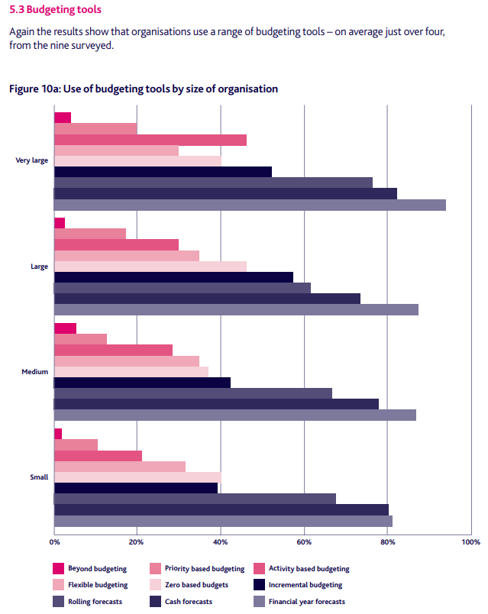

Budgeting will never be a simple process since it is about the future and deals with people. However, when budgeting is viewed as a positive process it can, with creative thinking, create the future.

