Paul Kerlaff | Making Futures 2017 | Paper Submission

Re-defining Finishing, Performance and Durability: User Re-Manufacturable Surfboards

Paul Kerlaff is Programme Leader for Interior and Spatial Design at Edinburgh Napier University, and an internationally exhibited furniture designer.

Abstract

This paper makes the case for surfboards being a prime archetype of user-object relations. It goes on to argue that design for remanufacture involves redefining notions of finishing, performance, and durability that underpin our relationship to material goods. Using the design of beginner-to-intermediate surfboards for user remanufacture as an illustration, the overlap between traditionally discrete phases of creation and use is explored as a way to extend life-spans and reduce non-linear material use.

Surfboards as an archetype of user-object relations

Our transition to a circular economy relies on evolving strategies for reducing our reliance on raw material consumption, but this in turn depends on a better understanding of how we relate to our possessions. The particularly intimate nature of surfers to surfboards, and the changing nature of user needs in surfing progression, present an opportunity for insight into the nature of this relationship. Exploring the idea of user remanufacture of surfboards allows us to reappraise current assumptions about when objects are finished, how we make value judgements on performance, and how obsolescence might be replaced by a new form of durability based on change.

The relationship between surfer and surfboard can be described as intimate because surfing itself is essentially uncertain, and the surfboard is a mediator of an unpredictable and potentially dangerous environment. Deciding to enter the sea for recreation is of course a voluntary act, but once a surfer has done so, they become dependent on their craft for survival in a real sense. Surfboards are tools, ready-to-hand as described by Heidegger [Horrigan-Kelly et al 2016:13] but their purpose is both a means of survival and a device for harnessing wave energy to create exhilaration. The relationship between surfer weight, volume and ability is simple to quantify - e.g. with Lost surfboards volume calculator (2018), but it is a dynamic intimacy, between user and thing – changing in use and over time– that makes surfing a particularly revealing subject for user-object relations. It is normal for boats and other sea-going craft to evoke personification, but surfboards are perceived as both valuable and, for reasons strongly associated with the learning process – subject to a high degree of obsolescence.

At least three different types of board are used in progression from beginner to intermediate level, each corresponding to a graduation in skill level and identity. The first board type facilitates the aim of all aspiring surfers: to catch a wave, stand up and ride it in a straight line into the beach. Around eight feet in length – using the dominant imperial system – beginner surfboards are relatively flat to facilitate paddling and speed, with a wide nose to encourage ‘planing’ over the surface of the water. These boards are often referred to as ‘foamies’ after the skin of soft EVA foam wrapping their expanded polystyrene core. Surfers hooked on the sensation of riding a moving band of energy will soon graduate to a shorter ‘mini-mal’ (derived from the Malibu boards of 1960’s California), around seven feet in length, with more curved outlines and thinner edges to allow the board to bite into the wave face when riding diagonally. Intermediate surfers then typically graduate to a shorter board again, around six feet long, with lower volume and a more rounded outline to allow increased manoeuvrability.

The standard process of beginner to intermediate progression in surfing can therefore be described as a repeated pattern of creation, use and obsolescence. At each of these points of use, the appropriate board for ability and for the conditions is paramount. Too small or short a board and the surfer will be unable to catch waves; too long and progression can be hampered by the lack of agility or responsiveness.

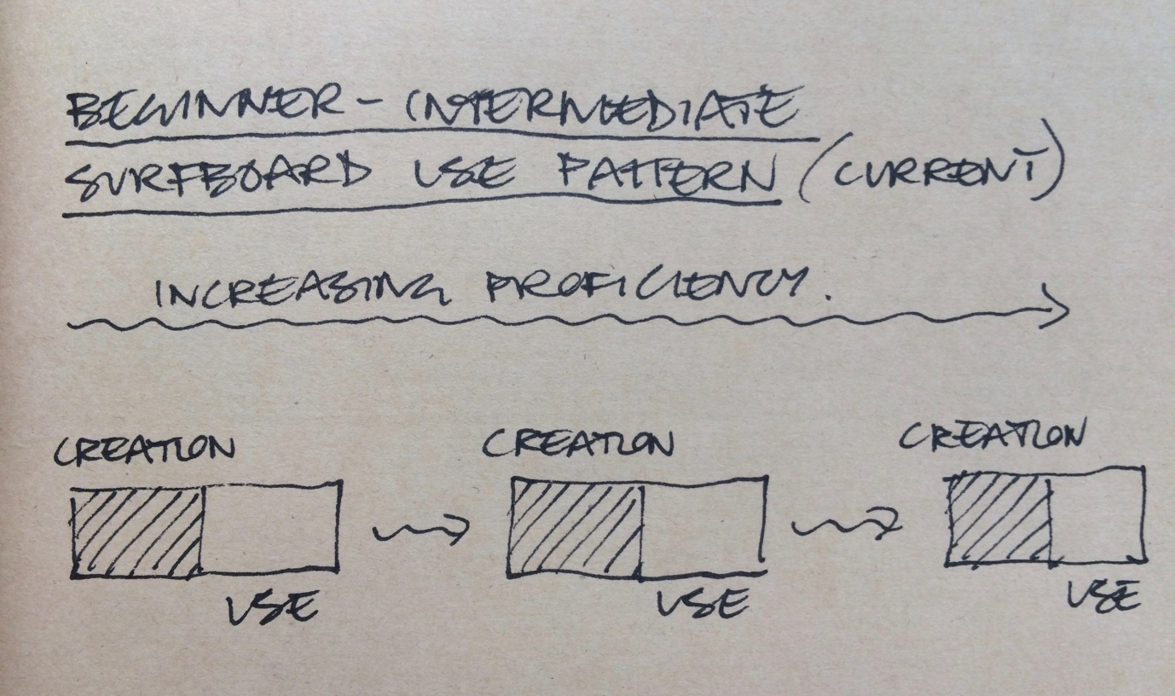
Image 1

Subsequently smaller board size is therefore linked to the various needs of progression, though the link between progression and obsolescence deserves further scrutiny. In addition, the ‘obsolescence’ is in question here is user-defined, based on a judgement about fitness-for-purpose rather than material degradation. Obsolescence here is also linked to social factors: different boards mark graduation through the ranks – surfing a shorter board means the ability to do so, and therefore represents an according status in the hierarchy of surfing. Hierarchy forms a functional part of the informal systems of priority which underpin surfing etiquette, helping to maintain order and safety in crowded surf spots across the world. Anticipation of others’ actions relies on an appreciation of the likely trajectory of fellow surfers, which is in part based on the type of board ridden. The presence of hierarchy in itself is perhaps only to be expected, given the variety of user ability and experience. However, just as car typologies often represent the social aspirations of owners more than practical use, so intermediate surfers are often keen to progress onto the subsequent vehicle, not least because those more manoeuvrable boards wait for waves closer into the breaking point, so gaining a competitive advantage in crowds. Social hierarchy is therefore a powerful factor in the perceived correlation between obsolescence and progression, being arguably just as significant as the functional needs of surfing itself. This phenomenon is by no means unique to surfing – Zero Waste Scotland (ZWS 2015:22) discovered compelling evidence of social factors being crucial in decisions about whether to re-use or throw away possessions, including items of small and large furniture, in addition to material considerations. Design for user-remanufacture should therefore address both individual and social needs.

Beyond the beginner-intermediate phase, the length of the board becomes much less related to ability; advanced surfers may swap between a small ‘quiver’ of boards, often custom made, and frequently used until irreparably damaged. The beginner-to-intermediate phase is where obsolescence is most closely linked to progression. In the sections which follow, we explore the origins of current surfboard making and use in order to frame our discussions of finishing, performance, and durability which underpin discussions of designing for user re-manufacture.

Defining the Finishing Point

Despite the intensity of user engagement, user participation in the shaping and reshaping of beginner-intermediate surfboards is relatively rare, and the patronage of specialist surfboard producers has a long history. Ancient Hawaiians would have cut down their own tree, leaving an offering of fish in the holes left in the roots (Britton, 2004), but the actual shaping would be carried out in a highly ritualised way by a local craftsman, concluding with a blessing by a priest. These boards were made from a limited palette of materials - one of three local woods (Koa, ‘Ulu, and Wiliwili) and, like today, there was a correlation between size and skill of rider, though this was inverted. The shortest of the four basic board types commonly in use, the 2-4’ paipo, was used by children, and the longest, the 18-24’ olo, was reserved for Hawaiian royalty who also retained the right to the best waves (Britton, 2004).

The introduction of polyurethane foam and polyester resin to surfboard construction after the second world war marked the ‘shortboard revolution’ – in which shorter, lighter and more manoeuvrable boards were associated with a higher level of skill. This new form of construction also marked the transformation of the ‘finishing point’ from a spiritual blessing to a more profane finishing – the process of wrapping a shaped foam core in glass fibre cloth, encapsulated in polyester resin. Material evolutions aside – most recently bio-resins and foams designed to minimise Volatile Organic Particles (VOCs)– this method of construction has formed the basis of custom and mass-produced surfboards for the last seventy years. Advanced surfers may engage with a detailed discussion with a shaper before commissioning a new board, but the cost in time is too high for the average surfer to participate extensively in the shaping process itself. Exceptions to this include ‘shape your own board’ workshops where participants make their own hollow wooden surfboards from kit parts, but these entail little room for experimentation and the boards produced are both highly labour intensive and unlikely to be surfed on an everyday basis for fear of damage. For the vast majority of surfboards, therefore, the point of ‘glassing’ marks the finishing point – a conceptual and literal threshold between creation and use.

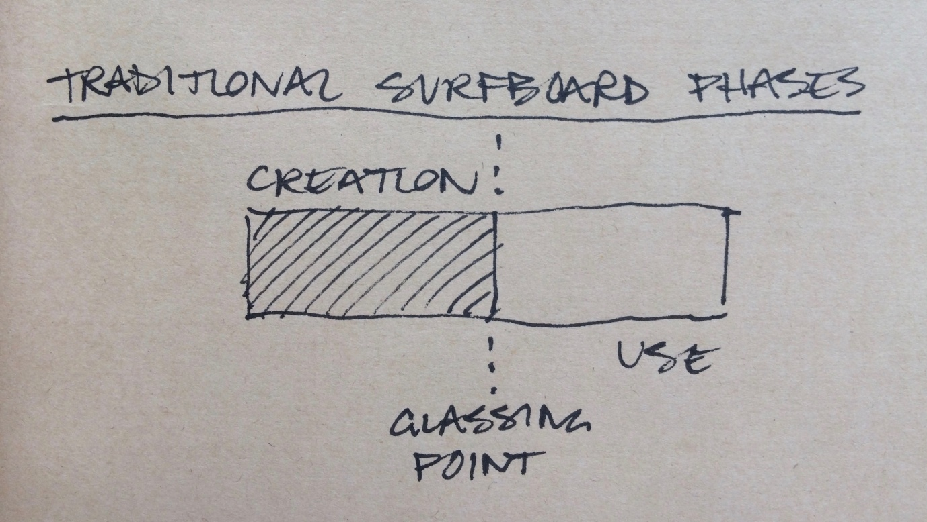
Image 2

However, this sequence was not always as unequivocally accepted. One of the key pioneers of surfboard shaping achieved some of his innovative forms by subverting the conventions of the new construction materials, and in doing so marked an overlap between creation and use. Bob Simmons, a talented mathematician, was introduced to surfing by a physician after a crippling bike accident in 1939. Simmons essentially applied modern materials and fins to harness the speed of early Paipo boards, pioneering a class of surfboards that he called “Hydrodynamic planing hulls’ (Kenvin, 2002). Founded in his understanding of fluid dynamics, this process was heavily reliant on testing and refinement, much of which was carried by out by Simmons himself. On some of his more radical designs, such as those with numerous deep channels on the base of the board, Simmons was seen testing his creations with a ‘tack coat’ of resin over the polyurethane foam core, before returning to the beach for final adjustments. He would only make the final fibreglass coat when satisfied, an iterative process which took several cycles. (Kenvin, 2002). In this process, Simmons was both designer and, for this short period, a user-remanufacturer.

In surfing a nearly-finished design Simmons was prototyping a finished product, but in doing so subverted the threshold between creation and use by overlapping the two and creating a phase of user remanufacture. Simmons feedback between change and effect was almost immediate, and more closely linked than the long-term feedback that a surfer and shaper would get through iterative development of surf board designs. User remanufacture here both catalysed design development and avoided obsolescence, both of a given prototype and of subsequent versions.

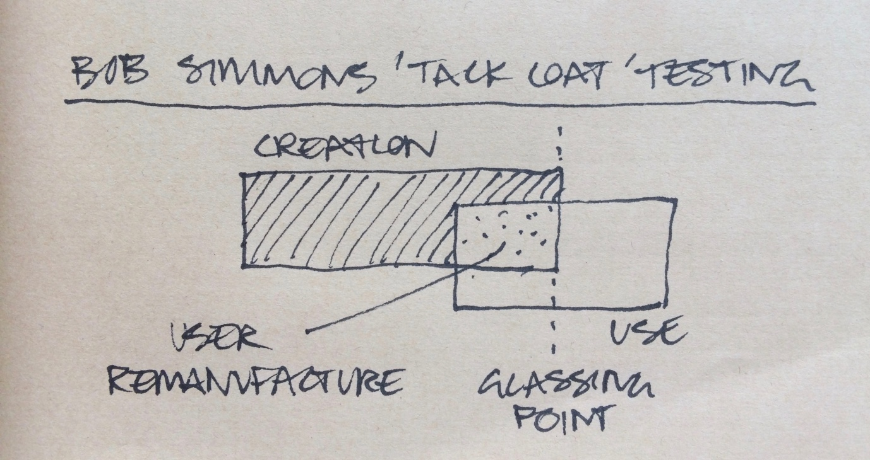
Image 3

Bob Simmons’ intense experimentation, made possible in part by user remanufacture, yielded some of the most influential developments in surfboard design, but many of these designs were not wholesale reinvention of the earlier forms. Simmons was heavily influenced by the work of naval architect Lindsay Lord, who first came to attention of the US government during the prohibition era by designing boats for ‘private clients’ that could outrun customs vessels. Lord avoided incarceration by the timely outbreak of the second world war, when he was commissioned by the US government to research high speed planing vessels, which he based on Hawaiian surfboards such as the Paipo. His ‘Naval Architecture of Planing Hulls’ (Lord, 1946) sought to quantify the best ratio of length to width for planing surfaces, and Bob Simmons project became the application of this knowledge back into surfboards. Simmons’ designs directly influenced the tiny, split-tailed, twin-finned ‘fish’ developed by San Diego knee boarder Steve Lis in 1967, and the Simon Anderson’s of the three-finned ‘thruster’ of the late 1970’s, broadly regarded as the dominant high-performance surfboard design in competitive wave riding. Simmons work was pivotal to the development of modern surfboard design, and his overlapping of the phases of creation and use underpinned his accelerated development of form.

Defining Performance

In any given design task, identifying which factors matter most in a particular context is essential. Design concepts, formed from the analysis of observation effectively act as the means of measuring relative value judgements about competing solutions. As an engineer, Bob Simmons firstly prioritised catching the waves as early as possible – to maximise the number of waves ridden in a crowded group of surfers, and then secondly, to attain the maximum speed whilst riding. He was less interested in manoeuvrability, and it took later iterations of his designs, including the much shorter ‘mini-simmons’ boards popularised by the Hydrodynmica project in the early 2000’s, to achieve more widespread attention from surfers. In reality, for most users, Simmons’ parameters for defining performance are relevant but are insufficient to describe the aims of recreational surfing. The overwhelming majority of participants do not actually compete in any formal sense, though competitions and sponsored competitive surfers heavily influence surfboard sales. The number of waves caught do matter for most surfers, but absolute speed is less important than enjoyment: ‘the best surfer out there is the one having the most fun’ (Ottom and Edwards, 1967:3)

The aim non-competitive surfing defies precise definition, but the enjoyment of the process depends on a surfer developing their ability to harness the power of a wave for exhilaration. Enjoyment is therefore bound together with individual agency – the same idea used for the promotion of consumer goods, including new surfboards. However, Matthew Crawford identifies a divergence between this idea of agency and the binding together of consumer freedom and consumption in ‘The Case for Working with your Hands’ (2010:63): ‘Somehow, self-realization and freedom always entail buying something new, never conserving something old’. For Crawford, this presumption is a kind of infantilization (2010:56), and he calls for a ‘a new sort of anthropology… one which is adequate to our experience of agency’ (2010:64). Seeking refuge from the world of right-leaning US think-tanks, Crawford finds his own agency in repairing motorbikes, but this principle of returning agency to consumers –of creation rather than consumption - suggests that the process of remanufacture may contribute not just to reduction in material use but also to the enjoyment of surfing.

Bob Simmons demonstrated the value of user reshaping to the design development process, but it is doubtful that enjoyment was a driving force, and his experiments always had an end in sight. But whereas Simmons aimed to extend the point of finishing in order to improve the finished state, Californian surfer Ryan Burch questioned the whole concept of ‘finishing’ altogether. In a series of finless, foam-only boards in 2009, explicitly based on the proportions of rectangular ‘plates’ used by Lord in his experiments on planing resistance (1946), Burch demonstrated with exceptional skill how these could be surfed, without fibreglass, in demanding waves. Burch is a professional surfer and shaper - but the principle demonstrated was clear: in order to enjoy surfing, and surf at an exceptional level, fibre-glassing a blank was not strictly necessary. According to conventional ‘competitive’ judging criteria, Burch could perform at an even higher level on a conventional three finned ‘thruster’, but what he demonstrated on the ‘Lord board’ was that if we accept enjoyment as a relevant metric in assessing surfboards, fibre-glassing was not necessary for performance. To appreciate the significance surfing of an un-glassed chunk of foam for our broader understanding of user-object relations, we can examine how this idea of an ‘enjoyment’ metric contrasts to the ‘perfect’ state of a finished, glassed surfboard.

Richard Sennett describes perfectionism as a ‘stopping of the clock’ and a denial of individual agent’s ability to create and to learn from that creative process (2016). Though Sennett was speaking about the relationship of the craftsman to the idea of perfection, his point resonates with other situations in which the user has the potential to engage meaningfully with the shaping of things. Completion or perfection in making also presents a practical problem of definition, and there are several instances in which the point of completion becomes ill-defined, often due to the overlap of creation and use. In architecture, Tim Ingold describes completion as ‘at best, a legal fiction’ (2013:48), invented for the purposes of completing contracts, yet a house may not be complete until the owners feel it has become their home, furnished and occupied; and the ‘snagging’ process of completing minor works outstanding may continue for months if not years. Defining the ‘perfect’ point of being finished is not confined to of architecture: furniture designer Hans Wegner considered that a chair is only finished when someone sits in it. If we understand making things as an assembly or coming together of materials for a certain purpose, then finishing is the point of it becoming usable. But materials begin to weather and degrade almost as soon as they are brought together, and the ideal point may not coincide for all elements of a made thing. A degree of overlap between the phases of creation and use therefore already exists in many fields of making, but user manufacture takes this one step further by explicitly defining the potential benefits of this overlapping phase.

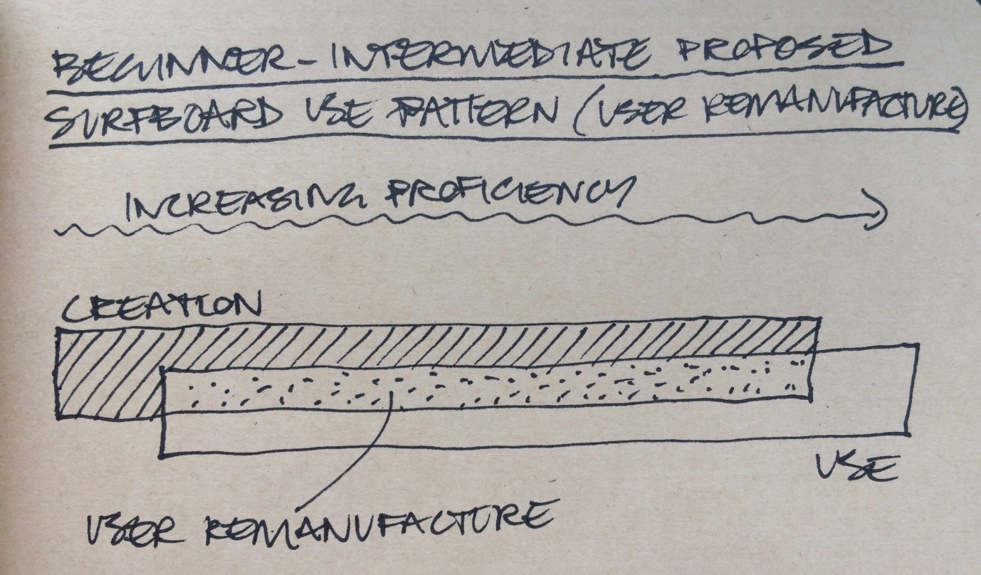
Image 4

User-remanufacture -in surfboards at least, but arguably in all user-object relations which contain some element of user enjoyment - relies on redefinition of finishing and performance, both underpinned by enjoyment as a metric. Removing the glassing point of traditional surfboard construction redefines the point of finishing, allowing use to begin as soon as the object allows enjoyment – and as Ryan Burch effectively proved, this could be in an almost raw state. If we redefine surfboard metrics to include enjoyment as a legitimate means of measuring the performance, we have a more robust criterion for assessing usefulness and fitness for purpose than those defined by manufacturers and other non-users. Individual agency, described by Crawford as a means of fostering creation rather than consumption (2010:6), and overlapping the traditionally discrete phases of creation and use greatly extends the opportunity for user enjoyment to create longer lasting bonds with possessions.

Defining Durability

Longevity of user-object relations requires a robust strategy for sustaining engagement. Yvon Chouinard, founder of the company which later became Patagonia, originally taught himself blacksmithing in 1957 as a means to improve the single-use pitons used by climbers up to that point. Pitons are metal spikes hammered into the rock to secure ropes, and Chouinards’ versions were made from Chrome-Molybdenum steel, strong enough to be re-used. His business soon flourished, and by 1970, Chouinard Equipment was the largest provider of climbing equipment in the USA (Chouinard 2016:26). The re-usability of his products, founded on improved material choice and design, has continued to inform the philosophy of Patagonia Inc., now one of the most successful large businesses engaged with environmental issues – though Chouinard himself recognises the contradictions of a business which consumes raw materials, summarised in his mission statement ‘make the best product, do no unnecessary harm’(2016: 3). Patagonia identified durability early on as the ability to resist material degradation, and for advanced surfers, such as those who order from Yvon’s son Fletcher Chouinard, this is indeed the appropriate perspective. A surfboard for an advanced user should cause the least harm in its manufacture, and outlasts several others by virtue of its resistance to change.

However, the key aim of this resistance is actually longevity, and the association between resistance to change and durability is only valid when obsolescence is caused by material exhaustion. Because the primary mechanism for obsolescence in beginner-intermediate surfboards is functional obsolescence, a definition of durability based on resistance to change in this cases is somewhat inappropriate. In fact, we might argue that resistance to change is a causal factor in beginner surfboards becoming unfit for purpose, and that inability to adapt prevents longevity. In redefining our concepts of finishing to accommodate the potential of user-reshaping, and by accepting enjoyment as a metric for performance, we also have to accept that our definition of durability needs to accommodate change.

The image below shows a first step of exploring what this newly-defined model of user-manufacturable surfboard might look like. A traditional polyurethane foam and basswood stringer longboard blank is marked out in pencil with three concentrically smaller templates, representing the three sequential forms that a beginner-intermediate surfer might use. This version could not be used without fibreglass, because the polyurathane foam would quickly take on water and be rendered useless, but a subsequent version, using an off the shelf high density Expanded Polystyrene foam blank, encapsulating a carbon fibre inner core, will be used for user testing in the following stages. The aim is both to evolve an increasingly effective design for surfboards which support user manufacture, and explore the reciprocal relations between humans and things which occur in user-remanufacture.

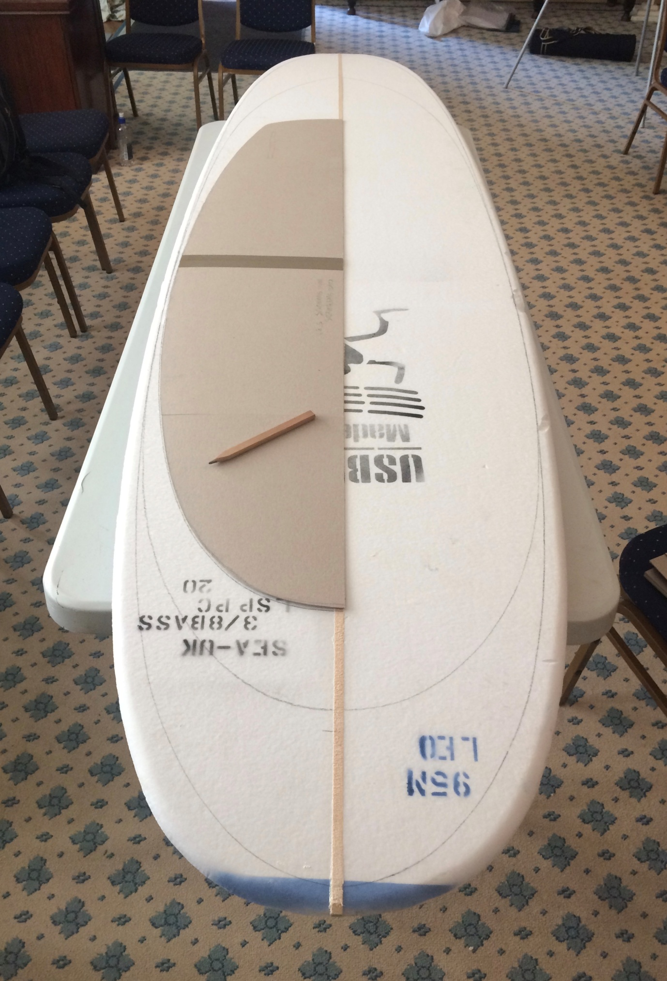

Image 5: prototype for user remanufacture: a polyurethane surfboard blank marked out with three concentric templates for beginner-intermediate use. Image: Paul Kerlaff / Making Futures 2017)

Summary

The intended purpose of this paper was to highlight the effect of user-remanufacture to explore the nature of our relation to things, as order to contribute to ongoing debate about our role as designers and makers in relation to raw materials. I have used the surfboard as a vehicle for illustration, but many of the questions surrounding finishing, performance and durability have a wider resonance, and it is hoped that this ongoing process of inquiry may help to refine future design practice.

User remanufacture offers a means of blurring the threshold between creation and use, potentially extending the point of disposal to the point of material exhaustion, rather than a functional obsolescence. This proposal implies three reconsiderations; of finishing to accommodate overlap between creation and use; of performance to accept enjoyment as a metric; and of durability to include transformative potential, the very opposite of resistance to change.

Design for user-remanufacture offers a number of opportunities to re-define our relationship with objects, but navigation of this new terrain will require more than semantic agility. Our role will necessarily be more active, because achieving longevity of use will depend on a reciprocal user-object relationship which is closer to our current model of fixing than of consumption. Accepting this idea involves accepting the possibility of failure, which Matthew Crawford describes as stochastic, like medicine, because we deal with pre-existing conditions when we fix or remake something, with no absolute control over the outcome. There is no guarantee that an operation will be a success, and medical practice prides itself in openly discussing cases in which new knowledge can be gained from the characteristics of failure. There is no guarantee that a motorbike may be fixed either (to take Crawford’s area of expertise), or in our discussion, no guarantee that any given removal of surfboard volume by a user-reshaper would be an improvement. The point of ‘perfection’, if it is ever reached, may only be appreciated retrospectively, but engaging users in the process of remanufacture has the potential to enrich our experience and understanding of things.

References

Britton, Veronica (2004) ‘The Sport of Kings’, A history of surfing http://iml.jou.ufl.edu/projects/Spring04/Britton/history.htm Accessed 8/3/18
Chouinard, Yvon (1972) Chouinard Equipment Catalog, from https://signalvnoise.com/posts/2776-on-writing-the-1972-chouinard-catalog-that-changed-a-business-and-climbing-forever accessed 12/3/18
Chouinard, Yvon (2016) Let My People Go Surfing: The Education of a Reluctant Businessman, Penguin, London
Crawford, Matthew (2010): The Case for Working with your Hands, Penguin, London
Horrigan-Kelly, M; Millar, M; Dowling, M (2016): Understanding the Key Tenets of Heidegger’s Philosophy for Interpretive Phenomenological Research: International Journal of Qualitative Methods https://doi.org/10.1177/1609406916680634 First Published November 30, 2016
Ingold, Tim (2013) Making: Anthropology, Archaeology, Art and Architecture, Routledge, London
Kenvin, Richard (2002) Hydrodynamica, http://hydrodynamica.com/totem/index.php accessed 20/2/18
Lord, Lindsay (1946) ‘Naval Architecture of Planing Hulls’, selection downloaded from https://www.wavetribe.com/products/naval-architecture-of-planing-hulls Downloaded 8/2/18
Lost Surfboards (accessed 2018)Volume Calculator, http://lostsurfboards.net/volume-calculator/ accessed 13/3/18

Ottom, Bob and Edwards, Phil (1967): You Should Have Been Here an Hour Ago, Harper and Row, USA
Sennett, Richard, (2016): quoted from lecture at Edinburgh University, November 2016 (Author’s notes).
Warshaw, Matt, (2005): The Encyclopaedia of Surfing, Harvest Books, USA
Zero Waste Scotland (2015) (author not attributed) http://www.zerowastescotland.org.uk/sites/default/files/Methodology%20-%20The%20composition%20of%20household%20waste%20at%20the%20kerbside%20in%202014-15.pdf accessed 8/3/18

