TITLE
“From souvenirs to 3D printed souvenirs”. Exploring the capabilities of additive manufacturing technologies in (re)-framing tourist souvenirs.

ABSTRACT
Souvenirs, whether mass-produced commodities made elsewhere or local artisanal handicrafts, are static objects that lack the capacity to mediate or generate the co-creative, active or immersive experiences that tourists desire. The expansion of additive manufacturing (3D printing) and open access digital fabrication facilities creates opportunities for personalisation, creativity and prosumption that could alter souvenir consumption. Using a qualitative approach, this study examined visitor preferences and managers views on 3D printed souvenirs that were mass-produced but individualised within a heritage retail environment, where the visitors were able to interact with the digital making process. The findings suggest while there is some interest in designing and personalising souvenirs using new technologies, there are also intellectual and ethical challenges which need to be addressed. We propose the 3D printed souvenir as a new type of souvenir and a future research agenda that considers the technology implications for tourist consumption.

Keywords: heritage, sustainability, gift shops; retailing; 3D printing; souvenir; additive manufacturing

HIGHLIGHTS:
- Souvenirs are passively consumed and lack co-creative and experiential features
- 3D printing can transform souvenirs from passive to experiential objects
- Some visitors desire further involvement in souvenir design and personalisation
- Managers identified challenges in adopting 3D printing for souvenir production
- A research agenda and future implications of 3D printing in tourism are considered

- INTRODUCTION
Gift shops generate significant revenue streams for heritage and tourism attractions (Jin, Moscardo, & Murphy, 2017; Kong & Chang, 2016; Swanson & Timothy, 2012). The purchase of souvenirs offers visitors the opportunity to transform the intangible encounters they experience during their visit into a tangible memory and expand the connection to the visited place beyond the visit itself (Collins-Kreiner & Zins, 2011; Fangxuan & Ryan, 2018; Haldrup, 2017). Greater value is assigned to objects that have been personalised to the taste and preferences of the buyer, as these souvenirs offer a superior fit. However, deciding on which items to offer in a gift shop is a costly and lengthy process - there are associated environmental costs in the manufacture, transportation and storage of souvenirs as well as fluctuating demand and changing preferences for souvenirs of visitors to accommodate (Sthapit, 2017; Sthapit & Björk, 2017; Swanson & Timothy, 2012; Timothy, 2005).
The use of technological innovations in heritage interpretation (Reino, Mitsche, & Frew, 2007) has altered how tourist spaces and experiences are created, mediated and consumed (Andersson, 2007; Gretzel, Fesenmaier, Formica, & O’Leary, 2006). Increasingly, greater value is assigned to creating memorable and compelling, personalised (Neuhofer, Buhalis, & Ladkin, 2012; Pine & Gilmore, 1999) and sensuous (Crouch & Desforges, 2003) experiences throughout the tourism product cycle. In addition, technological innovation may enable consumers to become “prosumers” (Flynn & Flynn Vencat, 2012), with co- production becoming part of the creative experience.
The expansion of 3D printing technologies and open access digital fabrication facilities (Fab Labs / Maker Spaces) create further opportunities for personalisation, creativity and prosumption (Fleischmann, Hielscher, & Merritt, 2016; Pearce, Blair, Laciak, Andrews, Nosrat, & Zelinka-Zovko, 2010). In several instances, these spaces are set within museum or library environments (Posch, Ogawa, Lindinger, Haring, & Hörtner, 2010). Through the “sharing economy”, “creative commons” licensing and utilising sites such as “Thingiverse” and “Shapeways”, there are now opportunities for people with limited knowledge and understanding of design principles and complicated software to create their own, unique objects that can be 3D printed. These developments have the potential to enhance and extend the engagement with the artefacts in visitor attractions, and for those individuals interested in interactive creativity, they offer new tools to create memorable and personalised experiences. At the same time, these technologies pose some challenges because of their novelty, under-researched potential within tourism environments and their potential impact on the consumption of tourist objects, places and spaces.
This study attempts to address this gap and thus to contribute to existing theories on souvenirs as important features of the material culture of tourism, which is being transformed by technological innovation, and the expansion of creative tourism and the experience economy. The paper examines visitor perceptions of and engagement with 3D printed, customisable souvenirs and considers the challenges the adoption of 3D printing as a souvenir manufacturing method may pose within a heritage environment. Initially, it considers the purpose of souvenirs and characteristics of souvenir shopping, considers emerging trends in consumer behaviour and tourist retail and then evidences the processes through which technological innovation is mediating tourist consumption.

2. LITERATURE REVIEW
2.1 Souvenir shopping and tourist retail
Souvenirs have been described as “those objects” sold in souvenir shops such as “T-shirts, key chains, pencil holders, often inscribed with the name of the city, park, or place—or displayed by local or nomadic vendors—often jewellery, wind chimes, scarves, purses, etc.” (LaSusa, 2007, p. 274). “Souvenir” may also refer to “anything that acts as a token of one’s experience, whether it is bought in a shop or not. It is any physical object that can be taken away from a place or experience that acts to represent that place or experience: a seashell from a beach, a photograph, or even a ticket stub” (LaSusa, 2007, p. 274). Souvenirs are noted for their symbolic, memory cueing significance, as they constitute the physical evidence that travel took place (Gordon, 1986; Littrell et al., 1994; Swanson, 2004; Wilkins, 2011).
Table 1 summarises different souvenir classifications, taxonomies and typologies, which capture the variety of objects that may be collected or purchased to act as reminders of the visit.

Gordon (1986)  Souvenir Typology | Decrop & Masset (2011)  Souvenir Typology | Swanson & Timothy (2012)  Souvenir Taxonomies | Swanson & Timothy (2012)  Souvenir Categories | Hume (2013)  Souvenir Classification | Decrop & Masset (2014)  Symbolic Souvenir Typology
Pictorial images;  pieces of rock; symbolic shorthand; markers;  local products | Symbolic Souvenir  Hedonistic Souvenir  Utilitarian Souvenir  Souvenir as a Gift | Symbolic Reminders  Other Commodities  Other reminders  Tourist Commodities | Totality Souvenirs  Linking souvenirs  Life Souvenirs  Pilgrimage Souvenirs | Sampled  Representative  Crafted | Tourist Trinkets;  Destination Stereotypes;  Paper Mementoes;  Picked-up Objects
Table 1 Souvenir Taxonomies and Typologies

Souvenirs are a major component of the tourist retailing system and many people around the world are involved in their production, distribution and sale (Cave & Buda, 2013, p. 101). Small scale cottage industries and larger, mass manufacturers which may distribute their merchandise globally constitute the main models of souvenir production (Swanson & Timothy, 2012). The former are usually associated with locally produced items such as handicrafts that may use traditional methods and retell local, ‘real’ stories while the latter are associated with the globalised, unsustainable, ‘cheap’ souvenirs that are made elsewhere and which lack authenticity (Thompson, Hannam, & Petrie, 2012). Nevertheless, how the commodification processes affect the authenticity of souvenir consumption is contested in the literature. Some authors distinguish between different types of souvenir authenticity, others have claimed that over time objects may gain emergent authenticity (Cohen, 1988) whereas others (Xie, Wu, & Hsieh, 2012), believe that the importance of the souvenir lies within the significance that individuals assign to the objects they purchase rather than the place or mode of manufacture (Asplet & Cooper, 2000; Littrell, 1990; Littrell et al., 1994; Littrell, Anderson, & Brown, 1993; MacCannell, 1973; Setiyati & Indrayanto, 2011; Trinh, Ryan, & Cave, 2014).

Determining consumer demand and sustaining operations can be a challenge for retailers. One-time shoppers, short seasons, undifferentiated product lines, highly concentrated direct competition, and other factors influence the potential for success (Swanson & Timothy, 2012). Moreover, issues associated with souvenir sales include the storage, design and distribution of souvenirs (Timothy, 2005). Store location, market demand, profit goals and merchandise planning influence the variety of products on offer. Leisure and tourism-oriented shops tend to offer a wider selection of goods (Timothy, 2005) and within heritage environments, shops are an important source of revenue.
Retail suppliers make assumptions of the types of souvenirs that would interest potential buyers but these may be flawed (Cave & Buda, 2013). To be successful, retailers must thus understand the shopping behaviour and needs of tourists (Swanson, 2004). For instance, heritage/cultural tourists are more inclined to have high levels of disposable income and spend more money during their holidays than other types of tourists, and to purchase souvenirs to document their travels (Edwards, 1989; Kim & Littrell, 1999).
Understanding what motivates tourists to shop and what items are more desirable are important factors in determining souvenir purchasing. Butler (1991) suggested that prestige, nostalgia, vanity and economic savings drive tourists to shop and can affect their selection of destinations and merchandise. Souvenirs are not only evidence and reminders of the tourist experience, but are also purchased as gifts for family and friends to maintain social networks and to meet interpersonal obligations (Moscardo, 2004; Wilkins, 2011). Timothy (2005) recognised that people have a desire to own keepsakes to remind them of their momentous journeys (Gordon, 1986), and the special moments they shared whilst being away from home (Littrell, 1990), as well as contribute to personal collections of items at home (Menzel Baker et al., 2006). In addition to this, souvenirs within the domestic setting, whether for utility or decoration, have the ability to bring the narrative and emotion of the heritage environment where they were purchased into the more mundane, everyday living environment (Haldrup, 2017). Often visitors will purchase souvenirs as gifts for people at home (Kim & Littrell, 2001), or even purchase items that will benefit indigenous people or marginalised groups, in what Timothy (2005) calls altruistic shopping. The shopping behaviour of different nationalities (Fangxuan & Ryan, 2018; Park & Reisinger, 2009), the significance of gift giving in different cultures (Bonney, Herd, & Moreau, 2010; Liu, Lu, Liang, & Wei, 2010) and age groups (Baker & Gentry, 1996; Menzel Baker et al., 2006), as well as the significance of psychographic attributes and behaviours (Oviedo-García et al., 2016; Vega-Vázquez, Castellanos-Verdugo, & Oviedo-García, 2015) are important influencing factors in souvenir purchasing.

For some visitors the main motivation for buying souvenirs is to demonstrate an appreciation of the workmanship of the items (Anderson & Littrell, 1996). According to Elomba and Yun (2018, p. 107) "To be deemed authentic, the features of the souvenir must provide a realistic reflection of the heritage area, destination, or values. The materials used for the souvenirs should be traditional and derive from the heritage area's country". Sthapit and Bjork's study found that tourists seek "quality craftsmanship” in the crafts that they purchase, which can be closely linked to uniqueness. These souvenirs should thus portray local languages, traditional methods of production and the habits and customs of craftspeople to meet the tourist appeal of handmade objects (Sthapit & Björk, 2017). High quality and locally made handicrafts and souvenirs that exhibit skilled workmanship are generally better received among visitors to represent the place being visited than cheaper souvenirs manufactured abroad (Timothy, 2005; Timothy & Boyd, 2003). While 'handicraft' types of souvenirs appear to be popular, they can often be 'geographically displaced' (Paraskevaidis & Andriotis, 2015), in their use of particular materials, where they have been made or the imagery and forms they represent. Therefore, “gift shop managers must be careful not to allow the range and type of souvenirs to detract from the heritage experience or lessen the aesthetic value of the place itself” (Timothy & Boyd, 2003, p. 147). In other words, consideration needs to be given on how the souvenirs on offer will represent the attraction and what it stands for.

Pricing, quality and exclusivity are also factors to consider in the offer of merchandise (Park & Reisinger, 2009; Timothy, 2005). Customers typically associate price with quality; the specialised labour and material embedded in them often makes superior quality products more expensive than lower quality items, and they are expensive for the retailer to store and maintain (Walters, 1994). Quality and exclusivity are linked because quality may be used to distinguish the souvenir offer from those of the competitors, and in so doing, to be seen as also offering exclusivity (Walters, 1994).
For both consumers and merchants, exclusivity has cost repercussions. For retailers, the supply of specialty items is more expensive and so might be its storage, shipment and packaging. Nonetheless, those customers who value exclusivity are prepared to pay more and look further afield for it (Burns & Warren, 1995; Walters, 1994). For instance, Franke, Keinz and Steger’s research (2009) suggested that customised products were more attractive to consumers who were willing to pay more than comparable, mass produced items because they offered a superior fit to their preferences and needs. Within tourist retail, it is popular to inscribe souvenirs with the date of purchase, name or dedication for an additional fee to make them unique to their recipients. Inscribed souvenirs may carry a premium because of the additional time and effort taken to customise them.
2.2 Tourist retailing and consumption
McIntyre (2012) claimed that there is now increased sophistication in modern tourist retail. As tourists become more experienced, they move away from ‘cheap souvenirs’ to more ‘authentic art forms’ that are related to the visited place, to a third stage where the tourist participates in activities and purchases objects in order to deepen their knowledge of the destination (Smith & Olsen, 2001). In this latter stage, tourist retail can be considered a form of educational or co-creative consumption (Payne, Storbacka, & Frow, 2008).
These changes in retailing reflect wider changes in society and the production and consumption processes. Toffler coined the terms “prosumer” and “prosumption” (1980) to describe how the Information Age was ushering in processes that were blurring the boundaries between producers and consumers. Researchers have used other terms such as co-creation, co-production and collaborative consumption to describe situations where consumers collaborate with companies or other consumers to produce things of value (Hymphreys & Grayson, 2008).
Pine and Gilmore (1998; 1999) introduced the concept of the “experience economy” to describe how economic value increased as the economy shifted from the production of commodities goods and services to the staging of experiences. They identified (ibid), four realms of experience: entertainment, educational, esthetic (aesthetic) and escapist and distinguished between the level of participation, (from active to passive experiences), and the kind of connection that ties the customers to the experience, (from absorptive to immersive experiences).They also suggested (Pine & Gilmore, 1999) that businesses must customise their products and services to fit their customers' bespoke needs. They distinguished between cosmetic (where items are packaged differently for each customer, i.e. labelling) , adaptive (where the product or service uses the customisable functionality it contains within itself to change itself), collaborative (where the company interacts directly with the customers to determine their needs and then produces it for them) and transparent customisation (which enables producers to observe their customers’ purchasing behaviours over time to determine their preferences.
Florida (2002) also noted the emergence of a Creative Class which values experiences over the acquisition of goods and services because “experiences stimulate our creative faculties and enhance our creative capacities” (ibid, p.168). Furthermore, the Creative Class has “no clear boundaries between work and leisure” and they “seek out venues where the lines between participant and observer or producer are blurred.” “[It], rather, wants a hand in structuring their own experiences” (Gretzel & Jamal, 2009, p. 8). The creative class craves “real experiences favouring active participatory recreation over passive, institutionalized forms” (Gretzel & Jamal, 2009, p. 8).
Within tourism, Richards and Wilson (2006) define the key consumption trends linked to creativity as the blurring of boundaries between work and leisure (serious leisure, work as play, lifestyle entrepreneurship); the increased desire for self-development and skilled consumption; dissatisfaction with contemporary modes of consumption; experience hunger of postmodern consumers; and building narrative, biography and identity and attractiveness of creativity as a form of expression. From these trends, the breadth of types of creativity can be seen. Tourism for the creative class is then no longer an escape from the world of work and everydayness but an integral part of a continuous quest for experience (Jansson, 2007).
Figure 1 synthesizes the product consumption frameworks discussed so far within the academic literature and positions the souvenir within these frameworks.

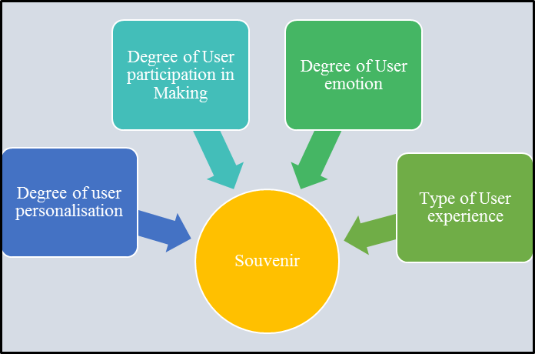
Figure 1: Positioning the Souvenir within Product Consumption Frameworks

Table 2 considers in more detail the fit of existing types of souvenir within these tourist consumption frameworks.

Types | Degree of user personalisation | Type of user participation | Degree of User emotion | Type of user experience
Picked up objects (i.e. pieces of rock; paper mementoes) | Possible through self-inscription of date, time etc. | Passive Consumption | High | Passive
Mass produced souvenir (i.e. destination trinkets) | Zero | Passive Consumption | May be high depending on whether item is purchased as gift or for own use; for its aesthetics or for its function as an object | Passive
Kit souvenirs (i.e. model planes) | Cosmetic customisation | Active Consumption | High | Active, Educational
Locally produced arts & crafts (i.e. pottery, jewellery; clothing) | Zero | Passive Consumption | May be high depending on whether item is purchased as gift or for own use; for its aesthetics or for its function | Passive
Inscribed, mass produced (i.e. pressed penny; commemorative gifts) | Adaptive Customisation | May incorporate co-creative elements | High | Active
Crafted souvenir (i.e. local arts & craft items with made to order specifications) | Adaptive Customisation | Passive consumption | High | Active
Table 2: Souvenir Types and Tourist Consumption

Table 2 demonstrates that existing souvenir offerings tend to be static objects that offer limited opportunities for co-creation beyond simple inscribing or building kit models. The user experience of the souvenir tends to focus on the aesthetic appearance of the souvenir and the souvenir consumption is mainly passive. The degree of emotional connection to the souvenir is dependent on whether the purchased souvenir is intended for personal consumption or to be given as a gift. As souvenirs are collected or bought because of their aesthetics or their functionality the user emotion tends to be high. Souvenirs would have been selected among several possible alternatives so the consumer investment in the souvenir is likely to be high regardless of their extrinsic value or whether they have been bought for personal consumption or as a gift for someone else. Where there is opportunity to inscribe the souvenir or request craft items to be modified, some level of adaptive customisation (Pine & Gilmore, 1999) takes place but this tends to be limited to specific options. The souvenir consumption experience tends to be passive, with the exception of building kit models where the making constitutes the key attraction of the souvenir itself.
Table 2 suggests that souvenirs, whether mass-produced commodities made elsewhere (Asplet & Cooper, 2000, p. 308) or local artisanal handicrafts, are static objects, designed by someone else for the tourists, who consume them passively. Souvenirs lack the capacity to mediate or generate the co-creative, active or immersive experiences that creative tourists desire. Retailers are then left with the challenge of offering souvenirs that bridge the gap between the tourists’ desire for immersive experiences and the limitations in design and performance associated with “traditional”, mass produced or handicraft souvenirs.

- RESEARCH SETTING
Technology has mediated tourist consumption and the spaces in which it takes place (Neuhofer et al., 2012) and has also facilitated the development of co-creative activities and experiences in tourism (Andersson, 2007; Gretzel et al., 2006; Prahalad & Ramaswamy, 2004). Gretzel and Jamal (2009, p. 12) claim that technologies have moved beyond being functional tools to becoming experiences and an integral part of the creative lifestyle.
One such technology is 3D printing, an additive manufacturing process which builds products on a layer-by layer basis, through a series of cross-sectional slices (Berman, 2012). The technology allows for objects to be scanned, manipulated into files and then shared to be printed anywhere in the world. 3D printing facilitates outsourcing [through online businesses such as Shapeways or in open access Fab Labs and Maker Spaces], as well as the sharing of designs among designers and users (Berman, 2012).
The early machines were somewhat expensive and specialised (Kietzmann, Pitt, & Berthon, 2015) but the technology has become much more accessible, both in price and in the way that is presented in the likes of the Makerbot and Ultimaker. Both of these 3D printers have an extremely user-friendly interface and would be simple and safe enough to use in a domestic setting (Celani, Cancherini, Oliveira, Vicente, & Archer, 2009; Hollinger et al., 2013). Consumers can readily design and manufacture personalised products using additive manufacturing design toolkits and 3D printers (Abdul Kudus, Campbell, & Bibb, 2016). According to Rayna, Striukova and Darlington (2015), consumers are no longer peripheral in the production of physical objects but their input becomes central in the production process. Yoo, Ko and Chun (2016) claim that the expansion of 3D printing technologies ushers a new era of digital prosumption that is based on social manufacturing- a new model of socio-economic production in which large numbers of people work cooperatively through the internet and social media platforms to obtain, modify and share again object designs. Many communities and user groups are providing facilities that facilitate “tinkering”, experimenting, making, crafting, and prototyping, fabricating and hacking using 3D printers.
Originally, 3D printers were created to improve rapid prototyping in engineering and manufacturing but 3D scanning and, sometimes, printing are also used within heritage and museum environments to produce scale models of artefacts for education and preservation purposes (Groenendyk & Gallant, 2013). The advantage of 3D printing over other manufacturing methods is that it generates opportunities to produce tailor-made, custom products. The on-demand replication of items reduces the ecological footprint of the manufacturing process and reduces the need for producers to store items for future use or distribute them through physical distribution channels (Kietzmann et al., 2015). Additionally, 3D printing can expand co-creation activities in physical objects (Rayna & Striukova, 2016; Rayna et al., 2015) such as souvenirs by allowing 3D creative consumers to adapt, modify or transform existing souvenirs to improve the associated experiences beyond simple inscribing and perhaps, to experientially participate in the production process using the 3D printer as their medium.

Wishing to explore the potential of 3D printing as an alternative approach to souvenir manufacturing and distribution, Héctor Serrano produced a collection of Reduced Carbon Footprint Souvenirs for an exhibition of sustainable design at the 100% Design London in September 2007 (Fairs, 2008). The project questioned how objects are currently manufactured and how new technologies may propose alternative ways that reduce their environmental impact. The project claimed minimum carbon footprint because the souvenirs were sent by email and then materialised using a 3D printer, so no transport or standard production methods were necessary (Fairs, 2008).

As 3D printers are becoming more accessible, it may be possible to reframe souvenirs as dynamic objects that accommodate tourists’ desires for immersive experiences, self-development and creativity by changing the manufacturing process of souvenirs from mass produced items to mass customised (individualised) items. For tourist retailers, as well as the potential for reduced manufacturing and storage costs, there is opportunity to understand better the shopping behaviour and needs of the tourists by removing the guesswork of what items the tourists are interested in. However, Serrano’s project did not report on how the users perceived their 3D souvenirs or if they preferred these items over more traditional souvenirs. Moreover, the practicalities associated with the manufacture and production of 3D printed souvenirs for retailers remain unknown. As portable 3D scanning devices and 3D printers in general, become more affordable and omnipresent, there could also be additional challenges in terms of controlling access and permitted ways in the consumption of artefacts and exhibits within heritage environments.

- MATERIALS AND METHODS

Wishing to build on Serrano’s study and explore further the possibilities and challenges that 3D printing could generate in the production and consumption of tourist souvenirs, the researchers undertook a study in collaboration with Historic Environment Scotland (previously Historic Scotland), in Stirling Castle, Stirling, UK. The aim of the project was to create a small prototype collection of 3D printed souvenirs based on scanned artefacts from the Castle and then interview visitors to the Castle on their perceptions of the printed items with the view of considering the feasibility of incorporating the technology within retail heritage environments and gift shops.

Data collection took place in July and August 2014 where visitors experienced a 3D printer in action. The researchers also observed and recorded their impressions of the visitor engagement with the 3D printed objects and the surrounding environments during data collection. Finally, informal conversations with retail buyers and conservation employees of Historic Scotland before, during and after the completion of the project revealed some of the opportunities and current obstacles in the further adoption of this technology within a heritage environment.
The research was qualitative and exploratory in nature based on a constructionist philosophical approach. Constructivism challenges the existence of an independent, external objective reality and argues that the individual constructs knowledge through social interaction. This research paradigm emphasizes the understanding of social phenomena rather than simply explaining it (Constantino, 2018). The researcher aims to understand the studied phenomenon from the perspective of those that experience it so constructivist studies rely on participant observation and interviewing to generate data. The researcher's understanding is co-constructed with that of the participants through their mutual engagement and interaction (Constantino, 2018).

The researchers had access to information regarding souvenir sales within Historic Scotland’s current gift shop provision in Stirling and interviewed the organisation’s buyers and retail managers before the pilot study took place to understand current trends in souvenir sales as the site. There were also discussions regarding scanning items from the collection for the purposes of the project but there was some resistance from the organisation because of intellectual rights concerns. Instead, it was suggested that artefacts that had already been scanned for the purposes of conservation be used instead. These were the Stirling Heads - metre-wide 16th-century oak medallions carved with images of Scottish historical figures, Bible and classical mythology characters. They are on prominent display within the Castle as one of its key attractions (Historic Environment Scotland, n.d.). After some deliberations over the suitability of the pre-scanned files for 3D printing and generating some prototypes, it was decided that they were not entirely appropriate and an alternative list of objects were produced. Illustrations show initial experiments with the 3D printed version of the Stirling Heads and several of the early design ideas, downloaded from Thingiverse.

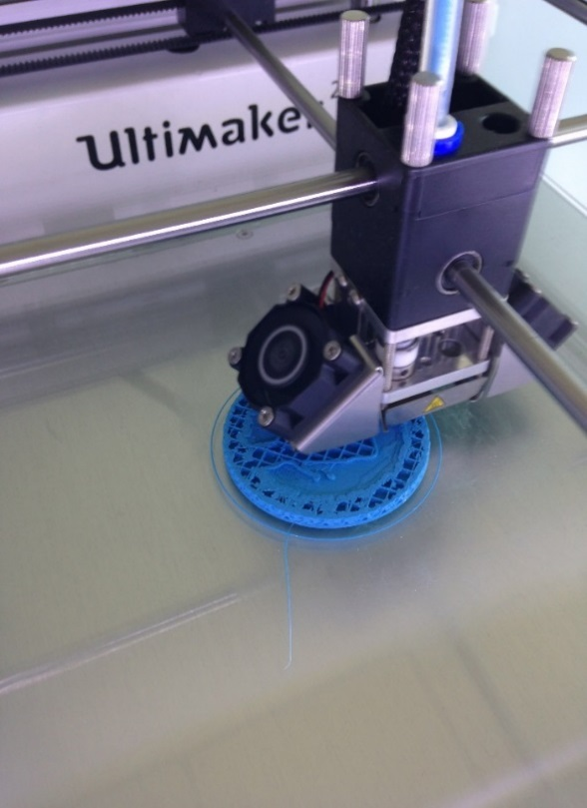
Figure 2: Stirling Head being printed out

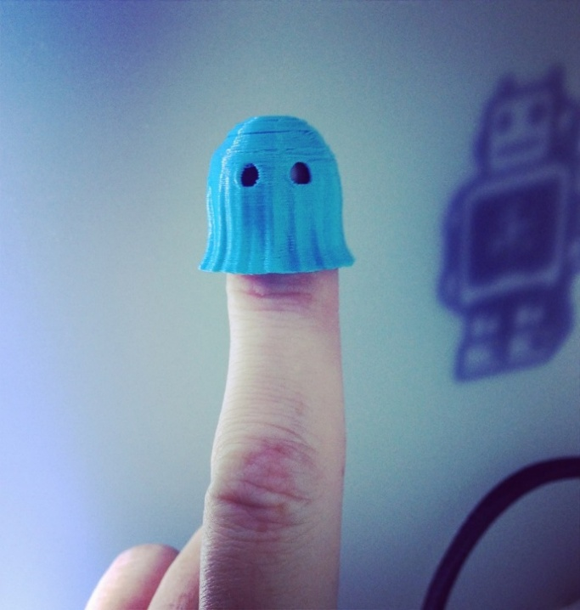
Figure 3: Experiment with ghost finger puppet souvenir from Thingiverse

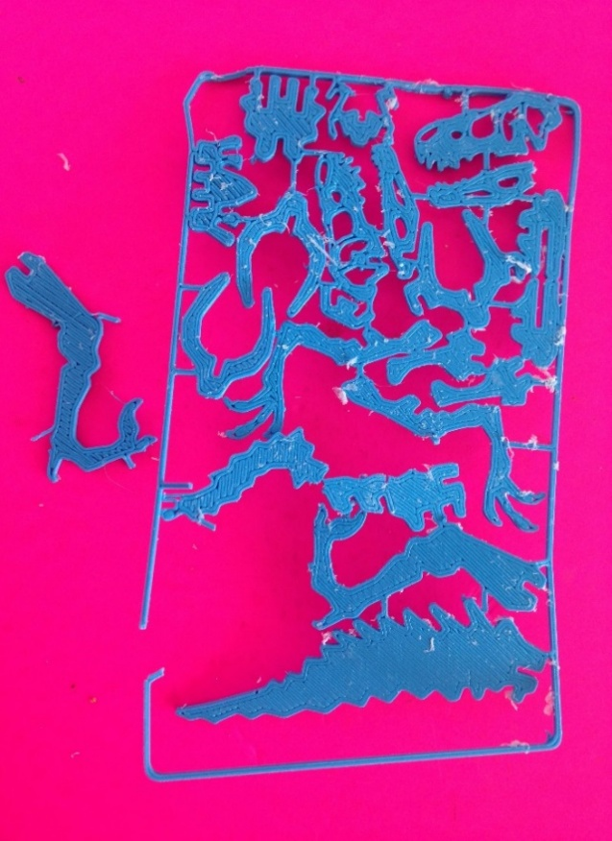
Figure 4: Experiment with buildable dragon design from Thingiverse

A pilot study (n=16) took place on site to test the interview questions, confirm the feasibility of collecting data on site and to help determine the best location within the castle to collect information. After the pilot study trials, the 3D printer was moved from the gift shop where it had been originally placed and where there was limited available space to the main Hall, which visitors accessed as they toured the site.

The researchers set up their “Ultimaker 2” portable 3D printer within main Hall and observed the visitor reactions to the potential of creating their own souvenirs of that place (through choice of pre-defined imagery, materials and scale). The printer was set up so that participants could see and hear the items being printed whilst they were being interviewed. Items that had been printed in a variety of materials and scales were also presented to the visitors. The researchers explained the purpose of the study and invited visitors to take part in a brief interview at the end of which, they were offered a 3D printed unicorn, which reflected the Castle’s branding, as a thank you for their participation. Each individual unicorn took around twenty minutes to print out from when the printer was heated up to the correct temperature. This took around five minutes at the start of the session.

Researchers have an obligation to avoid research that harms participants (Fontana & Frey, 2003). A research protocol was agreed with Historic Scotland regarding the processes and procedures in data collection and the use of photography and other media within the castle. These also adhered to the researchers’ university research integrity procedures and the funding body’s requirements. Visitors under the age of eighteen were not interviewed and there were a limited number of photos taken to protect the privacy of families with young children that were visiting the castle during data collection. The researchers had adapted the research design and methods prior to carrying out the data collection to address such research integrity issues. In addition, all the visitors who participated in the pilot and the main study signed a consent form, which detailed the purpose of the project and how the information they provided was processed, used and stored.

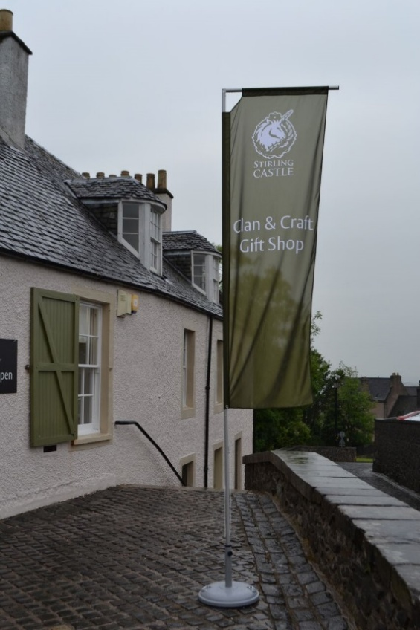
Figure 5: Stirling Castle gift shop showing Historic Scotland's branded flag

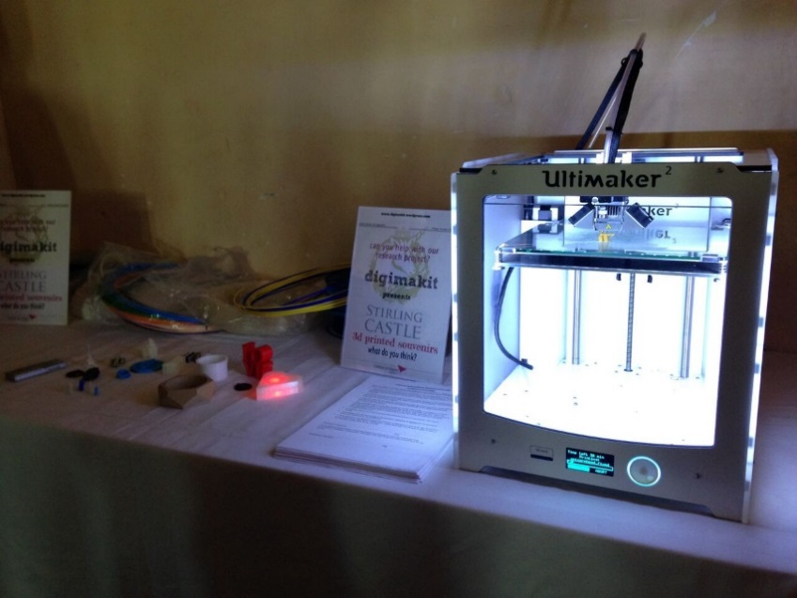
Figure 6: 3D printer and samples set up in Stirling Castle

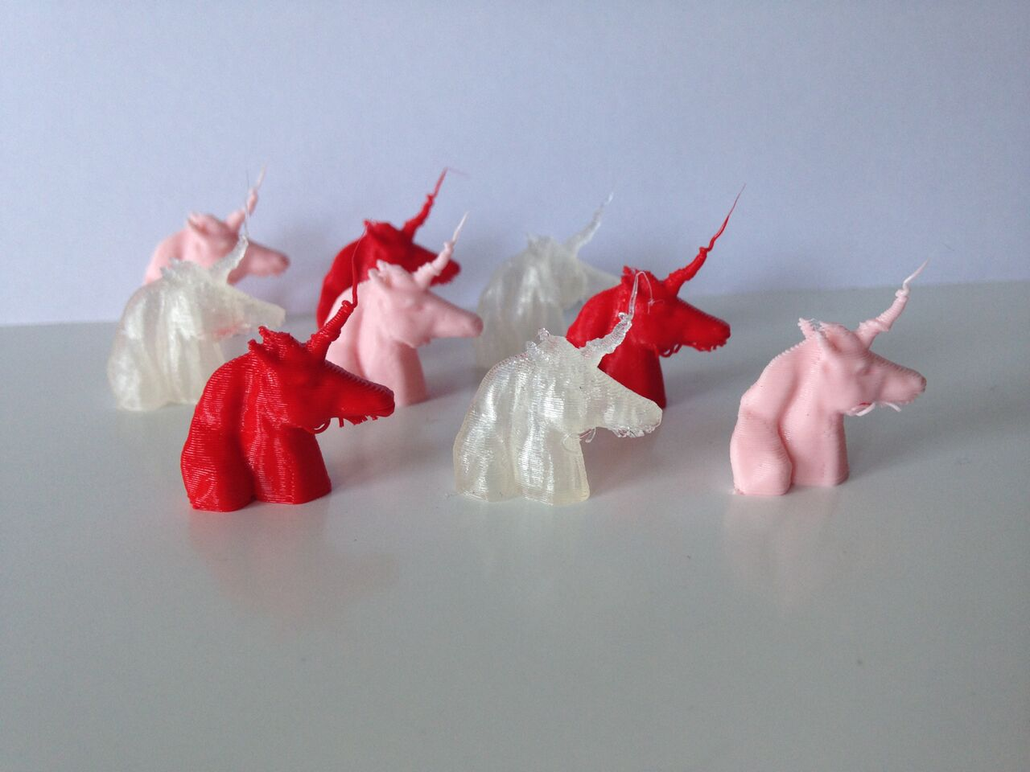
Figure 7: Small 1.5cm tall unicorn head souvenirs

A list of six questions were developed based on themes taken from the initial literature review that were then reworded to reflect the pilot study feedback. The questions sought to identify the participants’ previous knowledge and exposure to 3D printers; their impressions of the printed souvenirs, their willingness to pay and interest in souvenir personalisation through 3D printing. To make the connection to the visited site more explicit, they were also asked to identify any items that had seen during their visit that they wished to personalise as a souvenir. The participants could not be identified by the personal data they provided (gender, age group and nationality) and could refuse to participate.

In total, 139 short, semi-structured interviews were conducted on location during the four days and responses were also audio recorded to check for accuracy. The interviews were kept brief on purpose as they were carried out whilst individuals were visiting the Castle and to also encourage greater visitor participation.

The researchers also used participant observation onsite in a casual rather than a systematic way (Di Domenico & Phillips, 2010). This process of unstructured and direct observation (Sarantakos, 1998) allowed for researcher reflexivity and an exploration of the impact of researcher presence on the visitor engagement with the 3D printer and the 3D printed souvenirs.

Once the data collection process was completed, the researchers recorded their individual observations of the visitors’ engagement with the objects and the visitor interactions with the printer on site. The researcher observations offer a thicker description (Dawson, 2010) of the context of the data collection process.

Next, the participants’ responses and the researchers’ personal reflections and observations of the visitor engagement with 3D printing on site were synthesized and the findings were presented to representatives from Historic Scotland who further reflected on the implications of the project for the organisation. As the organisation was going through merging and restructuring at the time of the project, it was not possible to explore further collaboration to build on the pilot project findings. This point is further explored in the discussion of limitations/areas for further research part of the paper.

Guba and Lincoln (1985) asserted that credibility, transferability, dependability and confirmability are appropriate criteria to establish the trustworthiness of a qualitative research project. The use of different sources of data (direct and unstructured observation, interviews with visitors, informal conversations with Historic Scotland representatives and sales figures of souvenirs) helped produce an account of the study that is rich, robust and comprehensive. This process of data triangulation allows the researchers to claim the credibility of the study findings. In addition, the methodology described in detail the data collection process, the associated challenges and the restrictions imposed by the heritage organization. This thick description of the research setting allows the researchers to claim the transferability of the study findings. Moreover, the research team consisted of tourism researchers and design researchers who brought their individual experiences, practices and values to the project. This researcher reflexivity allows the researchers to claim the confirmability of the study findings. Finally, presenting the study findings to Historic Scotland representatives at the final stages of the project allowed for an external audit of the findings, which in combination with the data triangulation, enables the researchers to claim the dependability of their findings.

- FINDINGS AND DISCUSSION
This section presents the findings of the study. First it describes the data before organising against them into themes from the literature review: interest in souvenir personalisation; willingness to pay for 3D printed souvenirs and two emergent themes from the analysis: 3D printing as part of the tourist retail experience and reflections on the commercialisation potential of the technology.

5.1 Data Description

Table 3 below summarizes the descriptive characteristics of the achieved sample

N=139 | Gender breakdown | Age Breakdown | Nationality | Heard of 3D printing before
 | Male, n= 64, 46.05% of total  Female, n= 75, 53.95% of total | 18-30 n=25, 17.98% of total  31-45 n=52, 37.4% of total  46-60 n=37, 26.6% of total  61-75 n=22, 15.8% of total  76+ n=3, 2% of total | UK 31%  USA 19%  Australia 6%  Spain 6%  Canada 6%  France 6%  Others 26% | Yes - 90%,
No - 10%
Male n=4
Females, n=10
Table 3: Data Description

Seventy five females and sixty four males took part in the survey. The majority of participants came from the UK (31%), the USA (19%), Spain, Canada, France and Australia (6%). In our sample, only 10% of the participants had not heard of 3D printers before, 13% of the total female and 6.25% of the total male participants. However, several participants who had heard of 3D printing before, were only seeing a 3D printer for the first time.

5.2 Profiles of 3D Printer Users

Zamora, Monsen, & Jungenfeld, (2013) suggested that adoption of 3D printing is still limited to a small homogeneous group typically consisting of white, male, middle aged and well educated individuals. In our study, participants across the age groups were using them in their work environment and they were all well-educated or in skilled employment. Typically these participants worked as designers, engineers, in IT and as scientific researchers:

“I'm an engineer, we used it about 12 years ago in an early form” (Male, UK, 61-75).

“My work, I am a Communications Manager for Google” (Female, USA, 31-45).

“We have one at work, I'm a design school teacher” (Female, Switzerland, 46-60)

Some participants had come across 3D printers in their school environment or had previously experienced them at a museum or a science festival.

“Have one in my school” (Male, Brazil, 18-30)

“My son is learning to do it, and they have these 3D tourist gadgets at the Henry Ford museum in Michigan, they make autos’ industry models” (Female, USA, 46-60)

“In New York, at an exhibition at Grand Central Station” (Male, USA, 76+)

Public media (The Big Bang Theory sitcom) and a news item about a gun printed on a 3D printer in the USA were the most common associations (for 43% of the sample).
Researcher 1 observed: It was interesting that most of the Americans had first come across or heard of 3D printing because of the news stories regarding 3D printed guns. Most other nationalities associated it with engineering and medical [uses].
Medicine, prosthetics or in the manufacture of aeronautical parts were also mentioned as areas where 3D printers were being used.

“Your brother has one (To her husband), he built one. He's a prosthetics engineer in Melbourne” (Female, Australia, 46-60).

“Medicine, printing organ parts; and moving parts for electronics, guns, engineering” (Female, UK, 61-75).

5.3 Interest in souvenir personalisation
The participants were asked about their interest in personalisation. A few of the participants stated they were not particularly interested in purchasing souvenirs as a matter of principle.

“We mainly take photos. We like the authentic. We are not interested in souvenirs” (Male, USA, 76+).
For these participants, the possibility to personalize through 3D technologies did not appear to make tourist souvenirs more appealing.

Another participant also contemplated the potential impact of 3D printed personalised souvenirs on the production of souvenirs by local communities who would stand to lose out a source of income.

“I am not much into commercialisation. It takes away from the locals participating in the tourism part of the process” (Female, Canada 31-45).

Some participants were not interested in personalisation because they related souvenirs to crafted items, to which they assigned a higher value.

“Souvenirs must be handmade- you want craft” (Male, Slovenia, 46-60).

“Cool idea, not as good as hand carved but cheaper” (Male, USA 76+)

The large majority, however, indicated interest in some form of souvenir personalisation (87.7% of the sample). This personalisation ranged from selecting the souvenir materials and size, adding date and time, to scanning items seen in the Castle or even adding their own face to the Stirling Heads!

“I think it’s a good idea because you can print many things. So more options for me. It would be better if you could design your own souvenir” (Male, Austria, 18-30).

“There's as many options as there are ideas. What you see when you go into a gift shop, you've seen before. This is 3D it gives it more realism, it is tangible and I like the fact you can personalise it” (Male, UK, 61-75).

Some participants also highlighted the appeal of personalisation for gift giving and specifically for purchasing souvenirs for children rather than adults.

“Yes, and for gifts, more for a gift. Really like the idea of personalising it to family back home” (Female, USA 46-60).

A few participants purported that 3D printed, customisable souvenirs would appeal differently to adults and children.

“I think that kids would love it, because it’s modern. Adults would like it but from a novelty factor. Kids will see it as of their time” (Male, UK, 61-75).

One participant commented on how popularising 3D technologies in a heritage environment was a great way to offer access to novel technology to different audiences.

“It’s one of the marketing ways. Ivory Tower to common world. Great to introduce technology to the public” (Male, China, 18-30)

These findings demonstrate the variety of individual motivations for selecting specific items for souvenirs and how the visitors approach souvenirs may differ on whether they are purchasing items for themselves or as gifts (Kaell, 2012; Liu et al., 2010).

Although some participants explained that they were not be particularly interested in 3D printed, customisable souvenirs, they still accepted the printed unicorn as a thank you for their participation in the study. Such behaviour would suggest that if the self-designed souvenir were more to their taste, they may have been more open to personalisation. The researchers also noted instances where participants attempted to take additional printed items to take away with them, which would suggest that they had been impressed or intrigued by the 3D printed items.

5.4 3D printing as part of the tourist shopping experience

One of the most interesting observations was the interviewees and onlookers’ engagement with the process of 3D printing souvenirs on site. “People were very interested to watch the printer while it printed and some stood and watched for five minutes or longer without speaking at all. Many people pointed and tried to grab who they were with to also have a look. The general feel was positive and engaged” (Researcher 1, observations). Watching the 3D printer operating appealed to the visitors and altered their experience of the site.

“It is really clever, especially if you can see the items printed in front of you” (Male, USA, 17-30).
“Difference is it is made in front of you - not made in China” (Male, USA, 61-75).
“I think it would work for people like me who are a bit geeky. The process as well I am interested in. I would say definitely for me it is important to see it in action” (Male, UK, 31-45).
The participant comments and researcher observations demonstrate that printing the 3D souvenirs on site created further connections between the souvenir and the visited site and created opportunities for experience co-creation (Cave & Buda, 2013; Rayna et al., 2015; Suntikul & Jachna, 2016).

“Some people felt that even the process of being engaged in the design of the product, even if they had not designed the product themselves still made the product feel personal. So if they could pick the design, colour, material they would feel instrumental in the development of the product and this was a meaningful experience to them” (Researcher 2, observations).

Researcher 1 further observed:
People were very interested to know the process of how the design got from wherever it came from to becoming an object. This reinforces the whole “experience” element of the 3D printing process and how that seems relevant. This could change of course as [3D printers] become more widespread and known about.
The findings confirm Morgan and Pritchard (2005) assertion that discussions about souvenirs ultimately become about the place, sense memory and the narratives of self-identity. The findings further imply that innovative technologies can enhance the consumption of tourist souvenirs but the aspects of cost, feel and look of the final souvenir and the site context would condition the desirability of the 3D printed items. The onsite production of 3D printed souvenirs created an aesthetic experience, an emotional experience to the visitors and an experience of making personal, “authentic” meaning by the visitors. The 3D printed souvenir is a product with “experiential impact” that delights our sensory modalities, it “assigns personality and expressive characteristics to a product and, through interaction, the user is able to assess its symbolic significance.” (Desmet & Hekkert, 2007, p. 57).

5.5 Factors influencing willingness to pay for 3D printed souvenirs

Some participants (19.4% of the sample) commented that they would expect to pay the same or less for souvenir item that was simply a 3D printed replica item of an artefact whereas others were prepared to pay more depending on the cost, quality, size, etc., of the finished item and the level/ complexity of customisation.

One participant described the 3D printed souvenir ‘as just a piece of plastic', another as a “scam”, while a third participant stated:

“I think for me the end product is of the same value [as a standard souvenir], providing it has the same quality and durability. [At] the end of the day, it is just a step up from moulding” (Male, Australia, 18-30).
For these participants the 3D printed items they had seen were not special enough to warrant a higher price tag. Other participants stated they were prepared to pay a premium for a 3D printed souvenir if there was opportunity to customise or personalise the object further- 57% of participants indicated a preference for 3D printed souvenirs that were customised.

“Hard to tell how much you would pay, it depends on the item and the customisation. Possibly more, definitely if customised” (Female, Australia, 61-75).

“I can’t assess that. I don't know how they function. The cost should be linked to the complexity of it. I would pay more for a personal item” (Female, Brazil, 31-45).

“More if it’s personalised. Instead of buying something everybody else has” (Male, Canada, 31-45)

Personalisation would add element of exclusivity and hence increase the value of the souvenir item (Walters, 1994). Participants indicated that the material used, size, look of the finished object, price, perception of quality, cost associated with the personalisation and the complexity of the produced items would be the factors that they would consider before making a purchasing decision of a 3D printed personalised souvenir.

“It depends on the material and the complexity, maybe a bit more for personalisation. If it’s a replica probably the same or less. Part of what you pay for with a high quality item is craftsmanship.” (Female, UK, 31-45).
“I think a lot of this depends on the resolution its being run at, and the level of customisation. If just 3D printed then the same, if customised then definitely a bit more.” (Male, USA, 17-30).
Gaining access to the museum inventory or catalogue of items so they could select individual items for personalisation was also stated as a factor.

“It would depend on the quality of the souvenir. If it allows me to access something that is a great inventory, then that is of interest to me” (Female, Canada, 46-60).

Some participants also indicated that they would be would be prepared to pay a premium if they could customise or take part in souvenir designing during their souvenir purchase.

Collins-Kreiner and Zins (2011), Haldrup (2017) Fangxuan and Ryan (2018) commented on how souvenirs transform the visitors’ intangible experiences into tangible memories and transform their intangible encounters. For some study participants experiencing the souvenir production process on the site made the associations of the souvenir to the visited site stronger and made the experience of visiting the site more memorable and meaningful. The findings demonstrate that through the personal and emotional engagement in the production of the souvenir, some visitors may assign more emotional value and attachment to the customized souvenirs as unique mementos of their visit.

Researcher 1 also observed:
“The material was important to some and not to others. Even those who were quite negative about the process and technology and seemed to see no value in it were very pleased and excited to have a small plastic talisman of a unicorn head which they then attributed value to. The value they felt was clear from their comments overheard when they walked away. “Look, this is your very own 3D printed unicorn, printed today at Stirling Castle, hardly anyone else in the world will have one of these”. This led me to conclude that the value of even a small plastic talisman is increased by the experience of seeing and being part of the process.”
For a few participants the time commitment needed in decisions about designing and customising was a challenge and stated they would expect to pay less to compensate for the time they had to invest in designing and personalising their souvenir. These responses were given under the assumption that designing, customising and printing your souvenir would take place during the visit to the castle.

“Isn’t it quite slow? What’s the benefit?” (Female, South Africa, 46-60).
“Lesser value, because of the time, process and materials” (Female, Australia, 61-75).
“Nice idea, could be expensive- expensive in the time it takes to make them.” (Male, Italy, 31-45)
“[It may be] more efficient to 3D print and ship to the address of the recipient maybe. Also you could print an element that pops into a wooden plaque for instance, so you print the customisation part only.” (Male, USA, 17-30).

Researcher 2 reflected:
“Others expressed concern as to the time it would take to print products. They liked the idea of having something printed but offered ideas such as, ‘Could I order it at the beginning of my tour, and then collect it at the end? What if it could be posted to me afterwards? Will the machine be able to keep up with demand? It’s not as valuable to me if I can’t see it printed, but I don’t want to stand around waiting for it’ are examples of the type of comments made by the participants. Time was certainly proving to be an issue for some people, and they felt once 3D printing had become commonplace, if you had to wait for items, then this could become a drawback to the process for them (Researcher 2, observations).
These findings confirm Franke et al (2009) claims about consumers’ willingness to pay for objects that fit their preferences; Bardakci and Whitelock’s (2003, 2004) research on difference in the preparedness of consumers for product customisation and Mugge, Schoormans and Sciffersteen’s (2009, p. 81) assertion that personalisation options and their associated costs and benefits will vary in appeal for different groups of customers. Some consumers may be more prepared than others to undertake riskier personalisation options. Franke, Keinz and Steger’s (2010), study on why customers value self-designed products posited that customers will attribute higher value to a self-designed product if they enjoy the design process. If the perceived effort is high because of the time it takes for the souvenir to be designed and printed, as some participants claimed in our study, the value of the 3D printed souvenir is reduced.

One participant commented that they expected the prices for customised 3D printed souvenirs to decrease as the technology became more widely available and more affordable. Such expansion would also affect individuals’ preparedness and willingness to use 3D printers to develop their own souvenirs.

3D printing, in this context, therefore, can take imagery with the potential to be mass produced, but, because of the interactivity of the process of making the object, which can involve an element of choice by the consumer, it feels personal and participative. The added value of seeing the object being printed in front of them appeared to increase the participants’ willingness to pay despite the “romance” being taken out of the 3D printing and making process – glitches and mistakes were evident. The researchers have taken into account that the “novelty factor” and interest in the process may change once 3D printers become more readily available. As the 3D printers are becoming more accessible, this technology is becoming more user-friendly, and in the near future, souvenir objects could be easily printed from our homes.

5.6 Commercialisation Potential

Whilst acknowledging the inherent personalisation potential of 3D printed souvenirs, some participants considered the current gaps that existed from conceiving and developing souvenir prototypes to creating a saleable product- they questioned how long it would be before the customised souvenirs could become marketable.
“Research is needed to discover whether it is marketable” (Male, UK, 76+)
“Good idea, it should be better quality for [commercial] souvenirs” (Female, France, 46-60).
“As souvenirs? Probably a good idea. Speed up the process” (Male, UK, 61-75).
“Depends on the material, but this is in its early stages, so there's a design gap and it’s very labour intensive” (Female, USA, 61-75).
Others commented that the appeal of the 3D printed souvenirs was connected to their novelty which was time bound.

“Now, because it’s new, it is a novelty. In ten or so years, it won’t be that novel” (Female, UK, 31-45).

Two other participants also contemplated the implications that the personalisation of 3D souvenirs had for intellectual property rights.
“I’d worry it could be illegal” (Male, UK, 46-60).
These comments suggested that there was an interest in the potential to personalise souvenirs within a heritage environment but also a recognition that developments in the quality of the printed items, improvements in the time and processes of designing and producing souvenirs were necessary in order for visitor attractions to be able to offer 3D souvenirs alongside their regular gift shop fare.
To expand on this theme and explore these issues further, the researchers consulted with Historic Scotland staff in the areas of retail and conservation to gauge their take on the opportunities and challenges that 3D printing technologies could usher for souvenir production and consumption.

5.6.1 Managerial perceptions of 3D printed souvenirs
The discussions with members of the retail and conservation areas of Historic Scotland during the planning and execution stages of the project also reveal some of the current unknowns regarding the wider adoption of the technology within a heritage retail environment. These unknowns can be distinguished in terms of retail related, artefact integrity and intellectual property rights.
The retail-related issues focused on the possibilities of 3D printing to reduce costs associated with the ordering of souvenirs and the storage of unsold items. The retail manager had noted how the trends in the gift shops had changed in the last few years as a different mix of visitors were displaying diverse purchasing behaviours and preferences in terms of the style and the quality of souvenirs they were after. 3D printing technologies could offer further insights into the types of artefacts that visitors had seen displayed in the museum or heritage sites made into souvenirs without worrying about increasing manufacturing and storage costs. There was opportunity to offer more variety and identify the objects that were most popular with visitors. This could then lead to creating a better customer experience and a better retail offer and help distinguish the attraction further from other museums. These comments reflect McIntyre’s views (2012) modern tourist retail is becoming more sophisticated and the advantages associated with 3D printing (Kietzmann et al., 2015).
Moreover, there were practical issues to consider such as the positioning of 3D printers in a gift shop, the length of time it would take to select or design and then print the items in situ. Although the onsite production was an important feature in the Stirling Castle trial, it may not be feasible to have a printer positioned at each heritage site as this would increase running and management costs. However, visitors from all over the world could be offered the opportunity to select items online that they can customise and then have these printed at their homes or in a 3D printing facility of their choice to speed up process and navigate some of the other limitations.
Ensuring that the dignity of the original materials is reserved was seen as a fundamental issue during discussions of which items to offer as 3D printed souvenirs and throughout the running of the project. In particular, the organisation members who worked in conservation suggested that the ease with which scanning could take place could lead to the trivialisation of revered cultural artefacts. Protecting the integrity and authenticity of artefacts are important principles in heritage and conservation (Alberts & Hazen, 2010; Clavir, 1998; Wang, Huang, & Kim, 2015) which would be challenged by 3D printing technologies. In addition, rather than enhancing engagement with the heritage site, there was danger that carrying out the 3D printing process onsite could detract from the actual heritage experience, thus the medium becoming the message (McLuhan, 1967).
There were also questions raised about how the distribution of 3D printed items that the visitors had created was going to support the organisation’s wider objectives in terms of education, public engagement and outreach that form part of the organisation’s remit. Although 3D printing technologies are currently being used within heritage environments for conservation purposes (Hollinger et al., 2013; Bogdanova et al., 2013), the onsite printing of souvenirs using this technology could create additional opportunities for education and outreach activities.
Finally, the protection of intellectual property rights was an important issue to consider. Unlike souvenirs that were produced by trusted suppliers and then were sold in the designated gift shops, handheld 3D scanners could enable any visitor to scan items from the visitor attraction collection during their visit and then produce and distribute their own souvenirs. This was seen as a challenge because it affected an income stream for the heritage site as well as losing control of the way the artefacts of the exhibition were being displayed and consumed outside the heritage space.
Kietzmann et al., (2015) argued that 3D printing will raise many intellectual property and ethical challenges for businesses and policy makers. Firms will need to consider whether they wish to encourage and facilitate consumer creativity or resist and repress it, or even whether to ignore it altogether. In addition, rather than purchasing the real thing or the licenced, mass produced souvenir, it is possible to scan the original object or purchased souvenir, and make the scans available on the internet so that anyone can use them to print the object as many times they wish (Berthon, Pitt, McCarthy, & Kates, 2007). According to Berman (2012) once an item’s blueprints are available online product clones or pirated copies will appear on the market. Kietzmann et al., (2015) also argued that expanding the consumer production of items will challenge our current approaches to standardisation, quality assurance and quality control for consumable products that currently lie within manufacturers.

To address such concerns, it was contemplated whether it was possible to attach technology to the file making that could restrict its usage (for instance, only allow the maker to print the 3D scanned item once). This approach however, contravenes the spirit and ethos of 3D printing technologies the development of much of which depends on Creative Commons licensing and sharing between its users (Birtchnell & Urry, 2016; Rayna et al., 2015).
- CONCLUSIONS
The purpose of this study was to examine visitor perceptions of and engagement with 3D printed, customisable souvenirs and consider the challenges the adoption of 3D printing as a souvenir manufacturing method may pose within a heritage environment.
The findings suggest that by becoming involved in the design and “making” of souvenirs, even in the simple choice of colour or scale and witnessing the real time production, the visitor transforms from a consumer to a co-designer and prosumer of souvenir objects. For some visitors the opportunity to co-design (craft) their own souvenir gave them a sense of closer emotional connection to the visited site. Others, including retail and conservation managers, considered the perceived challenges in transforming 3D printed souvenirs into a marketable product.
Based on the analysis of the literature and the empirical findings we propose three additional types of souvenirs: the 3D printed mass produced souvenir; the 3D printed personalised and printed at a facility and the 3D printed, fully individualised souvenir printed at home. Table 4 summarises their key characteristics of these souvenir types against the tourist consumption frameworks mentioned earlier in the paper.
Degree Of User Involvement  _  + | Types | Degree of user personalisation | Type of user participation | Degree of User emotion | Type of user experience
 | 3D printed, mass produced souvenir (i.e. through MC toolkits) | High degree of personalisation | Co-design & co-creation | High | Active; Immersive; Educational
 | 3D printed, personalised printed at a facility | High degree of personalisation | Co-design & co-production- possibility of input from peers at facility | High | Active;  Immersive Educational
 | 3D printed, fully individualised souvenir printed at home | Individualisation | User as Designer & Producer- no external input | High | Active;  Immersive; Transformative
Table 4: 3D printed Souvenir Types within Tourist Consumption Frameworks

Unlike the souvenir types discussed in Table 2, these souvenir types are unique in the sense that they offer the potential for the consumer to be more involved in the design process of their souvenir. Moreover, unlike the souvenirs listed in Table 2, which were mainly manufactured and produced for the consumer with little or no direct consumer input, the degree of user involvement is much higher in the 3D printed souvenirs and user involvement extends beyond simple co-creation to co-design and even co-production of experience. The 3D printed, fully individualised souvenir printed at home shares some of the features of the picked up object in the sense that it is shaped as the consumer would like it and there is no formal manufacturing or marketing process behind it.

The paper now concludes by reflecting on the implications of the findings for the academic study of souvenirs and the management of heritage and visitor attractions and proposes several areas of further research on the potential of 3D printing technology for souvenir consumption.

6.1 Theoretical Contributions
The study contributes to theory in several ways. First, we proposed a new type of souvenir product that we argue is distinct from existing souvenirs because it places the visitor at the centre of the personalisation effort and production process and it does not fit within existing souvenir typologies (Decrop & Masset, 2014; Gordon, 1986; Hashimoto & Telfer, 2007; Swanson, 2012). Previously souvenirs were considered passive objects- memory holders, reminders, keepsakes – purchased or collected to make a tangible memory of an intangible experience (Collins-Kreiner & Zins, 2011; Fangxuan & Ryan, 2018; Haldrup, 2017; Morgan & Pritchard, 2005). 3D printed items as souvenirs can become interactive objects and there was evidence that some participants would be willing to take some time cost to participate in the process. As 3D printed souvenirs are individualised by the user, they are not mass produced and commercialised. Unlike existing souvenirs which are developed for the tourists without their input, the 3D printed souvenir offers the opportunity to have a hand in the design and personalisation process. They generate opportunities for co-creation (Chathoth, Altinay, Harrington, Okumus, & Chan, 2013; McIntyre, 2010; Minkiewicz, Evans, & Bridson, 2013), prosumption (Rayna et al., 2015; Yoo et al., 2016) and experiential learning (Campos et al., 2015; McIntyre, 2010; Pine & Gilmore, 1999). The findings add additional learning and opportunity to self-design and produce to the tourist motivations for purchasing souvenirs (Fangxuan & Ryan, 2018; Wilkins, 2011, 2013). Because of the higher degree of personal involvement and the time and effort sacrifice that has to be undertaken on the part of the consumer for the souvenir to materialise, the visitor may form stronger associations to the tourist site or experience.
Secondly, we identified additional factors that affect willingness to pay for souvenirs. Previous studies had identified the quality of craftsmanship and materials used (Anderson & Littrell, 1996); being locally made, handicraft and bespoke items (Sthapit & Björk, 2017) and exclusivity (Walters, 1994) as factors that influence the desirability and price of a souvenir. In addition to these, our study found that having a hand in making the souvenir; gaining access to a particular object (for example, if the 3D printed souvenir is based on something seen in the exhibition/heritage site or archive collection); the time invested in the production of the souvenir; the level of customisation or personalisation (with most participants prepared to pay more for personalised items) and for some, the opportunity to produce their souvenir during their visit, would affect the desirability of a souvenir. Future studies could examine how having a hand in designing and producing the souvenir onsite or at home may alter perceptions of souvenir quality and value. They may also examine the contexts, the experiences and the levels of customisation and personalisation that would be desirable.

Thirdly, the study also adds to an expanding body of literature which seeks to understand the psychographic characteristics of the 3D printing users as well as the factors that may encourage or inhibit individuals from being involved in 3D printing (Abdul Kudus et al., 2016; Bonney, Herd, & Moreau, 2010; Kietzmann et al., 2015). Kietzmann, Pitt, & Berthon, (2015) argued that to the next generation, which has already started experimenting with 3D printers in high schools and digital making and media clubs, open access design and 3D printing will be a normal part of everyday life. Zamora, Monsen, & Jungenfeld (2013) argued that hands-on experimentation by people with a diverse range of backgrounds and experiences is needed to gauge individuals’ engagement with 3D printing technologies. While this concept may seem at odds with how we currently approach souvenir purchasing, for younger generations, who are considered to be “digital natives” (Prensky, 2007) these processes may come naturally as additive manufacturing, consumerism and sustainability approaches evolve further.

The study findings were conditioned by the demographic profile of people who consume heritage attractions which tend to be older, more affluent and better educated (Edwards, 1989; Kim & Littrell, 1999). Their psychographic characteristics influence their souvenir consumption patterns and it is likely that they also influenced their perceptions of the 3D printed souvenirs. Future research could begin to explore more the profiles of the 3D “tinkerers” and designers to better understand their preferences and motivations. Such research may determine preferences for customisation onsite a visitor attraction or at home; the particular visitor segments and the types/levels of souvenir customisation they prefer; and finally, whether there is an adequate customisation sensitivity gap (Guilabert & Donthu, 2006) in souvenirs that warrants an investment in these technologies to satisfy visitor demand. In addition, the sustainable potential of having items printed onsite, for people to order in advance of the visit or to have them sent to their homes, is an innovation that could be explored further.

Fourthly, it was a premise of this paper that using digital technologies onsite in heritage environments has the potential to modify the visitor engagement with the visited places. Existing literature on 3D printing uses within the context of heritage environments had largely focused on the potential of the technology for the preservation and curation of objects (Celani, Pupo, & Piccoli, 2008). Not and Petrelli (2018) and Petrelli, Marshall and o’Brien (2017) began to explore how personalisation processes within heritage environments can mediate visitor experiences and interactions with cultural heritage. Our findings build further on this work but it was not fully possible to consider how the opportunity to (re)create heritage artefacts as souvenirs had influenced the visitor experience and engagement with the artefacts. The willingness of visitors to personalise their souvenirs may be conditioned by the context of the visitor attraction and future research could explore further how producing souvenirs onsite may affect visitor engagement and consumption of the visited space.
We do argue though that when the 3D printing of souvenirs takes place within a visitor attraction, souvenir consumption also acquires performative elements. There is opportunity to extend the tourist experience beyond the tourist gaze and staged authenticity (Chhabra, Healy, & Sills, 2003; MacCannell, 1973) to an embodied experience. On the other hand, 3D printing souvenirs onsite may become a spectacle that leads to the trivialisation of a site’s heritage, and of the memories and stories associated with its artefacts, that compromises its authenticity, if their incorporation is not sensitively introduced and managed. The historical or social significance of the site may influence the consumption of the souvenirs and condition what are considered suitable and acceptable visitor experiences within the space. Future research could ascertain the feasibility of positioning and running a 3D printer onsite different types of visitor attractions, to gauge the importance of place and to establish the associated impacts on heritage consumption and visitor experience. It may also consider the implications of comparing reactions to the objects with and without the printer being present. More broadly, there is a need to revisit the concept of retailing within heritage environments to study how the changing visitor expectations are adding pressure on heritage environments to move towards more experiential and co-creative shopping experiences and how heritage environments may respond to these changes in consumer demand.

6.2 Management Implications
There are several implications of the study for the managers of heritage and visitor attractions. Although it is evident that the technology is still new, it also has the potential to significantly alter tourist consumption in the future in the way the transport innovations and the internet had done in the past (Birtchnell & Urry, 2016). Similar to those technologies, it is difficult to chart this potential until it has materialised and its impacts are experienced in full. However, there are signs of where the opportunities and challenges may lie ahead.

First of all, the study demonstrated that that visitors wish to have 3D printed items that extend beyond producing simple replicas or scale models of artefacts to products that encourage self-design and participation in souvenir production as an educational experience. In this way the technology signals an opportunity for retailers to interact and engage with souvenir buyers in alternative ways. There is opportunity for visitor attractions to become facilitators of learning and mediators of the experience for those visitors who seek truly individualised souvenirs.

Secondly, in our study, the partner organisation was rather reserved and apprehensive in exploring the opportunities that 3D printing could afford beyond conservation work. There was opportunity to experiment more with scanning items and “playing” with the customisation options but there was resistance to experimentation. This reluctance may be explained by the remit of the organisation which focuses on heritage conservation and a desire to protect the authenticity and integrity of the artefacts under their care, as well as the timing of the study which coincided with a period of merging between Scottish heritage bodies and internal restructuring. Lack of understanding of the ethos of 3D printing communities in developing and sharing files freely or even, a fear of the unknown in terms of the potential impacts that experimenting with the technology could generate may have also been contributing factors. Other organisations and tourist attractions may wish to experiment further and explore how 3D printing can alter their retail offering and generate further opportunities for “play” as well as education and learning. They could take inspiration from Rijksmuseum’s ‘Rijksstudio Make Your Own Masterpiece’ project, which opened up a collection of 125,000 images of the museum artefacts in 2013, to be used without copyright. The museum, based in Amsterdam, the Netherlands, encouraged the public to access these high resolution images to play and even design their own objects including 3D printing. They also commissioned various designers to produce new artworks including Studio Droog, who created a tattoo design based on a still life from a 17th century painting. The museum saw this project as a ‘marketing instrument inspiring people to enjoy the work at first hand’. Its underlying philosophy was that when people interact directly with artworks, these gain a new significance, a “virtual” aura that enhances the original artefacts rather than detracting from them (Gorgels, 2013).

Thirdly, from a souvenir production point of view, 3D printed souvenirs will not replace existing mass produced or craft souvenirs in the foreseeable future, or possibly ever, because of issues associated to the cost, quality and availability of current 3D printers, as well as the knowledge gap that exists in terms of design and use of 3D printers. However, the expansion in the availability of 3D printing technologies in the future could challenge the established business models of souvenir production. Existing 3D printing technology is unsuitable for producing large volumes of souvenirs to replace current manufacturing methods and processes. However, 3D printing technology may be usefully employed to produce a smaller volume of selected items to gauge the interest of visitors in such items. Both small-scale local producers and larger mass manufacturers may use the technology to produce souvenirs that are more individualised. There is also opportunity for visitor attractions to consider how selected 3D scanned items from visiting or temporary exhibitions may be offered for customisation through additive manufacturing toolkits to enhance the souvenir product offering, engage with visitors to facilitate learning and co-creation activities and support product innovation.

There are also implications in terms of the design of the souvenirs- to be sold as desirable merchandise- it is not simply a scan and print process- the role of the designer is still important. A more experienced designer can act as a peer in mediating and tweaking the “amateur's” ideas so that they will work with the digital technology. In the case of this study, the designer/researcher running the 3D printer also “performed” and interacted with the participants, adding another layer to the visitor experience. It is important that tourist offerings are appropriate to the destination and gift shop managers must take care not to allow the range and types of souvenirs to take away from the leisure experience or lessen the aesthetic value of the place (Timothy & Boyd, 2003).

Fourth, in terms of sustainability, previous research has shown that souvenirs are often mass-produced (LaSusa, 2007) and transported over great distances to the point of sale. Other issues that arise in this regard are the disposal of unsold merchandise, the planning of sales, and the storage of stock. Producing 3D printed souvenirs onsite or purchasing them online but having them printed remotely could offset the environmental impacts of mass-produced souvenirs. The increasing user-friendly, interactive attributes of 3D printers and their ability to produce on the spot, lightweight objects, utilising biodegradable materials with little to no waste in their manufacture, shows potential to change consumer behaviour. Even at this time it is feasible that when a simple 3D printer such as the Ultimaker used in this project, is set up within a retail environment, a customer could print out their own design or “make (almost) anything” (Gershenfeld, 2005). Adding and changing materials are relatively simple as is adding one’s own 3D printable file. The more difficult process is the CAD modelling of the design, but in doing this in advance, customers could choose from a range of predetermined designs while still feeling that their “prosumer” experience of making was personal, participative and authentic.

Finally, while it would be tempting for managers to ignore 3D printing as a fad or an innovation that is still a long way from being relevant to their everyday operations, it would be unwise to do so. Our experience which was limited to only one heritage site, highlighted several intellectual property rights issues that needed to be addressed before we could proceed with the actual study. Existing literature has hinted at some of the complexities that may arise (Kietzmann et al., 2015) and the significance of acknowledging and addressing these effectively. There are challenges that are specific to heritage and visitor attractions that managers need to be aware of and consider how they may begin to address them. Visitors could scan items using handheld scanner devices or even download scanning apps on their mobile phone which they can use conspicuously whilst visiting the attraction. These files can then be uploaded on a computer and further manipulated for printing or sharing on online platforms. Once these files are available online, it is very difficult for the organisations to monitor their usage. Whereas the use of photos of artefacts and licensing for souvenir production are well established, the personal digitisation of artefacts through 3D scanning and printing constitutes an unchartered area. Understanding how to deal with intellectual property rights will be a significant challenge in the very near future. Determining whether to allow or forbid visitors to 3D scan artefacts, how to implement controls in the production, distribution and consumption of 3D printed items and the implications of such decisions in terms of conservation and the consumption of tourist objects and spaces will be the focus of extensive study in the near future.

REFERENCES

Abdul Kudus, S. I., Campbell, R. I., & Bibb, R. (2016). Customer perceived value for self-designed personalised products made using additive manufacturing. International Journal of Industrial Engineering and Management (IJIEM), 7(4), 183–193.
Alberts, H. C., & Hazen, H. D. (2010). Maintaining authenticity at cultural world heritage sites. The Geographical Review, 100(1), 56–73.
Anderson, L. F., & Littrell, M. A. (1996). Group profiles of women as tourists and purchasers of souvenirs. Family and Consumer Sciences Research Journal, 25(1), 28–56.
Andersson, T. D. (2007). The tourist in the experience economy. Scandinavian Journal of Hospitality and Tourism, 7(1), 46–58.
Asplet, M., & Cooper, M. (2000). Cultural designs in New Zealand souvenir clothing: the question of authenticity. Tourism Management, 21(3), 307–312.
Baker, S. M., & Gentry, J. . (1996). Kids as collectors: a phenomenological study of first and fifth graders. In K. P. Corfman & J. G. Lynch (Eds.), Advances in Consumer Research (pp. 132–137). Provo, UT: Association for Consumer Research.
Bardakci, A., & Whitelock, J. (2003). Mass-customisation in marketing: the consumer perspective. Journal of Consumer Marketing. 20(5), 463-479.
Bardakci, A., & Whitelock, J. (2004). How “ready” are customers for mass customisation? An exploratory investigation. European Journal of Marketing, 38(11/12), 1396–1416.
Berman, B. (2012). 3-D printing: The new industrial revolution. Business Horizons, 55(2), 155–162.
Berthon, P. R., Pitt, L. F., McCarthy, I., & Kates, S. M. (2007). When customers get clever: managerial approaches to dealing with creative consumers. Business Horizons, 50(1), 39–47.
Birtchnell, T., & Urry, J. (2016). A new industrial future? 3D printing and the reconfiguring of production, distribution and consumption. Abingdon: Routledge.
Bogdanova, G., Todorov, T., & Noev, N. (2013). Digitization and 3D scanning of historical artifacts. Digital Presentation and Preservation of Cultural and Scientific Heritage, (111), 133–138.
Bonney, L., Herd, K. B., & Moreau, C. P. (2010). For you or for me? How the intended recipient influences the customisation experience and valuations of customised products. Advances in Consumer Research, 38, 1–47.
Burns, & Warren. (1995). Need for uniqueness: shopping mall preference and choice of activity. International Journal of Retail and Distribution Management, 23(12), 4–12.
Butler, R. W. (1991). West Edmonton mall as a tourist attraction. Canadian Geographer, 35(3), 287–295.
Campos, A. C., Mendes, J., Valle, P. O. do, & Scott, N. (2015). Co-creation of tourist experiences: a literature review. Current Issues in Tourism, 21(4), 369-400.
Cave, J., & Buda, D. (2013). Souvenirs as transactions in place and identity: Perspectives from Aotearoa New Zealand. In J. Cave, L. Joliffe, & T.Baum (Eds.), Tourism and Souvenirs Glocal Perspectives from the Margins (pp. 98–116). Bristol: Channel View Publications.
Celani, G., Cancherini, L., Oliveira, M., Vicente, J., & Archer, C. T. I. R. (2009). 3D digitation of museum sculptures for model-making purposes: difficulties and possible solutions. In: SIGraDI 2009- Proceedings of the 13th Congress of the Iberoamerican Society of Digital Graphics (pp. 1–4). Sao Paolo Brazil.
Celani, G., Pupo, R., & Piccoli, V. (2008). Digital fabrication and art-exhibition design: a case study. Proceedings of In J. A Qawasmi, M .A. Chiuni & S. El-Hakim (Eds.), Digital Media and its Applications in Cultural Heritage Conference (pp. 413-428). Amman, Jordan: Centre for the Study of Architecture in the Arab Region.
Chathoth, P., Altinay, L., Harrington, R. J., Okumus, F., & Chan, E. S. W. (2013). Co-production versus co-creation: A process based continuum in the hotel service context. International Journal of Hospitality Management, 32(1), 11–20.
Chhabra, D., Healy, R., & Sills, E. (2003). Staged authenticity and heritage tourism. Annals of Tourism Research, 30(3), 702–719.
Clavir, M. (1998). The social and historic construction of professional values in conservation. Studies in Conservation, 43(1), 1–8.
Cohen, E. (1988). Authenticity and commoditization in tourism. Annals of Tourism Research, 15(3), 371–386.
Collins-Kreiner, N., & Zins, Y. (2011). Tourists and souvenirs: changes through time, space and meaning. Journal of Heritage Tourism, 6(1), 17–27.
Constantino, T. E. (2018). Constructivism in L. Given (Ed.), The SAGE Encyclopedia of Qualitative Research Methods (pp. 116–120). Thousand Oaks, CA: SAGE Publications.
Crouch, D., & Desforges, L. (2003). The sensuous in the tourist encounter. Tourist Studies, 3(1), 5–22.
Dawson, J. (2010). Thick description. In A. J. Mills, G. Durepos, & E. Wiebe (Eds.), Encyclopedia of Case Study Research (pp. 942–944). Thousand Oaks, CA: SAGE Publications.
Decrop, A., & Masset, J. (2011). I want this Ramses’ statue: Motives and meanings of tourist souvenirs. In M. Kozak & N. Kozak (Eds.), Sustainability of Tourism: Cultural and Environmental Perspectives (pp. 17–41). Newcastle-upon-Tyne: Cambridge Scholars Publishing.
Decrop, A., & Masset, J. (2014). “This is a piece of coral received from captain Bob”: Meanings and functions of tourist souvenirs. International Journal of Culture, Tourism and Hospitality Research, 8(1), 22–34.
Desmet, P., & Hekkert, P. (2007). Framework of product experience. International Journal of Design, 1(1), 57–66.
Di Domenico, M., & Phillips, N. (2010). Participant Observation. In A. J. Mills, G. Durepos, & E. Wiebe (Eds.), Encyclopedia of Case Study Research (pp. 653–655). Thousand Oaks, CA: SAGE Publications.
Edwards, J. A. (1989). Historic sites and the local environments. In D. T. Herbert, R. C. Prentice, & C. J. Thomas (Eds.), Heritage Sites: Strategies for Marketing and Development (p. 272-293). Aldershot: Avebury.
Elomba, M. N., & Yun, H. J. (2018). Souvenir authenticity: The perspectives of local and foreign tourists. Tourism Planning and Development, 15(2), 103–117.
Fairs, M. (2008). Reduced Carbon Footprint Souvenirs by Héctor Serrano. Dezeen. Retrieved from https://www.dezeen.com/2008/01/06/reduced-carbon-footprint-souvenirs-by-hector-serrano/ accessed 08/06/2018.
Fangxuan, L. (Sam), & Ryan, C. (2018). Souvenir shopping experiences: A case study of Chinese tourists in North Korea. Tourism Management, 64, 142–153.
Fleischmann, K., Hielscher, S., & Merritt, T. (2016). Making things in Fab Labs: a case study on sustainability and co-creation. Digital Creativity, 27(2), 113-131.
Florida, R. (2002). The rise of the creative class: And how it is transforming work, leisure, community and everyday life. New York: Basic Books.
Flynn, A., & Flynn Vencat, E. (2012). Custom nation: Why customisation is the future of business and how to profit from it. Dallas, TX: Benbella Books Inc.
Fontana, A., & Frey, J. H. (2003). The interview from structured questions to negotiated text. In N. K. Denzin & Y. S. Lincoln (Eds.), Collecting and Interpreting Qualitative Materials (2nd ed., pp. 61–106). Thousand Oaks: Sage Publications.
Franke, N., Keinz, P., & Steger, C. J. (2009). Testing the value of customization: When do customers really prefer products tailored to their preferences? Journal of Marketing, 73(5), 103–121.
Franke, N., & Schreier, M. (2010). Why customers value self-designed products: The importance of process effort and enjoyment. Journal of Product Innovation Management, 27(7), 1020–1031.
Gershenfeld, N. (2005). Fab: The coming revolution on your desktop – from personal computers to personal fabrication. New York: Basic Books.
Gordon, B. (1986). The souvenir: messenger of the extraordinary. The Journal of Popular Culture, 20(3), 135–146.
Gorgels, P. (2013). January. Rijksstudio: Make your own masterpiece!. In Museums and the web (Vol. 2013). Retrieved from: https://mw2013.museumsandtheweb.com/paper/rijksstudio-make-your-own-masterpiece/ accessed 17/08/2018.
Gretzel, U., Fesenmaier, D. R., Formica, S., & O’Leary, J. T. (2006). Searching for the future: Challenges faced by destination marketing Organizations. Journal of Travel Research, 45(2), 116–126.
Gretzel, U., & Jamal, T. (2009). Conceptualizing the creative tourist class: technology, mobility, and tourism experiences. Tourism Analysis, 14(979), 471–481.
Groenendyk, M., & Gallant, R. (2013). 3D printing and scanning at the Dalhousie University Libraries: a pilot project. Library Hi Tech, 31(1), 34–41.
Guilabert, M. B., & Donthu, N. (2006). Mass customisation and consumer behaviour: the development of a scale to measure customer customisation sensitivity. International Journal of Mass Customisation, 1(2/3), 166–175.
Haldrup, M. (2017). Souvenirs: Magical objects in everyday life. Emotion, Space and Society, 22, 52–60.
Hashimoto, A., & Telfer, D. J. (2007). Geographical representations embedded within souvenirs in Niagara: the case of geographically displaced authenticity. Tourism Geographies, 9(2), 191–217.
Historic Environment Scotland. (n.d.). Stirling Heads Gallery. Retrieved June 3, 2018, from https://www.stirlingcastle.scot/discover/highlights/stirling-heads-gallery/ accessed 03/06/2018.
Hollinger, R. E., Edwell John, J., Jacobs, H., Moran-Collins, L., Thome, C., Zastrow, J., & Rossi, V. (2013). Tlingit-Smithsonian collaborations with 3D digitization of cultural objects. Museum Anthropology Review, 7(1-2), 201-253.
Hume, D. (2013). The genealogy of the tourist gaze part 1: Art history, anthropology and souvenirs. In The International Symposium on Society, Tourism, Education and Politics (ISSTEP) (pp. 26–28). Bangkok, Thailand.
Hymphreys, A., & Grayson, K. (2008). The intersecting roles of consumer and producer: a critical perspective on co‐production, co‐creation and prosumption. Sociology Compass, 2(3), 963–980.
Jansson, A. (2007). A sense of tourism: new media and the dialectic of encapsulation/decapsulation. Tourist Studies, 7(1), 5–24.
Jin, H., Moscardo, G., & Murphy, L. (2017). Making sense of tourist shopping research: A critical review. Tourism Management, 62, 120–134.
Kaell, H. (2012). Of gifts and grandchildren: American Holy Land souvenirs. Journal of Material Culture, 17(2), 133–151.
Kietzmann, J., Pitt, L., & Berthon, P. (2015). Disruptions, decisions, and destinations: Enter the age of 3-D printing and additive manufacturing. Business Horizons, 58(2), 209–215.
Kim, S., & Littrell, M. A. (1999). Predicting Souvenir Purchase Intentions. Journal of Travel Research, 38(2), 153–162.
Kim, S., & Littrell, M. A. (2001). Souvenir buying intentions. Annals of Tourism Research, 28(3), 638–657.
Kong, W. H., & Chang, T.-Z. (Donald). (2016). Souvenir shopping, tourist motivation, and travel experience. Journal of Quality Assurance in Hospitality & Tourism, 17(2),163-177.
LaSusa, D. M. (2007). Eiffel tower key chains and other pieces of reality: the philosophy of souvenirs. Philosophical Forum, 38(3), 271-288.
Lincoln, Y.S. & Guba, E. G. (1985). Naturalistic inquiry. Newbury Park, CA: Sage Publications.
Littrell, M. A. (1990). Symbolic significance of textile crafts for tourists. Annals of Tourism Research, 17(2), 228–245.
Littrell, M. A., Anderson, L. F., & Brown, P. J. (1993). What makes a craft souvenir authentic? Annals of Tourism Research, 20(1), 197–215.
Littrell, M. A., Baizerman, S., Kean, R., Gahring, S., Niemeyer, S., Reilly, R., & Stout, J. (1994). Souvenirs and Tourism Styles. Journal of Travel Research, 33, 3–11.
Liu, S., Lu, Y., Liang, Q., & Wei, E. (2010). Moderating effect of cultural values on decision making of gift-giving from a perspective of self-congruity theory: an empirical study from Chinese context. Journal of Consumer Marketing, 27(7), 604–614.
MacCannell, D. (1973). Staged authenticity: arrangements of social space in tourist settings. American Journal of Sociology, 79(3), 589-603.
McIntyre, C. (2010). Designing museum and gallery shops as integral, co-creative retail spaces within the overall visitor experience. Museum Management and Curatorship, 25(2), 181–198.
McIntyre, C. (2012). Introduction Tourism and retail: the psychogeography of liminal consumption. In C. McIntyre (Ed.), Tourism and Retail The Psychogeography of Liminal Consumption (pp. 1–8). Abingdon: Routledge.
McLuhan, M. (1967). The medium is the message: an inventory of effects. New York: Penguin.
Menzel Baker, S., Schultz Kleine, S., Bowen, H. E., Baker, S. M., Kleine, S. S., & Bowen, H. E. (2006). On the symbolic meanings of souvenirs for children. Research in Consumer Behavior, 10, 213–252.
Minkiewicz, J., Evans, J., & Bridson, K. (2013). How do consumers co-create their experiences? An exploration in the heritage sector. Journal of Marketing Management, 30(1–2), 30–59.
Morgan, N., & Pritchard, A. (2005). On souvenirs and metonymy: narratives of memory, metaphor and materiality.Tourist Studies, 5(1), 29–53.
Moscardo, G. (2004). Shopping as a destination attraction: an empirical examination of the role of shopping in tourists’ destination choice and experience. Journal of Vacation Marketing, 10(4), 294–307.
Mugge, R., Schoormans, J. P. L., & Schifferstein, H. N. J. (2009). Incorporating consumers in the design of their own products. The dimensions of product personalisation. CoDesign, 5(2), 79–97.
Neuhofer, B., Buhalis, D., & Ladkin, A. (2012). Conceptualising technology enhanced destination experiences. Journal of Destination Marketing and Management, 1(1–2), 36–46.
Not, E., & Petrelli, D. (2018). Blending customisation, context-awareness and adaptivity for personalised tangible interaction in cultural heritage. International Journal of Human Computer Studies, 114, 3–19.
Oviedo-García, M. Á., Vega-Vázquez, M., Castellanos-Verdugo, M., & Reyes-Guizar, L. A. (2016). Tourist satisfaction and the souvenir shopping of domestic tourists: extended weekends in Spain. Current Issues in Tourism, 19(8), 845–860.
Paraskevaidis, P., & Andriotis, K. (2015). Values of souvenirs as commodities. Tourism Management, 48, 1–10.
Park, K., & Reisinger, Y. (2009). Cultural differences in shopping for luxury goods: Western, Asian, and Hispanic tourists. Journal of Travel & Tourism Marketing, 26(8), 762–777.
Payne, A. F., Storbacka, K., & Frow, P. (2008). Managing the co-creation of value. Journal of the Academy of Marketing Science, (36), 83–96.
Pearce, J. M., Blair, C. M., Laciak, K., Andrews, R., Nosrat, A., & Zelinka-Zovko, I. (2010). 3-D Printing of open source appropriate technologies for self-directed sustainable development. Journal of Sustainable Development, 3(4), 17–29.
Petrelli, D., Marshall, M. T., O’Brien, S., McEntaggart, P., & Gwilt, I. (2017). Tangible data souvenirs as a bridge between a physical museum visit and online digital experience. Personal and Ubiquitous Computing, 21(2), 281–295.
Pine, B. J., & Gilmore, J. H. (1998). Welcome to the experience economy. Harvard Business Review, 76(4), 97–105.
Pine, B. J., & Gilmore, J. H. (1999). The experience economy: work is theatre & every business a stage. Boston, MA: Harvard Business School Press.
Posch, I., Ogawa, H., Lindinger, C., Haring, R., & Hörtner, H. (2010). Introducing the FablLb as interactive exhibition space. In Proceedings of the 9th International Conference on Interaction Design and Children (pp. 254–257).
Prahalad, C. K., & Ramaswamy, V. (2004). Co-creation experiences: the next practice in value creation. Journal of Interactive Marketing.
Prensky, M. (2007). How to teach with technology: keeping both teachers and students comfortable in an era of exponential change. Emerging Technologies for Learning, 2, 40–46.
Rayna, T., & Striukova, L. (2016). From rapid prototyping to home fabrication: how 3D printing is changing business model innovation. Technological Forecasting and Social Change, 102, 214–224.
Rayna, T., Striukova, L., & Darlington, J. (2015). Co-creation and user innovation: the role of online 3D printing platforms. Journal of Engineering and Technology Management, 37, 90–102.
Reino, S., Mitsche, N., & Frew, A. J. (2007). The contribution of technology-based heritage interpretation to the visitor satisfaction in museums.In: M.Sigala, L. Mich & J.Murphy, (Eds.) Information and Communication Technologies in Tourism, (pp. 341–352). Springer, Vienna.
Richards, G., & Wilson, J. (2006). Developing creativity in tourist experiences: a solution to the serial reproduction of culture? Tourism Management, 27(6), 1209–1223.
Sarantakos, S. (1998). Social Research (2nd ed.). South Yarra: Macmillan Education Australia Ltd.
Setiyati, E. A., & Indrayanto, A. (2011). Outsourced souvenirs: An investigation towards authenticity anxiety and tourists purchase behaviour. International Journal on Social Science, Economics and Art, 1(3), 196–201.
Smith, R., & Olsen, L. (2001). Tourist shopping activities and development of travel sophistication. Visions in Leisure and Business, 20(1), 22–33.
Sthapit, E. (2017). Exploring tourists’ memorable food experiences: a study of visitors to Santa’s official hometown. Anatolia, 28(3), 404–421.
Sthapit, E., & Björk, P. (2017). Relative contributions of souvenirs on memorability of a trip experience and revisit intention: a study of visitors to Rovaniemi, Finland. Scandinavian Journal of Hospitality and Tourism, 2250, 1–26.
Suntikul, W., & Jachna, T. (2016). The co-creation/place attachment nexus. Tourism Management, 52, 276–286.
Swanson, K.K. (2012). Souvenirs, tourists, and tourism. In A. A. Lew, C. M. Hall, & A. M. Williams (Eds.), The Wiley Blackwell Companion to Tourism (pp. 179–188). Oxford: John Wiley and Sons Limited.
Swanson, K. K. (2004). Tourists’ and retailers’ perceptions of souvenirs. Journal of Vacation Marketing, 10(4), 363–377.
Swanson, K. K., & Timothy, D. J. (2012). Souvenirs: icons of meaning, commercialization and commoditization.Tourism Management, 33(3), 489–499.
Thompson, F., Hannam, K., & Petrie, K. (2012). Producing ceramic art works through tourism research. Annals of Tourism Research, 39(1), 336–360.
Timothy, D. J. (2005). Shopping tourism, retailing and leisure. Clevedon: Channel View Publications.
Timothy, D. J., & Boyd, S. W. (2003). Heritage tourism. Harlow: Pearson Education Limited.
Toffler, A. (1980). The third wave. New York: Bantam Books.
Torabian, P., & Arai, S. M. (2016). Tourist perceptions of souvenir authenticity: an exploration of selective tourist blogs. Current Issues in Tourism, 19(7), 697–712.
Trinh, T. T., Ryan, C., & Cave, J. (2014). Souvenir sellers and perceptions of authenticity – The retailers of Hội An, Vietnam. Tourism Management, 45, 275–283.
Vega-Vázquez, M., Castellanos-Verdugo, M., & Oviedo-García, M. Á. (2015). Shopping value, tourist satisfaction and positive word of mouth: the mediating role of souvenir shopping satisfaction. Current Issues in Tourism, 20(13), 1413–1430.
Walters, D. (1994). Retailing management: analysis, planning and control. London: Macmillan.
Wang, Y., Huang, S. (Sam), & Kim, A. K. (2015). Toward a framework integrating authenticity and integrity in heritage tourism. Journal of Sustainable Tourism, 23(10), 1468–1481.
Wilkins, H. (2011). Souvenirs: what and why we buy. Journal of Travel Research, 50(3), 239–247.
Wilkins, H. (2013). Souvenirs and self-identity. In J. Cave, L. Joliffe, & T. Baum (Eds.), Tourism and Souvenirs Glocal Perspectives from the Margins (pp. 40–48). Bristol: Channel View Publications.
Xie, P. F., Wu, T.-C. (Emily), & Hsieh, H.-W. (2012). Tourists’ perception of authenticity in indigenous souvenirs in Taiwan. Journal of Travel & Tourism Marketing, 29(5), 485–500.
Yoo, B., Ko, H., & Chun, S. (2016). Prosumption perspectives on additive manufacturing: reconfiguration of consumer products with 3D printing. Rapid Prototyping Journal, 22(4), 691–705.
Zamora, D., Monsen, K., & Jungenfeld, R. Von. (2013). Crafting public space: Findings from an interdisciplinary outdoor workshop on 3D printing. Participations Journal of Audience & Reception Studies, 10(2), 201–219.

