**Figure 1. PRISMA diagram**

Studies included in the meta-analysis (k = 51)

Records identified through first database search: Database inception to 26th October 2017 (k=16,406)

Records identified through second database search: Database inception to 18th January 2018

(k=11,995)

Additional records identified through other sources: Previous reviews (k=114)

Provided by authors (k=6)

Records remaining after screening (k=211)

Records excluded

(k=28,310)

Full-text articles assessed for eligibility (k=211)

Full-text articles excluded, with reasons:

No useable CPTSD index (k=79)

Study has overlapping sample with another study (k=20)

No relevant psychological intervention (k=15)

Sample not suitable (k=11)

No relevant comparator (k=8)

Not RCT (k=7)

Retracted (k=1)

Studies examined for clinical significance (k= 70)

Studies excluded, with reasons:

Baseline CPTSD index/indices not clinically significant (k=17)

No useable CPTSD index (k=1)

Unable to obtain relevant norms (k=1)

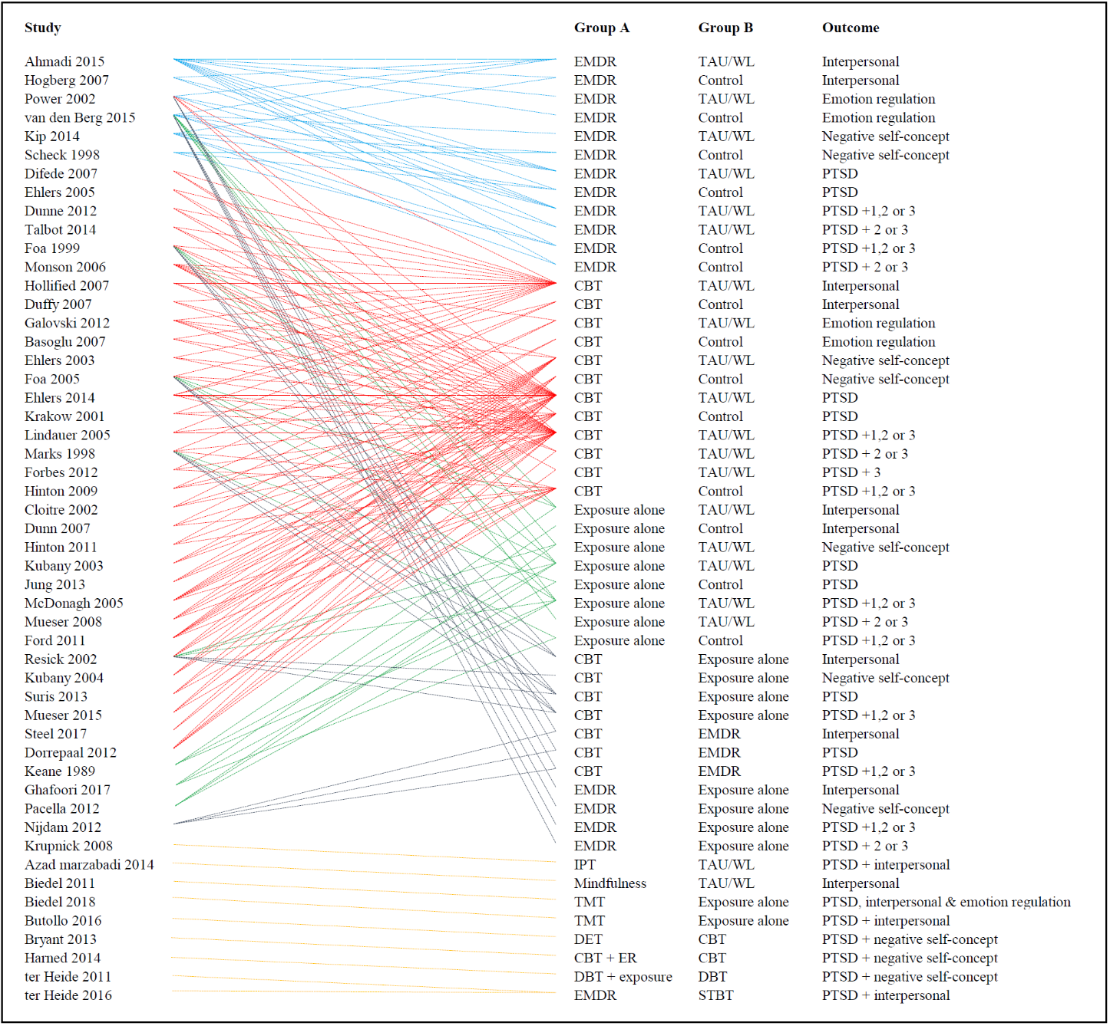**Figure 2. Overview of studies contributing to each analysis**

DR

DR

AD

AD

NSC

NSC

PTSD

PTSD

PTSD + 1, 2 or 3

PTSD + 2 or 3

PTSD + 1, 2 or 3

PTSD + 2 or 3

DR

DR

AD

AD

NSC

NSC

PTSD

PTSD

PTSD + 1, 2 or 3

PTSD + 2 or 3

PTSD + 3

PTSD + 1, 2 or 3

DR

DR

NSC

PTSD

PTSD

PTSD + 1, 2 or 3

PTSD + 2 or 3

PTSD + 1, 2 or 3

DR

NSC

PTSD

PTSD + 1, 2 or 3

DR

PTSD

PTSD + 1, 2 or 3

DR

NSC

PTSD + 1, 2 or 3

PTSD + 2 or 3

PTSD + DR

DR

PTSD, DR & AD

PTSD + DR

PTSD + NSC

PTSD + NSC

PTSD + NSC

PTSD + DR

Abbreviations: AD=affect dysregulation; CBT=cognitive behavioural therapy; CPTSD=complex posttraumatic stress disorder; DBT=dialectical behaviour therapy; DET=dialogical exposure therapy; DR=disturbances in relationships; DSO=disturbances in self-organisation; EMDR=eye-movement and desensitisation and reprocessing therapy; ER=emotion regulation (training); IPT=interpersonal psychotherapy; NSC=negative self-concept; PTSD=posttraumatic stress disorder; PTSD + 1, 2 or 3=PTSD + 1, 2 or 3 CPTSD (DSO) outcomes; PTSD + 2 or 3=PTSD + 2 or 3 CPTSD (DSO) outcomes; PTSD + 3=PTSD + all 3 CPTSD (DSO) outcomes; STBT=stabilisation treatment; TAU=treatment as usual; TMT=trauma management therapy; WL=waiting list.

**Figure 3. Bubble plot of trauma onset (adult vs child) by Hedges’ g, controlling for study quality, degree of CPTSD symptom severity, type of comparator, and type of treatment in multivariate meta-regression.**

