Published as: Lovreglio R., Fonzone A., dell'Olio L., 2016, A Mixed Logit Model for Predicting Exit Choice during Building Evacuations, Transportation Research Part A, DOI: 10.1016/j.tra.2016.06.018

A Mixed Logit Model for Predicting Exit Choice during Building Evacuations

Abstract
Knowledge on human behaviour in emergency is crucial to increase the safety of buildings and transportation systems. Decision making during evacuations implies different choices, of which one of the most important concerns the escape route. The choice of a route may involve local decisions between alternative exits from an enclosed environment. This work investigates the influence of environmental (presence of smoke, emergency lighting and distance of exit) and social factors (interaction with evacuees close to the exits and with those near the decision-maker) on local exit choice. This goal is pursued using an online stated preference survey carried out making use of non-immersive virtual reality. A sample of 1,503 participants is obtained and a Mixed Logit Model is calibrated using these data. The model shows that presence of smoke, emergency lighting, distance of exit, number of evacuees near the exits and the decision-maker, and flow of evacuees through the exits significantly affect local exit choice. Moreover, the model points out that decision making is affected by a high degree of behavioural uncertainty. Our findings support the improvement of evacuation models and the accuracy of their results, which can assist in designing and managing building and transportation systems. The main contribution of this work is to enrich the understanding of how local exit choices are made and how behavioural uncertainty affects these choices.

Keywords: Evacuation modelling, exit choice, social influences, behavioural uncertainty, random utility theory, efficient design.

Abbreviations
IBU | Intrinsic Behavioural Uncertainty
PPBU | Perceptions and Preferences Behavioural Uncertainty
ED | Efficient Design
MLM | Mixed Logit Model
MNL | Multinomial Logit
RP | Revealed Preference
RUM | Random Utility Model
RUT | Random Utility Theory
ST | Stated Preference
Highlights
- Local exit choice during emergency is modelled using a discrete choice approach
- A stated preference survey is developed using Efficient Design
- Exit choice is affected by environmental factors: presence of smoke, emergency lighting and distance of exit
- The presence of other evacuees and their flow though the exits affect the decision.
- Behavioural uncertainty is found decisive for the choice
1. Introduction

Reducing the number of fatalities and injuries during evacuations from buildings and transportation systems is the main aim of fire safety engineering. This goal can be achieved by designing evacuation systems and procedures so that the time needed by evacuees to escape safely (Required Safe Egress Time) is smaller than the time from ignition to the moment when the conditions of the given environment become untenable (Available Safe Egress Time). To date, several evacuation models have been developed to estimate the Required Safe Egress Time simulating human behaviour in fire [1,2].

The evacuees’ behaviour can be seen as the result of a hierarchical decision making process entailing three stages: (1) strategic (choice to go towards a safe place); (2) tactical (choice of routes and exits); and (3) operational (short range choices concerning the interaction with obstacles and other evacuees) [3–5]. The literature argues that escape route (i.e. tactical choices) can determine the effectiveness of the evacuation process in a crucial way [6–14]. From a modelling point of view, the decision concerning the route to a safe place entails global and local choice [15]. In fact, evacuees try to select the final goal(s) of their ‘evacuation journey’ through the global exit choice and then they try to achieve the selected goal making local exit choices. For example, the final/global goal could be to reach a specific exit of a building whereas the local exit choices are made to pursue the final/global goal. However, even though evacuees can be familiar with the building, it is not always realistic to assume that they have a complete knowledge of the global escape route. There could be situations in which the global evacuation route may be the consequence of local choices since different local exits from the same environment may lead to very different global escape routes [13,16].

Several environmental, social and personal factors can affect the global and local exit choice during emergencies [3]. The most influential environmental factors are (a) distance from the exits, (b) fire conditions (e.g., visibility of an exit; presence of smoke or flames close to an exit) and (c) emergency lighting [7,17–19]. Different kinds of social influences can also affect exit choice leading to different behaviour: herding behaviour, leader-follower behaviour, cooperative behaviour and competitive/selfish behaviour [20,21]. These social behaviours have been interpreted qualitatively using several theories: (1) the role-rule theory, explaining the behaviour on the basis of the behavioural rules of the evacuees, which depend on their everyday roles (e.g. staff of a transportation system may react differently from the users) [22,23]; (2) the affiliative theory, focusing on the decision maker’s attitude to follow familiar evacuees [24]; (3) the social influence theory, arguing that other evacuees are a source of information (informational social influence) and the decision-maker aims to conform his choice to that of other evacuees, to avoid their negative judgment (normative social influence) [25]; and (4) the social proof theory, according to which a decision is considered correct by the decision-maker because other evacuees have already taken it [26]. Besides the environmental and social factors, personal factors can impact exit choice. The most influential personal factor is the familiarity of the decision-maker with an exit (affiliation behaviour) [24,27–32]. Then, physical ability (depending on age or health), handedness, socio-psychological characteristics (like, for instance, direct or indirect risk perception, cultural background or training, past experiences) can also influence the exit choice [3,17,32–34].

A key issue in modelling and designing for evacuations is generally a lack of consideration of the stochastic nature of human behaviour [35,36].The behavioural uncertainty is due to two sources of randomness: the “Intrinsic Behavioural Uncertainty” (IBU), and the “Perceptions and Preferences Behavioural Uncertainty” (PPBU). IBU captures the fact that (a) the choices taken by different decision-makers perceiving a situation in the same way may be different; and (b) the same decision-makers could choose different exits when they face the same situation at different times. PPBU is related to different decision-makers’ perceptions (i.e. different decision-makers can have different quantitative estimates of the same factor) and preferences (i.e. a certain factor may have different importance to different evacuees) concerning the factors that influence the choice. Therefore, behavioural uncertainty represents a key feature that needs to be included in evacuation models. To enrich the understanding of how behavioural uncertainty may affect the decision-making process, new studies are necessary.

This work presents a case study of local exit choice during an evacuation from an enclosed environment with two exits. This study investigates the impact of both environmental and social factors on exit choice, including presence of other evacuees, fire conditions, emergency lighting and distance from the exit. The study is based on an online stated preference survey using non-immersive virtual reality scenarios. Responses form 1,503 respondents have been collected from all over the world. Choices are modelled using the Random Utility Theory (RUT), which assumes that the decision-maker chooses the alternative yielding the maximum utility and that this utility is not completely known to the modeller, so it has to be considered partially stochastic [37–39]. Therefore, the main contribution of this work is to provide new experimental data, which allows expanding and enriching the current understanding of local exit choice in emergencies, and to verify the importance of the behavioural uncertainty in local exit choice.

The paper begins with an introduction of existing approaches to model exit choice, supporting the use of the RUT and discussing the underpinning assumptions (Section 2). Section 3 introduces the methodological steps used in the case study. The survey is presented in Section 4, which provides details on the design and administration of the questionnaire and the obtained sample. The proposed exit choice model is introduced in Section 5 and discussed in Section 6, including a sensitivity analysis of the model. The conclusions in Section 7 discuss the practical implications of our study and future works.

2. Methodological Issues

Different approaches have been adopted to model exit choice [2]. Section 2.1 provides a general overview and supports the use of the RUT in this study. The modelling assumptions underpinning the RUT are introduced in Section 2.2, where models using the RUT are reviewed to justify the need for new model specifications/calibration.

2.1 Approaches to exit choice modelling

Three categories of exit choice rules are considered in existing evacuation models:

(a) Agents (i.e. simulated evacuees) head towards exits predefined by the modeller;
(b) Agents choose the closest exit;
(c) Agents choose the exit considering environmental, social and personal factors [2,18,32,40].

The first approach is clearly limited because it does not consider any evolution of the evacuating scenarios and the choice is a user input rather than an output of the model [41]. In the second one (distance-based model), the choice is context-dependent but static and based only on the building structure. It does not allow for dynamic adjustments to avoid congestion [40]. The third category of models entails that each agent evaluates the features of the simulated environment and takes decisions on the basis of the perceived information. In these models, the chosen exit can change during the evacuation process if the evacuation conditions change and a range of factors can be considered (e.g. presence of smoke, visibility, familiarity with an exit). The simplest and most common model of the third category is the time-based one, in which the agents choose the exit with the least evacuation time.

The modelling approaches to exit choice can be classified into deterministic and stochastic [3]. Deterministic approaches have been derived from different decision theories, such as the game theory [11,42,43] or the utility maximization theory [32,44]. Deterministic models can represent only average behaviours. By contrast, stochastic models take behavioural uncertainty into account. Several stochastic approaches have been used for exit choice. For instance, Zhang et al. [45] introduced an exit choice model in which the ‘base probability’ of using an exit is defined by the modeller. However, these pre-defined probabilities may change depending on the previous use of the exit and the fire condition of the next compartment connected to the exits. This approach requires prior knowledge of usage probabilities, which can be difficult to obtain. This issue can be overcome by Random Utility Models (RUMs) since these models do not require any pre-defined probability.

There are two main reasons for the adoption of the RUT as the modelling framework in this study. On the theoretical side, both IBU and PPBU can be taken into account. On the implementation side, well-established techniques exist to calibrate RUMs from Stated Preference (SP) or Revealed Preference (RP) surveys [37,46]. The RUMs implemented to analyse the results of our survey is discussed in the following section.

2.2 Random Utility Models Framework

In the RUT framework, the decision-maker assigns to each available option a utility which depends on the relevant attributes of the option itself. The option with the highest utility is more likely to be chosen. To consider the behavioural uncertainty, it is assumed that the utility $U_{iq}$ of the i alternative for the q decision-maker consists of two terms:

$$U_{iq}=V_{iq}+ε_{iq} (1)$$

where V_{iq} is a deterministic component whereas ε_{iq} is a random one (i.e. random residual) [37]. In this study, a linear specification is used for the deterministic part:

$$V_{iq}=\sum_{j}{β_{ij}X_{iqj}} (2)$$

where X_{iqj} are the known values of the j factors perceived by the q decision-maker influencing the choice for the i alternative, whereas β_{ij} are weights representing the decision-maker preferences related to j factors and are to be estimated. The functional form of the probability of choosing an each option depends on the hypothesis on the distribution of the random residual. The widely used multinomial logit models (MNL):

$$P_{iq}= \frac{e^{Viq }}{\sum_{k}{e^{Vik }}} (3)$$

derives from assuming that random residuals have Gumbel distributions with mean 0 and variance π²/6 and these are independent and homoscedastic [37]. The standard logit approach considers IBU by introducing the random residual term and it is simple to implement. The residual term includes also the modeller’s error (i.e. the lack of knowledge of the relevant factors affecting the decision) [37,47]. The MNL assumes that preferences/tastes are constant across evacuees and deterministic, therefore PPBU is not taken into account. PPBU is instead considered in random parameter models, such as Mixed Logit Models (MLMs) [38]. The MLM approach assumes that β_{ij} are randomly distributed because of decision-makers’ different tastes and perceptions of single factor. Therefore, the probability of choosing the i alternative by q decision-maker is:

$$\tilde{P_{iq}}= \int{\frac{e^{Viq }}{\sum_{k}{e^{Vik }}} f(β_{ij}|α_{ijz})}dβ_{ij} (4)$$

where f is the probability density function of the β_{ij} coefficients, and α_{ijz} is the z parameters of f [38,48]. In general the MLMs have no closed solution. However, the probabilities can be estimated by using Monte Carlo techniques [38,48]. Let be β_{z} vectors of β_{ij} coefficients drawn from f. An estimation of the probability that the q decision-maker selects the i alternative can be calculated by randomly drawing R vectors β_{z}, calculating the corresponding values of $P_{iq}$, and then averaging according to the following equation:

$$\tilde{\tilde{P_{iq}}}= \frac{1}{R}\sum_{z}^{R}{P_{iq}(β_{z})} (5)$$

$\tilde{\tilde{P_{iq}}}$ can be then used to estimate $α_{ijz}$ by maximising the likelihood function. The likelihood for Q decision-makers can be written as:

$L=\prod_{q=1}^{Q}{\sum_{i}^{I_{q}}{y_{iq}∙}}\tilde{\tilde{P_{iq}}}$ (6)

where $y_{iq}$ is equal to 1 if the q decision-maker (q=1,…,Q) selects the i alternative (i=1,…,I_{q}), otherwise it is 0. Numerous techniques are available in literature to solve the likelihood maximisation problem [37,39,46].

RUMs have been already used for modelling exit choice. Huang and Guo [10] proposed a multinomial logit model which predicted the probability of choosing an exit as a function of the distance associated to each available exit. The multinomial logit formulation was adopted also by Guo and Huang [49], whose model considered both free flow (related to the exit distance) and congestion (number of evacuees approaching the exit) disutilities, and the exit width (that is an indirect measure of the flow through an exit). Different from the studies described below, neither model was calibrated using experimental data.

Duives and Mahmassani [50] investigated the influences of exit distance, angular deviation, total number of evacuees, number of evacuees near the exit, and decision-maker handedness. A binary logit model was estimated using data collected through an online SP survey including 16 hypothetical scenarios. The sample included 117 participants from the Netherlands and the United States. The results showed that exit distance, angular deviation and total number of evacuees significantly affect exit choice.

Lovreglio et al. [3] studied the influence of the number of evacuees close to each exit and to the decision-maker, and the position of the decision-maker using a proxy measure of distance (i.e. close to an exit, far from an exit). A mixed binary logit was estimated using the choices of 191 Italian respondents, who were presented with 12 hypothetical scenarios in an online survey. All the environmental factors were found significant. The survey showed also that age, height and education influenced the perception of the distance from the exit and the impact of the evacuees near the decision-maker. Finally, the study proved the heterogeneity among respondents of the perception and preference (PPBU) concerning the number of evacuees close to each exit and the distance from the exit.

Haghani et al. [51] investigated the influence of exit distance, density around each exit, flow towards each exit, and exit visibility using data collected by face to face interviews with 53 Australian respondents. A hybrid survey technique combining SP and RP [52] was used to analyse the choices made in one real and 14 hypothetical scenarios. The authors estimated a MLM, proving that all the factors, with exception of the exit flow, were statistically significant. Also in this survey PPBU was observed.

Lovreglio et al. [20] focused on herding behaviour, i.e. the attitude of respondents to follow the decision taken by the majority of evacuees. Applying a MLM, the authors showed that herding behaviour was affected by both environmental (number of evacuees near the two exits) and personal (gender, weight and occupation) factors. Finally, Lovreglio et al. [21] refined the model in [20] introducing different herding classes. The study showed the existence of heterogeneity in the herding attitude.

It is noticed that each of these studies considered a subset of the potential influencing factors at a time and besides, the calibration was based on surveys in which the scenarios were represented in a simple way. This work improves the current knowledge by considering more factors than the existing studies, and by using virtual reality to better represent scenarios. The inclusion of more factors in the study allows a better estimation of the relative influence of these factors. The use of virtual reality greatly improves the realism of the experience the respondents during the survey.

3. Methodological Steps

RUMs can be calibrated using SPs or RPs [37]. In the SP approach, hypothetical scenarios are proposed to the participants in the study. Researchers can control for the variables deemed relevant in SP experiments and data collection is relatively quick and cheap (costs can increase though when face-to-face interviews are used to administer the survey). However, the data collected by SP approach may be biased because the interviewees do not face a real context (i.e. the results may have low ecological validity) [53]. The RP approach does not have this shortcoming, but data from actual evacuations are often difficult to obtain. Moreover, even when real data (in the form of videos) are available, there are two severe limitations. Firstly, researchers have no control over the sample and the variables affecting the choice. Secondly, the emotional state and the mental processes of the evacuees cannot be analysed directly but only induced from the behaviour in the emergency. Interviews with people involved in the evacuation may help overcome the latter limitation, but interviews can hardly be related to the data extracted from the videos [54]. A SP experiment based on virtual reality is considered suitable for the present study. The experimental control of this type of survey allows researchers to investigate the impact of several independent variables by collecting data suitable for the estimation of ‘good models’ [37]. The scenarios presented in SP experiments can be designed to have (a) sufficient variability of the independent variables, and (b) low collinearity of these variables [55].

In this study, we deal with social and environmental factors only, whereas the study of the influence of personal attributes on exit choice (except gender, see Section 5) is left to future work. Personal factors can indeed affect exit choice, but their influence is deemed not relevant here since our aim is to investigate the behavioural uncertainty related to social and environmental factors.

Our study includes three steps: (1) Background and Pilot Study, (2) Final Survey Design, (3) Data Collection and Modelling (Figure 1). In the first step, the variables which may influence exit choice were identified through literature review and analysing the interviews done during a previous study on exit choice [20]. Then an on-line pilot survey involving 88 participants was carried out both to improve the representation of the scenarios and to collect information for the design of the final survey. Face-to-face semi-structured interviews with some of the respondents provided insights into the perception of the contexts of choice and the involved variables. In the second step, the information collected through the pilot survey was used to define the levels of the variables characterising the scenarios in the final survey, using the Efficient Design technique explained below. Moreover, the results of interviews were used to improve the videos so that respondents could have an accurate perception of the contexts of choice. In the last stage, data collection was performed through an on-line survey. The videos representing the choice scenarios could be easily shown to respondents using the Internet. In addition, on-line survey allowed collecting data from large and heterogeneous samples in short time and with very small costs. The responses were analysed using a MLM, taking into account both IBU and PPBU.

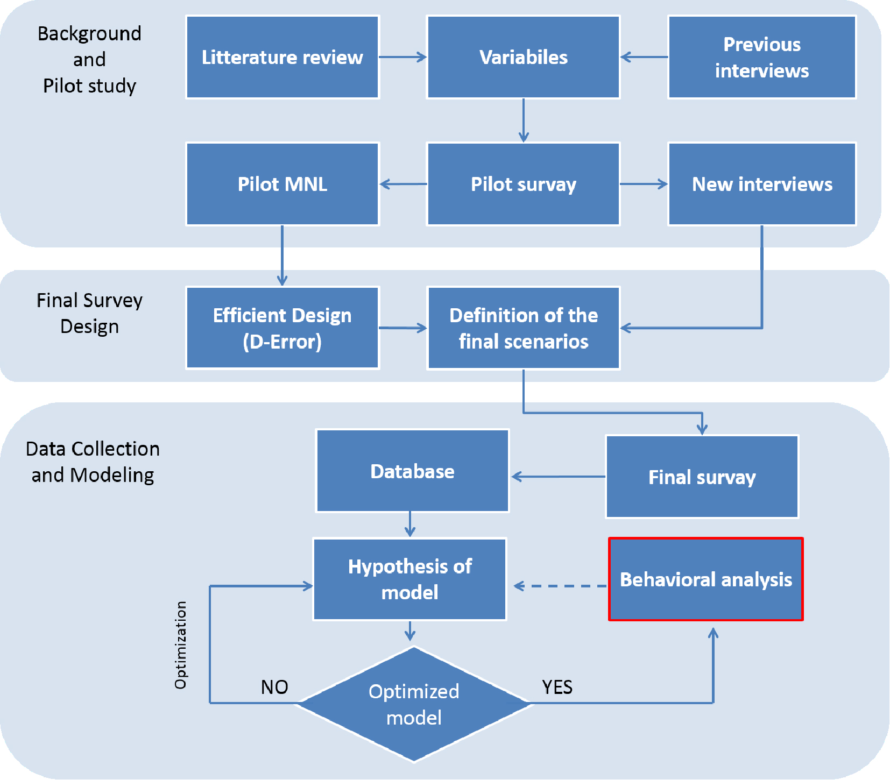
Figure 1 - Methodological scheme

The scenarios used in SP surveys were defined by the levels assumed by the relevant factors. When the number of variables is large, the number of the scenarios generated by the combinations of all levels of all variables becomes easily intractable. To cope with this issue, we used the Efficient Design (ED) technique to select the scenarios to be included in our survey [46,56–58]. This method is based on the minimization of the so called D-error, which is the determinant of the asymptotic variance-covariance matrix (i.e. the negative inverse of Hessian matrix of the log-likelihood function) to the power of 1/K, where K is number of parameters to estimate. Therefore, D-error is related to the p-values of the parameters to estimate since p-values are calculated using the variance matrix (i.e. the diagonal elements of variance-covariance matrix) [46]. To implement ED, approximated values of the model parameters (“prior” values) are necessary before running the survey. Prior values can be found in literature or, if not available as in our case, obtained from a pilot study. The pilot survey can be designed by means of ED, using educated guesses on the sign and the value of each parameter to estimate.

4. SP Experiment

4.1 Contexts of choice

The context of choice used in this study included two exits, one on the left-hand side and one on the right-hand side of the decision maker. The exits were set in an enclosed environment similar to a metro station with rectangular plant (size: 23m x 18m) as shown in Figure 2. The hypothetical scenarios were proposed using videos to make the context of choice more realistic. Moreover, videos allowed providing respondents with information deriving from the dynamic evolution of the evacuations: for instance, the capacity of an exit could be evaluated from the number of evacuees that flow through it in a fixed time. The videos were generated using Unity 3D (Personal Edition). The geometry of the metro station was built directly in Unity 3D whereas evacuees’ 3D bodies were downloaded from the web and their original file formats were converted using Blender. Pieces of code in C# were used to animate these virtual evacuees. To improve the realism, a fire alarm and voices were added (Video 1). During the experiment, decision-makers were supposed to be inside the environment and that videos were taken from their point of view.

It has been highlighted that exit choice can be influenced by environmental (concerning the physical features of the choice context), social (related to the presence of other evacuees) and personal factors. Social influences and the descending behaviours are a particular focus of this study. The factors we considered are:
- Number of evacuees Close to the Exits (NCE);
- FLow of evacuees through the exits (FL);
- Number of evacuees Close to the Decision-Maker heading towards one of the exits (NCDM);
- SMoke near the exits (SM);
- Evacuation Lights above the exits (EL);
- DISTance of the decision-maker from the exits (DIST);

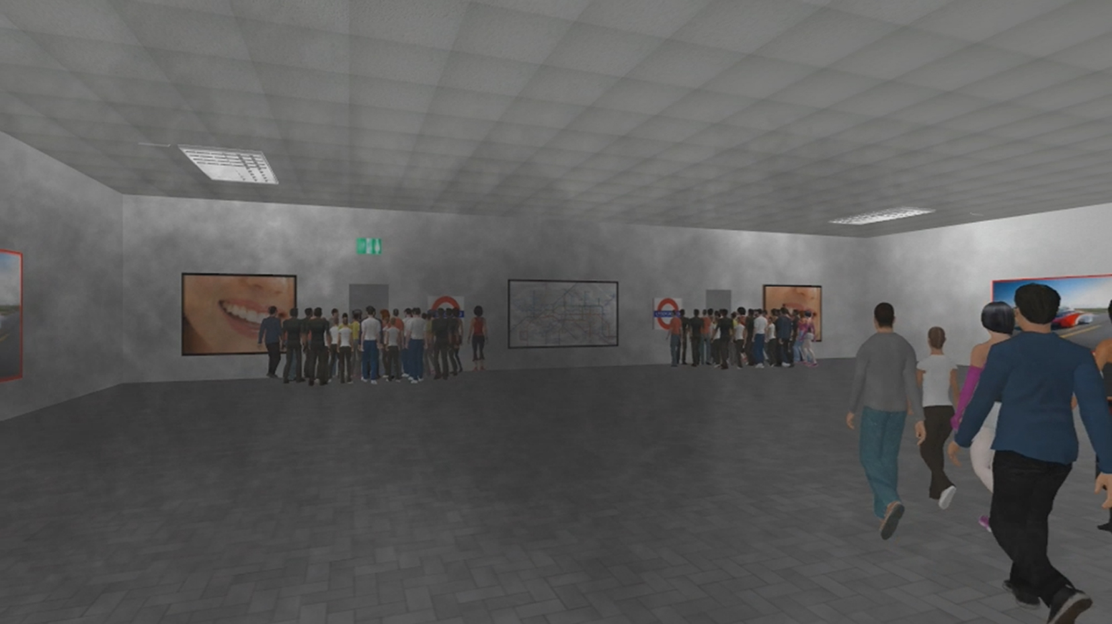
Figure 2 - Frame from one of the videos

Fire conditions can affect the exit choice in two ways: the presence of the smoke near an exit can induce decision-makers to avoid that exit; the presence of smoke near an evacuees can affect their range of visual perception. In our videos, the presence of smoke does not affect the visibility of the exits (the respondents are able to see the exit and the simulated evacuees in every video). Therefore, we only study the influence of the presence of smoke near the exits, represented by a dummy variable (SM).
In the pilot survey, respondents were asked to point out the exit they would choose in 12 scenarios, defined by different levels of the variables as reported in the Appendix (see Tables A1 and A2). The pilot study involved 88 respondents corresponding to 1056 (88 x 12) observations. The starting values of the parameters for the design of the final survey with ED were estimated by calibrating a MNL model (Table 1). 10 of the 88 respondents participated in a face-to-face semi-structured interview. Most of them stated that they could not perceive any difference between the flows though the two exits, which were actually different in some scenarios. This is confirmed by the MNL, where the parameter associated with FL is not significantly different from zero. To improve the perception of this variable two very different levels were chosen for the final survey (see Table 2). While in the pilot survey the different flows depend only on evacuees’ speeds, in the final survey different flows were determined both by evacuees’ speed and exit width. Even though the parameter associated with DIST is not significantly different from zero (see Table 1), almost all interviewees stated that they took into account the distance from the exits during the choice. Therefore, it was kept in the final survey.

Table 1 – Pilot MNL
 | Coeff. | Std.Err. | t-ratio | P-value
NCE | -0.108 | 0.012 | -9.108 | 0.000
FL | 0.214 | 0.209 | 1.022 | 0.307
NCDM | -0.049 | 0.021 | -2.318 | 0.020
SM | -0.985 | 0.123 | -7.995 | 0.000
EL | 0.175 | 0.101 | 1.736 | 0.082
DIST | -0.011 | 0.030 | -0.362 | 0.718
The scenarios of the final survey were defined by different combinations of the variables and levels shown in Table 2. The subscript i represents the exit: L stands for the exit on the left, R for that on the right-hand. NCE_{i} varies during the videos because evacuees evacuate through the exits; the values shown in the table are those visible at the beginning of each video. The two dummy variables NEAR_E and DIR define respectively the position of the decision-maker and the direction of evacuees close to the decision-maker. NEAR_E=0 if the decision-maker is closer to the right-hand exit, 1 otherwise. Similarly DIR=0 if the evacuees near the decision-maker move towards the right-hand exit, 1 otherwise (Figure3).

Table 2 - Levels for each variable
Variable\Levels | 1 | 2 | 3 | 4
NCE_{i} (pers) | 24 | 30 | 40 | /
FL_{i} (pers/s) | 0.6 | 1.2 | / | /
NCDM (pers) | 0 | 5 | 10 | /
SM_{i} | 0 | 1 | / | /
EL_{i} | 0 | 1 | / | /
DIST (m) | 10 | 12 | 14 | 16
NEAR_E | 0 | 1 | / | /
DIR | 0 | 1 | / | /

Given the variable levels in Table 2, the number of the possible scenarios (full factorial design) is 4¹3³2⁸=27648. From these 12 scenarios listed in Table 3 were selected using ED. The 12 scenarios were divided into two blocks of 6 and each respondent was presented with one of the two blocks. This allowed reducing the number of scenarios for each respondent and so to prevent respondents’ fatigue, a problem pointed out by some of the interviewees during the pilot survey where participants were asked to state their decision in 12 cases. Moreover, the scenarios were presented randomly to avoid that the collected data could be biased by the order of the scenarios.

Table 3 – Final scenarios
Scenario | NCE_{L} | NCE_{R} | FL_{L} | FL_{R} | SM_{L} | SM_{R} | EL_{L} | EL_{R} | NCDM | DIR | DIST | NEAR_E | Block
1 | 24 | 30 | 1.2 | 0.6 | 0 | 1 | 1 | 1 | 10 | 1 | 14 | 0 | 1
2 | 40 | 40 | 0.6 | 0.6 | 1 | 0 | 1 | 0 | 5 | 0 | 16 | 1 | 1
3 | 30 | 30 | 0.6 | 1.2 | 0 | 0 | 0 | 1 | 10 | 0 | 10 | 0 | 1
4 | 24 | 40 | 1.2 | 0.6 | 1 | 0 | 0 | 1 | 0 | 1 | 10 | 1 | 1
5 | 40 | 24 | 1.2 | 1.2 | 0 | 1 | 0 | 0 | 0 | 1 | 12 | 1 | 1
6 | 30 | 40 | 0.6 | 1.2 | 1 | 1 | 1 | 0 | 0 | 0 | 16 | 0 | 1
7 | 40 | 40 | 0.6 | 0.6 | 0 | 0 | 0 | 0 | 5 | 1 | 10 | 0 | 2
8 | 40 | 24 | 0.6 | 0.6 | 0 | 1 | 1 | 1 | 5 | 0 | 12 | 1 | 2
9 | 24 | 30 | 0.6 | 1.2 | 1 | 1 | 0 | 1 | 10 | 1 | 16 | 1 | 2
10 | 30 | 30 | 1.2 | 1.2 | 1 | 0 | 1 | 1 | 0 | 1 | 14 | 0 | 2
11 | 30 | 24 | 1.2 | 0.6 | 1 | 1 | 0 | 0 | 10 | 0 | 12 | 0 | 2
12 | 24 | 24 | 1.2 | 1.2 | 0 | 0 | 1 | 0 | 5 | 0 | 14 | 1 | 2

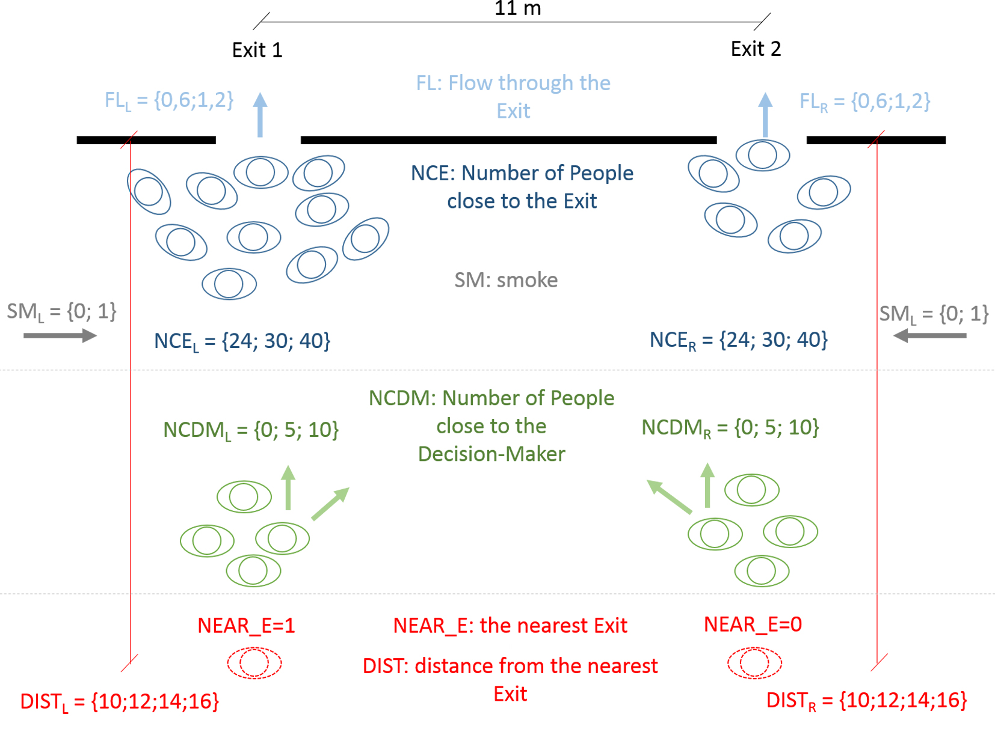
Figure 3 – Context of choice

4.2 Survey

The questionnaire, in English and Italian, was disseminated through the internet over a period of two months. The survey was advertised by mail lists and social networks (i.e. LinkedIn, Twitter, and Facebook). This advertising strategy was used to collect as much data as possible from respondents coming from different parts of the world. The goal was to collect data from more than 450 respondents, which was the lower bound for the sample size suggested by the ED technique for this case study [58].

The survey included three sections. The first contained an introduction and demographic questions. In the second the videos representing the contexts of choice were shown. The respondents were instructed to make a choice at the end of the playback. It explicitly stated that “ there is no right and wrong choice and we are only interested in understanding what you would do in the situation you are faced with in the video”. This was essential because the aim of the survey was not to collect data about the “most rational/optimal” behaviour but the “natural” response to the situation. At the end of each video, respondents were directed to a new web page to choose between the left and right-hand exits. This page included also a countdown timer that gave the respondents 5s to answer the question. The countdown timer was used to prevent that excessively long reflection may lead to choices different from those in emergencies. Actually, respondents were allowed to state their choice also after the time runs out to reduce non-response, but they were not made aware of this aspect to keep the level of alertness high. Finally, in the third section, at the end of the videos, the respondents were asked questions about the level of realism of the proposed scenarios and their level of anxiety during the experiment.
4.3 Sample

Our sample is made up of 1503 respondents, corresponding to 9018 (1503 participants x 6 scenarios) observations. 28.3% of the participants are female. The mean age is 28.2, with std deviations 11.4; 71% of the respondents are under 30 years old (Fig. 4). The majority of respondents are from Europe, mainly from Italy (22%) and the UK (11%) (Fig. 5).

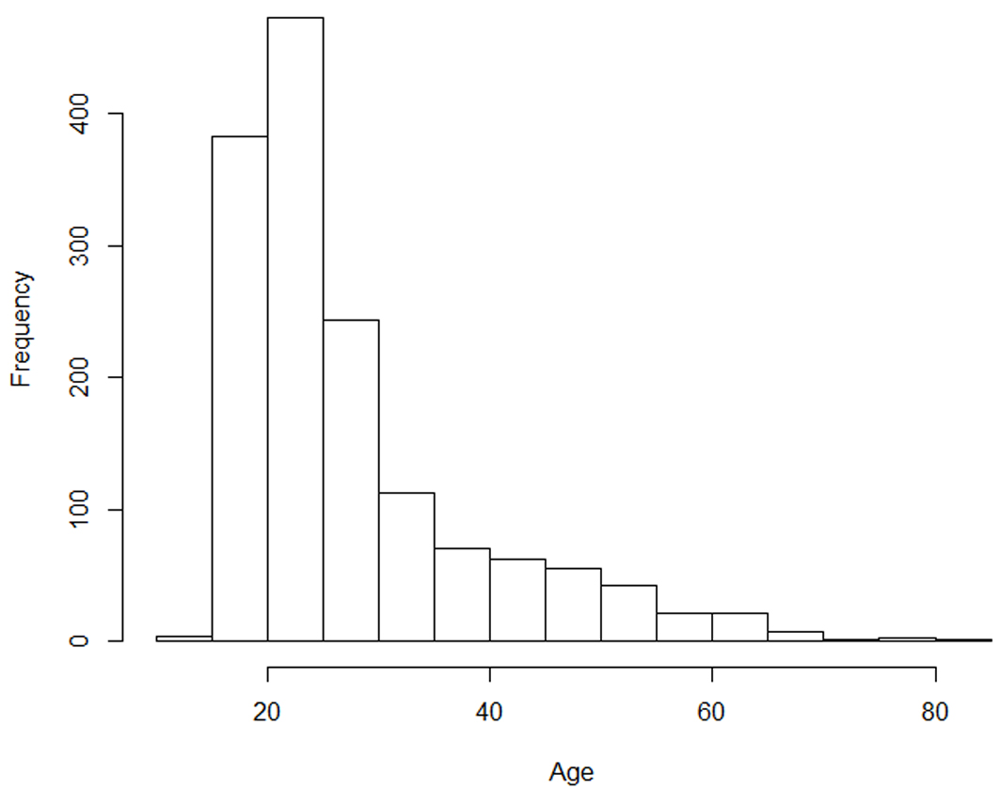
Figure 4 –Age distribution of respondents

Figure 5 – Geographical distribution of respondents

The sample demographics are explained by the dissemination channels. In fact, the age distribution reflects the age distribution of social network users [59,60]. However, the sample is large enough to take into account differences between male and female respondents as is discussed in Section 5.

4.4 Limitations

The data collected in this case study have some limitations. The main one is that the ecological validity of the results may be jeopardised by two issues:
- The decision-makers were exposed to hypothetical situations with the awareness that they were involved in a trial but not in a real emergency. This may imply that their answers are driven by their anticipation of what is the ‘right’ answer for the researcher, instead of reporting the “natural” behaviour.
- Despite the use of the countdown to increase respondents’ stress through time pressure, it is impossible to induce with the physiological implications generated by a real emergency through an online survey based on a not-immersive virtual reality.
Previous studies have found that social behaviour in virtual reality simulations can be affected by behavioural realism and agency, i.e. ‘whether an animated human is perceived as an agent or an avatar’ (see [61]) according to the threshold model of social influence [61,62]. These two factors are not taken into account in our survey. However, when the respondents are asked to rate the perceived general realism of the context of choice, they rate it 3.0 on average, in a scale from 1 - very realistic to 5 - not realistic at all.

The last limitation of the survey concerns the influence of the smoke. As explained in Section 4.1, we studied the smoke influence only by using a dummy variable indicating whether there was smoke near the two exits. However, it is evident that the visibility can play a key role in exit choice [7,63,64].

The effect of these limitations is discussed in the conclusion of this paper.

5. Estimated Model

Table 4 –Estimated MNL and MLM
 | MNL |  |  |  |  | MLM
 | Restricted log likelihood = -5419.025  Log likelihood function = -4357.728  RsqAdj = 0.19440 |  |  |  |  | Restricted log likelihood = -5419.025  Log likelihood function = -4284.297  RsqAdj = 0. 20798
 | Coeff. | Std.Err. | t-ratio | P-value |  | Coeff. | Std.Err. | t-ratio | P-value
NCE | -0.1161 | 0.0044 | -26.4984 | 0.0000 |  | -0.1713 | 0.0107 | -16.0148 | 0.0000
FL | 0.6092 | 0.0768 | 7.9348 | 0.0000 |  | 1.1455 | 0.1380 | 8.3008 | 0.0000
NCDM | -0.0771 | 0.0054 | -14.1997 | 0.0000 |  | -0.1041 | 0.0090 | -11.5533 | 0.0000
SM | -0.7621 | 0.0512 | -14.8936 | 0.0000 |  | -1.0041 | 0.0852 | -11.7836 | 0.0000
DIST | -0.0534 | 0.0066 | -8.0633 | 0.0000 |  | -0.0813 | 0.0114 | -7.1273 | 0.0000
EL | 0.8556 | 0.0397 | 21.5572 | 0.0000 |  | 1.2291 | 0.0853 | 14.4012 | 0.0000
CONST | 0.0959 | 0.0271 | 3.5440 | 0.0004 |  | 0.0690 | 0.0364 | 1.8950 | 0.0581
NsNCE | / | / | / | / |  | 0.0549 | 0.0105 | 5.2446 | 0.0000
NsFL | / | / | / | / |  | 1.6450 | 0.2477 | 6.6411 | 0.0000
NsNCDM | / | / | / | / |  | 0.0826 | 0.0171 | 4.8287 | 0.0000
NsSM | / | / | / | / |  | 0.8860 | 0.1299 | 6.8194 | 0.0000
NsDIST | / | / | / | / |  | 0.1972 | 0.0192 | 10.2540 | 0.0000
NsEL | / | / | / | / |  | 1.1631 | 0.1228 | 9.4733 | 0.0000
NsCONST | / | / | / | / |  | 0.4436 | 0.1013 | 4.3804 | 0.0000

An MNL and an MLM are estimated using the data from the survey described in Section 4 (Table 4). Different from MNL, the parameters in MLM are normally distributed.. Therefore, if the predictivity of latter model is better than that of the former, it can be concluded that PPBU plays a key role in the exit choice process. The utility function of the exits includes all the factors described in Section 4. A constant is added to the utility function of the right-hand exit to check whether respondents are biased towards one of the two exits. NCE changes over the duration of the videos because some evacuees leave the environment (with flow FL). In the model, we include the average values at the beginning and at the end of the simulation. Since there is a large difference between the number of female and male respondents, we have studied the interaction between a dummy variable defining the respondent gender (GEND=1 if the respondent is female) and each environmental and social variable (V_{i}=NCE, FL, NCDM, SM, EX or DIST) to check if the gender statistically affects the choice. The model specification in Table 4 does not include the interaction terms because they are not statistically different from zero (p-value>>0.05).

To estimate MLM, a panel data approach is used to take into account the correlation between the answers of the same respondent who makes a choice in 6 different scenarios. 300 Halton draws are used to simulate the random distribution of the parameters (Equation 5) [38,39].

In both models, all the factors are statistically significant (assuming a significance level of 0.05) except the constant of the MLM. The MLM shows that all the parameters are normally distributed. Figure 6 shows the distribution of the different parameters.

Figure 6 –Random distribution for (a) NCE and NCDM; (b) FL; (c) SM and DIST; (d) EL

The predictivity of the two models is studied through four indicators taken from the literature: the traditional Log-likelihood and adjusted R squared indicators, and two less common indexes [38,39,46,65]. The first of these two other indicators is

$$E=\sum_{s=1}^{S}{{(P_{s}-F_{s})}^{2}} (7)$$

where P_{s} is the predicted probability of choice of a scenario s and F_{s} is the corresponding observed frequency. Clearly E= 0 when the predictions perfectly match to the observation. The last considered indicator is

$F= \frac{1}{N_{obs}}\sum_{i=1}^{N_{obs}}{δ_{i}, }δ_{i}=1 if {(P}_{L,i}>P_{R,i} ∧C_{i}=L) ∨{(P}_{R,i}>P_{L,i} ∧C_{i}=R); δ_{i}=0 otherwise (8)$

where $N_{obs}$ is the total number of the i observations; $P_{L,i}$ and $P_{R,i}$ are the predicted probability of choosing the left-hand and right-side exit, respectively; $C_{i}$ is the actual choice made by the decision-maker between the left-hand (L) and right-side (R) exit.

Table 4 shows that the MLM outperforms the MNL model in the three first tests whereas they have the same values of F because the exit with the highest probability of being chosen is the same in the two models. This result highlights that PPBU improves the predictivity of the local exit choice.

6. Discussion

The MLM proposed in this study allows predicting the probability of a decision-maker to choose an exit by considering six environmental and social factors. The analysis confirms the existence of PPBU. In fact, the perception of the factors and/or their relevance in the decision makers is not constant among respondents, but the parameters (β_{ij}) associated to all the independent variables are normally distributed. Note that different parameters distribution can be tested using the MLM approach. In the absence of evidence on the distributions in our case, we have selected the normal one since it is the most commonly used [66]. This aspect should be investigated in future work. The results show that the MLM approach should be preferred to the MNL one to model exit choice. The interaction terms (i.e. the variables built by multiplying a dummy variable representing gender by each environmental and social variable, see Section 5) are not statistically different from zero. Therefore our data does not prove any difference between male and female.

A behavioural analysis is performed considering the averages of the parameter distributions. In general, the probability of choosing an exit decreases when the number of evacuees close to it (NCE) increases, i.e. the decision-makers perceive a large number of evacuees using an exit as an impedance. In other words, respondents demonstrate crowd avoidance behaviour with the evacuees near the two exits. The same tendency can be seen in the interaction with evacuees near the decision maker (NCDM). However, the distribution of NCDM implies that the crowd avoidance behaviour is sometimes replaced by the herding behaviour. In fact, in Figure 6 it can be seen that the probability is high when the parameter associated with NCDM is positive. This means that there are respondents for whom the fact that many other evacuees head towards one of the two exit is an incentive to select the same exit. This could be explained by the fear to be negatively judged by other evacuees by choosing the ‘wrong’ alternative (normative social influence [21]), and/or by the attitude to consider other people’s decisions as a proof of the correctness of a choice (social proof theory) [20,21,26]. In the figure, it is also evident that NCE and NCDM have different distributions, i.e. there is a difference in the way respondents perceive these two factors, related to the same factor, the presence of other evacuees. This could be explained by the proxemics approach, which argues that the closer other people are to a decision-maker, the more the decision-maker is affected by them [67]. This phenomenon has been observed also in virtual reality environments [68,69].

The exit distance is generally perceived as disutility as normally expected. However, the random distribution of the distance is characterised by a very large dispersion, i.e. several respondents choose the furthest exit (Figure 6). This could be because the two exits are not too far away from each other and therefore some participants did not consider distance as an important factor as most other did.

Considering the averages of the random parameters in Figure 6, it is possible to argue that overall the respondents perceive the flow through the exits as a utility because higher flow rates allow faster evacuation whereas the presence of smoke have a negative impact on the choice since it could harm the decision-maker. Then, the presence of emergency lights increases, on average, the probability of choosing an exit because it improves the functional affordance of the exit [19,70]. However, Figure 6 shows that the parameters associated to FL, SM and EX have very large dispersions, as indicated by the standard deviations in Table 4. As a consequence, there is high probability that, for a specific decision-maker, the concerned parameters assume a sign different from that of the average decision-maker. The high dispersion can be due to a combination of the high level of heterogeneity in the preferences [37].

Finally, the constant included in the utility function of the right-hand exit is not statistically significant (p-value = 0.07 > 0.05). This means that the right-hand exit is not chosen systematically more than the left-hand one under the social/physical conditions described in Table 3.

6.1 Sensitivity Analysis

A sensitivity analysis is provided to show how the probability of choosing an exit is influenced by the observed factors and their interaction. 300 β_{z} vector are draws randomly generated and the probabilities of choosing the two exits are estimated using Equation 5. The effect of the number of evacuees near the two exits (NCE) and near the decision-maker (NCDM) is shown in Figure 7, whereas the influence of flow (FL), smoke (SM), emergency lights (EL), and distances (DIST) is presented in Figure 8.

In Figure 7-a and 7-b, NCE and NCDM range between 0 and 50 whereas the other variables are the same for both exits. In the scenarios in which the variables are nil for one door and equal to 50 for the other, the probability of selecting the left-hand side door is very close to 1 and 0 in Figure 7-a, whereas in Figure 7-b the probability surface has the maximum and minimum equal to 0.85 and 0.12 respectively. Comparing the two charts, it can be seen that NCE influences (negatively) the probability of choosing an exit more than NCDM. In other words, a decision-maker is more willing to choose the less congested exit when the other evacuees are closer to the exit (NCE) than when they are close to them (NCDM).

(a) | (b)
Figure 7 –Sensitivity analysis for (a) NCE; (b) NCDM

In Figure 8, the number of evacuees close to the right-hand exit (NCE_R) is fixed to 25 while the evacuees close to the left-hand exit (NCE_L) varies between 0 and 50. All the other variables are the same for the two exits. In Figure 8-a and 8-b the flow and distance of the right-hand exit are 0.5persons/s and 10m respectively.

(a) | (b)
(c) | (d)
Figure 8 –Sensitivity analysis for (a) FL; (b) DIST; (c) EL; (d) SM

Figure 8-a and 8-b show the existence of situations in which flow and distance are not determinant in the exit choice because the social factors are predominant. These situations occur when the curves in the figures tend to overlap. For instance, Figure 8-a shows that for low values of NCE_L (NCE_L<10), the flow does not influence the choice. In these conditions, the left-hand exit is almost free and definitely freer than the right-hand one (NCE_R=25) and therefore the decision-maker may reckon that s/he can escape quicker by using it, even though the capacity of the exit is low. It has to be noted that, for low values of NCE, the flow is difficult to evaluate for the decision-maker, and so s/he may assume that the flow rate is the same for the two exits, leaving the number of evacuees as the only decision variable. In Figure 8-b, it can be seen that for high values of NCE_L (NCE_L>30) the distance from the left-hand exit does not affect the choice probability, since this exit is so crowded that the decision maker tends to avoid it anyway.

When the number of close evacuees is the same for the two exits as in Figure 8-c (NPE_L=NPE_R=25), the probability of choosing the left-hand exit depends on the presence of the emergency lights. The probability varies from 0.26 when there is no light on the left-hand exit but there is one on the right-hand one (EL_L=0 and EL_R=1), to 0.70 in the opposite case (EL_L=1 and EL_R=0). Figure 8-c suggests also that the decision-maker can neglect the information given by the emergency light. In fact, in the situation with emergency light on the right-hand exit only, one would expect that the decision-makers avoid the exit on the left-hand side. Instead, the plot shows the left-hand exit has high probability of being chosen for medium-small values of NCE_L. This could be explained by the informational social influence [25], which predicts that the presence of other evacuees close to an exit indicates that that exit is an available alternative. Finally, Figure 8-d shows how the presence of smoke can affect the choice considering different numbers of evacuees near the exits. Having smoke close to an exit is less important than the choice of other evacuees. In fact, when there is smoke near the left-hand exit and the other exit is clear (SM_L=1 and SM_R=0), the decision-makers prefer the former alternative if it is relatively uncongested (NCE_L approaching zero).

6.2 Comparison with existing models

In Table 5, our model is compared to the existing ones . All the models have been fitted using our dataset – that is definitely larger than all the others - for a fair comparison. It can be seen that the fit of our model in terms of adjusted R² indicator (which includes a penalty for each parameter included in the model) is much better than the others, proving the need for considering all the environmental and social factors together. The table shows also the mean values of the parameters (the parameters are proven random in all the cases) in each model specification. It can be seen that there is a remarkable difference between the parameter of FL (the exit flow rate) in the specification proposed by Haghani et al. [51] and in our model. The under-specification of the former model may lead to wrong design choices whenever evacuation scenarios include smoke and emergency lighting. In fact, a design based on results by Haghani et al. [51] may overestimate the possibility of inducing evacuees to select an exit by making it larger. However, the model specification proposed by Haghani et al. [51] may still be correct in evacuations which does not involve smoke and emergency lighting.

Table 5 – Comparison between the proposed model and the existing ones.
 | Model specification |  |  |  |  |  | Survey features |  | RsqAdj*
 | NCE | FL | NCDM | SM | EL | DIST | Sample size | Video
(Duives and Mahmassani, 2012) | Yes  (-0.087) | No  (-) | No  (-) | No  (-) | No  (-) | Yes  (-0.055) | 117 | no | 0.089
(Lovreglio et al., 2014a) | Yes  (-0.134) | No  (-) | Yes  (-0.076) | No  (-) | No  (-) | Yes  (-0.088) | 191 | yes** | 0.126
(Haghani et al., 2014) | Yes  (-0.089) | Yes  (1.615) | No  (-) | No  (-) | No  (-) | Yes  (-0.082) | 53 | no | 0.125
Proposed model | Yes  (-0.116) | Yes  (0.609) | Yes  (-0.077) | Yes  (-0.762) | Yes  (0.856) | Yes  (-0.053) | 1503 | yes | 0. 208

7. Conclusion

A Mixed Logit Model is proposed to predict exit choice in emergency at local level. The influence of different environmental and social factors is investigated. The model is estimated using the data collected through an on-line State Preference survey designed through Efficient Design.

Compared to the existing literature, our study has the advantage to investigate the influence of more factors simultaneously expanding the current understanding of local exit choice in emergencies. The findings show that presence of smoke, distance of the exit, number of evacuees near the exit or close to the decision-maker but moving towards the exit have a negative influence on the probability of an exit to be chosen. On the contrary, emergency lighting and flow of evacuees through the exit have a positive influence.

We explore the “intrinsic” behavioural uncertainty and the behavioural uncertainty linked to “perceptions and preferences” using Mixed Logit Model approach. In the estimated Mixed Logit Model all the parameters are randomly distributed, which proves the existence of Perceptions and Preferences Behavioural Uncertainty. Methodologically, a strength of our study is the use of non-immersive virtual reality to represent choice scenarios. Through virtual reality, respondents have a substantially more realistic perception of the context to evaluate. This increases the validity of the survey. We asked participants to rate the realism of the representation of the choice context. Previous studies did not include such an evaluation therefore a direct comparison is not possible.

The realism of our scenarios was rated 3 out of 5 on average, i.e. the choice context was sufficiently realistic to respondents. However, we suggest that future studies should try to further enhance the realism of choice contexts. We note that, in the field of exit choice in emergency, when decision makers are faced with unusual scenarios, the validity of results from simulated environments should be carefully assessed by means of comparison with naturalistic contexts. However, this is difficult because of the scarcity of data of real world emergencies and the ethical implications of asking people to participate in experiments which may harm their safety.

Our sample, made up of 1,503 respondents from different parts of the world, is much larger than those used so far to investigate the local exit choice process. Our sample is rather homogeneous as to gender (72% are male) and age (71% are under 30) of participants, but it is definitely more heterogeneous than previous studies in terms of nationalities. Because of this heterogeneity, our results are not influenced by the cultural attributes of the respondents linked to the nationality.

Our findings could have several applications. Once integrated with other models simulating strategic (i.e. pre-evacuation model) and operational (i.e. local movement) choices, our tactical model could improve the safety design and management of new and existing buildings [71,72]. In fact, the model provides more accurate predictions of local exit choice, an aspect that has been previously simplified or overlooked in most evacuation models. We note that some possibly relevant factors, e.g. number and position of the exits, are not taken into account in our model and their impact should be investigated in further studies.

Another important implementation of the proposed model concerns crowd management during evacuations from transportation systems. Recent studies have proved that it is possible to improve evacuation time and safety by using Intelligent Active Dynamic Signage System (IADSS) instead of using ‘classic’ passive signage system. The effectiveness of the system has been tested at the Sant Cugat Station in Barcelona using volunteers. The experiments prove the improvement of wayfinding decisions in complex structures (see GETAWAY European Project for more details [71,73]). The aim of this system is to direct evacuees in real time by an iterative procedure having four steps: (1) detecting the status quo of evacuations (e.g. evacuees’ position and movement direction, fire conditions, etc.); (2) predicting the outcomes due to the status quo conditions (e.g. total evacuation time, number of casualties, etc.); (3) verifying whether the evacuation process can be improved by directing the evacuees towards different exits/paths; (4) in case it could be improved, re-directing evacuees using dynamic sings. This approach crucially relies on evacuation modelling (steps 2 and 3) and an enhanced tactical model (e.g. global and local exit choice model) can improve the evacuation outcome since IADSS systems are designed to support both the global and local evacuees’ route choice using dynamic sings.

IADSS includes dissuasive emergency signage [74], a new generation of evacuation lighting not included in this study. Therefore, future work is necessary to investigate the effect of the dissuasive emergency signage, since our results show that the dynamic sings information may not be effective in determining exit choice (Section 6). Future studies should also investigate the influence of different smoke intensities (we only consider the presence or the absence of smoke), which can affect the visibility of the exit and its affordance.

Our results may be biased by the demographic characteristics of the sample, in particular by the fact that most of the respondents are under 30 years and European. However, we have found no significant difference between the choices of female and male respondents. This result differs from the previous findings showing that the attitude to follow other people’s choice depends on the gender [20]. The present study considers a broader set of explaining factors, which capture the effect previously attributed to gender.

This study was not designed with the purpose to recruit a specific population target but with the purpose to collect data from more than lower bound of the Efficient Design to investigate the behavioural uncertainty in local exit choice. However, analysing the sample demographics it is possible to characterise the “target population” a posteriori and so to identify the best areas of application of the model. Our model is particularly suitable for any evacuation from an enclosed environment in which the evacuees are young and coming from several nationalities, like evacuations from universities and underground stations in multinational cities at peak times [75]. The methodology and the survey developed in this work can be used in future studies to investigate the behaviour of specific population targets defined a priori.

Finally, in the research field, the parameters estimated in this study can be used as a starting point for future Stated Preference studies based on Efficient Design and using more advanced technique such as immersive virtual reality.

Appendix

The levels of the variables and the hypothetical scenarios of the pilot survey are shown in Table A1 and A2, respectively.

Table A1 - Levels for each variable included in the pilot survey
Variable | Description | Levels
NCE_{i}* (pers) | Number of evacuees Close to the Exits | 0 5 10 20
FL_{i} (pers/s) | FLow of evacuees through the exits | 0.6 1.2 1.5
NCDM (pers) | Number of evacuees Close to the Decision-Maker | 0 5 10
SM_{i} | SMoke near the exits | 0 1
EL_{i} | Evacuation Lights above the exits | 0 1
DIST (m) | DISTance of the decision-maker from the exits | 10 12 14 16
NEAR_E | Dummy variable equal to 0 if the decision-maker is closer to the right-hand exit, 1 otherwise | 0 1
DIR | Dummy variable equal to 0 if the agents near the decision-maker move towards the right-hand exit, 1 otherwise | 0 1

Table A2 – Pilot scenarios
Scenario | NCE_{L} | NCE_{R} | FL_{L} | FL_{R} | SM_{L} | SM_{R} | EL_{L} | EL_{R} | NCDM | DIR | DIST | NEAR_E
1 | 20 | 0 | 0.9 | 0.9 | 1 | 1 | 0 | 0 | 5 | 1 | 1 | 20
2 | 10 | 20 | 0.6 | 1.2 | 0 | 1 | 0 | 0 | 5 | 1 | 0 | 10
3 | 10 | 0 | 1.5 | 1.2 | 0 | 1 | 0 | 1 | 0 | 0 | 1 | 10
4 | 5 | 20 | 1.5 | 0.6 | 0 | 1 | 1 | 0 | 0 | 1 | 0 | 5
5 | 20 | 5 | 0.6 | 1.2 | 0 | 0 | 1 | 1 | 0 | 0 | 1 | 20
6 | 10 | 10 | 0.6 | 0.6 | 1 | 1 | 1 | 1 | 5 | 1 | 1 | 10
7 | 5 | 10 | 1.2 | 0.9 | 0 | 0 | 0 | 1 | 5 | 1 | 0 | 5
8 | 5 | 0 | 1.2 | 1.5 | 0 | 0 | 1 | 0 | 5 | 1 | 1 | 5
9 | 0 | 20 | 0.9 | 1.5 | 1 | 0 | 0 | 1 | 0 | 0 | 0 | 0
10 | 0 | 5 | 1.5 | 0.6 | 1 | 0 | 1 | 1 | 5 | 1 | 0 | 0
11 | 20 | 10 | 1.2 | 0.9 | 1 | 0 | 0 | 0 | 0 | 1 | 1 | 20
12 | 0 | 5 | 0.9 | 1.5 | 1 | 1 | 1 | 0 | 0 | 0 | 0 | 0

Reference
[1] S.M. Gwynne, E.R. Galea, M. Owen, P.J. Lawrence, L. Filippidis, A review of the methodologies used in evacuation modelling, Fire Mater. 23 (1999) 383–388. doi:10.1002/(SICI)1099-1018(199911/12)23:6<383::AID-FAM715>3.0.CO;2-2.
[2] E.D. Kuligowski, R.D. Peacock, B.L. Hoskins, A Review of Building Evacuation Models, 2nd Edition-Technical Note (NIST TN) - 1680, Gaithersburg, 2010.
[3] R. Lovreglio, D. Borri, L. Dell’Olio, A. Ibeas, A discrete choice model based on random utilities for exit choice in emergency evacuations, Saf. Sci. 62 (2014) 418–426. doi:10.1016/j.ssci.2013.10.004.
[4] R. Lovreglio, E. Ronchi, D. Nilsson, A model of the decision-making process during pre-evacuation, Fire Saf. Tecnol. (2015). doi:http://dx.doi.org/10.1016/j.firesaf.2015.07.001.
[5] R. Lovreglio, E. Ronchi, D. Nilsson, Calibrating floor field cellular automaton models for pedestrian dynamics by using likelihood function optimization, Phys. A Stat. Mech. Its Appl. (2015). doi:10.1016/j.physa.2015.06.040.
[6] E. Ronchi, Evacuation Modelling In Road Tunnel Fires, Politecnico di Bari, 2012. http://lup.lub.lu.se/luur/download?func=downloadFile&recordOId=4001477&fileOId=4001478.
[7] D. Nilsson, Exit choice in fire emergencies - Influencing choice of exit with flashing lights, Lund University, 2009.
[8] R. Lovreglio, Data-Collection Approaches for the Study of the Decision-Making Process in Fire Evacuations, in: 1st SCORE@POLIBA Work., Bari, 2014. doi:10.13140/2.1.1853.0884.
[9] K. Fridolf, D. Nilsson, H. Frantzich, Fire Evacuation in Underground Transportation Systems: A Review of Accidents and Empirical Research, Fire Technol. 49 (2013) 451–475. doi:10.1007/s10694-011-0217-x.
[10] H.-J. Huang, R.-Y. Guo, Static floor field and exit choice for pedestrian evacuation in rooms with internal obstacles and multiple exits, Phys. Rev. E. 78 (2008) 021131. doi:10.1103/PhysRevE.78.021131.
[11] S.M. Lo, H.C. Huang, P. Wang, K.K. Yuen, A game theory based exit selection model for evacuation, Fire Saf. J. 41 (2006) 364–369. doi:10.1016/j.firesaf.2006.02.003.
[12] X. Zheng, T. Zhong, M. Liu, Modeling crowd evacuation of a building based on seven methodological approaches, Build. Environ. 44 (2009) 437–445. doi:10.1016/j.buildenv.2008.04.002.
[13] S. Gwynne, E.. Galea, P.. Lawrence, L. Filippidis, Modelling occupant interaction with fire conditions using the buildingEXODUS evacuation model, Fire Saf. J. 36 (2001) 327–357. doi:10.1016/S0379-7112(00)00060-6.
[14] S. Heliövaara, J.-M. Kuusinen, T. Rinne, T. Korhonen, H. Ehtamo, Pedestrian behavior and exit selection in evacuation of a – An experimental studycorridor, Saf. Sci. 50 (2012) 221–227. doi:10.1016/j.ssci.2011.08.020.
[15] E. Ronchi, D. Nilsson, Basic Concepts and Modelling Methods, in: A. Cuesta, O. Abreu, D. Alvear (Eds.), Evacuation Model. Trends, Springer International Publishing, Cham, 2016: pp. 1–23. doi:10.1007/978-3-319-20708-7.
[16] A.U.K. Wagoum, A. Seyfried, S. Holl, Modelling dynamic route choice of pedestrians to assess the criticality of building evacuation, Adv. Complex Syst. (2011) 15.
[17] E. Ronchi, P. Colonna, J. Capote, D. Alvear, N. Berloco, A. Cuesta, The evaluation of different evacuation models for assessing road tunnel safety analysis, Tunn. Undergr. Sp. Technol. 30 (2012) 74–84.
[18] S. Gwynne, E.R. Galea, P.J. Lawrence, M. Owen, L. Filippidis, Adaptive Decision-making In Building Exodus In Response To Exit Congestion, Fire Saf. Sci. 6 (2000) 1041–1052.
[19] E. Ronchi, D. Nilsson, S. Kojić, J. Eriksson, R. Lovreglio, H. Modig, et al., A Virtual Reality experiment on flashing lights at emergency exit portals for road tunnel evacuation, Fire Technol. (2015). doi:10.1007/s10694-015-0462-5.
[20] R. Lovreglio, A. Fonzone, L. Dell’Olio, D. Borri, A. Ibeas, The Role of Herfing Behaviour in Exit Choice during Evacuation, Soc. Behav. Sci. 160 (2014) 390–399. doi:10.1016/j.sbspro.2014.12.151.
[21] R. Lovreglio, A. Fonzone, L. Dell’Olio, D. Borri, A Study of Herding Behaviour in Exit Choice during Emergencies based on Random Utility Theory, Saf. Sci. 82 (2016) 421–431.
[22] D. Canter, J. Breaux, J. Sime, Domestic, multiple occupancy, and hospital fires, in: D. Canter (Ed.), Fires Hum. Behav., Jhon Wiley and Sons, 1980: pp. 117–136.
[23] D. Tong, D. Canter, The decision to evacuate: a study of the motivations which contribute to evacuation in the event of fire, Fire Saf. J. 9 (1985) 257–265.
[24] J.D. Sime, Movement toward the Familiar: Person and Place Affiliation in a Fire Entrapment Setting, Environ. Behav. 17 (1985) 697–724. doi:10.1177/0013916585176003.
[25] D. Nilsson, A. Johansson, Social influence during the initial phase of a fire evacuation—Analysis of evacuation experiments in a cinema theatre, Fire Saf. J. 44 (2009) 71–79.
[26] R. Cialdini, Influence: The Psychology of Persuasion, William Morrow, New York, 1993.
[27] T.. Shields, K.. Boyce, A study of evacuation from large retail stores, Fire Saf. J. 35 (2000) 25–49. doi:10.1016/S0379-7112(00)00013-8.
[28] D. Nilsson, H. Frantzich, W.L. Saunders, Influencing Exit Choice in the Event of a Fire Evacuation, Fire Saf. Sci. 9 (2008) 341–352.
[29] M. Toyama, A. Bazzan, R. Da Silva, An agent-based simulation of pedestrian dynamics: from lane formation to auditorium evacuation, Proc. Fifth Int. Jt. Conf. Auton. Agents Multiagent Syst. (2006) 108–110.
[30] R.F. Fahy, G. Proulx, L. Aiman, Panic or not in fire : Clarifying the misconception, Fire Mater. 36 (2012) 328–338.
[31] G. Proulx, A stress model for people facing a fire, J. Environ. Psychol. 13 (1993) 137–147. doi:10.1016/S0272-4944(05)80146-X.
[32] A.U.K. Wagoum, Route Choice Modelling and Runtime Optimisation for Simulation of Building Evacuation, Forschungszentrum Jülich, 2012.
[33] D. Nilsson, M. Johansson, H. Frantzich, Evacuation experiment in a road tunnel: A study of human behaviour and technical installations, Fire Saf. J. 44 (2009) 458–468. doi:10.1016/j.firesaf.2008.09.009.
[34] A. Veeraswamy, E.R. Galea, P.J. Lawrence, Wayfinding Behavior within Buildings - An International Survey, Fire Saf. Sci. 10 (2011) 735–748.
[35] E. Ronchi, P.A. Reneke, R.D. Peacock, A Method for the Analysis of Behavioural Uncertainty in Evacuation Modelling, Fire Technol. (2013). doi:10.1007/s10694-013-0352-7.
[36] R. Lovreglio, E. Ronchi, D. Borri, The validation of evacuation simulation models through the analysis of behavioural uncertainty, Reliab. Eng. Syst. Saf. 131 (2014) 66–174.
[37] J. de D. Ortuzar, L.G. Willumsen, Modelling Transport, 4th Edition, John Wiley & Sons, 2011.
[38] K.E. Train, Discrete Choice Methods with Simulation, Cambridge University Press, Cambridge, 2009. doi:10.1017/CBO9780511805271.
[39] D.A. Hensher, J.M. Rose, W.H. Greene, Applied Choice Analysis: A Primer, Cambridge University Press, 2005.
[40] V. Schneider, R. Könnecke, Egress Route Choice Modelling—Concepts and Applications, Klingsch, W.W.F., Al (Ed.). Pedestr. Evacuation Dyn. 2008. (2010) 619–625.
[41] S.M. Gwynne, L.M. Hulse, M.J. Kinsey, Guidance for the Model Developer on Representing Human Behavior in Egress Models, Fire Technol. (2015) 1–26. doi:10.1007/s10694-015-0501-2.
[42] H. Ehtamo, S. Heliövaara, T. Korhonen, S. Hostikka, Game Theoretic Best-Response Dynamics For Evacuees’ Exit Selection, Adv. Complex Syst. 13 (2010) 113–134. doi:10.1142/S021952591000244X.
[43] B.L. Mesmer, C.L. Bloebaum, Incorporation of decision, game, and Bayesian game theory in an emergency evacuation exit decision model, Fire Saf. J. 67 (2014) 121–134. doi:10.1016/j.firesaf.2014.05.010.
[44] H. Ehtamo, S. Heliövaara, S. Hostikka, T. Korhonen, Modeling Evacuees’ Exit Selection with Best Response Dynamics, in: Pedestr. Evacuation Dyn. 2008, 2009: pp. 309–319.
[45] X. Zhang, X. Li, G. Hadjisophocleous, A probabilistic occupant evacuation model for fire emergencies using Monte Carlo methods, Fire Saf. J. 58 (2013) 15–24. doi:10.1016/j.firesaf.2013.01.028.
[46] W.H. Greene, Econometric Analysis - 7th Edition, Pearson, 2011.
[47] E. Cascetta, Transportation Systems Analysis: models and applications, Springer, 2009.
[48] W.H. Greene, D.A. Hensher, Modeling Ordered Choices: A Primer, Cambridge University Press, 2010.
[49] R.-Y. Guo, H.-J. Huang, Logit-based exit choice model of evacuation in rooms with internal obstacles and multiple exits, Chinese Phys. B. 19 (2010) 030501. doi:10.1088/1674-1056/19/3/030501.
[50] D.C. Duives, H.S. Mahmassani, Exit Choice Decisions During Pedestrian Evacuations of Buildings, Transp. Res. Rec. J. Transp. Res. Board. (2012).
[51] M. Haghani, O. Ejtemai, M. Sarvi, A. Sobhani, M. Burd, K. Aghabayk, Random Utility Models of Pedestrian Crowd Exit Selection based on SP-off-RP Experiments, Transp. Res. Procedia. 2 (2014) 524–532. doi:10.1016/j.trpro.2014.09.070.
[52] K. Train, W.W. Wilson, Estimation on stated-preference experiments constructed from revealed-preference choices, Transp. Res. Part B Methodol. 42 (2008) 191–203. doi:10.1016/j.trb.2007.04.012.
[53] M. Kinateder, E. Ronchi, D. Nilsson, M. Kobes, M. Müller, P. Pauli, et al., Virtual Reality for Fire Evacuation Research, in: Comput. Sci. Inf. Syst., IEEE, Warsaw, 2014: pp. 313 – 321. doi:10.15439/2014F94.
[54] R. Lovreglio, D. Borri, E. Ronchi, A. Fonzone, L. Dell’Olio, The need of latent variables for modelling decision-making in evacuation simulations, in: IX Int. Work. Plan. Eval., Bari, 2015. doi:10.13140/RG.2.1.4521.7684.
[55] J.J. Louviere, D.A. Hensher, J.D. Swait, Stated Choice Methods, Analysis and Applications, Cambridge University Press, 2000.
[56] J.M. Rose, M.C.J. Bliemer, D.A. Hensher, A.T. Collins, Designing efficient stated choice experiments in the presence of reference alternatives, Transp. Res. Part B Methodol. 42 (2008) 395–406. doi:10.1016/j.trb.2007.09.002.
[57] Z. Sándor, M. Wedel, Designing Conjoint Choice Experiments Using Managers’ Prior Beliefs, J. Mark. Res. 38 (2001) 430–444. doi:10.1509/jmkr.38.4.430.18904.
[58] Institute of Transport and Logistics Studies, Ngene – A Software Capability to Design and Generate Choice Experiments, 2007.
[59] M. Thelwall, Social networks, gender, and friending: An analysis of MySpace member profiles, J. Am. Soc. Inf. Sci. Technol. 59 (2008) 1321–1330. doi:10.1002/asi.20835.
[60] A. Acquisti, R. Gross, Imagined Communities: Awareness, Information Sharing, and Privacy on the Facebook, in: G. Danezis, P. Golle (Eds.), Priv. Enhancing Technol., Springer Berlin Heidelberg, Berlin, Heidelberg, 2006: pp. 36–58. doi:10.1007/11957454.
[61] M. Kinateder, Social Influence in Emergency Situations-Studies in Virtual Reality, University of Wuerzburg, 2012.
[62] J. Blascovich, A theoretical model of social influence for increasing the utility of collaborative virtual environments, in: Proc. 4th Int. Conf. Collab. Virtual Environ. - CVE ’02, ACM Press, New York, New York, USA, 2002: pp. 25–30. doi:10.1145/571878.571883.
[63] K. Fridolf, E. Ronchi, D. Nilsson, H. Frantzich, Movement speed and exit choice in smoke-filled rail tunnels, Fire Saf. J. 59 (2013) 8–21.
[64] E. Ronchi, D. Nilsson, S.M. V. Gwynne, Modelling the Impact of Emergency Exit Signs in Tunnels, Fire Technol. 48 (2012) 961–988. doi:10.1007/s10694-012-0256-y.
[65] J. Cramer, Logit models from economics and other fields, Cambridge University Press, 2003.
[66] S. Hess, M. Bierlaire, J.W. Polak, Estimation of value of travel-time savings using mixed logit models, Transp. Res. Part A Policy Pract. 39 (2005) 221–236. doi:10.1016/j.tra.2004.09.007.
[67] E.T. Hall, The Hidden Dimension, Anchor, 1966.
[68] J.N. Bailenson, J. Blascovich, A.C. Beall, J.M. Loomis, Interpersonal distance in immersive virtual environments., Pers. Soc. Psychol. Bull. 29 (2003) 819–33. doi:10.1177/0146167203029007002.
[69] N.J. Bailenson, N. Yee, J. Blascovich, A.C. Beall, N. Lundblad, M. Jin, The Use of Immersive Virtual Reality in the Learning Sciences: Digital Transformations of Teachers, Students, and Social Context, J. Learn. Sci. 17 (2008) 102–141.
[70] R. Lovreglio, E. Ronchi, D. Nilsson, A Mixed-Ordered Approach to Investigate Correlations Among Different Affordances in Fire Evacuation, in: Hum. Behav. Fire Proc. 6th Int. Symp., 2015.
[71] P. Bryant, C. Giachritsis, The GETAWAY Project - Improving Passenger Evacuation Techniques in Railway Stations (and Other Transport Hubs), in: Transp. Res. Arena 5th Conf. Transp. Solut. from Res. to Deploy., 2014.
[72] E. Galea, High-Rise Building Evacuation Post 911 – Addressing the Issues, in: Second Int. Conf. Tall Build. Fire Saf. Conf., Greenwich London, 2014: pp. 75–89.
[73] E. Galea, H. Xie, D. Cooney, L. Filippidis, Active Dynamic Signage System: A Full-Scale Evacuation Trial, in: 6th Int. Symp. Hum. Behav. Fire, 2015: pp. 303–314.
[74] J. Olander, Comparative Study of Dissuasive Emergency Signage - Report 5491, Lund, 2015.
[75] J.-J. Lin, C.-W. Lo, Valuing user external benefits and developing management strategies for metro system underground arcades, Tunn. Undergr. Sp. Technol. 23 (2008) 103–110. doi:10.1016/j.tust.2006.12.003.

