Research Paper

Designing to engage a television audience: how are different media used in tv ident creation?

INTRODUCTION

Television audiences are increasingly offered a greater choice of viewing options and the competition to attract them is intense. Similar to other consumer commodities television channels, and programmes, are constructed as brands designed to build audience loyalty and engagement (Johnson 2012). The brand identity is conveyed through animating idents, trailers and captions that combine a visual mark, typography, signature music or sound design that can be repeatedly viewed over 3,600 times (Grainge 2011). Channel idents can appear as simple as moving typography, a trademark, but since the early 1990s many idents have sought to create more visually complex and entirely imagined worlds. Through the art of illusion these worlds may appear realistic, and indeed filmed in live action on recognisable locations, but even then there are often extraordinary juxtapositions and embedded graphic elements that defy belief presenting a combination of different media in a seamless hybrid. These different graphic elements were once separate media with distinct methods of production. Today, computer software has enabled them to become ‘hybrid media (where) the languages of previously distinct media come together’ (Manovich 2013: 169).

The aesthetics of motion graphics, (and this is central to the design of channel brand identities), has been changed by the advances of software and digital media production that allow a fusion of different media and their production techniques. There is an opportunity for motion graphic designers and animators involved in television branding to engage with the traditions of the past and combine them with digital techniques to create new hybrids. Software allows for continual malleability of the image to achieve greater perfection. Designers can create high quality images to reflect brand values while looking to engage audiences with continually refreshed appearances.

Where previously high quality digital images represented the ‘hygienic purity of the machine age’ (Helfand 2001: 98), creatives involved in channel branding are looking at using technology and advances in marketing practice to engage audiences more ‘authentically’ (Pooley 2010; Holt 2002; Gilmore & Pine 2007), reflecting their culture rather than a ‘tainted’ corporate message. This may involve using audience-generated media in a hybrid that is embedded in a corporate brand identity, and it may involve a hybrid of design practices that combine handmade heritage and digital media to create a more individual appearance evoking warmth and humour.

Studies of the media industries have mapped how television branding has evolved into a large and complex undertaking, involving the skills of marketing strategists and creatives, similar to an advertising agency (Grainge 2011; Johnson 2012; Macdonald 2014). This was a structure and business model that was pioneered in television graphics by Martin Lambie-Nairn, widely regarded to be the first graphic designer to ‘transplant the creative research and planning techniques of advertising agencies to television presentation departments’ (Myerson in Lambie-Nairn, 1997: 14). Lambie-Nairn’s company began this process in the UK with the launch of Channel Four in 1982, followed by rebranding BBC1 and BBC2 (1991)(British Broadcasting Corporation). The commercial success of Lambie Nairn, and the fact that over a period of nearly twenty years there were few broadcasters in the UK that had not used his services, meant that others had to transform their businesses, not least the BBC Graphic Design and Presentation Departments. In 2005, after a brief tumultuous period they became a commercial company outwith the BBC called Red Bee Media (Grainge 2011; Johnson 2012; Macdonald 2014).

This study focuses on two case studies of channel brands designed by Red Bee Media. Using the phenomenology of the designers involved in branding BBC Three and BBC 2, the aims of this paper are to examine how contrasting production techniques and strategies in channel branding can be designed to engage an audience: one through audience interaction and cocreation, the other by exploring how the human mark (such as drawing and model-making) in an ident creates visual impact. By taking a media industry studies lens to examine an art/technology divide I wish to expand the theoretical discussions of the visual culture theories of Lev Manovich’s (2007, 2013) metamedium.

Manovich argues that ‘motion graphics is a dynamic part of contemporary culture’ (Manovich 2013: 46). The debates about materiality and creativity in the artform of the television title or ident have had little academic exposure or interrogation in media studies. The lines are often blurred between design and art, especially as many of the animators commissioned to execute television idents also inhabit the field of fine art animation, where their self-directed work establishes their creative methodologies and visual style. Prestigious high profile commissions, such as these case studies, provide animators with access to greater resources and technology than they may otherwise afford. Using the theory of Manovich’s metamedium it can assist us in understanding how designers approach different visual techniques and aesthetics in order to engage audiences. With that tensions may also occur between the artist, the designer and the client.

METAMEDIUM

The development and use of technology in visual media is not ‘autonomous’ (Darley 2000: 58), it takes place within the context of contemporary visual culture. It also takes place where there is a plurality of media, where different technologies compete and overlap. Jameson (1984) and Turkle (1995) both argue that the postmodern view of the world is one that is multi-layered and opaque. As postmodernism reached mainstream broadcast media, digital technology reached a maturity where a montage of layered sources could be brought together in ways previously impossible before digital compositing. A new aesthetic emerged in the 1990s with digital compositing, one that was ‘characterized by smoothness and continuity’ (Manovich 2001: 142). Analogue video degraded every time it was re-recorded to make new layers, and boundaries between image and text elements were well defined, each component was clearly from a different source. It was more ‘graphic’ in a similar way to Constructivist collages compared to Magritte’s smooth and continuous surrealism. In the mid 90s it appeared to many British and American academics writing in the international graphic design journals Émigré and Eye, that the very meaning of graphic image and text was changing with a new digital language.

While in the 1920s one aspect of modernism was the reaction to new media that saw the building of defensive barriers: literature as written art, theatre as performance art, film as cinematic art, radio as phonic art; today we readily see ideas cross over different media in an intertextual postmodern hybrid (Kittler 1999). Software has dissolved the boundaries between media and production processes.

What gets remixed today is not only content from different media but also their fundamental techniques, working methods, and ways of representation and expression.
(Manovich 2007)

Manovich describes work that combines all or some graphic design, cinematography, typography, animation and special effects as a ‘metamedium’. Where the media and the content were once unique to these different media they can now be fused together in a new form (Manovich 2007). This new form of television graphics as a metamedium not only combines a complex array of creative media and content, it does so in an increasingly multi-layered form. ‘Deep remixability is central to the aesthetics of motion graphics’ (Manovich 2013: 46).

Computer generated imagery (CGI) has enabled designers to remix and create an appetite for more images within quickly paced sequences and in more complex combinations, both in programme and channel branding.

Television graphics have a built in stylistic appetite for images. Because of this graphic appetite, images are transformed from the world of illusionistic realism into a frenetic world of spinning surfaces. Television is not just a succession of images or shots. It is a machine that consumes images within its own images.
(Caldwell in Ellis 2002: 97).

The self-referencing and enwrapping of digital images, what Eco (1985) calls ‘intertextuality’, is also enhancing digital mimetic forms that replicate or replace other traditional, particularly analogue visual forms in the same text (Darley 2000). The ‘act of referencing cultural styles or tailoring messages to narrowly defined communities’ (Lupton and Phillips 2008: 8), multi-layering and hierarchies of transparency are recognised as postmodern characteristics (Jameson 1984). Layers and transparency hierarchies can suggest conflict or synthesis of ideas, and they have always been at play in the graphic arts, it is just that today’s software makes them omnipresent and a generic graphic language (Wells and Hardstaff 2008).

CGI has become a tool frequently used in television and channel branding, initially to represent corporate power by being seen to use ‘state-of-the-art’ technology. Since 2000 advances in computing power and software have altered the appearance of CGI, allowing designers and directors to have greater creative expression and control (Woolman 2005). Darley (2000) argues that many audiences have become familiar with simulated artificial worlds created within a virtual film set where characters are lit, dressed and moved in a manner that reflects traditional 3D puppetry and animation conventions, such as parallax movement with camera tracking shots. Virtual CGI worlds which were once harshly lit, synthetic and intensified in appearance (Darley 2000) are now able to be rendered with greater verisimilitude using much improved CGI atmospheric lighting and surface lustres that are constructed to appear more naturalistic (Prince 2012). These can then be ‘seamlessly’ combined with live action atmospherics or motion-captured human movement to achieve increasingly persuasive illusions (Prince 2012: 223). Designers have the freedom to incorporate video footage from any source they wish, even audience-generated video. There is an unrelenting need to refresh and adapt ideas and techniques to counter familiarisation that renders an image stale.

By examining two case studies of contemporaneous but contrasting television idents I wish to argue that there is a new aesthetic in motion graphics, a hybrid one, a new ‘species’ (Manovich 2007) that combines analogue and heritage practices with digital processes and media. Manovich (2007) argues that ‘by 2000 “pure” moving-image media became an exception and hybrid media became the norm’ (Manovich 2007: 1). An examination of the production practices and creative methodologies in the design of comparative television idents can reveal subtler and complex hybrid uses of CGI when combined with more tangible forms in branding designs than the flying chrome logos of the late 1980s, typified by US broadcasters (Merritt 1987).

METHODOLOGY

This study examines two case studies of television branding campaigns by Red Bee Media, who as one of the world leaders in the field of television branding were a suitable focus of this study because of their global impact (Grainge 2011; Johnson 2012; Macdonald 2014). The BBC has also long been an innovator and world-leader in channel branding (Lambie-Nairn 1997; Grainge 2011). Despite being one organisation, in the case of channel idents the BBC commissioning process devolves power to each individual channel controller. The selection of the BBC Three and BBC 2 Christmas ident was determined by their contrasting approaches and innovative production techniques, as well as their impact within the dynamic environment of channel branding. Each channel ident has had a similar lifespan of three years, yet the BBC 2 Christmas was limited to a seasonal exposure while BBC Three was broadcast throughout the year. The audiences for BBC 2 and BBC Three are very different in size and demographic: in December 2012 BBC 2 had 6.3% share of the total television viewing in the UK, while BBC Three had 1.4% (BARB 2014).

The phenomenology of the commissioning and design process was researched through a series of recorded semi-structured interviews with the key creative personnel involved in the creation of the idents: the lead designers, animators and brand strategists. This offered an opportunity to uncover the different creative approaches at each stage of the planning, commissioning, designing and production processes at Red Bee Media. The creative executives Charlie Mawer and Jim de Zoete provide background to the brand strategy and a producer’s perspective respectively. Also at Red Bee, Claire Powell presents the graphic designer’s role in the origination of the creative idea and the decisions behind the commissioning of the freelance animators. Each of the animators were interviewed and they contribute the artist/director’s perspective to ident creation: Carolina Melis for BBC Three, and No Brain, three French animators working as one, for BBC 2 Christmas.

The questions were structured to reveal the narrative of the production process, but also the training, experience and creative approach to different media of each participant in the creative process. The designers’ relationship with different media and production techniques are investigated, not only to illustrate the aesthetic and pragmatic decisions they make during their creative process, but also in respect of designing to engage the audience.

BBC THREE – an unusual world where anything could happen

In 2008 Red Bee Media created a new brand identity for BBC Three (see figure 1), positioning the channel as a multiplatform entertainment hub. At the outset designing a branding system that allowed audience interaction was an essential goal in the creative brief (see figure 2). Charlie Mawer, Executive Creative Director at Red Bee Media said:
This is a rebrand which has multi-platform at its heart, not as an add on. The challenge we felt for the rebrand of BBC Three, was to make it feel a more populated and alive place. To reflect that it is a world buzzing with new talent and offering genuine viewer interaction beyond the programmes. Youth brands today live or die by their openness to the creativity of their users or viewers.
(Mawer 2008)

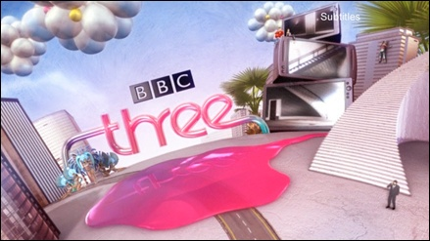 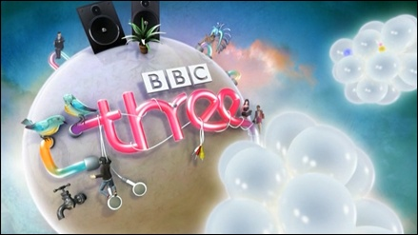Figure 1 BBC3 (2008-13)

Market research revealed to Red Bee that the youthful audience of BBC Three were not just passive consumers but active producers of social media content. To differentiate the channel in the competitive multi-channel marketplace of Freeview and subscription services Red Bee looked for an approach that could give ownership to the viewer and allow them to inhabit as well as reflect their own television ‘world’. Gobé (2010) argues that in a postmodern ‘emotional economy’ consumers are demanding more interaction with their brands. ‘Design…is innovation in action, it stimulates people’s senses and emotions to create preferences’ (Gobé 2010: 111). In America several corporate brands, such Converse All-Star and Jet Blue had been transformed by engagement with consumers who had become the ‘cocreator’ of communications in advertising campaigns (McCracken 2008). It was time for broadcasters to adjust to the idea that ‘the new media consumer is a “lean-forward” participator, no longer a “laid-back” couch potato’ (McCracken 2008: xvi).

It was with this approach that Red Bee graphic designer Claire Powell won the competitive pitch for the rebrand by devising a world for BBC Three that could build in user generated content using designated areas of fantasy jungle and city populated by people. It is indicative of today’s globalised creative industries that Powell invited four world-leading animation companies to pitch for the execution of the concept: Tokyo Plastics, Zeitgeist, National Television and Nexus Productions. Each company presented treatments and visualisations ranging from hand drawn sketches to fully visualized concept artwork. The animator at Nexus, Carolina Melis was chosen for her quirky visual ideas and the ‘lifeline’ motif, a pink tube that linked the different scenes. It took over eight months to bring the rebrand from storyboard to screen.

Melis was supported at Nexus by a talented team of animators and storyboard artists who were co-ordinated by a technical supervisor. Working from Melis’ ‘vision of a unique world’ (Melis 2013) they began by creating animatics and animation keyframes from her drawings. Melis used her training as a dancer to influence the choreography of scenes that contain repeated visual motifs and variations. Her sensibility for dance choreography does not yet define the work as a ‘metamedium’ (Manovich 2007), but it does contribute to the mix of artistic practices. The fluid movement of the animated people, surreal plant-life and objects that inhabit the scenes are orchestrated to the music.

Conscious of creating a channel brand that would sustain frequent viewing for a youthful audience Melis devised ‘a series of small events where you always find something new to look at’ (Melis 2013). Melis said:

Overall I wanted the films to contain an energy and excitement but also to offer something quite delicate, even beautiful, an exotic, unusual world where the surreally comic could mix with the dramatic, somewhere where anything could happen, somewhere with a tangible sense of possibility and potential.
(Melis 2008)

The series of six idents (see figure 1), stings and promo openers were all computer generated, providing graphic elements that could be mixed to offer the audience an opportunity to participate in the visual content. The client Reemah Sakaan, Head of Marketing, BBC Three, wanted to move away from the previous brand identity of real plasticine characters to a more glossy, virtual world, something that in her opinion had ‘high quality’ (Powell 2013). The quality of the surface texture was critical to the perception of ‘high quality’. The software afforded the designers the ability to render different surface finishes by combining sampled and coded texture maps on to the animated elements. Added to the CGI elements there would be audience-generated video content that could be mixed in such a way that the resulting metamedium retained the desired quality finish.

Yet as the production process progressed, it took six months to develop a texture for the environment that was agreeable to both Sakaan and the Red Bee creatives. This was an unusual experience for Nexus who were not used to such a hands-on approach from a client. Glossy CGI is more often associated with a corporate aesthetic, typically found in US broadcast identities, and Melis sought a different appearance of high quality in a matt finish. Melis’ original intention was to shoot live action people and elements to combine digitally, but she decided to create the idents entirely in CGI for technical and financial reasons in order to realise the variety of characters and scenes as the scope of the idea grew. ‘The technology itself does not matter. What is important is the design idea; technology is simply a tool to help express it, a means to an end’ (Lambie-Nairn 1997: 61). If the design idea is compromised by focusing on appearance, and the technology to create a look, it can lead to creative conflict.

In the commercial and contractual hierarchies of television there are frequently tensions between creative suppliers and commissioning clients (Hesmondhalgh 2007; Caldwell 2008; Born 2005). While the client insisted on an appearance that was clearly different to the previous idents, there was an aesthetic tension amongst the creative parties through the interference of the technology employed to create the look. Melis the animator/artist had a different creative approach to Powell the designer. While Melis debated aesthetics with the client, Powell had to design practical elements that would frame and present the audience-generated video. A pragmatic approach to technology had to be taken by Powell in order to design to engage audience interaction.

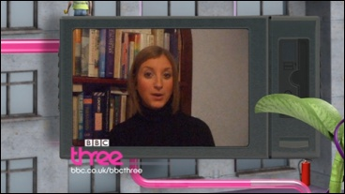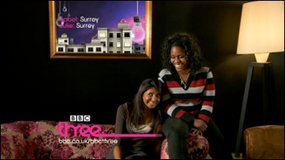
Figure 2 BBC Three audience interaction

The possibility of audience interaction (see figure 2) was provided through a ‘be on TV’ space on the BBC Three website. This was the most ambitious aspect of the project as it required a ‘kit of parts’ of CGI 3D graphic elements from Nexus that were then composited and adapted by the Red Bee creatives to produce the on-screen presentation graphics. Powell’s time was largely spent designing links and graphic backgrounds for viewers’ uploaded videos of themselves announcing their favourite tv shows, mostly recorded on their mobile phones (see figure 2). These were edited and broadcast within the BBC Three graphics to embed them in the virtual animated world while maintaining the brand identity. The creative window for audience cocreation may appear limited in this instance but it nonetheless broke new ground in channel branding (Red Bee 2008).

The corporate intention was to give the BBC Three brand greater value by offering cultural resources for the audience to produce their sense of ‘self’ on-air, because it is claimed that postmodern consumer culture seeks greater authenticity in brands (Holt 2002; Gilmore & Pine 2007). As a niche youth channel the Red Bee Media brand strategists sought to make this channel different to other BBC brands, which may be perceived as the establishment. This brand difference was defined by an openness to include audience creativity, in albeit controlled cocreation. The functional role that defined modernist ‘corporate identity’ (Olins 1990) has become a postmodern ‘brand identity’ that seeks to reflect the culture of niche audience demographics (Lupton & Phillips 2008).

As a combination of audience and corporate creation the BBC Three idents illustrate a constructed metamedium of different sources. The audience-generated material may mimic broadcast conventions that were once common when continuity presenters were in-vision, but nevertheless their homemade contribution also reflects the current cultural use of social media and self-promotion using videoblogs and YouTube. The graphic elements were designed to afford remixability and a versatility of presentation idents. The very construction of the CGI elements also incorporated a variety of material samples as a metamedium, but also an influence of Melis’ creative dance practice.

The next case study considers a bigger target audience, one that has an established relationship with a brand identity that has lasted over twenty years. As a seasonal ident it has however, limited exposure and a different brief to BBC Three. BBC2 Christmas (2011-14) offers a contrasting approach to audience engagement through the creative use of physical materials.

BBC 2 CHRISTMAS

BBC 2 Christmas (2011-14) was commissioned by James Wood, Head of Creative, Creative Marketing, at the BBC.

Red Bee came to us with a proactive idea to refresh our Christmas identity on BBC Two. We worked together on a brief and they came to us with an inspired idea for the refresh that clearly represented the channel and its values. The execution and crafting of the campaign is exquisite and we now have a Christmas campaign that exudes warmth, wit and is uniquely pleasurable. Most importantly, it is distinctly BBC Two at Christmas.
(Wood 2011)

In contrast to the creative approach to BBC Three (2008-13) and other channels using CGI, the iconic Gill Sans numeral of BBC 2 is unusually mostly recognized for its physical appearance and manifestations, such as a metal object, covered in fabric, a fluffy toy, and an aperture through a tent. BBC2 branding is one of the most successful and long running on UK television winning many industry accolades, including a BAFTA and D&AD awards (Lambie-Nairn 1997) since its ground-breaking re-launch in 1991. The BBC 2 Christmas (2011-14) (see figure 3) ident retains that sense of physical materiality, one that has the trace of human interference or manipulation. It breathes new life into what De Zoete (2014) views as a rather ‘lifeless’ window ident that runs the rest of the year. The longevity of the Christmas animation is perhaps due to its difference (of production process and idea), which makes it stand out from the live action window device.

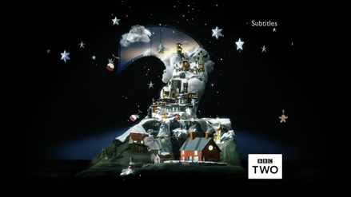
Figure 3 BBC2 Christmas (2011-14)

Working with a single proposition: ‘surprising delights from BBC2 this Christmas’ (De Zoete 2014), and inspired by the genres of BBC2 content, the designers created a physical ‘2’ originally as an advent calendar then as a model world inhabited by magical characters, elements and snowy buildings. The camera sweeps down over the rooftops while animated characters fly about (see figure 4). The creative approach embraced a craft aesthetic to emote seasonal warmth and pleasure.

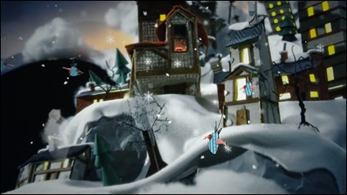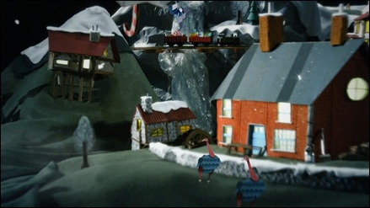
Figure 4 BBC2 Christmas (2011-14)

In a similar commissioning process to BBC Three, the concept was devised at Red Bee then the production was put out to tender to several animation companies. The French animators No Brain were chosen because of their showreel and their proposal, which was to shoot physical miniature models rather than create the idea in CGI. The media was a key factor in this instance because of the desire shared by Red Bee and the client, BBC 2 Controller Janice Hadlow, to exude more human warmth and humour.

No Brain are ‘three directors working as one’: Nico, Charles and Saii, who have come from a digital visual effects and CGI background (No Brain 2014). Yet the combination of three different visions allows them to work across digital and physical handmade media, the tools depend on the job and the idea. Their initial drawings indicated the shape of the set and the view of the camera (see figure 5). As the job progressed their presentation boards become more detailed. At a key point in the decision making process it was necessary to present a section of the model to the client in order for her to feel confident of the art direction and visual concept (see figure 6). There was a concern that the French designers would veer towards a scene that looked too much like France. Equally the design could not appear as a ‘bucolic version of the English Cotswolds’ (De Zoete 2014) but had to retain a flavour of a gothic fairytale.

The model world resembled an ornate and enchanting window display that might be seen in Piccadilly’s Fortnum and Mason’s, or part of the traditional nativity scene found in many churches. Similar to BBC Three, a variety of different animated vignettes helped sustain repeated viewing.

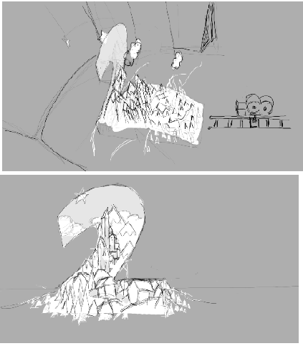
Figure 5 BBC2 Christmas pitch visual

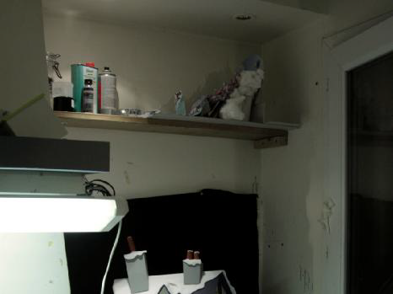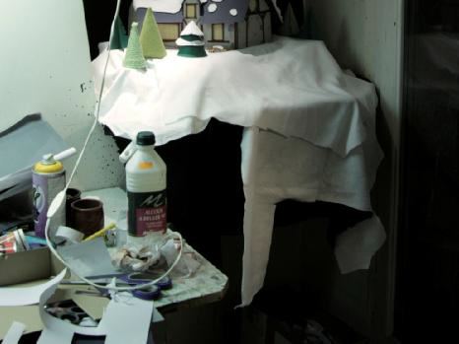
Figure 6 BBC2 Christmas model under construction

The animated elements of BBC 2 Christmas were first shot as live action puppetry that was then copied in digital editing. This simulation of real puppetry allowed the CGI elements to have greater realism while maintaining all the flexibility and mutability of digital elements. No Brain have valuable digital knowledge and hands-on puppetry experience that allows them to achieve highly accomplished visual illusions on a limited budget: ‘we know how it’s done, we know how to fake it’ (No Brain 2014). This is a compelling example of what Manovich calls a metamedium, it is a deep remix of analogue handcraft and digital animation techniques and language that is driven by economics as much as aesthetics. For these animators and designers ‘the more you mix the media, the more disguised it is, the more successful the illusion’ (No Brain 2014). On another level, the animated scenes and micro narratives of gothic-looking characters are influenced by the European fairytale traditions of Christmas.

Jim De Zoete, the Creative Director at Red Bee responsible for the BBC2 Christmas ident, believes that the magic of the ident is that at its core you know it is ‘real’. The CGI that is employed in the making of it is used only to embellish and is disguised to blend in with the model realism. Some designers argue that ‘is it entertaining is all the viewer thinks about’ (Powell 2013). Yet De Zoete is convinced that BBC2 is different because over the twenty years the ‘2’ has been on air it has lodged deep in the psyche of the UK viewing public as a much loved physical thing. This physicality, combined with humour that side steps any ‘pomposity’ (De Zoete 2014), is the point of difference from other channels that seek to appear glossy and glitzy at Christmas time and throughout the year. As an example of metamedium it retains the physicality of the materials used, yet the art of illusion is achieved through a hybrid combining digital processes and media.

HYBRID DESIGN APPROACHES TO TV IDENTS

There is a complexity to the debate on how ident design is received and interpreted, and in the context that it is created. While designers are concerned with aesthetics and what looks right to convey their idea, they are often unconscious of the wider cultural implications of their decisions. As they design to engage an audience in a multi-screen broadcast environment they respond to wider cultural trends and the branding strategies of their competitors. I have demonstrated how different media and production techniques can be employed with the intention of engaging an audience. The creative practices of the metamedium, involving different materials and hybrids, can revitalise not only the design but also the reception of the art of illusion in a postmodern context.

Grau argues that the ‘shock of the new’ quickly subsides as ‘habitation chips away at the illusion… and the audience are hardened to its attempts at illusion’ (Grau 2003: 152). When audiences become familiar with the trickery and play of an illusion their attention turns to the detail and they become receptive to content and artistic media competence (Grau 2003). There has long been a tension between on one hand the artifice and the spectacle of being captured in an illusion, and on the other the narrative as the greater entertainment (Darley 2000; King 2003). Many watch movies repeatedly to enjoy the ‘double-take’ to wonder ‘just how it was done’ as much as the visual spectacle of the image (Darley 2000: 115). With an earlier Russian film director, Sergei Eisenstein’s theory of montage in mind Barthes describes this artifice as: ‘at once falsification of itself – pastiche and derisory fetish, since it shows its fissure and its suture…’ (Barthes in Darley 2000: 115). The suggestion is that there is a contradiction that fascinates the viewer because the image appears both real and yet so extraordinary that it must be a fabricated illusion. How was it done? In a metamedium the deep remixability hides and disguises what were once clear boundaries of media and production practice: multimedia (Manovich 2013).

In order to create illusion some designers and animators have followed a formalism that was led by technology rather than meaning, ‘seduced into thinking of ideas as software’ (Jacobs 1997: 98). Yet even though Melis describes her work on BBC Three as ‘ornamental rather than narrative’, her designs were chosen because they stood out from the generic software ideas that were in competition. In her pitch presentation Melis managed to evoke a more humanist approach, using hand-drawn visuals. She cannot be accused of being ‘seduced’ by the media, because she had intended to shoot live action. In this case and in the work of No Brain’s BBC2 Christmas, digital processes have perfected existing analogue ones that were less accurate, slower and more expensive (Prince 2012), ‘simulating the already mediated’ (Darley 2000: 75).

What was once ‘the hygienic purity of the machine age’ (Helfand 2001: 98) has now been replaced by a dusty, atmospheric and lived-in aesthetic. The metamedium combines the digital benefits of endless malleability with the individuality of the human mark and the haptic resistance of handmade materials.

It has been argued that techniques in themselves are not an idea, and however innovative, must remain neutral for the design to communicate effectively. Paul Rand, a Modernist graphic designer argued that ‘the more neutral the technique, the simpler the solution – unencumbered by eccentricities or confusing (sentimental) associations’ (Rand in Helfand 2001: 162). Yet I would argue that it is the eccentricities of materials and handcrafted techniques that afford a humanist warmth and hospitality to channel idents in contrast to modernist corporate branding. This fits with a postmodern ‘emotional economy’ that seeks to appeal to people’s emotions and senses in order to build brands (Gobé 2010). Today, technology affords designers the opportunity to remix and combine all media innovatively into a metamedium. Rather than replacing traditional skills, digital media in a metamedium can ensure that heritage skills and techniques are valued and sustained. As we have seen with BBC 2 Christmas, hybrid processes can flourish ‘in the digital era, animation has simultaneously re-engaged with its past and looked to the future’ (Wells & Hardstaff 2008: 25). Tradition is like a bridge that is continually being built that never reaches the other side: a ‘bridge between memory and imagination’ (Negus & Pickering 2004: 104). This can only happen if the mark of the designer is evident and is not lost in the ‘shallow generic software solutions’ (Wells & Hardstaff 2008: 25) that digital technology provides.

CONCLUSION

Designing to engage a television audience involves a new language of motion graphics, a metamedium of production techniques, media and ways of representation and expression. It is a postmodern approach to branding that seeks to engage the consumer’s senses and emotions. The visual richness of the human mark and the varied modes of production that were used to create BBC 2 Christmas illustrate an alternative means of audience engagement to channel idents. Television graphics have trended towards postmodernism ‘intertextuality’ (Eco 1985), increasingly multi-layered and self-referencing. As intertextual and mimetic forms combined, and as old and new media fused it created what Manovich describes as a metamedia. The creative practices in television branding need to consider involving different materials and how hybrids can revitalise not only the design but also the reception of illusion in a postmodern context.

Design to engage an audience through entertaining visuals that can sustain repeated viewing continues to be a central objective of the television ident, but it must also bring authenticity to the brand. Television branding can develop more of a quirky personality, a tactile uniqueness that attempts to reflect the audience culture. BBC Three illustrated how designing idents and channel branding to accommodate or showcase viewer-generated content can offer opportunities for the unexpected. Through cocreation with audiences designers might begin to question rather than rely on technology through the process of design.

These two case studies offer different approaches to designing to engaging a television audience through brand identity creation. One fuses traditional handcraft media with digital, and the other fuses audience-generated material within a corporate frame, but they both represent a new language that encompasses the metamedium. What were once separate distinct media and processes are now becoming part of the deep remixability of motion graphics. Rather than replace ideas and old media, software can enable designers, particularly in television and motion graphics, to find a new creative dialogue with their materials and processes. Television audiences can look forward to future hybrids in brand identities that seek to touch their senses and emotions.

REFERENCES

BARB (2014) Monthly Viewing Summary, (online). BARB, London. (viewed 24.1.2015). Available at: www.barb.co.uk

BBC Three (2008-2013). (online) BBC, London. (viewed 24.1.2015). Available at: https://vimeo.com/14636808

BBC 2 (2011-2014) Christmas, (online). BBC, London. (viewed 24.1.2015). Available at: http://www.redbeemedia.com/work/bbc-two-christmas

Born, G. (2005) Uncertain Vision. London: Vintage.

Caldwell, J. T. (2008). Production culture: Industrial reflexivity and critical practice in film and television. Durham, USA: Duke University Press.

Darley, A. (2000) Visual Digital Culture. London: Routledge.

De Zoete, J. (2014) Interviewed by Author, 7 January.

Eco, U. (1985) ‘Innovation and Repetition: Between Modern and Post-Modern Aesthetics’, Daedelus 114(4): 161-184

Ellis, J. (2002) Seeing Things. London: IB Tauris.

Gilmore, J. & Pine, B.J. (2007) Authenticity. Boston: Harvard Business School Press.

Gobé, M. (2010) ‘Let’s Brandjam to Humanize Our Brands’. In: T. Lockwood (ed) Design Thinking. New York: Allworth Press.
Grainge, P. (2011). Ephemeral media: transitory screen culture from television to YouTube. Palgrave Macmillan.

Grau, O. (2003) Virtual Art From Illusion to Immersion. Boston: MIT Press.
Helfand, J. (2001) Screen: Essays on Graphic Design New Media and Visual Culture. New York: Princeton Architectural Press.

Hesmondhalgh, D. (2007) The Culture Industries. (2nd Edition). London: Sage.

Jameson, F. (1984) ‘Postmodernism, or the Cultural Logic of Late Capitalism’, New Left Review (146): 53-92

Johnson, C. (2012). Branding Television. Routledge.

Johnson, C. (2014) Why We Should Care About Who Makes the BBC’s Promotional Content. (online). CST Online, Hatfield. (viewed 24.1.2015). Available at: http://cstonline.tv/why-we-should-care-about-who-makes-the-bbcs-promotional-content

King, G. (2003). Spectacle, narrative, and the spectacular Hollywood blockbuster. Movie blockbusters, 114-127.

Kittler, F. (1999) Gramophone, Film, Typewriter, Stanford, California: Stanford University Press.

Lambie-Nairn, M. (1997) Brand Identity for Television. London: Phaidon.

Lupton, E & Phillips, J.C. (2008) Graphic Design: The New Basics. New York: Princeton Architectural Press.

Macdonald, I. (2014) ‘Cultural Change in the Creative Industries: a case study of BBC Graphic Design from 1990-2011’. Visual Communication (13.1)

Manovich, L. (2001) The Language of New Media. London: The MIT Press.

Manovich, L. (2007) Understanding Hybrid Media. (online). Manovich, New York. (viewed 24.1.2015). Available at: http://manovich.net/

Manovich, L. (2013) Software Takes Command. London: Bloomsbury.

McCracken, G. D. (2008) Transformations: Identity construction in contemporary culture. Bloomington: Indiana University Press.

McLuhan, M. & Fiore, Q. (2008) The Medium is the Massage: an inventory of effects. London: Penguin Classics.

Melis, C. (2008) (online) Red Bee Media, London. (viewed 24.1.2015). Available at: http://www.redbeemedia.com/news/red-bee-media-rebrands-bbc-three-1

Melis, C. (2013) Interviewed by Author, 10 March.

Merritt, D. (1987) Television Graphic Design: From Pencil to Pixel. London: Trefoil.

Myerson, J. & Vickers, G. (2002) Rewind: Forty Years of Design and Advertising. London: Phaidon.

Negus, K. & Pickering, M. (2004) Creativity, Communication and Cultural Value. London: Sage.

No Brain (2014) Interviewed by Author, 22 January.

Olins, W. (1990) Corporate identity: making business strategy visible through design. Boston: Harvard Business School Press.

Pooley, J. (2010) “The Consuming Self: From Flappers to Facebook.” In: M. Aronczyk and D. Powers (eds), Blowing Up the Brand: Critical Perspectives on Promotional Culture. New York: Peter Lang.

Powell, C. (2013) Interviewed by Author, 14 March.

Prince, S. (2012) Digital Video Effects in Cinema: The Seduction of Reality. New Jersey: Rutgers University Press.

Red Bee Media (2008) (online) Red Bee Media, London. (viewed 24.1.2015). Available at: http://www.redbeemedia.com/news/red-bee-media-rebrands-bbc-three-1

Red Bee Media (2011) (online) Red Bee Media, London. (viewed 20.9.14). Available from: http://www.redbeemedia.com/work/bbc-two-christmas

Tunstall, J. (1993) Television Producers (Communication and Society). London: Routledge.

Turkle, S. (1995) Life on the Screen, London: Phoenix.

Wells, P. & Hardstaff, J. (2008) Re-imagining Animation: The Changing Face of the Moving Image. Lausanne: AVA Publishing.

Wood, J. (2011) (online) Red Bee Media, London. (viewed 20.9.14). Available from: http://www.redbeemedia.com/work/bbc-two-christmas

Woolman, (2005) Type in Motion 2. London: Thames & Hudson.

ILLUSTRATIONS

Figure 1 BBC3 (2008-13)
Figure 2 BBC Three audience interaction
Figure 3 BBC2 Christmas (2011-14)
Figure 4 BBC2 Christmas (2011-14)
Figure 5 BBC2 Christmas pitch visual
Figure 6 BBC2 Christmas model under construction

All figures copyright of RedBee Media and used with permission.

