Abrandcadabra - successful brands magically transforming our world

Introduction
It is well documented that marketing can do magical things for brands (Hall, 2014). It surges market share, swells shareholder profit, escalates brand value scores, increases awareness levels and deepens affinity rates. But it is also worth considering what the effects on the brand are when it truly does magic, such as changing, helping and nurturing life and building community. In an age when consumers and marketers have ever increasing empathies with corporate social responsibility (CSR) (Sampson and Obinna 2014) then it is important to understand what foundations need to be in place for brands to positively change the world around them (Yumurtacı, 2014). In a time when business world goodness appears thin on the ground (Yan, 2011) this paper presents a case that by simply doing good, brands can do better – better broadly for society but also the culture and wellbeing of all organisational stakeholders.

A recent interview (December 2014) with the Swedish experimental artist Alexander Lumsden uncovered a key insight. He had just launched a bottled water called Kranvatten, the English translation being “Tap Water”. Gothenburg (his home town), the source of the water, is renowned for its purity not only in lifestyle but more importantly for its municipal water. The premise of the idea is Gothenburg’s water is not only good for the body but it is now good for the soul as all its profits will be reinvested into local cultural projects. Financially Lumsden makes nothing but gains richly in the pleasure of seeing culture flourish in his city. And the benefit on “Lumsden the brand”? Well this conundrum laid out the premise for this paper. In another catalyst for enquiry the story of TOMS, the global footwear manufacturer and retailer also has “doing good” hardwired into their DNA (Ponte and Richey, 2014). Founded by Blake Mycoskie, as a consequence of seeing the plight of rural children in Argentina, he committed to matching every pair of shoes sold with supplying a child in need with a new pair. In total they have donated 35 million pairs of new shoes and via a more recent initiative helped restore sight to over 250,000 people. So for TOMS marketing has magically spread the goodness over nine years and influenced the lives of many but the driver has been the company’s social responsibility premise (Ward & Sweetser, 2014) and this has resonated loudly with consumers. Doing better by doing good bonds with consumers and the effect is noticeably magnified when the honesty of the corporate ethos and culture is believed by consumers (Kemp et al, 2011). This is where the subtle difference exists between brand enhancing “believable betterment” and the “CSR greenwash” that permeates most of present day consumerism (Parguel et al, 2011). Many brands have passionately embraced CSR (Wolf, 2014) and are now allowing consumers to help invigorate their community (Ben & Jerry’s Join our Core campaign, 2014 / Pepsi Refresh, ongoing), reduce childhood hunger (Tyson Hunger Relief Campaign, 2010) decrease the number of starving dogs in communities (Pedigree Feeding Project Campaign, 2014) and even prevent infant disease (Pampers, 2013) . It appears marketing can and does have a broader agenda than just increasing market share or penetration and that by incorporating CSR it can build deeper relationship networks with its many stakeholders (Xueming and Shuili, 2014). This CSR integrated approach has become a widespread marketing phenomenon across brands communications activities and indeed when executed with insight, compassion and honesty certainly reaps rewards (Marin-Aguilar and Vila-López, 2014). Consequently the question and fundamental aim posed in this paper asks where the real magic of marketing exists and subsequently what foundations must be in place to really engage consumers and build brand affinity.

Literature review
Today’s informed citizens leave nowhere for brands to hide (Moynihan (2011) and it is now difficult for organisations to hide their sometime undesirable activities (Terblanche, 2011). As background to this study, brands are now facing up to a serious collapse in consumer confidence and this is having an increasingly detrimental effect on the trust that people place in brands, leading to erosion in emotional connectivity (Basini, 2011; Hey et al., 2009; Travis, 2001). More so there is a need for brands to open up, have dialogue and be a positive force for community change. In gaining deeper insight, several key themes from the literature have been identified: 1. Trust breakdown between consumers and brands (Quandt, 2012). 2. Diminishing consumer connectivity as brands have not delivered on their promises (Alam et al., 2012). 3. Authenticity or a lack of it. A realisation in the consciousness of society that stories and actions used by brands and advertisers do not stack up (Haig, 2011 and Campbell et al; 2012). 4. A shared consumer / brand narrative where brands become a robust living entity that get shaped as consumers become integral (Lundqvist et al., 2012; Scholes, 2012). 5. The importance of co-creation which is about participation, openness, transparency and has the power to empower and engage (Ind et al, 2012) 6. The changing role of the marketer which acknowledges that marketers must go beyond the traditional sphere of relationship building to fully engage today’s digitally empowered consumer (Vivek et al, 2012). 7. The power of open relationships which suggests that as consumers evolve, organisations can engage through a more open relationship (Friedrich et al, 2011). 8. Involve, engage and individualise. Customers have more choices about how they interact with companies and this has required new methods of engaging customers of which CSR plays a key role (Murugesan, 2011). 9. Everyone should be living the brand (Ind, 2007; Gyrd-Jones and Kornum, 2012; Baumgarth, 2010). This establishes strong foundations for shared narrative and affinity amongst the many stakeholders. To love it, is to live it. Unfortunately very few current brands appear to be heeding and acting on these insights and certainly no institutions appear to be able to in the public’s eyes (Pierre, and Rothstein, 2010).
In parallel to these industry reshaping insights, consumers are ever more demanding that companies exhibit an active social conscience (Langen et al., 2010) and are now more able to establish specific organisational credentials and their real commitment to CSR (Sashi, 2012). Importantly, reflected in a growing corporate alignment to it, the creation of social magic by brands and organisations does not only matter to consumers, but also individuals within the organisation (Hyllegard, 2012). Brands have really got to take and deal with this rising consumer voice (Wang et al., 2011) and meet anticipation with action. There is paramount importance of real, emotional connectivity (Basini, 2011) amongst modern day consumers and companies performing CSR magic can be the real glue in the relationship. Importantly consumers are beginning to use CSR information to evaluate brands and this is now demonstrating real impact on brand image (Beal, 2014) and furthermore reputation and profits (Conrad and Thompson, 2014). Indeed the findings of more recent studies support the positive effect on brand image of CSR initiatives (Arslan and Saman, 2014) and on brand corporate image and sales (Liu, et al 2014). Finally the literature underlines that organisations really have to be aware of the power they can exert and therefore must use this power to do well by simply doing good (Lindner, 2011). There is an ever-more intrusive societal movement for everything to be questioned these days by an ever-sceptical consumer (Campbell et al., 2012) but the brand has to be laid bare and owners have to be confident they are doing the right thing. Ind (2007) and Baumgarth (2010) also suggest that for brands to really connect in today’s open narrative, the organisation has to truly live the brand and take a humanistic position. Furthermore in today’s interconnected and interdependent world consumers are seeking “sustainable innovation” (Aronczyk and Powers, 2011) and this has to be a fluid and inter-related relationship (Merz et al., 2009). Ultimately the literature signposts that brands must now demonstrate the magic and it is fundamentally about enhancements within consumers’ and their communities’ lives (Szmigin, 2005). Organisations are definitely waking up to the mutual benefits of driving community to the heart and soul of the business (Casalo et al., 2007) and realising that brands do shine when their activities are socially colourful. CSR is still sometimes seen as “greenwash” such as cleaning the sins of pollution (BP), or "white wash" to provide a facelift to the company's public image (Gupta et al., 2009) however this paper will illustrate that starting the journey does allow the brand benefits to commence. Nowadays the magic in marketing sparkles with CSR and it is not a cost centre but an effective management tool with multi-dimensional benefits. The literature highlights that CSR offers a new way to look at the relationship between business and society that does not treat corporate growth and social welfare as “a zero sum game” (Karnani, 2010). CSR has emerged as an inescapable priority for business leaders as a response to new conditions, new challenges and new opportunities – it is the all new marketing magic that has to be embraced. This paper aims to identify the organisational foundations that must be established to allow the magic to happen.

Research methods
As the research centres on branding, both brand owner and respective consumer were engaged to draw out the emerging major themes Zikmund (1997). In total, six in depth interviews with key brand stakeholders were held together with six focus groups (Yin, 2003). The data collection method was grounded in qualitative and central to the design was a case study approach, as it provided a means of investigating the critical phenomena which included a large range of factors and relationships (Fidel, 1984). The design allowed for a degree of generalisation, making causal statements (Kasi, 2009) and understanding the phenomena at work to generate practical insights. Questioning was used as the method of data collection through semi-structured questions and the sampling frame was in-depth interviews and focus groups. This study’s brand cases were from the worlds of Sportswear – Nike Inc; Alcoholic drinks - Guinness and from a branding practitioner perspective - international marketing communications agency – Livity. A diverse spectrum of cases, bringing breadth in order to evoke the richest of insights (Denzin and Lincoln, 2005)

Since it was founded in 1964 in Oregon USA Nike has grown into the world’s leading supplier of clothing, footwear, sportswear, and sports equipment. It employs more than 44,000 people worldwide and according to Forbes (2010) the brand alone is valued at $10.7 billion making it the most valuable sports business brand. Its manufacturing has taken criticism for undesirable conditions and practices. However, in recent years it has achieved accolades for its environmental/climate initiatives and through its groundbreaking work in the Nike Foundation which aims to change lives in Africa by playing a role in eradicating poverty. The in-depth interviewees had extremely senior brand positions within Nike Inc. – from ultimate creative leadership, Caroline Whaley, to director of marketing, Ben Gallagher. The second case, Guinness, is a global alcoholic drinks brand that originated in the brewery of founder Arthur Guinness at St. James’ Gate, Dublin. Today it is brewed in almost sixty countries, available in over a hundred, and its global sales amount to approximately 1.5 billion pints. Now part of Diageo, its headquarters are in Park Royal, London where its global brand marketing is orchestrated. The two individuals engaged within the in-depth interviews have played vital roles in the brand’s more recent history - Kenny Jamieson who held the roles of Brand Marketing Director Guinness Ireland and Global Marketing Innovation Director at Diageo, and Andy Fennel who ran Guinness brand marketing and is the current Chief Marketing Officer for Diageo.

Finally Livity, a marketing and branding agency founded in 2001, have embraced CSR to the extent it has become the organisation’s raison d’etre. Co-founders, Sam Conniff and Michelle Clothier, started with one emotive objective – to change the lives of underprivileged young people. Livity lets young people physically come in and get involved in creating the work for their clients. For over a decade Livity has pioneered co-creation with young people and this has delivered competitive advantage through deep youth insight and understanding. In return young people (traditionally those with limited options) are provided with inspiration, skills, experience and access to employment and opportunity. This approach of interviewing only those senior calibre individuals mirrors the work of Reyneke et al (2012) and, as with the focus groups, uses only respondents who have the most informed insight into the phenomenon under study (Harker, 2008).

Findings and analysis
In determining how a brand with both a social and community conscience can deliver real affinity magic, the cases delivered rich foundational insights. On Nike, Caroline Whaley (CW) acknowledges that many brands are focused on CSR but it has to be viewed as a long-term process, “Brands have lost their cache, from a trust point of view, and brands are trying to work out what their role is in corporate social responsibility” a view mirrored in the literature as organisations/brands work out how best to employ CSR (Langen et al., 2010). With deepening consumer mistrust (Talton et al., 2011) Nike appreciates the difficulty in “doing good and doing magical things” and of it being understood, expected and welcomed empathically by an increasingly critical and ever-changing consumer. They do however sense a palpable change in organisational culture that is gaining momentum “There are some amazing people at Nike and there is an opportunity to have an impact on the world beyond our world of sport and as a global business we have a responsibility to do that” (BG, Nike). Indeed from Nike’s perspective, CSR is playing an absolutely vital and ever increasingly integral role at the heart of their activities. In addition to this, CW highlights that there is “a real responsibility in being a powerful brand and how you behave and take responsibility as you grow up”. They realise that by thinking and acting together with the wider community good things happen to those in the brandsphere and that this can have great effects on brand image, brand engagement and the corporate wellbeing of all stakeholders. BG maintains “as a brand you must become culturally relevant and culturally resonant and that’s where the magic can happen”. He adds that it is about making real changes: “getting involved in a community is about changing attitudes and about how a brand behaves which is a more fruitful and interesting space to be in”. Nike are also behind the under promoted Girl Hub initiative – a mission to empower Africa’s 250 million adolescent girls living in poverty to reach their full potential. It is a powerful initiative that very few would ever realise is funded significantly by the global sportswear company. The reasons were aligned around the desires of key stakeholders within the organisation to make an unconditional commitment to use the power of the brand to change the lives of those less fortunate. It was their aspiration to make working for Nike and living the Nike brand one that stands for compassion and one that has an unreserved pledge for empathetic global citizenship. BG captured the real sentiment “it is about understanding consumers’ world and what role you have a right to play in that world and that’s finding and embracing the community narrative”.
The Guinness interviews also delivered rich insights. Andy Fennel (AF) Chief Marketing Officer laid out the foundations “Consumers are really attuned to authenticity with regard to being a good citizen in a community - so all we can do is behave authentically and behave in a true way and be open to scrutiny”. AF highlighted the positive effect of doing good in the community “trust is one of those things where it is given to you – you cannot claim it”. A view supported by Kenny Jamieson (KJ) “people are just trying to make stuff happen, good selfless stuff and that creates real empathy”. This humanistic quality (Wilson and Morgan, 2011) has sat comfortably with the brand and its activities for centuries and still delivers the message that the brand cares. “Guinness is a very paternalistic business with a passion for the people and the product. It started with Arthur Guinness who was very forward thinking and enlightened in his approach to staff – caring and sharing” (KJ, Guinness). As KJ concludes, “Having a cause is one way of engaging consumers – it doesn’t have to be a social cause or environmental – just having an ethos is crucial – and people will respect you if you are true to those values”. Engagement is a key takeout, “Guinness is all about goodwill and the company getting a good reputation – that breeds affinity and loyalty” (AF. Guinness). Diageo also places great credence in legacy: “we brought back the Arthur Guinness foundation and what we do with that money is what Arthur did, which is to give it to social entrepreneurs so that they can build community” (AF. Guinness). The key insight is that this conscience must sit at the heart of the brand essence “we have something in our credo called Standing on the Shoulders of Giants – it basically says let’s know the stories of our founders and be inspired by them” (AF. Guinness). This has led to socially inspired initiatives such as water to Africa and other more intimate initiatives to communities around Ireland. This approach, in their minds, is what modern day brands have to be doing as it gives consumers real reason to engage more deeply. It is good for the soul and good for the sales. This interest in community is reflected with new recruits at Diageo, where according to AF, the number one question is “what is your policy on social responsibility?” It is ever more important that people care both inside and outside the organisation.

Some organisations have CSR hardwired into their essence. An example is London based marketing agency Livity. Co-founders, Sam Conniff (SC) and Michelle Clothier (MC), set up their business with one emotive objective – they wanted to change lives of underprivileged young people. They were two youth marketers, disillusioned with selling consumer goods to young people and shared a vision to harness the influence of big brands to tackle social challenges facing youth. As MC highlights “every project we undertake for a client (brand) has to have the potential for 3 effects – on the client business, on the brand but crucially a real social effect. If there is no social impact we won’t get involved”. For Livity marketing is “all about enabling and empowering young people”. Livity acknowledge that when they started back in 2001 this corporate social stance was a rare phenomenon and that now CSR is part of almost every brand’s priorities – but for them that is progress “as long as brands are on a continuum of CSR then that can only be a good thing – yes some are placing CSR at the centre of how they do things, others as a promotional badging exercise but at least people are doing something” (MC, Livity). For Livity it is a stance that delivers magic both ways – they were recently awarded “Agency of the Year” by the Marketing Agencies Association having returned year-on-year growth since its inception and for the positive impact it continues to have on the young people of its local community.

Certainly our societal interconnectedness has required new thinking on brand management (Berthon, et al., 2012) and, as the research highlights, those brands that are making positive progress in affinity are those who make a real difference to the societies in which they do business. Increasingly brand marketing that does not add value in its broadest sense will be largely ignored and trusted less than those that see their role in community as an inherent structural premise of their raison d'être. A point suggested by Wachtman and Johnson (2009 p. 29), and further supported by Dowling and Weeks (2011) “Every day we face the daunting challenges of finding a competitive edge, discovering new ways of reaching people, capturing their attention, and most importantly persuading them to take action. In order to get people to act, we must engage them emotionally”. The sentiment is reflected in that the brands that are doing well are the ones embracing social good and are best placed to succeed in an ever more connected world. From the research, and returning to the papers aims, a number of key influencers were identified in stimulating magic to flourish amongst consumers and the broader community.
Figure. 1 presents the key insights divested from the study that should act as guidance in establishing a platform for building affinity. To have CSR as a driver, organisations have to live the brand first (Ind, 2011) as this compassion will be ever more visible to consumers in our interconnected world. As Tyagi and Tyagi (2012) suggested, in today’s hyper-connected society, consumers seek out these traits and support organisations that show compassion and have an active social conscience.
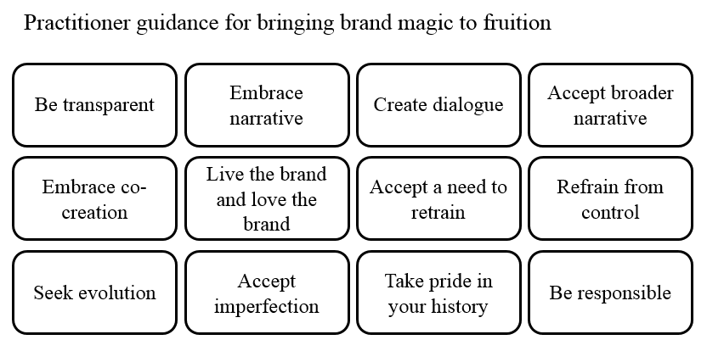Figure. 1. Bringing Magic to fruition. Source: Original
As social responsibility drives affinity (Hyllegard, 2012) then there is equal requirement to take responsibility at all levels of the organisation and to see it as a key foundation stone. Embracing an open, transparent dialogue with the community is also paramount and a consequence of the transparency means the organisation will have to accept its imperfections “Our approach is to lay everything open, warts and all” (CW, Nike). All organisations knew their history well and allowed this (good or bad) to shape their CSR. Taking the Guinness case, it respects, reflects and allows its colourful history to resonate with consumers and, in a period when consumerism is so fickle and demands a new type of relationship (Katsioloudes, et al., 2007) this acts as a spine to brand trust and delivers a willingness to build narrative and embrace more readily the new community magic it offers. Marketing and broader branding is now all about giving the consumer the best possible experience and reality of the brand (Thellefse, Sørensen, and Andersen, 2005) and indeed from the research it is apparent that this new reality must be to create social impact – the real magic of modern-day marketing.

Conclusions and management implications
Present day consumers, fuelled by the digital revolution, make conscious choices and make increasingly more conscious consumption and these are now the two defining issues for brands. It is vital that marketers and brand owners appreciate these trends as real opportunities to not only build and let consumer affinity flourish but really to make a positive difference to the world – it now matters for consumers enormously in many brand categories. This research also illuminated that brand owners have to move beyond short-term thinking and the drive for immediacy of achieving financial targets and instead focus on the real needs of people and the social value brands can additionally offer. Placing consumers at the heart of the brand and of why the brand does is where the real magic of marketing can flourish. Companies that still see their business as a great production resource super-efficiently pumping out product instead of realising that in order to truly connect with consumers they must create real positive human outcomes, are still living in the past and the digital age will ultimately pass them by. From the research findings the paper presents a framework (Figure 2) for brand owners to consider to allow brand affinity to really flourish in today’s brandscape and to make a recognizable difference to the world around them.
The diagram reflects a key insight from the study with regard to future brand essence understanding. It recommends to practitioners that real consumer affinity magic can be achieved by ensuring marketing activities have three essential ingredients: real business and brand impact and a clear societal effect. From the study it is clear that when the three cogs are moving simultaneously great advancements in consumer (and internal corporate) affinity can be achieved.
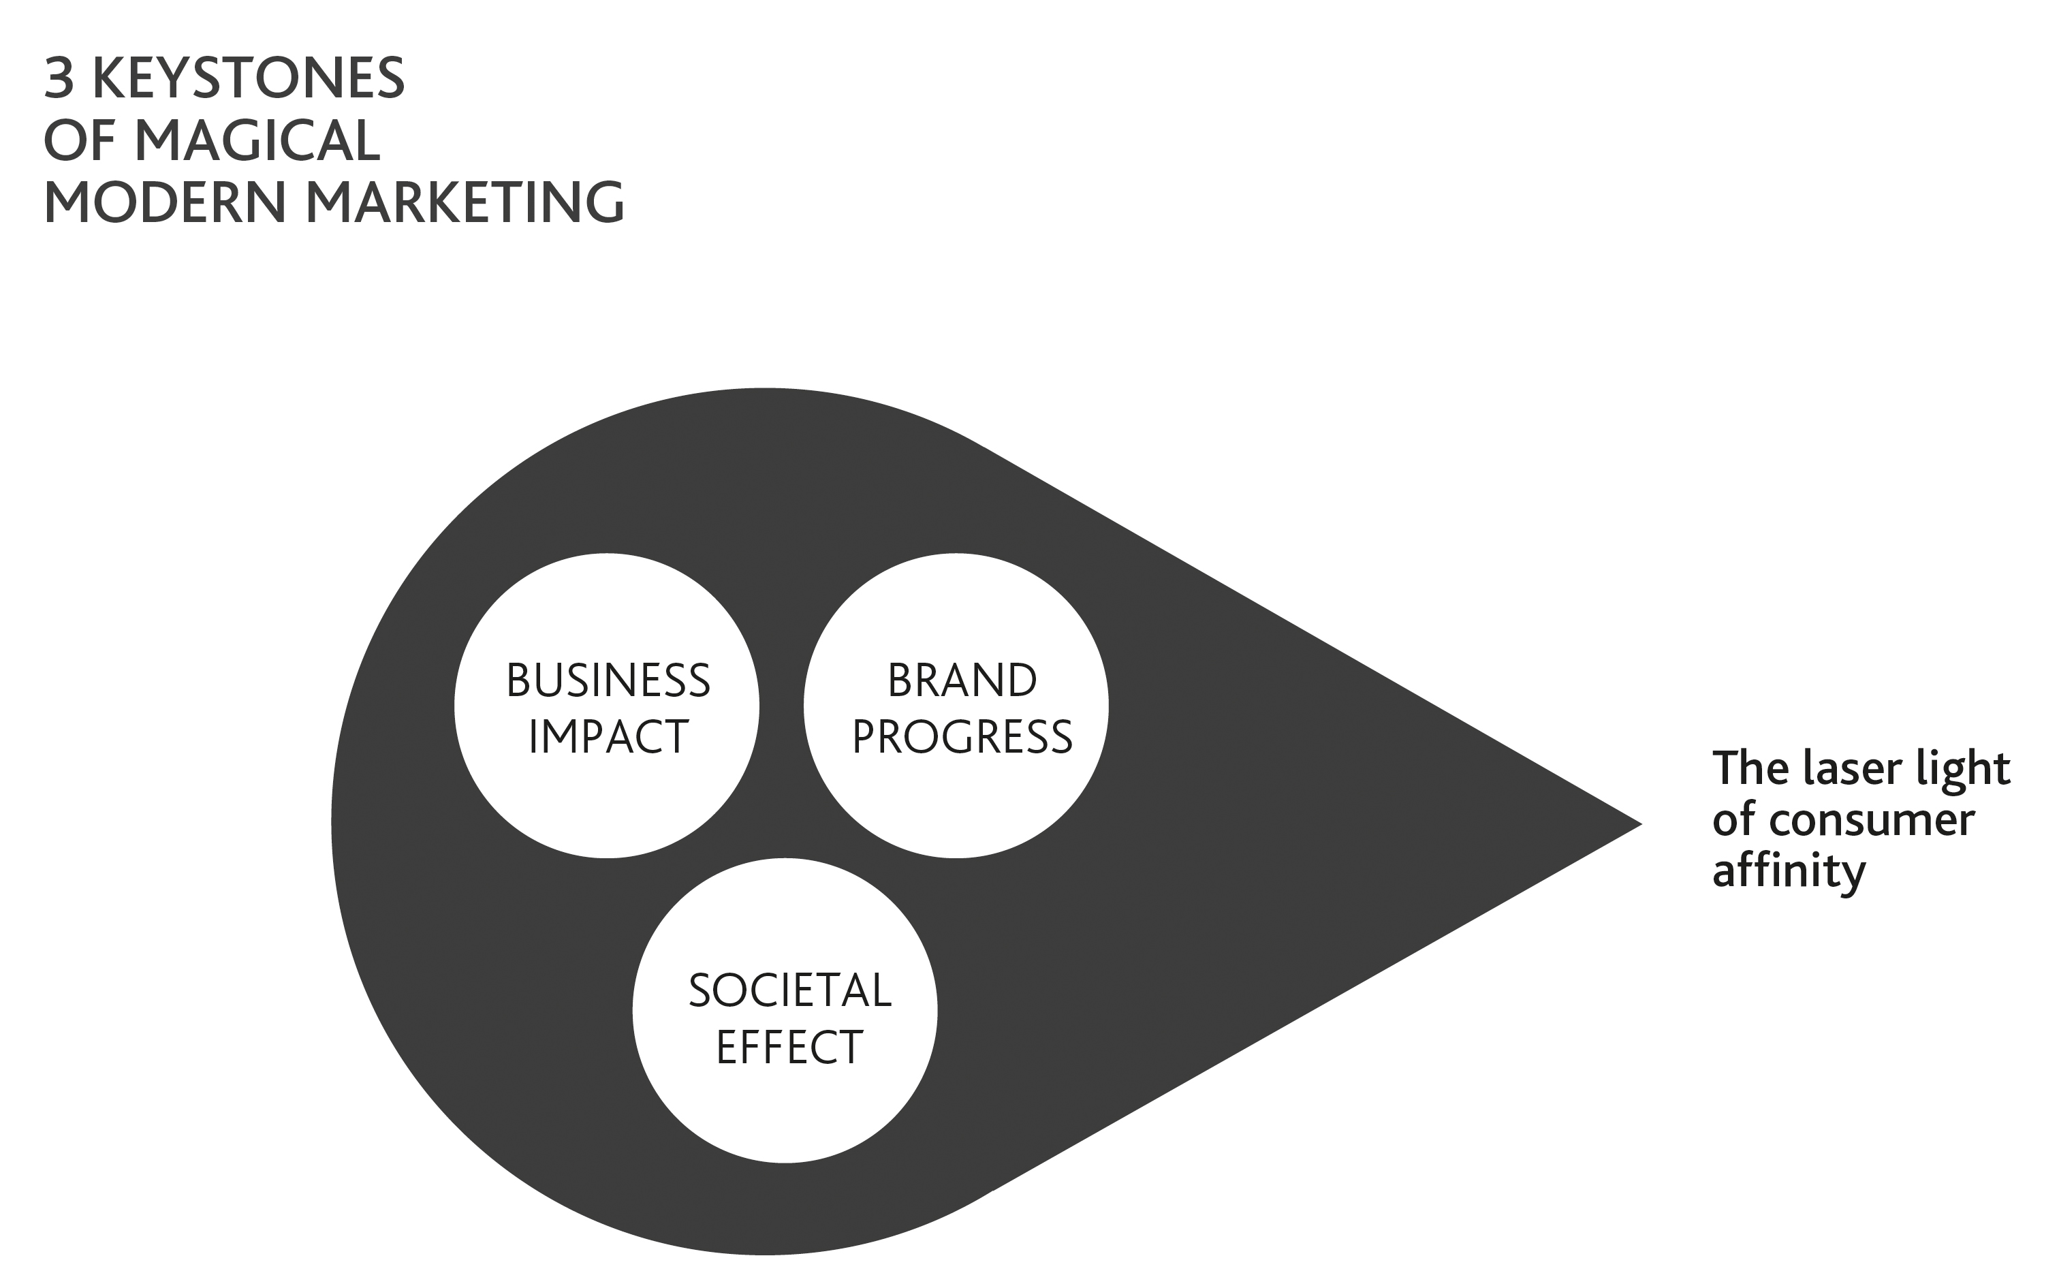

Figure. 2. The three keystones of magical modern marketing. Source Original

This study has been developed around the key branding and affinity themes identified within the literature (Jensen, 1999; Ind, 2007; Woodside et al., 2008, Wachtman et al., 2009, O’Sullivan, 2006) and, together with the aim of identifying rich qualitative insights, an additional framework (Figure 3) has been developed for brand owners to consider when developing their marketing and communications plans. Emanating from the foundational premise outlined in Figure 2 it recommends initially that two key features of branding are implicit.
Firstly an organisational passion for authenticity (Vincent, 2012) is paramount as for too long consumer trust in authenticity has collapsed (Haig, 2011 and Campbell et al 2012). Together with this, real affinity can be achieved if the brand exhibits “derring-do” - a real can-do sense of ambition. It is about giving the brand a sense of spirit, desire and openness and reflects a willingness to achieve progress. This real mind shift is supported in the literature by Fournier and Avery (2011) and Round and Roper (2012) who suggest it is important that brand owners let go and release greater control to consumers in our increasingly chaotic environment.
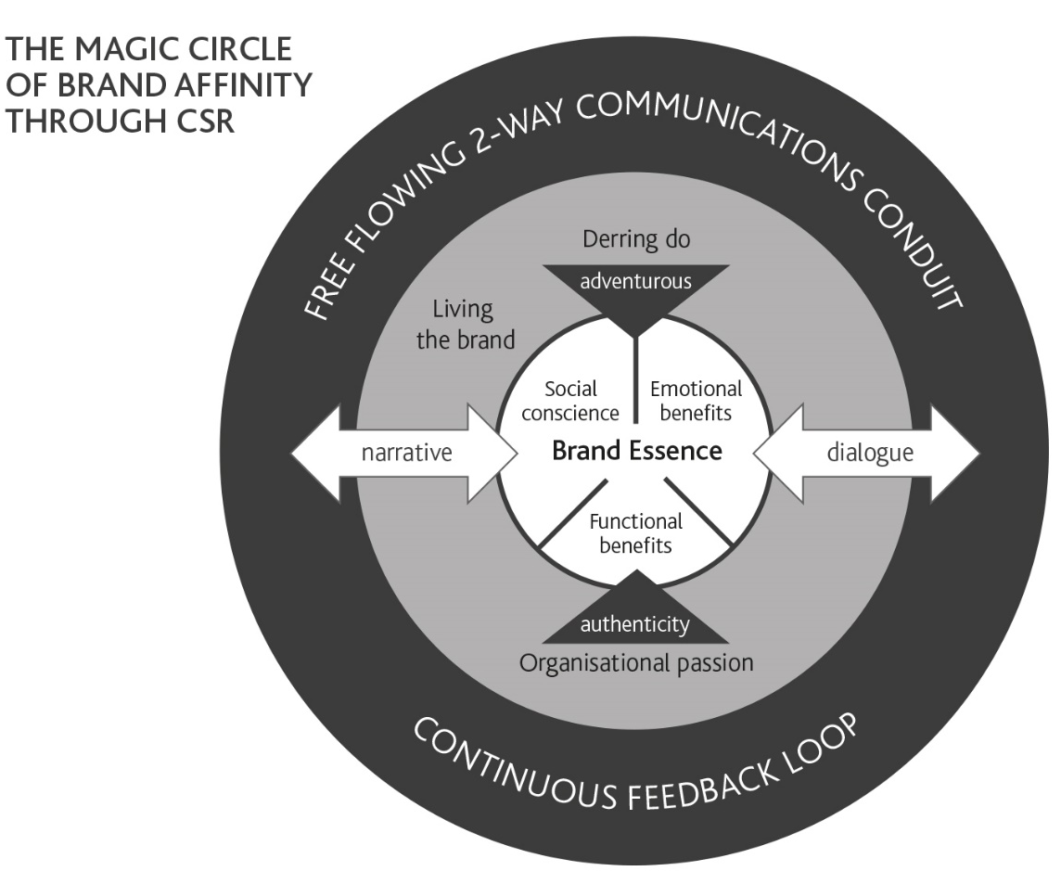

Figure. 3. Magic Circle of Brand Affinity. Source Original

With these tenets in place and the organisation really “living it” (Ind 2011) then it is essential for the organisation to nourish and flourish two-way communications with the broader consumer universe. It is not only about doing better by doing good but embracing feedback all the way through the process. The research reflects that positive CSR beliefs held by consumers are associated not only with greater purchase likelihood but also with longer-term loyalty and advocacy behaviours (Beal, 2014). Today it is not the case anymore that marketing communications have to be on brand, but more so the organisation has to be on brand as well. This study uncovered, as it set out to, the powerful foundational factors that are essential in building or rebuilding brand affinity.

The marketing landscape has changed. New skills, new approaches and new paradigms have to be embraced to ensure brands are constantly in-tune with the zeitgeist of an ever-evolving consumer. So when does the real magic in marketing happen? From the research it appears that when we care and change the world around us for the better through business then this creates real consumer affinity and this is where the magic manifests.
References

Alam, A., Arshad, M., Shabbir, S., (2012). Brand credibility, customer loyalty and the role of religious orientation, Asia Pacific Journal of Marketing and Logistics, 24(4), pp.583 – 598.
Aronczyk, M., and Powers, D., (2011). Blowing up the brand: Critical perspectives on promotional culture. The Communication Review, 14(2), pp.152 – 154.
Arslan, M and Zaman, R., (2014). Impact of corporate social responsibility on brand image: A study on telecom brands, Developing Country Studies, 4(21).

Basini, J., (2011). Why should anyone buy from you? London: FT Prentice Hall.
Baumgarth, C., (2010). “Living the brand”: Brand orientation in the business-to-business sector, European Journal of Marketing, 44(5), pp. 653-671.
Beal, B., (2014). Consumer participation in online product recommendation services: augmenting the technology acceptance model, Journal of Services Marketing, 28(6)
Berthon, P., Pitt, L., Plangger, K., and Shapiro, D., (2012). Marketing meets Web 2.0, social media, and creative consumers: Implications for international marketing strategy, Business Horizons, 55(3), pp. 261–271.
Campbell, C., Piercy, N., Heinrich, D., (2012). When companies get caught: The effect of consumers discovering undesirable firm engagement online, Journal of Public Affairs, (pre view March, 2012).
Casaló, L., Flaviá, C., Guinalíu,M., (2007). The impact of participation in virtual brand communities on consumer trust and loyalty: The case of free software, Online Information Review, 31(6), pp. 775 – 792.
Conrad, C., and Thompson, M., (2014). The new brand spirit: How communicating sustainability builds brands, reputation and profits, Journal of Product & Brand Management, 23(4/5), pp. 376-377.
Denzin, N., and Lincoln, Y., (2005) The SAGE Handbook of Qualitative Research, London: Sage.
Dowling, G., and Weeks, W., (2011). Reputation management, Management for Professionals, 3, pp. 111-125.
Fournier, S., and Claudio, A., (2011). Brands as relationship partners: Warmth, competence, and in-between (October 1, 2011), Journal of Consumer Psychology, Forthcoming; Boston University School of Management Research Paper.
Friedrich, R., Peterson. M., and Koster, A., (2011). The rise of generation C: How to prepare for the connected generation’s transformation of the consumer and business landscape, Strategy and Business, 62, pp. 1-17.
Gyrd-Jones, R., and Kornum, N., (2012). Managing the co-created brand: Value and cultural complementarity in online and offline multi‐stakeholder ecosystems, Journal of Business Research.
Hall, R., (2014). Brilliant marketing: What the best marketers know, do and say, New Jersey; Pearson Education Limited.
Haig, M., (2011). Brand failures: The truth about the 100 biggest branding mistakes of all time, UK: Kogan Page.
Harker, D., (2008). Regulating online advertising: The benefit of qualitative insights, Qualitative Market Research: An International Journal, 11(3) pp. 295 – 315.
Hey, T., Tansley, S. and Tolle, K. (2009). The fourth paradigm: Data-intensive scientific discovery, Redmond: Microsoft Research.
Hyllegard, K., Yan, R., Ogle, J., and Lee, K., (2012). Socially responsible labeling: The impact of hang tags on consumers’ attitudes and patronage intentions toward an apparel brand, Clothing and Textiles Research Journal.
Ind, N., (2007). Beyond branding: How the new values of transparency and integrity are changing the world of brands, UK: Kogan Page.
Ind. N., and Ryder. I., (2011). Conscientious brands editorial, Journal of Brand Management, 18, pp. 635–638
Ind, N., Fuller,C., Treva, C., (2012). Brand together: How co-creation generates innovation and re-energizes brands, London: Kogan Page.
Jensen, R., (1999). The dream society: How the coming shift from information to imagination will transform your business, New York, NY: McGraw-Hill.
Karnani, A., (2010). Doing well by doing good: The grand illusion, California Management Review, pp. 1-35.
Kasi, P., (2009). Research: What, why and how? A Treatise from Researchers to Researchers, Bloomington, IN; Author House.
Katsioloudes,M., Grant, J., and McKechnie, D., (2007). Social marketing: Strengthening company-customer bonds, Journal of Business Strategy, 28(3), pp. 56-64.
Kemp, E., Bui, M., (2011). Healthy brands: Establishing brand credibility, commitment and connection among consumers, Journal of Consumer Marketing, 28(6), pp. 429 – 437.
Langen, N., Grebitus, C. and Hartmann, M., (2010). Is there need for more transparency and efficiency in cause-related marketing? International Journal on Food System Dynamics, 1(4), pp. 366-381.
Lindner, E., (2011). In a world where primacy is given to maximizing profit, mistrust is bound to become ubiquitous, Journal of Globalisation for the Common Good, pp.1-8.
Liu, M., Wong, I., Shi, G., Chu, R., & Brock, J., (2014). The impact of corporate social responsibility (CSR) performance and perceived brand quality on customer based brand preference. Journal of Services Marketing, 28(3), pp. 1-1.
Lundqvist, A., Liljander, V., Gummerus, J., and Riel, A., (2012). The impact of storytelling on the consumer brand experience: The case of a firm-originated story, Journal of Brand Management.
Marin-Aguilar, J., and Vila-López., (2014). How can mega events and ecological orientation improve city brand attitudes? International Journal of Contemporary Hospitality Management, 26(4), pp.629 – 652.
Merz, M., He, Y., and Vargo, S. (2009) .The evolving brand logic: a service-dominant logic perspective, Journal of the Academy of Marketing Science, March.
Moynihan, R., (2011). Reality check power to the people. BMJ, pp. 342.
Murugesan, S., (2011). The future of web Apps, IT Professional, 13(5), pp. 12-14.
O'Sullivan, T., (2006). All marketers are liars: The power of telling authentic stories in a low-trust world, Journal of Targeting, Measurement and Analysis for Marketing, 15(1), pp. 65–66.
Parguel, B., Benoît-Moreau, F., and Larceneux, F., (2011). How sustainability ratings might deter ‘Greenwashing’: A closer look at ethical corporate communication, Journal Of Business Ethics, 102(1), pp. 15-28.
Peppers, D., and Rogers, M., (1995). A new marketing paradigm: Share of customer, not market share. Managing Service Quality, 5(3), pp.48 – 51.
Pierre, J., and Rothstein, B., (2010). Reinventing Weber: The role of institutions in creating social trust. Published in The Ashgate Research Companion to New Public Management. Burlington: Ashgate Publishing.
Ponte, S., and Richey, L., (2014). Buying into development? Brand Aid forms of cause-related marketing, Third World Quarterly 35(1), pp. 65-87.
Quandt, T., (2012). What’s left of trust in a network society? An evolutionary model and critical discussion of trust and societal communication. European Journal of Communication, 27(1), pp. 7-21.
Reyneke, M., Sorokáčová, A., and Pitt, L., (2012). Managing brands in times of economic downturn: How do luxury brands fare? Journal of Brand Management, 19, pp. 457–466.
Round. D., and Roper. S., (2012). Exploring consumer brand name equity: Gaining insight through the investigation of response to name change, European Journal of Marketing, 46(7/8).
Sampson, O., and Obinna. I., (2014). Corporate social responsibility: The marketing implications. International Journal of Academic Research 6(4).
Sashi, C., (2012). Customer engagement, buyer-seller relationships, and social media. Management Decision, 50(2), pp. 253 – 272.
Scholes, J., (2012). Understanding religion and popular culture, New York: Routeledge.
Shuili, D., Bhattacharya, C., Sen, S., (2007). Reaping relational rewards from corporate social responsibility: The role of competitive positioning. International Journal of Research in Marketing 24(3), pp. 224–241.
Szmigin, I., Canning, L., and Reppel, A., (2005). Online community: Enhancing the relationship marketing concept through customer bonding, International Journal of Service Industry Management, 16(5), pp. 480-496.
Talton, R., Singh, J., and Berente, N., (2011). Trust payoffs in distrust dominated environments. First International Conference on Engaged Management Scholarship.
Terblanche, N., (2011). You cannot run or hide from social media – ask a politician, Journal of Public Affairs, 11(3), pp. 156 – 167.
Thellefsen, T., Sørensen, B., and Andersen, C. (2005). Significance-effect, semiotics and brands, Cybernetics and Human Knowing, 13(3-4), pp. 111-134.
Travis, D., (2001). Branding in the digital age, Journal of Business Strategy, 22(3), pp.14 – 18.
Tyagi, A., & Tyagi, R. (2012). Social media: Opportunities and challenges for Human Resource Management. International Journal of Knowledge-Based Organizations 2(2), pp. 54-67.
Vincent, L., (2012). Brand real: How smart companies live their brand promise and inspire fierce customer loyalty, New York: AMACOM.
Vivek, S., Beatty, S., and Morgan, R., (2012). Customer engagement: Exploring customer relationships beyond purchase, The Journal of Marketing Theory and Practice, 20(2), pp. 122 – 146.
Wachtman, E., and Johnson, S., (2009). Discover your persuasive story, American Marketing Associations Journal Marketing Management, pp. 22-27.
Wang. Y., Butt. O., and Wei. J., (2011). My identity is my membership: A longitudinal explanation of online brand community members’ behavioural characteristics, Journal of Brand Management, 19, pp. 45–56.
Ward, M., & Sweetser, K., (2014). Connecting to a cause: An experiment testing dialogic theory and relationships within social marketing, Public Relations Journal, 8(1).
Wolf, R., (2014). Empowering Organizations through Corporate Social Responsibility, Hershey, PA: IGI Global.
Woodside, A., Suresh, S., Miller, K., (2008). When consumers and brands talk: Storytelling theory and research in Psychology and Marketing, Psychology and Marketing, 25(2), pp. 97 -145.
Wilson, J., Morgan, J., (2011). Friends or Freeloaders? Encouraging brand conscience and introducing the concept of emotion-based consumer loss mitigation Journal of Brand Management, 18, pp. 659–676.
Xueming, L., and Shuili, Du.,(2014). Exploring the relationship between corporate social responsibility, and firm innovation, Marketing Letters, 25(4), pp. 1-12.
Yan, J., (2011). Social media in branding: Fulfilling a need. Journal of Brand Management, 18, pp. 688–696.
Yin, R., (2003). Case study research: Design and methods (3rd ed.), Thousand Oaks, CA: Sage.
Yumurtacı, I., (2014). Book review: Good Works! Marketing and corporate initiatives that build a better world… and the bottom line, Journal of Macromarketing, 34(4), pp. 539-540.
Zikmund, W., (1997). Exploring marketing research, 6th ed, Fort Worth, TX: The Dryden Press.

