Effects of Geophysical Cycles on the Rhythm of Mass Mate-Searching of a Harvested Mangrove Crab

Anders Jensen Schmidtª
Carlos Emílio Bemvenutiª
Karen Diele^{b, c} *

ªInstituto de Oceanografia, Depto. de Oceanografia Biológica, Universidade Federal do Rio Grande, Brazil.
^{b}Edinburgh Napier University, School for Life, Sport and Social Sciences, Edinburgh, EH11 4BN, UK
^{c}Leibniz Center for Tropical Marine Ecology, Bremen, Germany

*Corresponding author: Karen Diele, Edinburgh Napier University, Edinburgh, EH11 4BN, UK, k.diele@napier.ac.uk
Phone: ++44 (+) 131 455 3353 6, Fax: ++44 (+) 131 455 2291

Anders Jensen Schmidt
anders.schmidt@water-eye.org

Carlos Emílio Bemvenuti
docbemve@furg.br

Word count: 6329 (Abstract: 198; Manuscript: 6131)
ABSTRACT
The harvested mangrove crab Ucides cordatus exhibits conspicuous cycles of searching for mates en-masse. This phenomenon, called andada, always occurs at the syzygies, but the particular moon phase, full, new or rarely both, varies for unknown reasons. The presence and absence of andada activities of a NE-Brazilian crab population was assessed by boat between 2006 and 2011. In 2008 crabs were additionally collected in sampling plots to determine the duration and intensity of andada events and in 2010 the timing of andada with respect to the light-dark cycle and tidal cycle was studied by observations from platforms. We found that andada occurred during the day and night and that the rhythm of mate-searching was linked to the “syzygy tide inequality cycle” (STIC). In sync with this cycle, andada shifted between new and full moon, depending upon which moon phase had the higher amplitude tides. The likely ultimate cause of andada is increased larval survival after synchronous release at highest amplitude spring tides one month later. Such anticipatory behaviour is probably under endogenous control. The results of this study may help to improve temporal placements of capture bans for this harvested species and reduce current conflicts between fishers and regulatory agencies.

Key-words: behaviour; chronobiology; crustacean; fisheries; management; reproduction; syzygy inequality cycle; syzygy tide inequality cycle; tides; Ucides cordatus

INTRODUCTION
Biological rhythms are universal but frequently overlooked phenomena of life and found in all major groups of organisms (Koukkari & Sothern 2006). They are often synchronized with the earth’s major geophysical cycles (Palmer 1995; Naylor 2010). Knowledge of the rhythmicity and predictability of reproductive behaviour of exploited species is important for their management and conservation (Sutherland 1998; Naylor 2005). For example, the activity and catchability of the lobster Nephrops norvegicus is driven by the light-dark cycle whereas the fishery of the palolo worm Eunice viridis is restricted to spawning periods determined by the seasonal cycle (Naylor 2010). Cycles related to tides are also significant for fisheries management (Naylor 2005). The lunar synodic cycle (29.53 days) is the successive approximate alignment and non-alignment of the moon, sun and earth driving the tidal amplitude cycle. Tidal amplitudes are highest at new and full moon when the centres of the earth, moon and sun lie along a straight line, a configuration called syzygy. Tide-related cycles are particularly important for intertidal organisms exposed to fluctuating environments. Land crabs (sensu Burggren & McMahon 1988), for example, exhibit daily cyclic routine behaviour such as feeding during low tide and burrow dwelling during high tide (Crane 1975; Nordhaus et al. 2009). In addition, some crabs perform episodic movements related to reproduction, like the Christmas Island crab Gecarcoidea natalis with its spectacular migration synchronized with the synodic cycle (Adamczewska & Morris 2001).

In addition to the synodic cycle, the less well known anomalistic cycle (27.55 days) affects tidal amplitudes. This cycle results from the gradual shift of the moon from a point closest (perigee) to a point farthest from the earth (apogee). When perigee coincides with new moon syzygy, tidal amplitudes are higher than around full moon and vice versa. In most places of the world perigee and syzygy coincide every ~ 7 months, alternately at new and full moon (Dronkers 1964; Wood 1986; Skov et al. 2005). This cycle was called “Syzygy Inequality Cycle” (SIC) (Skov et al. 2005), but we use the term “Syzygy Tide Inequality Cycle” (STIC) as it is the tide (height, amplitude and resulting current) and not the alignment of the sun, moon and earth that is unequal between full and new moon.

Spawning rhythms of many crab species are synchronized with highest tidal amplitudes that facilitate larval exportation, thereby maximizing larval survivorship (reviewed by Christy 2011). Skov et al. (2005) demonstrated for the first time a direct linkage between STIC and crab larval release rhythms. Switches in reproductive rhythms between new and full moon are also known from some other marine taxa (Korringa 1947; Pearse 1972; Zucker 1978; Berry 1986; Wood 1986; Morgan & Christy 1995), but have not unequivocally been related to STIC, mostly because sampling periods were often not long enough. Rhythms of larval release are well investigated in crabs while relatively few long-term data are available regarding the rhythmicity of mating.

The abundant neotropical mangrove crab Ucides cordatus performs conspicuous cyclic mass mate-searching activities called andada (= “walk” in Portuguese) (Wunderlich et al. 2008; Diele & Koch 2010a). These long-lived crabs (Pinheiro et al. 2005; Diele & Koch 2010b) can reach a carapace width > 90 mm and are an important source of food for traditional coastal populations in Brazil (Glaser & Diele 2004; Diele et al. 2005; Nishida et al. 2006). It is traditional knowledge that andada occurs every austral summer around new (NM) or full moon (FM) and lasts for some days (Nordi 1994; Fiscarelli & Pinheiro 2002). However, data on variation in the intensity of andada are available for only two locations (Diele 2000; Wunderlich et al. 2008). When andada is not occurring, during low tide, crabs stay in or close to (<1 m) their burrows where they feed and maintain their burrows by digging (Piou et al. 2007; Nordhaus et al. 2009). In contrast, during andada the crabs, mostly males, are unusually active and walk over longer-distances while searching for mates (Diele & Koch 2010a). Copulations have rarely been observed on the sediment surface (Góes et al. 2000; Diele & Koch 2010a). Crabs that are looking for mates often remain on the surface even when they are disturbed. This makes them easy to capture, the reason why the fishery is banned on andada days. Andada occurs at either full or new moon, or, more rarely, at both moons (Diele & Koch 2010a; Diele and Schmidt, pers. observation). The reason for this has not yet been identified and capture is therefore banned nation-wide around each NM and FM during the reproductive season, generating discordance between fishermen and managers. The placement of the bans, including their duration, is re-evaluated every year by governmental institutions. However, re-evaluations are based on local information only while quantitative data regarding the duration of andada are mostly lacking. Such data can be used by managers to impose bans only during andada and this will encourage fishers to comply with the law.

The present work focuses on a NE-Brazilian U. cordatus population within a marine protected area in which fishing is permitted and regulated. We monitored the temporal occurrence and abundance of crabs displaying mate searching behaviour to determine whether the local rhythm of andada is linked to geophysical cycles, including STIC.

METHODS

Study area

The study was performed in Rhizophora mangle mangrove stands of Caravelas estuary (Bahia), NE-Brazil (17°45'45.0, 039°13'48.0). Average annual air temperature is 24°C, with lowest values occurring in July, (21.9°C, austral winter) and highest in February (26.3°C, austral summer) (Gomes-Sobrinho 2008). Precipitation is highest in November (195.3 mm) and lowest in August (57.3 mm), with intermediate values in February (68.0 mm), March (112.5 mm) and April (146.4 mm) (Gomes-Sobrinho 2008). Tides are semidiurnal with amplitudes between 0.5 m and 2.5 m. The forest is at least partially inundated by oceanic water twice a day, except during neap tides. Average salinity and surface water temperatures during summer were 37.5 ± 0.19 and 29.4 ± 0.14°C respectively and 32.5 ± 1.86 and 23.0 ± 0.06 °C in winter (Travassos et al. 2006). The study site is part of the Extractive Reserve Cassurubá and all permits necessary for the field work were issued by Instituto Chico Mendes de Conservação da Biodiversidade, (Sistema de Autorização e Informação em Biodiversidade Number 22945-1,2). Our study species Ucides cordatus is neither an endangered nor a protected species.

Occurrence of andada at new or full moon

For rapid assessment of whether andada occurred at new moon (NM) or full moon (FM) or both, in different months and years, data were collected at the respective moon phases from January and April between 2006 and 2011. Monitoring of presence or absence of andada was conducted on tidal day (24h and 51 min) 1, 2 and 3 after NM and FM, about two hours after high tide during the day, by slowly driving along the shore of an approx ~4.5 km long channel with a motor boat. The distance between the boat and the forest margin was ~ 5 m. We judged that andada occurred on the days we saw crabs walking extensively outside their burrows.

Total duration and intensity of andada over different days

To study the duration and to quantify the intensity of andada events, crabs were collected inside three 5 x 100 m replicate plots (with a distance of ~1500 m in between) in February and March 2008. Two persons simultaneously captured the crabs that were active out of their burrows and put them in bags carried by a third person. Crabs were counted and released at the same place. The total time spent to sample each plot varied between 10 and 20 minutes, depending on the intensity of the andada. Collecting was started 1 tidal day before NM and FM to ensure that the onset of the andada, which usually occurs 1 or 2 days after NM or FM (Diele & Koch 2010a), was not missed. Sampling was continued until no more andada activities occurred in all three plots. At each tidal day, plots were sampled once during the day and once during the night, beginning 2 to 3 hours after high tide when the forest floor was no longer inundated.

Andada intensity throughout the light-dark cycle and tidal cycle

Studying the timing of andada with respect to the day-night and tidal cycles requires more frequent observations. Walking humans produce visual stimuli and substrate vibrations that disturb crabs. To reduce such disturbances we observed crabs from platforms. Three, 3.5 m² and 2 m high platforms, were installed in 2010 approximately 1500 m apart from each other at sites with similar vegetation cover and crab burrow density. At each of the four sides of each platform at a distance of 2 m, a 2 x 2 m replicate plot was marked with cord. Crabs inside these plots were counted in February, starting on tidal day 2 after NM and FM, at the first slack high tide, and finishing on tidal day 4, at the ending flood. Counting began every 1h 33 min and included 16 scans per tidal day, eight at daytime and eight at night-time. Scanning took 1 to 5 minutes per plot, depending on the crabs’ activity. The four plots were scanned one after the other by instantaneous sampling (Martin & Bateson 1993). With infra-red monoculars (Newton NV 2 × 24, Germany) it was easy to count during the night, except during the highest water level at nocturnal high tide when it was more difficult to spot active crabs.

Abiotic data

In 2008 and 2010 air temperature, water temperature and salinity at 5 cm water depth were measured in adjacent tidal creeks or around the platforms prior to the scans. Inundation depth around the platforms was measured in 2010. Tidal amplitudes at syzygy were calculated subtracting low tide values from previous high tide values as predicted by the local tidal table (DHN - Marinha do Brasil, unpublished) at 3 days around NM and FM (day 0 until day 2). In the study area the largest tidal amplitudes usually occur at day 1 after FM or NM throughout the year.

Statistical analysis

Analyses were performed separately for mate-searching behaviour (walking, exploring burrows and fighting) and routine behaviour (foraging, feeding and burrow maintenance). Average abundance (number of crabs active outside their burrows at each plot) per scan was compared with Repeated Measures ANOVA followed by a Bonferroni post-hoc test. The sphericity assumption was tested with Mauchly’s Test and no correction of degrees of freedom was necessary. Data were square root transformed when necessary using (√x) + (√x+1) to reach homoscedasticity (Freeman & Tukey 1950), tested with Cochran’s “C” Test. Data remained non-normal even after transformation, but parametric statistics were still applied due to the robustness of ANOVA (Underwood 1997). A detrended cross-correlation analysis between the time series of crab abundance and the time series of air temperature, water temperature, salinity, (for both collections and platform scan data), tidal amplitude (for collection data) and tidal height (for platform scan data) was performed. Tidal height was considered for the platform data as sampling from the platforms was more frequent than the amplitude data provided by the tide table. Mean inundation depth during high tide and mean tidal amplitude around FM and NM were compared with the Student “t” Test. All average values are given together with standard error.

RESULTS

Abiotic data

In 2008 and 2010 abiotic parameters (except tidal amplitude, see below) at NM and FM were similar (p > 0.05). Pooled average values in 2008 were 27.0 ± 0.3°C for air temperature, 28.3 ± 0.2°C for water temperature and 39 ± 0.5 for salinity. In 2010 air temperature was 28.8 ± 0.07°C, water temperature was 29.0 ± 0.12°C and salinity was 39 ± 0.13.

In 2006 and 2007, from January to April, mean tidal amplitude at syzygy was significantly higher (t test: t₁₀ < 5.29, P < 0.05) at NM than at FM (Fig. 1a). A shift occurred in 2008, when tidal amplitude was significantly higher at FM in January (t test: t₁₀ = 2.41, P = 0.04), equal at NM and FM in February and significantly higher at NM in March, January (t₁₀ = 3.63, P = 0.005) and April (t₁₀ = 4.50, P = 0.001) (Fig. 1a, b). In January 2009 tidal amplitude was significantly higher at FM (t₁₀ = 2.58, P = 0.03) and from February 2009 to April 2009 no significant differences existed between tidal amplitudes at NM and FM (Fig. 1a, c). In 2010 and 2011, from January to April, mean tidal amplitude at syzygy was significantly higher (t test: P < 0.05) at FM (Fig. 1a). Inundation height was measured in 2010 and was also significantly higher around FM than in NM (0.30 ± 0.01 m versus 0.42 ± 0.02 m; t test: t₁₄₂ = 4.93, P < 0.0001).

Cross-correlation between crab abundance and abiotic data

There was no significant cross-correlation between crab abundance and air temperature, water temperature or salinity (both crab collection and platform scan data), but crab abundance and tidal amplitude were in phase as indicated by a maximum cross-correlation at lag zero (crab collection data, February 2008, Cross-correlation: ρ = 0.81, P < 0.001; March 2008: ρ = 0.75, P = 0.014). The latter two parameters were always higher at night than during the day. Crab abundance and tidal height correlated only very weakly (Platform scan data, February 2010, Cross-correlation: ρ = 0.32, P = 0.047).

Occurrence of andada at new or full moon

Across years, andada occurred during the moon phase with the larger amplitude tides and it occurred during both syzygies when the two monthly spring tides were approximately equal in amplitude (Fig. 1a).

Insert Figure 1

Total duration and intensity of andada over different days

A total of 418 crabs were counted at collections during andada around NM in 2008, 236 in February and 182 in March. Average crab abundance differed significantly between tidal days (Repeated Measures ANOVA: February: F_{12,26} = 8.060, P < 0.0001; March: F_{12,26} = 5.359, P < 0.001). In February, mate-searching activities were first observed at the day of NM (day 0) and reached a peak at day 2 (Fig. 2a) when high tide occurred just after dusk (Fig. 2b) (18.3 ± 3.92 ind. / 500 m²). Crab abundance was significantly lower in the morning of day 3 and increased again at the following night (16.0 ± 1.53 ind. / 500 m²) (Fig. 2a, b). After this secondary peak, abundance decreased until reaching zero on day 7 after NM. In March, a similar pattern was observed, but peaks occurred one day later, on day 3 (16.3 ± 5.70 ind. / 500 m²) and day 4 (11.7 ± 1.20 ind. / 500 m²) just after dusk (Fig. 2a, b).

Insert Figure 2

Andada intensity throughout the light-dark cycle and tidal cycle

A total of 1817 crabs were counted from the platforms in February 2010, 1630 after FM (45% mate searching behaviour records and 55% routine behaviour records) and 187 after NM (100% routine behaviour records). At platform 3, the abundance of males performing mate-searching behaviour was significantly lower (possibly due to a lower number of ovigerous females) and the variances were not homogeneous with the ones at the other two platforms. Therefore data from platform 3 were analysed separately. No significant differences in average crab abundance of throughout the light-dark- and tidal cycle was found at this platform (Fig. 3b, d). However, average crab abundance at platforms 1 and 2 was similar and there was significant variation throughout the light-dark and tidal cycle (Repeated Measures ANOVA: F_{42,301} = 5.869, P < 0.0001). High tide coincided with dusk on day 3 and soon afterwards crab abundance was significantly higher than during the first few days of andada. This higher abundance (4.3 ± 0.96 ind. / 4 m²) occurred at the beginning of the nocturnal ebb tide. A similarly high abundance occurred also on day 4, during the diurnal half ebb tide (4.4 ± 1.31 ind. / 4 m²). Thereafter, crab abundance gradually decreased (Fig. 3a, d).

Routine behaviour, which was additionally monitored from the platforms in 2010, occurred at both NM and FM. The abundance of crabs performing routine behaviour did not differ significantly between the three platforms, but varied over the light-dark- and tidal cycle at FM (Repeated Measures ANOVA: F_{43,484} = 10.761, P < 0.0001) and NM (F_{37,418} = 2.702, P < 0.0001). At both lunar samplings, routine activities were more intense during daytime, especially when the mangrove forest was not inundated (Figs. 3c, d and 4a, b).

Insert Figure 3

DISCUSSION

The rhythmic mate-searching behaviour of U. cordatus in NE-Brazil was linked with the “syzygy tide inequality cycle” (STIC), complementing the study of Skov et al. (2005) who demonstrated a link between larval release rhythms and STIC in East African brachyuran crabs. We found that the rhythm of andada of U. cordatus is driven by geophysical cycles of different temporal scales. We will discuss the likely adaptive significance and implications for the management of this species.

Seasonal cycle

On an annual scale, reproduction in U. cordatus is controlled by the seasonal cycle as andada only occurs during the austral summer (Nascimento 1993; Nordi 1994; Fiscarelli & Pinheiro 2002; Wunderlich et al. 2008; Diele & Koch 2010a). At our study site, average air and water temperature during andada months were approximately five degrees higher than during winter (Travassos et al. 2006; Gomes-Sobrinho 2008). The optimal water temperature range for tropical and subtropical crab species is above 25°C, accelerating larval growth, development and metabolism (Anger 2001). Warmer sea water and longer daylight periods probably provide even better conditions for phytoplankton production, thereby increasing the food supply for the larvae and survivorship (Giese & Pearse 1974). Despite the role of temperature and photoperiod for reproductive fitness, seasonal cycles in invertebrates have been associated with rainfall rather than temperature (Hartnoll 1988), mainly because of the benefits of reduced desiccation during rainy seasons (Hartnoll et al. 2002). In fact, in many regions the onset of U. cordatus reproduction coincides with the beginning of the rainy season (De Geraldes & De Calventi 1983; Nascimento 1993; Diele 2000) and decreasing salinity was suggested as a trigger (Nascimento 1993). However, at our NE-Brazilian study area andada occurred at times of low rainfall and high salinities. Salinity is always above 32 throughout the entire year (Travassos et al. 2006) and most rainfall occurs between April and June (Gomes-Sobrinho 2008) outside the period of andada peaks. Hence, in Caravelas the seasonal pattern of andada is not related to rainfall. Instead, temperature and light appear to be more important for the seasonal cycle.

Synodic and anomalistic cycles

Andada occurred during 7 days between NM and first quarter or between FM and last quarter at our NE-Brazilian study site, with highest intensity on day 2 and 3. The two other quantitative studies of andada found similar patterns in North and Southeast Brazil (Diele 2000; Wunderlich et al. 2008), suggesting that this timing is typical for reproduction in U. cordatus. The higher intensity of andada two or three days after FM or NM may be a strategy of males to prevent unnecessary mate-searching efforts. Females that have copulated during previous andada usually release larvae from two days before until one day after FM or NM, during larger, mainly nocturnal amplitude tides (Diele 2000). Before having spawned they are probably not yet ready for another copulation. The delay in the onset of andada relative to FM or NM may already be beneficial for males during the first andada of a reproductive season as females can store sperm for long time periods (Sant’Anna et al. 2007) and become ovigerous without recent copulation (Diele & Koch 2010a).

At our study site crabs performed andada at the syzygy that coincided with perigee and that therefore presented the highest tidal amplitude. Additionally, within the chosen syzygy, crab abundance kept phase with the daily tidal amplitude fluctuations. Tidal amplitude successively rose at night and fell during the day and the same held true for the intensity of mate searching activities. While high tidal amplitudes do not seem to bear any direct advantage for mating, the precise timing of mating (and fertilization, see below) sets the clock for subsequent larval release at high amplitude spring tide one month later. High tidal amplitudes produce strong water currents that facilitate larval export to coastal waters where the larvae can avoid fluctuating salinities and high predation pressure typical for estuaries (Anger et al. 1994; Morgan & Christy 1995; Morgan 1996; Diele & Simith 2006; Christy 2007; Christy et al. 2011). This probably increases larval survival, the likely ultimate cause for synchronous larval release and the timing of all other preceding reproductive processes, including andada.

The proximate causes of the synchrony of andada with STIC are less clear and three hypotheses can be raised. Firstly, synchronization may begin during oogenesis. This was proposed for females of East African intertidal crabs by Skov et al. (2005). As in these species “larval release is the culmination of a process that takes 4-6 weeks to complete (it comprises ovary maturation and embryonic incubation)” (Skov et al. 2005), the authors concluded that a physiological change in the lunar association was initiated at least one month before the phase shift in the STIC. In U. cordatus, however, this endogenously controlled physiological change would need to occur at a much earlier time since females with gonads in maturation can be found as early as 7-5 months before the onset of andada (Mota-Alves 1975; Vale 2003). An alternative hypothesis is that synchronization of andada with STIC begins with the endogenous control of the timing of mating, followed by the females’ control of ovulation, fertilization and incubation, providing the fine tuning for achieving larval release at highest tidal amplitudes. As formulated in a recent review article on the timing of hatching and release of larvae by brachyuran crabs: “Adults control the timing of the release of larvae with respect to the biweekly and monthly cycles of tidal amplitudes by controlling when they court and mate and females control when development begins by controlling when they ovulate and allow their eggs to be fertilized by sperm” (Christy et al. 2011).

Finally, it is also possible that synchrony of andada with STIC is under exogenous control. In contrast to shorter-lived species with faster development, such as those studied by Skov et al (2005), U. cordatus is long-lived and reaches maturity only when 3-4 years old (Pinheiro et al. 2005; Diele & Koch 2010a, b). Consequently, these crabs experience several complete STIC before they start to perform andada and its periodicity may thus be entrained by cues associated with these cycles. This hypothesis however fails to explain why in February 2008 U. cordatus performed andada only at NM, despite equal tidal amplitude at FM. We propose that the crabs mated only at NM because they were able to anticipate the increase in tidal amplitude at NM in the following months (see arrow in Fig. 1a). In contrast, in February 2009 andada was performed at both FM and NM which may have been due to the fact that the difference between tidal amplitudes at NM and FM decreased in later months (see arrow in Fig. 1a), complicating the detection of the best moon phase for mating (and larval release). Such anticipatory responses are more likely to be related to endogenous control and increase the genetic fitness of organisms by programming the appropriate time for reproductive events (DeCoursey 1983). Thus, the third hypothesis regarding the proximate causes of the synchrony of andada with STIC does not seem to be very plausible.

Light-dark cycle and tidal cycle

The rhythms of routine and mate-searching behaviour of U. cordatus in relation to light-dark and tidal cycles were quite distinct. Regarding the light-dark cycle, routine behaviour was more intense during daytime, probably because these crabs locate their food (mostly fallen leaves) visually (Nordhaus et al. 2009). In contrast, mate-searching behaviour of U. cordatus occurs with high intensity both during the day and night, indicating that crabs can use other senses than vision to find mates, at least during the dark new moon nights. The occurrence of andada at night has not been previously recorded. Regarding the tidal cycle, routine behaviour occurred mainly at low tides which may relate to avoidance of fish predation (Giarrizo & Saint-Paul 2008; Nordhaus et al. 2009) or to the ease of detecting and collecting falling leaves, the main food source of this species. Mate searching, however, occurred along the entire tidal cycle, including slack high tide. This suggests that the benefit of continuing to walk and find a mate exceeds the cost of increased risk of predation at night.

In addition to the separate effects of the light-dark and the tidal cycle, they also seem to act in combination determining the days and hours within the perigee-syzygy period when andada begins. When the two cycles were coincident, high tide occurred at dawn and dusk and andada started immediately afterwards during the subsequent nocturnal ebb tide. This pattern was observed during all andada events, suggesting that the coincidence of the two cycles prompted mate searching activities (see arrows and rectangles in Figs. 2 and 3). The ultimate cause is unclear. Possibly this first andada peak after the over-imposition of the tidal and day-night cycle relates to the timing of later larval release, which peaks at night in U. cordatus (Diele 2000), probably in response to the lower activity of visual predators (e.g. Morgan 1996). In contrast, predation avoidance of mating crabs during night is unlikely because most of their natural predators are nocturnal.

Implications for management and outlook

The duration of individual andada events assessed for our NE-Brazilian study site matches well with the time span of current bans for the capture of U. cordatus. Our results also showed that andada occurs during the night as well as during high tide. Hence, it is advisable to extend current daytime- and ebb-phase controls to these periods to prevent illegal capture of crabs.

The revealed link between the syzygy tide inequality cycle and the mass mate-searching activities suggests that andada days at our study site, and possibly elsewhere in Brazil, are predictable in time. We recommend using tide tables to focus local management efforts at our study site on the moon phase with the highest amplitude, instead of banning crab capture at both FM and NM as a precautionary measure. The later generates conflicts between fishers and policy makers because of the existing bans. To generalize our results from NE-Brazil and to establish bans on the national scale that accurately match the crabs’ biology, we will test the andada-predictability-hypothesis in the years to come across the species’ full distributional range. Ucides cordatus is a good example of how the comprehension of the linkage between geophysical cycles and rhythmic animal behaviour can help establish better policies for the management of fisheries. Mating of other fisheries resources elsewhere in the world may be equally driven by the syzygy tide inequality cycle, and identifying this linkage may thus also improve the management of these species.

ACKNOWLEDGEMENTS

We thank staff and volunteers of CEPENE / ICMBio - Caravelas, coordinated by U Scofield. Special thanks to JBG de Jesus and LE Moraes for practical support and advice. The manuscript benefitted greatly from the comments made by John Christy and anonymous reviewers.This work is part of the PhD thesis of AJ Schmidt, supported by CAPES (Brazil), DAAD (Germany) and Projeto Manguezal / CEPENE (sponsored by Fibria). Tide tables were kindly provided by DHN / Marinha do Brasil.

REFERENCES

Adamczewska, A. M. & Morris, S. 2001. Ecology and Behaviour of Gecarcoidea natalis, the Christmas Island Red Crab During the Annual Breeding Migration. Biological Bulletin, 200, 305–320.
Anger, K., Spivak, E., Bas, C., Ismael, D. & Luppi, T. 1994. Hatching rhythms and dispersion of decapod crustacean larvae in a brackish coastal lagoon in Argentina. Helgoland Marine Research, 48, 445–466.
Anger, K. 2001. The Biology of Decapod Crustacean Larvae. Leiden: A. A. Balkema Publishers.
Berry, A. J. 1986. Semi-lunar and lunar spawning periodicity in some tropical littorinid gastropods. Journal of Molluscan Studies, 52, 144–149.
Burggren, W. W. & McMahon, B. R. 1988. Biology of the land crabs: an introduction. In: Biology of the Land Crabs (Ed. by W. W. Burggren & B. R. McMahon), pp.1–5. Cambridge: Cambridge University Press.
Christy, J. H. 2007. Predation and the Reproductive Behavior of Fiddler Crabs (Genus Uca). In: Evolutionary Ecology of Social and Sexual Systems: Crustaceans as Model Organisms (Ed. by J. E. Duffy & M. Thiel), pp. 211–232. Oxford: Oxford Scholarship Online.
Christy, J. H. 2011. Timing of Hatching and Release of Larvae by Brachyuran Crabs: Patterns, Adaptive Significance and Control. Integrative and Comparative Biology, 51, 62–72.
Crane, J. 1975. Fiddler crabs of the world (Ocypodidae: genus Uca). Princeton: Princeton University Press.
DeCoursey, P. J. 1983. Biological Timing. In: The Biology of Crustacea, Vol. 7, Behavior and Ecology (Ed. by D. E. Bliss), pp. 107–162. New York: Academic Press..
De Geraldes, M. G. & De Calventi, I. B. 1983. Estúdios experimentales para el mantenimento em cautiverio del cangrejo Ucides cordatus. Ciencia Interamericana, 23, 41–53.
Diele, K. 2000. Life history and population structure of the exploited mangrove crab Ucides cordatus cordatus (L.) (Decapoda: Brachyura) in the Caeté estuary, North Brazil, ZMT Contribution 9. Bremen: Center for Tropical Marine Ecology (ZMT).
Diele, K., Koch, V. & Saint-Paul, U. 2005. Population structure, catch composition and CPUE of the artisanally harvested mangrove crab Ucides cordatus (Ocypodidae) in the Caeté estuary, North Brazil: Indication for overfishing? Aquatic Living Resources, 18, 169–178.
Diele, K. & Simith, D. J. B. 2006. Salinity tolerance of northern Brazilian mangrove crab larvae, Ucides cordatus (Ocypodidae): necessity for larval export? Estuarine, Coastal and Shelf Science, 68, 600–608.
Diele, K. & Koch, V. 2010a. Comparative Population Dynamics and Life Histories of North Brazilian Mangrove Crabs, Genera Uca and Ucides. In: Mangrove Dynamics and Management in North Brazil, Ecological Studies 211 (Ed. by U. Saint-Paul & H. Schneider), pp. 275–283. Berlin: Springer-Verlag.
Diele, K. & Koch, V. 2010b. Growth and mortality of the exploited mangrove crab Ucides cordatus (Ucididae) in north Brazil. Journal of Experimental Marine Biology and Ecology, 395, 171–180.
Dronkers, J. J. 1964. Tidal computations in rivers and coastal waters. New York: John Wiley and Sons.
Fiscarelli, A. G. & Pinheiro, M. A. A. 2002. Perfil sócio-econômico e conhecimento etnobiológico do catador de caranguejo-uçá, Ucides cordatus (LINNAEUS, 1763), nos manguezais de Iguape (24º41’ S), SP, Brasil. Actualidades Biológicas, 24, 39–52.
Freeman, M. F. & Tukey, J. W. 1950. Transformations Related to the Angular and the Square Root. The Annals of Mathematical Statistics, 21, 607–611.
Giarrizzo, T. & Saint-Paul, U. 2008. Ontogenetic and seasonal shifts in the diet of the pemecou sea catfish Sciades herzbergii (Siluriformes: Ariidae), from a macrotidal mangrove creek in the Curuçá estuary, Northern Brazil. Revista de Biología Tropical, 56, 861–873.
Giese, A. C. & Pearse, J. S. 1974. Introduction: General Principles. In: Reproduction of Marine Invertebrates (Ed. by A. C. Giese & J. S. Pearse), pp. 2–49. New York: Academic Press..
Glaser, M. & Diele, K. 2004. Asymmetric outcomes: assessing central aspects of the biological, economic and social sustainability of a mangrove crab fishery, Ucides cordatus (Ocypodidae), in North Brazil. Ecological Economics, 49, 361–373.
Gomes-Sobrinho, T. R. 2008. Classificação climática de Caravelas (BA) conforme metodologia de Koppen. Segmentos, 1, 33–50.
Hartnoll, R. G. 1988. Eco-Ethology of Mangroves. In: Behavioural Adaptation to Intertidal Life (Ed. by G. Chelazzi & M. Vaninni), pp. 477–489. New York: Plenun Press.
Hartnoll, R. G., Broderick, A. C., Godley, B. J., Musick, S., Pearson, M., Stroud, S. A. & Saunders, K. E. 2010. Reproduction in the Land Crab Johngarthia lagostoma on Ascension Island. Journal of Crustacean Biology, 30, 83–92.
Korringa, P. 1947. Relations between the moon and periodicity in the breeding of marine animals. Ecological Monographs, 17, 349–381.
Koukkari, W. L. & Sothern, R. B. 2006. Introducing Biological Rhythms: A Primer on the Temporal Organization of Life, with Implications for Health, Society, Reproduction, and the Natural Environment. New York: Springer.
Martin, P. & Bateson, P. 1993. Measuring Behaviour: An Introductory Guide. 2nd edn. Cambridge: Cambridge University Press.
Morgan, S. G. & Christy, J. H. 1995. Adaptive significance of the timing of larval release by crabs. The American Naturalist, 145, 457–79.
Morgan, S. G. 1996. Influence of tidal variation on reproductive timing. Journal of Experimental Marine Biology and Ecology, 206, 237–251.
Mota-Alves, M. I. 1975. Sobre a reprodução do caranguejo-uçá, Ucides cordatus (Linnaeus), em mangues do estado do Ceará (Brasil). Arquivos de Ciências do Mar, 15, 84–91.
Nascimento, S. A. 1993. Biologia do Caranguejo-Uçá (Ucides cordatus). Aracajú: ADEMA.
Naylor, E. 2005. Chronobiology: implication for marine resource exploitation and management. Scientia Marina, 69, 157–167.
Naylor, E. 2010. Chronobiology of Marine Organisms. Cambridge: Cambridge University Press.
Nishida, A. K, Nordi, N. & Alves, R. N. 2006. The lunar-tide cycle viewed by crustacean and mollusc gatherers in the state of Paraíba, Northeast Brazil and their influence in collection attitudes. Journal of Ethnobiology and Ethnomedicine, 2,1. Available: http://www.ethnobiomed.com/content/2/1/1. Accessed 2011 Aug 08.
Nordhaus, I., Diele, K. & Wolff, M. 2009. Activity patterns, feeding and burrowing behaviour of the crab Ucides cordatus (Ucididae) in a high intertidal mangrove forest in North Brazil. Journal of Experimental Marine Biology and Ecology, 374, 104–112.
Nordi, N. 1994. A captura do caranguejo-uçá (Ucides cordatus) durante o evento reprodutivo da espécie: o ponto de vista dos caranguejeiros. Revista Nordestina de Biologia, 9, 41–47.
Palmer, J. D. 1995. The biological rhythms and clocks of intertidal animals. Oxford: Oxford University Press
Pearse, J. S. 1972. A monthly reproductive rhythm in the diadematid sea urchin Centrostephanus coronatus Verrill. Journal of Experimental Marine Biology and Ecology, 8, 167–186.
Pinheiro, M. A. A., Fiscarelli, A. G. & Hattori, G. Y. 2005. Growth of the mangrove crab Ucides cordatus (BRACHYURA, OCYPODIDAE). Journal of Crustacean Biology, 25, 293–301.
Piou, C., Berger, U., Hildenbrandt, H., Grimm, V., Diele, K. & D’Lima, C. 2007. Simulating cryptic movements of a mangrove crab: Recovery phenomena after small scale fishery. Ecological Modelling, 205, 110–122.
Sant’Anna, B. S., Pinheiro, M. A. A., Mataqueiro, M., Zara, F. J. 2007. Spermathecae of the mangrove crab Ucides cordatus: a histological and histochemical view. Journal of the Marine Biological Association of the United Kingdom, 87, 903-911.
Skov, M. W., Hartnoll, R. G., Ruwa, R. K., Shunula, J. P., Vannini, M. & Cannicci, S. 2005. Marching to a different drummer: Crabs synchronize reproduction to a 14-month lunar-tidal cycle. Ecology, 86, 1164–1171.
Sutherland, W. J. 1998. The importance of behavioural studies in conservation biology. Animal Behaviour, 56, 801–809..
Travassos, M. P., Krüger, G. T., Lopes, E. B. P. & Pinto, J. A. 2006. Hydrochemical Characteristics of the Caravelas River Estuary and Surrounding Seazone, Brazil. Journal of Coastal Research, 39, 736–740.
Underwood, A. J. 1997. Experiments in Ecology. Cambridge: Cambridge University Press.
Vale, P. A. A. 2003. Biologia reprodutiva do caranguejo Ucides cordatus cordatus (Linnaeus 1763), num manguezal do estuário do rio Caeté. MSc thesis, University of Pará.
Wood, F. J. 1986. Tidal Dynamic: Coastal Flooding, and Cycles of Gravitacional Force. Dordrecht: Kluwer Academic Publishers.
Wunderlich, A. C., Pinheiro, M. A. A. & Rodrigues, A. M. T. 2008. Biologia do caranguejo-ucá, Ucides cordatus (Crustacea:Decapoda:Brachyura), na Baía da Babitonga, Santa Catarina, Brasil. Revista Brasileira de Zoologia, 25, 188–198.
Zucker, N. 1978. Monthly reproductive cycles in three sympatric hood-building tropical fiddler crabs (genus Uca). Biological Bulletin of Woods Hole, 155, 410–424.

Figures
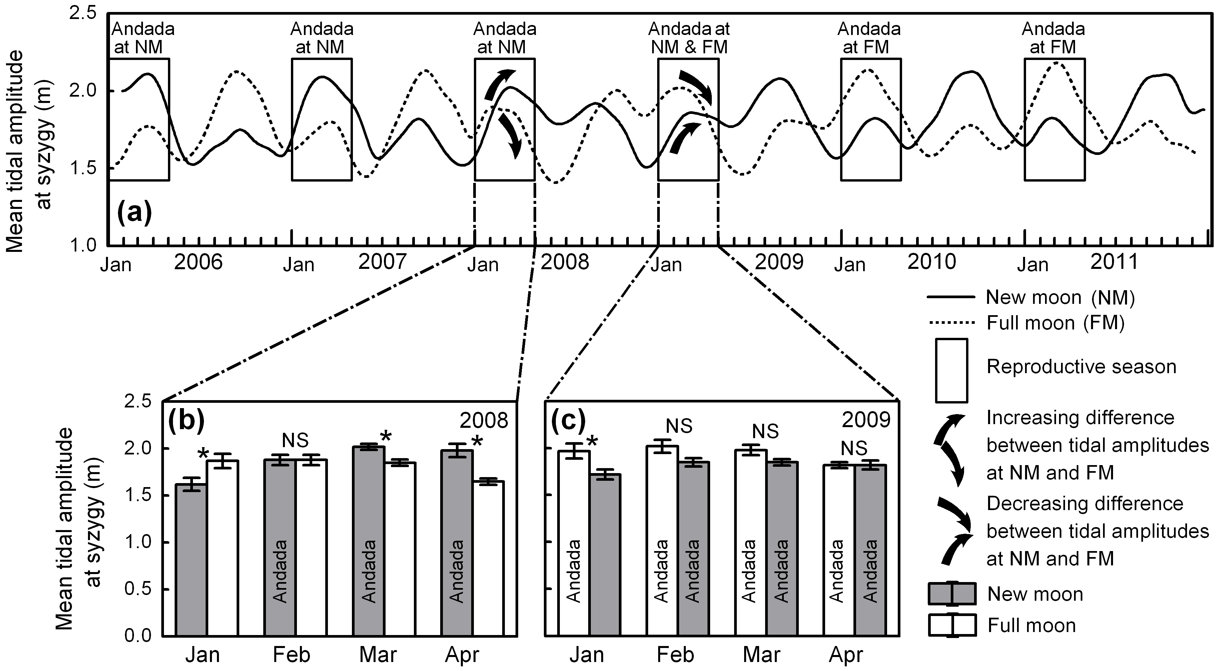

Figure 1. (a) Mean tidal amplitude around new moon (NM) and full moon (FM) from 2006 to 2011 (points were connected with rounded curves by cubic spline interpolation). Boxes mark the reproductive season monitored for the presence or absence of andada. (b) and (c) Details of the mean and standard error of the tidal amplitude during the reproductive season in 2008 and 2009 when the shift in the STIC occurred. *: Significant differences between NM and FM mean tidal amplitudes (10 df, p < 0.05), N.S.: Not significant.

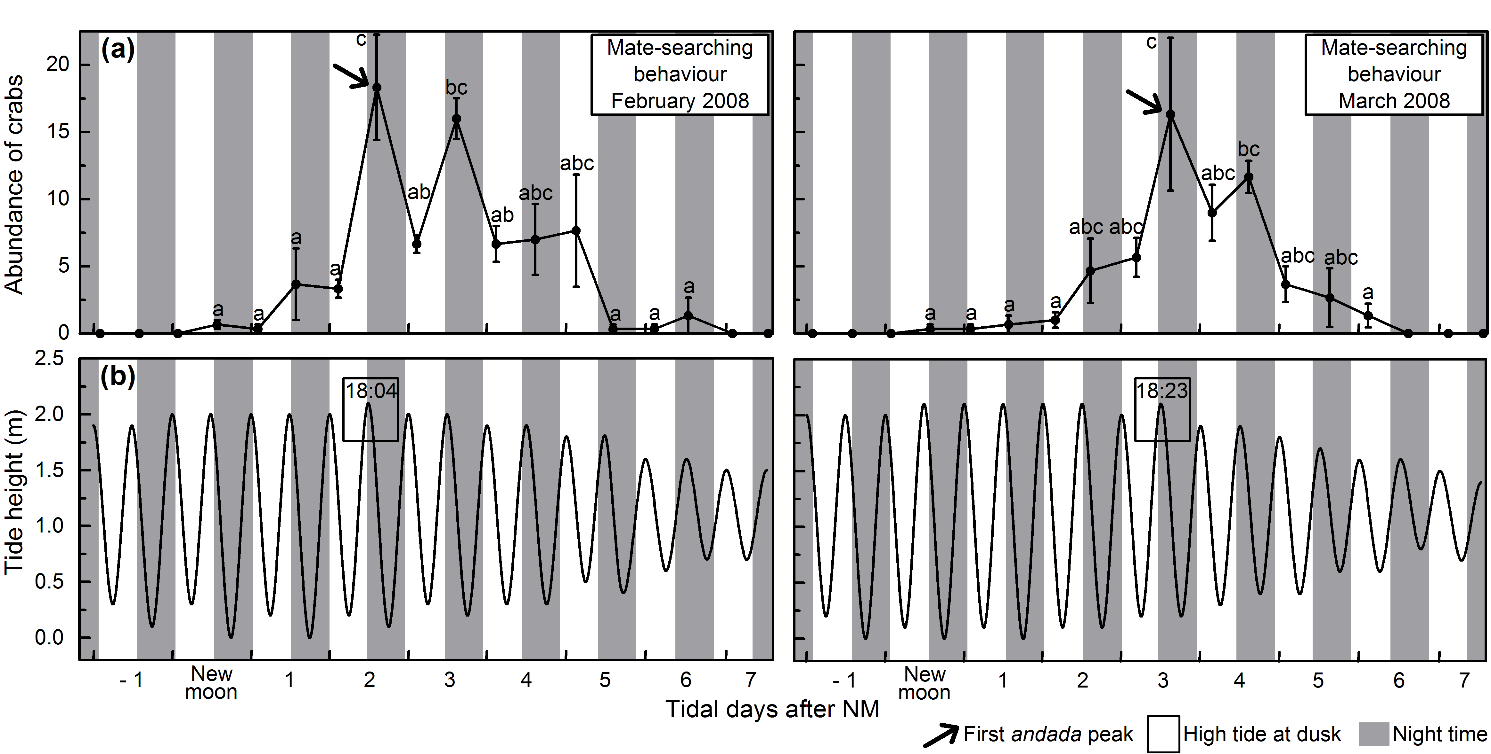

Figure 2. (a) Average and standard error of the abundance (ind. / 500 m²) of U. cordatus showing mate-searching behaviour outside burrows around new moon in February and March 2008 (at full moon crabs did not display mate-searching behaviour). Each average value refers to three sampled plots. Equal letters: No significant difference. (b) Predicted tidal height during low and high tide along the sampled tidal days.

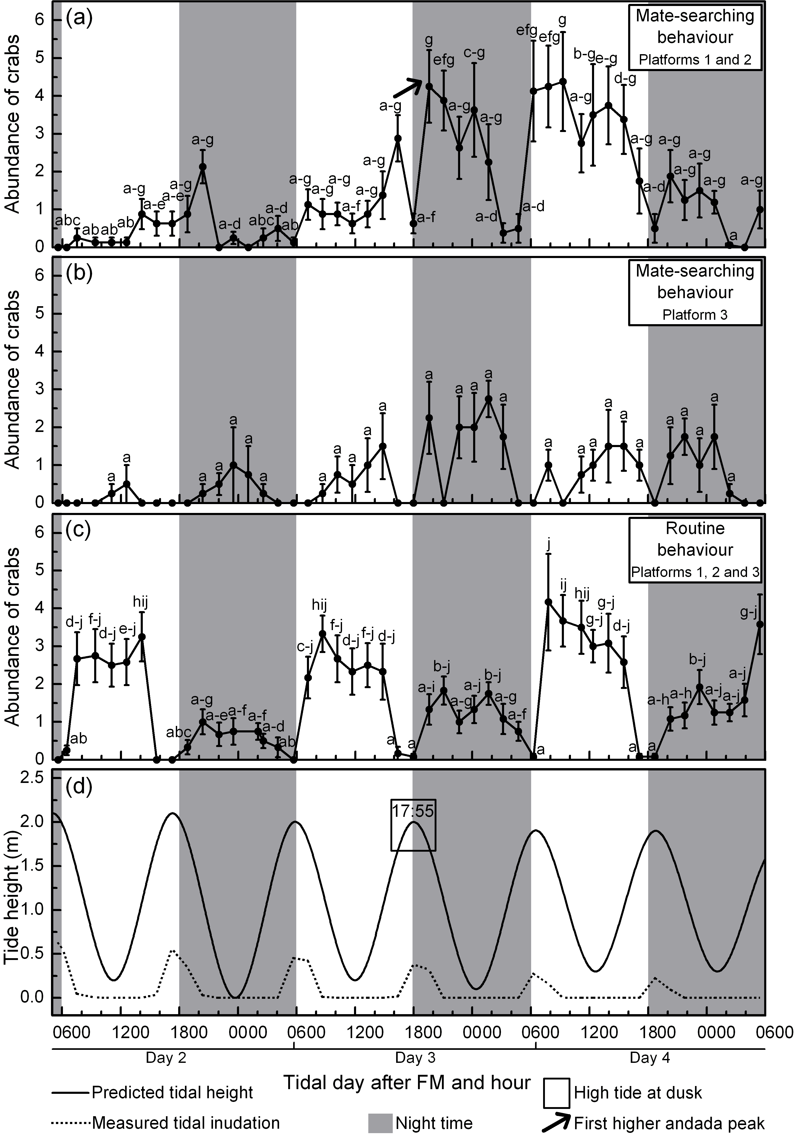

Figure 3. (a) Average and standard error of the abundance (ind. / 4 m²) of U. cordatus outside burrows displaying mate-searching behaviour during andada around full moon in February 2010. (b) Average and standard error of the abundance of U. cordatus outside burrows showing routine behaviour around full moon in February 2010. Each average value refers to 12 sampled plots. Equal letters: No significant difference. (c) Predicted tidal height and measured tidal inundation at the sampled tidal days.
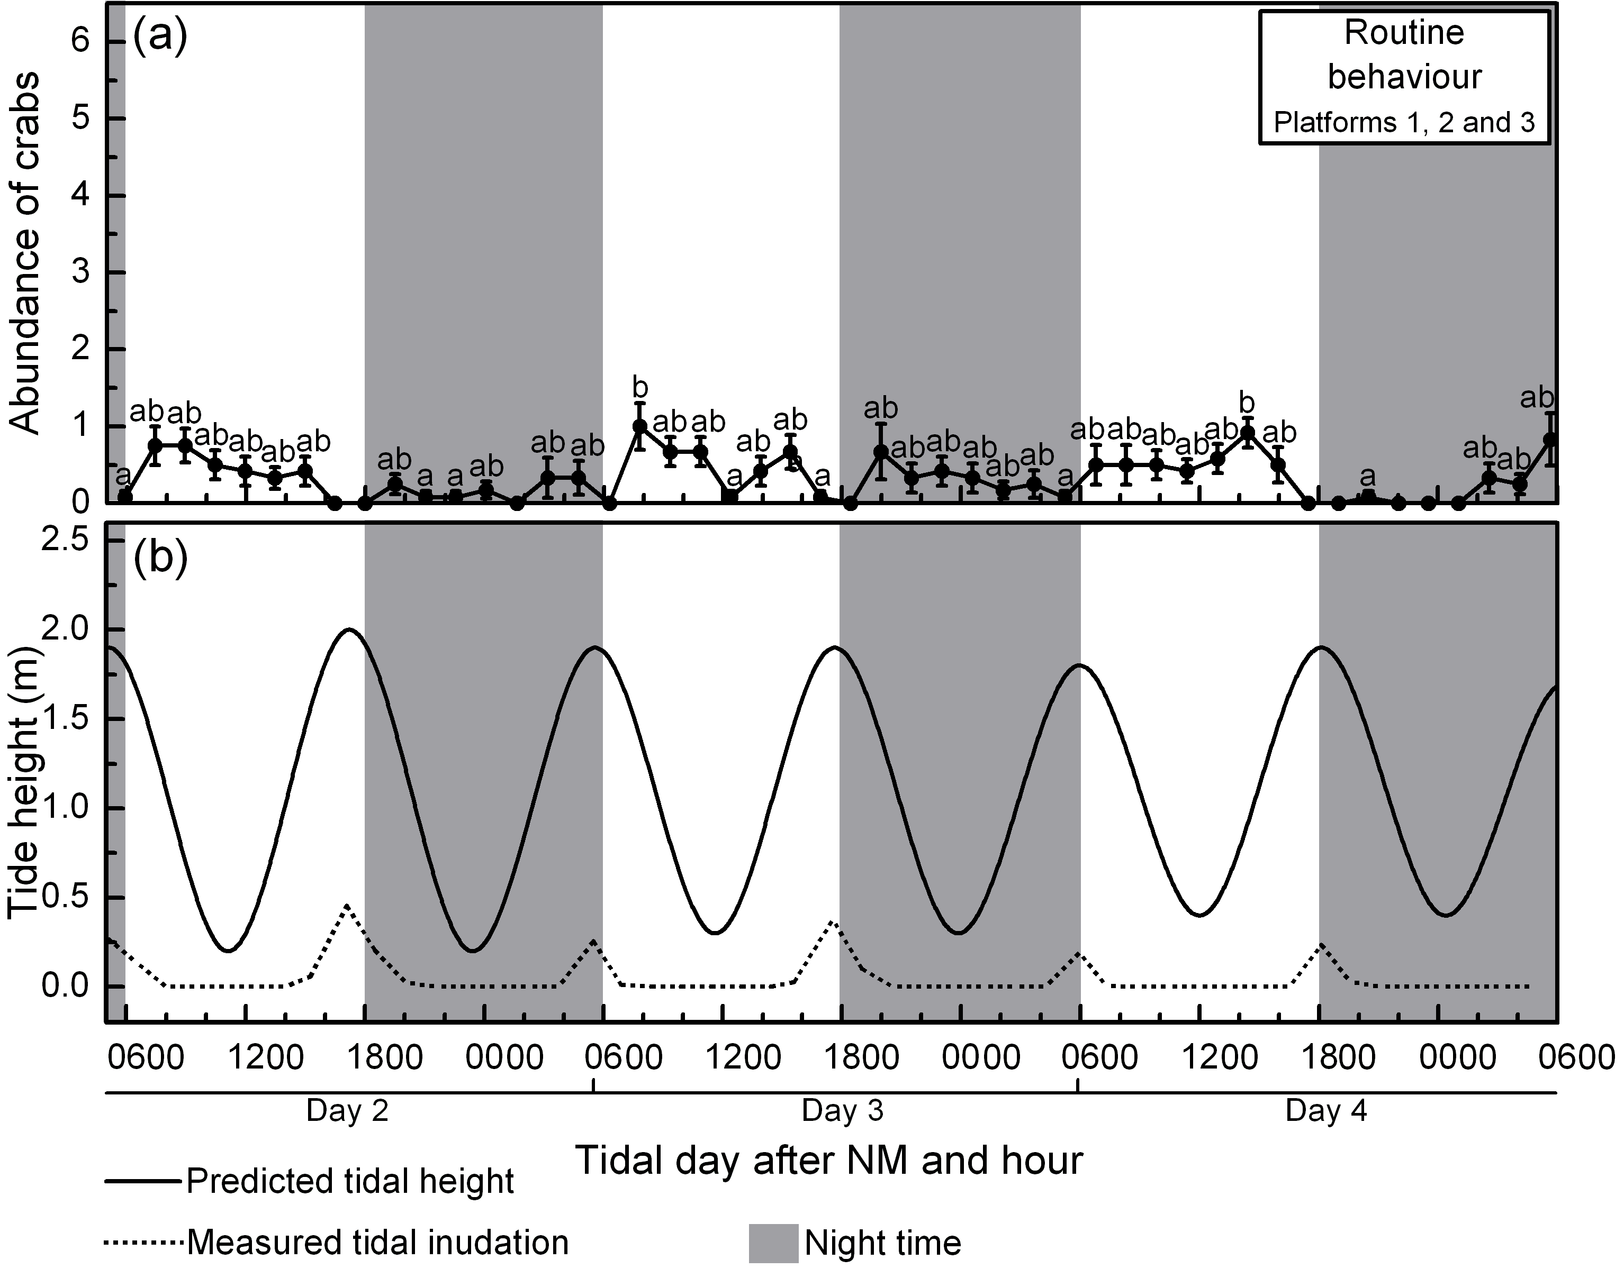

Figure 4. (a) Average and standard error of the abundance (ind. / 4 m²) of U. cordatus outside burrows showing routine behaviour around NM in February 2010 when no andada took place. Each average value refers to 12 sampled plots. Equal letters: No significant difference. (b) Predicted tidal height and measured tidal inundation at the sampled tidal days.

