The Value Flame at the Base of the Pyramid:
Opportunities to Source and Sell in Emerging Markets.

Abstract
Emerging markets are diverse and can require separate market entry and market development strategies. This paper will look at these opportunities through the lenses of two theories: The value at the Bottom of the Pyramid (BOP) concept was pioneered by Prahalad, and London & Hart, to identify the potential of emerging markets not only as resource suppliers but as a market to sell into. Blue Ocean Strategy (BOS) developed by Kim & Mauborgne is characterised by untapped market space, demand creation, and possibilities for highly profitable growth, rather than focusing on trying to outperform rivals and increase market share within existing demand. These two concepts will be used to see the potential of shifting paradigms in regards to emerging markets to identify a leap in value for both consumers and producers. The purpose of this paper is to show that emerging markets offer two separate but complimentary areas of opportunity for multinational corporations to generate profits from not only sourcing lower cost / higher quality products from these areas, but to also increase revenue and global market share by designing and selling offerings to these areas: to sell to the Value Flame at the Base of the Pyramid.

Key words
Value Flame at the Base of the Pyramid, emerging markets, VFBOP, Blue Ocean Strategy, Bottom of the Pyramid, market entry.

Introduction
Emerging markets are diverse and can require separate market entry and market development strategies. This paper will look at these opportunities through the lenses of two theories: The value at the Bottom of the Pyramid (BOP) concept was pioneered by Prahalad, and London & Hart, to identify the potential of emerging markets not only as resource suppliers but as a market to sell into. Blue Ocean Strategy (BOS) developed by Kim & Mauborgne is characterised by untapped market space, demand creation, and possibilities for highly profitable growth, rather than focusing on trying to outperform rivals and increase market share within existing demand. These two concepts will be used to see the potential of shifting paradigms in regards to emerging markets to identify a leap in value for both consumers and producers. The purpose of this paper is to show that emerging markets offer two separate but complimentary areas of opportunity for multinational corporations to generate profits from not only sourcing lower cost / higher quality products from these areas, but to also increase revenue and global market share by designing and selling offerings to these areas: to sell to the Value Flame at the Base of the Pyramid.

Literature Review
Global Importance of Emerging Markets
In large part due to the majority of firms focused on the ‘triad’ market of North America, European Union, and the Asia Pacific region, with its slowing growth rate (absolute market size is dramatic), more companies are turning to emerging economies to generate higher growth rates for sales and profits (Ohmae, 1985). 75% of the world’s population lives in the emerging economy countries, and the mobilization of technology and capital has increased globalization and fostered a paradigm shift in international business (Cavusgil et al., 1997). Indeed, globalization has been defined as the most powerful force for social good in the world today (Bhagwati, 2004). In the 21st century there has been a major fragmentation of production systems, such that the functions can be “reorganized” or “outsourced”, and companies need to create strategies “for selecting which of the steps, from defining a product and delivering it to a customer, should remain in-house versus the functions that will be outsourced – that is, purchased from other firms” (Berger, T., 2006, p.15). Similarly, in order to amortize increasing R&D costs (see Bartlett and Ghoshal, 1990; Pearce and Singh, 1992), globally active corporations are responding by attempting to introduce innovations as fast as possible over the widest geographical area. The “varieties of capitalism” model (Hall and Soskice, 2001) predicts that companies expanding globally try to recreate the same types of institutions that they successfully depended upon at their domestic base.

Bottom of the Pyramid (BOP) and Blue Ocean Strategy (BOS)
The Bottom of the Pyramid global economic system as defined by Prahalad and Hart (2002) refers to the enormous untapped potential of emerging markets previously thought of as unreachable or difficult to reach. More than 4 billion people, nearly 70% of the total world, are in the Bottom Of the Pyramid (see figure 1). These markets are often unlinked to the global supply chain and global marketing channels. The lack of development of marketing infrastructure such as communications channels for advertising, distribution channels to supply the market, and the low income of this target market made it difficult and many times unprofitable to penetrate this market. However, the bottom of the pyramid market is perhaps the world’s largest and the accessibility of this market is becoming easier.

Potential customers at the BOP have annual purchasing power parity less than US $1,500. The BOP can not be tapped by just modifying current global approaches, but instead companies must create a totally new approach. A standard western marketing mix offering will not work with this group whose circumstances require a highly customized approach. Buyers at the BOP behave differently not only from their counterparts in developed country markets but also from the upper and middle-income customers in their own societies (London and Hart, 2004). Most MNCs fail to recognise the potential at the bottom of the pyramid, and often hold assumptions similar to those listed in Table 1 below. Traditional MNCs with product lines priced and developed for Western or Top Of the Pyramid (TOP) markets are often inaccessible to customers in BOP markets, and the feature-function set is often inappropriate.

Assumption | Implication
The poor are not our target customers; they cannot afford our products or services | Our cost structure is a given; with our cost structure we cannot serve to BOP market.
The poor do not have use for products sold in developing countries. | Committed to a form over functionality: there is no market in the BOP.
Only developed countries appreciate and pay for technological innovations. | The BOP cannot afford advanced technology solutions; thus not a source of innovation.
The BOP market is not critical for long-term growth and vitality of MNCs. | BOP markets are at best an attractive distraction.
Intellectual excitement is in developed markets; hard to recruit managers for BOP | We cannot assign our best people to work on market development in BOP markets.
Table 1: The Dominant Logic of MNCs as it relates to BOP. (Prahalad, 2006)

Note that since Prahalad’s initial work there have been studies which paint a contrasting picture regarding BOP markets. Karnani (2007) indicates caution is recommended, as the BOP market is currently generally too small to profitably attract most MNC’s; indeed the opportunity is for small to medium local companies. Crabtree (2007) questions the profit-making proof in the BOP strategy, while acknowledging positive fundamental capabilities. Landrum (2007) finds that although Prahalad’s examples of innovation are market-specific, and his claim of poverty eradication is not fully supported, the overall intent of Prahalad’s analysis is to “challenge corporations to be innovative and creative”.

In the Blue Ocean Strategy Kim and Mauborgne (2005) define two separate market spaces. One – the “Red Ocean” – is comprised of all the known industries in existence today. The industry boundaries are defined and accepted. Competition is focused on trying to outperform rivals and increase market share within existing demand. In contrast, “Blue Oceans” are characterised by untapped market space, demand creation, and possibilities for highly profitable growth. The key to a Blue Ocean strategy is Value Innovation (figure 2), which is created at the intersection

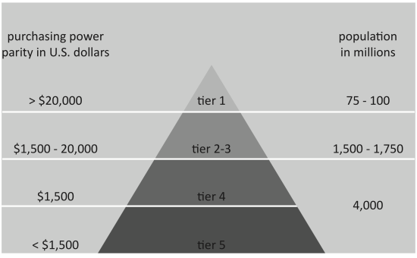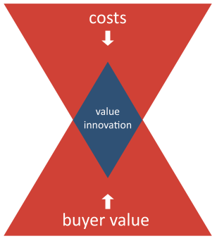
Fig. 1: Bottom Of the Pyramid (Prahalad & Hart, 2002) Fig. 2 Blue Ocean Strategy
(Kim & Mauborgne, 2005)

where a company’s actions profitably affect both its cost structure and its value proposition to buyers. Buyer value is increased by creating and raising elements the industry has never offered to the market. Costs are reduced initially by eliminating and reducing the factors an industry competes on, and later as economy of scale savings due to increased volume materialize. Value Innovation requires companies to orient the whole system toward achieving a leap in value for both buyers and themselves.

The Value Flame at the Base of the Pyramid
We suggest that indeed the BOS Value Innovation targets the BOP, in part because of the BOS characteristics of untapped market spaces, demand creation, and possibilities for highly profitable growth (fig. 3). The key defining features of BOS involves the creation of uncontested space; irrelevance of competition; creation and capture of new demand; and value-cost trade-off disconnection. Perhaps most importantly it requires the alignment of the whole firm in pursuit of differentiation. This is likely to lead an organization away from the “Top of the Pyramid” Red Ocean markets where most emerging market strategy is focused, and towards the BOP. We can compare BOS Value Innovations and the BOP Principles of Innovation in Table 2.

BOP Principles of Innovation | BOS Value Innovation
* Focus on Price Performance  * Scalable and transportable across countries  * Focus on conserving resources  * Hostile environment operation  * Methods to access poor | * Break the value-cost trade-off
* Deep understanding of product functionality.  * Platform easily incorporates feature / function evolution* * Develop infrastructure/technology hybrid solutions | * Make competition irrelevant
* Process innovations are as critical as product innovations.  * Deskilling work is critical. | * Align all firm activities in pursuit of differentiation.
* Educate consumers on product usage.  * Interfaces are critical | * Create and capture new demand
Table 2: BOS / BOP Innovation

The analysis of BOP and BOS strategies undertaken in this paper suggests that there may be a “Blue Ocean” opportunity at the “Bottom of the Pyramid”, which we refer to as the Value Flame at the Base of the Pyramid (VFBOP). Note that the VFBOP strategy does not result in a complete BOP pyramid shape nor the BOS diamond shape (see figure 4). Given that the VFBOP strategy in this situation is employed typically by a Multi-National Corporation (MNC) entering the emerging market from a developed country, it implies enough of an existing (LDC) market and existing (LDC) competition, thus the Blue Ocean market does not linearly taper off. Local competition is likely to be to a large extent, red at the BOP.

Fig. 3 BOP and BOS Fig. 4 VFBOP
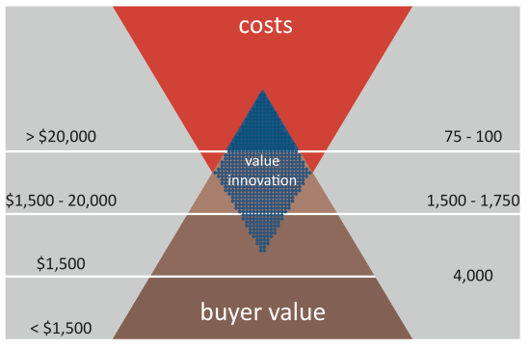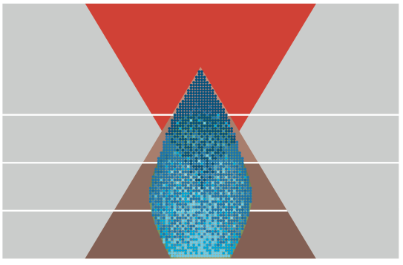
Graphics: Adam J. Williams

The Value Innovation area in Figure 4 widens out as a company moves further lower from the Top of the Pyramid, but in deference to the existing competitive red ocean at the BOP it does not completely envelop it, and in fact if entered with unsuccessful strategies the company may not be able to compete at the base of the pyramid, and eventually retreat. We suggest that in fact, some of these red competitors may survive and perhaps succeed at the TOP, or go global.

Conclusion
The opportunities that emerging economies provide to multinational corporations, within a context of a paradigm shift of international business that includes an LDC market which offers more manageable risks, higher income growth and increasing consumer purchasing power, lies in both the market available to source from but additionally the market to sell to. This shifting dynamic allows corporations to generate profit not solely from reducing costs by utilizing new suppliers offering low cost and high quality resources; they also offer opportunities to be able to enter new markets and generate revenues and expand global market share. Through both the Bottom Of the Pyramid and Blue Ocean Strategy theories it can be seen that enormous opportunities may be available in these emerging economies, in the Value Flame at the Base of the Pyramid.
References
Bartlett, C. A., and Ghoshal, S. (1990) "Managing Innovation in the Transnational Corporation." In Managing the global firm / edited by Christopher A. Bartlett, Yves Doz, and Gunnar Hedlund. London; New York: Routledge, 1990
Berger, T. (2006) “From nation-building to state-building: The geopolitics of development, the nation-state system and the changing global order”, Third World Quarterly, Volume 27(1), pp. 5 – 25
Bhagwati, J. (2004) “In defense of globalization”, Oxford University Press, New York, NY
Cavusgil, S.T. (1997), "Measuring the potential of emerging markets: an indexing approach", Business Horizons, Vol. 40 pp.87-91.
Crabtree, A. (2007) “Evaluating ‘The Bottom of the Pyramid’ from a Fundamental Capabilities Perspective”, CBDS Working Paper Series, Working Paper No. 1, 2007, pp1-18
Karnani, A. (2007), “The Mirage of Marketing to the Bottom of the Pyramid”, California Management Review, Vol. 49, No.4, Summer 2007, pp91-111
Kim, M.C. and Mauborgne, R (2005) “Blue Ocean Strategy”, Journal of Business Strategy, Vol. 26, NO. 4, Pp. 22-28.
Landrum, N. (2007), “Advancing the ‘Base of the Pyramid’ debate”, Strategic Management Review, Vol. 1, No. 1, 2007, pp12-16
London, T. Hart, S. L. (2004) “Reinventing strategies for emerging markets: beyond the transnational model”, Journal of International Business Studies, Vol. 35 (5), pages 350-370
Ohmae, K. (1985) “Triad Power: The Coming Shape of Global Competition” The Free Press, New York.
Omar, M., Williams, R. (2009) “Marketing to the Bottom of the Pyramid; Opportunities in emerging Markets”, International Journal of Services, Economics and Management, Vol. 1, No. 4, pp427-446
Pearce, R.D., Singh, S. (1992), Globalizing Research and Development, Macmillan, London,
Prahalad, C.K. (2006) “The Fortune at the Bottom of the Pyramid: Eradicating Poverty Through Profits” N.J: Wharton School Publishing.
Prahalad, C.K., and Hart, Stuart L., (2002) “The Fortune at the Bottom of the Pyramid”, Strategy+Business, 26: 54- 67, First Quarter 2002, Booz, Allen & Hamilton Inc.

