Chapter 4

Statistical Analysis of KSI/ Fatal Accidents with Casualties and Involved Vehicles

4.0: Introduction

This chapter is based on statistical analysis of secondary data of road traffic fatal/ KSI (based on availability of data) accidents with casualties and involved vehicles. The data of the rates (per 10,000 population) of KSI/ fatal accidents with casualties, and involved vehicles, by road environment and class; by location (city-non-city, division and district); by type of collision and junction; by mode of time; and by mode of travel will be analysed using a range of statistical methods utilising a selection of predictor explanatory variables. Other variables will be used in the analysis include data on population size/ population density to produce rates.
This chapter is organised in the following sections:

Section- 4.1
Statistical Analysis Approaches

As the raw data are not available only aggregated totals, so analysis is conducted using mainly non-parametric methods and procedures to model or analyse row and column effects and their interactions from tables using SPSS.

4.1.1: Time series classified data
These are analysed applying linear regression model.
Let y_{ti} denote the i^{th} (1, 2 …n) observation in the t^{th} (1, 2 ... t) year.
For example, if y_{ti} denotes the i^{th} (1, 2 …9) observation of rate of KSI casualties in the t^{th} (1999 = 1, 2000 = 2 ... 2007 = 9) year; then data are analysed applying linear regression model.

4.1.2: One-way classified data:
These are analysed applying Mann-Whitney or Kruskal-Wallis tests
Let y_{ij} denote the j^{th} (1, 2… n_{i}) observation in the i^{th} (1, 2... m) A-classification.
- When m = 2, Mann-Whitney ANOVA is applied.
- When m > 2, Kruskal-Wallis ANOVA is applied.

4.1.2a: Mann-Whitney ANOVA
For example, if y_{ij} denotes KSI accident rate of the j^{th} (2002 = 1, 2003 = 2… 2007 = 6) year in the i^{th} (urban = 1, rural = 2) road environment/ locality; then these data are analysed applying M-W test.
The test involves the calculation of a statistic, usually called U, whose distribution under the null hypothesis is known. In the case of small samples, the distribution is tabulated, but for sample sizes above ~20 there is a good approximation using the normal distribution.

4.1.2b: Kruskal-Wallis ANOVA
For example, if y_{ij} denotes the fatal accident of the j^{th} (2002 = 1, 2003 = 2… 2007 = 6) year in the i^{th} (January = 1, February = 2… December = 12) month; then these data are analysed applying K-W test.
Data that can be analysed with Kruskal-Wallis should have following criteria:
- Data points must be independent from each other.
- Distributions are not normal and the variances are not equal.
- Should ideally have more than five data points per sample.
- All individuals must be selected at random from the population.
- All individuals must have equal chance of being selected.
- Sample sizes should be as equal as possible.

4.1.3: Two-way and three-way classified data
These are analysed applying Univariate Linear Model.
Let y_{ijk} denote the k^{th} (k = 1, 2… m) observation in the i^{th} (1, 2… p) A-classification and the j^{th} (1, 2... q) B-classification.
For example, if y_{ijk} denotes the fatal accident of the k^{th} (2002 = 1, 2003 = 2… 2007 = 6) year in the i^{th} (January = 1, February = 2… December = 12) month and the j^{th} (National = 1, Regional = 2, Feeder = 3, Rural = 4, City = 5) road class; then these data are analysed applying Univariate Linear Model.

Let y_{ijkl} denote the l^{th} (l = 1, 2… m) observation in i^{th} (1, 2… p) A-classification and the j^{th} (1, 2... q) B-classification and k^{th} (k = 1, 2… r) C-classification.
For example, if y_{ijkl} denotes the rate of road fatalities of the l^{th} (2002 = 1, 2003 = 2… 2007 = 6) year in the i^{th} (pedestrian = 1, passenger = 2, driver = 3, motorcyclist = 4) travel mode; the j^{th} (0-5 = 1, 6-10 = 2, 11-15 = 3… 71-75 = 15, 75+ = 16, unknown = 17) age and the k^{th} (1 = male and 2 = female) gender; then these data are analysed applying Univariate Linear Model.
KSI casualty rates are analysed at next section (4.2).

Section- 4.2
Analysis of Rates of Fatal/ KSI Casualties by Location

This section is based on analysis of rates of fatal/ KSI casualties, 1999-2007. Firstly, the time series of these are analysed. Then, these splitting into 2 cities-non-cities; 10 divisions/ cities and 68 districts/ cities for 2002-2007; are analysed. Finally, the rates of fatal casualties of 68 national highway links for 2003-2006 are analysed. The results are summarised in the following table (4.2):
# | Year | Predictor  Variable | Dependent  Variable | Test | P-value |  | Comment
 |  |  |  |  | Variable | Value | Comment
1 | 1999-  2007 | Year | Rate of  KSI Casualties | Linear Regression  Model |  |  | No significant difference among the rates of KSI casualties is found, even although, the rates have fallen from 0.423 in 1999 to 0.356 in 2007 in a fallen rate of 15.84%.
2 | 1999-  2007 | City-  non-City | Rate of  KSI Casualties | Mann-  Whitney | KSI CR | <0.01 | With significant variations, cities have higher casualty rates than that in non-cities (divisions/ Districts, excluding cities.
3 | 2002-  2007 | Division/ City | Rate of  KSI Casualties | Kruskal-  Wallis | KSI CR | <0.01 | With significant differences, Rajshahi City, Dhaka City, Dhaka, Sylhet and Khulna City have higher rates of casualties.
4 | 2002-  2007 | District/ City | Rate of  KSI Casualties | Kruskal-  Wallis | KSI CR | <0.01 | There is a significant difference. According to mean rank, Rajshahi City, Dhaka City, Feni, Narayanganj, Manikganj, Munshiganj, Faridpur, Sylhet, Narsingdi and Jhenaidah are highly affected.
5 | 2003-  2006 | National Highway  Link | Rate of  Fatal Casualties | Kruskal-  Wallis | Fatal CR | <0.01 | With significant differences, links as Mainamati- Brahmanbaria; Chittagong- Feni; Daudkandi- Mainamati; Mainamati - Feni and Keranirhat-Cox’sbazar have higher rates of fatalities.
Table- 4.2: Summary of Analysis of Rates of Fatal/ KSI Casualties by Location

It has been found that there are significant differences among the rates of KSI casualties by location. These may be for size of area, population, population density, plying vehicles, geographical situation, location, transit etc.
Rates of fatalities by travel mode are analysed at next section (4.3).

Section- 4.3
Analysis of Rates of Fatalities by Travel Mode and by Age and Gender

This section is based on analysis of rates of fatalities by travel mode, 2002-2007. Firstly, time series of these and these by age and gender are analysed. Then, these splitting into age, gender, age* gender, alcohol-drinking, age* alcohol-drinking, helmet-wearing and age* helmet-wearing are analysed. The results are summarised in the following table (4.3):

# | Year | Predictor  Variable | Dependent  Variable^{i} | Test | P-value |  | Comment
 |  |  |  |  | Variable | Value | Comment
1 | 2002-  2007 | Travel Mode | Rate of  Fatalities | Kruskal-  Wallis | Fatality  rate | <0.01 | With significant differences, rate of fatalities for pedestrian is greater than any other travel mode.
2 | 2002-  2007 | Travel Mode  Vs Age | Rate of  Fatalities | Univariate  Linear  Model | Travel M  Age  Age*TM | <0.01  <0.01  <0.01 | With significant differences, males of ages 26-40 are greater than any other ages and females of ages of 26-35 and 46-50 are greater than any other ages. See the natures of differences in Figure # 4.3f.
3 | 2002-  2007 | Travel Mode  Vs Gender | Rate of  Fatalities | Univariate  Linear  Model | Travel M  Gender  Gen*TM | <0.01  <0.01  0.03 | With significant differences, males of ages 26-40 are greater than any other ages and females of ages of 26-35 and 46-50 are greater than any other ages.
4 | 2002-  2007 | Travel Mode  Vs  Age  Vs Gender | Rate of  Fatalities | Univariate  Linear  Model | Travel M  Gender  Age  TM*Age  TM*Gen  Age*Gen  TM*A*G | <0.01  <0.01  <0.01  <0.01  <0.01  <0.01  <0.01 | With significant differences, males of ages 26-40 are greater than any other ages and females of ages of 26-35 and 46-50 are greater than any other ages with higher involvement of pedestrian.
5 | 2002-  2007 | Age | Rate of  Fatalities  for ARU | Kruskal-  Wallis | FRARU | <0.01 | With significant differences, ages of 21-35 are having higher fatality rates than any ages.
6 | 2002-  2007 | Age | Rate of  Fatalities  for Pedestrian | Kruskal-  Wallis | FRPed | <0.01 | With significant differences, the ages 66-70, 56-60 and 46-50 are having higher fatality rate than any ages.
7 | 2002-  2007 | Age | Rate of  Fatalities  for Passenger | Kruskal-  Wallis | FRPas | <0.01 | With significant differences, ages of 26-40 have higher fatality rates than any ages.
8 | 2002-  2007 | Age | Rate of  Fatalities  for Driver | Kruskal-  Wallis | FRDri | <0.01 | With significant differences among the FRs for Drivers, ages of 26-40 are having higher FRs than other ages.
9 | 2002-  2007 | Age | Rate of  Fatalities  for Motorcyclist | Kruskal-  Wallis | FRMoc | <0.01 | With significant differences, ages of 26-40 are having higher than other ages.
10 | 2002-  2007 | Gender | Rate of  Fatalities  for ARU | Mann-  Whitney | FRARU | <0.01 | With significant differences, males are greater than females.
11 | 2002-  2007 | Gender | Rate of  Fatalities  for Pedestrian | Mann-  Whitney | FRPed | <0.01 | With significant differences, males are greater than females.
12 | 2002-  2007 | Gender | Rate of  Fatalities  for Passenger | Mann-  Whitney | FRPas | <0.01 | With significant differences, males are greater than females.
13 | 2002-  2007 | Age Vs  Gender | Rate of  Fatalities  for  All Road  User | Univariate  Linear  Model | Age  Gender  Age*Gen | <0.01  <0.01  <0.01 | With significant differences, males of ages 26-30, 36-40 and 66-70 are greater than any other ages and females of ages 6-10, 46-50, 56-60 and 66-70 are greater than any ages. See the natures of differences in Figure # 4.3a.
14 | 2002-  2007 | Age Vs  Gender | Rate of  Fatalities  for Pedestrian | Univariate  Linear  Model | Age  Gender  Age*Gen | <0.01  <0.01  <0.01 | With significant differences, the males of ages 66-70, 56-60 and 46-50 are greater than any other ages and the females of ages6-10, 56-60 and 66-70 are greater than any other ages. See the natures of differences in Figure # 4.3b.
15 | 2002-  2007 | Age Vs  Gender | Rate of  Fatalities  for Passenger | Univariate  Linear  Model | Age  Gender  Age*Gen | <0.01  <0.01  <0.01 | With significant differences, males of ages 26-40 are greater than any other ages and females of ages 26-35 and 46-50 are greater than any other ages. See the natures of differences in Figure # 4.3c.
16 | 2004-  2007 | Alcohol-  Drinking | Rate of  Fatalities  for Driver | Mann-  Whitney | FRDri | <0.01 | With significant differences, alcohol not suspected is greater than alcohol suspected.
17 | 2004-  2007 | Helmet-  Wearing | Rate of  Fatalities  for Motorcyclist | Mann-  Whitney | FRMoc | <0.01 | With significant differences, helmet not worn is greater than helmet worn.
18 | 2004-  2007 | Age Vs  Alcohol-  Drinking | Rate of  Fatalities  for Driver | Univariate  Linear  Model | Age  AD  Age*AD | <0.01  <0.01  <0.01 | With significant differences, alcohol not suspected ages of 26-40 are greater than any other ages. See the natures of differences in Figure # 4.3d.
19 | 2004-  2007 | Age  Vs  Helmet-  Wearing | Rate of  Fatalities  for Motorcyclist | Univariate  Linear  Model | Age  HW  Age*HW | <0.01  <0.01  <0.01 | With significant differences, helmet not worn ages of 26-35 are greater than any other ages. See the natures of differences in Figure # 4.3e.
Table- 4.3: Summary of Analysis of Rates of Road Traffic Fatalities by Travel and by Age and Gender

The variations in the mean rates are displayed in the following figures:

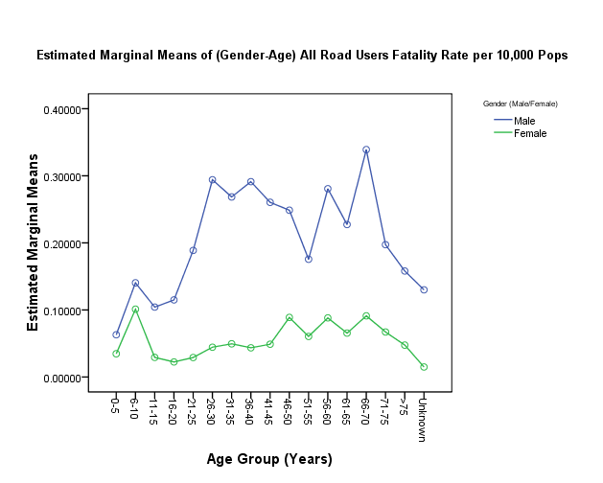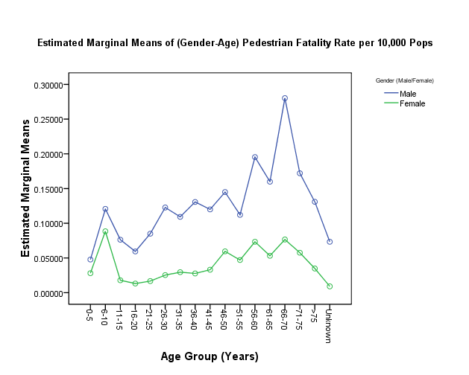
Figure- 4.3a Figure- 4.3b
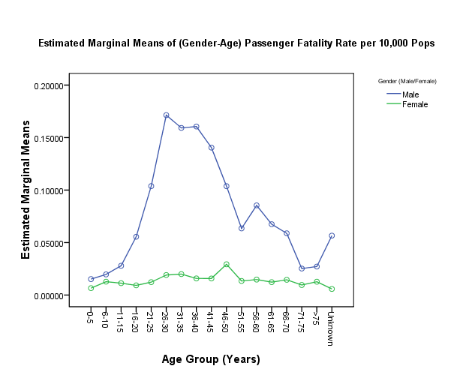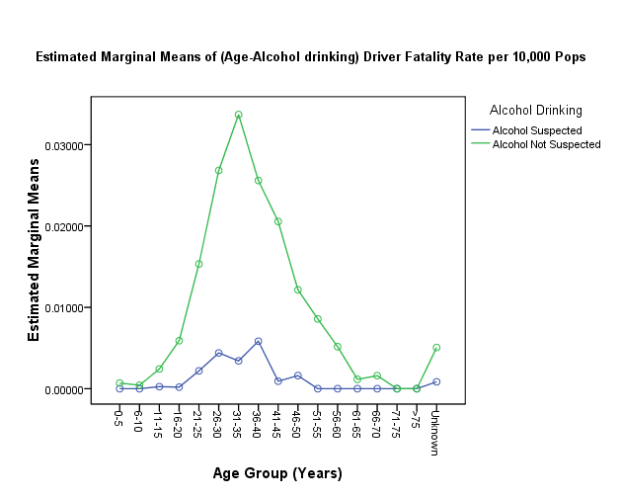
Figure- 4.3c Figure- 4.3d
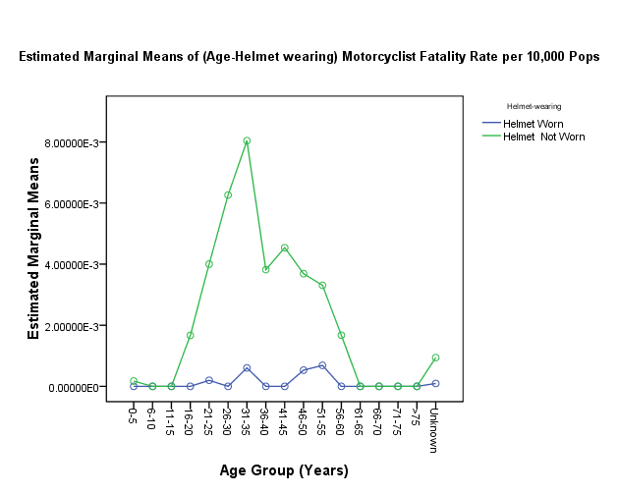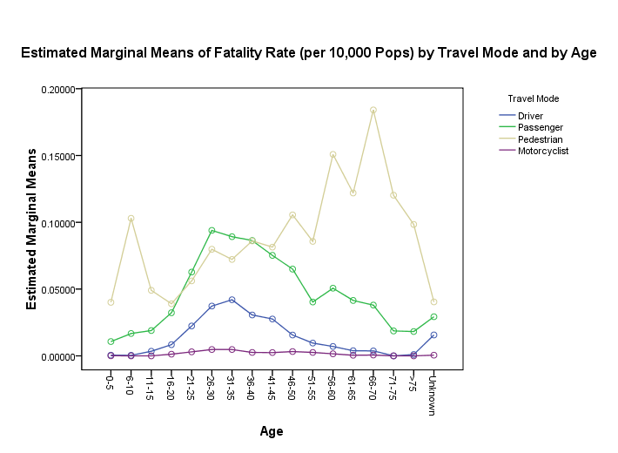
Figure- 4.3e Figure- 4.3f
Figure-4.3: Estimated marginal means of rates of fatalities by travel mode and by age and gender

It has been found that there are significant differences among rates of fatalities by travel mode with age, gender, age*gender, alcohol-drinking and helmet-wearing.
Drivers’ injury (inclusive others) may vary for primary factors (performance, recognition of impending events and decision-making factors) and prevalence of various characteristics (age, experience, emotional state, pressure from carriers and drug usage in specific crash types addressed by on-board safety systems that support drivers). Motorcyclists’ fatalities may vary for helmet wearing (minimum for helmet-worn and maximum for helmet-not-worn). Wearing helmet may have 5 major motions as imitation, experience, self-protection, environmental conditions and legality and finance issues. Again, it may have 3 major barriers as discomfort, underestimation of danger and risky behaviour. Passengers’ (by far the weakest road user) injury may vary for position/ location (inside vehicle, outside vehicle, on roof), action (no action, boarding, de-boarding, falling off etc.). Pedestrians’ injury may vary for location (on pedestrian crossing, within 50m of pedestrian-crossing, central island/divider, road centre, footpath, roadside, bus stop) and action (no action, crossing the road, walking along the road, walking along roadside, playing on road and other), movement parameters (velocity, head and leg movements of pedestrians) and traffic flow.
The Fatal/ KSI accident rates are analysed at next section (4.4).

Section- 4.4
Analysis of Fatal/ KSI Accident Rates by Location

This section is based on analysis of rates of fatal/ KSI accident rates, 1999-2007. Firstly, time series of KSI accident rates analysed. Then, fatal accident rates or KSI accident rates for 2002-2007 splitting into 2 cities-non-cities, 10 divisions/ cities, 68 districts/ cities, 2 road environments/ localities and 5 road classes are analysed. Finally, fatal accident rates of 68 national highway links are analysed. The results are summarised in the following table (4.4):

# | Year | Predictor  Variable | Dependent  Variable^{i} | Test | P-value |  | Comment
 |  |  |  |  | Variable | Value | Comment
1 | 1999-  2007 | Year | KSI Accident Rate | Linear Reg.  Model |  |  | No significant difference among KSI accident rates is found, even although, rates have fallen from 0.286 in 1999 to 0.266 in 2007 in a fallen rate of 6.99%. No significant variation in the slope of it over the time could be found.
2 | 1999-  2007 | Cities-  non-Cities | KSI Accident Rate | Mann-  Whitney | KSI AR | <0.01 | With significant variations, cities have higher accident rates than that in non-cities (divisions/ districts, excluding cities).
3 | 2002-  2007 | Division/ City | KSI Accident Rate | Kruskal-  Wallis | KSI AR | <0.01 | With significant differences, Rajshahi city, Dhaka city, Sylhet division, Dhaka division and Chittagong city are highly affected.
4 | 2002-  2007 | District/ City | KSI Accident Rate | Kruskal-  Wallis | KSI AR | <0.01 | With significant differences, Rajshahi city, Dhaka city, Narayanganj, Feni, Manikganj, Munshiganj, Sylhet, Faridpur, Narsingdi and Rajbari are highly affected.
5 | 2002-  2007 | Locality | Fatal AR | Mann-  Whitney | Fatal AR | 0.117 | With significant differences, the urban locality is greater than rural locality.
6 | 2002-  2007 | Road | Fatal AR | Kruskal-  Wallis | Fatal AR | <0.01 | With significant differences, national highway and city road are greater than any roads.
7 | 2003-  2006 | National Highway  Link | Fatal Accident Rate | Kruskal-  Wallis | Fatal AR | <0.01 | With significant variations, links as ‘Dinajpur- Beldanga’, ‘Dasuria-Natore’, ‘Shahepratap- Bhairab’, ‘Ashuganj-Sarail’, ‘Katchpur- Daudkandi’, ‘Jatrabari-Katchpur’, ‘Manikganj- Aricha’, ‘Barisal-Patuakhali’, ‘Daudkandi- Mainamati’, ‘Natore- Rajshahi’, ‘Kashinathpur- Hatikamrul’, ‘Chittagong-Keranirhat’, ‘Rangpur-Kurigram’, ‘Nabinagar- Manikganj’ and ‘Jhenaidah- Kushtia’ have higher fatal accident rates than any other links.
Table- 4.4: Summary of Analysis of Road Traffic Fatal/ KSI Accident Rates by Location

It has been found that there are significant differences among KSI accident rates or fatal accident rates by location.
Fatal accident rates by collision type and junction type are analysed at next two sections (4.5 and 4.6).

Section- 4.5
Analysis of Fatal Accident Rates by Collision Type and by Location

This section is based on analysis of fatal accident rates by collision type, 1999-2007. Firstly, time series of annual fatal accident rates by collision type are analysed. Then, these for 2002-2007 splitting into 2 road environments/ localities, 5 road classes, 10 divisions/ cities, 68 districts/ cities and 2 cities-non-cities are analysed. Finally, fatal accident rates into 68 national highway links for 2003-2006 are analysed. The results are summarised in the following table (4.5):

# | Year | Predictor  Variable | Dependent  Variable^{i} | Test | P-value |  | Comment
 |  |  |  |  | Variable | Value | Comment
1 | 1999-  2007 | Collision | Fatal Accident Rate | Kruskal-  Wallis | Fatal AR | <0.01 | ‘Hit pedestrian’, ‘head on’, ‘rear end’, ‘overturned vehicle’ and ‘side swipe’ account for a significantly greater proportion.
2 | 2002-  2007 | Collision  Vs  Locality | Fatal Accident Rate | Univariate  Linear  Model | Collision  Locality  Coll*Loc | <0.01  <0.01  <0.01 | There are significant variations in collision type and locality and also the interaction between collision and locality for fatal accident rates. See the differences in figure # 4.5a.
3 | 2002-  2007 | Collision  Vs  Road | Fatal Accident Rate | Univariate  Linear  Model | Collision  Road  Coll*Rd | <0.01  <0.01  <0.01 | There must be significant variations in collision and road class and also the interaction between collision and roads for fatal accident rates. See the differences in figure # 4.5b.
4 | 2002-  2007 | Collision  Vs  Division/ City | Fatal Accident Rate | Univariate  Linear  Model | Collision  Div/ City  Col*Div/Ci | <0.01  <0.01  <0.01 | There must be significant variations in collision and division/ city and also the interaction between them for fatal accident rates. See the differences in figure # 4.5c.
5 | 2002-  2007 | Collision  Vs  District/ City | Fatal Accident Rate | Univariate  Linear  Model | Collision  Dis/ Ci  Col*Dis/Ci | <0.01  <0.01  <0.01 | There must be significant variations in collision and district/ city and also the interaction between collision and district/ city for fatal accident rates.
6 | 1999-  2007 | Collision  Vs  City-  non-City | Fatal  Accident  Rate | Univariate  Linear  Model | Collision  CnC  Col*CnC | <0.01  <0.01  <0.01 | With significant variations, non-cities by collision types have lower accident rates than cities except ‘overturned vehicle’. See the differences in figure # 4.5d.
7 | 2003-  2006 | National Highway  Link Vs Collision | Fatal Accident | Univariate  Linear  Model | NHWL  Collision  Col*Link | <0.01  <0.01  <0.01 | With significant differences among the collision type and national highway link, ‘hit pedestrian’ is dangerous at any links.
Table- 4.5: Summary of Analysis of Fatal Accident Rates by Collision Type and by Location
The variations in the mean rates are displayed in the following figures:

Figure- 4.5a: By ‘Road Environment’ Figure- 4.5b: By ‘Road Class’
Figure- 4.5c: By ‘Division (EC)/ City’ Figure- 4.5d: By ‘City-non-City’
Figure-4.5: Estimated Marginal Means of Fatal Accident Rates by Collision Type and by Location

It has been found that there are significant differences among fatal accident rates by collision type and by location. it may vary in the movement (1-way, 2-way), divider (with, without), weather (fair, rain, wind, fog), light (day light, dawn/dusk, night-lit, night-unlit), road geometry (straight+flat, curve only, slope only, curve+slope, crest), surface condition (dry, wet, muddy, flooded, other), surface type (sealed, brick, earth), surface quality (good, rough, under repair), road class (national, regional, feeder, rural, city), road feature (none, bridge, culvert, narrowing/ restriction, speed breakers), location type (urban, rural) and population.
Fatal accident rates by junction type are analysed at next chapter (4.6).

Section- 4.6
Analysis of Fatal Accident Rates by Junction Type and by Location

This section is based on analysis of fatal accident rates by junction type, 1999-2007. Firstly, annual fatal accident rates by junction and non-junction are analysed. Then, fatal accident rates by junction type for 2002-2007 splitting into 2 road environments/ localities, 5 road classes, 2 cities-non-cities, 10 divisions/ cities and 68 districts/ cities are analysed. Finally, the comparison of fatal accident rates by ‘at junction’ and ‘not at junction’, for annual time series data for 1999-2007 and then these splitting into 2 road environments/ localities, 5 road classes, 2 cities-non-cities, 10 divisions/ cities and 68 districts/ cities for 2002-2007 are analysed.. The results are summarised in the following table (4.6):

# | Year | Predictor  Variable | Dependent  Variable^{i} | Test | P-value |  | Comment
 |  |  |  |  | Variable | Value | Comment
1 | 1999-  2007 | Junction | Fatal  Accident  Rate | Kruskal-  Wallis | Fatal  Accident Rate | <0.01 | Tee junction and cross junction account for a significantly greater proportion of fatal accident rates than any junction.
2 | 2002-  2007 | Junction  Vs  Locality | Fatal  Accident  Rate | Univariate  Linear  Model | Junction  Locality  Junc*Loc | <0.01  <0.01  <0.01 | There are significant variations in junction and locality and also the interaction between junction and locality. See the differences in figure # 4.6a.
3 | 2002-  2007 | Junction  Vs  Road | Fatal  Accident  Rate | Univariate  Linear  Model | Junction  Road  Junc*Rd | <0.01  <0.01  <0.01 | There must be significant variations in junction and road class and also the interaction between junction and road. See the differences in figure # 4.6b.
4 | 2002-  2007 | Junction  Vs  Division/ City | Fatal  Accident  Rate | Univariate  Linear  Model | Junction  Div/ C  Junc*DivC | <0.01  <0.01  <0.01 | There must be significant variations in junction and division/ city and also the interaction between junction and division/ city. See the differences in figure # 4.6c.
5 | 2002-  2007 | Junction  Vs  District/ City | Fatal  Accident  Rate | Univariate  Linear  Model | Junction  District/ C  Junc*DisC | <0.01  <0.01  <0.01 | There must be significant variations in junction and district/ city and also the interaction between junction and district/ city for fatal accident rates.
6 | 1999-  2007 | Junction Vs  City-  non-City | Fatal  Accident  Rate | Univariate  Linear  Model | Junction  CnC  Junc*CnC | <0.01  <0.01  <0.01 | There must be significant variations in junction and cities/ non-cities and also the interaction between junction and cities/ non-cities. Non-cities by junction have lower accident rates than cities. See the differences in figure # 4.6d.
7 | 1999-  2007 | Junction-  non-  Junction | Fatal  Accident  Rate | Mann-  Whitney | Fatal  Accident Rate | <0.01 | ‘Not at junction’ accounts for a significantly greater proportion of fatal accident rates than ‘at junction’.
8 | 2002-  2007 | JnJ  Vs  Locality | Fatal  Accident  Rate | Univariate  Linear  Model | JnJ  Locality  JnJ*Loc | <0.01  <0.01  <0.01 | There are significant variations in junction-non-junction and locality and also the interaction between JnJ and locality.
9 | 2002-  2007 | JnJ  Vs  Road | Fatal  Accident  Rate | Univariate  Linear  Model | JnJ  Road  JnJ*Rd | <0.01  <0.01  <0.01 | There must be significant variations in JnJ and road class and also the interaction between JnJ and road.
10 | 2002-  2007 | JnJ  Vs  Division/ City | Fatal  Accident  Rate | Univariate  Linear  Model | JnJ  Div/ City  JnJ*DivC | <0.01  <0.01  <0.01 | There must be significant variations in JnJ and division/ city and also the interaction between JnJ and division/ city.
11 | 2002-  2007 | JnJ  Vs  District/ City | Fatal  Accident  Rate | Univariate  Linear  Model | JnJ  Dist/ City  JnJ*DistC | <0.01  <0.01  <0.01 | There must be significant variations in JnJ and district/ city and also the interaction between JnJ and district/ city for fatal accident rates.
12 | 1999-  2007 | JnJ Vs  City-  non-City | Fatal  Accident  Rate | Univariate  Linear  Model | JnJ  CnC  JnJ*CnC | <0.01  <0.01  <0.01 | There must be significant variations in JnJ and CnC and also the interaction between JnJ and CnC.
Table- 4.6: Summary of Analysis of Fatal Accident Rates by Junction Type and by Location

The variations in the mean rates are displayed in the following figures:

Figure- 4.6a: By ‘Road Environment’ Figure- 4.6b: By ‘Road Class’
Figure- 4.6c: By ‘Division (EC)/ City’ Figure- 4.6d: By ‘City-non-City’
Figure-4.6: Estimated Marginal Means of Fatal Accident Rates by Junction Type and by Location

It has been found that there are significant differences of fatal accident rate by junction and by locality, road, division/ city and district/ city. The fatal accident rate by junction may vary for traffic control (no control, centreline, pedestrian crossing, police controlled, traffic lights, police+traffic lights, stop/give way sign, other), population, area size, location, density of population (population/area) etc.
Fatal accidents by time mode are analysed at next section (4.7).

Section- 4.7
Analysis of Fatal Accidents by Time and by Road Environment and Class

This section is based on analysis of fatal accidents by mode of time, 2004-2007. Firstly, fatal accidents by time of day, by day and by month are analysed. Then, fatal accidents by time mode splitting into 2 road environments/ localities and 5 road classes are analysed. The results are summarised in the following table (4.7):

# | Predictor  Variable | Dependent  Variable | Test | P-value |  | Comment
 |  |  |  | Variable | Value | Comment
1 | Time | Fatal Accident | Kruskal-  Wallis | FA | <0.02 | With significant differences, the occurrences of time as 11hr-12hr and 23hr-24hr have the maximum and the minimum fatal accidents respectively.
2 | Time  Vs Locality | Fatal Accident | Univariate  Linear  Model | Time  Locality  Time*Loc | <0.01  <0.01  <0.01 | With significant differences, rural locality has higher at 11hr-14hr and urban locality has higher at 09hr-12hr. See the differences in figure # 4.7a.
3 | Time  Vs  Road Class | Fatal Accident | Univariate  Linear  Model | Time  Road  Time*Rd | <0.01  <0.01  <0.01 | With significant differences, national highways have higher at 09hr-14hr; regional highways have higher at 09hr-12hr; feeder roads have higher at 11hr-12hr; rural roads have higher at 09-12hr and city roads have higher at 09hr-12hr. See the differences in figure # 4.7b.
4 | Day | Fatal Accident | Kruskal-  Wallis | FA | 0.10 | With significant differences, the occurrence of day as Sunday, Friday, Tuesday and Thursday have higher accidents.
5 | Day  Vs Locality | Fatal Accident | Univariate  Linear  Model | Day  Locality  Day*Loc | <0.01  <0.01  <0.01 | With significant differences, rural locality has higher on Friday and Sunday and urban locality has higher on Tuesday and Sunday. See the differences in figure # 4.7c.
6 | Day  Vs  Road Class | Fatal Accident | Univariate  Linear  Model | Day  Road  Day*Rd | <0.01  <0.01  <0.01 | With significant differences, national highway has higher on Friday, Thursday and Monday; regional highway has higher on Saturday, Friday and Sunday; feeder road has higher on Friday and Saturday; rural road has higher on Tuesday, Wednesday and Sunday and city road has higher on Tuesday, Friday, Monday and Sunday. See the differences in figure # 4.7d.
7 | Month | Fatal Accident | Kruskal-  Wallis | FA | <0.01 | with significant differences, the occurrence of month as January, may, march, February, April, June and December are having more than any other month.
8 | Month  Vs Locality | Fatal Accident | Univariate  Linear  Model | Month  Locality  Month*Loc | <0.01  <0.01  <0.01 | With significant differences, rural locality has higher on January, May, June and December and urban locality has higher on January, May, April and March. See the differences in figure # 4.7e.
9 | Month  Vs  Road Class | Fatal Accident | Univariate  Linear  Model | Month  Road  Month*Rd | <0.01  <0.01  <0.01 | with significant differences, national highway has higher on May, June and January; regional highway has higher on May, June and February; feeder road has higher on January, march and February; rural road has higher on December, January and march and city road has higher on January, April and March. See the differences in figure # 4.7f.
Table- 4.7: Summary of Analysis of Fatal Accidents by Time Mode and by Road Environment and Class
The variations in the mean rates are displayed in the following figures:

Figure- 4.7a: By Time and by ‘Road Environment’ Figure- 4.7b: By Time and by ‘Road Class’
Figure- 4.7c: By Day and by ‘Road Environment’ Figure- 4.7d: By Day and by ‘Road Class’
Figure- 4.7e: By Month and by ‘Road Environment’ Figure- 4.7f: By Month and by ‘Road Class’
Figure-4.7: Estimated Marginal Means of Fatal Accident by Time Mode and by Road Environment and Class

It has been found that there are significant differences of fatal accidents by occurrence of time mode including road environments and road classes and collision types.
Involved vehicles at fatal accidents are analysed at next section (4.8).
Section- 4.8
Analysis of Vehicles (at Fatal Accidents) by Road and Collision Type

This section is based on analysis of involved vehicles by type at fatal accidents, 2002-2007. Firstly, time series of vehicles by type are analysed. Then, the vehicles by type and by vehicle per accident are analysed. Finally, the vehicles splitting into 2 road environments/ localities, 5 road classes and 11 collision types with vehicle (one and more than one) per accident are analysed. The results are summarised in the following table (4.8):

# | Predictor  Variable | Dependent  Variable^{ii} | Test | P-value |  | Comment
 |  |  |  | Variable | Value | Comment
1 | Vehicle type | Involved Vehicle | Kruskal-  Wallis | Vehicle Type | <0.01 | With significant differences, the buses, heavy trucks, minibuses and motorcycles have higher involvement than any other vehicles.
2 | Vehicle type  and  Vehicle per accident | Involved Vehicle | Univariate  Linear  Model | Vehicle Type  VPA  VT*VPA | <0.01  <0.01  <0.01 | With significant differences, multiple vehicles per fatal accidents are more than single vehicle per accident with both having largely involvement of buses, heavy trucks, minibuses and microbuses. See the differences in figure # 4.8a.
3 | Vehicle type;  Vehicle per accident  and  Locality | Involved Vehicle | Univariate  Linear  Model | Vehicle Type  VPA  Locality  Type*VPA  Type*Locality  VPA*Locality  Type*VPA*Loc | <0.01  <0.01  <0.01  <0.01  <0.01  <0.01  <0.01 | With significant differences, multiple vehicles per fatal accidents are more than single vehicle per accident with both having largely involvement of buses, heavy trucks, minibuses and microbuses. Also, rural localities have significantly higher involvement than urban.
4 | Vehicle type;  Vehicle per accident  and  Road class | Involved Vehicle | Univariate  Linear  Model | Vehicle Type  VPA  Road  VT*VPA  VT*Road  VPA*Road  Type*VPA*Rd | <0.01  <0.01  <0.01  <0.01  <0.01  <0.01  <0.01 | With significant differences, multiple vehicles per fatal accidents are more than single vehicle per accident with both having largely involvement of buses, heavy trucks, minibuses and microbuses. Also national highways have higher involvement than any road.
5 | Vehicle type;  Vehicle per accident  and  Collision  type | Involved Vehicle | Univariate  Linear  Model | Vehicle Type  VPA  Collision type  VT*VPA  VT* Collision  VPA* Collision  Type*VPA*Coll | <0.01  <0.01  <0.01  <0.01  <0.01  <0.01  <0.01 | With significant differences, multiple vehicles per fatal accidents are more than single vehicle per accident with both having largely involvement of buses, heavy trucks, minibuses and microbuses. Also ‘hit pedestrian’, ‘overturned vehicle’, ‘head on’, ‘side swipe’ and ‘rear end’ have higher involvement significantly.
6 | Vehicle type  (Single Vehicle per Accident) | Involved Vehicle | Kruskal-  Wallis | Vehicle Type | <0.01 | With significant differences, buses, heavy trucks, minibuses, microbuses, trucks and motorcycles are more involved than the others.
7 | Vehicle type  and  Locality  (Single Vehicle per Accident) | Involved Vehicle | Univariate  Linear  Model | Vehicle Type  Locality  VT*Locality | <0.01  <0.01  <0.01 | With significant differences, rural locality has more than urban with both having largely involvement of buses, heavy trucks, minibuses and microbuses. See the differences in figure # 4.8b.
8 | Vehicle type  and  Road class  (Single Vehicle per Accident) | Involved Vehicle | Univariate  Linear  Model | Vehicle Type  Road  VT*Road | <0.01  <0.01  <0.01 | With significant differences, national high ways and regional highways have more involvement than any other road classes, having largely involvement of buses, heavy trucks, minibuses and microbuses. See the differences in figure # 4.8c.
9 | Vehicle type  and  Collision type  (Single Vehicle per Accident) | Involved Vehicle | Univariate  Linear  Model | Vehicle Type  Collision  VT*Collision | <0.01  <0.01  <0.01 | With significant differences, hitting pedestrian has the majority and more than any other collision, having largely involvement of buses, heavy trucks, minibuses and microbuses. See the differences in figure # 4.8d.
10 | Vehicle type (Multiple Vehicles per Accident) | Involved Vehicle | Kruskal-  Wallis | Vehicle | <0.01 | With significant differences, heavy trucks, buses, rickshaws, minibuses, motorcycles and bicycles are more involved than the others.
11 | Vehicle type and  Locality  (Multiple Vehicles per Accident) | Involved Vehicle | Univariate  Linear  Model | Vehicle Type  Locality  VT*Locality | <0.01  <0.01  <0.01 | With significant differences, rural locality has more than urban locality with both having largely involvement of heavy trucks, buses, rickshaws, minibuses, motorcycles and bicycles. See the differences in figure # 4.8e.
12 | Vehicle type and  Road class  (Multiple Vehicles per Accident) | Involved Vehicle | Univariate  Linear  Model | Vehicle Type  Road  VT*Road | <0.01  <0.01  <0.01 | With significant differences, national high way and city road have more than any other road classes, having largely involvement of heavy trucks, buses, rickshaws, minibuses, motorcycles and bicycles. See the differences in figure # 4.8f.
13 | Vehicle type and  Collision type  (Multiple Vehicles per Accident) | Involved Vehicle | Univariate  Linear  Model | Vehicle Type  Collision  VT*Collision | <0.01  <0.01  <0.01 | With significant differences, heading on, rearing end, side swiping and overturning vehicle have the majority and more than any other collisions, having largely involvement of heavy trucks, buses, rickshaws, minibuses, motorcycles and bicycles. See the differences in figure # 4.8g.
Table- 4.8: Summary of Analysis of Involved Vehicles (at FA) by Type and by Road Environment and Class

The variations in the mean rates are displayed in the following figures:

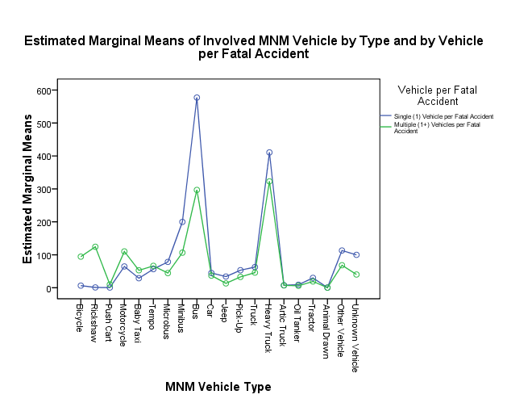
Figure- 4.8a: By ‘Vehicle per Accident’ Figure-4.8b: By ‘Road Environment’ (1 Vehicle/accident)
Figure- 4.8c: By ‘Road Class’ (1 Vehicle/accident) Figure- 4.8d: By ‘Collision Type (1 Vehicle/accident)
Figure-4.8e: By ‘Road Environment’(1+Vehicle/accident) Figure-4.8f: By ‘Road Class’(1+Vehicle/accident)
Figure- 4.8g: By ‘Collision Type’ (1+ Vehicle/accident)
Figure-4.9: Estimated marginal means of involved vehicles by type and by location

It has been found that there are significant differences of involved motorised or non-motorised vehicles including by type and by road environment, road class and collision type for single (1) and multiple (1+) vehicle(s) per accident.
The involvement of vehicles with fatal accidents may vary for type of vehicle manufacturer, valid fitness certificate, insurance cover (third party, comprehensive), vehicle type (motorised, non-motorised), vehicle manoeuvre (left turn, right turn, ‘u’ turn, crossing road, overtaking, going ahead, reversing, sudden start, sudden stop, parked, other), vehicle loading (legal, illegal/unsafe), vehicle defect (none, lights, brakes, steering, tyres, multiple, other) and vehicle damage ( none, front, rear, right, left, roof, multiple, other).
This chapter is concluded at next section (4.9).

Section- 4.9
Conclusion

This chapter can be concluded as follows:
- Rates of KSI casualties are higher in cities than in non-cities with significant variations.

- With statistically significant variations, the higher rate of fatalities is with pedestrian comparing with other users. Most affected ages are unknown and known ages are 6-10 and 21-40 for all road user; 6-10 and 46-75 for pedestrian; 21-50 for passenger; 21-45 for driver; 21-50 for motorcyclist by age. The males of all road users/ pedestrians/ passengers are about 2.5 times more than female. By age and gender, the males of pedestrians/ passengers are more than the females with any ages. Alcohol suspected drivers are more than alcohol not suspected. Helmet worn motorcyclists are less than helmet not worn. Youth drivers suspected alcohol drinking; youth motorcyclists helmet not worn have higher rates.

- KSI/ fatal accident rates by location have significant variations. In cities, these are greater than that of non-cities (divisions and districts). At urban locality, accident rates are higher than that of rural. At national highways, these are higher among other roads.

- Having significant differences of fatal accident rates; the ‘hit pedestrian’ contains larger and higher than any. At urban locality, these are greater than that of rural. At national highways, these are higher among others. These by divisions or districts are smaller than that by cities.

- Having significant differences of fatal accident rates; ‘Tee’ junction contains larger and higher than any junction. At urban locality, these are greater than that of rural. National highways, these are higher than others. These by divisions or districts are less than that by cities.

- With significant variations, morning has higher and late-night has lower numbers of fatal accident. Sundays, Fridays and Thursdays have higher numbers of fatal accident. January, March, April, May and December have higher numbers of fatal accidents. Urban has always higher fatal accident rates than that of rural road environments; and national highways have always greater fatal accidents than any other roads on any time or day or month.

- With significant variations, national highway link as ‘Dinajpur-Beldanga’, ‘Dasuria-Natore’ have higher fatal accident rates.

- With significant differences, motorised vehicles are having higher involvement than non-motorised vehicles in single vehicle per accident. National highways are having the highest number of vehicle involvement. ‘Hit pedestrian’ by bus, heavy truck, minibus and minibus, is having highest. Non-motorised vehicles are involved largely by collision type of motorised vehicles in multiple vehicles per fatal accident. Urban localities have more involvements than that for rural. National highways and city roads have the largest vehicles’ involvement. ‘Head on’ by bus, heavy truck, rickshaw, minibus and minibus, is having highest.

Two-way and three-way classified data are modelled at next chapter (5).

The rates of all dependent variables are computed per 10,000 of the population. Data were not available to compute case specific rates.
The frequencies are considered for all dependent variables.

