C: APPENDIX FOR FORMS/ MAPS

C₁: Accident Reporting Form
Figure- C₁: Accident Reporting Form
C₂: Map of Bangladesh with six Divisions
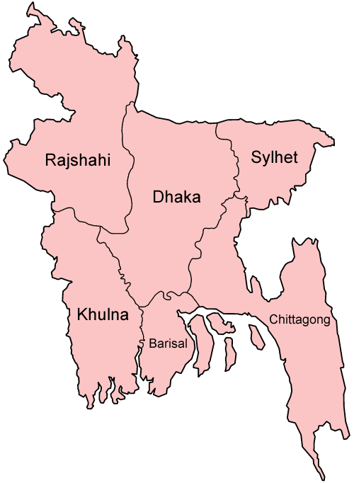
Figure- C₂: Map of Bangladesh with six Divisions
Source: http://upload.wikimedia.org/wikipedia/commons/3/3f/Bangladesh_divisions_english.png (17/06/2009)

C₃: Map of Bangladesh with sixty four districts
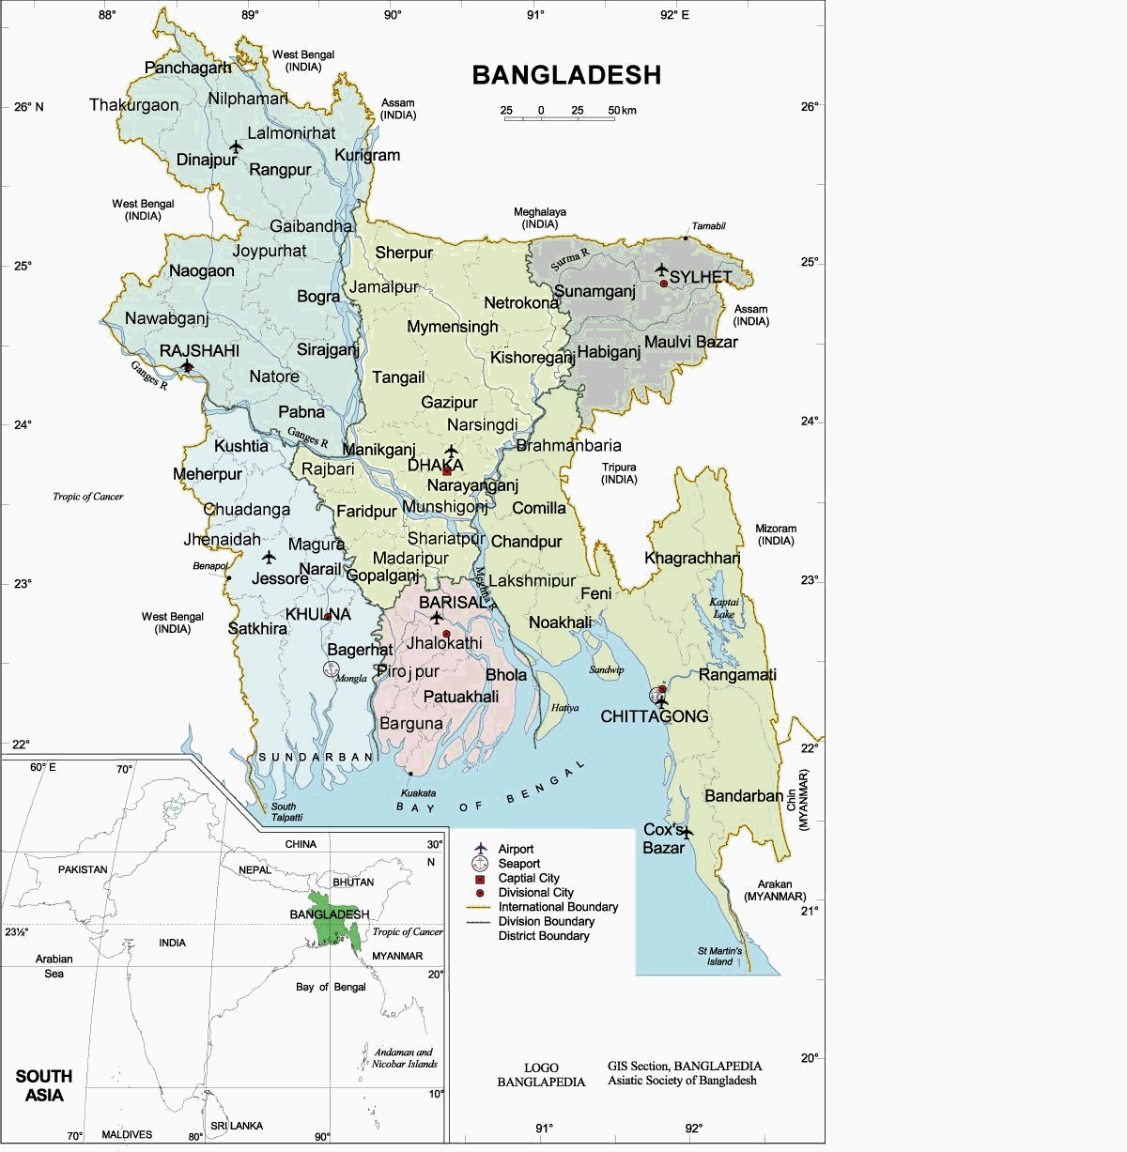
Figure- C₃: Map of Bangladesh with sixty four districts

C₄: Map of Bangladesh
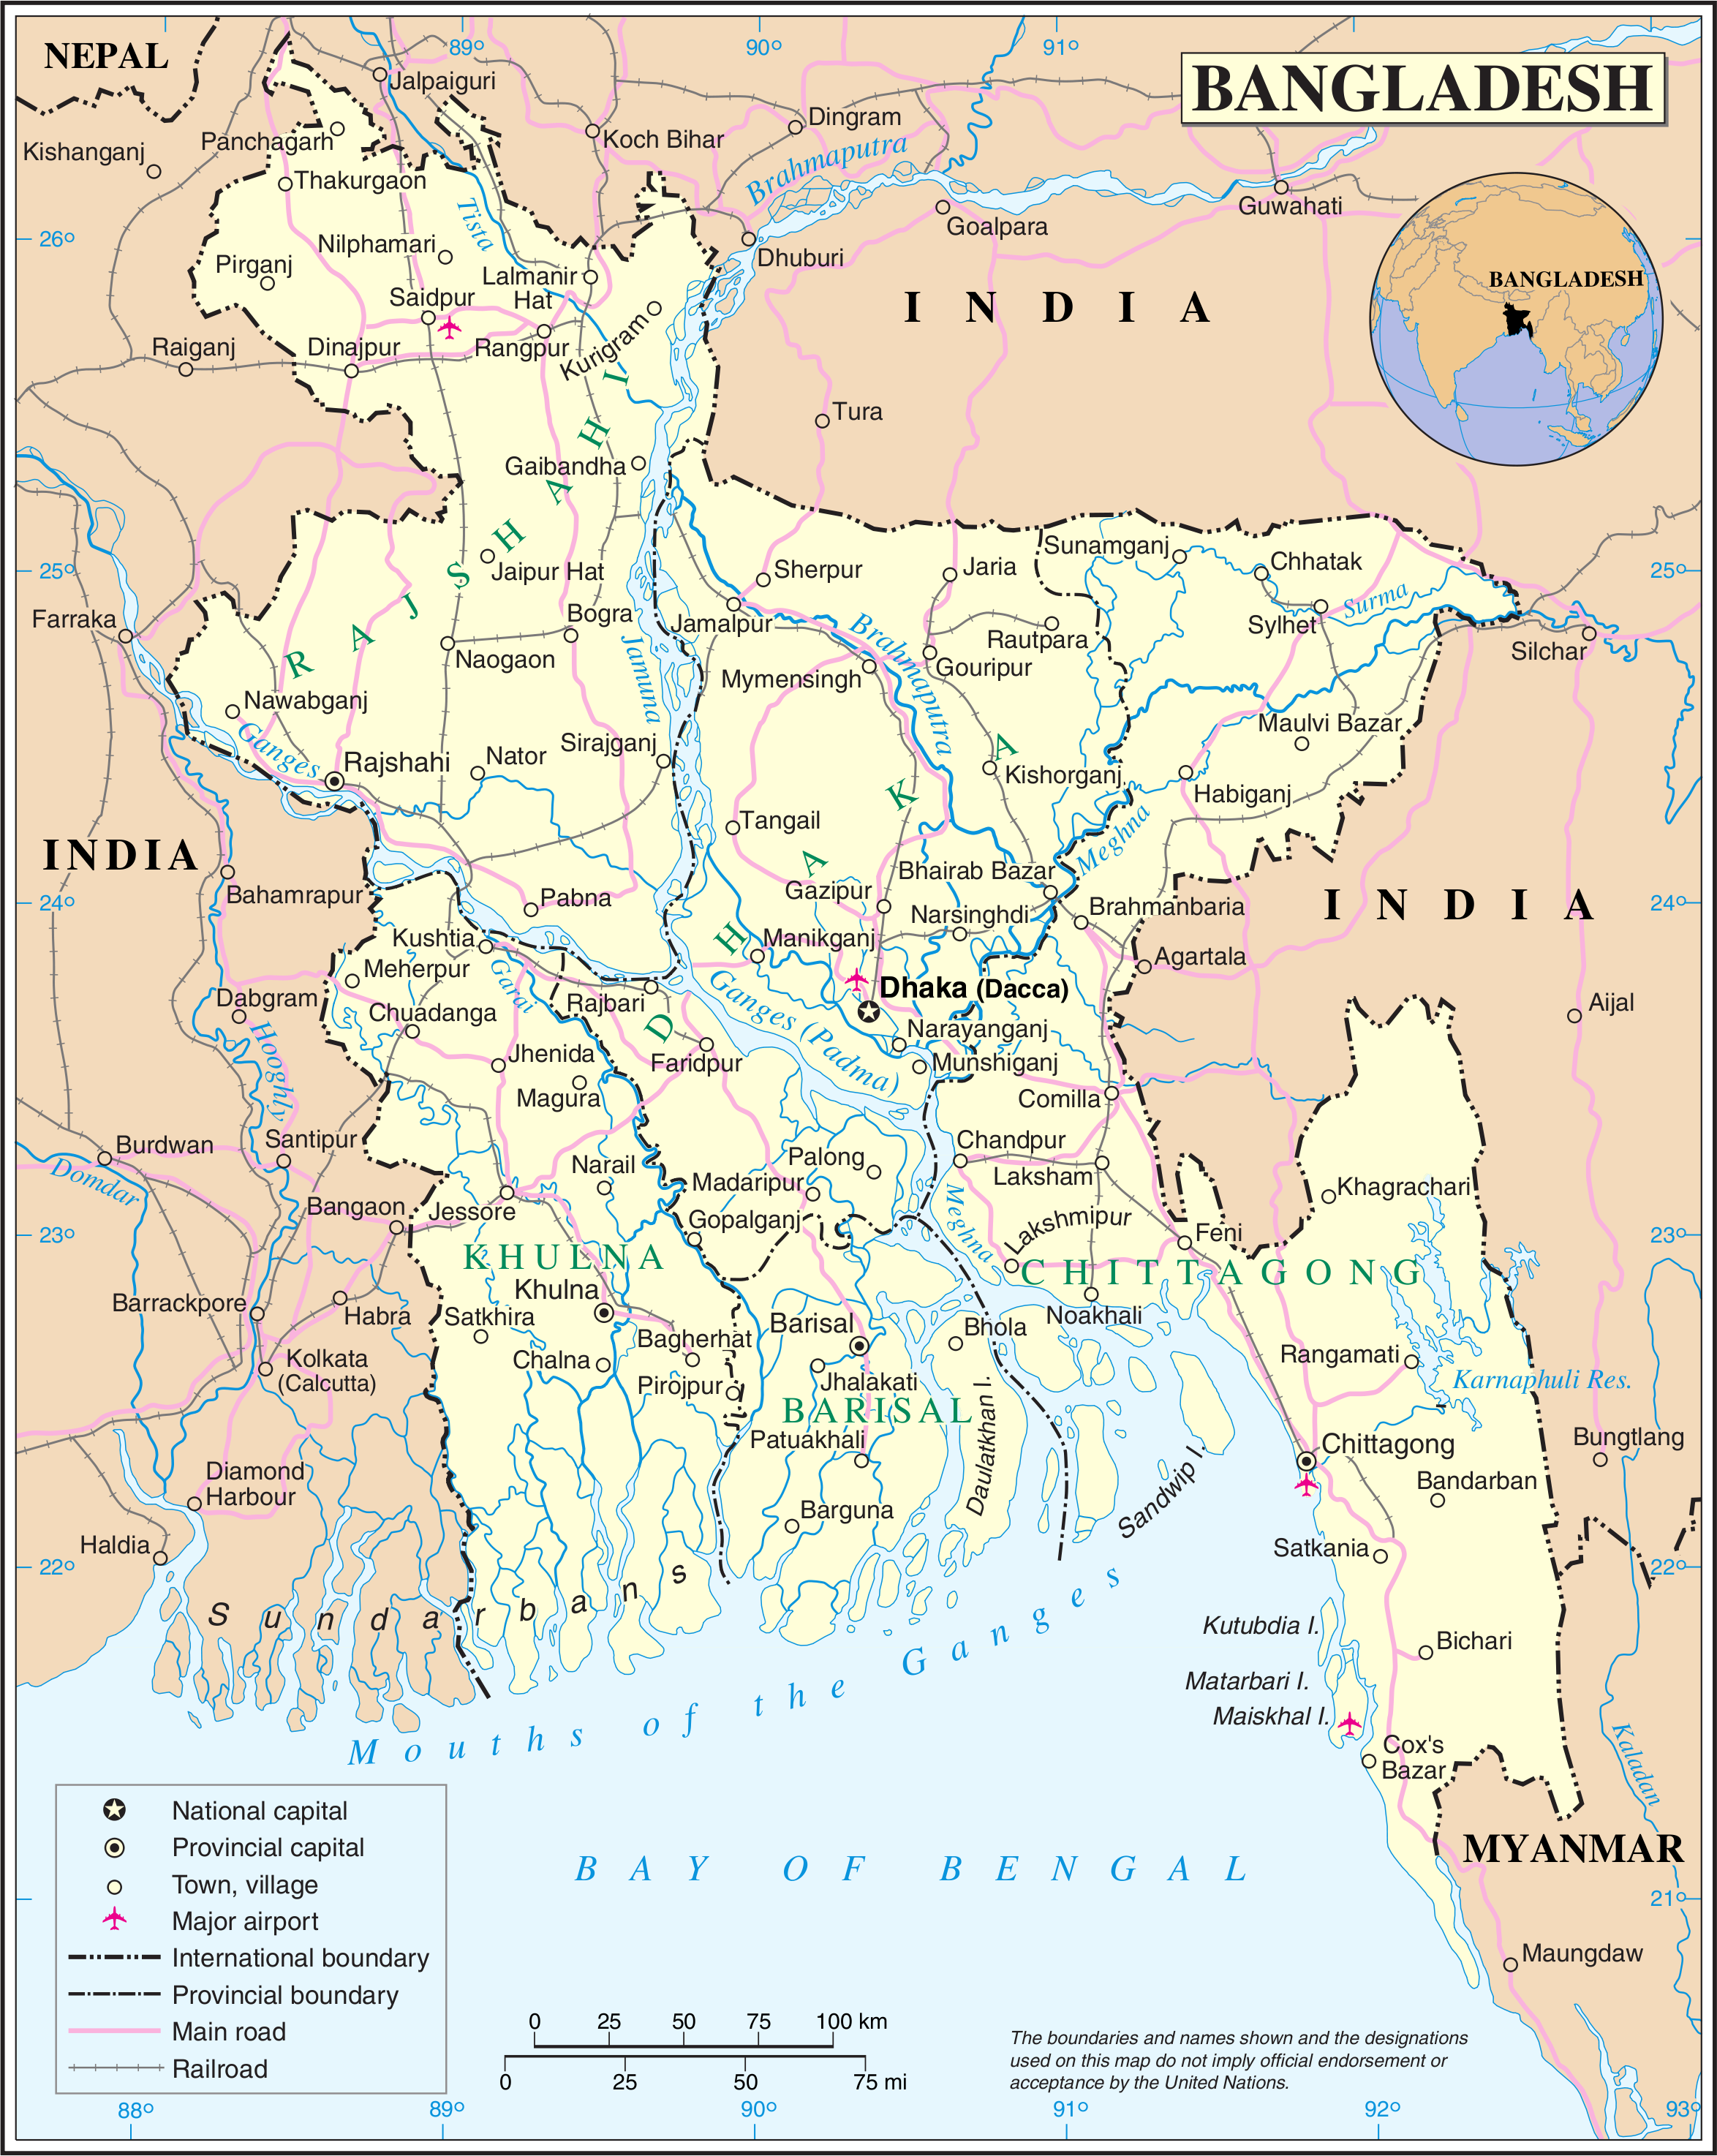
Figure- C₄: Map of Bangladesh
(Source: http://mapsof.net/Bangladesh/static-maps/png/un-bangladesh; Retrieved on 17/06/2009)

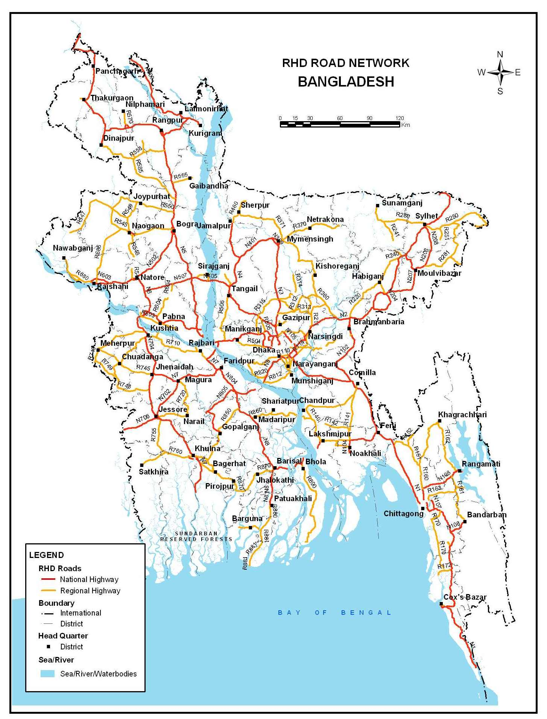
C₅: Map of Bangladesh with Road Networks and 64 Districts

Figure- C₅: Map of Bangladesh with Road Networks and 64 Districts
(Source: Source: BRTA, RTA Annual Report- 2007)

