Napier University
EDINBURGH

Investigating the frequency of senescent T lymphocytes with ageing, exercise and obesity

Cormac Cosgrove

Doctorate of Philosophy

December 2008

In partial fulfilment of the requirements for the degree of doctorate of philosophy

Abstract

Cellular senescence is a state of permanent cell cycle arrest in which a cell is unable to further divide in response to normal growth stimuli. Telomere shortening, believed to be a mechanism of cellular senescence, is a result of numerous rounds of cell division and can be accelerated by heightened levels of oxidative stress. An accumulation of senescent T lymphocytes in blood and tissues has been suggested to contribute to the general immunosuppression seen in the elderly. Obese individuals and athletes taking part in regular high intensity exercise are subjected to heightened states of oxidative stress which appears to result in immunosuppression and increased susceptibility to infection. It was hypothesised that there would be an accumulation of senescent T lymphocytes with ageing, with obesity and during six months training for an Iron man competition.

Senescent CD4+ and CD8+ T peripheral blood lymphocytes were identified by 4 colour flow cytometry, based on their cell surface expression of CD57, the killer cell lectin-like receptor G1 (KLRG1) and the lack of cell surface expression of CD28. Where telomere length measurements were performed, CD4+ and CD8+ T lymphocyte subsets were isolated and telomere lengths were compared to the proportions of KLRG1+, CD57+ and CD28+ cells in each subset.

Older subjects and obese subjects had significantly larger proportions of senescent cells (KLRG1+/CD57+) in the CD8+ but not the CD4+ peripheral blood T lymphocyte subset. Furthermore, during six months training for an Iron Man competition, compared to the first month, club level athletes showed a 92% increase in the frequency of senescent cells (KLRG1+/CD57+) in the CD4+ but not the CD8+ T lymphocyte subset. Telomere length was negatively correlated with the proportion of KLRG1+ and CD57+ cells and positively correlated with the proportion of CD28+ cells in the CD4+ but not the CD8+ T lymphocyte subset.

It is concluded from this work that KLRG1+/CD57+ senescent T lymphocytes accumulate with age, obesity and regular high intensity training, which may contribute to the increased immunosuppression associated with these states.

Acknowledgements

My supervisors Dr. Keith Guy and Dr. Richard Simpson for their endless help and advice over the past three years. They were always available when required, and hopefully they understand just how much I value their efforts and talents.

Dr. Geraint Florida-James for his supervisory input early in my PhD, and his continued interest thereafter.

My Mum and Dad, whose endless support, understanding, patience, strength and love are the basis for every success I have. I couldn’t ask for better parents.

My sisters Noeleen and Paula, and my brother Garvan, whose love helps in everything I do, even though they may not realise it.

My best friends Keith Hodgson, Danny Hoyle, Sam Lord and Keith Alison, who push me in every aspect of life. I am a better person for their friendship.

My friends and colleagues in the PhD offices and the lab, who provided a lot of laughs and help throughout the last three years.

Dr. Sandra Bonellie, whose constant availability to provide statistical aid was much appreciated and instrumental in managing my stress levels during my write up.

My collaborators at Stirling University; Dr. Stuart Galloway, Khalid Al-Jaloud and Craig Neal for recruiting subjects and collecting blood samples for Chapters 6 and 7.

Dr. Brian McFarlin for his hospitality, generosity and help during my trip to the University of Houston and thereafter, especially concerning his help with the statistical analysis of the data in Chapter 6.

Dr. Paul Shiels of Glasgow University who provided the telomere length analyses and a lot of help and input for Chapter 8.

The members of the Biomedical and Sports Science Research Group at Napier University for their support and ideas throughout the past three years.

All the subjects who volunteered to participate in my studies. Without their generous aid, this thesis would not have been possible.
Contents

Section Page

1. Chapter One: Introduction and literature review 1

1.1. Replicative senescence 2
1.1.1. Telomere dependent senescence 3
1.1.2. Oxidative stress and telomere dependent senescence 4
1.1.3. Oxidative stress and telomere independent senescence 5

1.2. The immune response 6
1.2.1. CD antigens 7
1.2.2. The adaptive immune response 7
1.2.2.1. T cells 7
1.2.2.2. Circulation of naive T cells 8
1.2.2.3. T cell activation 10
1.2.2.4. Clonal expansion: The T cell response to infection 11
1.2.2.5. T lymphocyte cell surface phenotype 12
1.2.3. The role of Natural Killer Cells 13
1.2.3.1. NK cell killing 14
1.2.3.2. The Killer Cell Lectin-like Receptor G1 14
1.2.3.3. Cadherins as the natural ligand for KLRG1 15

1.3. Immunosenescence 16
1.3.1. Cell surface phenotypes of T cell senescence 18
1.3.2. Ageing and immunosenescence 21
1.3.3. Oxidative stress and immunosenescence 22
1.3.4. Obesity and immunosenescence 23

1.4. Exercise and the immune system 26
1.4.1. Regular high-intensity training and immune dysfunction 27
1.4.1.1. Cross sectional studies 27
1.4.1.2. Longitudinal studies 28
1.4.2. Acute exercise 29
Section Page

Chapter One (Continued)

1.4.3. Regular Moderate exercise and immunosenescence 31

1.5. Summary 32

2. Chapter Two: General materials and methods 34

2.1. Peripheral blood and organ collection 35
2.1.1. Human subjects 35
2.1.2. Mice 35
2.2. Mononuclear cell isolation 35
2.2.1. Peripheral blood 35
2.2.2. Animal spleens 36
2.3. Cell staining for flow cytometric analysis 36
2.3.1. Gated lymphocyte population purity 37
2.4. Effects of storing peripheral blood overnight at room
temperature on the proportions of T lymphocyte populations 40
2.5. Flow Cytometry 42
2.5.1. Flow cytometers 42
2.5.2. Flow cytometry gating procedures 42
2.6. Lymphocyte subset enrichments from whole blood 45
2.7. Cell storage in liquid nitrogen 45
2.8 Telomere length analysis 46
2.8.1. Sample Preparation 46
2.8.2. Plate Construction 47
2.8.3. Running the Plates 47
2.8.4. Analysing the Output 48
2.9. Statistical analysis 49
2.9.1. T-tests 49
2.9.2. Correlations 49

Section Page

3. Chapter Three:
“The use of total lymphocyte CD8+ or CD8^{bright} populations as a
single antigenic marker to identify the CD8+ T lymphocyte subset” 50

3.1. Introduction 51

3.2. Materials and Methods 53
3.2.1. Subjects 53
3.2.3. Antibodies 53
3.2.4. Statistics 53

3.3. Results 54

3.4. Discussion 59

4. Chapter Four:
“The frequency and diversity of markers of senescence on
peripheral blood lymphocytes in healthy human subjects” 61

4.1. Introduction 62

4.2. Materials and Methods 64
4.2.1. Subjects for normative data study 64
4.2.2. Subjects for correlation study 64
4.2.3. Antibodies 64
4.2.4. Statistics 64

4.3. Results 65
4.3.1. Normative data study 65
4.3.1.1. Frequency of cell surface markers in lymphocyte subsets 65
4.3.1.2. Diversity in the frequency of cell surface markers in lymphocyte
Subsets 68
Section Page

4. Chapter 4 (continued)

4.3.2. Correlations of the frequency of cell surface senescence markers
and age 71

4.4. Discussion 75
4.4.1. The frequency of cell surface markers of senescent lymphocytes 75

4.4.2. Diversity in the frequency of lymphocytes expressing cell surface
markers of senescence 78
4.4.3. Correlations between the frequency of lymphocytes expressing
cell surface markers of senescence and age 79

5. Chapter Five:

“The co-expression of KLRG1 with CD28, CD57, CD45RA and

CD45RO on peripheral blood T lymphocyte subsets in younger

and older adults” 81

5.1. Introduction 72

5.2. Materials and Methods 85
5.2.1. Subjects 85
5.2.2. Antibodies 85
5.2.3. Statistics 85

5.3. Results 86
5.3.1. Frequency of T lymphocytes expressing cell surface markers
of senescence markers in younger and older subject groups 86
5.3.2. The frequency of cells co-expressing KLRG1 with CD57,
CD28, CD45RA and CD45RO on T lymphocyte subsets in older
and younger subject groups 91

5.4. Discussion 96
Section Page

5. Chapter 5 (continued)

5.4.1. KLRG1 co expression with CD57 and CD28 96
5.4.2. KLRG1 co expression with CD45RA and CD45RO 98

6. Chapter Six:
“Changes in the frequency of senescent blood T-cells in
triathletes during six months training preparation for an Iron man competition” 101

6.1. Introduction 102

6.2. Materials and methods 105
6.2.1. Subjects 105
6.2.2. Antibodies 105
6.2.3. Statistical analysis 105

6.2. Results 107
6.2.1. Frequency of cell surface subset markers in the total lymphocyte
and the CD3+ lymphocyte populations during the six months
training. 107
6.3.2. Changes in the frequency of senescence, naïve and
memory cell markers on T cell subsets 108
6.3.3. Changes in the frequency of the co-expression of
the senescence markers in the lymphocyte subsets during
the six months training 109

6.3.4. Changes in the frequency of CD4+ and CD8+ T lymphocytes

co-expressing the naïve and memory cell markers, CD45RA and CD45RO 114

6.4. Discussion 116

Section Page

6. Chapter 6 (continued)

6.4.1. Changes in the frequency of KLRG1+, CD57+ and CD28+ T
lymphocytes 116
6.4.2. Changes in the frequency of CD45RA+ and CD45RO+ T
lymphocytes 118

7. Chapter Seven:

“The frequency of peripheral blood senescent T lymphocytes in

obesity” 121

7.1. Introduction 122

7.2. Materials and methods 126
7.2.1. Human Subjects 126
7.2.2. Animals 126
7.2.2.1. Rearing and care of animals 126
7.2.2.2. Organ and peripheral blood collection 127
7.2.3. Mononuclear cell isolation and staining with monoclonal antibodies 127
7.2.3.1. Animals 127
7.2.3.2. Human subjects 127
7.2.4. Statistical analysis 128

7.3. Results 129
7.3.1. Human Study 129

7.3.2. Mouse study 138

7.4. Discussion 141
7.4.1. Human study 141
7.4.2. Mouse studies 143

Section Page

8. Chapter Eight:

“The relationship between cell surface markers of senescence and telomere length in peripheral blood lymphocyte subsets” 146

8.1. Introduction 147

8.2. Materials and methods 150
8.2.1. Subjects 150
8.2.2. Mononuclear cell isolation and staining with monoclonal antibodies 150
8.2.3. T cell and T cell subset enrichment 150

8.2.2.2. T cell and T cell subset enrichment cocktails 151
8.2.4. Cell storage for telomere length analysis 151
8.2.5 Telomere length analysis 151
8.2.6. Statistical analysis 151

8.3. Results 152
8.3.1. Purity of the enriched fractions 152
8.3.2. Loss of cells as a result of the enrichment process 154
8.3.2.1. The enrichment process leads to a preferential loss of CD8+
T cells and T cells expressing cell surface markers of
senescence 154
8.3.2.2. The enrichment process results in the preferential loss
of T cells expressing cell surface markers of senescence in both
the CD4+ and CD8+ T cell subsets 154
8.3.2.3. The enrichment process results in the preferential loss of
KLRG1+ cells from all cell types investigated 156
8.3.3. Correlations between subject age and telomere lengths in T
lymphocyte subsets 158
8.3.4. Correlations between the proportion of T lymphocyte subsets
expressing cell surface markers of senescence and mTRF in the
enriched fractions. 158

8.3.5. Frequency of senescence markers in the T cell subsets of

pre- and post-enrichment fractions 167
Section Page

8. Chapter Eight (Continued)

8.3.6. Individual breakdown of telomere length data 169

8.4. Discussion 172
8.4.1. Preferential loss of KLRG1+ cells due to the enrichment process 172
8.4.2. Relationship between mTRF and cell surface markers of
senescence in CD4+ and CD8+ T cell subset populations 173
8.4.3. Comparison of the mTRFs of the CD3+, CD4+ and CD8+ T
lymphocyte subsets 177

9. Chapter 9: General Discussion 179

9.1. Aims of the project 180

9.2. Cell surface phenoytyping of senescent T lymphocyte subsets 181

9.3. Ageing 185

9.4. Exercise 186

9.5. Obesity 186

9.6. Telomeres 187

9.7. Diversity of cell surface markers of expression 189

9.10. Future work 191

9.11. Limitations of flow cytometry 192

9.12. Clinical implications 193

References 194

Appendices 231
Appendix 1. Table of CD antigens; their expression, function and
alternative designations. 231
Appendix 2. IMag Buffer solution 233
Appendix 3. Standard Curve Construction 234
Appendix 4. TrisEDTA Buffer 235
Appendix 5. Master Mix table 236

Publications 237
Figures and Tables

Section Page

1. Chapter One:
“Introduction and literature review”

Figure 1.1. T lymphocyte development 9

2. Chapter Two:
“General Materials and Methods”

Figure 2.1. Whole blood carefully layered onto Lymphoprep, by
pipetting, was centrifuged for 25 minutes at 800g depositing
a cloudy layer of peripheral blood mononuclear cells at the
Lymphoprep-plasma interface. 36

Table 2.1. The isotype, clone, format, target species and supplier of
all the antibodies used in this thesis 38

Figure 2.2. The frequency of CD4+, CD8+, KLRG1+, CD57+ and
CD28+ cells in the CD3+ lymphocyte subset and the
Frequency of KLRG1+, CD57+ and CD28+ cells
in the CD3+/CD4+ and CD3+/CD8+ lymphocyte
subsets from peripheral blood samples analysed on the
day of blood collection (day 1) and left overnight and
analysed the next day (day 2). 41

Figure 2.3. An electronic gating sequence was used for T lymphocyte
subset cell surface analysis. 44

Figure 2.4. Telomere melting curve analysis 48

Section Page

3. Chapter Three
“The use of total lymphocyte CD8+ or CD8^{bright} populations as a single antigenic marker to identify the CD8+ T lymphocyte subset”

Table 3.1. The proportions of the total lymphocyte population and
the CD8+ lymphocyte subset population expressing the cell
surface markers of interest. 55

Figure 3.1. The proportion of CD3+, CD4+, CD8+, CD3+/CD4+,
CD3+/CD8+ and CD3-/CD8+ cells in the total lymphocyte
population. 56

Figure 3.2. Representative flow cytometric histogram showing
the CD8+, CD8^{bright} and CD8^{dim} subsets of the total
lymphocyte population. 57

Figure 3.3. Representative flow cytometric dot plot showing the
CD3+/CD8^{bright}, CD3+/CD8^{dim} and CD3-CD8+ cells
in the total lymphocyte population. 57

Figure 3.4. The proportions of CD8+ and CD3+/CD8+ cells,
CD8^{bright} and CD3+/CD8+ cells and CD8^{dim} and
CD3+/CD8^{dim} cells in the total lymphocyte population. 58

4. Chapter Four:
“The frequency and diversity of markers of senescence on peripheral blood lymphocytes in healthy human subjects”

Table 4.1. The expression of lymphocyte subset markers
and senescence markers on all lymphocytes, CD3+
lymphocytes and CD3- lymphocytes. 65

Section Page

4. Chapter Four (Continued)

Figure 4.1. The frequency of peripheral blood CD3+/CD4+, CD3+/CD8+
and CD3-/CD56+ lymphocytes expressing the Killer cell
lectin-like receptor G1 (KLRG1), CD57, CD28,
CD45RA, CD45RO and CD62L in a young, healthy,
male population. 66

Figure 4.2. Representative single parameter flow cytometric
histograms showing the frequency of KLRG1, CD57,
CD28+, CD45RA+, CD45RO+ and CD62L+ cells in the
CD3+, CD3+/CD4+ and CD3+/CD8+ lymphocyte subsets. 67

Figure 4.3. Representative flow cytometric histograms showing the
frequency of KLRG1+, CD57+, CD28+, CD45RA+, CD45RO+
and CD62L+ cells in the CD3-/CD56+ lymphocyte
subset in a young, healthy, male subjects. 68
Figure 4.4. Scatter graphs showing the diversity in the frequency
of KLRG1+ CD57+, CD28+, CD45RA+, CD45RO+ and
CD62L+ cells in the CD3+/CD4+, CD3+/CD8+ and
CD3-/CD56+ lymphocyte subsets of young, healthy,
male subjects 70
Table 4.2. Correlations within the frequency of peripheral blood
senescence markers, and with age, on CD3+/CD4+
and CD3+/CD8+ peripheral blood lymphocytes 72

Section Page

4. Chapter Four (Continued)

Figure 4.5. Scatter graphs showing the relationship between the
frequency of KLRG1+ and CD57+ cells, KLRG1+ and
CD28+ cells and CD57+ and CD28+ cells on the
CD3+/CD8+ lymphocyte subset, and KLRG1+ and
CD45RA+ cells on the CD3+/CD4+ lymphocyte subset. 73

Figure 4.6. Scatter graphs showing the significant correlations between
the frequency of KLRG1+, CD57+, CD28+,
CD45RA+ and CD45RO+ cells in the CD3+/CD4+
and CD3+/CD8+ lymphocyte subsets and subject
age, in a diverse population of healthy, lean, male subjects. 74

5. Chapter 5:

“The co-expression of KLRG1 with CD28, CD57, CD45RA and CD45RO on peripheral blood T lymphocyte subsets in younger and older adults”

Table 5.1. The frequency of senescence, memory and naïve markers
on the peripheral blood lymphocytes from younger and
older subject groups. 86

Figure 5.1. The frequency of KLRG1+, CD57+, CD28+, CD45RA+
and CD45RO+ cells in the CD3+/CD4+ and
CD3+/CD8+ lymphocyte subsets of younger and older
subjects. 88

Figure 5.2. Representative flow cytometric histograms showing the
frequency of KLRG1+, CD57+, CD28+, CD45RA+ and
CD45RO+ cells in the CD3+/CD4+ peripheral blood
lymphocyte subset of younger and older subjects. 89

Section Page

5. Chapter Five (Continued)

Figure 5.3. Representative flow cytometric histograms showing the
distribution of KLRG1+, CD57+, CD28+, CD45RA+ and
CD45RO+ cells in the CD3+/CD8+ lymphocyte subsets
of younger and older subjects. 90

Figure 5.4. The frequency of cells co-expressing KLRG1 with CD57,
CD28, CD45RA and CD45RO in the CD3+/CD4+
lymphocyte population of younger and older subjects. 92

Figure 5.5. Representative two parameter flow cytometer dot plots
showing the distribution of cells co-expressing KLRG1 with
CD57, CD28, CD45RA and CD45RO in the CD3+/CD4+ T lymphocyte subset of younger and older subjects. 93

Figure 5.6. The frequency of cells co-expressing KLRG1 with CD57,
CD28, CD45RA and CD45RO in the CD3+/CD8+ peripheral
blood lymphocyte subsets of younger and older subjects. 94

Figure 5.7. Representative two parameter flow cytometry dot plots
showing distribution of cells co-expressing KLRG1 with
CD57, CD28, CD45RA and CD45RO in the CD3+/CD8+ peripheral blood lymphocyte subsets of younger and older subjects. 95

6. Chapter Six:
“Changes in the frequency of senescent blood T-cells in triathletes during six months training preparation for an Iron man competition”

Table 6.1. Testing dates for Iron man athletes. 105

Section Page

6. Chapter Six (Continued)

Table 6.2. Frequency of CD3+, CD4+ and CD8+ cells in the total
lymphocyte population and KLRG1+, CD57+, CD28+,
CD45RA+ and CD45RO+ cells in the T lymphocyte subset
of peripheral blood samples taken monthly from subjects
training for an iron man competition 108

Figure 6.1. Changes in the frequency of KLRG1+, CD57+ and CD28+
cells in the CD3+/CD4+ and CD3+/CD8+ lymphocyte
subsets during six months training preparation for an iron
man. 110

Figure 6.2. Changes in the frequency of CD45RA+ AND CD45RO+
cells in the CD3+/CD4+ and CD3+/CD8+ lymphocyte
subsets during six months training preparation for an
iron man. 111

Figure 6.3. Changes in the frequency of KLRG1+/CD57+, KLRG1+/CD57-, KLRG1-/CD57+ cells in the CD3+/CD4+ and CD3+/CD8+ lymphocyte subsets during six months training preparation
for an iron man. 112

Figure 6.4. Changes in the frequency of KLRG1+/CD28+, KLRG1+/CD28-, KLRG1-/CD28+ cells in the CD3+/CD4+ and CD3+/CD8+ lymphocyte subsets during six months training preparation
for an iron man. 113

Figure 6.5. Changes in the frequency of CD45RA+/CD45RO+, CD45RA+/CD45RO-, CD45RA-/CD45RO+ cells in the CD3+/CD4+ and CD3+/CD8+ lymphocyte subsets during
six months training preparation for an iron man. 115

Section Page

7. Chapter Seven:

“The frequency of peripheral blood senescent T lymphocytes in obesity”

Table 7.1. The age, BMI and % body fat of the lean and obese
subjects. 126

Figure 7.1. The weights of the lean and obese mice on the day of
sacrifice. 127

Table 7.2. The frequency of senescence, memory and naïve markers
on peripheral blood lymphocytes from lean and obese human subject groups. 129

Figure 7.2. The frequency of the Killer Lectin-like Receptor G1+
(KLRG1), CD57+, CD28+, CD45RA+ and CD45RO+ cells
in the CD3+/CD4+ and CD3+/CD8+ lymphocyte
subsets in obese and lean human subject groups. 130
Figure 7.3. Representative flow cytometric histograms showing the
frequency of KLRG1+, CD57+, CD28+, CD45RA+ and
CD45RO+ cells in the CD3+/CD4+ peripheral blood
lymphocyte subset of lean and obese human subjects. 131

Figure 7.4. Representative flow cytometry histograms showing the
frequency of KLRG1+, CD57+, CD28+, CD45RA+ and
CD45RO+ cells in the CD3+/CD8+ peripheral blood
lymphocyte subset of lean and obese human subjects. 132

Figure 7.5. The frequency of cells co-expressing KLRG1 with CD57,
CD28, CD45RA and CD45RO in the CD3+/CD4+ peripheral
blood lymphocyte subsets of lean and obese human
subjects. 133
Section Page

7. Chapter Seven (Continued)

Figure 7.6. Representative two parameter flow cytometer dot plots
showing the distribution of cells co-expressing KLRG1
with CD57, CD28, CD45RA and CD45RO in the
CD3+/CD4+ T lymphocyte subset of lean and obese
human subjects. 134

Figure 7.7. Frequency of cells co-expressing KLRG1 with CD57,
CD28, CD45RA and CD45RO in the CD3+/CD8+
peripheral blood lymphocyte subset of lean and obese
human subjects. 136

Figure 7.8. Representative two parameter flow cytometer dot plots
showing the distribution of cells co-expressing KLRG1
with CD57, CD28, CD45RA and CD45RO in the
CD3+/CD8+ T lymphocyte subset of lean and obese
human subjects. 137

Table 7.3. The frequency of CD4+, CD8+, KLRG1+ and CD28+
cells in the CD3+ peripheral blood lymphocyte and
splenocyte subsets of lean and obese mice. 138

Figure 7.9. The frequency of KLRG1+ and CD28+ cells in the
CD3+/CD4+ and CD3+/CD8+ splenocyte subsets of lean
and obese 14 month old male CD-1 mice. 139

Figure 7.10. The frequency of KLRG1+ and CD28+ cells in the
CD3+/CD4+ and CD3+/CD8+ peripheral blood lymphocytes
of lean and obese 14 month old male CD-1 mice. 140

Section Page

8. Chapter Eight:

“The relationship between cell surface markers of senescence and telomere length in peripheral blood lymphocyte subsets”

Table 8.1. The frequency of senescence, memory and naïve markers
on peripheral blood lymphocytes from human subjects. 152

Figure 8.1. The purity of the T cell enriched, CD4+ T cell enriched and
CD8+ T cell enriched fractions as indicated by the frequency
of CD3+, CD4+, CD8+, CD14+, CD16+ and CD19+ cells
in each fraction. 153

Figure 8.2. The frequency of CD4+, CD8+, KLRG1+, CD57+ and
CD28+ cells in the CD3+ populations of the peripheral
blood mononuclear cell (PBMC) and T cell enriched
fraction from human subjects. 154

Figure 8.3. The frequency of KLRG1+, CD57+ and CD28 + cells in
the CD3+/CD4+ and CD3+/CD8+ subsets from the PBMC,
T cell enriched and T cell subset enriched fractions of
human subjects. 155

Figure 8.4. The distribution of cells co-expressing KLRG1 and CD57 or
CD28 in the CD3+/CD4+ lymphocyte subsets of the PBMC,
T cell-enriched and CD4+ T cell-enriched fractions of
human subjects. 156

Figure 8.5. The distribution of cells co-expressing KLRG1 and CD57 or
CD28 in the CD3+/CD8+ lymphocyte subsets of the PBMC,
T cell-enriched and CD8+ T cell-enriched fractions of
human subjects. 158

Section Page

8. Chapter Eight (Continued)

Figure 8.6. Scatter plots showing the relationship between subject
age and mTRF in the CD3+, CD4+ and CD8+ T
cell-enriched fractions. 161

Figure 8.7. Scatter plots showing the between mTRF (kbps) and the
proportion of KLRG1+, CD57+ and CD28+ cells in the
CD3+ lymphocyte subset of the T cell-enriched fraction of
PBMCs from human subjects. 162

Figure 8.8. Scatter plots showing the between mTRF (kbps) and the
proportion of KLRG1+, CD57+ and CD28+ cells in the CD3+/CD4+ lymphocyte subset of the CD4+ T
cell-enriched fraction of PBMCs from human subjects. 163

Figure 8.9. Scatter plots showing correlations between mTRF (kbps)
and the proportion of KLRG1+, CD57+, and CD28+ cells in
the CD3+/CD8+ lymphocyte subset of the CD8+ T
cell-enriched fraction of PBMCs from human subjects. 164

Figure 8.10. Scatter plots showing correlations between mTRF (kbps)
and the proportion of KLRG1+/CD57+, KLRG1+/CD57-,
KLRG1-/CD57+, KLRG1+/CD28+, KLRG1+/CD28- and
KLRG1-/CD28+ cells in the CD3+/CD4+ lymphocyte subset
of the CD4+ T cell-enriched fraction of PBMCs from human subjects. 165

Section Page

8. Chapter Eight (Continued)

Figure 8.11. Scatter plots showing correlations between mTRF (kbps)
and the proportion of KLRG1+/CD57+, KLRG1+/CD57-,
KLRG1-/CD57+, KLRG1+/CD28+, KLRG1+/CD28- and
KLRG1-/CD28+ cells in the CD3+/CD8+ lymphocyte subset
of the CD8+ T cell-enriched fraction of PBMCs from human subjects. 166

Figure 8.12. The mean telomere restriction fragment lengths (mTRFs)
and the proportions of KLRG1+, CD57+ and CD28+ cells
in the CD3+, CD3+/CD4+ and CD3+/CD8+ lymphocyte
subsets of the PBMC, T cell-enriched, CD4+ T
cell-enriched and CD8+ T cell-enriched fractions. 168

Figure 8.13. The mTRFs in the CD3+, CD4+ and CD8+ T
cell-enriched fractions from PBMCs of healthy subjects 170

Abbreviations

- Negative
~ Approximately
+ Positive
< Less than
> More than
± Plus or minus
A Adenine
ADP Adenosine diphosphate
Ag Antigen
APC Allophycocyanin
APC Antigen presenting cell
ARF ADP-ribosylation factor
BD Becton Dickinson
BMI Body mass index
BSA Bovine serum albumin
C Cytosine
CA California
CCR7 C-C motif Receptor 7
CD Cluster of differentiation
CHD Chronic heart disease
CMV Cytomegalovirus
Ct Threshold cycles
CV Cardiovascular
CVD Cardiovascular disease
DEPC Diethylpyrocarbonate
DNA Deoxyribonucleic acid
dNTP Deoxyribonucleotide phosphate
DTT Dithiothreitol
EBV Epstein-Barr Virus
E-Cadherin Epithelial cadherin
EDTA Ethylenediaminetetraacetic acid
FACS Fluorescence-activated cell sorting
FSC Forward Scatter
FITC Fluorescein
FL Fluorescent label
FoxP3 Forkhead box P3
G Guanine
G1 Growth phase 1
GlyCAM Glycosylation dependent cellular adhesion molecule
H₂O Water
H₂O₂ Hydrogen peroxide
HCl Hydrochloric acid
HDF Human diploid fibroblasts
HDL High density lipoprotein
HIV Human immunodeficiency virus
hTERT Human telomerase reverse transcriptase
ICAM Inter-cellular adhesion molecule
IFN Interferon
Ig Immunoglobulin
IL Interleukin
IRP Immune risk phenotype
kbp Kilobase pairs
kg/m² Kilograms per metre-squared
KIR Killer cell immunoglobulin-like receptor
KLR Killer cell lectin-like receptor
KLRG1 Killer cell lectin-like receptor G1
LFA-1 Lymphocyte function-associated antigen-1
LRC Leukocyte receptor complex
M Molar
mAb Monoclonal antibody
Mg Magnesium
mg/ml Milligram per millilitre
MHC Major histocompatibility complex
MHO Metabolically healthy but obese
ml Millilitre
mTRF Mean telomere restriction fragment length
mW Milliwatt
n Number of subjects
N₂ Nitrogen
NaCl Sodium chloride
NaN₃ Sodium Azide
NaOH Sodium Hydroxide
NJ New Jersey
NK Natural killer
NKC NK cell receptor complex
nm Nanometers
PAF Platelet activating factor
PBMC Peripheral blood mononuclear cells
PBS Phosphate buffered Saline
PCR Polymerase chain reaction
PE Phycoerythrin
PE-Cy Phycoerythrin cyanine
PHA phytohemagglutinin
Rb Retinoblastoma protein
ROS Reactive Oxygen Species
ROX 6-Carboxyl-X-Rhodamine
SD Standard deviation or Serial Dilution
SSC Side Scatter
T Thymine
T/S Telomere/Sample ratio
TCR T cell receptor
Th T helper
TNF Tumour Necrosis Factor
Treg Regulatory T cell
TX Texas
UK United Kingdom
UoF University of Freiburg
URTI Upper respiratory tract infection
USA United States of America
α Alpha
β Beta
γ Gamma
μg/ml Microgram per millilitre
List of Publications

The following publications are included in full at the back of this thesis

Original articles

Simpson RJ, Florida-James GD, Cosgrove C, Whyte GP, Macrae S, Pircher H & Guy K. (2007). High-intensity exercise elicits the mobilization of senescent T-lymphocytes into the peripheral blood compartment in human subjects. Journal of Applied Physiology 103 396-401.

Campbell JP, Guy K, Cosgrove C, Florida-James GD, & Simpson RJ. (2007). Total lymphocyte CD8 expression is not a reliable marker of cytotoxic T-cell populations in human peripheral blood following an acute bout of high-intensity exercise. Brain, Behaviour and Immunity 22 375-380.

Simpson RJ, Cosgrove C, Ingram L, Florida-James GD, Whyte GP, Pircher H & Guy K. (2008). Senescent T-lymphocytes are mobilised into the peripheral blood compartment in young and older humans after exhaustive exercise. Brain, Behaviour and Immunity 22 544-551

Abstracts

Cosgrove C, Simpson RJ, Florida-James GD, Whyte GP & Guy K. (2007). KLRG1 and CD57 are expressed on a greater proportion of CD8+ T lymphocytes from older subjects compared to those from younger subjects. Immunology 120 66.

CHAPTER 1

Introduction and literature review

1.1. Replicative senescence

Replicative senescence was first described around 45 years ago when in vitro experiments on cultured primary human diploid fibroblasts (HDF) showed that cells had a limited capacity for replication (Hayflick and Moorhead, 1961). After undergoing a cell-specific number of replications (between 40 and 60 population doublings), a cell undergoes replicative senescence, a state of permanent cell cycle arrest. The number of attainable replications before a cell enters a senescent state has become known as The Hayflick Limit. Hayflick (1965) also reported that cultured cells from older human donors underwent fewer population doublings before becoming senescent. These findings suggested the presence of a “replication counting mechanism” which, by the results of a series of enucleation and fusion experiments on both young and old cultured cells, was shown to be located in the nucleus (Wright and Hayflick, 1975; Muggleton-Harris and Hayflick, 1976; Hayflick, 2003).

The onset of senescence is associated with global transcriptional re-gearing of the arrested cell, leading to a cellular phenotype profoundly different from that of a normal, replicating cell (Bird, Ostler and Faragher, 2003). As well as the inability to divide in response to a mitotic stimulus, senescent cells show distinctive changes in morphology and function compared to normally replicating cells. Senescent endothelial cells and HDFs have been found to show increases in size, incidence of nuclear abnormalities, cellular flattening and vacuolisation (Rosen et al., 1981; Faragher and Kipling, 1998; van der Loo, Fenton, and Erusalimsky, 1998; Kipling, 2001). Cytoskeletal changes have also been noted with a decline in migration rate in fibroblasts (Bird, Ostler, and Faragher, 2003). However, different cell types do not exhibit a consistent set of changes (Shelton et al., 1999). For example, senescent HDFs show an increase in the transcription of genes associated with the inflammatory response (Funk et al., 2000) whereas senescent retinal pigmented epithelial cells do not show this inflammatory profile (Bird, Ostler, and Faragher, 2003) indicating that this change is not universal. Distinctive changes in function have been noted in immune cells, specifically in T lymphocytes.

1.1.1. Telomere dependent senescence

Telomeres are a simple series of hexameric repeats located at the end of linear eukaryotic chromosomes and were first isolated in the ciliated protozoan, Tetrahymena, as the simple nucleotide sequence TTGGGG (Blackburn and Gall, 1978). They are highly conserved, with the human sequence, TTAGGG, having a difference of a single nucleotide from that of protozoa (Moyzis et al., 1988). Telomeres appear to play a role in the attachment of chromosome ends to the nuclear envelope during the interphase stage of cell division (Agard and Sedat 1983; Sharpless and DePinho, 2004) and “protect” highly polymorphic repeats on the chromosome from end to end fusions and aberrant recombination (Meyne, Ratliff and Moyzis, 1989). The existence of telomeres has been documented since the middle of the 20th century (McClintock, 1941), but the link between telomere erosion and cellular senescence was not considered until work by Harley, Futcher and Greider (1990). These studies showed a 2-3 kilobase pair (kbp) reduction in the mean telomere length of several in vitro strains of cultured normal HDFs during a long period of culture, a decrease that averages about fifty base pairs per population doubling (Levy et al., 1992). This phenomenon has also been shown to occur in vivo in skin epidermal cells (Lindsey et al., 1991), peripheral blood leukocytes (Weng, 2001) and colon mucosa epithelia (Allsopp et al., 1992) amongst other normal cell types. Allsopp et al., (1992) also showed that in cultured normal fibroblasts from human donors aged 0-93 years, those cells with initially longer telomeres were able to undergo significantly more population doublings than those with initially shorter telomeres, suggesting telomere shortening as a causal agent for senescence in aging.

Telomere attrition is a side effect of the imperfection of the mechanism of DNA replication, known as the ‘end-replication problem’. During cell replication, a small portion of the telomere is lost due to the inability of DNA polymerase to fully replicate the 3’ end of linear duplex DNA (Olovnikov, 1973). As a result the telomere undergoes progressive shortening throughout its replicative lifespan. At a critical length, this triggers the anticancer pathways, retinoblastoma (Rb) and/or p53 proteins and expression of their regulators p16^{INK4a}, p21^{waf} and ARF (Sharpless and DePinho, 2004), preventing further cellular replication and causing the cell to enter a state of replicative senescence.

However, germ line cells, stem cells and some cell lines are able to undergo numerous rounds of replication without reaching senescence. Olovnikov proposed the idea of a special form of DNA polymerase that protects telomeric DNA in these cells. This was later identified in Tetrahymena and named telomerase (Greider and Blackburn, 1985). Telomerase is a reverse transcriptase that can maintain telomere length (Greider and Blackburn, 1985) by synthesising de novo TTAGGG repeats and adding them to pre-existing telomeres (Pelicci et al., 2004) preventing entry of a cell into senescent state. In human somatic cells this enzyme is repressed during embryonic development (Allsopp et al., 1992) and in adults is only expressed in germ line cells, tissue stem cells and in activated lymphocytes (Broccoli, Young, and de Lange, 1995; Counter et al., 1995; Weng et al., 1996; Wright et al., 1996). Telomerase is expressed in immortalised human cell lines (Morin, 1989; Counter et al., 1992) and in the majority of human tumours (Bryan et al. 1997; Sharpless and DePinho, 2004) at significantly higher levels than in normal cell populations (Chiu and Harley, 1997). Pre-senescent human fibroblasts, retinal pigmented epithelial cells and other cell types immortalised with the retention of their normal properties, by transfection with vectors containing human telomerase reverse transcriptase (hTERT), the catalytic sub-unit of human telomerase (Bodnar et al., 1998; Dickson et al., 2000; Rheinwald et al., 2002), provide the best evidence for the role of telomerase in cellular senescence.

1.1.2. Oxidative stress and telomere dependent senescence

Oxidative stress in a biological system is a result of an imbalance between reactive oxygen species (ROS) and the reducing capacity of cellular redox couples, such as glutathione (Schafer and Buettner, 2001). This results in an accumulation of ROS such as free radicals and peroxides, which can directly damage proteins, lipids and DNA (Evans and Cooke, 2004), triggering apoptosis and in extreme cases, necrosis (Lennon, Martin and Cotter, 1991).

Oxidative stress is also thought to be capable of inducing senescence in cells well before the Hayflick limit is reached (von Zglinicki, Pilger, and Sitte, 2000; Lorenz et al., 2001; von Zglinicki, 2002) . Oxidative stress causes single strand breaks in the telomeric DNA of HDFs in culture (Petersen, Saretzki, and von Zglinicki, 1998) the accumulation of which leads directly to telomere shortening (Sitte, Saretzki and von Zglinicki, 1998; von Zglinicki, Pilger, and Sitte, 2000). Indeed, telomeric repeats appear to be several-fold more susceptible to damage by oxidative stress than non telomeric DNA as a result of the high guanine content (Kurz et al., 2004). Oxidative damage has been shown to be less well repaired in telomeric DNA than elsewhere in the chromosome (von Zglinicki, 2002). Furthermore, in vitro experiments on HDFs with low oxidative stress levels using oxygen depleted medium (Packer and Fuehr, 1977; Saito, Hammond and Moses, 1995) or free radical scavengers (von Zglinicki, Pilger, and Sitte, 2000) led to a delay in the onset of replicative senescence. As such, increases in oxidative stress appear to directly increase the rate of telomere shortening leading to premature replicative senescence.

1.1.3. Oxidative stress and telomere independent senescence

Mechanisms of cellular senescence independent of telomere shortening and p16 have both been reported in a variety of cell types: in epithelial cells via the Rb pathway (Kiyono et al., 1998), in HDFs (Chen et al., 2001), cultured keratinocytes (Rheinwald et al., 2002) and in human melanocytes (Toussaint, Medrano and von Zglinicki, 2000; Toussaint et al., 2002). Recent work by Duan et al., (2005) has disputed the findings of Chen et al., (2001), suggesting that the repeated acute treatment of cells with sub-lethal doses of H₂O₂ used by Chen et al., (2001) was insufficient to trigger telomere shortening and that their method of chronic treatment with sub-lethal doses of H₂O₂ was more appropriate and indeed showed telomere shortening. However, it may be that these findings are not incompatible and represent two separate mechanisms of oxidative induced cellular senescence. It is not unlikely that there are situations in vivo where there are repeated acute bursts of oxidative stress, not unlike the Chen model.

1.2. The immune response

The immune system can be described as having two types of response the innate and adaptive immune responses. Innate immunity is the body’s first response to infective agents, and consists of epithelial barriers and antimicrobial substances produced there, effector cells such as macrophages, natural killer cells, eosinophils, basophils and neutrophils, blood proteins such as the complement system and cytokines that help co-ordinate the activities of the innate immune cells. Innate immunity relies on specific receptors to recognise highly conserved features common to many pathogens. These are known as pathogen-associated molecular patterns and can interact with acute phase proteins such as complement, or directly with toll-like receptors, scavenger receptors and carbohydrate receptors on the cell surface of phagocytic cells to trigger cellular activation and pathogen clearance.

Adaptive immunity relies on the generation of long term immunological “memory” to mount increasingly efficient immune responses to successive encounters of a specific antigen. The adaptive immune response is reliant on T and B lymphocytes and can be divided into two branches, humoral and cell-mediated. Humoral immunity is mediated by B cell production of antibodies and is mainly involved in the clearance of extracellular microbes through stimulation of other effector mechanisms such as phagocytosis and inflammatory responses. Cell-mediated adaptive immunity is mediated by T lymphocytes and involves killing of virally infected cells and microbes residing in phagocytes.

All blood cells develop from pluripotent haemopoietic stem cells of the bone marrow into common lymphoid progenitors, common myeloid progenitors, megakaryocytes and erythroblasts. The latter two develop into platelets and erythrocytes respectively with the rest maturing into the various effector cells of the immune system. Myeloid progenitor cells mature and differentiate to form granulocytes, macrophages, dendritic cells and mast cells of the innate immune system and the T lymphocytes and B lymphocytes of the adaptive immune system and NK cells of the innate immune system are formed from the lymphoid progenitor cells (Janeway et al., 2005).

1.2.1. CD antigens

Leukocytes can be identified based on their cell surface expression of specific antigens. Cell surface antigen-specific monoclonal antibodies (mAbs), conjugated with a fluorescent tag, are routinely used in conjunction with flow cytometry to identify and isolate leukocyte sub-populations.

The cluster of differentiation (CD) nomenclature was proposed and instigated at the first Human Leuckocyte Differentiation Antigens Workshop in Paris in 1982, to provide a universal method of naming leukocyte cell-surface molecules (Bernard and Boumsell, 1984). Initially, statistical cluster analyses and immunoprecipitation experiments were used to show specific binding of two or more mAbs to a proposed CD antigen, whereupon it could be assigned a CD number. However, modern day identification of CD antigens is mainly via gene cloning, with the antibodies then made after the molecule has been cloned (Zola et al., 2005). There are currently over 250 CD antigens identified (Zola et al., 2005), and those pertinent to this thesis are presented in appendix 1.

1.2.2. The adaptive immune response

The adaptive immune response relies on the ability of T and B lymphocytes to recognise infectious agents and respond more vigorously with each successive exposure to that particular agent. The ability of the adaptive immune system to repeatedly recognise and respond to a previously encountered antigen requires cell “memory” of that antigen. Lymphocytes that gain antigenic memory by cell surface interactions with antigen presenting cells (APCs) displaying specific processed antigens, undergo phenotypic and functional changes and become specific for that antigen. This specificity, or memory, allows a more efficient response to re-encounters with the antigen whilst expanding the antigen-specific lymphocyte clone population, providing a highly efficient and adaptable level of protection from a variety of potentially dangerous antigens.

1.2.2.1. T cells
T cells, a main effector component of the adaptive immune response, are defined by the presence of the T cell receptor (TCR) complex on the cell surface. They migrate at an early stage of their development from the bone marrow to the thymus, a central lymphoid organ, to undergo maturation and receptor gene rearrangement whereupon antigen receptors may be expressed. Developing T cells that express a functional antigen receptor are selected to survive whereas those that fail to express a functional antigen receptor die by apoptosis. Those that survive then undergo either positive or negative selection based on the avidity of their reaction with self major histocompatibility complex (MHC). Cells that have strong self antigen recognition are negatively selected and undergo apoptosis, helping to maintain tolerance to self antigens. Cells that have low avidity interactions with self antigens are positively selected for survival, resulting in the apoptotic cell death of cells that do not recognise MHC and as such would not be able to recognise MHC-associated antigens. The remaining cells continue in their development and will express, in most cases, either CD4 or CD8. Upon completion of their thymic development, T cells enter the bloodstream, pass though the peripheral lymphoid organs and re-enter the blood, re-circulating until they encounter a pathogen presented on the cell surface of an APC.

1.2.2.2. Circulation of naive T cells
T cells that have left the thymus but have yet to encounter a specific antigen are termed naïve. Naïve T cells continually circulate in the blood and through the secondary lymphoid organs until they encounter a specific antigen. The ability of naïve T cells to enter and leave the lymphoid organs is known as diapedesis and is controlled by cell surface molecules on both the T cells and the vascular endothelial venules of the lymph nodes. L-selectin (CD62L) on the cell surface of naïve T cells bind GlyCAM-1 and CD34, vascular addressins expressed on the cell surface of vascular endothelium (Berg et al., 1998). However, this low affinity interaction, known as tethering, is readily broken by the shear force of blood flow and the repeated tethering and detatching results in rolling of the lymphocytes on the surface of the HEV. Tethering and rolling are however, insufficient for T cell migration across the endothelium. Chemokines such as CCL21 are expressed on the cell surface of endothelial cells, and are able to bind the chemokine receptor CCR7 (CDw197) expressed on the cell surface of naive T cells (Yoshida et al., 1998), an interaction that sufficiently slows the rolling of the lymphocyte, facilitating migration of the T cell across the basement

Pluripotent stem cell
CD34+
Double-negative thymocyte
CD4-/CD8-/TCR-
Double-positive thymocyte
CD4+/CD8+/TCRαβ
Apoptosed
cells
Single-positive thymocyte
CD4+/CD8-TCRαβ or
CD4-/CD8+/TCRαβ
Negative selection
Positive selection
Lack of positive selection
Apoptosis
Antigen encounter
No antigen encounter
Formation of memory cell
Naïve T cell
Naïve T cell
Antigen specific T cell clones
Memory T cell
Bone Marrow
Thymus
Lymph nodes
Peripheral blood and tissues

Figure 1.1. T lymphocyte development.

membrane of the vessel and into the lymphoid tissues (Abbas and Lichtman, 2005).

1.2.2.3. T cell activation
The stimulation of a naïve T cell to differentiate into an effector T cell is known as priming and requires two signals. The primary signal is the interaction of the TCR and an MHC-antigen peptide complex expressed on the cell surface of an APC. The secondary, co stimulatory signal is provided by the interaction of CD28 on the cell surface of the T cell, with CD80 or CD86 (previously known as B7.1 and B7.2 respectively), expressed primarily on the cell surface of macrophages and dendritic cells (Freeman et al., 1991). Upon activation, naïve T cells mature both physically and functionally into one of three categories of effector T cell as classified by their cell surface phenotype and interactions with MHC class I and II molecules (Janeway et al., 2005).

MHC class I molecules are produced by all nucleated cells. Intracellular pathogens such as viruses can be processed and broken down by the proteosome in the cytoplasm of the infected cell, and the viral antigens presented at the cell surface, complexed to an MHC I molecule. Effector CD8+ T cells (also known as cytotoxic T cells) recognise the antigen-MHC class I complex expressed on the surface of any virally infected cell without requiring a secondary signal (Crispe, Bevan and Staerz, 1985). Production and release of the cytokines perforin and granzyme B, trigger apoptosis in the infected cell before viral replication is completed (Trapani and Smyth, 1993). Extracellular pathogens such as bacteria are endocytosed by APCs, processed in the lysosome and the bacterial antigens are presented at the cell surface, complexed to an MHC class II molecule. CD4+ T (helper T cells) cells recognise the antigen-MHC class II complex and if the appropriate secondary signal is present, differentiate into T helper (Th) 1 and Th2 T cells dependent on the type of pathogen encountered. Pathogens accumulating in large numbers in macrophage and dendritic cell vesicles tend to stimulate Th1 differentiation whereas endocytosed extracellular pathogens such as parasitic worm antigens stimulate Th2 differentiation. CD4+ Th1 cells are able to activate infected macrophages and B cells, and CD4+ Th2 cells stimulate B cells only. Activation of the macrophage triggers fusion of the lysosomes with the pathogen containing vesicles, causing a respiratory burst, resulting in the destruction of the pathogen. When activated by interaction with mature CD4 effector cells, B cells differentiate into plasma cells and secrete Igs into the bloodstream in the form of soluble antibodies. The antibodies provide a defence against pathogens in the extracellular spaces of the body and the different classes of antibody engage a distinct set of effector mechanisms for disposing of antigens once recognised. Both Th1 and Th2 are able to stimulate IgM and IgG antibody production from B cells, with Th2 also capable of stimulating isotype switching in B cells resulting in the secretion of IgA and IgE production. As such CD4+ Th1 cells are able to play a role in both cell-mediated and humoral immunity but CD4+ Th2 cells are the main trigger of humoral immunity (Janeway et al., 2005).

1.2.2.4. Clonal expansion: The T cell response to infection
Clonal expansion is the large-scale replication of T lymphocytes in response to antigenic challenge. Initial contact of a naive T cell with the antigen in the presence of a co-stimulatory signal triggers entry to the G1 phase of the cell cycle, synthesis of interleukin 2 (IL-2), and up-regulation of a high affinity version of the IL-2 receptor at the T cell surface. Binding of IL-2 to its receptor triggers progression of the cell cycle, leading to T cell proliferation (Stern and Smith, 1986). This process can happen two or three times a day for several days, potentially resulting in a single cell giving rise to thousands of cells specific for a single antigen. A secondary effect of IL-2 is maturation of the activated T cells into effector T cells that do not require co-stimulation to act and are able to synthesise all the effector molecules required for their functions e.g. Tumour Necrosis Factor-α (TNF-α) and Interferon-γ (IFN-γ).

Upon resolution of the antigenic challenge, the majority of the expanded T cell population will undergo apoptosis triggered by a lack of the specific stimulus that activated them, leaving a small, highly regulated memory cell population specific to that antigen. This population has a higher turnover rate than naïve T lymphocytes yet is maintained at a constant size by a balanced level of proliferation and cell death, maintained by IL-7 and IL-15 stimulation (Fuller et al., 2005). Subsequent encounters with the same pathogen triggers further quick and widespread expansions of the memory cells, providing a more effective response to pathogenic invasion than naïve cell activation (Janeway et al., 2005). The proliferative responses to re-encounter of specific antigen by memory CD4+ and CD8+ T cells are distinctly different. Murine CD4+ T cells specific for Listeria monocytogenes have been shown to exhibit proliferative arrest in earlier cell divisions than CD8+ T cells in response to antigen, anti-CD3 mAb and anti-CD28 mAb (Foulds et al., 2002). This suggests that over the period of a lifetime, the CD8+ memory T cells will undergo many more rounds of clonal expansion than their CD4+ memory T cells counterparts. Regardless, this ability to efficiently respond to antigen re-encounter is the basis for long term immunity.

1.2.2.5. T lymphocyte cell surface phenotype
The expression of specific glycoproteins on the cell surface of immune cells reflects function and is used to define certain cell types. CD3 is an invariant protein of the TCR complex that links antigen recognition by the TCR to functional activation of T cells (Abbas and Lichtman, 2005). All T cells express CD3 at the cell surface and in most cases one of CD4 or CD8. The CD45 tyrosine phosphate is expressed on all nucleated haematopoietic cells (Alexander, 2000). Isoforms of CD45 have been described as markers of T cell antigen encounter (Bruunsgaard et al., 1999), with naive cells expressing CD45RA and memory cells expressing CD45RO (Hamann et al., 1997; Alexander, 2000). However, human CD8+ T cells (but not CD4+ T cells) have been shown to be capable of re-expressing CD45RA+ whilst continuing to exhibit cytolytic and replicative function, defining them as effector memory cells (Hamann et al., 1997; Dunne et al., 2002). In addition, during initial activation of naive T cells, there is a period where, as CD45RA is being down-regulated concurrent with an up-regulation of CD45RO, cells express both at low levels (Visser, Lai and Poppema, 1993; Summers, O’Donnell and Hart, 1994; Wroblewski and Hamann, 1996). CCR7 and CD62L are expressed on naive T cells and play an important role in trafficking to the secondary lymph organs, as previously discussed. T cell activation and ligation of CD45 triggers shedding of CD62L loss of CCR7 expression from lymphocytes (Wroblewski and Hamann, 1996; Campbell et al., 2001), as lymph node homing is an unnecessary function for effector and memory lymphocytes (Hamann et al., 1997). Furthermore, naive T cells require a secondary signal for initial activation, which is provided by the co-stimulatory molecules CD27 and CD28 (Camerini et al. 1991; Jenkins et al., 1991). Upon repeated stimulation CD28 expression is down-regulated (Ligthart et al., 1986; Gruters et al., 1991; Azuma et al., 1993; Tomiyama et al., 2000), followed by CD27 (Hintzen et al., 1993). As such, “true” naïve T cells can thus regarded as CD45RO-/CD62L+/CCR7+/CD28+/CD27+.
Memory T cells express CD45RO+, and may or may not express CD45RA. During the effector phase of the immune response, a subset of CD8+ T cells express the IL-7R α-chain (CD127) and these CD127^{high} cells are phenotypically and functionally characteristic of memory T cells (Fuller et al., 2005; Sarkar et al., 2008). As such, memory T cells are CD45RO+/CD62L-/CD127+/CD28-/CD27- but can be identified based on their cell surface expression of CD45RO, and one of co-expression of CD127 or lack of CD62L, CD28 or CD27.

1.2.3. The role of Natural Killer Cells

Natural killer (NK) cell-mediated killing of virus-infected cells occurs at an early stage of infection, serving to contain the infection until the immune system is able to mount a cytotoxic T-cell response. NK cells recognise infected targets through cell surface protein interactions, and kill them by local release of granzyme and perforin, to trigger apoptosis pathways in the infected cell (Bots and Medema, 2006). The same cell surface protein interactions can have an inhibitory effect on NK cells to prevent the killing of uninfected cells.

NK cells develop in the bone marrow from lymphoid progenitor cells, maturing to circulate in the blood. Compared to T and B lymphocytes, they are larger, more granular cells and are capable of killing certain tumour cell lines without prior immunisation or activation. Early infection cytokines such as IFN-α, IFN-β and IL-12, serve to activate NK cells, increasing their sensitivity to target cells 20-100 fold (Abbas and Lichtman, 2005). IL-12 acts synergistically with TNF-α to trigger release of IFN-γ from NK cells in large amounts, helping to control some infections before CD8 T cells have been activated (Janeway et al., 2005).

1.2.3.1. NK cell killing
NK cells have two different types of cell surface receptor that control their cytotoxic activity, with activation depending on a balance between the activation and inhibitory signals. The activation signal is provided by a several types of receptor, including members of the C type lectins that make up the NK receptor complex (NKC). The inhibitory signal is triggered through killer cell immunoglobulin-like receptors (KIRs), and the killer cell lectin-like receptors (KLRs), members of the C type lectin family. The KIRs form a part of a larger cluster of immunoglobulin-like receptors known as the leukocyte receptor complex (LRC). The KIRs, CD94/NKG2 (a heterodimer of two C-type lectins, expressed by both humans and mice) and the mouse lectin-like Ly49 NK receptor are specific for MHC class I molecules expressed on the cell surface of healthy cells. Ligation of these cell surface receptors by MHC class I molecules up-regulates an inhibitory signal, triggering inhibition of the cytolytic activity of the NK cell (Raulet, Vance and McMahon, 2001). Many viruses trigger down regulation of MHC class I molecules on the surface of cells they have infected in an attempt to avoid killing by CD8+ cytotoxic T cells, but as a result, the low level of MHC class I cell surface expression is insufficient to suppress NK cell activation through the inhibitory receptors (Janeway et al., 2005) resulting in cytotoxic killing of the infected cell.

NK cells can also kill infected cells through a process known as antibody dependent cell-mediated cytotoxicity, where an antibody bound to an infected cell interacts with FcγRIII (CD16) on the surface of an NK cell, which is triggered to release granzyme and perforin, leading to apoptosis of the target cell (Janeway et al., 2005).

1.2.3.2. The Killer Cell Lectin-like Receptor G1
The killer cell lectin-like receptor G1 (KLRG1) is a member of the C type Lectin family of negative regulatory receptors expressed on NK cells in both mice and humans (Voehringer et al., 2001; Voehringer, Koschella and Pircher, 2002). In humans, KLRG1 is expressed on 50-80% of CD56^{dim} NK cells, (Gründemann et al., 2006), a cell type known to have potent cytolytic activity but limited proliferative potential in response to mitogenic stimuli (Voehringer et al., 2001). Robbins et al., (2002) have shown that KLRG1 expression on murine NK cells is up-regulated upon activation in vivo. Recently, E-cadherin has been identified as an endogenous ligand for KLRG1 in mice and humans, and murine KLRG1 has been reported to bind three members of the mouse classical cadherin family (Gründemann et al., 2006; Ito et al., 2006).

1.2.3.3. Cadherins as the natural ligand for KLRG1
Cadherins are ubiquitously expressed among vertebrate solid tissues and help maintain tissue morphology by mediating cell-cell adhesion through homotypic interaction at tight junctions of epithelia and similar such structures forming physical barriers (Ito et al., 2006). It is postulated that if cadherins do indeed inhibit NK cell cytotoxicity through KLRG1 ligation then expression of the cadherins on these solid tissues would act as a protective mechanism for the healthy tissues (Ito et al., 2006). E-cadherins are the main adhesion molecule of epithelia, are either down-regulated or are found with somatic mutations in ~50% of diffuse-type gastric carcinomas in humans and are implicated in carcinogenesis (Takeichi, 1993). Schwartzkopff et al., (2007) have shown that human NK cells expressing KLRG1 are capable of discriminating between wild-type and tumour-associated E-cadherin mutations, supporting the notion that KLRG1+ NK cells provide an immune surveillance function.

Ligation of murine KLRG1 on a mouse NK cell line, NK03, by E-cadherin expressed on F9 cells has been reported to inhibit NK cell cytotoxicity (Gründemann et al., 2006) and cross-linking of murine KLRG1 by mAbs inhibits cytokine production and NK cell cytotoxicity (Robbins et al., 2002). This has been disputed by recent work showing that KLRG1-expressing splenic NK cells from B6 and KLRG1 transgenic mice were equally capable of lysing E-cadherin expressing human and mouse cell lines (Ito et al., 2006). In addition, Hanke et al. (1998) isolated 2F1Ag (murine KLRG1) and were able to show that ligation of this receptor on murine NK cells by a specific antibody to 2F1Ag (2F1mAb) failed to trigger inhibition of the NK cells. They did however have problems demonstrating inhibition caused by other antibodies against known inhibitory receptors, including various Ly49 receptors (Hanke et al., 1998) questioning the reliability of these data. Recently, human E-Cadherin has been shown to function as a ligand for human KLRG1 inhibiting de-granulation and IFN-γ secretion by polyclonal human KLRG1+ NK cells (Schwartzkopff et al., 2007).
1.3. Immunosenescence

As previously discussed, the ability of T cells to undergo repeated rounds of cell division in response to antigen encounter is vital to the adaptive immune response. Extensive in vitro studies on cultured CD4+ and CD8+ T lymphocytes stimulated to undergo repeated bouts of mitogen or antigen-induced proliferation have led to an irreversible cell cycle (Grubeck–Loebenstein, Lecher and Trieb, 1994; Weng et al., 1995 and 2001; Abidzadeh et al., 1996; Spaulding, Guo and Effros, 1999) consistent with cellular senescence in other human cell types (Harley, Futcher and Greider, 1990; Lindsey et al., 1991; Allsopp et al.,1992; Levy et al., 1992). In vivo, T cells from centenarians have been shown to share many characteristics with T cell cultures having undergone senescence (Vaziri et al., 1993). Weng et al., (1995) demonstrated telomere shortening in T cells in vivo by showing naïve CD4+ T cells isolated from human peripheral blood to have longer telomeres and a greater capacity for replication based on CD3/CD28 stimulated proliferation than memory cells from the same donor. Indeed, accumulation of senescent T lymphocytes is believed to play a role in the greater frequency of infectious diseases and autoimmune diseases commonly seen in the elderly (Valenzuela and Effros, 2002; Ouyang et al., 2003; Akbar, Beverley and Salmon, 2004; Effros, 2004; van Baarle et al., 2005).

Despite being non-proliferative, senescent T cells retain the ability to produce pro-inflammatory cytokines and carry out functions that are specific to effector T lymphocytes. In long term cultures of T lymphocytes, progressive increases in the production of the pro-inflammatory cytokines TNF-α, IFN-γ, and IL-6, have been noted (Effros, Dagarag, and Valenzuela, 2003). Studies on isolated peripheral blood mononuclear cells (PBMC) have shown older individuals to accumulate senescent cells capable of producing TNF-α, IL-6 and IFN-γ (Nociari, Telford and Russo, 1999; Effros, Dagarag, and Valenzuela, 2003; Zanni et al., 2003; Vescovini et al., 2007). As such, senescent cells remain functional as they are able to carry out effector functions such as cytotoxic cell killing of specific target cells. Indeed, it is the current paradigm that senescence is the final stage in the normal differentiation pathway of human T cells (Effros, Dagarag, and Valenzuela, 2003).

Apoptosis resistance may be a mechanism by which senescent T cells persist and accumulate in the blood and tissues with ageing. Apoptosis is activation induced cell death, and is used for the deletion of clonally expanded effector T cells. There are two pathways along which apoptosis can occur; ligation of death receptors such as Fas (CD95) on the cell surface of CD4+ T cells (Ashkenazi and Dixit, 1999) or through mitochondrial permeability changes. Apoptosis via the death receptor pathway is a result of persistent stimulation of an activated T cell, the ligation of Fas by Fas ligand leading to cleavage of the cytosolic enzyme caspase-8 to its active form, in the case of CD4+ T cells (Abbas and Lichtman, 2005). Further downstream signalling through a series of effector caspases cleavages eventually triggers apoptosis. This is known as activation induced cell death. The second pathway is known as passive cell death, and occurs when an activated T lymphocyte is deprived of a co-stimulatory signal necessary for survival. These signals may be provided through ligation of CD28 by B7 molecules, leading to the up-regulation of anti-apoptotic protein from the Bcl-2 family (Marsden and Strasser, 2003). Loss of the survival signal results in a rapid increase in mitochondrial permeability leading to the release of cytochrome c into the cytoplasm (Liu et al., 1996). Binding of this protein to the cytoplasm-resident apoptosis activating factor leads to the downstream cleavage of caspase-9 to its active form, which triggers downstream cleavage of effector caspases leading to apoptosis (Abbas and Lichtman, 2005).

Senescent fibroblasts in culture have been shown to be resistant to apoptosis (Wang et al., 1994; Linskens et al., 1995) and in long term cultures of CD8+ T cells, senescent cells showed diminished caspase 3 activity when compared to non senescent cells from the same culture (Spaulding, Guo, and Effros, 1999). Furthermore, apoptosis resistance has been shown in a population of CD8+/CD45RA+ effector memory T cells (Dunne et al., 2002) and in senescent CD8+ T cells from PBMCs of healthy human subjects (Kaneko et al., 1996; Posnett et al., 1999). However, many studies have also suggested senescent T cells to be more sensitive to apoptosis. CD8+ effector memory T cells from peripheral blood have been shown to be prone to undergoing apoptosis (Wever et al., 1998) and virus-specific CD8+ memory T cells undergo apoptosis as a result of down-regulation of Bcl-2 (Borthwick et al., 1996). However, the apoptosis prone cells identified by Wever et al., (1998) and Borthwick et al., (1996) are likely to be a quiescent population of effector cells waiting for clearance through apoptosis. Indeed, this is consistent with the programmed cell death of clonally expanded effector T cells after infection resolution. Brenchley et al., (2003) however, isolated a population of peripheral blood CD8+ T cells with shortened telomeres, and showed them to undergo activation induced apoptosis when stimulated with phytohemagglutinin (PHA) for 24 hours. This is the strongest evidence for apoptosis in senescent T cells, however, this mechanism may not apply in vivo and so it remains unclear whether or not apoptosis resistance is a feature of senescent T cells.

Non-senescent T and B cells are capable of up-regulating telomerase during activation (Weng, Hathcock, and Hodes, 1998) and during this period T cells have been associated with stable telomere lengths (Plunkett et al., 2001; Valenzuela and Effros, 2002). There is evidence showing T cell senescence due to telomere loss is secondary to the loss of telomerase as a result of repeated stimulation of activated T cells (Akbar, Beverley, and Salmon, 2004). T cells express high levels of the co-stimulatory molecule, CD28 (Camerini et al., 1991; Jenkins et al., 1991; Akbar, Beverley, and Salmon, 2004), which has been also implicated in telomerase activation (Shimizu et al., 1992; Valenzuela and Effros, 2002). Repeated antigenic stimulation of T cells leads to the down-regulation of CD28 (Ligthart et al., 1986; Gruters et al., 1991; Shimizu et al., 1992; Azuma et al., 1993; Tomiyama et al., 2000) and it appears that telomerase up-regulation in T cells is highly dependent on CD28 signal transduction (Weng et al., 1996; Valenzuela and Effros, 2002). Furthermore, peripheral blood CD4+ T cells appear to be capable of up-regulating telomerase further into their replicative lifespan than CD8+ T cells, paralleling CD28 expression on these subsets (Valenzuela and Effros, 2002).

1.3.1. Cell surface phenotypes of T cell senescence

CD28 expression on effector T cells is down-regulated following activation in response to antigenic challenge. As previously discussed, loss of CD28 from the cell surface of T cells is linked to the loss of the ability to up-regulate telomerase (Weng et al., 1996; Valenzuela and Effros, 2002). T Lymphocytes lacking cell surface expression of CD28 have shortened telomeres (Monteiro et al., 1996; Bruunsgaard et al., 1999) and a reduced proliferative capacity (Azuma and Lanier, 1995). Furthermore, CD28- T cells have been found in greater numbers in the elderly (Bruunsgaard et al., 1999; Effros, 2000) and their frequency is significantly correlated with poor antibody responses to vaccines (Goronzy et al., 2001; Saurwein-Teissl et al., 2002). As such, loss of CD28 expression on T cells has been used as a cell surface marker of T cell senescence.

CD8+ T cells, generally of the memory phenotype CD45RO+/CD62L-, have been reported to show expression of NK cell receptors such as CD57 and KLRG1, capable of blocking cytotoxic T cell effector function (Beyersdorf et al., 2001; Raulet, Vance and McMahon, 2001; Robbins et al., 2003). The CD57 cell surface glycoprotein is expressed on human peripheral blood CD4+ T cells, CD8+ T cells and NK cells. Its expression on peripheral blood T cells defines cells with an inability to proliferate, a history of more cell divisions and shortened telomeres (Brenchley et al., 2003). HIV specific CD8+T cells that produce cytokines but cannot proliferate in response to cognate antigen, IL-2 or IL-15 are defined by CD57 expression on the cell surface and this is suggested to be a result of the chronic antigenic stimulation associated with the infection (Brenchley et al., 2003). Studies have also shown that the proportion of CD8+/CD57+ T cells in the peripheral blood compartment increases with age (Tarazona et al., 2000; Wikby et al., 2002; Brzezinska, 2005) in line with an accumulation of senescent T cells in the elderly.

KLRG1 is up-regulated on murine CD8+ T cells through a cytokine-independent mechanism, during viral infection and on both CD4+ and CD8+ T cells during a parasitic infection (Robbins et al., 2003). KLRG1 expression on murine CD8+ T cells has been reported to define a population of senescent cells based on their inability to further proliferate in response to antigenic stimulation and their continued production of IFN-γ (Voehringer et al., 2001). Human T cells expressing KLRG1 are antigen experienced cells that have undergone a large number of clonal expansions and are capable of secreting cytokines but lack proliferative capacity (Voehringer, Koschella and Pircher, 2002). Studies have shown that persistent stimulation by the chronic viruses cytomegalovirus (CMV), Epstein-Barr Virus (EBV) and Human immunodeficiency virus (HIV) leads to enhanced expression of KLRG1 on the cell surface of virus specific CD8+ T cells in mice and humans (Thimme et al., 2005). Furthermore, there is a larger proportion of CD8+ T lymphocytes expressing KLRG1 in elderly individuals, consistent with the accumulation of replicatively senescent cells in the elderly (Ouyang et al., 2003).

However, recent work has cast doubt on KLRG1 expression as a marker of T cell senescence. A small population of murine CD4+/KLRG1+ splenic T cells have been identified as effector/memory cells with a replicative history, characteristics that are consistent with a population of senescent cells. However, the majority of the CD4+/KLRG1+ cells were identified as regulatory T cells (Tregs) (Beyersdorf et al., 2007). Peripheral blood Tregs are suppressor T cells that maintain T cell tolerance and help in the prevention of autoimmune disease development (Sakaguchi, 2004; Kim, Rasmussen and Rudensky, 2007). KLRG1+ Tregs are capable of replication, distinguishing them clearly from the non-proliferative KLRG1+ effector/memory cells in the same T cell subset (Beyersdorf et al., 2007). It is not known whether or not KLRG1 is expressed on human Tregs, but it appears that the sole use of KLRG1 expression on CD4+ T cells as a marker of cellular senescence may be unreliable.

Ibegbu et al., (2005) isolated a small population of CD8+/KLRG1+ T cells that up-regulated Ki67 (a nuclear marker of proliferative ability) in response to antigenic stimulation, suggesting that the expression of KLRG1 on CD8+ T cells does not in itself define a senescent phenotype. Indeed, recent work has shown KLRG1 expressed at a high level on peripheral blood effector CD8+ T cells targeting persistent viruses such as HIV and EBV, and at a lower level on memory CD8+ T cells specific for resolved viruses such as influenza (Bengsch et al., 2007). In addition, Sarkar et al., (2008) investigated the changing expression patterns of KLRG1 on CD8+ T cells from mice infected with lymphocytic choriomeningitis virus over time. They showed KLRG1 to be up-regulated early in the immune response (4.5 days post infection), and persisted at high expression levels on clonally expanded cells, until resolution of the virus. Upon resolution, the majority of the effector cells underwent apoptosis, and a small population of central and effector memory cells expressing CD127 and intermediate levels of KLRG1 persisted (Sarkar et al., 2008). This was consistent with a study by Bengsch et al., (2007) that showed human CD8+ T cells that target hepatitis C virus, a persistent infection, tend to be KLRG1^{high}/CD127^{low} whereas CD8+ T cells that target influenza, a resolved virus, tend to be KLRG1^{low}/CD127^{high}. These studies suggest KLRG1 expression to define a population of CD8+ T cells that are antigen specific, have a history of replication, but have not necessarily become senescent. Indeed, Ibegbu et al., (2005) have suggested KLRG1 expression on CD8+ T cells to define a population of effector and memory cells destined for senescence.

Recent work has shown that some CD28+ T cells are unable to replicate (Voehringer, Koschella and Pircher, 2002; Brenchley et al., 2003; Ibegbu et al., 2005) indicating that CD28 on its own is an unreliable marker of senescence. CD8+/CD28+ T-cells that failed to divide following mitogenic stimulation also expressed KLRG1 (Voehringer, Koschella and Pircher 2002) and CD57 (Brenchley et al., 2003) suggesting KLRG1 and/or CD57 are better markers of replicative senescence than CD28. Furthermore, the majority of CD8+/KLRG1+ cells express CD57, and are capable of expressing perforin, granzyme B and various cytokines (Ibegbu et al., 2003). As such, the co-expression of CD57 and KLRG1 appears to accurately define senescent T lymphocytes.

1.3.2. Ageing and immunosenescence

The immune system appears to undergo an age-related decline resulting in an increased susceptibility to infective and neoplastic diseases (Pawelec et al., 2002). Thymic involution and prolonged exposure to antigenic stimulation with ageing have been implicated in the reduced proportion of naïve T cells commonly seen in older adults (Akbar, Beverley, and Salmon 2004). Elderly individuals also appear to have an increased incidence and severity of infective diseases such as urinary tract infections, influenza, pneumonia and meningitis (Gorse et al., 1984; LaCroix et al., 1989; Sprenger et al., 1989; Ackerman and Monroe, 1996). Furthermore, the latent pathogens Varicella Zoster Virus, CMV and EBV, have been shown to become reactivated in elderly individuals, coupled with a loss of virus specific T cell numbers (Scott et al., 1994; Akbar, Beverley, and Salmon 2004). There is also a severe decrease in memory T cell responses (the recall of antigens in delayed-type hypersensitivity tests) in elderly subjects (Dworsky et al. 1983). Taken together, the data suggest an accumulation of a pool of less effective virus specific memory T cells with ageing (Akbar, Beverley, and Salmon, 2004).

Telomere loss in T cells with ageing is a well established phenomenon (Iwama et al., 1998; Hodes, Hathcock and Weng, 2002; Valdes et al., 2005). Elderly individuals also appear to have larger proportions of KLRG1+, CD57+ and CD28- T cells than younger individuals (Bruunsgaard et al., 1999; Fagnoni et al., 2000; Olsson et al., 2000; Tarazona et al., 2000; Wikby et al., 2002; Brenchley et al., 2003; Ouyang et al., 2003; Brzezinska, 2005) suggesting that
senescent T cells accumulate with age. Concurrent with the pro-inflammatory effects of accumulating senescent T cells, many of the diseases associated with normal ageing appear to be the outcome of increased general inflammation (Effros, Dagarag, and Valenzuela, 2003). As such it has been postulated that immunosenescence impacts on human morbidity and mortality (Effros, 2004; van Baarle et al., 2005) as the increased risk of infectious diseases and autoimmune diseases common in the elderly is believed to be due to the accumulation of senescent T-lymphocytes (Ouyang et al., 2003; Effros, 2004).

1.3.3. Oxidative stress and immunosenescence

Recent reports have indicated a role for smoking and psychological stress in immunosenescence (Epel et al., 2004; Valdes et al., 2005). Both are important risk factors in many age related diseases and are associated with a heightened level of oxidative stress, a state known to cause cellular senescence. Valdes et al., (2005) investigated the effects of smoking, measured in pack years, on telomere length in white blood cells of women. After taking age into account, women that smoke showed significantly shorter telomere lengths than controls, indicating that smoking leads to telomere shortening. Life stress has long been considered a factor in the level of poor health in the population, including posing a risk factor for cardiovascular diseases. A recent study has shown that increased perceived and chronic stress in female carers at home is linked with shorter telomere length, possibly contributing to higher levels of cellular senescence (Epel et al., 2004). Heightened levels of oxidative stress in smokers and in subjects with high levels of psychological stress may lead to cellular senescence through accelerated telomere attrition or through telomere independent mechanisms as previously discussed.

1.3.4. Obesity and immunosenescence

Obesity is a growing problem in the developed world with over half the population of several developed countries overweight and obese (The Scottish Health Survey, 2003). Recently, the mean weight of the population of the UK was shown to fall within the overweight classification based on a body mass index (BMI) of over 25 kg/m² (The Scottish Health Survey, 2003). Obesity is linked with an array of serious health disorders such as cardiovascular disease (CVD), type 2 diabetes mellitus, hypertension, cancer and osteoarthritis (World Health Organisation, 2003). It has been predicted that the direct cost of obesity to the Scottish Health Service could rise to over £300 million per annum by 2025 (The Scottish Health Survey, 2003).

Obesity is often associated with immunosuppression. Indeed, recent studies have shown that overweight children have reduced anti-tetanus IgG antibody titres (Eliakim et al., 2006) and obese patients have problems with wound healing after surgical operations (Munoz, Mazure and Culebras, 2004) as well as having increased risk of surgical site infection, nosocomial infection, ondontogenic infections, respiratory infection, gastrointestinal, liver and biliary infections, urogenital infections, skin infections, and bone and joint infections (Munoz, Mazure and Culebras, 2004; Falagas and Kompoti, 2006).

Obesity can be described as a chronic state of inflammation. Adipose tissue has long been considered an endocrine organ capable of producing cytokines, hormones such as leptin and adiponectin, complement components and platelet activation factor-1 (PAF-1) (Kershaw and Flier, 2006). Adipocyte production of pro-inflammatory cytokines contributes to increased plasma levels of TNF-α, C-reactive protein, IL-6 and PAF-1 (Dandona, Aljada and Bandyopadhyay, 2004), contributing to the increased levels of oxidative stress associated with obesity (Epel et al., 2004; Furukawa et al., 2004). Leukocyte telomere length has been shown to be inversely correlated with BMI in women (Valdes et al., 2005), and it is possible that the oxidative environment associated with obesity plays a direct role in telomere shortening through single strand breaks in the telomeric DNA (Petersen, Saretzki, and von Zglinicki, 1998). Increased plasma levels of leptin have also been correlated with shortened leukocyte telomeres, suggesting leptin could play a role in telomere shortening with obesity (Valdes et al., 2005). Leptin is an energy homeostasis protein secreted by adipocytes (Kershaw and Flier, 2004), the blood plasma concentration of which is correlated with increases in BMI (Matarese, Moschos and Mantzoros, 2005; Valdes et al., 2005). Leptin appears to cause the activation and proliferation of circulating CD4+ and CD8+ T lymphocytes. It is unclear whether or not this action is receptor mediated as there are contradictory reports on the expression of the leptin receptor on T cells (Lord et al., 1998, 2002; Martίn-Romero et al., 2000; Zarkesh-Esfahani et al., 2001). Leptin increases TCR-stimulated proliferation and IL-2 production from naive CD4+ T cells and increases IFN-γ production but suppresses proliferation of memory CD4+ T cells (Lord et al., 2002). This is consistent with other studies showing that leptin activation of T cells elicits a shift to a more Th1 cytokine-profile response (Lord et al., 1998, Martίn-Romero et al., 2000; Mito et al., 2003; Goldberg et al., 2005) contributing to the inflammatory and oxidative profile in obesity. As such, leptin could play a role in telomere shortening through increased levels of oxidative stress or by triggering bouts of clonal expansion in T cell populations.

Obesity is a risk factor for CVD (Haslam, Sattar and Lean, 2006). Increases in the incidences of CVD have been closely linked to chronological ageing (Lakatta and Levy, 2003). Mean telomere restriction fragment length (mTRF) of leukocytes from atherosclerotic patients appears to be a reliable marker for biological ageing of the cardiovascular system and has been used to provide predictive information on the risk of developing atherosclerosis as it is associated with both increased endothelial dysfunction and extent of atherosclerosis (Samani et al., 2001; Obana et al., 2003; Nakashima et al., 2004). Subjects with premature myocardial infarction show significantly shorter leukocyte telomere lengths compared to controls (Brouilette et al., 2003) as do subjects with chronic heart disease (Starr et al., 2007).

Atherosclerosis has also been shown to be accompanied by increased levels of systemic inflammation (Ross, 1999). CD4+/CD28- T-cells are a clonally expanded population of lymphocytes with shortened telomeres (Bruunsgaard et al., 1999) that contribute to systemic inflammation through production of IFN-γ (Liuzzo et al., 1999) and infiltrate plaques in patients with unstable angina potentially playing a role in plaque disruption (Liuzzo et al., 2000; Gerli et al., 2004), perhaps through acceleration of oxidative based telomere dependent senescence of the vascular smooth muscle cells (Matthews et al., 2006).

1.4. Exercise and the immune system

Habitual vigorous exercise has been shown to increase longevity (Lee, Hsieh and Paffenbarger, 1995) and reduce overall mortality (Siscovick et al., 1984; Williams, 1997; Schnohr, Scharling and Jensen, 2003; Barengo et al., 2004). Being fit or active has been associated with a greater than 50% reduction in risk of all cause mortality including CVD, through reduction of hypertension, chronic obstructive pulmonary disease, diabetes, high cholesterol, smoking and obesity (Myers et al., 2002). Furthermore, a study investigating the relationship between distance running and coronary heart disease (CHD) risk factors, showed that incremental increases in weekly distance runs are associated with significant improvements in CHD risk factors such as high density lipoprotein (HDL) cholesterol levels, triglyceride levels, and the ratio of total cholesterol to HDL lipoprotein cholesterol levels (Williams, 1997). In addition, moderate physical activity has also been shown to reduce CVD risk (Lee et al., 2001; Mittleman et al., 1993; Barengo et al., 2004; Schnohr, Scharling and Jensen, 2003) metabolic deterioration (Slentz, Houmard and Kraus, 2007) and is associated with reduced incidences of breast and colon cancer (Warburton, Nicol and Bredin, 2006).

Natural immunity has been shown to be strongly influenced by physical exercise (Drela, Kozdron, and Szczypiorski, 2004), while increasing life expectancy and general immune function (Barclay and Vega, 2006). Indeed, regular, vigorous exercise improves the immune response of the elderly (60+ year olds) to the influenza vaccine (Kohut et al., 2002) and regular, moderate exercise appears to reduce the incidence of upper respiratory tract infections (URTIs) whilst increasing NK cell activity in untrained subjects (Nieman et al., 1990).
However, elite athletes regularly show high incidences of URTIs compared to recreational athletes (Davis et al., 1997; Nieman et al., 1997; Tollier et al., 2005; Spence et al., 2007; Murphy et al., 2008), a phenomenon suggested to be a result of heavy acute or chronic exercise (Nieman et al., 1997). In fact, elite athletes appear to be at most risk of contracting a URTI in the few weeks leading up to and following competition, which appears to be related to increases in training volume and intensity (Nieman et al., 1997). Indeed, studies that exposed mice to the herpes simplex virus 1 or the influenza virus after regular bouts of exercise to volitional exhaustion indicate a significantly greater risk of infection post exercise compared to non-exercising controls (Davis et al., 1997; Murphy et al., 2008). During acute bouts of intense exercise, there is an increase in the production of reactive oxygen species and the level of oxidative stress (Niess et al., 1996; Vider et al., 2001; Shin et al., 2008) perhaps impacting on immune function in response to exercise. However, studies have also indicated increases in antioxidant activity and a reduction in the levels of oxidative stress in both resting and post exercise blood samples from trained individuals compared to non-trained controls (Miyazaki et al., 2001; Urso and Clarkson, 2003; Shin et al., 2008). It may be that long-term moderate exercise has a protective effect against oxidative stress, however, the data investigating changes in oxidative stress and anti-oxidant levels are inconsistent and as such it is difficult to draw reliable conclusions.

1.4.1. Regular high-intensity training and immune dysfunction

Studies investigating the effect of high intensity training on the immune system have used both cross sectional and longitudinal methods. Cross sectional studies generally have compared the immune response to exercise in elite and recreational or sedentary subjects, whereas longitudinal studies have investigated the changes in immune response at different time points during a period of heavy training or a sports season.

1.4.1.1. Cross sectional studies
A study investigating illness patterns in male and female runners over a twelve month period indicated increased incidences of URTIs with higher running mileage (Heath et al., 1991), consistent with studies linking increased incidence of URTIs with elite athletes (Davis et al., 1997; Nieman et al., 1997; Tollier et al., 2005; Spence et al., 2007; Murphy et al., 2008). In a comparative study of master athletes and recreational athletes, the latter showed higher levels of IgG (Buyukyazi et al., 2004), suggesting a suppression of humoral immunity with regular high intensity training. Furthermore, the VO₂ max of the master athletes was negatively correlated with the proportion of CD4+ T lymphocytes. This was consistent with previous studies showing differences in T lymphocyte subsets with fitness level. An investigation comparing subjects with low, moderate and high levels of fitness showed a significant increase in the absolute number of CD4+ T lymphocytes directly post exercise in only the high fitness group (Kendall et al., 1990). In addition, in a bicycle ergometry test at maximum exertion, trained subjects showed a decrease in the proportion of lymphocytes expressing IL-2R (CD25) in response to PHA stimulation 6 hours post exercise, an effect not observed in the untrained subject group (Gray et al., 1992). Considering loss of CD25 is an indication of a reduced ability to proliferate, this may suggest an accumulation of non proliferative cells in trained individuals, characteristic of a senescent cell population.

1.4.1.2. Longitudinal studies
A study evaluating humoral immunity in a group of American college football players showed that over a competitive season there was an increase in the incidence of URTIs, suggesting a greater susceptibility of athletes to infection during a period of intensive training (Fahlman and Engles, 2005). Furthermore, Verde et al., (1992) showed a reduction in the production of IgG and IgM in elite male runners after a three week period of increased intensity training.

Longitudinal studies of intense exercise have also shown changes in lymphocyte subsets. The peripheral blood CD4/CD8 ratio has been shown to be lower in soccer players at the end of season compared to pre-season (Rebelo et al., 1998), in male runners on day 11 of a 14 day intense training period compared to day 0 (Pizza et al., 1995) and in elite male runners after a three week period of increased intensity training (Verde et al., 1992). In addition, changes were seen in the proportions of naïve and memory cells in the CD4+ T lymphocyte subset. Baum, Liesen and Enneper, (1994) noted an increase in the proportion of CD4+/CD45RO+ cells in male track and field runners during the transition from the training to the competitive period, Rebelo et al., (1998) showed male soccer players to have an increased proportion of CD4+/CD45RA+ lymphocytes during preseason, while a decreased proportion of CD4+/CD45RA+ lymphocytes was noted in middle aged moderately trained men at the end of a 4 week anaerobic training period (Weiss et al., 1995) and in healthy untrained subjects at the end of an eight week anaerobic training regime compared to base levels (Hack et al., 1997). These data suggest an accumulation of antigen experienced cells in the CD4+ T lymphocyte subset during periods of regular intense exercise. An attenuated proliferative T lymphocyte response to mitogenic stimulation has also been noted in trained subjects. Bury et al., (1998) reported a reduction in T lymphocyte proliferation in professional football players during a training season whilst Verde et al., (1992) showed reduced PHA-stimulated lymphocyte proliferation in a post-exercise blood sample from elite male runners after a three week increased intensity training regime.

Senescent T lymphocytes are known to be antigen specific, have a long replicative history and are incapable of proliferation in response to mitogenic stimuli. It could be that the increased proportions of memory T lymphocytes and the reduced proliferative capacity of the T lymphocyte subset from trained subjects during and immediately following a period of regular high-intensity training, reflects an accumulation of senescent T lymphocytes.

1.4.2. Acute exercise

Extended periods of high-intensity training include numerous, regular, acute bouts of aerobic exercise. During and immediately after these bouts, an influx of lymphocytes to the blood compartment is observed, quickly followed by a lymphocytopenia in the recovery phase (Shek et al., 1995; Steensberg et al., 2002; Simpson et al., 2006, 2007a, 2008). This is particularly notable in the CD8+ and NK-cell populations (Shek et al., 1995; Gannon et al., 2002; Simpson et al., 2006, 2007a, 2008) and appears to be due to the alteration in the expression of lymphocyte cell surface adhesion molecules triggered by the increase in catecholamines in the blood stream as a result of exercise (Nagao et al., 2000; Okutsu et al., 2004). Furthermore, this lymphocytopenia occurs to such an extent that the number of immune cells falls to below pre-exercise resting levels, before full recovery within 24 hours (Shek et al., 1995; Gannon et al., 2002; Simpson et al., 2006, 2007a, 2008).

The influx and subsequent extravasation of lymphocytes, appears to be type specific to NK cells and particular sub-populations of T lymphocytes. An influx of both memory and naïve CD4+ and CD8+ T cells in response to acute exercise has been reported, but it appears that memory cells are recruited in greater numbers than naïve cells during, and immediately post-exercise (Gannon et al., 2002; Ibfelt et al., 2002). Furthermore, studies have shown a preferential influx of CD4+ and CD8+ T cells expressing cell surface markers of replicative senescence. Indeed, in both young and old individuals there is a large influx of CD45RO+, KLRG1+, CD57+ and CD28- T cells to the blood stream (Bruunsgaard et al., 1999; Krzywkowski et al., 2001; Simpson et al., 2007a, 2008). Within one hour, the levels of lymphocytes expressing these markers had fallen to below pre-exercise values, returning to pre-exercise values within 24 hours (Simpson et al., 2007a, 2008). As previously discussed, senescent T cells are incapable of proliferation in response to antigenic or mitogenic stimuli. Consistent with the recruitment of a greater number of T cells with a senescent cell surface phenotype immediately post exercise, studies have shown a reduction in the proliferative capacity of the T cell population in response to mitogenic stimulation by PHA, after bouts of acute exercise (Nieman et al., 1994; Vider et al., 2001; Green and Rowbottom, 2003; Green, Rowbottom and MacKinnon, 2003) and as a result of high acute heavy resistance work (Dohi et al., 2001). Furthermore, Green, Rowbottom and MacKinnon, (2002) showed that there was no difference in the expression of the early activation marker CD69 on the cell surface of T cells in the pre and post exercise samples in response to PHA stimulation, suggesting the post exercise T cell populations are still able to be activated. However, this result was not replicated by Vider et al., (2001) who showed a significant reduction in the proportion of CD69+ T cells post exercise. This is likely due to the different concentrations of PHA used by the two groups; the Green model used 5μg/ml whereas the Vider model used 5mg/ml and also added a second mitogen, concanacalin A, to the cell culture. The result of the Green model is consistent with the ability of senescent T cells to produce high levels of pro-inflammatory cytokines upon activation. Indeed, the extravasation of senescent T lymphocytes post exercise is consistent with studies showing a decrease in IFN-γ production from post exercise CD4+ and CD8+ T cells stimulated with mitogen (Starkie et al., 2001; Steensberg et al., 2001; Ibfelt et al., 2002; Lancaster et al., 2005). These data point towards an acute pro-inflammatory state immediately post exercise followed closely by a period of immunosuppression. Repeated cycles of these events in a high intensity training regime may result in regular spikes in levels of cellular oxidative stress, impacting on the level of immunosenescence through accelerated telomere shortening or telomere independent senescence as indicated by Chen et al., (2001) and discussed previously.

1.4.3. Regular Moderate exercise and immunosenescence

Long term, moderate exercise, distinct from regular, high intensity bouts of exercise, may be able to play a role in reducing age-related immunosenescence (Yan et al., 2001; Kohut and Senchina, 2004). A two year physical activity programme in elderly women led to increased production of IL-2 (Drela, Kozdron, and Szczypiorski, 2004). Shin et al., (2008), showed long-term aerobic exercise training to have a protective effect against increases in oxidative stress with no changes in the telomere length of obese middle aged women, a subject group whose telomeres are believed to be more sensitive to oxidative damage than non-obese individuals. In addition, moderate physical activity has been shown to have a protective effect on leukocyte telomere length (Ludlow et al., 2008), and leisure time physical activity was positively correlated with leukocyte telomere length, after adjustment for age, gender, BMI, smoking, socioeconomic status and physical activity at work (Cherkas et al., 2008). Further studies have indicated that long term exercise in the elderly could improve immune function, possibly by altering neuroendocrine mediators (e.g. the beta-adrenergic receptor) that are known to be able to alter antibody titres, T cell proliferation and Th1 cytokines production (Kohut and Senchina, 2004).

As mentioned previously, moderate exercise reduces cardiovascular (CV) risk factors and improves overall morbidity and mortality, as well general immune function. Considering CV risk is associated with immunosenescence, and exercise has been shown to improve immune function in the elderly, it has been postulated that a moderate exercise regime could improve immune function through reduction of senescence leading to improved mortality rates.

1.5. Summary

It is clear that immunosenescence impacts on the immune system in the elderly as a lifetime of constant challenges to the immune system from various infections, both chronic and acute, eventually lead to an accumulation of replicatively senescent T lymphocytes. Furthermore, it appears that heightened levels of oxidative stress can cause premature cellular senescence via acceleration of telomere attrition or telomere independent mechanisms. Obesity and intensive exercise are believed to cause increases in oxidative stress and have all been linked to greater incidences of infection, general immune suppression, and an accumulation of senescent immune cells.

The use of flow cytometry to identify the expression of cell surface markers indicative of a senescent cell phenotype on peripheral blood lymphocytes is an effective method of assessing the level of cellular senescence in humans.

This thesis aims to address the dearth of information regarding the accumulation of senescent T lymphocytes in states associated with immunosuppression, such as exercise, obesity and ageing, based on the cell surface expression of recently identified markers of senescence. As such, the following aims were investigated:

Chapter 3: The aim of this study was to assess the reliability of using total lymphocyte CD8+ or CD8^{bright} populations as a single antigenic marker to identify the CD8+ T lymphocyte subset in peripheral blood compartment. This was required as a population of NK cells has been shown to express CD8.

Chapter 4: The aim of this study was to investigate the frequency and diversity of peripheral blood lymphocyte markers of senescence on T lymphocyte and NK lymphocyte subsets in young, healthy, active, lean, male subjects. This was required in order to limit the impact of extraneous factors (i.e. age, gender, obesity, stress, sedentary lifestyle) that can influence the acquisition of a senescent phenotype and to establish normative data for this subject group.

Chapter 5: The aim of this study was to investigate the frequency of KLRG1 co-expressed with CD28, CD57, CD45RA or CD45RO on blood T-lymphocyte subsets with age.

Chapter 6: The aim of this study was to investigate the frequency of KLRG1 co-expressed with CD28 or CD57 in the peripheral blood of athletes during an intensive 6 month training programme in preparation for an Iron man competition.

Chapter 7: The aim of this study was to investigate the frequency of KLRG1 co-expressed with CD28 or CD57 in the peripheral blood of obese and lean individuals.

Chapter 8: The aim of this study was to investigate the relationship between the frequency of KLRG1+, CD57+ and CD28+ cells, and telomere lengths, in CD3+, CD3+/CD4+ and CD3+/CD8+ peripheral blood lymphocyte populations.

CHAPTER 2

General materials and methods

2.1. Peripheral blood and organ collection
2.1.1. Human subjects
Blood was drawn from donors by a trained phlebotomist using K2E EDTA Vacutainer blood collection tubes (BD Biosciences, Oxford, UK) with ¾” BD Vacutainer Safety-Lok™ blood collection sets (BD Biosciences, Oxford, UK) unless otherwise indicated. All donors gave written informed consent and the studies had approval from the Faculty research ethics and governance committee at Napier University.

2.1.2. Mice
All sacrifice and tissue collections were completed at the beginning of the light cycle (0700 hours) by Dr. Brian McFarlin (University of Houston, Texas, USA). Mice were anaesthetised by intra-peritoneal injection of xylazine-ketamin solution, and once they lacked a foot pressure response on all four feet the thoracic cavity was opened and the blood was collected from the vena cava into a tube treated with sodium heparin. The spleen was removed and placed in Phosphate Buffered Saline (PBS) (Sigma-Aldrich, UK), prior to mononuclear cell isolation.

2.2. Mononuclear cell isolation
2.2.1. Peripheral blood
Whole blood was diluted with an equal volume of 0.9% NaCl solution (Baxter, UK). The blood-saline mixture was layered carefully onto Lymphoprep (Axis-Shield, Oslo, Norway) in a 6ml:3ml volume ratio (or an equal ratio but with smaller volumes in the case of the mouse studies), in 15ml centrifuge tubes (Bibby Sterilin, UK). The tubes were centrifuged for 25 minutes at 800g. At the end of 25 minutes, a distinct layering of the blood components was seen as illustrated in figure 2.1. The cloudy layer at the Lymphoprep-plasma interface, containing the peripheral blood mononuclear cells (PBMCs), was carefully removed by pipetting and transferred to a 50ml centrifuge tube (Bibby Sterilin, UK). The isolated PBMCs were washed twice for 7 minutes and centrifuged at 300g, firstly in an excess of 0.9% NaCl solution and then in an excess of PBS (Sigma-Aldrich, UK) + 1% bovine serum albumin (BSA) (Roche Diagnostics GbmH, Germany) + 0.02% Sodium Azide (NaN₃) (Sigma-Aldrich, UK) before being resuspended in the PBS-BSA-NaN₃ solution. A cell count was performed using a NeuBauer haemocytometer or Nucleocounter (Chemometic, Denmark) and cell viability was determined in each instance by Trypan Blue exclusion.

PBMCs (cloudy layer)
Lymphoprep
Plasma
Red Blood Cells
Figure 2.1. Whole blood carefully layered onto Lymphoprep, by pipetting, was centrifuged for 25 minutes at 800g depositing a cloudy layer of peripheral blood mononuclear cells at the Lymphoprep-plasma interface.

2.2.2. Animal spleens
Harvested mouse spleens were minced using scissors, and filtered using nylon mesh to remove large pieces of debris. The resultant cell suspension was layered onto Lymphoprep, and the isolated mononuclear cells were washed twice and resuspended as per section 2.2.1.

2.3. Cell staining for flow cytometric analysis
All monoclonal antibodies (mAb) were titrated to establish appropriate working dilutions. Information on the isotype, format, target species and supplier of all antibodies used are presented in Table 2.1. Appropriate isotype controls were used in each instance to account for any background binding of immunoglobulin.

Aliquots of 0.5x10⁶ cells were incubated for 1 hour at room temperature in Falcon tubes (BD Labware, France) with 100μl each of specific mAbs at working dilution. After incubation cells were resuspended in 300μl PBS-BSA NaN₃ for analysis by flow cytometry.

2.3.1. Gated lymphocyte population purity
The purity of the cell population within the lymphocyte gate was assessed using FITC-conjugated anti-CD53 mAb (BD PharMingen, CA, USA). Monocytes were identified using FITC-conjugated anti-CD14 mAb (Immunotools, Germany) and neutrophils using PE-conjugated anti-CD66 mAb (Immunotools, Germany).

Table 2.1. The isotype, clone, format, target species and supplier of all the antibodies used in this thesis.

Specificity | Clone | Isotype | Format | Target  species | Supplier | Working dilutions
CD3 | MEM-57 | IgG2a | APC | Human | Immunotools, Friesoythe, Germany | 1/100
CD3e | 145-2C11 | IgG1 | APC | Mouse | BD Pharmingen, CA, USA | 1/50
CD4 | MEM-241 | IgG1 | PE | Human | Immunotools, Friesoythe, Germany | 1/50
CD4 | RPA-T4 | IgG1 | PE Cy-5 | Human | BD Pharmingen, CA, USA | 1/50
CD4 (L3T4) | RM4-5 | Rat (DA) IgG2a | PE Cy-7 | Mouse | BD Pharmingen, CA, USA | 1/50
CD8 | MEM-31 | IgG2a | PE | Human | Immunotools, Friesoythe, Germany | 1/50
CD8 | HIT8a | IgG1 | PE Cy-5 | Human | BD Pharmingen, CA, USA | 1/50
CD8a | 53-6.7 | IgG2a | PE Cy-7 | Mouse | BD Pharmingen, CA, USA | 1/50
CD14 | MEM-15 | IgG1 | FITC | Human | Immunotools, Friesoythe, Germany | 1/50
CD16 | LNK16 | IgG1 | PE | Human | Immunotools, Friesoythe, Germany | 1/50
CD16 | 3G8 | IgG1 | PE Cy-7 | Human | BD Pharmingen, CA, USA | 1/50
CD19 | LT19 | IgG1 | PE | Human | Immunotools, Friesoythe, Germany | 1/50
CD28 | KOLT-2 | IgG1 | FITC | Human | Immunotools, Friesoythe, Germany | 1/50
CD28 | CD28.2 | IgG1 | PE | Human | BD Pharmingen, CA, USA | 1/50
CD28 | 37.51 | IgG2 | PE | Mouse | BD Pharmingen, CA, USA | 1/50
CD45RA | F8-11-13 | IgG1 | FITC | Human | Immunotools, Friesoythe, Germany | 1/100
CD45RA | HI100 | IgG2b | PE | Human | BD Pharmingen, CA, USA | 1/50
CD45RO | UCHL1 | IgG2a | FITC | Human | Immunotools, Friesoythe, Germany | 1/50
CD45RO | UCHL1 | IgG2a | PE | Human | BD Pharmingen, CA, USA | 1/50
CD53 | HI29 | IgG1 | FITC | Human | BD Pharmingen, CA, USA | 1/100
CD56 | B159 | IgG1 | PE | Human | Immunotools, Friesoythe, Germany | 1/50
CD57 | NC1 | IgM | FITC | Human | Immunotools, Friesoythe, Germany | 1/100
CD57 | NK-1 | IgM | PE | Human | Abcam, Cambridge, UK | 1/400
CD62L | 4G8 | IgG1 | FITC | Human | R&D Systems, MN, USA | 1/50
CD66 | B13.9 | IgG1 | PE | Human | Immunotools, Friesoythe, Germany | 1/50
KLRG1 | 13F12F2 | IgG2a | Alexafluor 488 | Human | Dr. H Pircher, UoF, Germany | 1/400
KLRG1 | 2F1 | IgG1 | FITC | Mouse | Abcam, Cambridge, UK | 1/100

APC = Allophycocyanin
PE = Phycoerythrin
FITC = Fluorescein
PE-Cy = Phycoerythrin cyanine
2.4. Effects of storing peripheral blood overnight at room temperature on the proportions of T lymphocyte populations
As a result of some blood samples being collected by collaborators later in the day or at another site, it was necessary to store some blood samples overnight at room temperature before isolation of PBMCs. To ensure that the incubation period did not alter the proportions of particular T lymphocyte subset populations, PBMCs were isolated from peripheral blood on the day of collection and after 24 hours of incubation at room temperature, and the proportion of T lymphocyte subsets expressing KLRG1, CD57 and CD28 were separated from peripheral blood on the day of collection was compared.

Two tubes of blood were drawn on day one of the experiment as per section 2.1. PBMCs from tube 1 were isolated on the day of blood collection (day 1) as per section 2.1, and were labelled with anti-KLRG1 Alexafluor 488, one of anti-CD28 or CD57 PE, one of anti-CD4 or CD8 PE Cy-5 and anti-CD3 APC. Tube 2 was left at room temperature overnight before PBMC isolation and labelling with anti-KLRG1 Alexafluor 488, one of anti-CD28 or CD57 PE, one of anti-CD4 or CD8 PE Cy-5 and anti-CD3 APC on day 2. There were no differences in the frequency of CD4+, CD8+, KLRG1+, CD57+ or CD28+ cells in the CD3+ lymphocyte subset, the frequency of KLRG1+ and CD28+ cells in the CD3+/CD4+ lymphocyte subset or the frequency of KLRG1+ and CD57+ cells in the CD3+/CD8+ lymphocyte subset from the day 1 and day 2 samples (figure 2.2)

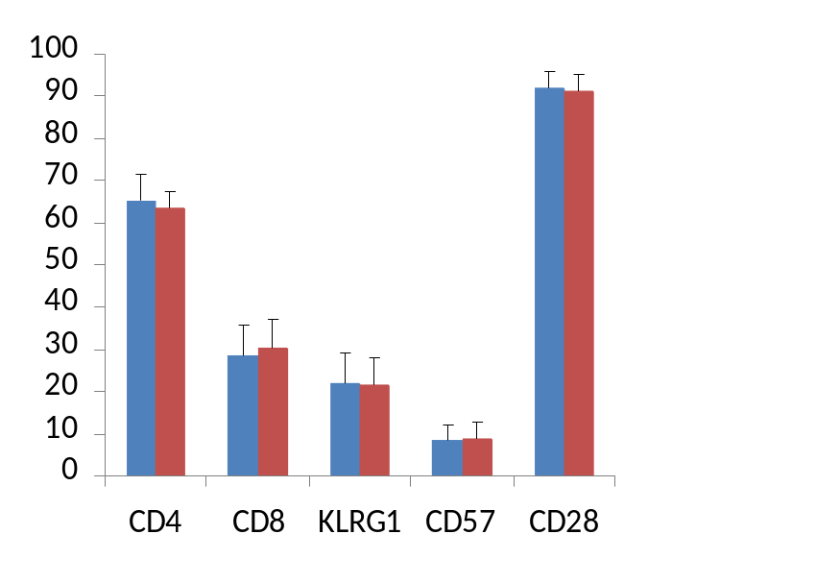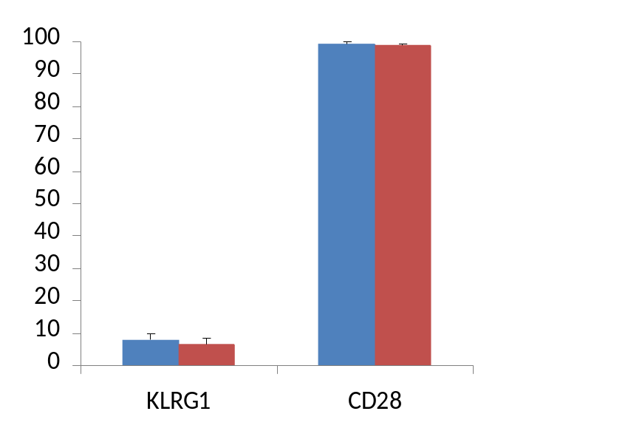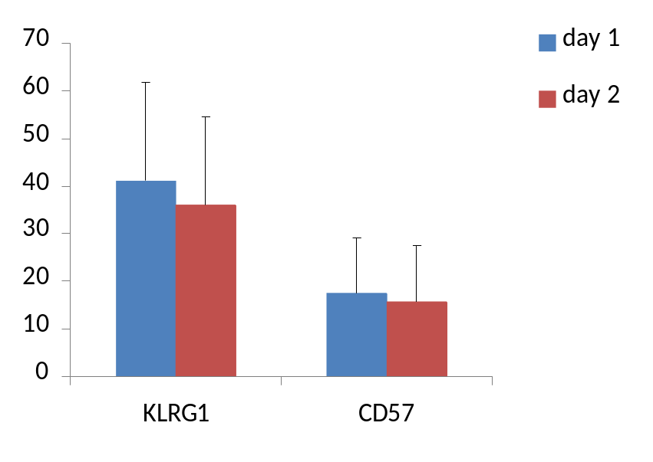
% CD3+ lymphocytes
% CD3+/CD4+ lymphocytes
% CD3+/CD8+ lymphocytes
B
A
C
Figure 2.2. The frequency of CD4+,CD8+, KLRG1+, CD57+ and CD28+ cells in the CD3+ lymphocyte subset (A) and the frequency of KLRG1+, CD57+ and CD28+ cells in the CD3+/CD4+ (B) and CD3+/CD8+ (C) lymphocyte subsets from peripheral blood samples analysed on the day of blood collection (day 1) and left overnight and analysed the next day (day 2). All values are mean ± SD.
2.5. Flow Cytometry
2.5.1. Flow cytometers
Human lymphocyte phenotype analysis was conducted on a FACSCalibur flow cytometer (BD Biosciences, San Jose, CA, USA) equipped with a 15 mW argon-ion laser emitting light at a fixed wavelength of 488nm. FITC and Alexafluor 488 fluorescence was detected in the FL1 filter centred at 530nm with a 30nm half-peak bandpass. PE fluorescence was detected in the FL2 filter centred at 585nm with a 42nm bandpass. PE Cy-5 fluorescence was detected in the FL3 filter centred at 670nm longpass. APC fluorescence was detected in the FL4 filter centred at 661 with a 16nm bandpass. Flow cytometry for mouse studies was performed using a FACSAria LSR II flow cytometer (BD Biosciences, San Jose, USA) equipped with BD FACSDiva software (BD Biosciences, San Jose, USA). In all cases, fluorescent signals were collected in logarithmic mode (4 decade logarithmic amplifier) and cell numbers per channel in linear mode.

2.5.2. Flow cytometry gating procedures
The electronic gating sequence used in lymphocyte subset analysis is presented in figure 2.3. An electronic gate was placed around the lymphocyte population in the forward scatter (FSC height) against side scatter (SSC height) mode. FSC height against APC fluorescence was used to identify the CD3+ T lymphocyte population. This population was gated electronically and the expression of the senescence markers on the T lymphocyte subsets was assessed within this gate using two parameter dot plots and single parameter histograms. A further electronic gate was placed around the CD3+/CD4+ or CD3+/CD8+ population where appropriate, and the level of FL1 and FL2 fluorescence on this population was assessed using a two parameter dot plot and single parameter histograms. For each sample, at least 10,000 events were collected in the CD3+ lymphocyte gate for analysis. The fluorescent amplifiers of the FL1-FL4 detector filters were adjusted to ensure that the negative cell population (as defined by the lymphocytes labelled using the appropriate isotype control) appeared in the first logarithmic decade. An electronic marker was placed at the limit of the negative controls to quantify the percentage of lymphocytes and lymphocyte subsets that were positive and negative for each cell surface antigen and any overlapping of emission spectra was resolved using electronic colour compensation.
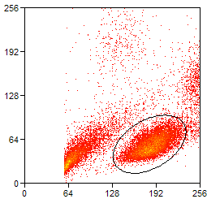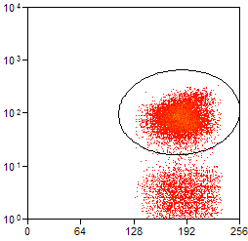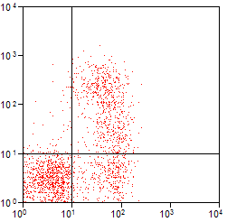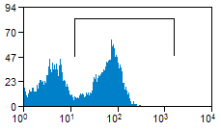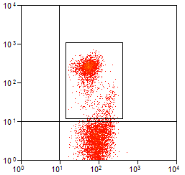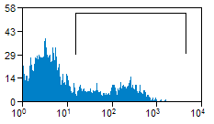
FCS Height
FSC Height
CD3
KLRG1
CD57
KLRG1
Lymphocytes
T lymphocytes
CD3
CD8+ T lymphocytes
CD57
B
C
D
E
Figure 2.3. An electronic gating sequence was used for T lymphocyte subset cell surface analysis. Lymphocytes were identified based on their forward and side scatter light properties (A). T lymphocytes within the lymphocyte gate were identified based on their cell surface expression of CD3 (B). CD8+ T lymphocytes within the CD3+ lymphocyte gate were identified based on their cell surface expression of CD8 (C) and the senescent cells were identified based on the cell surface expression of KLRG1 and/or CD57 on the CD3+/CD8+ gate (D, E).
SCS Height
CD8
A

2.6. Lymphocyte subset enrichments from whole blood
T lymphocyte, CD4+ T lymphocyte and CD8+ T lymphocyte fractions were purified from PBMCs using appropriate enrichment sets (BD Biosciences, Oxford, UK). Isolated PBMCs, at a concentration of 10x10⁶ cells ml⁻¹ in IMag™ Buffer (see appendix), were incubated with 5μl of the appropriate biotinylated enrichment cocktail (BD Biosciences, Oxford, UK) per 1x10⁶ cells, for 20 minutes at room temperature in a 15ml centrifuge tube, before washing in 10x volume of IMag Buffer solution at 300g for 7mins (see appendix 1 for details of IMag Buffer solution). After all the supernatant was aspirated by pipetting, the cell pellet was resuspended in 5μl of IMag™ streptavadin-conjugated magnetic particles (BD Biosciences, Oxford, UK) per 1x10⁶ cells and incubated at room temperature for 30 minutes.

The cell concentration was diluted to 50x10⁶ cells ml⁻¹ with IMag™ Buffer before being transferred to a falcon tube and placed in the IMagnet (BD Biosciences, Oxford, UK) for 7 minutes. The supernatant (the enriched negative fraction of interest) was transferred to a separate falcon tube by pipetting. The positive fraction was resuspended in IMag Buffer and left in the IMagnet for a further 7 minutes before the supernatant was added to the falcon tube containing the enriched negative fraction. This was repeated once more before discarding the positive fraction. The falcon tube containing the enriched negative fraction was then placed in the IMagnet for 7 minutes and the now twice enriched negative fraction was pipette transferred to a new Falcon tube.

2.7. Cell storage in liquid nitrogen
One million cells were centrifuged at 300g for 7 minutes and the supernatant fully aspirated. The cells were then resuspended, dropwise, in Foetal Calf Serum (Gibco, Invitrogen, Scotland, UK) Dimethyl Sulfoxide (7%) (Sigma-Aldrich, Germany) on ice, before transfer to a cryo tube (NUNC, Denmark). The cryo tube containing the cell fraction was placed in a polystyrene container and stored overnight at -80°C, before being submerged in liquid N₂ for long term storage.

2.8 Telomere length analysis
Mean telomere restriction fragment length (mTRF) analysis of enriched samples was done by Dr. Paul Shiels (University of Glasgow, UK) using quantitative PCR, using the methods of Cawthon et al., (2002), and Harris et al., (2006).

2.8.1. Sample Preparation
DNA was extract from the enriched T lymphocyte subset sample and a stock volume of the DNA was made up to as close to 150ng/μl as possible. A reference DNA sample (36B4), was used at a concentration of 70ng/μl, to construct a standard curve of serial dilutions of DNA. These were diluted serial to a factor of 1 in 2 (see appendix 3), which is generally used in PCR standard curve construction. A six point standard curve also allowed for detection and quantification of telomeres in samples with a smaller input amount of DNA or shorter telomeres.

For accurate curve construction, pulse-vortexing and centrifuging was used after transferring 50μl in 30μl and each subsequent transfer of 150μl DNA solution into 150μl buffer solution to attempt to homogenise the DNA in the sample.

A standard sample was produced by taking 7μl of the 70ng/μl reference DNA stock and diluting it in 133μl Buffer solution, (TrisEDTA [pH7.5], Appendix 4). This created a standard sample that was plotted against the standard curve to verify it the reaction efficiency was ideal (sample fell roughly within middle of standard curve).

7μl of the 150ng stock of DNA samples was diluted in 133μl Buffer. This created 140μl of sample. 120μl of sample was needed for this assay therefore there was a 20μl allowance for pipetting inaccuracies. The assay was carried out in triplicate in a 96 well plate (Fisher Scientific, Leicestershire, UK). 3 wells x 20μl per well were used for the Telomere plate, and 3 wells x 20μl per well were used for the 36B4 plate).

All DNA samples to be used at 95ºC were heated for 5 minutes, and then transferred immediately to ice.

2.8.2. Plate Construction
A Master Mix was created (as per Appendix 5), beginning with water. All reagents were added to the master mix container except Rox Reference Dye, Syber Green, and Amplitaq Gold DNA polymerase. When all other reagents were added, the Master Mix container was surrounded with aluminium foil to prevent light mediated degradation of dyes. Once this was is done, the two dyes and the Amplitaq enzyme were added, the mix centrifuge at 170g for 5 minutes and stored the in the dark on ice.

30μl of the Master Mix, and 20μl of Sample, were added to each reaction well, (triplicates on each plate in same positions; Telomere plate A1, A2, A3; 36B4 plate A1, A2, A3). Each pipette tip was used only once, and then changed to ensure maximal reduction in pipetting error. Used wells were capped, the plates wrapped in aluminium foil and centrifuged for 5 minutes at 1600g. The plates were then loaded into the ABI Prism (7900HT) sequence detection system (Applied Biosystems, CA, USA).

2.8.3. Running the Plates
The thermal cycling profiles are as such;

Telomere plate:
- 95ºC for 10 minutes, (to activate the Amplitaq enzyme).
- 95ºC for 15 seconds x 30 cycles.
- 54ºC for 2 minutes.

36B4 plate:
- 95ºC for 10 minutes, (to activate the Amplitaq enzyme).
- 95ºC for 12 seconds x 30 cycles.
- 58ºC for 1 minute.

A dissociation step was run at the end of these profiles. This allowed for melting curve analysis of the PCR product, which helped ensure that the primers had one product, (figure 2.4).

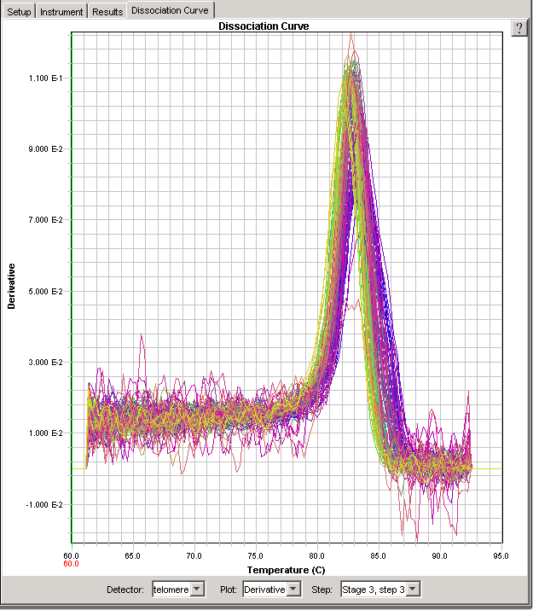

Figure 2.4. Telomere melting curve analysis

2.8.4. Analysing the Output
If the standard curves are of similar slopes then relative quantification can be made due to primer efficiency being similar, (acceptable slopes are between -3.2 and -3.8).

Threshold Cycles (Ct), were calculated for each sample and comparison of sample Cts with the standard curve allowed calculation of the input amount of DNA amplified in each optical well (Telomere or 36B4). To prove primer efficiency similarities, plate validation was carried out to plot ∆Ct against log amount of input DNA (ng). Validation was achieved when this slope was less than 0.1.

Comparison of sample quantities on the Telomere (T) plate with their counterparts on the 36B4 (S) plate gave a T/S ratio. The T/S ratio for the Reference Sample DNA calculated close to 1. All sample T/S ratios were normalised to the T/S ratio of the Reference Sample, termed the Relative T/S. The Relative T/S of the Reference sample calculated equal to 1.

Telomere length was extrapolated from the Relative T/S ratios using an equation derived from a normogram developed in the host laboratory. The normogram illustrates the linear relationship between the Relative T/S and the actual telomere length calculated by the Southern blot technique.

Cawthon Equation: 1910.5*Relative T/S+4157

Harris Equation: 1095.4*Relative T/S+6845.5

2.9. Statistical analysis
Data are expressed as mean ± standard deviation (SD) unless otherwise indicated. Statistical significance was accepted at p<0.05. All statistics were done using Minitab 15 or SPSS 14.

2.9.1. T-tests
Where data were normally distributed, differences between two means were calculated using a 2 sample t-test, or the Mann-Whitney U-test where data were not normally distributed.

2.9.2. Correlations
Where data were normally distributed, correlations were calculated using Pearson’s product-moment method or Spearman’s rank order method where data were not normally distributed.

CHAPTER 3

The use of total lymphocyte CD8+ or CD8^{bright} populations as a single antigenic marker to identify the CD8+ T lymphocyte subset

3.1. Introduction

Natural Killer (NK) and T cells are subsets of lymphocytes with distinct immunological roles. The use of flow cytometry and fluorescently labelled monoclonal antibodies can identify lymphocyte subsets based on the expression of cell surface antigens. T cells are commonly identified by their cell surface expression of CD3, and can be further subdivided into one of two functionally distinct subsets, based on the cell surface co-expression of CD3 with either CD4 (helper T cells) or CD8 (cytotoxic T cells). NK cells can be identified by their cell surface expression of CD56 or CD16, and their lack of CD3 expression. As such, identification of the CD3+ lymphocyte population is required for accurate T cell phenoytyping.

A number of studies have based T cell subset identification solely on the expression of CD4 or CD8 in a total lymphocyte population (Mazzeo et al., 1998; Gannon et al., 2001, 2002; Krzywkowksi et al., 2001; van der Pompe et al., 2001; Vider et al., 2001; Ibfelt et al., 2002; Ouyang et al., 2003; Simpson et al., 2006, 2007a). Although the expression of CD4 on a total lymphocyte population defines a pure T cell population (Simpson et al., 2007a) CD8 is expressed by both cytotoxic T cells and a population of immature NK cells (Maccario et al., 1984), suggesting the sole use of CD8 expression to identify T cells in a total lymphocyte population is flawed (Gannon et al., 2001, 2002; Simpson et al., 2007a).

Two populations of CD8+ cells can be identified on a total lymphocyte population based on the fluorescent intensity of CD8 expression. Cells expressing CD8 at high fluorescent intensities (CD8^{bright}) constitute approximately two thirds of all CD8+ lymphocytes with cells expressing CD8 at low fluorescent intensities (CD8^{dim}) making up the remaining proportion (Maccario et al., 1984; Gannon et al., 2001; Simpson et al., 2007a). Studies have attempted to exclude CD8+ NK cells by gating around the CD8^{bright} population (Gannon et al., 2001, 2002; Ouyang et al., 2003; Simpson et al., 2007a), known to be a pure T cell population (Simpson et al. 2007a). Although the CD8^{dim} lymphocyte population contains a subset of NK cells (Maccario et al., 1984), it is likely to also contain a population of CD8^{dim} T cells. As such, by gating around the CD8^{bright} lymphocyte population, a population of CD8^{dim} T cells may be excluded from analysis, introducing error to the investigation. The aim of this study therefore, was to assess the reliability of using total lymphocyte CD8+ or CD8^{bright} populations as a single antigenic marker to identify the CD8+ T lymphocyte subset of the peripheral blood compartment.

It is hypothesised that the CD8+ lymphocyte population contains a significant proportion of CD3-/CD8+ cells, and that by gating around the CD8^{bright} population, a population of CD3+/CD8^{dim} cells is excluded from analysis.

3.2. Materials and Methods

3.2.1. Subjects
Venous blood was drawn between 9am and 11am on the morning of the experiment as described in Chapter 2.1. The subject group was comprised of healthy, non-smoker males aged 19-24 years (mean = 21.9 ± 1.6 years, n=8). All subjects were active but not undertaking any strenuous exercise protocols, not on any medication and were free of any infectious illness for 6 weeks prior to the study.

3.2.3. Antibodies
Peripheral blood mononuclear cells (PBMC) were isolated as per the general materials and methods, section 2.2.1. Each sample was labelled with anti-CD3 APC, and one of anti-CD4 or anti-CD8 PE or both anti-CD8 FITC and anti-CD56 PE monoclonal antibodies, before flow cytometric analysis using a FACSCalibur flow cytometer equipped with Cell Quest Pro software.

3.2.4. Statistics
All values are mean ± SD unless otherwise indicated. Differences between subject groups were assessed for statistical significance using 2-sample t-tests where the data were normally distributed and the Mann-Whitney U-test where the data were not normally distributed. Statistical significance was accepted at p<0.05. All statistics were done using Minitab 15.
3.3. Results

The proportion of CD3+, CD4+, CD8+, CD56+, CD8^{bright}, CD8^{dim}, CD3-/CD8+, CD3-/CD8+/CD56+, CD3+/CD4+, CD3+/CD8+, CD3+/CD8^{bright} and CD3+/CD8^{dim} cells in the total lymphocyte population and the proportion of CD8^{bright}, CD8^{dim}, CD3+/CD8+, CD3+/CD8^{bright}, CD3+/CD8^{dim}, CD3-/CD8+ and CD3-/CD8+/CD56+ cells in the CD8+ lymphocyte population is presented in table 3.1. Approximately 60% of all lymphocytes were T cells as defined by cell surface expression of CD3. The CD4+ lymphocyte subset accounted for ~40%, and the CD8+ lymphocyte subset accounted for ~30% of the total lymphocyte population. The CD3+/CD4+ and the CD3+/CD8+ lymphocyte subsets accounted for ~35% and ~25% of the total lymphocyte population respectively, whilst the CD3-/CD8+ lymphocytes accounted for ~9% of all lymphocytes. All CD3-/CD8+ cells expressed the NK cell marker CD56. Figure 3.1 shows the proportions of CD3+, CD4+, CD8+, CD3+/CD4+, CD3+/CD8+ and CD3-/CD8+ cells in the total lymphocyte population.

The CD8+ lymphocyte subset population contained approximately two thirds CD8^{bright} cells and one third CD8^{dim} cells. Approximately 75% of all CD8+ lymphocytes were CD3+/CD8+ cells, with CD3-/CD8+ cells accounting for the remaining ~25% of the population. CD3+/CD8^{bright} lymphocytes accounted for ~90% of all CD3+/CD8+ lymphocytes with the remaining 10% a CD3+/CD8^{dim} population. The CD3-/CD8+ lymphocyte subset was >98% CD8^{dim}. A representative histogram showing the CD8+, CD8^{bright} and CD8^{dim} subsets of the lymphocyte population is presented in figure 3.2. and a representative flow cytometry dot plot showing the distribution of CD3+/CD8+, CD3+/CD8 ^{bright}, CD3+/CD8^{dim} and CD3-/CD8+ cells is presented in figure 3.3.

Comparisons of the proportions of CD8+ and CD3+/CD8+ cells, CD8^{bright} and CD3+/CD8+ cells and CD8^{dim} and CD3+/CD8^{dim} cells are presented in figure 3.4. There was a significantly larger proportion of CD8+ cells in the lymphocyte population than CD3+/CD8+ cells (p<0.01), but no difference in the proportions of CD3+/CD8+ and CD8^{bright} cells in the lymphocyte population. The CD8^{dim} population accounted for a significantly larger proportion of the lymphocyte population than the CD3+/CD8^{dim} cells.

Table 3.1. The proportions of the total lymphocyte population and the CD8+ lymphocyte subset population expressing the cell surface markers of interest. All values are mean ± SD (subjects were male, aged 19-24, n = 8).

 | % of all lymphocytes
CD3+ | 60.7 ± 8.4
CD4+ | 38.7 ± 8.2
CD8+ | 31.1 ± 6.2
CD8^{bright} | 20.5 ± 4.0
CD8^{dim} | 10.8 ± 6.2
CD56+ | 10.2 ± 6.4
CD3+/CD4+ | 35.7 ± 8.7
CD3+/CD8+ | 22.4 ± 4.5
CD3+/CD8^{bright} | 20.2 ± 4.1
CD3+/CD8^{dim} | 2.5 ± 1.0
CD3-/CD8+ | 8.6 ± 5.1
CD3-/CD8+/CD56+ | 8.8 ± 4.6
 | % of CD8+ lymphocytes
CD8^{bright} | 67.2 ± 14.7
CD8^{dim} | 33.3 ± 14.8
CD3+/CD8+ | 73.5 ± 14.7
CD3+/CD8^{bright} | 66.2 ± 14.3
CD3+/CD8^{dim} | 7.9 ± 2.5
CD3-/CD8+ | 26.7 ± 13.6
CD3-/CD8+/CD56+ | 28.3 ± 14.9
 | % of CD8+ T lymphocytes
CD3+/CD8^{bright} | 89.8 ± 3.2
CD3+/CD8^{dim} | 10.9 ± 3.5

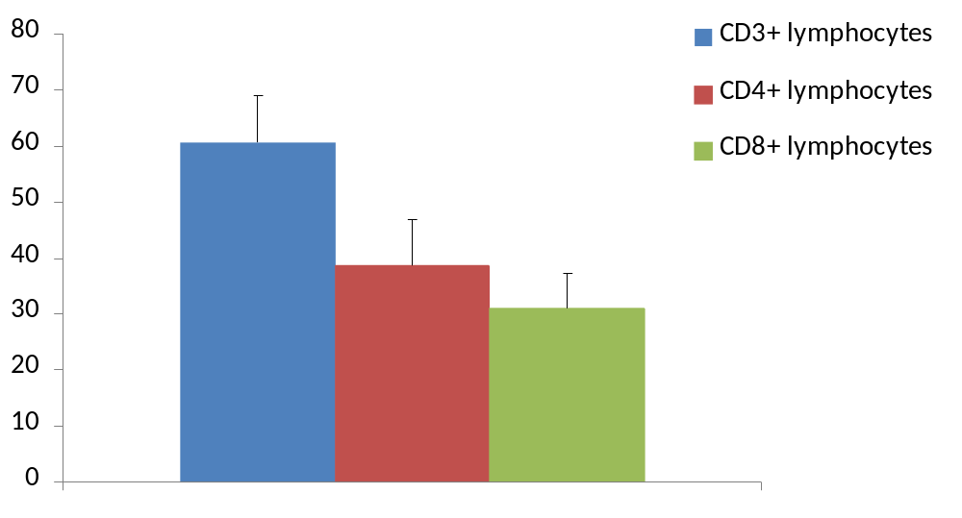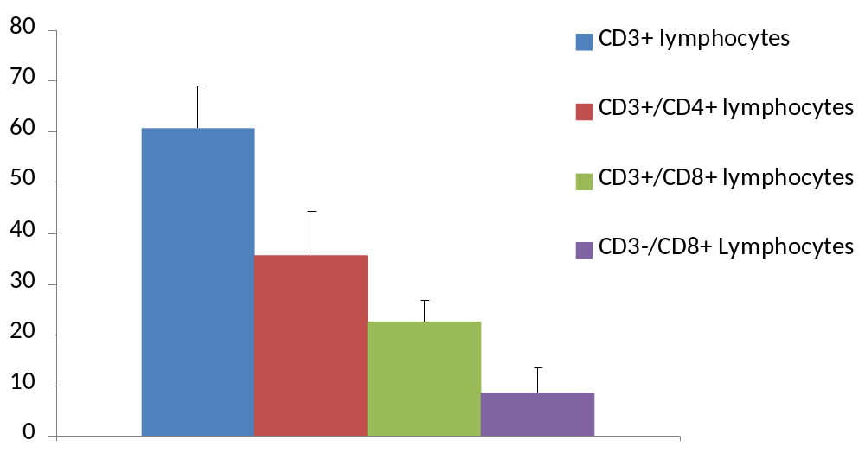
% total lymphocyte popualtion
% total lymphocyte popualtion
Figure 3.1. The proportion of CD3+, CD4+, CD8+, CD3+/CD4+, CD3+/CD8+ and CD3-/CD8+ cells in the total lymphocyte population. All values are mean ± SD (subjects were male, aged 19-24, n = 8)..

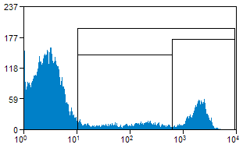
Count
A
B
C
CD8

Figure 3.2. Representative flow cytometric histogram showing the CD8+ (A), CD8^{bright} (B) and CD8^{dim} (C) subsets of the total lymphocyte population. The x-axis represents the log of the fluorescent intensity of the antibody.

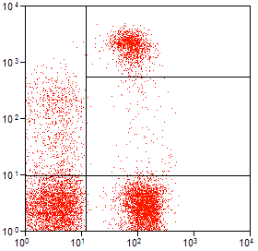
CD8
A
B
C
CD3

Figure 3.3. Representative flow cytometric dot plot showing the CD3+/CD8^{bright} (A), CD3+/CD8^{dim} (B) and CD3-CD8+ (C) cells in the total lymphocyte population. Both axes are log of the fluorescent intensity of the antibody.

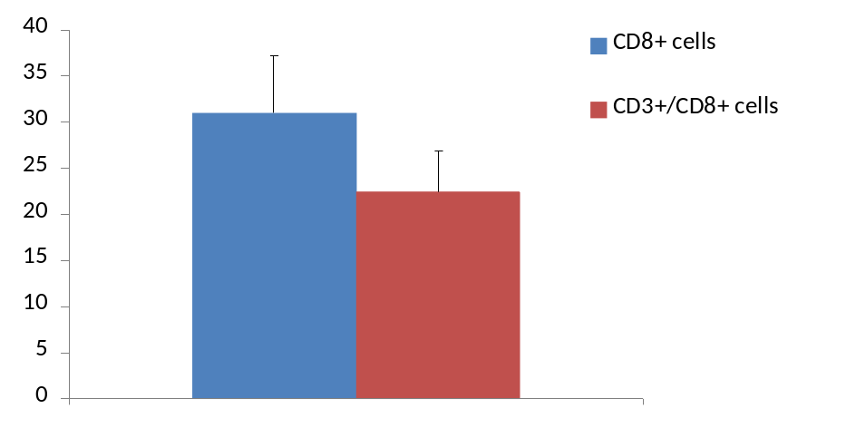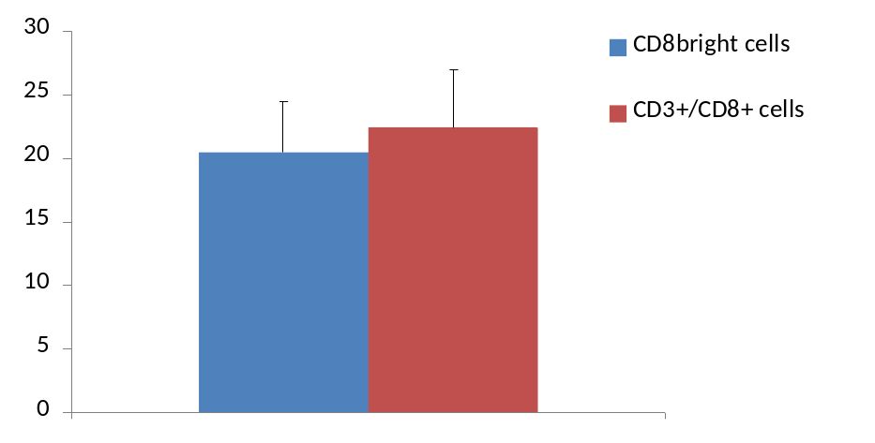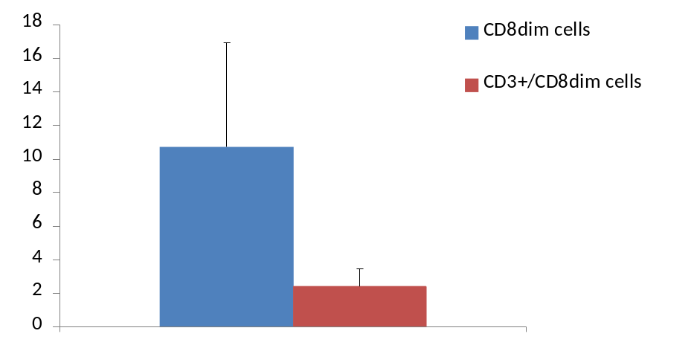
% total lymphocyte population
% total lymphocyte population

% total lymphocyte population

B
A
C
**
**
Figure 3.4. The proportions of CD8+ and CD3+/CD8+ cells (A), CD8^{bright} and CD3+/CD8+ cells (B) and CD8^{dim} and CD3+/CD8^{dim} cells (C) in the total lymphocyte population. All values are mean ± SD (subjects were male, aged 19-24, n = 8).. Statistically significant differences are indicated by ** (p<0.01).
3.4. Discussion

The aim of this study was to investigate the reliability of using total lymphocyte CD8+ or CD8^{bright} expression as a single antigenic marker to identify the CD8+ T lymphocyte subset of the peripheral blood compartment. As CD3+ T lymphocytes are almost exclusively CD4+ or CD8+, the combined proportions of these subsets in the total lymphocyte population should equal that of the CD3+ subset. It was found that although 60.7% of lymphocytes were CD3+, the combined proportions of CD4+ and CD8+ cells added up to 69.8% of the total lymphocyte population. However, in line with previous work showing CD8 expression on a subset of CD3- NK cells (Maccario et al., 1984) a subset of CD3-/CD8+ cells accounted for 8.6% of the total lymphocyte population, whilst the CD3+/CD4+ and CD3+/CD8+ lymphocyte subsets accounted for 58.1% of the total lymphocyte population suggesting the use of total lymphocyte CD8 to identify a CD8+ T lymphocyte population as flawed. Indeed, there was a significantly greater proportion of CD8+ compared to CD3+/CD8+ cells in the total lymphocyte population. Furthermore, there was a high level of diversity amongst the subjects in the proportion of CD3-/CD8+ cells, suggesting that the error associated with the use of total lymphocyte CD8 expression is variable from subject to subject.

The total lymphocyte CD8^{bright} expression has also been used to identify a CD8+ T lymphocyte population (Gannon et al., 2001, 2002; Ouyang et al., 2003; Simpson et al., 2007a). Although, in line with previous work, this subset was shown to be a pure T lymphocyte population (Simpson et al., 2007a), gating around the total lymphocyte CD8^{bright} subset excludes a small population of CD3+/CD8^{dim} cells. Although this population is small, and indeed, its exclusion did not lead to a significant difference between the proportion of CD3+/CD8+ and CD8^{bright} cells in the total lymphocyte population, it does constitute ~10% of the CD8+ T lymphocyte subset, and as such could significantly impact analysis of the expression of further subset markers on the CD8+ T lymphocyte population.

Furthermore, considering this thesis intends to measure the frequency of senescent cells in the CD8+ T lymphocyte subset, it is important to consider the impact that inclusion of an NK cell subset or exclusion of CD3+/CD8^{dim} subset would have on those markers. KLRG1+, CD57+ and CD28- cells in the CD8+ T lymphocyte subset have been suggested as populations of senescent cells (Simpson et al., 2007a) based on their long replicative history and an inability to proliferate in response to mitogenic stimuli (Bruunsgaard et al., 1999; Voehringer, Koschella and Pircher, 2002; Brenchley et al., 2003; Ouyang et al., 2003). However, the expression of CD57 and KLRG1 is not limited to T lymphocytes. KLRG1 is expressed on 50-80% of CD56^{dim} NK cells (Voehringer et al., 2001) and CD57 is expressed on approximately 10% of NK cells (Brenchley et al., 2003). CD45RA and CD45RO are also expressed on CD8+ T lymphocytes and help define naïve and memory cells respectively (Wroblewski and Hamann, 1996; Alexander, 2000). In addition, both can be expressed on NK cells and define resting or activated cells (Warren and Skipsy, 1991).

Although flawed, gating around the CD8^{bright} population is preferable to the use of total lymphocyte CD8+ expression, as there were no significant differences between the proportion of CD3+/CD8+ and CD8^{bright} cells in the total lymphocyte population, and gating around the CD8^{bright} population excludes a significantly larger proportion of CD3-/CD8+ NK cells than CD3+/CD8+ T cells from analysis. However, to avoid introducing error, when using flow cytometry, CD8+ T lymphocytes should be identified based on the co-expression of CD3 and CD8, especially when identifying subpopulation of cells on the CD8+ T lymphocyte subset.

.

CHAPTER 4

The frequency and diversity of markers of senescence on peripheral blood lymphocytes in healthy human subjects

4.1. Introduction

Telomere shortening due to excessive rounds of cell division has been described as a mechanism of replicative senescence (Harley, Futcher and Greider, 1990). Telomeric DNA is more sensitive than other chromosomal DNA to damage by oxidative stress and as such can trigger premature senescence either through increased rates of telomere attrition (Petersen, Saretzki, and von Zglinicki, 1998; Duan et al., 2004), or through telomere independent mechanisms such as single strand breaks (Chen et al., 2001). Smoking and obesity have been linked with telomere shortening in peripheral blood leukocytes and increased levels of oxidative stress (Valdes et al., 2005). Early mortality, ageing, life stress and a sedentary lifestyle have also been linked with shortened telomeres (Vaziri et al., 1993; Weng et al., 1995; Valenzuela and Effros, 2002; Cawthon et al., 2003; Epel et al., 2004; Cherkas et al., 2008), while studies have shown regular moderate exercise to reduce oxidative stress levels (Shin et al., 2008). In addition, females have been shown to have longer telomeres than age-matched males, and have a lower rate of telomere attrition (Benetos et al., 2001).

Naïve T lymphocytes express CD45RA (Alexander, 2000) and the lymph node homing marker CD62L (Shephard, 2003). Upon antigenic encounter, these cells undergo clonal expansion and take on a memory phenotype, down regulating both these markers and concurrently up-regulating CD45RO (Wroblewski and Hamann, 1996; Hamann et al., 1997), although some terminally differentiated memory cells have been shown to re-express CD45RA (Hamann et al., 1997; Dunne et al., 2002). T lymphocytes with shortened telomeres, a long replicative history and an inability to proliferate in response to mitogenic stimuli have been shown to express the NK cell marker CD57 (Brenchley et al., 2003), and lack expression of the co-stimulatory molecule CD28 on the cell surface (Bruunsgaard et al., 1999). Furthermore, the killer cell lectin-like receptor G1 (KLRG1), normally expressed on NK cells, has been shown to be expressed on the cell surface of T lymphocytes unable to undergo further clonal expansion, and on a greater proportion of T lymphocytes in the elderly (Voehringer et al., 2001; Ouyang et al., 2003).

Previous studies of senescence have shown a high level of diversity in both peripheral blood leukocyte telomere lengths and the frequency of KLRG1+ T lymphocytes (Iwama et al., 1998; Voehringer, Koschella and Pircher, 2002; Ouyang et al., 2003; Epel et al., 2004; Valdes et al., 2005). These studies were on subject groups with varying degrees of diversity in age, ethnicity, gender, health (mental and physical), obesity and physical fitness levels (Vaziri et al., 1993; Weng et al., 1995; Valenzuela and Effros, 2002; Epel et al., 2004; Valdes et al., 2005; Cherkas et al., 2008). As these factors are known to impact on the level of immune cell senescence, it could be argued that the data on the frequency of peripheral blood senescence markers (both telomere length and cell surface markers) previously published represents a very diverse population.

The ‘Immune Risk Phenotype’ (IRP) has been suggested to be predictive of lifespan, with one of the criteria being a high frequency of senescent T lymphocytes (Ferguson et al., 1995; Wikby et al., 1994; Strindhall et al., 2007). It may be that some individuals have a predisposition to senescence, which could partially account for the diversity of telomere length and cell surface markers of senescence in the population. However, the diverse natures of the subject groups studied are likely to mask any data in support of this theory. As such, this study aimed to investigate the frequency and diversity of peripheral blood lymphocyte markers of senescence on T lymphocyte and NK lymphocyte subsets in young, healthy, active, lean, male subjects to limit the impact of the aforementioned extraneous factors (i.e. age, gender, obesity, stress, sedentary lifestyle) that can influence the acquisition of a senescent phenotype.

It is therefore hypothesised that in a healthy human male population, there is a low level of diversity in the frequency of T lymphocytes expressing KLRG1, CD57, CD28, CD45RA, CD45RO and CD62L.

4.2. Materials and Methods

4.2.1. Subjects for normative data study
Venous blood was drawn between 9am and 11am on the morning of the experiment as per the general materials and methods, section 2.1. The subject group was comprised of healthy, non-smoker males aged 18-30 years (mean = 24 ± 2.3 years, Body Mass Index (BMI) = 24 ± 1.9 kg/m², n=20). All subjects were active but not undertaking any strenuous exercise protocols, not on any medication and were free of any infectious illness for 6 weeks prior to the study.

4.2.2. Subjects for correlation study
Venous blood was drawn between 9am and 11am as described in the general materials and methods, chapter 2.1. The subject group was mixed gender, aged 13-63 (mean = 34.4 ± 11.8 years). For markers of senescence (KLRG1, CD57 and CD28), n = 147, and for naïve and memory phenotype markers (CD45RA and CD45RO), n = 107. All subjects were healthy, lean (BMI < 25 kg/m²), active, non smokers. None of the subjects were on any medication and all were free of infectious illness for 6 weeks prior to the study.

4.2.3. Antibodies
Peripheral blood mononuclear cells (PBMCs) were isolated as per the general materials and methods, section 2.2.1. Each sample was labelled with anti-CD3 APC, one of anti-CD4, anti-CD8, anti-CD16, or anti-CD56 PE and one of anti-KLRG1 Alexafluor 488, anti-CD28, anti-CD45RA, anti-CD45RO, anti-CD57 or anti-CD62L FITC monoclonal antibodies before flow cytometric analysis using a FACSCalibur flow cytometer equipped with Cell Quest Pro software.

4.2.4. Statistics
Differences between subject groups were assessed for statistical significance using 2-sample t-tests where the data were normally distributed and the Mann-Whitney U-test where the data were not normally distributed. Correlations were assessed using Pearson’s product-moment correlations where data were normally distributed and Spearman’s rank-order correlation where data were not normally distributed. Statistical significance was accepted at p<0.05. All statistics were done using Minitab 15 or SPSS 14.
4.3. Results

4.3.1. Normative data study
The distribution of lymphocyte subset markers CD3, CD4, CD8 and CD56, indicators of T cell senescence KLRG1, CD57 and CD28, naïve and memory cell markers, CD45RA and CD45RO, and the lymph node homing receptor, CD62L, on the total lymphocyte population, the CD3+ lymphocyte population (T cells) and CD3- lymphocyte population are presented in Table 4.1.

Table 4.1. The expression of lymphocyte subset markers and senescence markers on all lymphocytes, CD3+ lymphocytes and CD3- lymphocytes. Values are mean ± SD (subjects were male, aged 18-30, n = 20).
 | % all  lymphocytes | % CD3+  lymphocytes | % CD3-  lymphocytes
CD3+ | 67.7 ± 7.8 | 100 | 0
CD4+ | 43.0 ± 6.8 | 62.6 ± 7.2 | Not measured
CD8+ | 27.3 ± 5.1 | 33.8 ± 5.6 | 16.5 ± 9.6
CD56+ | 14.0 ± 7.8 | Not measured | 26.3 ± 14.2
KLRG1+ | 23.1 ± 6.8 | 24.1 ± 7.7 | 15.4 ± 13.7
CD57+ | 6.5 ± 4.2 | 5.4 ± 3.5 | 4.6 ± 2.5
CD28+ | 56.6 ± 7.5 | 84.8 ± 7.8 | 2.0 ± 0.6
CD45RA+ | 71.5 ± 10.1 | 70.0 ± 14.3 | 43.1 ± 22.4
CD45RO+ | 22.5 ± 8.0 | 30.8 ± 10.6 | 28.2 ± 14.4
CD62L+ | 69.4 ± 4.3 | 76.4 ± 8.5 | 50.8 ± 10.8

4.3.1.1. Frequency of cell surface markers in lymphocyte subsets
The proportions of CD3+/CD4+, CD3+/CD8+ and CD3-/CD56+ cells expressing KLRG1, CD57, CD28, CD45RA, CD45RO and CD62L are presented in Figure 4.1. There was a greater proportion of KLRG1+, CD57+, CD45RO- and CD62L- cells in the CD3+/CD8+ lymphocyte subset compared to the CD3+/CD4+ lymphocyte subset (p<0.01), but there were no differences in the proportion of CD28+ or CD45RA+ cells between the two lymphocyte subsets. Representative flow cytometric dot plots showing the distribution of the markers of T cell senescence on the CD3+/CD4+ and CD3+/CD8+ lymphocyte subsets are presented in Figure 4.2.

KLRG1 was expressed on approximately half of all CD56+ NK cells, with CD57 expressed on approximately a quarter and CD28 being expressed on ~5% of CD3-/CD56+ NK cells. The majority of CD56+ NK cells express CD45RA (~95%) with only a small proportion expressing CD45RO and approximately 40% expressing CD62L. Representative flow cytometric histograms showing the frequency of KLRG1+, CD57+, CD28+, CD45RA+, CD45RO+ and CD62L+ cells on CD3-/CD56+ NK cells are presented in Figure 4.3.

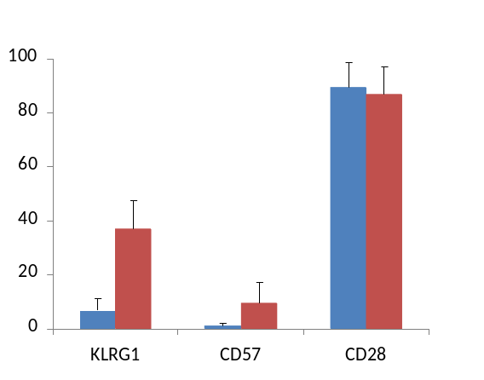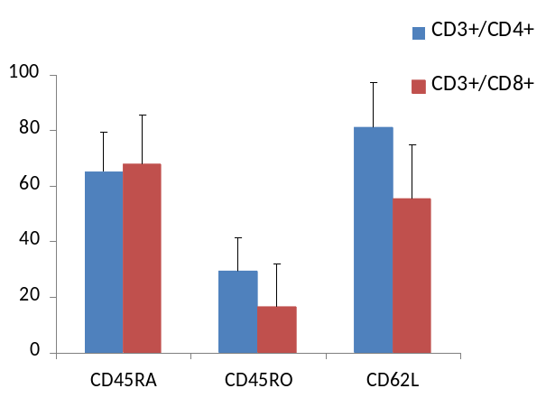
% positive cells
**
**
% positive cells
**
**
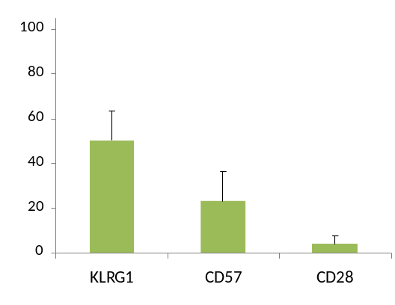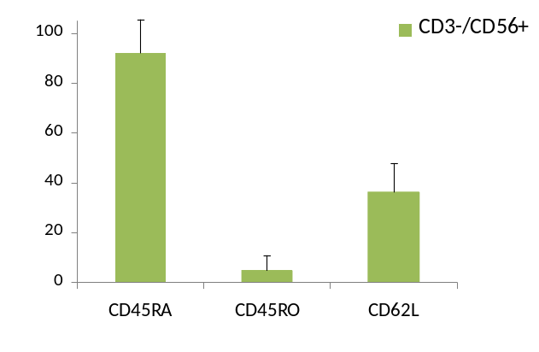
% positive cells
% positive cells
Figure 4.1. The frequency of peripheral blood CD3+/CD4+, CD3+/CD8+ and CD3-/CD56+ lymphocytes expressing the killer cell lectin-like receptor G1 (KLRG1), CD57, CD28, CD45RA, CD45RO and CD62L in a young, healthy, male population. Values are mean ± SD and statistically significant differences from the CD3+/CD4+ lymphocyte subset are indicated by * (p<0.05) and ** (p<0.01). Subjects were male, aged 18-30, n = 20.

CD8
CD4
CD45RA
CD45RO
CD62L

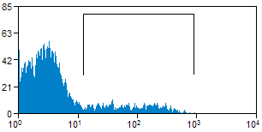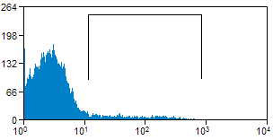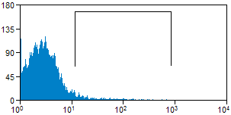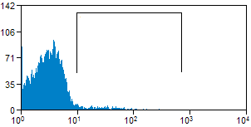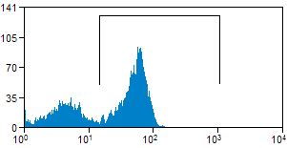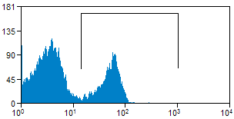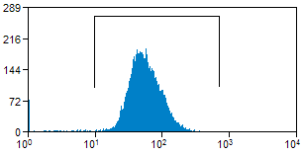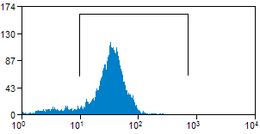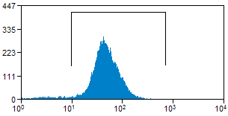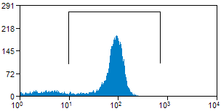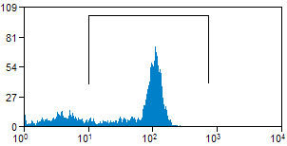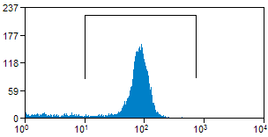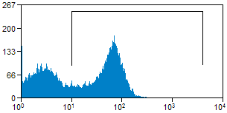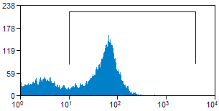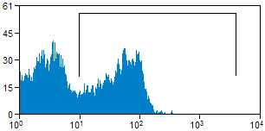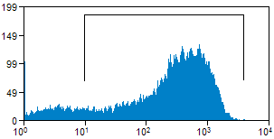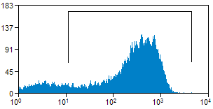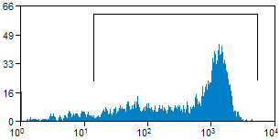
Count
Count
Count
Count
Count
Count
Count
Count
Count
Count
Count
Count
Count
Count
Count
Count
Count
Count
CD62L
KLRG1
KLRG1
KLRG1
CD57
CD57
CD57
CD28
CD28
CD28
CD45RA
CD45RA
CD45RA
CD45RO
CD45RO
CD45RO
CD62L
CD62L
CD3+ cells
CD3+/CD4+ cells
CD3+/CD8+ cells
Figure 4.2. Representative single parameter flow cytometric histograms showing the frequency of KLRG1, CD57, CD28+, CD45RA+, CD45RO+ and CD62L+ cells in the CD3+, CD3+/CD4+ and CD3+/CD8+ lymphocyte subsets. In each case the positive population is located between the vertical bars of the marker gate. The y-axis is the log of the fluorescent intensity.

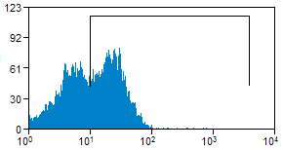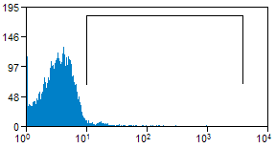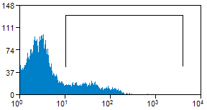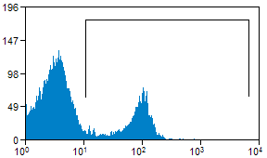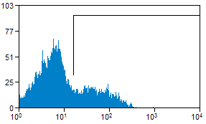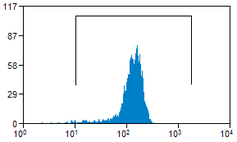
Count
Count
Count
Count
Count
Count
KLRG1
CD28
CD45RA
CD45RO
CD57
CD62L

Figure 4.3. Representative flow cytometric histograms showing the frequency of KLRG1+, CD57+, CD28+, CD45RA+, CD45RO+ and CD62L+ cells in the CD3-/CD56+ lymphocyte subset in a young, healthy, male subject. In each case the positive population is located between the vertical bars of the marker gate. The y-axis is the log of the fluorescent intensity.

4.3.1.2. Diversity in the frequency of cell surface markers in lymphocyte subsets
Scatter graphs showing the diversity in the frequency of KLRG1+, CD57+, CD28+, CD45RA+, CD45RO+ and CD62L+ cells in the CD3+/CD4+ and CD3+/CD8+ T lymphocyte subsets, and in the CD3-/CD56+ NK cell subset are presented in Figure 4.4. There was a greater range in the frequency of KLRG1+, CD57+ and CD62L+ cells in the CD3+/CD8+ subset compared to the CD3+/CD4+ lymphocyte subset, with an even distribution of the frequency of each marker within the subject group. The range in the frequency of CD28+ and CD45RA+ cells was equal in the CD3+/CD4+ and CD3+/CD8+ lymphocyte subsets. The CD3-/CD56+ lymphocyte subset showed equal diversity in the frequency of KLRG1+ and CD57+ cells. Compared that of the CD3+/CD8+ lymphocyte subset, the CD3-/CD56+ lymphocyte subset had similar diversity in the case of KLRG1+ cells, but larger in the case of CD57+ cells. The diversity of the frequency of CD28+ cells in the CD3-/CD56+ lymphocyte subset was very low, and much lower than that of the CD3+/CD8+ lymphocyte subset. The diversities of the frequency of CD45RA+ and CD45RO+ cells in the CD3-/CD56+ subset were also equal, but less than in the CD3+/CD4+ and CD3+/CD8+ lymphocyte subsets. The diversity in the frequency of CD62L+ cells in the CD3-/CD56+ lymphocyte subset was greater than that of the CD3+/CD4+ subset but less than that of the CD3+/CD8+ lymphocyte subset.

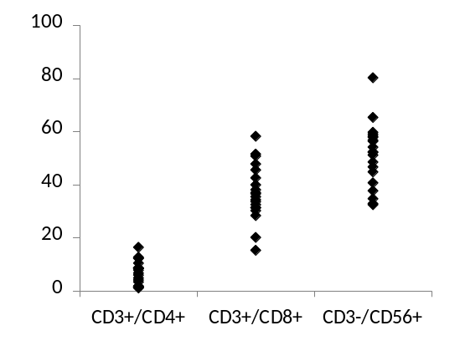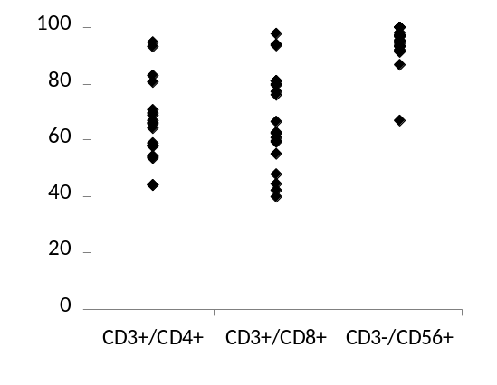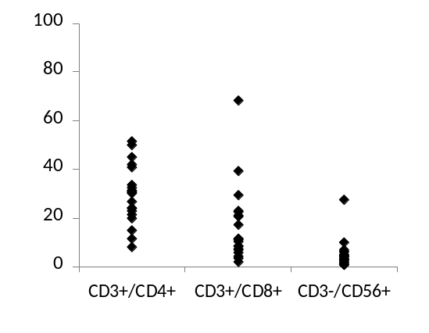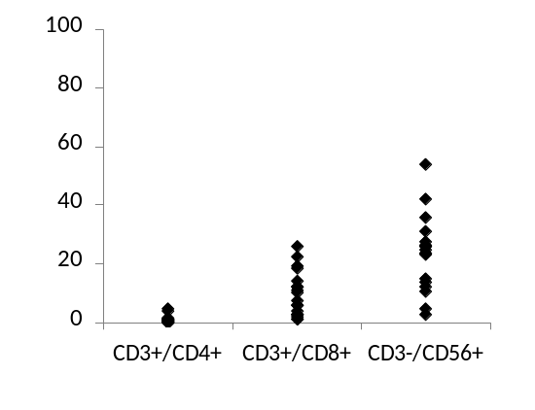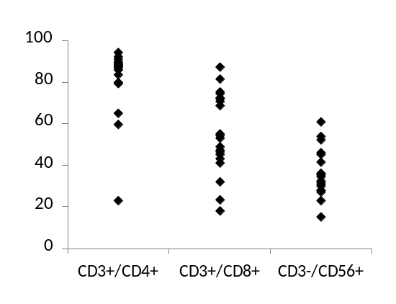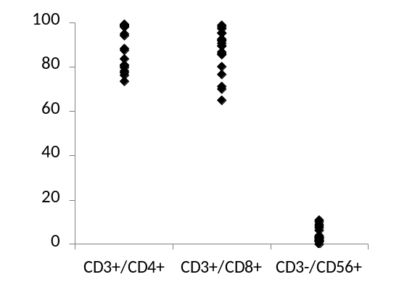
% CD57+ cells
% CD45RO+ cells
% KLRG1+ cells
% CD28+ cells
% CD45RA+ cells
% CD62L+ cells
Figure 4.4. Scatter graphs showing the diversity in the frequency of KLRG1+ CD57+, CD28+, CD45RA+, CD45RO+ and CD62L+ cells in the CD3+/CD4+, CD3+/CD8+ and CD3-/CD56+ lymphocyte subsets of young, healthy, male subjects aged 18-30 (n = 20).

4.3.2. Correlations of the frequency of cell surface senescence markers and age
Correlation coefficients of age, and of the frequency of KLRG1+, CD57+, CD28+, CD45RA+ and CD45RO+ cells, in the CD3+/CD4+ and CD3+/CD8+ lymphocyte subsets, are presented in Table 4.2. A strong positive correlation was noted between the frequency of KLRG1+ and CD57+ cells (r = 0.704, p<0.01) and a strong negative correlation between the frequency of KLRG1+ and CD28+ cells (r = -0.727, p<0.01) in the CD3+/CD8+ lymphocyte subset. The strongest negative correlation noted was between the frequency of CD57+ and CD28+ cells (r = -0.873, p<0.01), also in the CD3+/CD8+ lymphocyte subset. In addition, there was a significant but weaker negative correlation between the frequency of KLRG1+ cells in the CD3+/CD8+ lymphocyte subset and CD45RA+ cells in the CD3+/CD4+ lymphocyte subset (r = -0.649, p<0.01). These four correlations described linear relationships between these markers, and are presented as scatter plots in Figure 4.5.

Although there were no strong correlations between any of the peripheral blood lymphocyte senescence markers and age, the frequency of KLRG1+ (r = 0.228), CD45RA+ (r = -0.312) and CD45RO+ cells (r = 0.367) in the CD3+/CD4+ lymphocyte subset and KLRG1+ (r = 0.375), CD57+ (r = 0.432), CD28+ (r = -0.360) and CD45RO+ cells (r = 0.380) in the CD3+/CD8+ lymphocyte subset were all significantly correlated with subject age (p < 0.01 in all cases). The significant correlations between age and frequency of T lymphocyte cell surface senescence markers are presented in figure 4.6.

 |  | KLRG1 |  | CD57 |  | CD28 |  | CD45RA |  | CD45RO | Age
 |  | CD4+ | CD8+ | CD4+ | CD8+ | CD4+ | CD8+ | CD4+ | CD8+ | CD4+ | Age
KLRG1 | CD4+ |  |  |  |  |  |  |  |  |  | 0.228  0.007 **
KLRG1 | CD8+ | 0.382  0.000 ** |  |  |  |  |  |  |  |  | 0.375  0.000 **
CD57 | CD4+ | 0.266  0.001 ** | 0.225  0.007 ** |  |  |  |  |  |  |  | 0.147  0.086
CD57 | CD8+ | 0.308  0.000 ** | 0.704 #  0.000 ** | 0.501  0.000 ** |  |  |  |  |  |  | 0.432  0.000 **
CD28 | CD4+ | -0.409  0.000 ** | -0.178  0.034 * | -0.034  0.690 | -0.050  0.552 |  |  |  |  |  | 0.071  0.401
CD28 | CD8+ | -0.263  0.002 ** | -0.727 #  0.000 ** | -0.460  0.000 ** | -0.873 #  0.000 ** | 0.082  0.337 |  |  |  |  | -0.360  0.000 **
CD45RA | CD4+ | -0.479  0.000 ** | -0.649  0.000 ** | -0.289  0.004 ** | -0.460  0.000 ** | 0.173  0.089 | 0.428  0.000 ** |  |  |  | -0.312  0.002 **
CD45RA | CD8+ | -0.048  0.641 | 0.122  0.233 | -0.047  0.645 | 0.179  0.078 | -0.019  0.852 | -0.096  0.348 | 0.148  0.147 |  |  | -0.155  0.134
CD45RO | CD4+ | 0.455  0.000 ** | 0.611  0.000 ** | 0.476  0.000 ** | 0.571  0.000 ** | 0.132  0.190 | -0.521  0.000 ** | -0.532  0.000 ** | 0.578  0.000 ** |  | 0.367  0.000 **
CD45RO | CD8+ | 0.206  0.040 * | 0.500  0.000 ** | 0.376  0.000 ** | 0.436  0.000 ** | 0.285  0.004 ** | -0.376  0.000 ** | 0.595  0.000 ** | -0.099  0.331 | 0.578  0.000 ** | 0.380  0.000 **
Table 4.2. Correlations within the frequency of peripheral blood senescence markers, and with age, on CD3+/CD4+ and CD3+/CD8+ peripheral blood lymphocytes. r values are the upper value, p values are the lower value. Statistical significance is indicated by * (p<0.05) or ** (p<0.01). Strong correlations are indicated by # (r > 0.700 or r < -0.700). Subjects were mixed gender, aged 13-63 (n = 147).

A
B
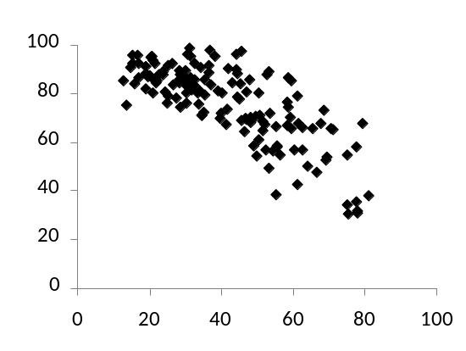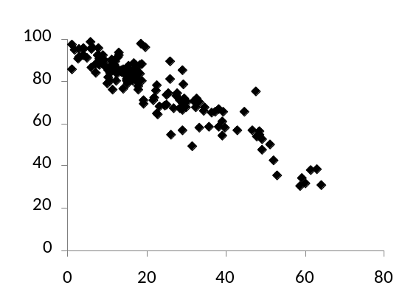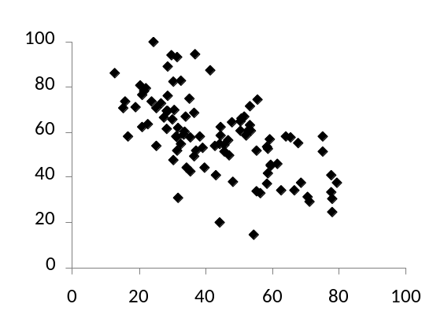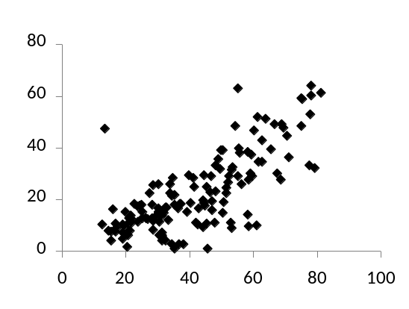
% CD57+ cells
% CD28+ cells
% KLRG1+ cells
% KLRG1+ cells
% CD57+ cells
% CD28+ cells
% CD45RA+ cells
C
D
r = 0.704
r = -0.873
r = -0.649
% KLRG1+ cells
r = -0.727

Figure 4.5. Scatter graphs showing the relationship between the frequency of KLRG1+ and CD57+ cells (A), KLRG1+ and CD28+ cells (B) and CD57+ and CD28+ cells (C) on the CD3+/CD8+ lymphocyte subset, and KLRG1+ and CD45RA+ cells on the CD3+/CD4+ lymphocyte subset (D). In each case the correlations were significant at p<0.01. Subjects were aged 13-63 year. (n = 147).

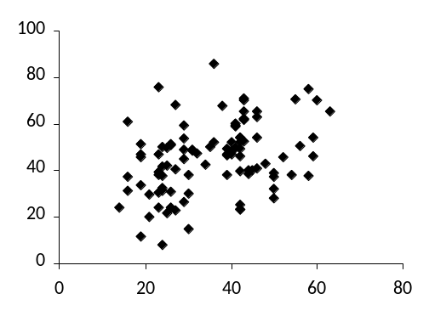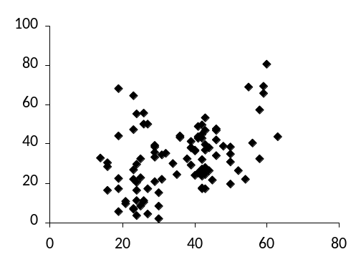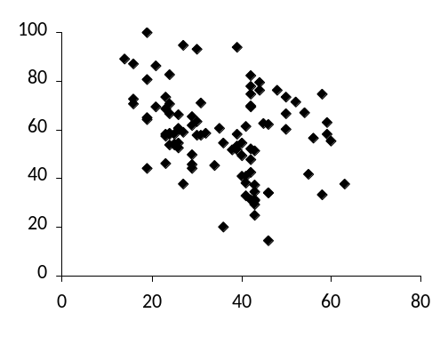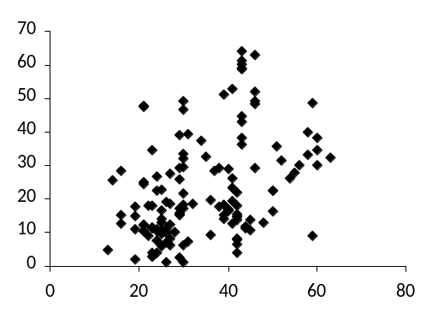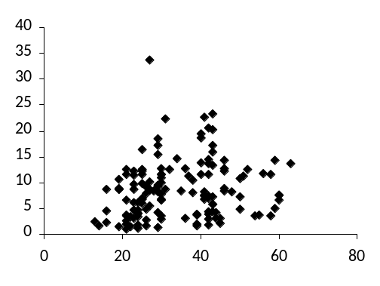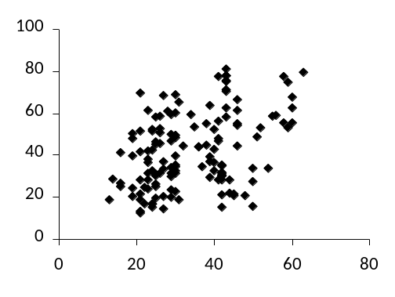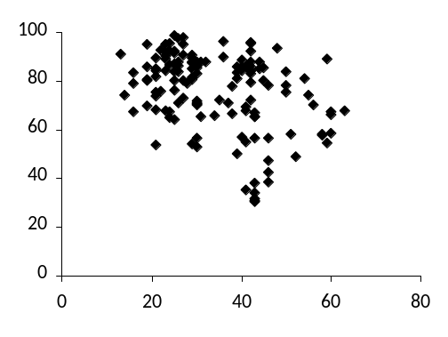
% KLRG1+ cells
% CD45RA+ cells
% CD45RO+ cells
Age (years)
Age (years)
Age (years)
Age (years)
Age (years)
Age (years)
Age (years)
% KLRG1+ cells
% CD57+ cells
% CD28+ cells
% CD45RO+ cells
r = 0.228
r = 0.375
r = -0.312
r = 0.432
r = 0.367
r = 0.380
r = -0.360
CD3+/CD4+ Lymphocytes
CD3+/CD8+ Lymphocytes
Figure 4.6. Scatter graphs showing the significant correlations between the frequency of KLRG1+, CD57+, CD28+, CD45RA+ and CD45RO+ cells in the CD3+/CD4+ and CD3+/CD8+ lymphocyte subsets and subject age, in a diverse population of healthy, lean, male subjects. All correlations are statistically significant at p <0.01. Subjects were aged 13-63 year. (n = 147).

4.4. Discussion

The primary aim of this study was to investigate the diversity in the frequency of KLRG1+, CD57+, CD28+, CD45RA+, CD45RO+ and CD62L+ cells in the CD3+/CD4+, CD3+/CD8+ and CD3-/CD56+ lymphocyte subsets of young, healthy, active, lean, male subjects. The secondary aim of the study was to investigate the relationships of the aforementioned markers with each other, and with age, in a healthy, lean, mixed gender population.

4.4.1. The frequency of cell surface markers of senescent lymphocytes
As in previous studies, the CD8+ T lymphocyte population had a greater frequency of KLRG1+, CD57+ and CD62L- cells compared to the CD4+ T lymphocyte subset (Voehringer, Koschella and Pircher, 2002; Mills, Karnik and Dillon, 1997; Simpson et al., 2008) suggesting a greater frequency of senescent cells in the CD8+ T lymphocyte subset than in the CD4+ T lymphocyte subset. This is consistent with previous studies that have shown CD4+ T lymphocytes to have lower replication kinetics than CD8+ T lymphocytes (Foulds et al., 2002) undergoing more rounds of clonal expansion in response to antigenic encounter. Furthermore, CD4+ T lymphocytes are able to up-regulate the telomere-lengthening enzyme, telomerase, further into their replicative lifespan than CD8+ T lymphocytes (Valanzuela and Effros, 2002). As such, individuals are likely to have a larger proportion of senescent CD8+ T lymphocytes, expressing markers such as KLRG1 and CD57 on the cell surface, compared to CD4+ T lymphocytes.

The frequency of KLRG1+ cells in the CD4+ T lymphocyte subset was lower than that previously described by Voehringer, Koschella and Pircher (2002) (6.9 ± 4.5% in this study, versus 18 ± 10%) suggesting a lower level of senescence, possibly reflecting the less diverse population used in this study.

Furthermore, the greater frequency of CD57+ cells in the CD8+ compared to the CD4+ T lymphocyte subset populations in this study is consistent with previous work (Mills, Kamik and Dillon, 1997; Simpson et al., 2008). CD57 has been shown to be expressed on T lymphocytes with shortened telomeres and an inability to proliferate (Brenchley et al., 2003), and as such, the greater frequency in the CD8+ T lymphocyte subset is in line with the larger proportion of this population expressing KLRG1, and reflects the greater likelihood of CD8+ T cells to undergo replicative senescence before CD4+ T lymphocytes as previously discussed (Foulds et al., 2002; Valanzuela and Effros, 2002).

There were no differences in the frequency of CD28+ cells between the CD4+ and CD8+ T lymphocyte subsets. This contrasts earlier work by Bruunsgaard et al., (1999), who showed a similar frequency of CD28+ cells in the CD4+ T lymphocyte subset but a lower frequency in the CD8+ T lymphocyte subset (~60%) of a young, healthy, active, mixed gender population, compared to this study (~85%). Considering previous work has shown females to have longer telomeres and a lower rate of telomere attrition than males (Benetos et al., 2001), it is possible, though unlikely, that the mixed gender aspect of this population contributes to the observed differences. The study by Brunnsgaard et al., (1999) used a subject group aged 19-31, comprising 4 females and 6 males, whereas this study used 20 male subjects only. The reported differences in mean telomere length and attrition rates between females and males (0.02 kilo base pairs and 0.002 kilo base pairs per year respectively, Benetos et al., 2001) are unlikely to have sufficient impact on telomere length so early in life to reflect the differences in such young subject groups.

As previously documented, the CD8+ T cell subset had a lower frequency of CD45RO+ memory cells and CD62L+ cells than the CD4+ T lymphocyte subset, with no differences noted in the frequency of CD45RA+ naïve cells between the two subsets (Simpson et al., 2008). Considering the observed difference in the expression of CD45RO, it was surprising that there was no difference in the frequency of CD4+ and CD8+ T lymphocytes expressing CD45RA. Although CD45RA+ and CD45RO+ cells have been described as reciprocal subsets of T lymphocytes (Bruunsgaard et al., 1999), they can be co-expressed during a transitional phase after antigenic encounter (Visser, Lai and Poppema, 1993; Summers, O’Donnell and Hart, 1994) and CD45RO+ memory T lymphocytes are also able to re-express CD45RA late in their replicative lifespan, resulting in the presence of a population of CD45RA+ memory T lymphocytes (Hamann et al., 1997; Dunne et al., 2002). It may be that the CD4+ T lymphocyte subset has a larger proportion of transition phase or CD45RA+ memory cells, explaining the greater frequency of CD45RO+ cells in the CD4+ compared to the CD8+ T lymphocyte population in this study.

The lymph node homing receptor marker CD62L, is lost from the cell surface of CD45RA+ naïve cells upon antigenic encounter, concurrent with an up-regulation of CD45RO (Wroblewski and Hamann, 1996; Hamann et al., 1997). A such, it would be reasonable to expect a low frequency of CD45RO+ cells to be mirrored by a large frequency of CD62L+ cells. However, a lower frequency of CD62L+ cells were seen in the CD8+ compared to the CD4+ T lymphocyte subset. CD45RA+ memory cells are likely to also be CD62L- (Hamann et al., 1997; Dunne et al., 2002), perhaps explaining these results. Furthermore, a larger pool of CD45RO+/CD45RA+/CD62L- or CD45RO-/CD45RA+/CD62L- cells in the CD8+ T lymphocyte subset would be consistent with the greater frequency of KLRG1+ and CD57+ cells in this subset, indicating a higher level of senescence in the CD8+ compared to the CD4+ T lymphocyte subset. However, studies investigating the co-expression of these markers would be required to confirm this.

KLRG1 was expressed on approximately half the cells in the CD3-/CD56+ NK cell subset, consistent with previous work on CD56+ NK cells (Voehringer et al., 2001; Simpson et al., 2008). KLRG1 expression is up-regulated on CD56+ NK cells upon activation (Robbins et al., 2002) and is limited to the mature, CD56^{dim} subset (Huntington et al., 2007). KLRG1+ NK cells are more cytotoxic, more susceptible to oxidative cell death and have shorter telomeres than KLRG1-/CD56^{bright} NK cells (Cooper, Fehniger and Caligiuri, 2001; Ouyang et al., 2007; Thorén et al., 2007). E-cadherin has been identified as an endogenous ligand for KLRG1 humans (Gründemann et al., 2006; Ito et al., 2006), ligation of which suppresses NK cell cytotoxicity preventing killing of healthy cells and improving the efficiency of KLRG1+ NK cells in a potential cancer surveillance role (Schwartzkopff et al., 2007).

The frequency of CD57+ cells within the CD56+ NK cells subset in this study was not consistent with previous data (Ohkawa et al., 2001; Simpson et al., 2007a, 2008). However, this is likely due to differences in age of subject groups as the previous investigations were inconsistent in this aspect and frequency of CD57+ NK cells has been shown to be greater in older individuals (Tarazona et al., 2000; Wikby et al., 2000; Brzezinska, 2005).

Warren and Skipsy (1991) showed that CD45RA is expressed on resting, non-activated NK cells, and upon activation is down-regulated concurrent with an up-regulation of CD45RO, although this up-regulation is not stable and the cell may revert to a CD45RA+ phenotype. In the context of this study, this suggests that the majority of CD3-/CD56+ NK cells (~90%) are not activated in a healthy, active, lean, male population. Although ~50% of CD56+ NK cells were KLRG1+ in this study, this is not inconsistent with the low frequency of CD45RO+ activated NK cells as once an NK has up-regulated KLRG1 on the cell surface, it is not able to revert to a KLRG1- phenotype (Huntington et al., 2007), so in healthy individuals there is likely to be a large frequency of KLRG1+ NK cells that have been activated but have re-expressed CD45RA (Warren and Skipsy, 1991). The frequency of CD62L+ cells in the NK cell subset is consistent with previous work (Frey et al., 1998; De Martinis et al., 2000) and coincides with the frequency of mature NK cells as indicated by the KLRG1 and CD57 expression in this study.

4.4.2. Diversity in the frequency of lymphocytes expressing cell surface markers of senescence in a young, lean male population
A high level of diversity has been noted in previous studies of leukocyte telomere length (Iwama et al., 1998; Epel et al., 2004; Valdes et al., 2005), and in studies of the frequency of KLRG1+ cells in peripheral blood CD4+ and CD8+ T lymphocyte subsets (Voehringer, Koschella and Pircher, 2002; Ouyang et al., 2003). In the current study, there was a larger diversity in the frequency of KLRG1+, CD57+ and CD62L+ cells in the CD8+ than in the CD4+ T lymphocyte subset. These data suggest that the greater frequency of KLRG1+, CD57+ and CD62L- cells in the CD8+ T lymphocyte subset is due to only some of the individuals in the subject group having greater frequencies of these markers. As the subject group in this study was controlled in such a way as to exclude factors known to impact the level of immunosenescence (e.g. gender, age, obesity, sedentary lifestyle, life stress and smoking), it could be suggested that certain individuals in the population are either predisposed to expressing these phenotypes on their CD8+ T cells, or they are more sensitive to the factors that lead to immunosenescence, consistent with an IRP (Wikby et al., 1994; Ferguson et al., 1995; Strindhall et al., 2007). Indeed the idea that individuals are genetically predisposed to a higher level of immunosenescence is intriguing, especially considering the hereditary component in telomere length (De Meyer et al., 2007; Kimura et al., 2008), and the natural diversity in telomere length and telomerase activity between individuals (Iwama et al., 1998).

4.4.3. Correlations between the frequency of lymphocytes expressing cell surface markers of senescence and age in a diverse, mixed gender population
It has been well documented that KLRG1+, CD57+ and CD28- T lymphocytes accumulate with age, have undergone multiple rounds of cell division and do not proliferate in response to antigenic stimuli (Azuma and Lanier, 1995; Brenchley et al., 2003; Brzezinska, 2005; Bruunsgaard et al., 1999; Kern et al., 1999; Labalette et al., 1999; Nociari, Telford and Russo, 1999; Weekes et al., 1999; Tarazona et al., 2000; Wikby et al., 2000; Voehringer et al., 2001; Voehringer, Koschella and Pircher, 2002; Ouyang et al., 2003; Ibegbu et al., 2005). As such, in healthy individuals it would follow that a T lymphocyte population expressing KLRG1 would be likely to simultaneously express CD57 and lack expression of CD28. The correlation data presented in this chapter also suggests this as the case. The strong positive correlation between the frequency of KLRG1+ and CD57+ cells and the strong negative correlations between the frequencies of KLRG1+ and CD28+ cells, and CD57+ and CD28+ cells in the CD8+ T lymphocyte subset suggest complex expression relationships between these markers. Indeed, some studies have investigated the co-expression of KLRG1 and CD28 (Voehringer, Koschella and Pircher, 2002) and KLRG1 and CD57 (Ibegbu et al., 2005) in individuals with various common infections. Furthermore, the stronger correlation between the frequency of CD57+ and CD28+ compared to the correlation between the frequency of KLRG1+ and CD28+ cells can be explained by the presence of KLRG1+/CD28+ cells in the CD8+ T lymphocyte subset. However, further work to investigate the co expression patterns of these markers on T cell subsets would be required to clarify this.

The correlations between the frequency of T lymphocyte cell surface markers of senescence and subject age are consistent with data showing an increase in the expression of these markers with age (Bruunsgaard et al., 1999; Effros, 2000; Tarazona et al., 2000; Wikby et al., 2002; Ouyang et al., 2003; Brzezinska, 2005) although the r values in this study indicate weak relationships. The subject group investigated consisted of few subjects over the age of 60 years, and as such may have impacted on the strength of the correlation. Therefore increasing the number of 60+ year old individuals in the cohort is likely to result in much stronger correlations. Equally, the weak correlations may be an indication of the divergence of chronological and biological ageing, where chronological age is the elapsed time since birth and biological age represents the biological function compared to others of the same age. Biological age has been suggested as a better predictor of mortality (Mitnitski et al., 2002) and telomere length has previously been suggested to be a good biomarker of biological ageing (Bekaert, De Meyer and Van Oostveldt, 2005). As such, where individuals have been exposed to oxidative stress environments such as obesity, life stress and smoking throughout their lives, or perhaps have a genetic component predisposing them to shorter telomere lengths or accelerated telomere attrition, a divergence of chronological and biological ageing may be apparent, contributing to the diversity in immunosenescence within the population.

CHAPTER 5

The co-expression of KLRG1 with CD28, CD57, CD45RA and CD45RO on peripheral blood T lymphocyte subsets in younger and older adults

5.1. Introduction

The adaptive immune response relies upon the ability of T lymphocytes to form memory cells and undergo repeated bouts of clonal expansion in response to antigenic challenge. Cellular senescence is a state of permanent cell cycle arrest in which a cell is unable to further divide in response to normal growth stimuli. Chromosome telomeres are progressively eroded with each round of cell division which can eventually trigger replicative senescence (Harley, Futcher and Greider, 1990). States of increased oxidative stress have been shown to trigger both telomere dependent (Petersen, Saretzki, and von Zglinicki, 1998) and independent senescence (von Zglinicki, Pilger and Sitte, 2000; Chen et al., 2001; Lorenz et al., 2001; von Zglinicki, 2002). Repeated stimulation of specific memory T cells over the period of a lifetime results in an accumulation of senescent T cells in blood and tissues (Akbar, Beverley and Salmon, 2004). In long term cultures of T lymphocytes, progressive increases in the production of the pro-inflammatory cytokines TNF-α, IFN-γ, and IL-6, have been noted (Effros, Dagarag and Valenzuela, 2003). The greater frequency of infectious diseases and autoimmune diseases commonly seen in the elderly is believed to be due to an accumulation of senescent T-lymphocytes (Vaziri et al., 1993; Weng et al., 1995; Valenzuela and Effros, 2002; Ouyang et al., 2003; Akbar, Beverley and Salmon, 2004; Effros, 2004; van Baarle et al., 2005) and many of the diseases associated with normal ageing are considered the outcome of increased general inflammation (Effros, Dagarag and Valenzuela, 2003).

T-lymphocytes with an incapacity to proliferate have shortened telomeres and are known to express the Killer cell Lectin-like Receptor G1 (KLRG1) and/or CD57 on the cell surface (Kern et al., 1999; Labalette et al., 1999; Nociari, Telford and Russo, 1999; Weekes et al., 1999; Tarazona et al., 2000; Wikby et al., 2000; Voehringer et al., 2001; Brenchley et al., 2003; Ouyang et al., 2003; Brzezinska, 2005; Ibegbu et al., 2005; Voehringer, Koschella and Pircher, 2002), and simultaneously lack surface expression of the co-stimulatory molecule CD28 (Azuma and Lanier, 1995; Monteiro et al., 1996; Effros et al., 1997; Bruunsgaard et al., 1999; Labalette et al., 1999; Nociari, Telford and Russo, 1999; van Baarle et al., 2005). Recent work has shown that some CD28+ T cells are unable to replicate (Voehringer, Koschella and Pircher, 2002; Brenchley et al., 2003; Ibegbu et al., 2005) indicating that CD28 on its own is an unreliable marker of senescence. Voehringer, Koschella and Pircher (2002) showed CD28+ T-cells that failed to divide following mitogenic stimulation also expressed KLRG1, suggesting KLRG1 as a better marker of replicative senescence than CD28.

Thymic involution and prolonged exposure to various antigens with ageing have been implicated in the reduced proportion of naïve T cells commonly seen in older adults, thus impacting on T cell memory (Akbar, Beverley and Salmon, 2004). CD45RA and CD45RO are cell surface markers that are expressed on reciprocal subsets of T lymphocytes in humans (Bruunsgaard et al., 1999) and have been used to help define naïve and memory phenotypes respectively (Hamann et al., 1997; Alexander, 2000). Initial activation of the T cell results in a loss of CD45RA and a gain of CD45RO on the cell surface (Hamann et al., 1997), although effector memory cells are capable of re-expressing CD45RA (Hamann et al., 1997; Dunne et al., 2002) which may be co-expressed with cell surface markers of senescence (Voehringer, Koschella and Pircher, 2002; Brenchley et al., 2003). As such, a larger proportion of CD45RO+ and CD45RA+ cells co-expressing KLRG1 would be expected in the older subject group.

Both KLRG1 and CD57 expression on CD8+ T cells have been shown to increase with age (Tarazona et al., 2000; Wikby et al., 2002; Ouyang et al., 2003; Brzezinska, 2005), and a reduction in CD28 expression on both T cell subsets with ageing has been well documented (Bruunsgaard et al., 1999; Effros, 2000). Co-expression of these markers on CD4+ and CD8+ T cell subsets with ageing, however, has not been investigated. Although the expression of KLRG1 or CD57 on CD45RA+ or CD45RO+ lymphocytes has recently been investigated (Voehringer, Koschella and Pircher; 2002; Brenchley et al., 2003; Ibegbu et al., 2005) on CD8+ T lymphocytes, this relationship with ageing is still unclear. In light of this, the expression of KLRG1 with CD28, CD57, CD45RA or CD45RO on blood T-lymphocyte subsets in healthy adult male volunteers was investigated.

It was hypothesised that older subjects would have a greater frequency of KRLG1+/CD57+, KLRG1+/CD28-, KLRG1+/CD45RO+ and KLRG1+/CD45RA+ cells in the CD3+/CD8+ T lymphocyte subset from older subjects.

5.2. Materials and Methods

5.2.1. Subjects
Intravenous blood samples were drawn between 9am and 11am on the morning of the experiment as described in the general materials and methods, section 2.1. The two subject groups were comprised of healthy, non-smoker males aged 20-30 years (mean = 24±2.3 years, n=10) and 50-60 years (mean = 57.4±3.2 years, n=10). Height and weight measurements were used to calculate body mass index of each group (24±1.9 kg/m² and 25.2±3.1 kg/m² respectively). All subjects were active but not undertaking any strenuous exercise protocols and not on any medication and were free of any infectious illness for 6 weeks prior to the study. The subjects gave written informed consent and ethical approval was granted by the institution.

5.2.2. Antibodies
Peripheral blood mononuclear cells (PBMCs) were isolated as per the general materials and methods, section 2.2.1., and labelled with anti-human anti-CD3 APC, anti-KLRG1 Alexafluor 488, one of anti-CD4 or anti-CD8 PECy-5, and one of anti-CD57, anti-CD28, anti-CD45RA or anti-CD45RO PE monoclonal antibodies where appropriate before flow cytometric analysis using a FACSCalibur flow cytometer equipped with Cell Quest Pro software.

5.2.3. Statistics
All values are mean ± SD. Where data were normally distributed, differences between younger and older subject groups were investigated using 2-sample t tests. Where data were not normally distributed, differences between younger and older subject groups were investigated using Mann-Whitney U-tests. Statistical significance was accepted at p<0.05. All statistics were done using Minitab 15.

5.3. Results

5.3.1. Frequency of T lymphocytes expressing cell surface markers of senescence markers in younger and older subject groups
The frequency of CD3+, CD4+ and CD8+ cells within the total lymphocyte population, the frequency of CD4+ and CD8+ cells within the CD3+ T lymphocyte population and the frequency of KLRG1+, CD57+, CD28+, CD45RA and CD45RO cells within the CD3+/CD4+ and CD3+/CD8+ lymphocyte subsets, in the younger and older subject groups, is presented in Table 5.1.

Table 5.1. The frequency of senescence, memory and naïve markers on the peripheral blood lymphocytes from younger and older subject groups. Values are mean ± SD. The subjects were male, aged 20-30 years in the younger group (n = 10) and 50-60 years in the older group (n = 10).
 | % all lymphocytes
 | younger | older
CD3+ | 63.9 ± 11.7 | 72.1 ± 6.3
CD4+ | 40.9 ± 7.8 | 47.9 ± 5.5
CD8+ | 25.8 ± 5.8 | 23.8 ± 6.3
 | % T lymphocytes
CD4+ | 61.8 ± 6.4 | 65.3 ± 6.4
CD8+ | 30.7 ± 5.6 | 30.0 ± 7.3
KLRG1+ | 23.2 ± 7.0 | 28.8 ± 8.9
CD57+ | 11.1 ± 5.7 | 15.7 ± 7.5
CD28+ | 89.5 ± 7.3 | 56.6 ± 6.5 *
CD45RA+ | 74.3 ± 10.2 | 63.8 ± 11.1
CD45RO+ | 45.8 ± 11.5 | 50.0 ± 15.2

The frequency of KLRG1+, CD57+, CD28+, CD45RA+ and CD45RO+ cells in the CD3+/CD4+ and CD3+/CD8+ lymphocyte subsets in the younger and older subject groups is presented in Figure 5.1. The older subject group had a greater frequency of KLRG1+ cells in the CD3+/CD4+ lymphocyte subset compared to the younger subject group, but there were no differences in the frequency of CD57+, CD28+, CD45RA+ and CD45RO+ cells between the two subject groups in the same lymphocyte subset. Representative flow cytometric histograms showing the frequency of KLRG1+, CD57+, CD28+, CD45RA+ and CD45RO+ cells in the CD3+/CD4+ lymphocyte subset of younger and older subjects are presented in Figure 5.2.

There was a greater frequency of KLRG1+, CD57+, CD28- and CD45RA- cells in the CD3+/CD8+ lymphocyte subset of the older compared to the younger subject group. There were no differences in the frequency of CD45RO+ cells in the CD3+/CD8+ lymphocyte subset between the younger and older subject groups. Representative flow cytometric histograms showing the frequency of KLRG1+, CD57+, CD28+, CD45RA+ and CD45RO+ cells in the CD3+/CD8+ lymphocyte subset of younger and older subjects are presented in Figure 5.3.

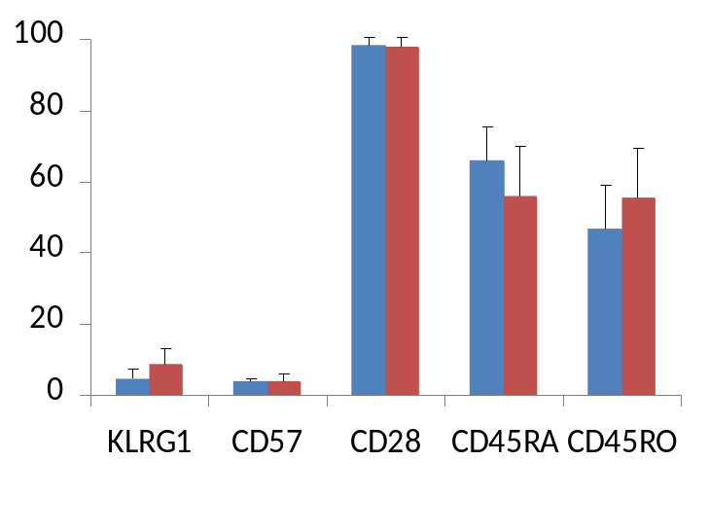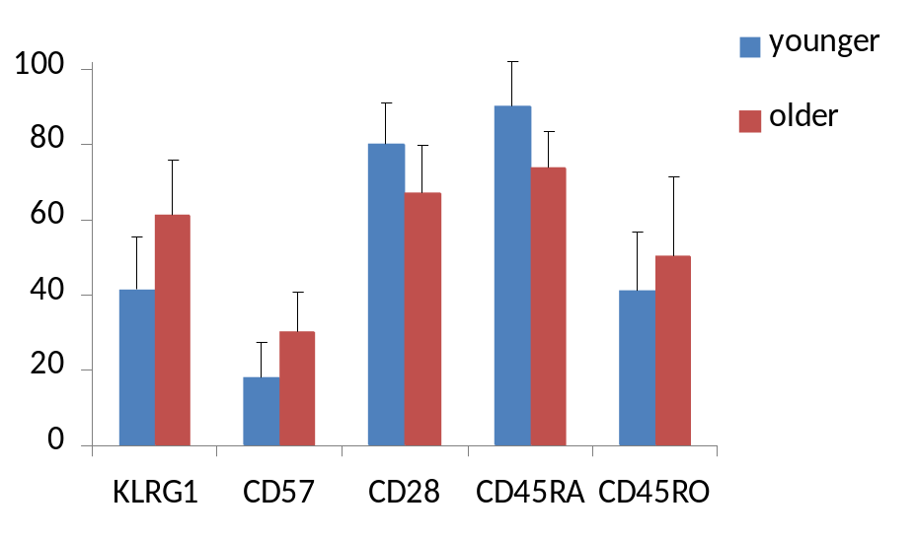
% positive cells
% positive cells
A
B
**
*
*
*
*
Younger
Figure 5.1. The frequency of KLRG1+, CD57+, CD28+, CD45RA+ and CD45RO+ cells in the CD3+/CD4+ (A) and CD3+/CD8+ (B) lymphocyte subsets of younger and older subjects. All values are mean ± SD. Statistically significant differences from the younger subject group are indicated by * (p<0.05) or ** (p<0.01). The subjects were male, aged 20-30 years in the younger group (n = 10) and 50-60 years in the older group (n = 10).
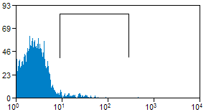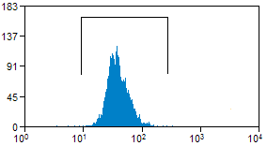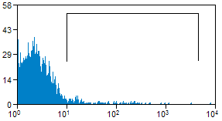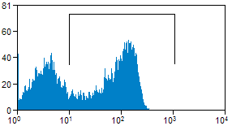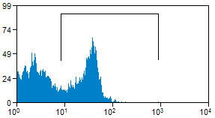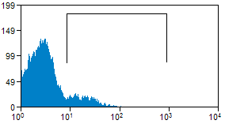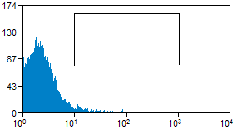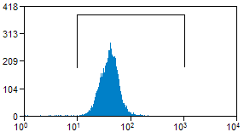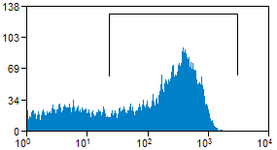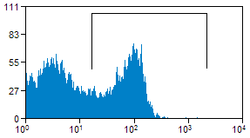
Count
Count
Count
Count
Count
Count
Count
Count
Count
Count
KLRG1
KLRG1
CD57
CD57
CD28
CD28
CD45RA
CD45RA
Younger
Older
CD45RO
CD45RO
Figure 5.2. Representative flow cytometric histograms showing the frequency of KLRG1+, CD57+, CD28+, CD45RA+ and CD45RO+ cells in the CD3+/CD4+ peripheral blood lymphocyte subset of younger and older subjects. The positive population is indicated by the marker gate. The y-axis is the log of the fluorescent intensity.
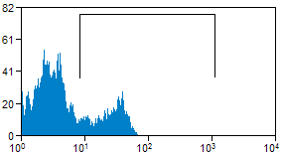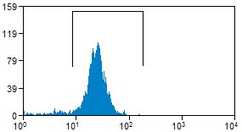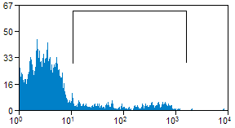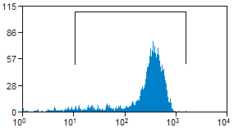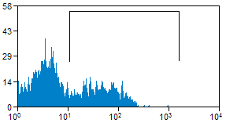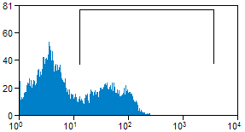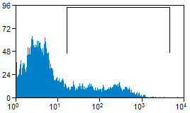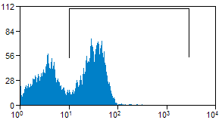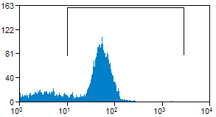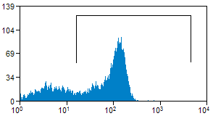
Count
Count
Count
Count
Count
CD28
CD28
CD45RA
CD45RA
CD45RO
CD57
CD57
KLRG1
KLRG1
Count
Count
Count
Count
Count
CD45RO
Younger
Older
Figure 5.3. Representative flow cytometric histograms showing the distribution of KLRG1+, CD57+, CD28+, CD45RA+ and CD45RO+ cells in the CD3+/CD8+ lymphocyte subsets of younger and older subjects. Both axes are the log of the fluorescent intensity.
CD4
CD8

5.3.2. The frequency of cells co-expressing KLRG1 with CD57, CD28, CD45RA and CD45RO on T lymphocyte subsets in older and younger subject groups

The frequency of cells co-expressing KLRG1 with CD57, CD28, CD45RA and CD45RO in the CD3+/CD4+ lymphocyte subsets of younger and older subjects are presented in figure 5.4. There was a lower frequency of KLRG1-/CD45RA+ cells in the CD3+/CD4+ lymphocyte subset of older subjects compared to younger subjects. No other significant differences in the frequency of cells co-expressing KLRG1 with CD57, CD28, CD45RA and CD45RO in the CD3+/CD4+ lymphocyte subset of younger and older subjects were seen. Only a small proportion of cells co-expressed KLRG1 with CD45RA (<5%), or with CD45RO (<1%) in the CD3+/CD4+ lymphocyte subset of both the younger and older subject groups. Representative two parameter flow cytometer dot plots showing the distribution of KLRG1 with CD57, CD28, CD45RA and CD45RO in the CD3+/CD4+ lymphocyte subsets of younger and older subjects are presented in figure 5.5.

The frequency of cells co-expressing KLRG1 with CD57, CD28, CD45RA and CD45RO in the CD3+/CD8+ lymphocyte subset of younger and older subjects is presented in figure 5.6. There was a greater frequency of KLRG1+/CD57+ cells in the CD3+/CD8+ lymphocyte subset of older subjects with no differences observed in the frequency of KLRG1+/CD57- and KLRG1-/CD57+ cells within the same T-lymphocyte subset. There was a greater frequency of KLRG1+/CD28- cells and a lower frequency of KLRG1-/CD28+ cells in the CD3+/CD8+ lymphocyte subset of the older subjects, with no difference in the frequency of KLRG1+/CD28+ cells in the same lymphocyte population between the younger and older subject groups. The older subject group had a greater frequency of KLRG1+/CD45RA- cells (p<0.05) and a lower frequency of KLRG1-/CD45RA+ cells in the CD3+/CD8+ lymphocyte subset compared to the younger subject group. No differences were seen, between the two subject groups, in the frequency of KLRG1+/CD45RO+ cells in the same lymphocyte subset. The older subject group had a greater frequency of KLRG1+/CD45RO- cells in the CD3+/CD8+ lymphocyte subset compared to the younger population (p<0.01) but there were no differences in the frequency of KLRG1+/CD45RO+ or KLRG1-/CD45RO+ cells in the same subset between the two subject groups.
Representative two parameter flow cytometer dot plots showing the distribution of KLRG1 with CD57, CD28, CD45RA and CD45RO in the CD3+/CD8+ lymphocyte subset of younger and older subjects are presented in figure 5.7.

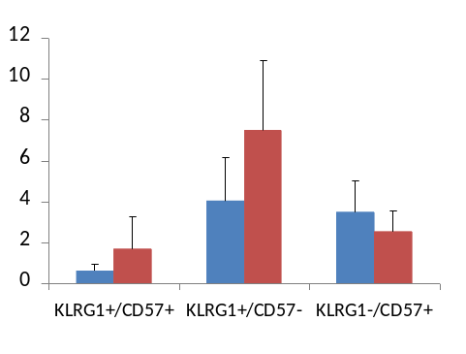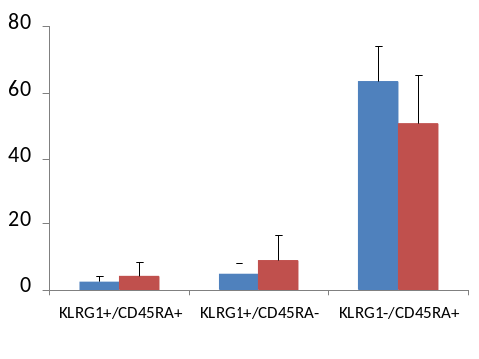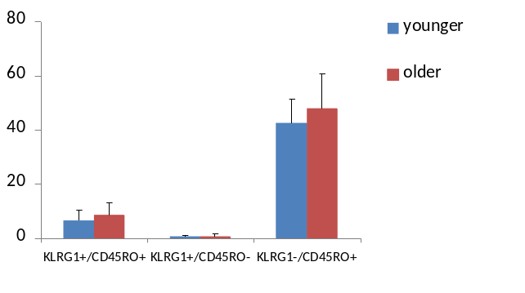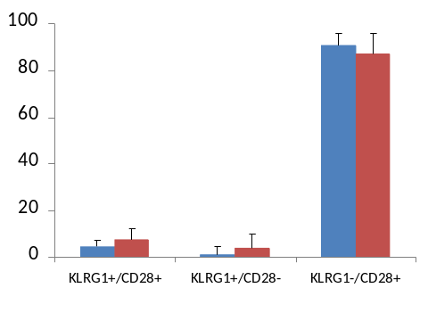
% positive cells
% positive cells
*
% positive cells
% positive cells
Figure 5.4. The frequency of cells co-expressing KLRG1 with CD57, CD28, CD45RA and CD45RO in the CD3+/CD4+ lymphocyte population of younger and older subjects. All values are mean ± SD. Statistically significant differences from the younger subject group are indicated by * (p<0.05). The subjects were male, aged 20-30 years in the younger group (n = 10) and 50-60 years in the older group (n = 10).

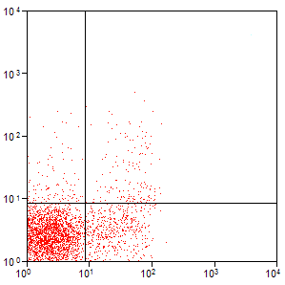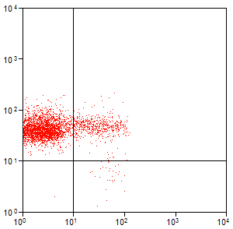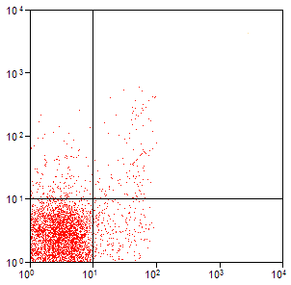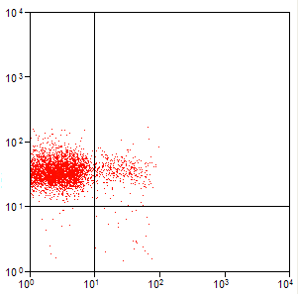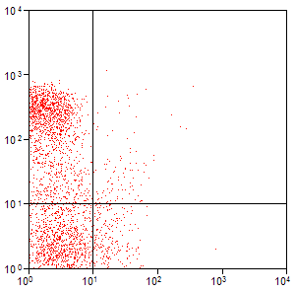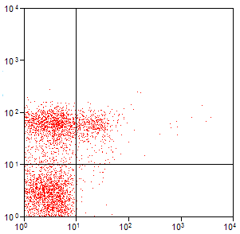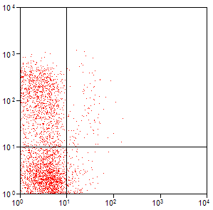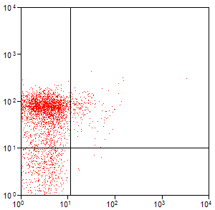
CD28
CD45RO
CD45RA
CD57
CD28
CD45RO
CD45RA
CD57
KLRG1
KLRG1
KLRG1
KLRG1
KLRG1
KLRG1
KLRG1
KLRG1
Younger
Older
Figure 5.5. Representative two parameter flow cytometer dot plots showing the distribution of cells co-expressing KLRG1 with CD57, CD28, CD45RA and CD45RO in the CD3+/CD4+ T lymphocyte subset of younger and older subjects. Both axes show the log of the fluorescent intensity.

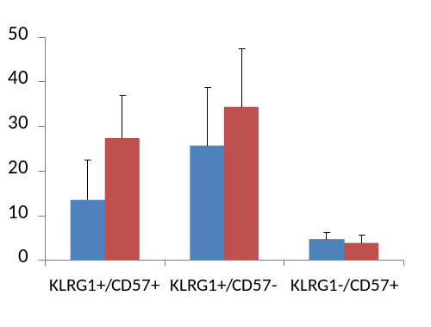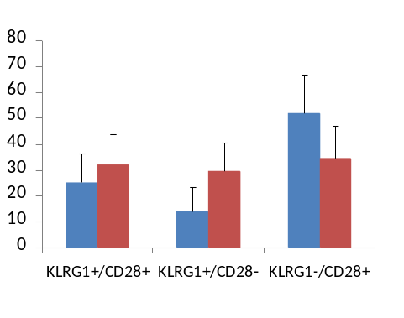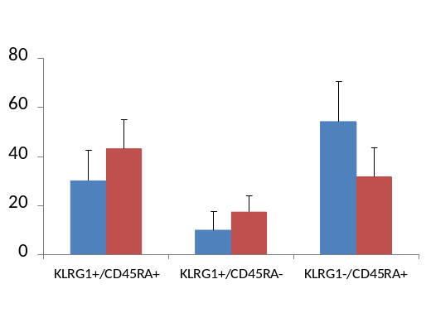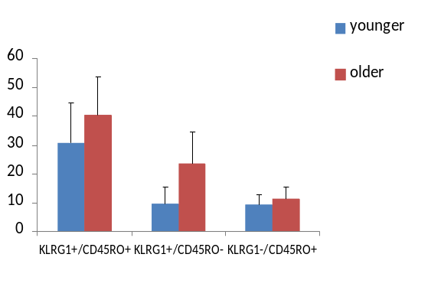
% positive cells
% positive cells
**
**
**
*
**
**
% positive cells
% positive cells
Figure 5.6. The frequency of cells co-expressing KLRG1 with CD57, CD28, CD45RA and CD45RO in the CD3+/CD8+ peripheral blood lymphocyte subsets of younger and older subjects. All values are mean ± SD. Statistically significant differences from the younger subject group are indicated by * (p<0.05) or ** (p<0.01). The subjects were male, aged 20-30 years in the younger group (n = 10) and 50-60 years in the older group (n = 10).

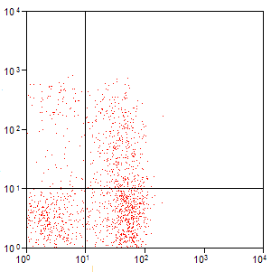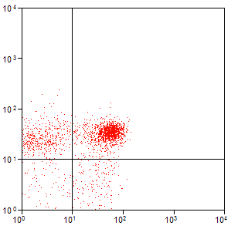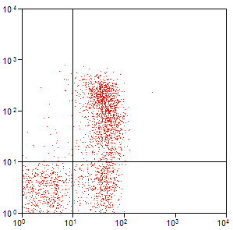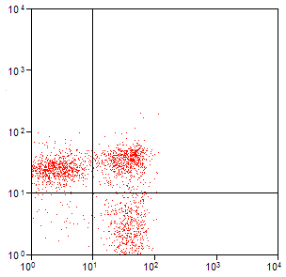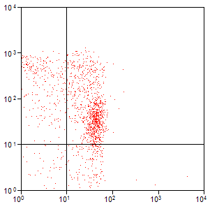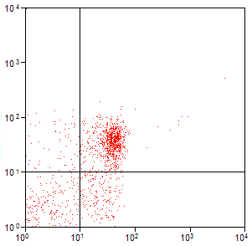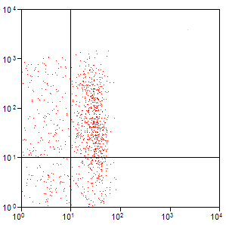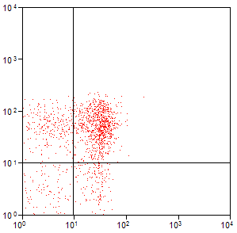
CD28
CD45RO
CD45RA
CD57
KLRG1
KLRG1
KLRG1
KLRG1
CD28
CD45RO
CD45RA
CD57
KLRG1
KLRG1
Younger
Older
KLRG1
KLRG1

Figure 5.7. Representative two parameter flow cytometry dot plots showing distribution of cells co-expressing KLRG1 with CD57, CD28, CD45RA and CD45RO in the CD3+/CD8+ peripheral blood lymphocyte subsets of younger and older subjects. Both axes show the log of the fluorescent intensity.

5.4. Discussion
A
B

The aim of this study was to compare the co expression of KLRG1 with the cell surface senescence markers CD57 and CD28, and the classic naïve and memory phenotype markers CD45RA and CD45RO, on T lymphocyte subsets in younger and older subject groups.

5.4.1. KLRG1 co-expression with CD57 and CD28
It has previously been shown that older individuals have a greater frequency of KLRG1+, CD57+ and CD28- cells in the peripheral blood CD8+ T lymphocyte subset compared to younger individuals (Bruunsgaard et al., 1999; Effros, 2000; Tarazona et al., 2000; Wikby et al., 2000; Ouyang et al., 2003; Brzezinska, 2005), and that these populations are incapable of proliferation in response to antigenic stimulation (Voehringer, Koschella and Pircher, 2002; Brenchley et al., 2003; Ibegbu et al., 2005). A larger proportion of CD45RO+ cells have also been noted in this subset with older individuals (Gabriel, Schmitt and Kindermann, 1993). However, investigations of the co-expression of these markers with KLRG1 within defined T lymphocyte subsets have been limited.

Consistent with previous studies (Bruunsgaard et al., 1999; Effros, 2000; Tarazona et al., 2000; Wikby et al., 2000; Ouyang et al., 2003; Brzezinska, 2005), the older subject group had a greater frequency of KLRG1+, CD57+ and CD28- cells in the CD8+ T lymphocyte subset, suggesting a greater level of senescence with aging in this subset. These results show that the greater frequency of KLRG1+ cells reflects a greater proportion of KLRG1+/CD57+ and KLRG1+/CD28- cells in the older subject group (although these could potentially be one and the same; a subset of KLRG1+/CD57+/CD28- cells within the CD3+/CD8+ population).

The differences, between the subject groups, in the frequency of CD8+ T cells expressing CD57 reflects only a larger proportion of KLRG1+/CD57+ cells in the older subject group. There were no differences in the frequency of KLRG1+/CD57- or KLRG1-/CD57+ cells suggesting that CD8+T lymphocytes acquire both KLRG1 and CD57 with ageing, and not one of KLRG1 or CD57 exclusive of the other. It has previously been suggested that the KLRG1+/CD57+ population is a senescent phenotype and the KLRG1+/CD57- subset a population of effector or central memory cells destined to become senescent (Ibegbu et al., 2005). The role of a KLRG1-/CD57+ subset has yet to be investigated, although it may be possible that KLRG1+/CD57+ cells mature from central memory cells and KLRG1-/CD57+ cells from effector memory cells or vice versa. Alternatively, the latter group may represent the ultimate endpoint of a highly apoptosis resistant memory T cell population, as senescent CD8+ T lymphocytes have been suggested to be apoptosis-resistant (Spaulding, Guo, and Effros, 1999), that has lost expression of KLRG1 on the cell surface. Regardless, this subset appears to make up only a small proportion of the T cell repertoire in both older and younger individuals and as such may be unlikely to adversely impact the immune response severely.

The results suggest that the larger frequency of CD28- cells in the CD8+ T lymphocyte subset of the older subject group does not reflect a greater frequency of KLRG1+/CD28+ cells, but is due to a smaller proportion of KLRG1-/CD28+ and a larger proportion of KLRG1+/CD28- cells. The KLRG1+/CD28+ population of cells has previously been shown to be incapable of proliferation (Voehringer, Koschella and Pircher, 2002) and may represent an intermediate phase in a cell’s transition from a non senescent KLRG1-/CD28+ to a senescent KLRG1+/CD28- phenotype, although further work would be required to address this.

The CD4+ T lymphocyte subset of the older subjects also showed a greater frequency of KLRG1+ cells compared to the younger subjects whilst failing to show a greater frequency of CD57+ or CD28- cells. The greater frequency of KLRG1+ cells in the CD4+ T-cell population with age appears to be a novel finding. While Bruunsgaard et al., (1999) previously showed a significantly smaller frequency of CD4+ T cells to express CD28 in older subjects, no published data were found showing differences between old and young subjects in the frequency of CD4+ T cells expressing CD57. Contrary to Bruunsgaard et al. (1999), the present study found no differences in CD28 expression on the CD4+ T-cell population between the young and older subjects. However, this could be due to the differences in age between the studies, as the subjects used by Bruunsgaard et al. (1999) were significantly older than in this study (age range: 78-80 versus 52-63),

The results did not show any differences between the frequency of CD4+ T cells co-expressing KLRG1 with CD57 or CD28 in the older and younger subject groups, suggesting that the greater frequency of KLRG1+ cells in the older population reflects the overall effect of slight differences in the KLRG1+ sub-populations investigated. This may reflect one of two possibilities. Firstly, KLRG1 expression on CD4+ T cells may define a central or effector cell destined to become senescent, as has been suggested on CD8+ T cells (Ibegbu et al., 2005). If so, then the data suggest that the older subjects have a greater frequency of CD3+/CD4+, non senescent, central memory cells. The reason this population is smaller than in the CD8+ T lymphocyte subset could be due to the lower replication kinetics of CD4 +T cells compared to CD8+ T cells (Foulds et al., 2002) and their ability to up regulate the activity of telomerase, the telomere lengthening enzyme, further into their replicative lifespan (Valanzuela and Effros, 2002). This would enable them to undergo more bouts of clonal expansion than the CD8+ T cell population before becoming senescent (Valanzuela and Effros, 2002). Alternatively, the majority of peripheral blood CD4+/KLRG1+ cells in mice have recently been shown to be CD25+/FoxP3+ regulatory T cells (Treg) (Beyersdorf et al., 2007). The frequency of Tregs in humans has been shown to increase with age (Rosenkranz et al., 2007), and therefore may be partially responsible for the greater frequency of CD4+ T cells expressing KLRG1 in the older subject group. Studies to investigate the level of KLRG1 expression on Tregs in older and younger individuals would be needed to confirm this.

5.4.2. KLRG1 co expression with CD45RA and CD45RO
The results showed a lower frequency of CD45RA+ cells in both the CD8+ and CD4+ T lymphocyte subsets of the older population, consistent with a reduction in the frequency of naïve T lymphocytes in the circulation of older individuals. This difference appears to be due to the lower frequency of KLRG1-/CD45RA+ cells in the older subject group as no differences were seen in the KLRG1+/CD45RA+ populations in either subset.

In the CD3+/CD8+ lymphocyte subset, co-expression of CD45RA with KLRG1 has previously been reported (Voehringer, Koschella and Pircher, 2002) and is likely to denote a virus specific memory cell population that has re-expressed CD45RA (Hamann et al., 1997; Dunne et al., 2002). This population has been reported as an apoptosis-resistant, effector memory cell population capable of proliferation (Dunne et al., 2002), a phenotype consistent with KLRG1 expression as a memory cell marker (Ibegbu et al., 2005) but inconsistent with KLRG1 as a marker of senescence. This study indicates no differences between the frequency of the KLRG1+/CD45RA+ cells in either the CD4+ or CD8+ T lymphocyte subsets from younger and older subjects, suggesting that this phenotype is unlikely to have more than a minor role in the overall impact of senescence with ageing.

Although there was a greater frequency of CD4+ and CD8+ T lymphocyte subsets expressing CD45RO in the older subject group, the differences were not statistically significant, but may reach significance in a larger sample cohort. There was, however, a greater frequency of KLRG1+/CD45RO- cells in the CD8+ T lymphocyte subset of the older subject group. As T lymphocytes express at least one of these markers (Bruunsgaard et al., 1999), it follows that the KLRG1+/CD45RO- population would express CD45RA, suggesting a greater frequency of KLRG1+/CD45RA+ cells in the CD8+ T lymphocyte subset. Although this was shown, the difference was not statistically significant, and perhaps with larger subject numbers this difference would reach statistical significance. Regardless, this result suggests that older individuals have a larger proportion of virus specific T lymphocytes that have re-expressed CD45RA and concurrently express KLRG1, which is consistent with ageing.

In conclusion the results are consistent with an accumulation of senescent T lymphocytes with ageing, as described by the use of established cell surface markers. The novel finding of a larger proportion of KLRG1+ cells in the CD3+/CD4+ of an older subject group needs to be addressed as to whether it truly represents a larger senescent population of cells or a larger population of KLRG1+ Treg cells. Furthermore, this work shows investigation of the co-expression of KLRG1 with other cell surface markers of senescence, such as CD57, CD28, CD45RA or CD45RO, to be important in studying the differences in senescent lymphocyte populations in older and younger individuals as only some of the KLRG1 subpopulations show differences with aging. Work to assess the differing functions of these subpopulations will be important in establishing their impact in the immune dysfunction associated with ageing.

CHAPTER 6

Changes in the frequency of senescent blood T-cells in triathletes during six months training preparation for an Iron man competition
6.1. Introduction

Natural immunity has been shown to be strongly influenced by physical exercise (Drela, Kozdron, and Szczypiorski, 2004), and while it is widely accepted that moderate exercise increases life expectancy and general immune function (Kohut et al., 2002; Barclay and Vega, 2006; Gleeson, 2007), periods of heavy exercise appear trigger an elevation in the level of oxidative stress (Niess et al., 1996; Vider et al., 2001; Shin et al., 2008) and increase the risk of upper respiratory tract infections (URTIs) (Davis et al., 1997; Nieman, 1997; Spence et al., 2007; Murphy et al., 2008) suggesting an immunosuppressive effect of exercise (Pederson and Toft, 2000).

Cellular senescence is a state whereby cells are unable to further proliferate in response to antigenic stimuli. Telomere shortening, due to excessive rounds of cell division over the period of a lifetime, can lead an accumulation of replicatively senescent memory T cells in blood and tissues (Harley, Futcher and Greider, 1990; Akbar, Beverley and Salmon, 2004). States of increased oxidative stress can accelerate the rate of telomere erosion (Petersen, Saretzki, and von Zglinicki, 1998) or trigger senescence independent of telomere shortening by causing single strand breaks in the chromosomal DNA (von Zglinicki, Pilger and Sitte, 2000; Chen et al., 2001; Lorenz et al., 2001; von Zglinicki, 2002) leading to premature senescence.

Memory T cells can be identified by cell surface expression of CD45RO (Hamann et al., 1997). Naïve T cells express CD45RA and up-regulate CD45RO concurrent with loss of CD45RA from the cell surface (Wroblewski and Hamann, 1996; Hamann et al., 1997), although CD45RA can be re-expressed later in the replicative lifespan (Hamann et al., 1997; Dunne et al., 2002). The cell surface glycoprotein CD57 is expressed on T lymphocytes that have a long replicative history, shortened telomeres, an inability to proliferate in response to mitogenic stimuli (Brenchley et al., 2003) and commonly lack expression of the co-stimulatory molecule CD28 on the cell surface (Bruunsgaard et al., 1999). Cell surface expression of the killer cell lectin-like receptor G1 (KLRG1) on T lymphocytes defines a cell type unable to undergo further clonal expansion (Voehringer et al., 2001; Ouyang et al., 2003). As such, KLRG1+, CD57+ and CD28- T lymphocytes have been suggested as populations of senescent cells (Simpson et al., 2007a). However, the co-expression of KLRG1 with CD57 or CD28 may help to more accurately identify the senescent status of a cell (Voehringer, Koschella and Pircher, 2002; Brenchley et al., 2003; Ibegbu et al., 2005; Chapter 5).

Longitudinal studies have shown well-trained athletes to have increased incidences of URTIs (Fahlman and Engles, 2005) and suppressed humoral immunity (Verde et al., 1992). In addition, changes have been noted in the T cell repertoire. Regular high-intensity training has been shown to reduce the CD4/CD8 ratio (Verde et al., 1992; Pizza et al., 1995; Rebelo et al., 1998) whilst increasing the proportion of CD4+ memory T cells expressing CD45RO (Baum, Liesen and Enneper, 1994), and decreasing the proportion of CD4+ naïve T cells expressing CD45RA (Weiss et al., 1995; Hack et al., 1997). Furthermore, in well-trained subjects, an attenuated proliferative T cell response has been noted (Verde et al., 1992; Bury et al., 1998), suggesting regular high-intensity exercise leads to an accumulation of antigen experienced memory cells with reduced proliferative capacity, consistent with the characteristics of senescent T lymphocytes.

During and immediately after bouts of acute exercise, there is an influx of T lymphocytes with shortened telomeres and a senescent cell surface phenotype to the blood compartment, quickly followed by a lymphocytopenia in the recovery phase (Shek et al., 1995; Steensberg et al., 2002; Simpson et al., 2006, 2007a, 2008). These changes are accompanied by an increase in the production of reactive oxygen species and the level of oxidative stress (Niess et al., 1996; Vider et al., 2001; Shin et al., 2008).

Repeated cycles of these events in a high intensity training regime may result in regular spikes in levels of cellular oxidative stress, impacting on the level of immunosenescence through accelerated telomere shortening or telomere independent senescence, leading to an accumulation of senescent T lymphocytes. To date, no studies have investigated the effects of an intensive training programme on the frequency of senescent T lymphocytes in peripheral blood. The aim of this study was to examine the frequency of T lymphocyte subsets expressing the cell surface markers of senescence KLRG1, CD57 and CD28, in a group of club-level triathletes during six months training preparation for an iron man competition.

It is hypothesised that a six month intensive training programme leads to an increase in the frequency of peripheral blood lymphocytes expressing cell surface markers of senescence.
6.2. Materials and methods

6.2.1. Subjects
Subjects were recruited by Craig Neal (Stirling University) from the Stirling Triathlon club and were scheduled to compete in the Zurich Ironman race on July 13th 2008. The subjects were aged 39-50 years old (mean = 42.9 ± 3.1 years, n = 10, comprising 9 males and 1 female). Each subject agreed to provide a blood sample every 6 weeks as per table 6.1. Fasting, resting blood samples were collected in the morning at Stirling University as per the general materials and methods section 2.1. Sample collection started in December 2007, and continued through to August, three weeks after the subjects competed in the Zurich Iron man race.

Table 6.1. Testing dates for Iron man athletes.
Time point | Date of testing
1 | 12th Dec 2007
2 | 31st Jan 2008
3 | 28th Mar 2008
4 | 8th May 2008
5 | 20th June 2008
6 (3 weeks post Iron man race) | 4th Aug 2008

6.2.2. Antibodies
Peripheral blood mononuclear cells (PBMCs) were isolated as per the general materials and methods, section 2.2.1., and labelled with anti-CD3 APC, one of anti-CD4 or anti-CD8 PE Cy-5, one of anti-CD57, anti-CD28, anti-CD45RA or anti-CD45RO PE and anti-KLRG1 Alexafluor 488 monoclonal antibodies where appropriate, before 4-colour flow cytometric analysis using a FACSCalibur flow cytometer equipped with Cell Quest Pro software.

6.2.3. Statistical analysis
Statistical analysis was performed using SPSS version 17 (Chicago, Ilinois). Data was analyzed for time change via a repeated measures, linear mixed model. Subject ID was used as the within subject identifier variable and time was a second, repeated variable. An autoregressive covariance structure was employed in order to compensate for missing data due to unavoidable absences from sampling dates by various subjects. Statistical significance was accepted at p < 0.05.

6.2. Results

6.2.1. Frequency of cell surface subset markers in the total lymphocyte and the CD3+ lymphocyte populations during the six months training.
The frequency of CD3+, CD4+ and CD8+ cells in the total lymphocyte population, and the frequency of CD4+ and CD8+ cells, the CD4/CD8 ratio and the frequency of KLRG1+, CD57+, CD28+, CD45RA+ and CD45RO+ cells in the CD3+ lymphocyte subset are presented in table 6.2. The frequency of CD3+ cells in the total lymphocyte population was significantly lower in August compared to December (43.0%), January (41.9%), March (46.3%) and May (50.6%). The frequency of CD4+ cells in the total lymphocyte population was significantly lower in August compared to December (53.3%), January (52.6%), March (57.4%) and May (61.1%). There were no significant changes in the frequency of CD8+ cells in the total lymphocyte population, or the frequency of CD4+, CD8+, KLRG1+, CD57+, CD28+, CD45RA+ and CD45RO+ cells in the CD3+ lymphocyte subset during the study. Furthermore, there were no significant changes in the CD4/CD8 ratio during the study.

Table 6.2. Frequency of CD3+, CD4+ and CD8+ cells in the total lymphocyte population, and the frequency of CD4+ cells, CD8+ cells, the CD4/CD8 ratio and the frequency of KLRG1+, CD57+, CD28+, CD45RA+ and CD45RO+ cells in the T lymphocyte subset of peripheral blood during six months training. Percentage values are mean ± SD. Significant differences from August are indicated by * (p<0.05) or ** (p<0.01). There were no other significant changes between months. The subject group comprised 9 males and 1 female, aged 39-50.

 | % of all lymphocytes
 | Dec | Jan | Mar | May | Jun | Aug
CD3 | 50.2 ± 8.2* | 49.3 ± 7.1* | 53.4 ± 17.2** | 58.0 ± 12.0** | 41.4 ± 10.4 | 33.1 ±17.9
CD4 | 31.9 ± 9.3* | 31.4 ± 7.3* | 34.9 ± 14.0** | 38.3 ± 10.1** | 25.8 ± 7.7 | 19.5 ± 13.9
CD8 | 20.8 ± 2.1 | 21.9 ± 6.4 | 21.6 ± 6.9 | 19.3 ± 4.7 | 17.0 ± 6.0 | 17.4 ± 10.2
 | % of T lymphocytes
CD4 | 62.8 ± 8.2 | 62.7 ± 10.8 | 62.7 ± 10.6 | 64.1 ± 10.0 | 61.3 ± 10.6 | 52.8 ± 13.1
CD8 | 36.1 ± 9.6 | 35.0 ± 10.1 | 35.1 ± 9.9 | 34.8 ± 8.9 | 32.9 ± 10.8 | 44.4 ± 12.5
CD4/CD8 | 1.9 ± 0.8 | 2.0 ± 0.9 | 2.0 ± 0.9 | 2.0 ± 0.8 | 2.3 ± 4.5 | 1.5 ± 1.1
KLRG1 | 25.8 ± 11.8 | 25.3 ± 13.1 | 29.0 ± 13.2 | 25.4 ±11.1 | 27.2 ± 13.7 | 34.9 ± 18.0
CD57 | 16.3 ± 9.6 | 16.6 ± 11.5 | 16.5 ± 11.1 | 13.3 ± 8.2 | 16.4 ± 12.3 | 20.7 ± 12.8
CD28 | 84.0 ± 11.7 | 84.9 ± 12.2 | 85.0 ± 11.9 | 86.3 ± 9.4 | 86.3 ±12..3 | 79.3 ± 15.6
CD45RA | 57.2 ± 9.5 | 60.0 ± 11.8 | 55.4 ± 10.0 | 45.2 ± 14.0 | 60.3 ± 11.9 | 75.1 ± 9.8
CD45RO | 45.6 ± 10.3 | 45.5 ± 13.7 | 45.8 ± 10.6 | 47.2 ± 10.8 | 48.7 ± 14.1 | 52.4 ± 20.4

6.3.2. Changes in the frequency of senescence, naïve and memory cell markers on T cell subsets
The frequency of KLRG1+, CD57+ and CD28+ cells in the CD3+/CD4+ and CD3+/CD8+ lymphocyte subsets are presented in figure 6.1. In the CD3+/CD4+ lymphocyte subset, the frequency of KLRG1+ cells increased by 71.6% in March compared to December (p < 0.05) , decreased by 30.0% in May compared to March (p = 0.063), and increased by 36.5% in August compared to June. Overall changes in the frequency of KLRG1+ cells in the CD3+/CD8+ lymphocyte subsets were just short of significance (p = 0.065) and compared to January the frequency increased by 20.1% in March (p = 0.065). There were no other significant changes in the frequency of KLRG1+, CD57+ or CD28+ cells in either the CD3+/CD4+ or CD3+/CD8+ lymphocytes subsets.

The frequency of CD45RA+ and CD45RO+ cells in the CD3+/CD4+ and CD3+/CD8+ lymphocyte subsets are presented in figure 6.2. In the CD3+/CD4+ lymphocyte subset the frequency of CD45RA+ cells decreased by 18.9% in May compared to December, increased by 30.9% in June compared to May (p < 0.01) and increased by 26.8% from June to August (p < 0.01). There were no other significant changes in the frequency of CD45RA+ and CD45RO+ cells in the CD3+/CD4+ or CD3+/CD8+ lymphocyte subsets.

6.3.3. Changes in the frequency of the co-expression of the senescence markers in the lymphocyte subsets during the six months training
The changes in the frequency of KLRG1+/CD57+, KLRG1+/CD57- and KLRG1-/CD57+ cells in the CD3+/CD4+ and CD3+/CD8+ lymphocyte subsets are presented in figure 6.3. In the CD3+/CD4+ lymphocyte subset the frequency of KLRG1+/CD57+ cells increased by 192.4% in August compared to December (p < 0.01), a significantly greater frequency than in January (p <0.05), March (p < 0.05), May (p < 0.05) and June (p < 0.01). No significant changes were noted in the frequency of KLRG1+/CD57+ cells in the CD3+/CD8+ lymphocyte subset. In the CD3+/CD4+ lymphocyte subset the frequency of KLRG1+/CD57- cells increased by 42.5% in March compared to January (p = 0.60) and decreased by 47.3% August compared to March (p <0.05). In the CD3+/CD8+ lymphocyte subset, the frequency of KLRG1+/CD57- cells increased by 37.0% in June compared to December (p < 0.05) and increased by 25.6% in August compared to June (p < 0.05). There were no significant changes in the frequency of KLRG1-/CD57+ cells in the CD3+/CD4+ or CD3+/CD8+ lymphocyte subsets during the six months training.

The changes in the frequency of KLRG1+/CD28+, KLRG1+/CD28- and KLRG1-/CD28+ cells in the CD3+/CD4+ and CD3+/CD8+ lymphocyte subsets during the six months training are presented in figure 6.4. There were no significant changes in the proportion of KLRG1+/CD28+, KLRG1+/CD28- and KLRG1-/CD28+ cells in the CD3+/CD4+ or CD3+/CD8+ lymphocyte subsets during the six months training.

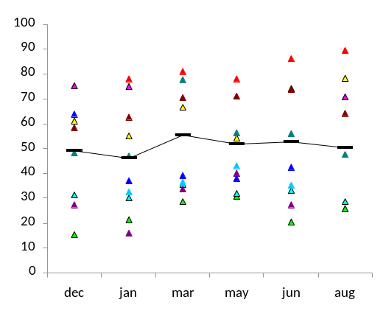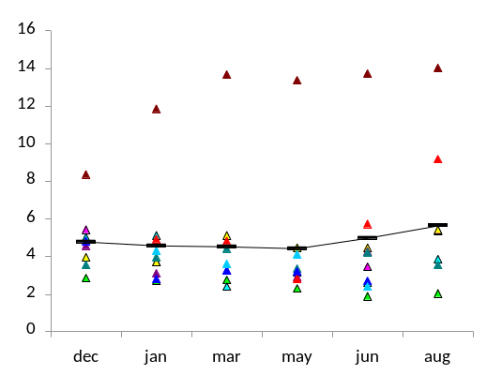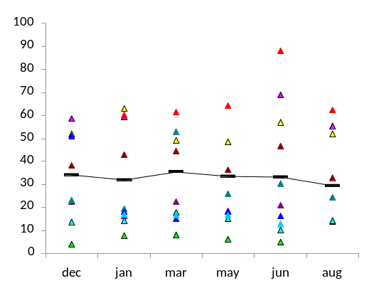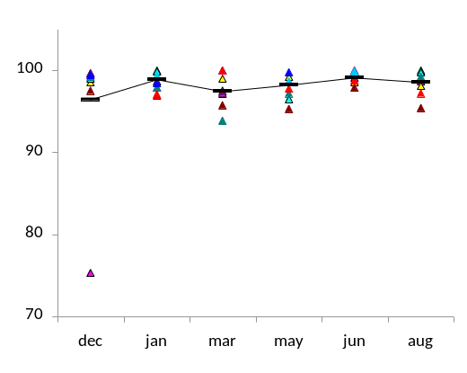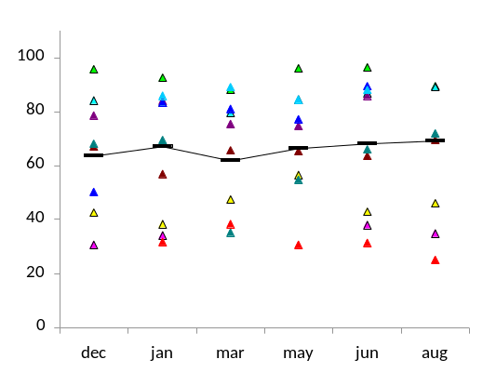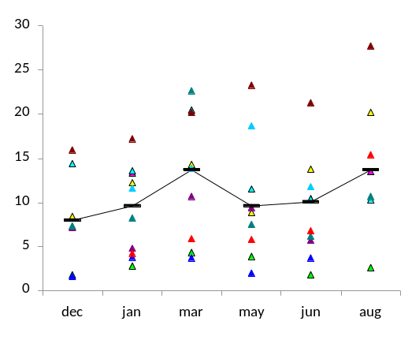
CD3+/CD4+
CD3+/CD8+
*
% KLRG1+ cells
% CD57+ cells
% CD28+ cells
Figure 6.1. Changes in the frequency of KLRG1+, CD57+ and CD28+ cells in the CD3+/CD4+ and CD3+/CD8+ lymphocyte subsets during six months training preparation for an iron man. Each symbol indicates a different subject except for the linked black bars which indicate the mean values. Significant differences between two time points are indicated by the horizontal black line and the level of significance by * (p < 0.05). The subject group comprised 9 males and 1 female, aged 39-50.
% KLRG1+ cells
% CD57+ cells
% CD28+ cells

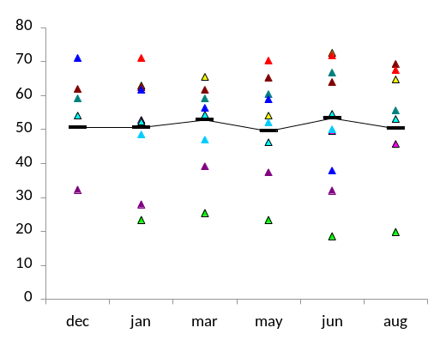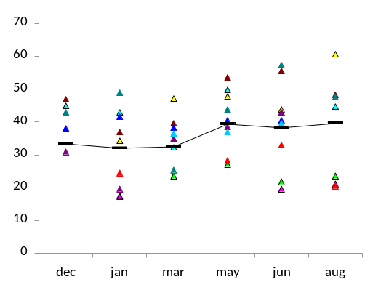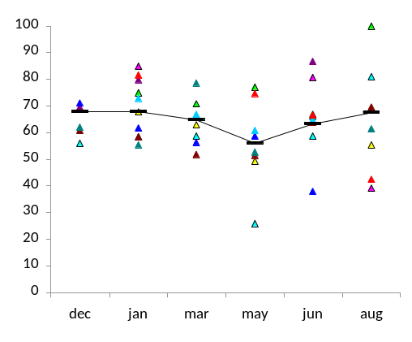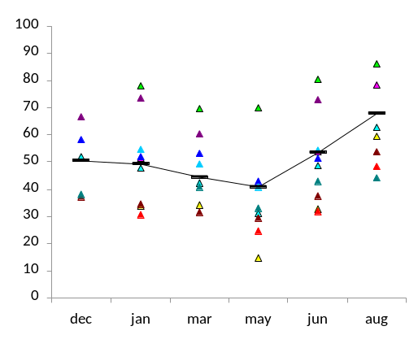
CD3+/CD4+
CD3+/CD8+
*
**
**
**
**
**
% CD45RA+ cells
% CD45RO+ cells
Figure 6.2. Changes in the frequency of CD45RA+ and CD45RO+ cells in the CD3+/CD4+ and CD3+/CD8+ lymphocyte subsets during six months training preparation for an iron man. Each symbol indicates a different subject except for the linked black bars which indicate the mean values. Significant differences between two time points are indicated by the horizontal black line and the level of significance by * (p < 0.05) or ** (p < 0.01). The subject group comprised 9 males and 1 female, aged 39-50.
% CD45RA+ cells
% CD45RO+ cells

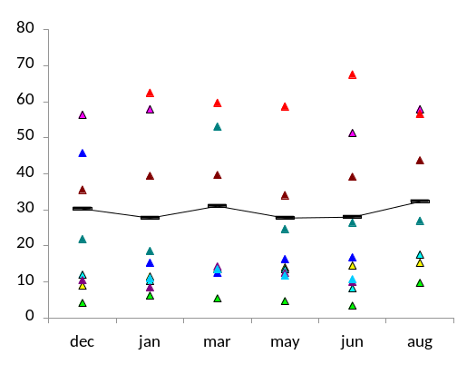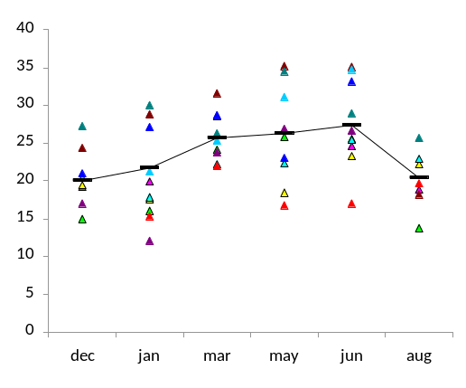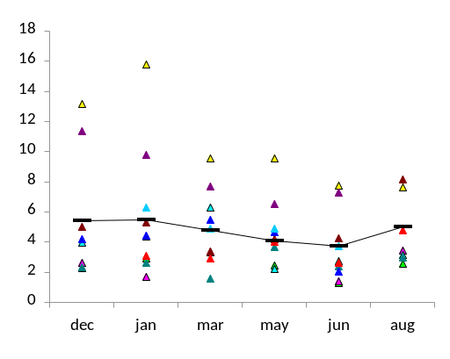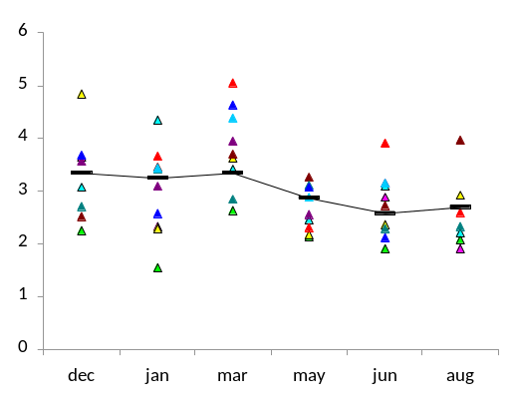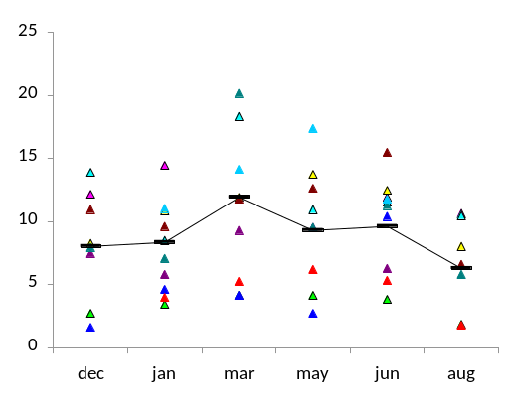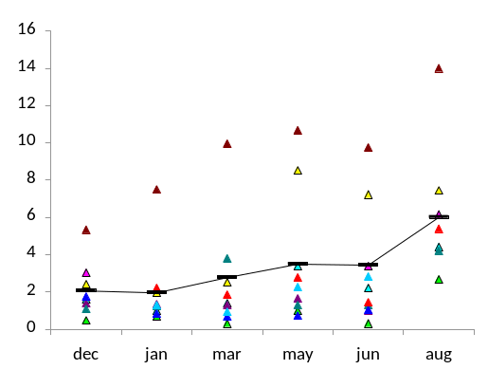
% KLRG1-/CD57+ cells
% KLRG1+/CD57- cells
% KLRG1+/CD57+ cells
*
% KLRG1-/CD57+ cells
% KLRG1+/CD57- cells
% KLRG1+/CD57+ cells
*
**
*
*
**
CD3+/CD4+
CD3+/CD8+
*
Figure 6.3. Changes in the frequency of KLRG1+/CD57+, KLRG1+/CD57-, KLRG1-/CD57+ cells in the CD3+/CD4+ and CD3+/CD8+ lymphocyte subsets during six months training preparation for an iron man. Each symbol indicates a different subject except for the linked black bars which indicate the mean values. Significant differences between two time points are indicated by the horizontal black line and the level of significance by * (p < 0.05) or ** (p < 0.01). The subject group comprised 9 males and 1 female, aged 39-50.

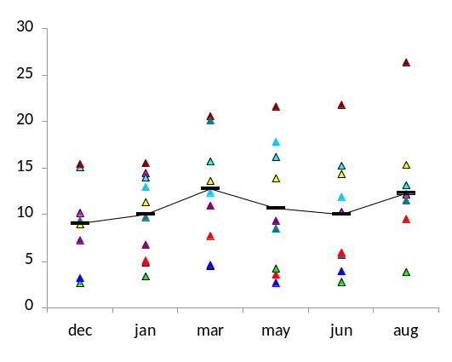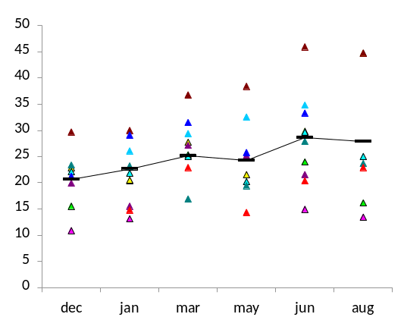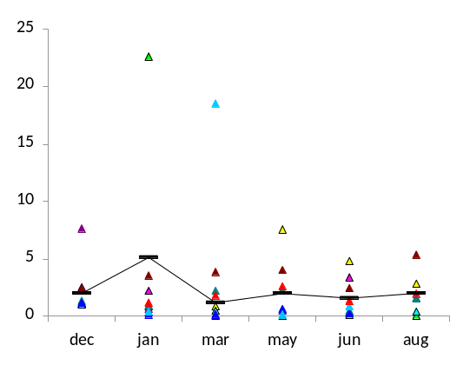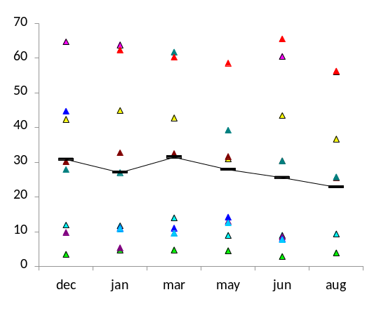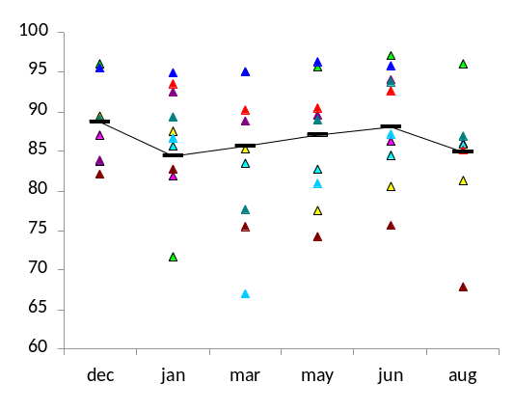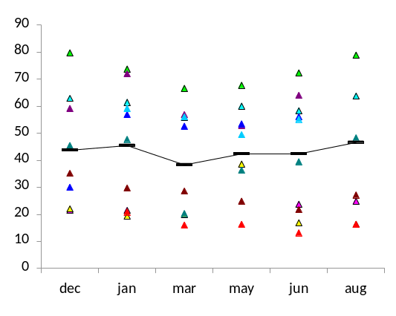
% KLRG1+/CD28+ cells
% KLRG1+/CD28- cells
% KLRG1-/CD28+ cells
CD3+/CD4+
CD3+/CD8+
% KLRG1+/CD28- cells
% KLRG1+/CD28+ cells
% KLRG1-/CD28+ cells
Figure 6.4. Changes in the frequency of KLRG1+/CD28+, KLRG1+/CD28-, KLRG1-/CD28+ cells in the CD3+/CD4+ and CD3+/CD8+ lymphocyte subsets during six months training preparation for an iron man. Each symbol indicates a different subject except for the linked black bars which indicate the mean values. No significant changes were noted. The subject group comprised 9 males and 1 female, aged 39-50.
6.3.4. Changes in the frequency of CD4+ and CD8+ T lymphocytes co-expressing the naïve and memory cell markers, CD45RA and CD45RO
Changes in the frequency of CD45RA+/CD45RO+ cells were noted in the CD3+/CD4+ and CD3+/CD8+ lymphocyte subsets during the six months training (p < 0.01). In the CD3+/CD4+ lymphocyte subset, the frequency of CD45RA+/CD45RO+ cells did not change significantly from December to May, but increased by 141.5% in June compared to May (p < 0.01) and increased, although not significantly, by 29.3% in August compared to June. In the CD3+/CD8+ lymphocyte subset, the frequency of CD45RA+/CD45RO+ cells did not change significantly between December and May, but increased by 115.5% in June compared to May (p < 0.01), and decreased, although not significantly, by 24.7% in August compared to June. In the CD3+/CD4+ lymphocyte subset the frequency of CD45RA+/CD45RO- cells decreased by 31.2% in August compared to December, to a frequency significantly lower than at the rest of the time points (p < 0.05 compared to March , May and June, and p < 0.01 compared to December and January). In the CD3+/CD8+ lymphocyte subset there were no significant changes in the frequency of CD45RA+/CD45RO- cells during the 6 months training. In the CD3+/CD4+ lymphocyte subset, there were no significant changes in the frequency of CD45RA-/CD45RO+ cells during the 6 months training. In the CD3+/CD8+ lymphocyte subset, the frequency of CD45RA-/CD45RO+ cells increased by 47.1% in May compared to January (p = 0.093), decreased by 36.2% in June compared to May (p < 0.05) and then increased by 73.8% in August compared to June (p < 0.01).
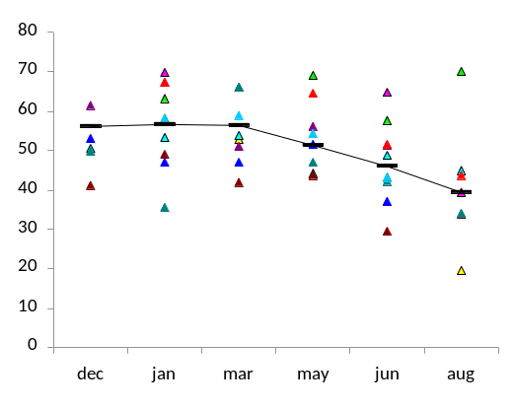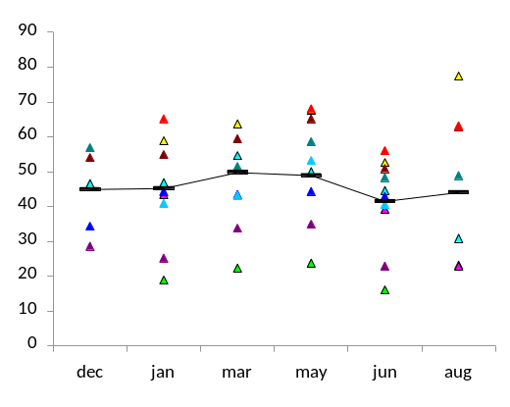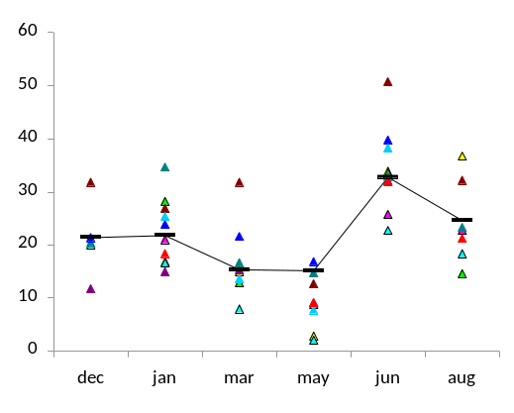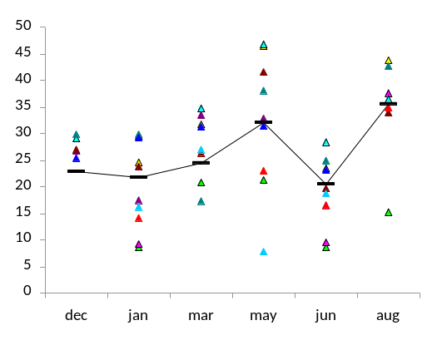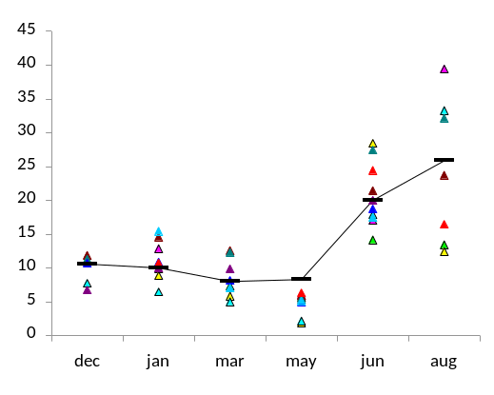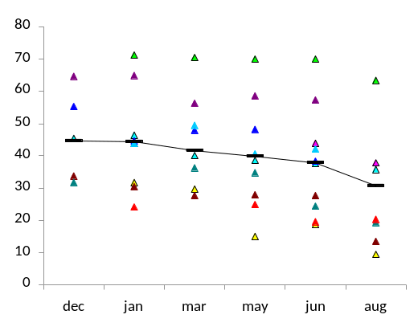
% CD45RA+/CD45RO- cells
% CD45RA-/CD45RO+ cells
**
**
**
*
**
**
**
**
**
**
*
*
**
**
*
*
*
% CD45RA+/CD45RO+ cells
% CD45RA+/CD45RO- cells
% CD45RA-/CD45RO+ cells
CD3+/CD8+
CD3+/CD4+
% CD45RA+/CD45RO+ cells
Figure 6.5. Changes in the frequency of CD45RA+/CD45RO+, CD45RA+/CD45RO-, CD45RA-/CD45RO+ cells in the CD3+/CD4+ and CD3+/CD8+ lymphocyte subsets during six months training preparation for an iron man. Each symbol indicates a different subject except for the linked black bars which indicate the mean values. Significant differences between two time points are indicated by the horizontal black line and the level of significance by * (p < 0.05) or ** (p < 0.01). The subject group comprised 9 males and 1 female, aged 39-50.

6.4. Discussion

The aim of this study was to examine the frequency of T lymphocyte subsets expressing the cell surface markers of senescence KLRG1, CD57 and CD28, and naïve (CD45RA) and memory (CD45RO) cells in a group of club-level triathletes during six months training preparation for an iron man competition.

6.4.1. Changes in the frequency of KLRG1+, CD57+ and CD28+ T lymphocytes
The initial peak increase from December to March in the frequency of KLRG1+ cells in the CD4+ T lymphocyte subset appears to be due to an increase in the frequency of KLRG1+/CD57- cells, whilst the increase from May to August appears to be a result of the accumulation of KLRG1+/CD57+ cells. This is intriguing as the KLRG1+/CD57+ and KLRG1+/CD57- populations have been suggested as functionally diverse (Ibegbu et al., 2005; Sarkar et al., 2008; Chapter 5). CD57 expression on CD8+ T cells defines a population of cells with shortened telomeres and an inability to proliferate in response to antigenic stimulation (Brenchley et al., 2003) suggesting it as a marker of senescence. Although KLRG1 expression on CD8+ T cells has also been shown to define cells with a history of cell division and reduced capacity for proliferation in response to antigen (Voehringer, Koschella and Pircher, 2002), it has also been shown to be expressed with Ki67, a nuclear marker of an ability to replicate, casting doubt on reliability of KLRG1 expression as a marker of senescent T lymphocytes (Ibegbu et al., 2005). However, care must be taken in drawing conclusions from these data as Ibegbu et al., (2005) did not investigate the replicative capacity of the KLRG1+/Ki67+ population, so it remains unclear which is the better marker of proliferative ability. In the CD8+ lymphocyte subset, the KLRG1+/CD57- population has been suggested to be a subset of memory cells destined to become senescent, whereupon they would up-regulate CD57 (Brenchley et al., 2003; Ibegbu et al., 2005). The same rationale may be applicable to the CD4+ T lymphocyte subset and as such, the data may suggest an accumulation of non-senescent KLRG1+ memory cells in the first few months of training, which become senescent and up-regulate CD57, with continued high levels of training during the next three months. The mechanism for this could be due to increased levels of oxidative stress associated with repeated acute bouts of intense exercise (Niess et al., 1996; Vider et al., 2001; Shin et al., 2008). This could potentially cause telomere damage triggering premature senescence via telomere dependent or independent mechanisms (Sitte, Saretzki and von Zglinicki, 1998; von Zglinicki, Pilger, and Sitte, 2000; Chen et al., 2001) leading to the acquisition of a senescent phenotype. However, as intense exercise has also been correlated with increased incidences of URTIs (Davis et al., 1997; Nieman, 1997; Spence et al., 2007; Murphy et al., 2008), it may be that the extra rounds of clonal expansion required in response to more frequent viral encounters results in an accumulation of senescent cells. Alternatively, changes in the frequency of CD4+ T lymphocytes expressing KLRG1+ during the six months training may be due to alterations in the frequency of regulatory T cells (Tregs). CD4+ Tregs are highly proliferative and can be defined by their expression of CD25 at a high fluorescent intensity (Sakaguchi, 2004; Beyersdorf et al., 2007; Kim, Rasmussen and Rudensky, 2007). Furthermore, the majority of CD4+ Tregs in mice are KLRG1+ (Beyersdorf et al., 2007), and although it has not been investigated, the same may be true in humans. Long term, moderate training has been shown to lead to an accumulation of CD4+/CD25+ T lymphocytes (Crist et al., 1989; Broadbent and Gass, 2008) a cell population that could also express KLRG1.

Despite no changes in the frequency of KLRG1+ or CD57+ cells in the CD3+/CD8+ lymphocyte subset, an increase in the frequency of KLRG1+/CD57- cells was seen from December to June, followed by a decrease back to base level between June and August. If KLRG1 expression without CD57 expression does define a memory cell as opposed to a senescent cell, then the data suggest an accumulation of CD8+ memory T cells with training, followed by a relatively rapid decrease in the three weeks following the Iron man race.

There were no changes in the frequency of CD28+ cells in the CD3+/CD4+ and CD3+/CD8+ lymphocyte subsets during the six months training. This was surprising considering that previous data have shown larger proportions of KLRG1+ cells in a T cell subset to be reflected by a smaller proportion of CD28+ cells in the same subset (Chapters 4 and 5). However, there were no significant changes in the frequency of CD57+ cells in the CD4+ and CD8+ T lymphocyte subsets suggesting that perhaps CD28 loss is more closely linked with CD57 expression than KLRG1 expression on T lymphocytes. Indeed, previous data have shown the proportion of CD28- cells in a T lymphocyte subset to be more closely correlated with the proportion of CD57+ cells than the proportion of KLRG1+ cells (Chapter 4), and KLRG1 has been shown to be co-expressed with CD28 in CD4+ and CD8+ T lymphocyte subsets (Voehringer, Koschella and Pircher, 2002; Chapter 5).

6.4.2. Changes in the frequency of CD45RA+ and CD45RO+ T lymphocytes
There was a steady decrease in the frequency of CD45RA+ cells in the CD4+ T lymphocyte subset from until May, followed by a significant increase in June to above base level, and then again in August. There appeared to be no changes in the frequency of CD45RO+ cells in the CD4+ T lymphocyte subset during the six months training. The frequency of CD45RA+ cells in the CD8+ T lymphocyte subset decreased from December to May followed by an increase back to base level from May to August. Although this was similar to the profile in the CD4+ T lymphocyte subset, there wasn’t an accumulation of CD45RA+ cells in June and August i.e. leading up to the iron man race and three weeks after. There was a slight increase in the proportion of CD45RO+ cells in the CD8+ T lymphocyte subset during the six months training, however, this was not a significant increase.

CD45RA and CD45RO have been suggested as markers of naïve and memory phenotypes on T cells respectively (Wroblewski and Hamann, 1996; Hamann et al., 1997) and as such, changes in the frequency of CD45RA+ cells should be reflected by reciprocal changes in the frequency of CD45RO+ cells, which is not the case in the CD4+ T lymphocyte subset in this study. Some memory cells are capable of expressing both CD45RA and CD45RO, either during initial activation of the naïve T cell (Visser, Lai and Poppema, 1993; Summers, O’Donnell and Hart, 1994; Wroblewski and Hamann, 1996) or late in the replicative lifespan of a memory cell where CD45RA is re-expressed (Hamann et al., 1997; Dunne et al., 2002). This would suggest that cells expressing CD45RO are memory cells (regardless of CD45RA expression), and that CD45RA+ cells that do not express CD45RO are true naïve T cells. Indeed, there is a steady decrease in the frequency of “true” naïve cells (CD45RA+/CD45RO-) from December to a significantly lower level in August, than at any of the other time points. The increase from May to August noted in the frequency of CD45RA+ cells in the CD4+ T lymphocyte subset appears to be due to an increase in the frequency of CD45RA+/CD45RO+ cells, as there was a significant increase from May to June, followed by a further increase to from June to August. There were no changes in the frequency of CD45RA-/CD45RO+ memory cells in the CD4+ T lymphocyte subset during the six months training. These data are consistent with a decrease in the frequency of naïve cells and an increase in the frequency of memory cells in the CD4+ T lymphocyte subset during the six months training.

Despite no observed changes in the frequency of CD45RA+ or CD45RO+ cells in the CD8+ T lymphocyte subset during the six months training, there were changes apparent when looking at the co-expression of these markers. Similar to the CD4+ T lymphocyte subset, there was a steady decrease noted in the frequency of CD45RA+/CD45RO- cells from March to August suggesting a decrease in the frequency of naïve cells with exercise, consistent with previous studies (Weiss et al., 1995; Hack et al., 1997). Following an initial increase from January to May, there was a significant decrease in the frequency of CD45RA-/CD45RO+ cells from May to June, followed by a sharp increase in August. This profile is mirrored in the frequency of CD45RA+/CD45RO- cells, where an initial decrease from December to May was followed by a sharp increase from May to June and a further decrease from June to August. These changes in the CD8+ T lymphocytes suggest that in the final four months of training there were dynamic changes occurring in the memory cell population accompanied by a steady decrease in the frequency of naïve cells. This may be a result of extensive activation of T lymphocytes in response to the intensive training, triggering a transition from a naïve to memory phenotype.

In summary, the changes in the frequency of naïve and memory cells in the CD4+ T lymphocyte are consistent with the accumulation of KLRG1+/CD57+ cells during the six months training. In the CD8+ T lymphocyte subset, there appears to be a much more dynamic response in the frequency of memory and naïve cells, to six months training. An accumulation of KLRG1+/CD57+ cells was not seen, although a similar profile in the frequency of KLRG1+/CD57- cells was noted in the CD4+ and CD8+ T lymphocyte subsets. If, as discussed, the KLRG1+/CD57- population are memory cells that up regulate CD57 to become KLRG1+/CD57+ when entering a senescent state, these data could indicate that the transition of a KLRG1+ memory cell to a CD57+ senescent cell may be differentially regulated in the CD4+ and CD8+ T lymphocyte subsets in response to exercise.

The limitation of this study is the lack of a control group. As such, the baseline measurements from each subject, collected in December before the start of the six months training, was used to compare with the measurements taken at the other time points. Although a non training subject group providing blood samples on the same days as the active subjects would have been preferable as a control for this study, previous data sampling the non training individuals at different time points over a 3 year period have suggested that changes in frequency of the cell surface proteins measured in this study are not significant in such a group (unpublished data). As such, the data changes observed in this study are likely to represent true, exercise related changes, and not seasonal or time related variations.

This study suggests an increase in the frequency of senescent T cells with intense training. This could lead to increasing immunosuppression of well trained athletes with regular high intensity training, perhaps contributing to the greater incidences of URTIs in these individuals (Davis et al., 1997; Nieman, 1997; Spence et al., 2007; Murphy et al., 2008).

CHAPTER 7

The frequency of peripheral blood senescent T lymphocytes in obesity

7.1. Introduction

Obesity is a growing problem in the developed world with over half the population of several developed countries overweight and obese (The Scottish Health Survey, 2003). Recently, the mean weight of the population of the UK was shown to fall within the overweight classification (The Scottish Health Survey, 2003) based on body mass index (BMI) of over 25kg/m². Obesity is linked with an array of serious health disorders such as cardiovascular disease (CVD), type 2 diabetes mellitus, hypertension, cancer and osteoarthritis (World Health Organisation, 2003). It has been predicted that the direct cost of obesity to the Scottish Health Service could rise to over £300M per annum by 2025 (The Scottish Health Survey, 2003).

Obesity is often associated with immunosuppression. Indeed, recent studies have shown that overweight children have reduced tetanus antibody titres (Eliakim et al., 2006) and obese patients have problems with wound healing after surgical operations (Munoz, Mazure and Culebras, 2004) as well as having increased risk of surgical site infection, nosocomial infection, ondontogenic infections, respiratory infection, gastrointestinal, liver and biliary infections, urogenital infections, skin infections, and bone and joint infections (Munoz, Mazure and Culebras, 2004; Falagas and Kompoti, 2006). In addition, obesity is a risk factor for CVD (Haslam, Sattar and Lean, 2006) and a state of chronic inflammation (Dandona, Aljada and Bandyopadhyay, 2004), contributing to increased levels of oxidative stress (Furukawa et al., 2004).

Telomere shortening due to excessive rounds of cell division can lead to replicative senescence (Harley, Futcher and Greider, 1990). Increased states of oxidative stress can increase the rate of telomere erosion (Petersen, Saretzki, and von Zglinicki, 1998) or trigger senescence independent of telomere shortening by causing double strand breaks in the chromosomal DNA (von Zglinicki, Pilger, & Sitte, 2000; Chen et al., 2001; Lorenz et al., 2001; von Zglinicki, 2002). In humans, T lymphocytes with shortened telomeres, a long replicative history and an inability to proliferate in response to mitogenic stimuli have been shown to express the natural killer (NK) cell marker CD57 (Brenchley et al., 2003), and lack expression of the co-stimulatory molecule CD28 on the cell surface (Bruunsgaard et al., 1999). Furthermore, the killer cell lectin-like receptor G1 (KLRG1) has been identified as a possible marker of senescence on human and mouse T lymphocytes (Voehringer et al 2001; Voehringer Koschella and Pirher, 2002). KLRG1+ T lymphocytes are unable to undergo further clonal expansion and accumulate with age in humans (Voehringer et al., 2001; Ouyang et al., 2003; Beyersdorf et al., 2007).

The classic naïve and memory cell markers CD45RA and CD45RO have been described as reciprocal markers on T lymphocytes (Bruunsgaard et al., 1999) although they are capable of being co-expressed on ‘transitional’ subsets of T lymphocytes after antigenic encounter (Visser, Lai and Poppema, 1993; Summers, O’Donnell and Hart, 1994). Furthermore, CD45RO+ memory T lymphocytes are able to re-express CD45RA late in their replicative lifespan (Hamann et al., 1997), giving rise to a population of CD45RA+ memory T lymphocytes shown to express CD57 and KLRG1 (Brenchley et al., 2003; Ibegbu et al., 2005).

Leukocyte telomere length has been shown to be inversely correlated with BMI in women (Valdes et al., 2005). In addition, peripheral blood lymphocyte telomere length has been shown to be predictive of CVD (Nakashima et al., 2004) and accumulation of senescent T lymphocytes has been correlated with indices of CVD (Buja and Willerson 1994;, 1995; Liuzzo et al., 1999, 2000; Samani et al., 2001; Brouilette et al., 2003; Obana et al., 2003; Gerli et al., 2004; Starr et al., 2006; van der Harst et al., 2007). As such, immune cell senescence appears to play a role in obesity and obesity related illnesses.

The mechanisms by which obesity may contribute to premature immune cell senescence are unclear. However, the increased level of oxidative stress associated with obesity (Epel et al., 2004; Valdes et al., 2005) may play a role through telomere dependent and/or independent mechanisms as previously discussed (Chapter 4). The effects of leptin may also play a role. Leptin is an energy homeostasis protein secreted by adipocytes (Kershaw and Flier, 2004), the blood serum concentration of which is correlated with increases in BMI (Matarese, Moschos and Mantzoros, 2005) and shortened blood leukocyte telomeres (Valdes et al., 2005). Furthermore, Leptin is capable of enhancing activation and proliferation of circulating CD4+ and CD8+ T lymphocytes and eliciting a shift to a more Th1 cytokine-profile response (Martίn-Romero et al., 2000; Lord et al., 2001; Mito et al., 2003; Goldberg et al., 2005). This could accelerate telomere shortening and contribute to an increased level of immune cell senescence in obese individuals.

With such a range of factors affecting telomere length and senescence over the period of a lifetime in humans (Chapter 4), a mouse model of obesity could provide an insight into the effect of obesity on the frequency of lymphocytes expressing cell surface markers of immunity. Murine studies investigating immune cell senescence have frequently examined peripheral blood lymphocytes and splenocytes (Connoy, Trader and High, 2005; Beyersdorf et al., 2007). Previous work has shown age related increases in the frequency of CD28+ cells in CD3+/CD4+ and CD3+/CD8+ splenocytes of DBA/2 mice, with no changes in the same subsets in the peripheral blood (Connoy, Trader and High, 2005). The expression of KLRG1 on murine T lymphocytes is an indicator of a long replicative history and defines cells incapable of proliferation in response to mitogenic stimulation (Voehringer et al., 2001; Ortiz-Suárez and Miller, 2002; Beyersdorf et al., 2007). However, weight-related changes in murine splenocytes and peripheral blood lymphocytes have not been well defined. To date there have been no studies that have looked at cell surface markers of cellular senescence on T lymphocytes of obese and lean mice.

The co-expression of KLRG1 with CD57 or CD28 appears to be a more accurate cell surface marker at identifying changes in the frequency of senescent cells than expression of just one of these proteins (Chapter 5). As such, this study will investigate the frequency of KLRG1 co-expressed with CD57, CD28, CD45RA and CD45RO in an obese human male subject group compared to a lean, healthy human male control group. In addition, the frequency of KLRG1+ and CD28+ cells in murine CD3+/CD4+ and CD3+/CD8+ peripheral blood lymphocyte and splenocyte subsets will be investigated in a mouse model of obesity.

It is hypothesised that obese subjects have a greater frequency of peripheral blood T lymphocytes expressing the aforementioned cell surface markers of senescence compared to healthy, lean, controls.
7.2. Materials and methods

7.2.1. Human Subjects
All human subjects were recruited by Dr. Stuart Galloway and Khalid Al-Jaloud (University of Stirling). Intravenous blood samples were drawn as described in the general materials and methods section 2.1. The age, BMI and percentage body fat of the lean and obese groups are presented in table 7.1. Height and weight measurements were used to calculate BMI of each group and percentage body fat of both groups was determined by bioelectrical impedance. None of the subjects were on any medication, and were free of any infectious illness for 6 weeks prior to the study. The subjects gave written informed consent and ethical approval was granted by the institution.

Table 7.1. The age, BMI and % body fat of the lean (n = 10) and obese subjects (n = 10). All values are mean ± SD. Statistically significant differences from the lean subject group are indicated by ** (p<0.01).

 | Subject group
 | lean | obese
Age | 30.6 ± 10.6 | 40.1 ± 9.7
BMI | 22.2 ± 0.7 | 29.4 ± 4.1**
% body fat | 13.8 ± 3.1 | 27.8 ± 4.8**

7.2.2. Animals
7.2.2.1. Rearing and care of animals
Male CD-1 mice (Charles River Laboratories, Wilmington, MA, USA) were purchased and raised to an age of 12 months by Dr. Brian McFarlin in the University of Houston (TX, USA) animal care facility on a standard 12:12 light dark cycle with ad libitum access to standard rodent chow and water. Mice were housed three to a cage during acclimation and all subsequent experiments. At the end of the 12th month, the rodent chow was switched so that mice consumed either a high-fat (60% of calories from fat, n=3) or low-fat diet (10% of calories from fat, n=5). The high and low fat diets were purchased from Research Diets Inc (New Brunswick, NJ, USA). Combined cage weights of mice (all animals in the same cage) were collected at the beginning and end of the diet modification period. Mice consumed either the high-fat or low-fat diet for 9-weeks prior to tissue collection.
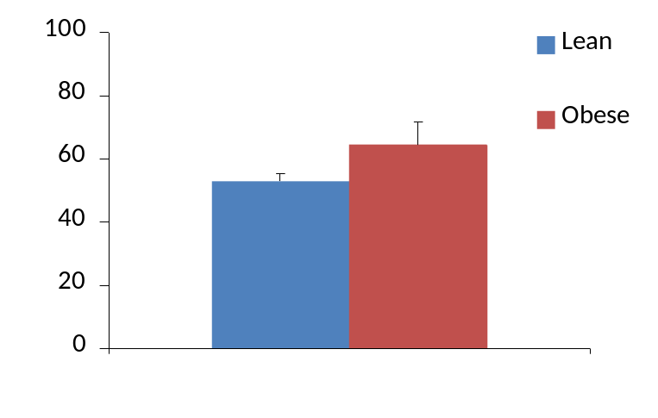
Weight of mice (gms)
**

Figure 7.1. The weights of the lean (n = 3) and obese (n = 5) mice on the day of sacrifice. All values are mean ± SD. Significant differences from the lean group are indicated by ** (p<0.01).

7.2.2.2. Organ and peripheral blood collection
All sacrifice and tissue collections were completed at the beginning of the light cycle (0700 hours) by Dr. Brian McFarlin. Mice were injected intra-peritoneally with xylazine-ketamin solution, and once they lacked a foot pressure response on all four feet the thoracic cavity was opened, the mice were killed by exsanguination and blood was collected from the vena cava into a tube treated with sodium heparin. The spleen was removed and stored in Phosphate Buffered Saline, prior to mononuclear cell isolation.

7.2.3. Mononuclear cell isolation and staining with monoclonal antibodies
Mononuclear cells were isolated from peripheral blood and spleens as per the general materials and methods section 2.2.1.

7.2.3.1. Animals
Isolated mononuclear cells were stained with anti-CD3e APC, anti-CD28 PE, anti-KLRG1 FITC and one of anti-CD4 (L3T4) or CD8a (Ly-2) PE-Cy7 monoclonal antibodies where appropriate before flow cytometric analysis using a FACSAria LSR II flow cytometer equipped with FACSDiva software.

7.2.3.2. Human subjects
Isolated peripheral blood mononuclear cells were labelled with anti-CD3 APC, anti-KLRG1 Alexafluor 488, one of anti-CD4 or anti-CD8 PECy-5, and one of anti-CD57, anti-CD28, anti-CD45RA or anti-CD45RO PE monoclonal antibodies where appropriate before flow cytometric analysis using a FACSCalibur flow cytometer equipped with Cell Quest Pro software.

7.2.4. Statistical analysis
All data are presented as mean ± SD. Differences between subject groups were assessed using 2-sample t-tests where data were normally distributed and Mann-Whitney U-tests where data were not normally distributed. Statistical significance was accepted at p<0.05. All statistics were done using Minitab 15.
7.3. Results

7.3.1. Human Study
The frequency of CD3+, CD4+, CD8+ cells on all lymphocytes, and the frequency of CD4, CD8, KLRG1+, CD57+, CD28+, CD45RA+ and CD45RO+ cells on the CD3+ lymphocyte subset is presented in table 7.2.

Table 7.2. The frequency of senescence, memory and naïve markers on peripheral blood lymphocytes from lean and obese human subject groups. Values are mean ± SD. There were no significant differences between the two groups. All subjects were male, and aged 19-55 years (n = 10 for each subject group).

 | % all lymphocytes
 | lean | obese
CD3+ | 57.9 ± 9.9 | 52.3 ± 14.2
CD4+ | 36.6 ± 7.6 | 31.7 ± 9.3
CD8+ | 19.7 ± 7.0 | 21.1 ± 8.2
 | % T lymphocytes
CD4+ | 62.1 ± 10.9 | 60.7 ± 8.6
CD8+ | 30.9 ± 9.9 | 36.2 ± 8.2
KLRG1+ | 21.4 ± 9.0 | 26.9 ± 12.3
CD57+ | 12.0 ± 5.5 | 17.7 ± 7.4
CD28+ | 87.7 ± 5.3 | 81.8 ± 9.8
CD45RA+ | 78.4 ± 10.8 | 73.5 ± 14.9
CD45RO+ | 38.6 ± 10.9 | 48.3 ± 16.6

The frequency of KLRG1+, CD57+, CD28+, CD45RA+ and CD45RO+ cells in the CD3+/CD4+ and CD3+/CD8+ lymphocyte subsets of the lean and obese subject groups is presented in Figure 7.2. No significant differences in the frequency of these markers were seen between the lean and obese subject groups in the CD3+/CD4+ lymphocyte subset. In the CD3+/CD8+ lymphocyte subset the obese subject group had a greater frequency of CD57+, CD28- and CD45RO+ cells (p<0.05). The obese subject group also had a greater frequency of KLRG1+ cells in the CD3+/CD8+ subset, although this difference fell short of statistical significance (p = 0.059). Representative flow cytometric histograms showing the frequency of KLRG1+, CD57+, CD28+, CD45RA+ and CD45RO+ cells in the CD3+/CD4+ lymphocyte subsets of lean and obese subjects are presented in Figure 7.3. Representative flow cytometric histograms showing the frequency of KLRG1+, CD57+, CD28+, CD45RA+ and CD45RO+ cells in the CD3+/CD8+ lymphocyte subsets from lean and obese subjects are presented in Figure 7.4.

A
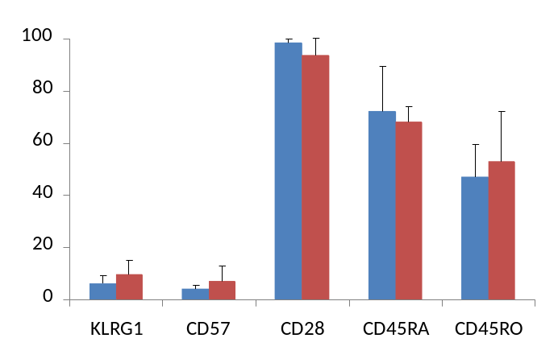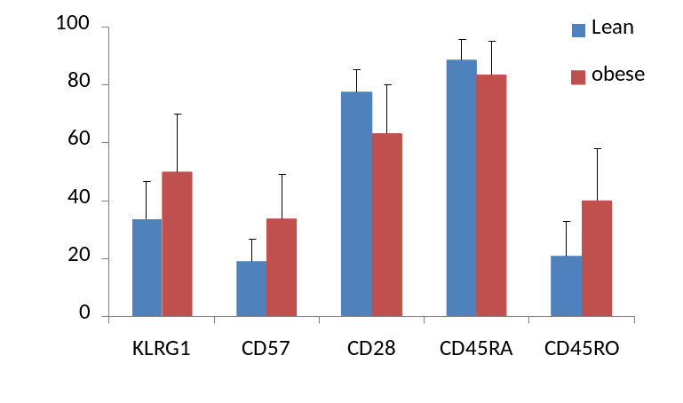
*
*
*
% positive cells
% positive cells
B
Figure 7.2. The frequency of the killer cell lectin-like receptor G1+ (KLRG1), CD57+, CD28+, CD45RA+ and CD45RO+ cells in the CD3+/CD4+ (A) and CD3+/CD8+ (B) lymphocyte subsets in obese and lean human subject groups. Values are mean ± SD and statistically significant differences from the lean subject group are indicated by * (p<0.05). All subjects were male, and aged 19-55 years (n = 10 for each subject group).

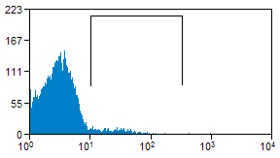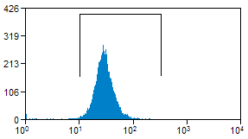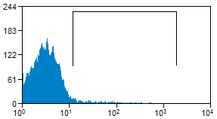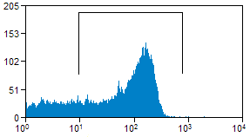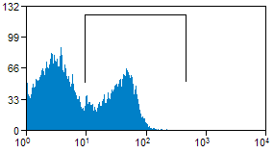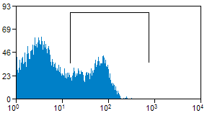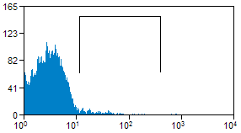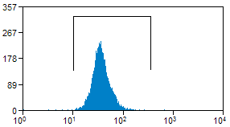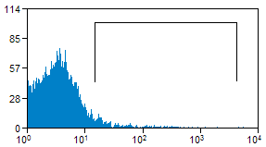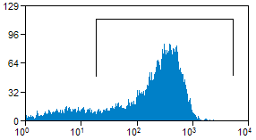
KLRG1
KLRG1
CD57
CD57
CD45RA
CD45RA
CD28
CD28
CD45RO
Count
Count
Count
Count
Count
Count
Count
Count
Count
Count
CD45RO
Lean
Obese
Figure 7.3. Representative flow cytometric histograms showing the frequency of KLRG1+, CD57+, CD28+, CD45RA+ and CD45RO+ cells in the CD3+/CD4+ peripheral blood lymphocyte subset of lean and obese human subjects. The positive population is indicated by the marker gate. The y-axis is the log of the fluorescent intensity.
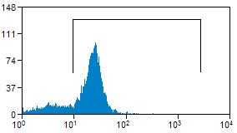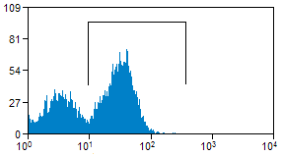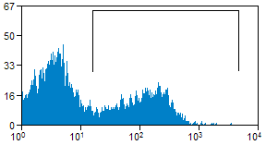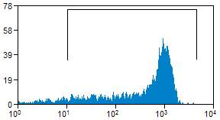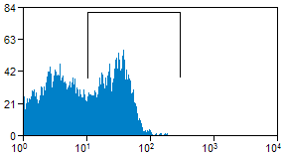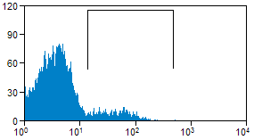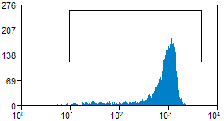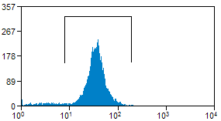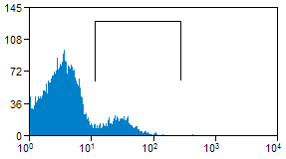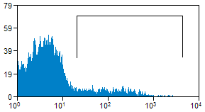
Count
Count
Count
Count
KLRG1
KLRG1
CD57
CD57
CD28
CD28
CD45RA
CD45RA
CD45RO
CD45RO
Count
Count
Count
Count
Count
Count
Lean
Obese
Figure 7.4. Representative flow cytometry histograms showing the frequency of KLRG1+, CD57+, CD28+, CD45RA+ and CD45RO+ cells in the CD3+/CD8+ peripheral blood lymphocyte subset of lean and obese human subjects. The positive population is indicated by the marker gate. The y-axis is the log of the fluorescent intensity.
The distribution of KLRG1+/CD57+, KLRG1+/CD57-, KLRG1-/CD57+, KLRG1+/CD28+, KLRG1+/CD28-, KLRG1-/CD28+, KLRG1+/CD45RA+, KLRG1+/CD45RA-, KLRG1-/CD45RA+, KLRG1+/CD45RO+, KLRG1+/CD45RO- and KLRG1-/CD45RO+ cells in the CD3+/CD4+ lymphocyte subset of lean and obese human subjects are presented in Figure 7.5. No differences between the lean and obese subject groups were noted in the frequency of these populations in the CD3+/CD4+ lymphocyte subset. Representative two parameter flow cytometric dot plots showing the distribution of CD3+/CD4+ lymphocytes co-expressing KLRG1 with CD57, CD28, CD45RA or CD45RO in lean and obese subjects are presented in figure 7.6.

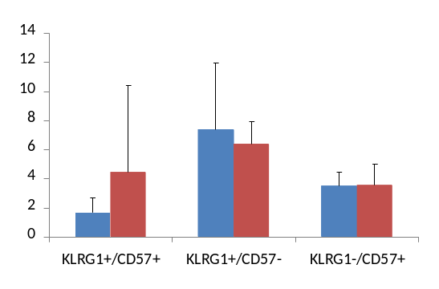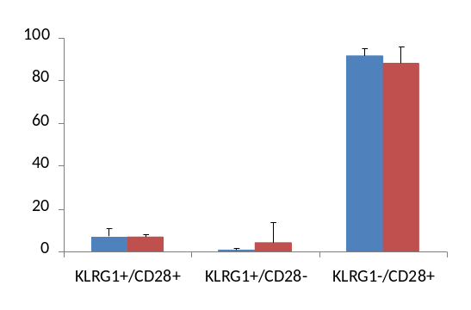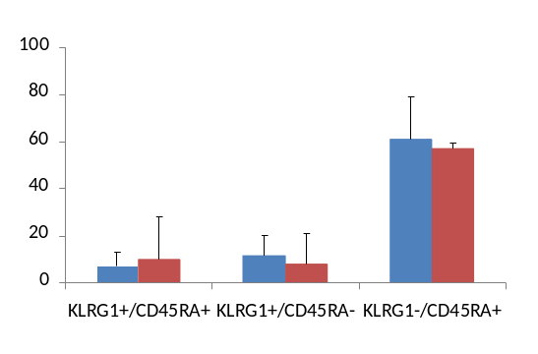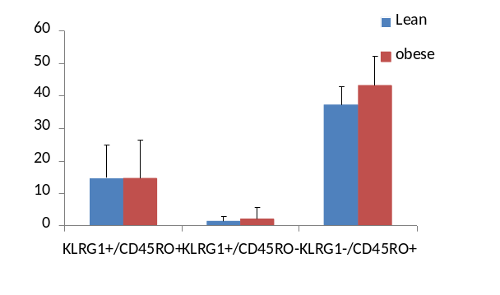
% positive cells
% positive cells
% positive cells
% positive cells
Figure 7.5. The frequency of cells co-expressing KLRG1 with CD57, CD28, CD45RA and CD45RO in the CD3+/CD4+ peripheral blood lymphocyte subsets of lean and obese human subjects. All values are mean ± SD. All subjects were male, and aged 19-55 years (n = 10 for each subject group).

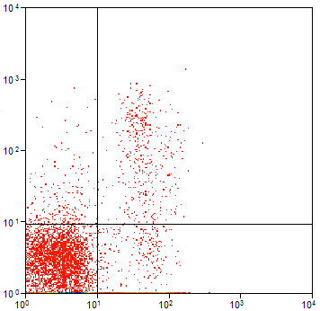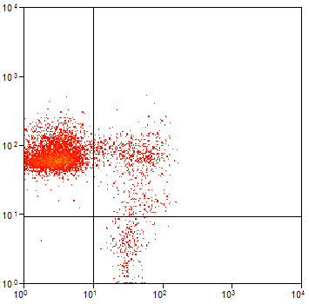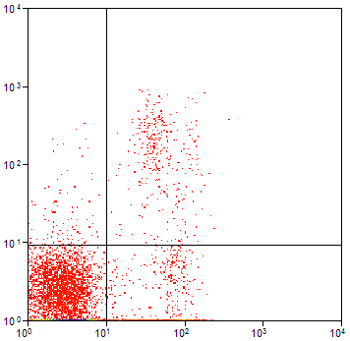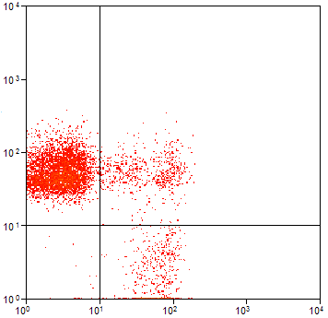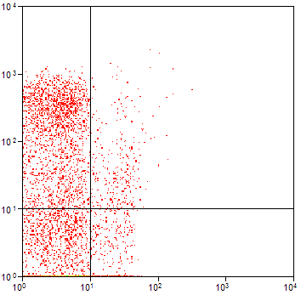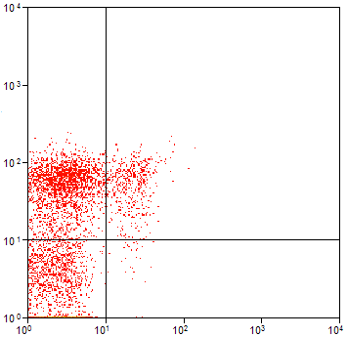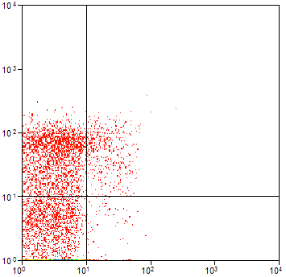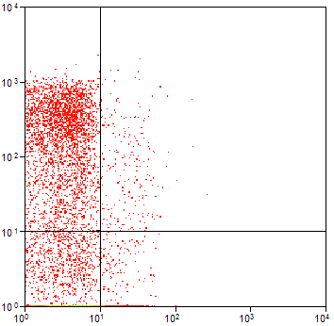
CD57
CD28
CD45RA
CD45RO
KLRG1
KLRG1
KLRG1
KLRG1
KLRG1
KLRG1
CD57
CD28
CD45RA
CD45RO
Lean
Obese
KLRG1
KLRG1

Figure 7.6. Representative two parameter flow cytometer dot plots showing the distribution of cells co-expressing KLRG1 with CD57, CD28, CD45RA and CD45RO in the CD3+/CD4+ T lymphocyte subset of lean and obese human subjects. Both axes show the log of fluorescent intensity.
The distribution of KLRG1+/CD57+, KLRG1+/CD57-, KLRG1-/CD57+, KLRG1+/CD28+, KLRG1+/CD28-, KLRG1-/CD28+, KLRG1+/CD45RA+, KLRG1+/CD45RA-, KLRG1-/CD45RA+, KLRG1+/CD45RO+, KLRG1+/CD45RO- and KLRG1-/CD45RO+ cells in the CD3+/CD8+ lymphocyte subset of lean and obese human subjects are presented in Figure 7.7. There was a greater frequency of KLRG1+/CD57+ cells in the CD3+/CD8+ lymphocyte subset of the obese compared to the lean subject group (p<0.05). Although there were no other significant differences, the obese subject group had a greater frequency of KLRG1+/CD28- (p = 0.054), KLRG1+/CD45RA+ (p = 0.076) and KLRG1+/CD45RO+ cells (p = 0.055) and a lower frequency of KLRG1-/CD28+ (p = 0.082) and KLRG1-/CD45RA+ cells (p = 0.06) in the CD3+/CD8+ lymphocyte subset. Furthermore, the larger frequency of KLRG1+/CD45RA+ cells in the CD3+/CD8+ lymphocyte subset of the obese subjects appeared to be mainly CD45RA^{bright}, whereas the majority of KLRG1+/CD45RA+ cells in the CD3+/CD8+ lymphocyte population of the lean subject group were CD45RA^{dim}. Representative two parameter flow cytometry dot plots showing the distribution of CD3+/CD8+ lymphocytes co-expressing KLRG1 with CD57, CD28, CD45RA or CD45RO in lean and obese subjects are presented in figure 7.8.

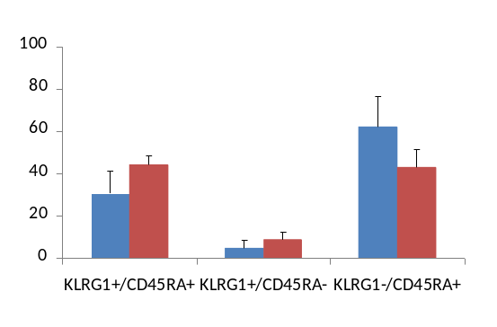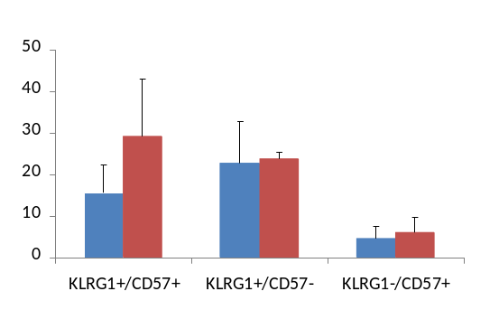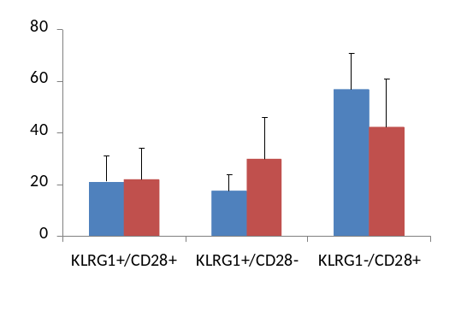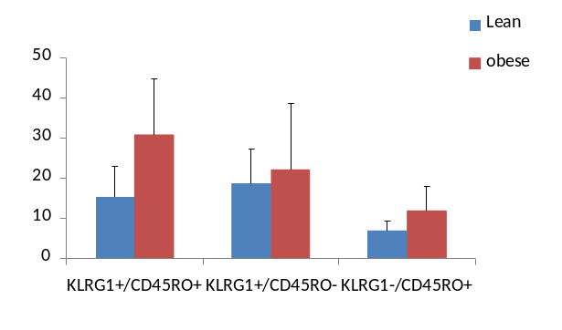
% positive cells
% positive cells
% positive cells
% positive cells
*
Figure 7.7. Frequency of cells co-expressing KLRG1 with CD57 (A), CD28 (B), CD45RA (C) and CD45RO (D) in the CD3+/CD8+ peripheral blood lymphocyte subset of lean and obese human subjects. All values are mean ± SD. Statistically significant differences from the lean subject group are indicated by * (p<0.05). All subjects were male, and aged 19-55 years (n = 10 for each subject group).

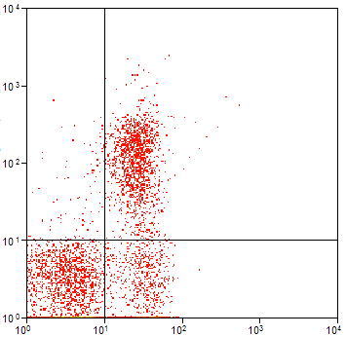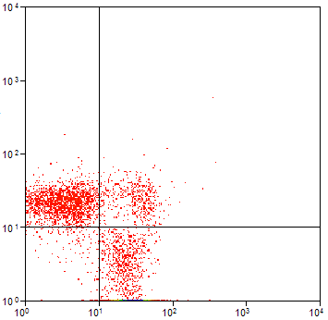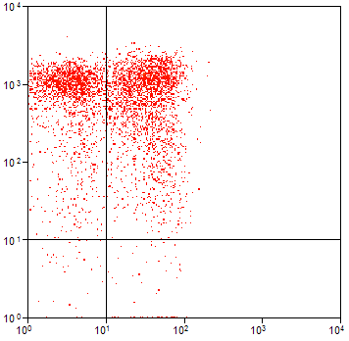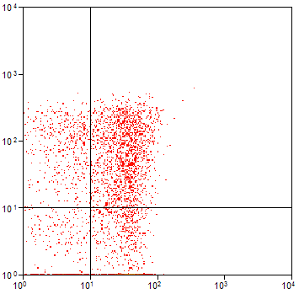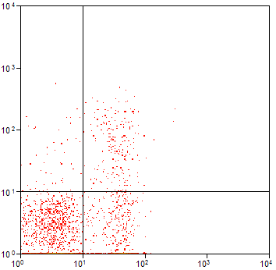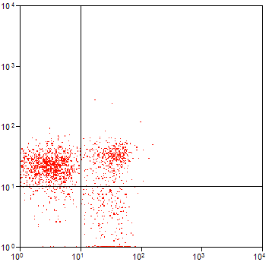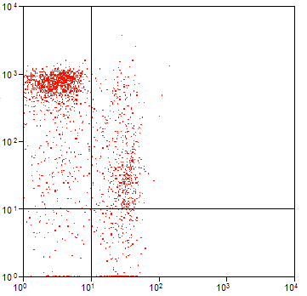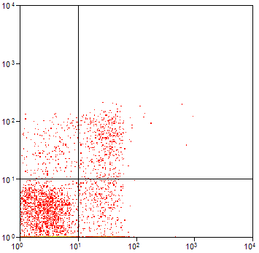
CD57
CD28
CD45RA
CD45RO
KLRG1
KLRG1
KLRG1
KLRG1
KLRG1
KLRG1
CD57
CD28
CD45RA
CD45RO
CD57
CD28
CD45RA
CD45RO
Lean
Obese
KLRG1
KLRG1
Figure 7.8. Representative two parameter flow cytometer dot plots showing the distribution of cells co-expressing KLRG1 with CD57, CD28, CD45RA and CD45RO in the CD3+/CD8+ T lymphocyte subset of lean and obese human subjects. Both axes show the log of fluorescent intensity.
7.3.2. Mouse study

The frequency of CD4+, CD8+, KLRG1+ and CD28+ cells in the CD3+ peripheral blood lymphocyte and splenocyte subsets of lean and obese mice is presented in Table 7.3.

Table 7.3. The frequency of CD4+, CD8+, KLRG1+ and CD28+ cells in the CD3+ peripheral blood lymphocyte and splenocyte subsets of lean (n = 3) and obese (n = 5) mice. All values are mean ± SD. There were no significant differences between the lean and obese groups.

 | % T lymphocytes
 | Spleen |  | Peripheral Blood
 | Lean | Obese | Lean | Obese
CD4+ | 60.3 ± 7.0 | 60.6 ± 8.5 | 70.05 ± 8.6 | 72.7 ± 6.3
CD8+ | 29.3 ± 4.8 | 26.2 ± 5.8 | 28.43 ± 8.6 | 25.6 ± 4.7
CD28+ | 62.1 ± 2.3 | 62.4 ± 9.2 | 57.59 ± 8.3 | 72.0 ± 5.9
KLRG1+ | 12.2 ± 6.7 | 20.5 ± 9.7 | 8.26 ± 4.8 | 8.9 ± 6.0

The frequency of KLRG1+ and CD28+ cells in the CD3+/CD4+ and CD3+/CD8+ splenocyte subsets of lean and obese mice is presented in figure 7.9. There were no significant differences in the frequency of KLRG1+ and CD28+ cells in the CD3+/CD4+ or CD3+/CD8+ splenocyte subset between the lean and obese mice. Although not significant, there was a greater frequency of KLRG1+ cells in the CD3+/CD4+ and CD3+/CD8+ splenocyte subsets of the obese mice compared to the lean mice.

The frequency of KLRG1+ and CD28+ cells in the CD3+/CD4+ and CD3+/CD8+ peripheral blood lymphocyte subsets of lean and obese mice is presented in figure 7.10. There were no differences in the frequency of KLRG1+ or CD28+ cells in the CD3+/CD4+ and CD3+/CD8+ peripheral blood lymphocyte subsets between the lean and obese mice.

A

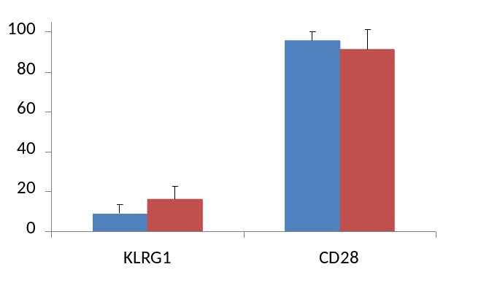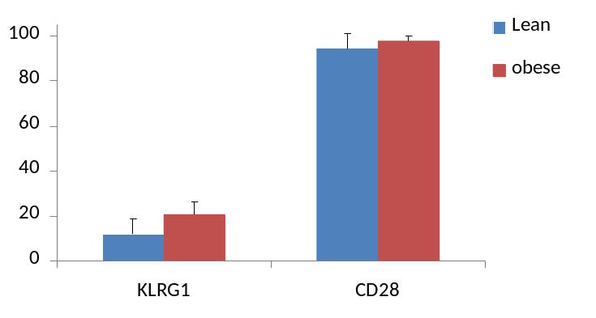
% positive cells
% positive cells
B
Figure 7.9. The frequency of KLRG1+ and CD28+ cells in the CD3+/CD4+ (A) and CD3+/CD8+ (B) splenocyte subsets of lean (n = 3) and obese (n = 5) 14 month old male CD-1 mice. Values are mean ± SD. There were no significant differences between the lean and obese subject groups.

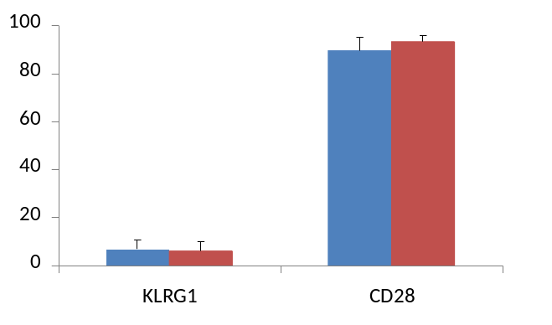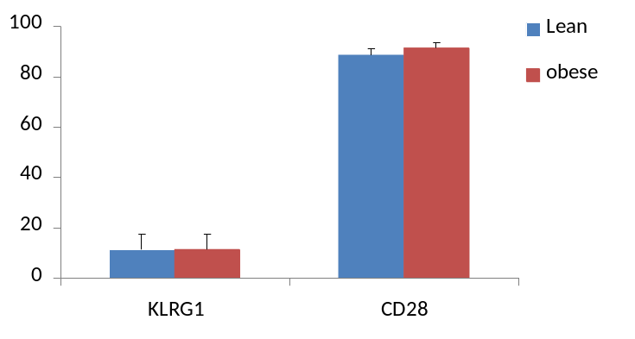
% positive cells
% positive cells
B
Count
Count
Count
Count
A
Figure 7.10. The frequency of KLRG1+ and CD28+ cells in the CD3+/CD4+ (A) and CD3+/CD8+ (B) peripheral blood lymphocytes of lean (n =3) and obese (n =5) 14 month old male CD-1 mice. All values are mean ± SD. There were no significant differences between the lean and obese subject groups.

7.4. Discussion

7.4.1. Human study
The aim of this study was to investigate the frequency of CD3+CD4+ and CD3+/CD8+ lymphocytes co-expressing KLRG1 with CD57, CD28, CD45RA and CD45RO in lean and obese human subjects.

Previously, older subjects have been shown to have a greater frequency of KLRG1+ cells in the CD4+ T lymphocyte subset compared to younger subjects (Chapter 5). This difference was not observed between the lean and obese subject groups. It was suggested in Chapter 5.4 that the greater frequency of KLRG1+ cells in the CD4+ T lymphocyte subset may represent a regulatory T cell (Treg) population, which has recently been shown to express KLRG1 on the cell surface (Beyersdorf et al., 2007) and accumulate with age (Gregg et al., 2005; Rosenkranz et al., 2007). If this were the case, then considering that the lean and obese subject groups in this study are of comparable age, they would be expected to accumulate KLRG1+ Treg cells at a similar rate making it unsurprising to see no difference in the frequency of KLRG1+ cells in the CD4+ T lymphocyte subset.

Consistent with an accumulation of senescent T lymphocytes in obesity, there was a greater frequency of CD57+, CD28- and CD45RO+ cells in the CD8+ T lymphocyte population of obese compared to lean subjects. In previous studies, a greater frequency of KLRG1+, CD57+, CD28- or CD45RO+ cells in the CD8+ T lymphocyte subset (Voehringer, Koschella and Pircher, 2002; Brenchley et al., 2003; Ibegbu et al., 2005) compared to controls was suggested as an accumulation of senescent T lymphocytes. There was a greater frequency of KLRG1+ cells in the CD8+ T lymphocyte subset of the obese subject group, but it fell just short of statistical significance. This difference would likely be significant if larger cohorts of lean and obese subjects were investigated, and would be consistent with a greater level of senescence in obesity.

In previous work, the greater frequency of KLRG1+ and CD57+ cells in the CD8+ T lymphocyte subset of an older subject group reflected a larger proportion of cells co-expressing KLRG1 and CD57, not differences in the frequency of KLRG1+/CD57- or KLRG1-/CD57+ cells (Chapter 5). In the current study, the difference in the frequency of CD57+ cells in the CD8+ T lymphocyte subset also reflected a greater frequency of KLRG1+/CD57+ cells, not differences in KLRG1+/CD57+ or KLRG1-/CD57+ cell populations. Furthermore, the greater frequency of CD28- cells in the CD8+ T lymphocyte subset of the obese compared to the lean subject group appears to be due to a greater frequency of KLRG1+/CD28- cells and a lower frequency of KLRG1-/CD28+ cells, as these differences were very close to significance (p = 0.054 and p = 0.082 respectively), whereas the difference between the lean and obese groups in the frequency of KLRG1+/CD28+ cells, was not close to significance (p = 0.992).

Previous work investigating the co-expression of KLRG1 and CD57 on CD8+ T lymphocytes in infection has suggested that KLRG1+/CD57+ cells are terminally differentiated memory cells that have developed from KLRG1+/CD57- effector memory cells (Ibegbu et al., 2005). This would suggest a maturation of cells from KLRG1-/CD57- to KLRG1+/CD57- to KLRG1+/CD57+, and the greater frequency of KLRG1+/CD57+ cells in the obese subject groups suggests an acceleration of this maturation in obesity. However it could be that the increased levels of oxidative stress associated with obesity (Dandona, Aljada and Bandyopadhyay, 2004; Furukawa et al., 2004) triggers a near simultaneous up-regulation of both KLRG1 and CD57 on the cell surface of KLRG1-/CD57- cells in the CD8+ T lymphocyte subset, resulting in a greater frequency of these cells in obese individuals. However, studies to elucidate the mechanisms whereby obesity contributes to premature senescence of immune cells would be required before this could be addressed.

KLRG1 co-expression with the naïve and memory cell markers; CD45RA and CD45RO respectively, was investigated in lean and obese subject groups. CD45RA and CD45RO have been described as reciprocal markers on T lymphocytes (Bruunsgaard et al., 1999) although they are capable of being co-expressed on ‘transitional’ subsets of T lymphocytes after antigenic encounter (Visser, Lai and Poppema, 1993; Summers, O’Donnell and Hart, 1994). Furthermore, CD45RO+ memory T lymphocytes are able to re-express CD45RA late in their replicative lifespan perhaps defining a terminally differentiated population (Hamann et al., 1997). Indeed, CD45RA+ T lymphocytes have been shown to express CD57 and KLRG1 (Brenchley et al., 2003; Ibegbu et al., 2005). Therefore, an accumulation of KLRG1+/CD45RO+ and KLRG1+/CD45RA+ cells would suggest a higher level of senescence.

The obese subject group had a lower frequency of naïve cells (KLRG1-/CD45RA+), and a greater frequency of classic (KLRG1+/CD45RO+) and terminally differentiated (KLRG1+/CD45RA+) memory cells in the CD8+ T lymphocyte subset, providing further evidence for an accumulation of senescent CD8+ T lymphocytes with obesity.

A KLRG1+/CD45RA^{bright} population was observed in the obese but not the lean subjects perhaps suggesting that terminally differentiated memory cells re-express high levels of CD45RA on a per cell basis. As such, the KLRG1+/CD45RA^{dim} cells may be transitional non-terminally differentiated memory cells that are destined for senescence as defined by their KLRG1 expression (Ibegbu et al., 2005). It is likely that such a cell type would also express CD45RO, and indeed, the obese subject group had a greater frequency of KLRG1+/CD45RO+ cells in the CD8+ T lymphocyte subset. Further phenoytyping and proliferation studies, coupled with telomere length analysis could confirm this.

7.4.2. Mouse studies
The aim of this study was to investigate the frequency of KLRG1+ and CD28+ cells in the CD4+ and CD8+ T splenocyte and peripheral blood lymphocyte subsets of a mouse model of obesity. There were no significant differences in the frequency of KLRG1+ and CD28+ cells in the CD4+ and CD8+ T splenocyte or peripheral blood lymphocyte subsets of the lean and obese mice. The frequency of KLRG1+ cells in both the CD4+ and CD8+ lymphocyte subsets of the spleens in obese mice was greater than in the lean group, although these differences were not significant. It is difficult to say whether these are ‘true’ differences due to the low subject numbers; however, if these were shown to be significant in a larger group, then the majority of CD4+/KLRG1+ cells are likely to represent a Treg population (Beyersdorf et al., 1997) with the CD8+/KLRG1+ cells representing a true senescent cell population (Voehringer et al., 2001).

There have been no studies investigating the frequency of KLRG1+ cells in the splenic or peripheral blood lymphocytes of CD-1 mice. Being a non-inbred strain, it is likely that there would be higher natural diversity than in inbred strains. This may be the reason that this study showed a greater frequency of KLRG1+ cells in splenic and peripheral blood lymphocytes of the lean group compared to previous work with the C57BL/6 strain of mice (Beyersdorf et al., 2001, 2007; Voehringer et al., 2001; Robbins et al., 2003). This also may be because the mice in this study were much older than the mice from previous studies (14 months versus ‘young adult mice’ or 4 months old at the oldest), although it is not known whether or not KLRG1+ cells accumulate with age in mice.

No differences were noted in the frequency of CD28+ cells in the splenic or peripheral blood CD4+ and CD8+ T lymphocytes between the lean and obese mice. This was unsurprising considering the different roles of CD28 in mice and humans. In humans, CD28 loss from CD8+ T lymphocytes is linked to an attenuation of the ability to up-regulate telomerase, resulting in telomere shortening (Weng et al., 1996; Valenzuela and Effros, 2002). However, it is unlikely that CD28 expression is linked to replicative history in mice (Kipling, 1997; Wright and Shay, 2000; Marie-Egyptienne et al., 2008). Compared to humans, murine chromosomes have longer telomeres, show no telomere shortening with ageing (Kipling, 1997) and do not undergo telomere-dependent senescence, suggesting that any increases in the frequency of KLRG1+ cells in the CD8+ T lymphocyte subset in mice would be due to an accumulation of cells that have undergone telomere independent senescence (Wright and Shay, 2000; Marie-Egyptienne et al., 2008). Indeed, this would be consistent with the high levels of oxidative stress as a mechanism for increased senescence in obesity (Furukawa et al., 2004). However, this also suggests that murine models would be unlikely to show leptin-induced changes in levels of senescence, inconsistent with the hypothesized role of leptin in senescence through cell proliferation and telomere length shortening, as suggested in this thesis. Therefore it remains to be seen whether or not mice models are well suited for investigating obesity-induced T cell senescence.

In conclusion, there was an accumulation of KLRG1+/CD57+, KLRG1+/CD28-, KLRG1+/CD45RO+ and KLRG1+/CD45RA+ cells in the CD8+ T lymphocyte subset of obese human subjects, suggesting obesity increases the level of immune cell senescence, possibly contributing to the immunosuppression seen in obese individuals.

CHAPTER 8

The relationship between cell surface markers of senescence and telomere length in peripheral blood lymphocyte subsets

8.1. Introduction

The adaptive immune response relies upon the ability of T lymphocytes to form memory cells and undergo repeated clonal expansion in response to antigenic challenge. Senescent T cells are unable to proliferate in response to antigenic challenge (Spaulding, Guo, and Effros, 1999) but are still considered to be functional as they retain the ability to produce pro-inflammatory cytokines such as TNF-α, IL-6 and IFN-γ (Nociari, Telford and Russo, 1999; Effros, Dagarag, and Valenzuela, 2003; Zanni et al., 2003; Vescovini et al., 2007). Indeed, senescence is believed to be the final stage in the normal differentiation pathway of human T cells (Effros, Dagarag, and Valenzuela, 2003).

Telomeres are highly conserved portions of DNA that protect chromosomal DNA from end to end fusions and aberrant recombinations . Telomere erosion, a consequence of the imperfection of the DNA replication mechanism, occurs progressively with each round of cell division, eventually triggering replicative senescence (Harley, Futcher and Greider, 1990). The reverse transcriptase, telomerase, is expressed in activated T lymphocytes (Weng et al., 1996) and can maintain telomere length, preventing early entry of a cell into replicative senescence (Greider & Blackburn, 1985). Shortened telomeres in peripheral blood leukocytes have been linked to ageing (Vaziri et al., 1993; Weng et al., 1995; Valenzuela & Effros, 2002) and a reduction in lifespan (Cawthon et al., 2003). In addition, oxidative stress can accelerate the rate of telomere attrition, leading to premature senescence (Petersen, Saretzki, & von Zglinicki, 1998; von Zglinicki, Pilger, & Sitte, 2000; Lorenz et al., 2001; von Zglinicki, 2002). Indeed, high levels of oxidative stress in obesity, smoking and atherosclerosis have been linked with shortened telomeres in peripheral blood leukocyte populations (Harrison, 1998; Brouilette et al., 2003; Valdes et al., 2005) and may contribute to the high level of diversity of leukocyte telomere lengths found in previous studies (Iwama et al., 1998; Epel et al., 2004; Valdes et al., 2005; discussed in Chapter 4).

Senescent T lymphocytes appear to express CD57 and the killer cell lectin-like receptor G1 (KLRG1), and lack expression of CD28 on the cell surface (Simpson et al., 2007a, 2008). CD57 is expressed on T cells with shortened telomeres, a long replicative history and an inability to proliferate in response to mitogenic stimuli (Brenchley et al., 2003). CD28 loss from the cell surface of T lymphocytes also defines a cell population with limited proliferative capacity and shortened telomeres (Bruunsgaard et al., 1999) and the expression of KLRG1 on T cells defines a population of cells that are unable to undergo further clonal expansion but are still able to up-regulate production of IFN-γ (Voehringer et al., 2001; Ouyang et al., 2003). No study to date, however, has investigated the link between telomere length and frequency of KLRG1+ T lymphocytes. Although KLRG1+, CD57+ and CD28- T lymphocytes have been suggested as populations of senescent cells (Simpson et al., 2007a), the co-expression of KLRG1 with CD57 or CD28 may be a more accurate marker of a cell’s senescent status (Voehringer, Koschella and Pircher, 2002; Brenchley et al., 2003; Ibegbu et al., 2005; Chapter 5) and as such, the link between telomere length and these subpopulations may provide new data on the phenotype of a truly senescent population.

Many studies that have investigated telomere length have used whole leukocyte, or peripheral blood mononuclear cell (PBMC) populations (Harrison, 1998; Brouilette et al., 2003; Cawthon et al., 2003; Epel et al., 2004; Valdes et al., 2005; Cherkas et al., 2008). However, cellular subsets within these populations display distinct functional differences that may impact on their telomere lengths. For instance, CD4+ T lymphocytes have lower replication kinetics (Foulds et al., 2002) and are able to up-regulate telomerase further into their replicative lifespan compared to CD8+ T lymphocytes (Valanzuela and Effros, 2002). This may contribute to the greater frequency of senescent CD8+ compared to CD4+ T lymphocytes seen in previous studies (Voehringer, Koschella and Pircher, 2002; Simpson et al., 2008; Chapter 4). As such, the use of whole leukocyte or even whole T lymphocyte populations for telomere length studies may mask differences among T lymphocyte subset telomere lengths and indeed, may contribute to the aforementioned diversity in telomere length in previous studies.

This study examined the relationship between the frequency of KLRG1+, CD57+ and CD28+ cells, and telomere lengths, in CD3+, CD3+/CD4+ and CD3+/CD8+ lymphocyte populations in human subjects.

It was hypothesised that the frequency of KLRG1+, CD57+ and CD28- cells in CD3+, CD3+/CD4+ and CD3+/CD8+ lymphocyte subsets is inversely correlated with telomere length. An additional hypothesis was that the average telomere length of the CD3+/CD8+ lymphocyte subset will be significantly shorter than that of the CD3+ and the CD3+/CD4+ lymphocyte subsets.

8.2. Materials and methods

8.2.1. Subjects
All subjects provided a resting, peripheral blood sample. Intravenous blood samples were drawn as described in the general materials and methods section 2.1. Subjects were aged 21-60 years (mean = 32.7 ± 10.8 years, n = 27). The subject group was mixed gender (25 males, 2 females). None of the subjects were on any medication, and all were free of any infectious illness for 6 weeks prior to the study. The subject group contained a diverse population such as diabetics, an individual having undergone stem cell therapy, well trained athletes, and sedentary individuals. This was to introduce a greater diversity in the proportions of KLRG1+ cells in the lymphocyte subsets, to more accurately investigate the relationship between telomere length and KLRG1 expression. The subjects gave written informed consent and ethical approval was granted by the institution.

8.2.2. Mononuclear cell isolation and staining with monoclonal antibodies
PBMCs were isolated from peripheral blood, as per the general materials and methods section 2.2.1., before labelling with anti-CD3 APC, anti-KLRG1 Alexafluor 488, one of anti-CD4 or anti-CD8 PECy-5, and one of anti-CD57, or anti-CD28 monoclonal antibodies where appropriate. Analysis was by four colour flow cytometry using a FACSCalibur flow cytometer equipped with Cell Quest Pro software.

8.2.3. T cell and T cell subset enrichment
Isolated PBMCs were enriched as per the general materials and methods section 2.6. Cells from each of the CD3+ T cell enriched, CD4+ T cell enriched and CD8+ T cell enriched fractions were labelled with anti-CD3 APC, anti-KLRG1 Alexafluor 488, one of anti-CD4 or anti-CD8 PECy-5, and one of anti-CD57 or anti-CD28 PE monoclonal antibodies where appropriate before 4 colour flow cytometric analysis using a FACSCalibur flow cytometer equipped with Cell Quest Pro software.

8.2.2.2. T cell and T cell subset enrichment cocktails
T cell enriched fraction |  | CD4+ T cell enriched fraction |  | CD8+ T cell enriched fraction
Antigen | Clone | Antigen | Clone | Antigen | Clone
 |  | CD8 | SK1 | CD4 | L200
CD11b/Mac-1 | ICRF44 | CD11b/Mac-1 | ICRF44 | CD11b/Mac-1 | ICRF44
CD16 | 3GB | CD16 | 3GB | CD16 | 3G8
CD19 | HIB19 | CD19 | HIB19 | CD19 | HIB19
CD36 | CB38 (NL07) | CD36 | CB38 (NL07) | CD36 | CB38 (NL07)
CD41a | HIP8 | CD41a | HIP8 | CD41a | HIP8
CD56 | B159 | CD56 | B159 | CD56 | B159
 |  | CD123 | 9F5 | CD123 | 9F5
CD235a | GA-R2(HIR2) | CD235a | GA-R2(HIR2) | CD235a | GA-R2(HIR2)
 |  | γδ TCR | B1 | γδ TCR | B1

8.2.4. Cell storage for telomere length analysis
Samples of each enriched fraction were frozen in liquid nitrogen as per the general materials and methods, section 2.7.

8.2.5 Telomere length analysis
Mean telomere restriction fragment lengths (mTRFs) were measured by Dr. Paul Shiels (University of Glasgow, UK) as per the general materials and methods, section 2.8.

8.2.6. Statistical analysis
Differences between subject groups were assessed using 2-sample t-tests where data were normally distributed and Mann-Whitney U-tests where data were not normally distributed. Correlations were assessed using Pearson’s product-moment correlations where data were normally distributed and Spearman’s rank-order correlations where data were not normally distributed. Regression analyses using cell surface marker as the response and mTRF and age as predictors were run to assess the significance of age in any relationship between mTRF and cell surface marker expression. All statistics were done using Minitab 15 or SPSS 14. Statistical significance was accepted at p<0.05.
8.3. Results

The frequency of CD3+, CD4+ and CD8+ cells in the whole lymphocyte population and CD4+, CD8+, KLRG1+, CD57+, CD28+, CD45RA+ and CD45RO+ cells in the CD3+ subset of the whole lymphocyte population from the subject group are presented in table 8.1. The proportions of lymphocytes and lymphocyte subsets were as expected in healthy human subjects as per chapters 3 and 4.

Table 8.1. The frequency of senescence, memory and naïve markers on peripheral blood lymphocytes from human subjects. Values are mean ± SD. Subjects were mixed gender (25 males, 2 females) aged 21-60 years.
 | % of all lymphocytes
CD3 | 43.9 ± 8.03
CD4 | 43.5 ± 10.6
CD8 | 23.0 ± 10.6
 | % of all T lymphocytes
CD4 | 60.5 ± 10.9
CD8 | 35.5 ± 9.8
KLRG1 | 25.0 ± 14.1
CD57 | 13.9 ± 10.3
CD28 | 86.0 ± 11.9
CD45RA | 64.3 ± 13.1
CD45RO | 46.4 ± 12.2

8.3.1. Purity of the enriched fractions
The purity of the CD3+, CD4+ and CD8+ T cell enriched fractions as indicated by the frequency of CD3+, CD4+, CD8+, CD14+, CD16+ and CD19+ cells in each fraction is presented in figure 8.1. The T cell enriched, CD4+ T cell enriched and CD8+ T cell enriched fractions consistently showed greater than 90% CD3+ cell purity. The CD4+ T cell fraction was ~90% pure for CD4+ cells, and the CD8+ T cell fraction was ~84% for CD8+ cells. The main impurities were CD4+ cells in the CD8+ T cell enriched fraction and CD8+ cells in the CD4+ T cell fraction with ~2% each of CD14+, CD16+ and CD19+ cells in each of the enriched fractions.
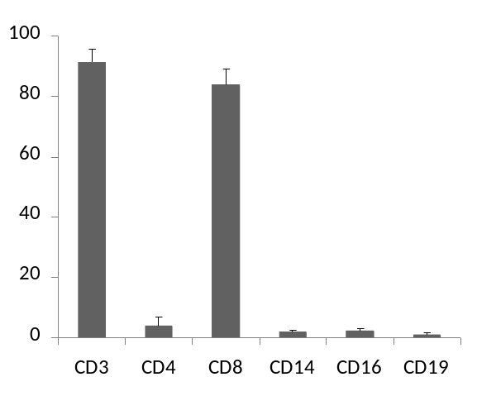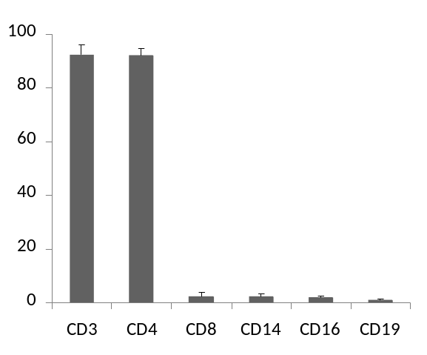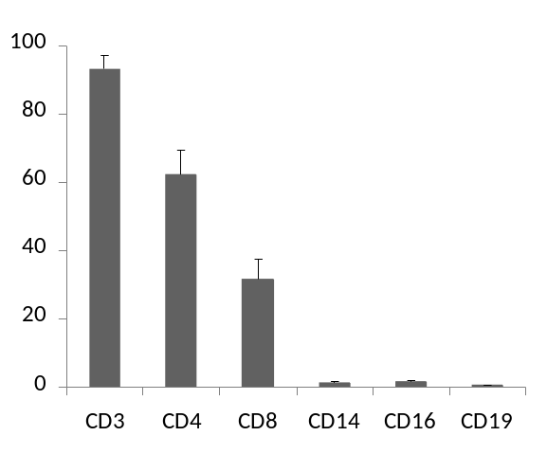
% positive cells
% positive cells
% positive cells
A
B
C
Figure 8.1. The purity of the T cell enriched (A), CD4+ T cell enriched (B) and CD8+ T cell enriched (C) fractions as indicated by the frequency of CD3+, CD4+, CD8+, CD14+, CD16+ and CD19+ cells in each fraction. All values are mean ± SD. Subjects were mixed gender (25 males, 2 females) aged 21-60 years.
8.3.2. Loss of cells as a result of the enrichment process
8.3.2.1. The enrichment process leads to a preferential loss of CD8+ T cells and T cells expressing cell surface markers of senescence.
The proportions of CD4+, CD8+, KLRG1+, CD57+ and CD28+ cells in the CD3+ population of the PBMC fraction and the T cell-enriched fraction are presented in figure 8.2. The T cell-enriched fraction had a larger proportion of CD4+ (p<0.05) and CD28+ (p<0.01), and a smaller proportion of KLRG1+ (p<0.01) and CD57+ (p<0.01) cells in the CD3+ population compared to the PBMC fraction. There was also a smaller proportion of CD8+ cells in the CD3+ population of the T cell enriched fraction, although this was not statistically significant (p = 0.0765).

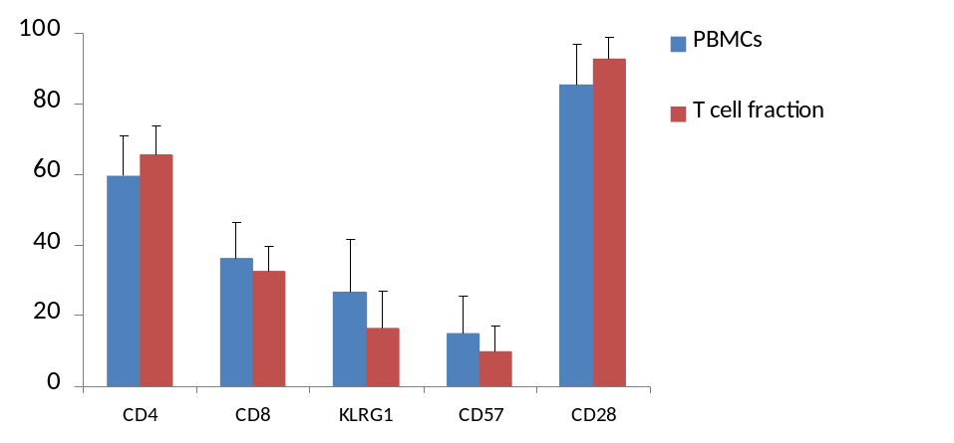
**
*
**
**

% positive cells

Figure 8.2. The frequency of CD4+, CD8+, KLRG1+, CD57+ and CD28+ cells in the CD3+ populations of the peripheral blood mononuclear cell (PBMC) and T cell enriched fraction from human subjects. All values are mean ± SD. Differences from the PBMC fraction are indicated by * (p<0.05) and ** (p<0.01). Subjects were mixed gender (25 males, 2 females) aged 21-60 years.

8.3.2.2. The enrichment process results in the preferential loss of T cells expressing cell surface markers of senescence in both the CD4+ and CD8+ T cell subsets.
The frequency of KLRG1+, CD57+ and CD28+ cells in the CD3+/CD4+ and CD3+/CD8+ lymphocyte subsets of the PBMC, T cell enriched, CD4+ T cell enriched and CD8+ T cell enriched fractions from healthy subjects are presented in figure 8.3. There was a smaller proportion of KLRG1+ and CD28- cells in the CD4+ T cell enriched fraction than in the PBMC fraction (p<0.01). Although not significant, there was a smaller proportion of CD57+ cells in the CD3+/CD4+ lymphocyte subset of the CD4+ T cell enriched fraction than in the PBMC fraction (p = 0.085). Furthermore, there was a larger proportion of CD28+ cells in the CD3+/CD4+ lymphocyte subset of the CD4+ T cell enriched fraction than in the T cell enriched fraction (p<0.05). There was a smaller proportion of KLRG1+ (p<0.05), CD57+ (p<0.01) and CD28- (p<0.01) cells in the CD3+/CD8+ lymphocyte subset of the T cell enriched and the CD8+ T cell enriched fractions than in the PBMC fraction.

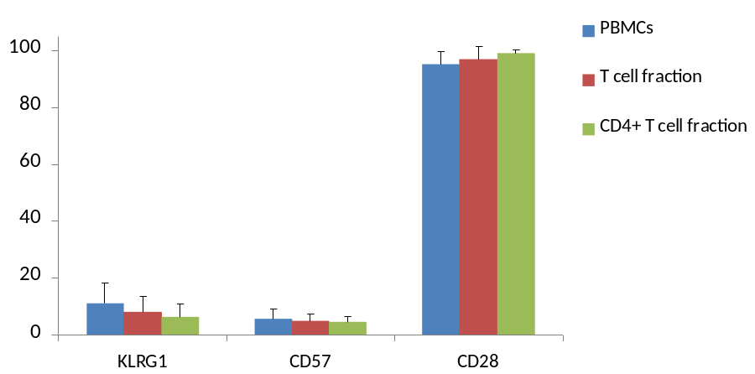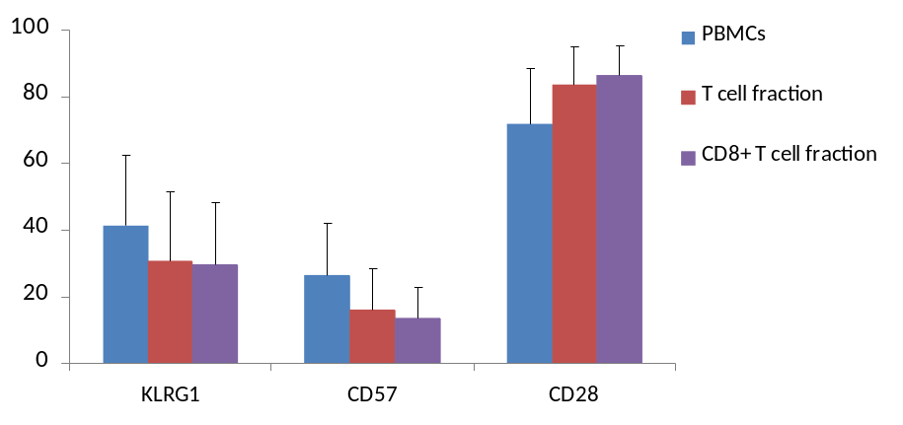
% positive cells
% positive cells
B
**
*
*
**
**
**
**
A
#
**
Figure 8.3. The frequency of KLRG1+, CD57+ and CD28 + cells in the CD3+/CD4+ (A) and CD3+/CD8+ (B) subsets from the PBMC, T cell enriched and T cell subset enriched fractions of human subjects. All values are mean ± SD. Statistically significant differences from the PBMC fraction are indicated by * (p<0.05) or ** (p<0.01). Statistically significant differences from the T cell enriched fraction are indicated by # (p<0.05). Subjects were mixed gender (25 males, 2 females) aged 21-60 years.

8.3.2.3. The enrichment process results in the preferential loss of KLRG1+ cells from all cell types investigated
The proportions of KLRG1+/CD57+, KLRG1+/CD57-, KLRG1-/CD57+, KLRG1+/CD28+, KLRG1+/CD28- and KLRG1-/CD28+ cells in the CD3+/CD4+ lymphocyte subset of the PBMC, T cell-enriched and CD4+ T cell enriched fractions are presented in figure 8.4. There was a smaller proportion of KLRG1+/CD57+ (p<0.01), KLRG1+/CD57- (p<0.01), KLRG1+/CD28+ (p<0.05), KLRG1+/CD28- and KLRG1-/CD28+ cells in the CD3+/CD4+ lymphocyte subset of the CD4+ T cell enriched compared to the PBMC fraction. In addition, there was a smaller proportion of KLRG1+/CD28- cells in the CD3+/CD4+ lymphocyte subset of the CD4+ T cell enriched compared to the T cell enriched fraction (p<0.05).

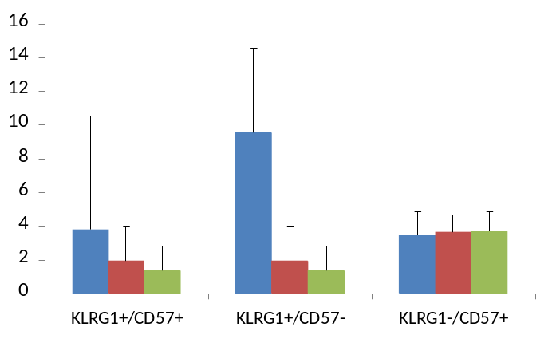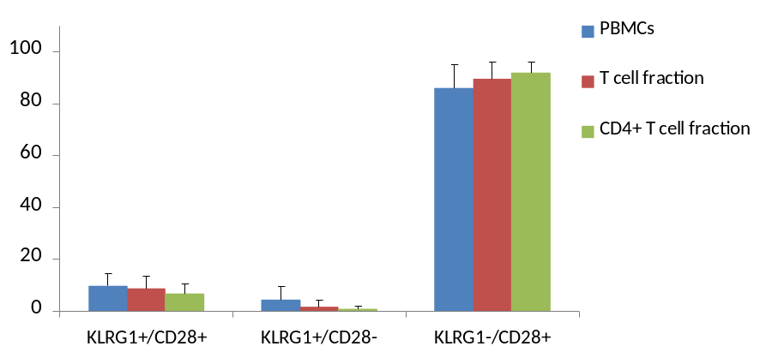
% positive cells
% positive cells
**
**
*
*
**
**
Figure 8.4. The distribution of cells co-expressing KLRG1 and CD57 or CD28 in the CD3+/CD4+ lymphocyte subsets of the PBMC, T cell-enriched and CD4+ T cell-enriched fractions of human subjects. All values are mean ± SD. Statistically significant differences from the PBCM fraction are indicated by * (p<0.05) and ** (p<0.01). Subjects were mixed gender (25 males, 2 females) aged 21-60 years.

The proportions of KLRG1+/CD57+, KLRG1+/CD57-, KLRG1-/CD57+, KLRG1+/CD28+, KLRG1+/CD28- and KLRG1-/CD28+ cells in the CD3+/CD8+ lymphocyte subset of the PBMC, T cell-enriched and CD8+ T cell enriched fractions are presented in figure 8.5. There was a smaller proportion of KLRG1+/CD57+ (p<0.01) and KLRG1+/CD57- cells (p<0.05) as a percentage of the CD3+/CD8+ lymphocyte subset of the CD3+ and the CD8+ T cell-enriched, compared to the PBMC fraction. There were no differences in the proportion of KLRG1-/CD57+ cells as a percentage of the CD3+/CD8+ lymphocyte subset of the PBMC, CD3+ and CD8+ T cell enriched fractions. There was a smaller proportion of KLRG1+/CD28- cells as a percentage of the CD3+/CD8+ lymphocyte subset of the CD3+ and CD8+ T cell enriched fractions compared to the PBMC fraction (p<0.01). There was also a greater proportion of KLRG1+/CD28- cells as a percentage of the CD3+/CD8+ lymphocyte subset of the CD8+ T cell-enriched fraction compared to the CD3+ T cell-enriched fraction (p<0.01). Furthermore, there was a larger proportion of KLRG1-/CD28+ cells as a percentage of the CD3+/CD8+ lymphocyte subset of the CD3+ T cell-enriched subset (p<0.05) and the CD8+ T cell-enriched fraction (p<0.01) compared to the PBMC fraction.

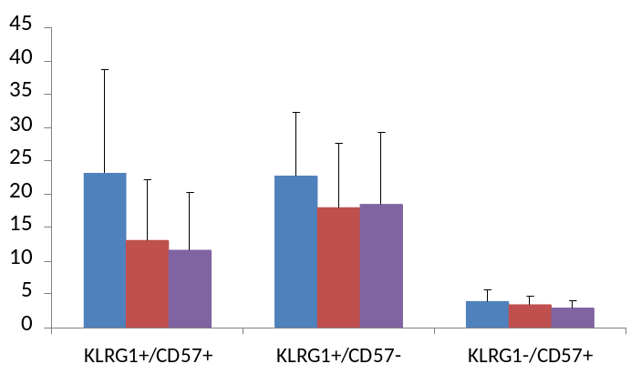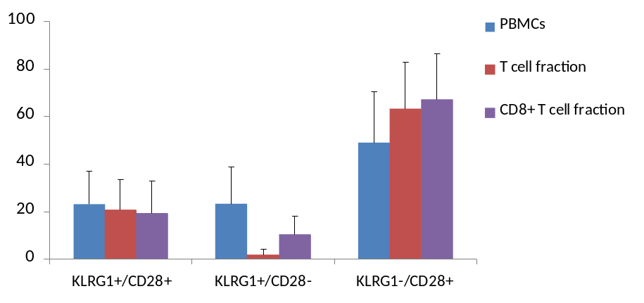
% positive cells
% positive cells
**
**
*
*
**
**
##
**
*
Figure 8.5. The distribution of cells co-expressing KLRG1 and CD57 or CD28 in the CD3+/CD8+ lymphocyte subsets of the PBMC, T cell-enriched and CD8+ T cell-enriched fractions of human subjects. All values are mean ± SD. Statistically significant differences from the PBMC fraction are indicated by * (p<0.05) and ** (p<0.01). Statistically significant differences from the T cell enriched fraction are indicated by ## (p<0.01). Subjects were mixed gender (25 males, 2 females) aged 21-60 years.

8.3.3. Correlations between subject age and telomere lengths in T lymphocyte subsets
Correlations between mTRF and subject age in the CD3+, CD4+ and CD8+ T cell-enriched fractions are presented in figure 8.6. Telomere length was inversely correlated with age in the CD3+ (p<0.01), CD4+ (p<0.01) and CD8+ (p<0.05) T cell-enriched fractions.

8.3.4. Correlations between the proportion of T lymphocyte subsets expressing cell surface markers of senescence and mTRF in the enriched fractions.
Scatter plots showing the correlations between mTRF and the proportion of KLRG1+, CD57+ and CD28+ cells in the CD3+ subset of the T cell-enriched fraction, the CD3+/CD4+ lymphocyte subset of the CD4+ T cell-enriched fraction and the CD3+/CD8+ lymphocyte subset of the CD8+ T cell-enriched fraction are presented in figures 8.7, 8.8 and 8.9. The proportion of CD28+ cells in the CD3+ lymphocyte subset of the CD3+ T cell-enriched fraction and the CD3+/CD4+ lymphocyte subset of the CD4+ T cell-enriched fraction were positively correlated with mTRF (p<0.05) with age taken into account. The proportions of KLRG1+ and CD57+ cells in the CD3+/CD4+ lymphocyte subset of the CD4+ T cell-enriched fraction were negatively correlated with mTRF (p<0.05) taking age into account. No significant correlations between mTRF and the proportion of KLRG1+, CD57+ or CD28+ cells were seen in the CD3+/CD8+ lymphocyte subset of the CD8+ T cell-enriched fraction.

Scatter plots showing the correlations between mTRF and the proportion of KLRG1+/CD57+, KLRG1+/CD57-, KLRG1-/CD57+, KLRG1+/CD28+, KLRG1+/CD28- and KLRG1-/CD28+ cells in the CD3+/CD4+ lymphocyte subset of the CD4+ T cell-enriched fraction and the CD3+/CD8+ lymphocyte subset of the CD8+ T cell-enriched fraction are presented in figures 8.10 and 8.11.

The proportion of KLRG1+/CD28+ (p<0.05), KLRG1+/CD28- (p<0.05) and KLRG1-/CD28+ (p<0.05) cells in the CD3+/CD4+ lymphocyte subset of the CD4+ T cell-enriched fraction were negatively correlated with mTRF when age was taken into account. The proportion of KLRG1+/CD57+ (p<0.084) and KLRG1+/CD57- (p<0.084) cells in the CD3+/CD4+ lymphocyte subset of the CD4+ T cell-enriched fraction were negatively correlated with mTRF when age was taken into account, but fell just short of significance. There was no significant correlation between mTRF and the proportion of KLRG1-CD57+ cells (p<0.136) in the same lymphocyte subset. In addition, there were no significant correlations between mTRF and the proportion of KLRG1+/CD57+, KLRG1+/CD57-, KLRG1-/CD57+, KLRG1+/CD28+, KLRG1+/CD28- and KLRG1-/CD28+ cells in the CD3+/CD8+ lymphocyte subset of the CD8+ T cell-enriched fraction.

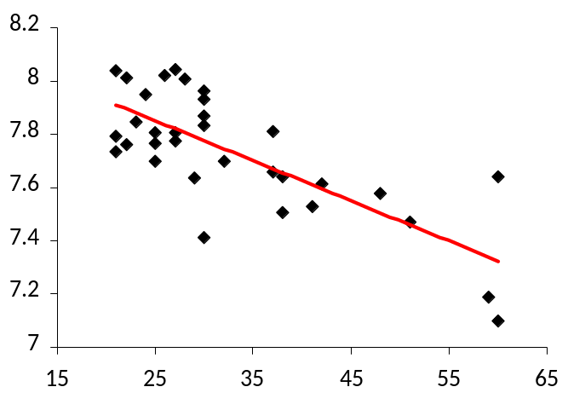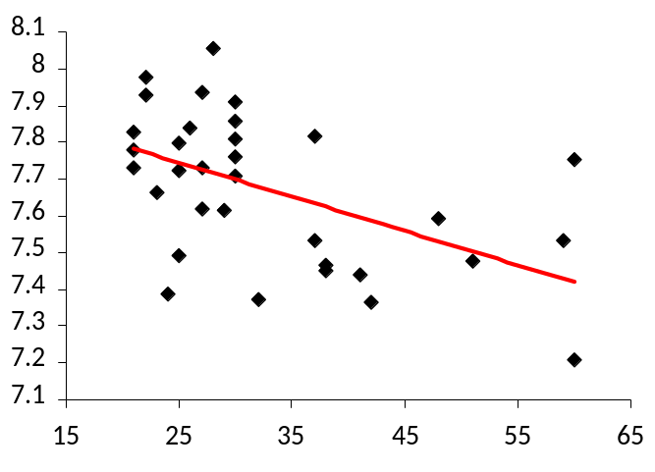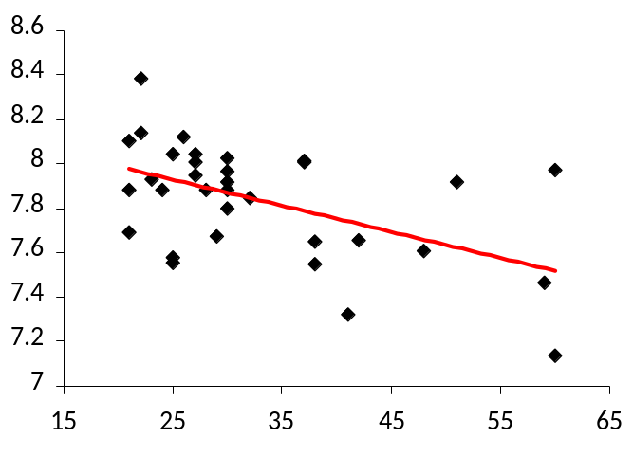
r = -0.676**
r = -0.515**
r = -0.447*
Age (years)
Age (years)
Age (years)
mTRF (kbp)
mTRF (kbp)
mTRF (kbp)
A
B
C
Figure 8.6. Scatter plots showing the relationship between subject age and mTRF in the CD3+ (A), CD4+ (B) and CD8+ (C) T cell-enriched fractions. r values are displayed on each scatter plot and statistically significant correlations are indicated by * (p<0.05) or ** (p<0.01). Subjects were mixed gender (25 males, 2 females) aged 21-60 years.
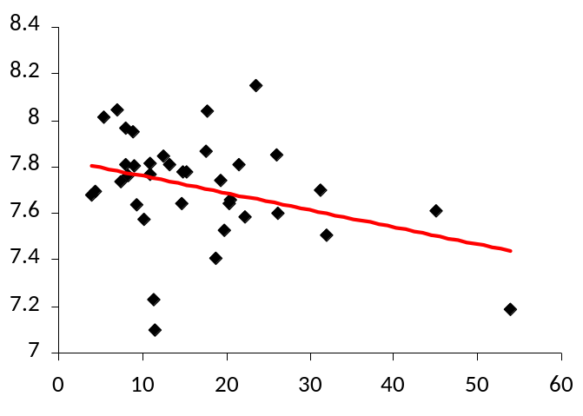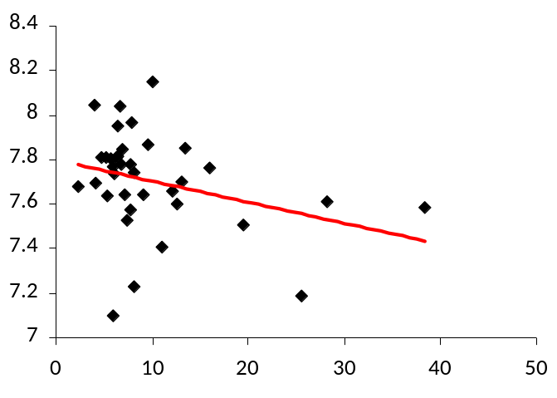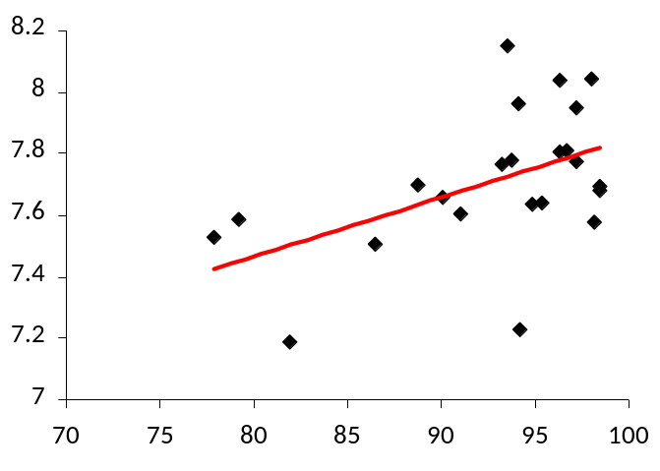
% CD28+ cells
% CD57+ cells
% KLRG1+ cells
r = 0.427*
r = 0.314
r = 0.311
mTRF (kbp)
mTRF (kbp)
mTRF (kbp)
Figure 8.7. Scatter plots showing the between mTRF (kbps) and the proportion of KLRG1+, CD57+ and CD28+ cells in the CD3+ lymphocyte subset of the T cell-enriched fraction of PBMCs from human subjects. r values are displayed on each scatter plot and statistically significant correlations are indicated by * (p<0.05). Subjects were mixed gender (25 males, 2 females) aged 21-60 years.

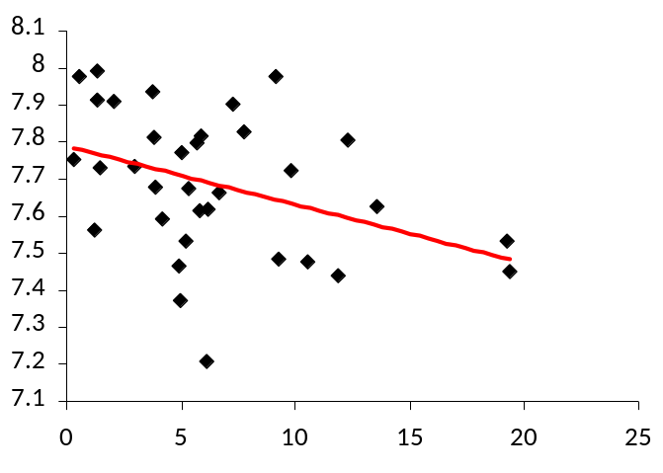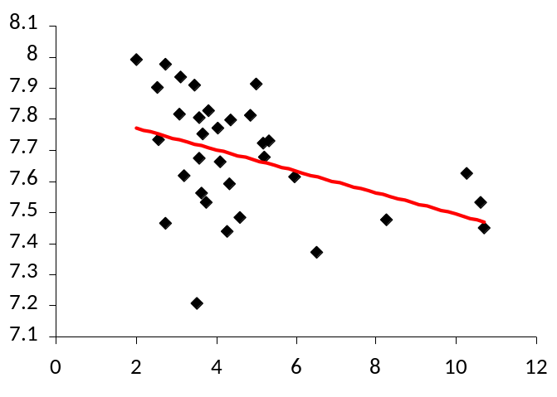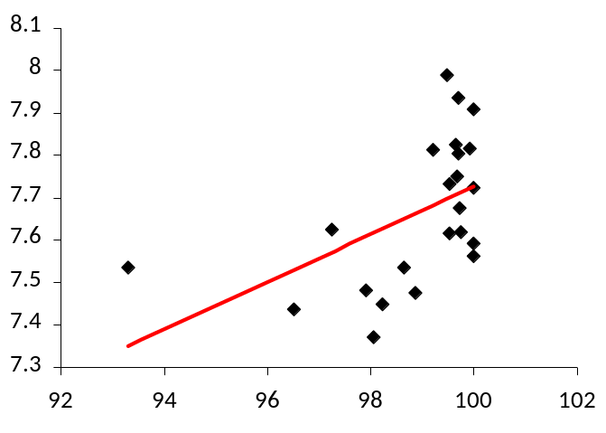
r = 0.518*
% CD28+ cells
% CD57+ cells
% KLRG1+ cells
r = -0.393*
r = -0.456*
mTRF (kbp)
mTRF (kbp)
mTRF (kbp)
Figure 8.8. Scatter plots showing the correlations between mTRF (kbps) and the proportion of KLRG1+, CD57+ and CD28+ cells in the CD3+/CD4+ lymphocyte subset of the CD4+ T cell-enriched fraction of PBMCs from human subjects. r values are displayed on each scatter plot and statistically significant correlations are indicated by * (p<0.05) and ** (p<0.01). Subjects were mixed gender (25 males, 2 females) aged 21-60 years.

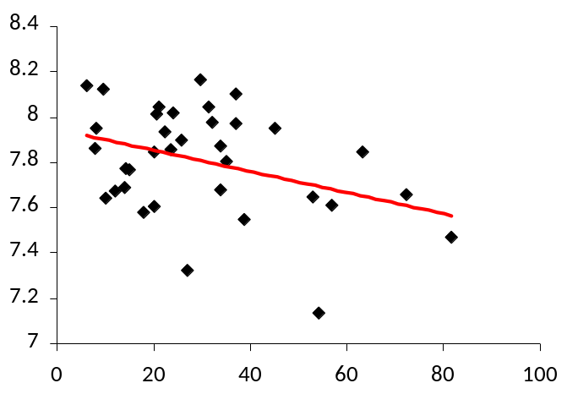
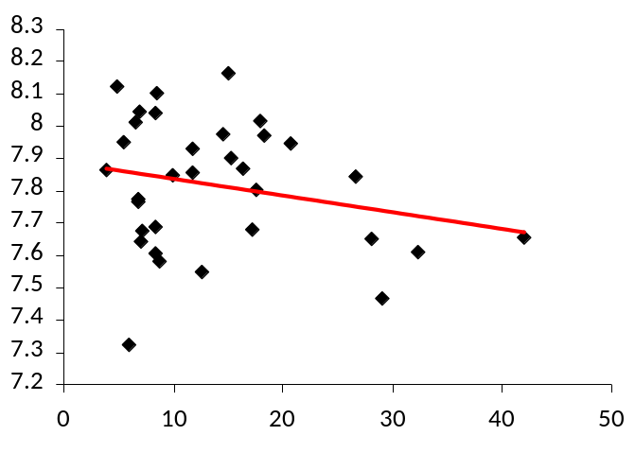
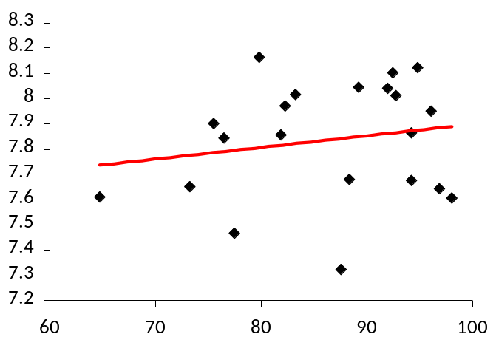
% CD28+ cells
% CD57+ cells
% KLRG1+ cells
r = -0.258
r = -0.166
r = 0.184

mTRF (kbp)

mTRF (kbp)

mTRF (kbp)

Figure 8.9. Scatter plots showing correlations between mTRF (kbps) and the proportion of KLRG1+, CD57+, and CD28+ cells in the CD3+/CD8+ lymphocyte subset of the CD8+ T cell-enriched fraction of PBMCs from human subjects. r values are displayed on each scatter plot. None of the correlations were statistically significant. Subjects were mixed gender (25 males, 2 females) aged 21-60 years.

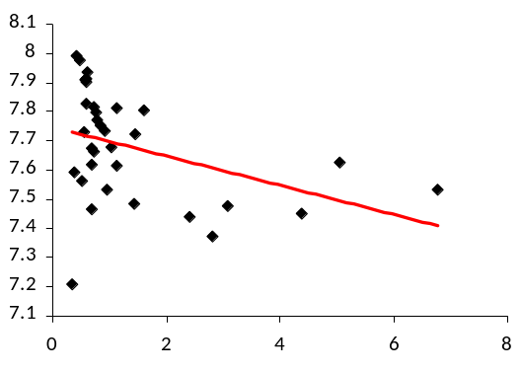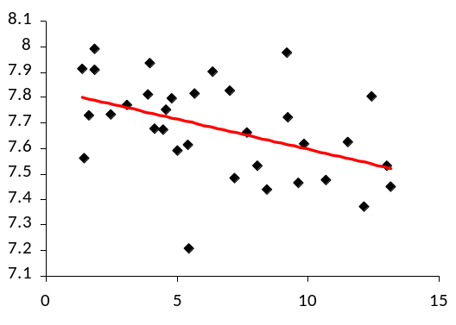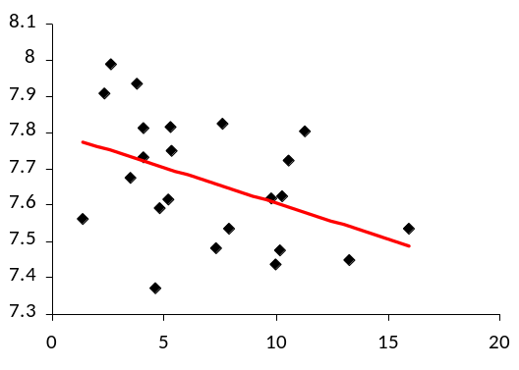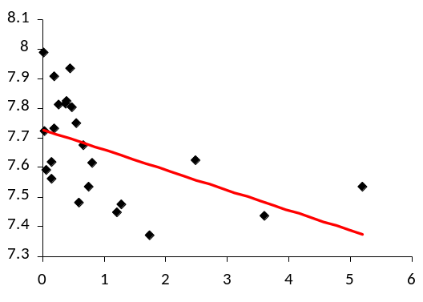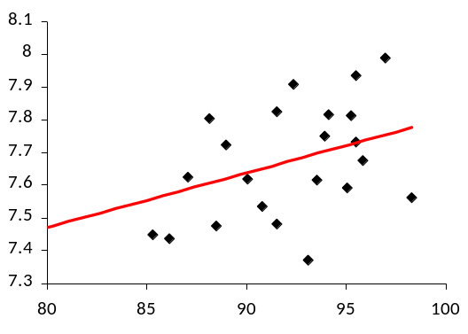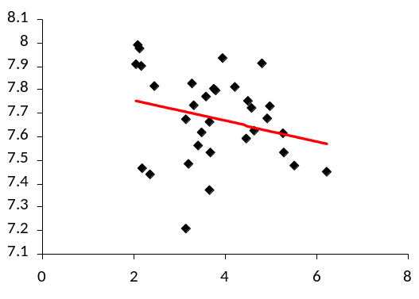Figure 8.10. Scatter plots showing correlations between mTRF (kbps) and the proportion of KLRG1+/CD57+, KLRG1+/CD57-, KLRG1-/CD57+, KLRG1+/CD28+, KLRG1+/CD28- and KLRG1-/CD28+ cells in the CD3+/CD4+ lymphocyte subset of the CD4+ T cell-enriched fraction of PBMCs from human subjects. r values are displayed on each scatter plot and statistically significant correlations are indicated by * (p<0.05). Subjects were mixed gender (25 males, 2 females) aged 21-60 years.
mTRF (kbp)
mTRF (kbp)
mTRF (kbp)
% KLRG1+/CD57+ cells
% KLRG1+/CD57- cells
% KLRG1+/CD28+ cells
% KLRG1+/CD28- cells
% KLRG1-/CD28+ cells
r = -0.420
r = -0.454
r = -0.436*
r = -0.597*
r = 0.439*
% KLRG1-/CD57+ cells
r = -0.256
mTRF (kbp)
mTRF (kbp)
mTRF (kbp)
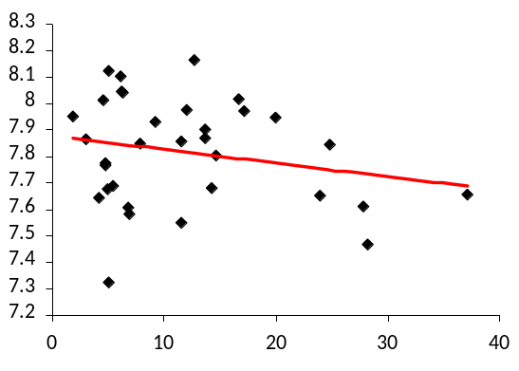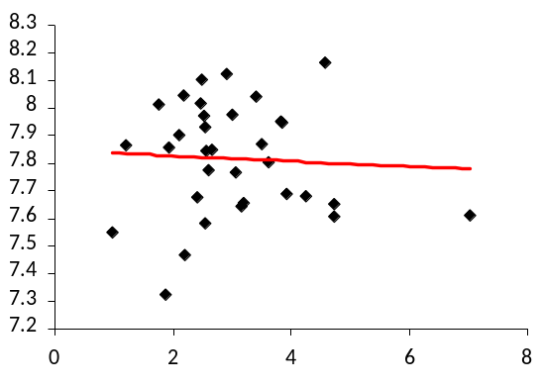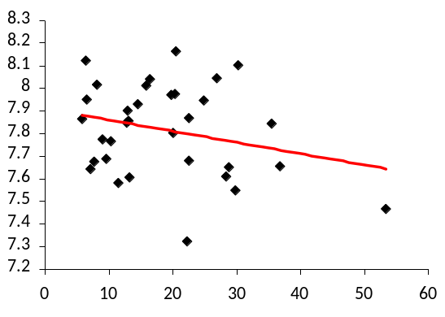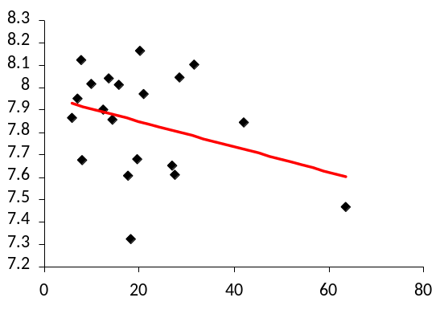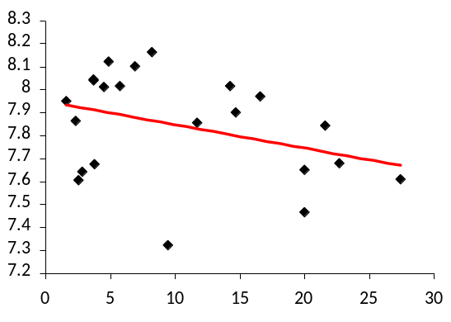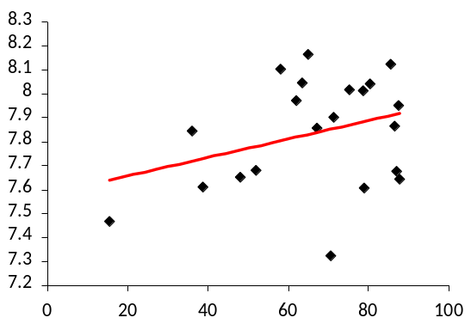
% KLRG1+/CD57+ cells
% KLRG1+/CD57- cells
% KLRG1+/CD28+ cells
% KLRG1+/CD28- cells
% KLRG1-/CD57+ cells
% KLRG1-/CD28+ cells
mTRF (kbp)
mTRF (kbp)
mTRF (kbp)
r = -0.133
r = -0.264
r = -0.056
r = -0.192
r = -0.256
r = 0.325
mTRF (kbp)
mTRF (kbp)
mTRF (kbp)
Figure 8.11. Scatter plots showing correlations between mTRF (kbps) and the proportion of KLRG1+/CD57+, KLRG1+/CD57-, KLRG1-/CD57+, KLRG1+/CD28+, KLRG1+/CD28- and KLRG1-/CD28+ cells in the CD3+/CD8+ lymphocyte subset of the CD8+ T cell-enriched fraction of PBMCs from human subjects. r values are displayed on each scatter plot. None of the correlations were statistically significant. Subjects were mixed gender (25 males, 2 females) aged 21-60 years.

8.3.5. Frequency of senescence markers in the T cell subsets of pre- and post-enrichment fractions
The mTRFs and the proportion of KLRG1+, CD57+ and CD28+ cells in the CD3+, CD3+/CD4+ and CD3+/CD8+ lymphocytes subsets of the PBMC, T cell-enriched, CD4+ T cell-enriched and CD8+ T cell enriched fractions are presented in figure 8.12. In the PBMC fraction, there was a smaller proportion of KLRG1+, CD57+ and CD28- cells in the CD3+/CD4+ compared to the CD3+ lymphocyte subset (p<0.01) and a larger proportion of KLRG1+, CD57+ and CD28- cells in the CD3+/CD8+ compared to both the CD3+ and the CD3+/CD4+ lymphocyte subsets of the PBMC fraction (p<0.01). The same differences were apparent between the T lymphocyte subsets of the enriched fractions. There was a smaller proportion of KLRG1+, CD57+ and CD28- cells in the CD3+/CD4+ lymphocyte subset of the CD4+ T cell-enriched fraction compared to the CD3+ lymphocyte subset of the T cell-enriched fraction (p<0.01). There was also a larger proportion of KLRG1+ (p<0.01), CD57+ (p<0.05) and CD28- cells (p<0.01) in the CD3+/CD8+ lymphocyte subset of the CD8+ T cell-enriched fraction compared to both the CD3+ lymphocyte subset of the T cell-enriched fraction and the CD3+/CD8+ lymphocyte subset of the CD8+ T cell-enriched subset compared to the CD3+/CD4+ lymphocyte subset of the CD4+ T cell-enriched subset (p<0.01).

The CD3+/CD8+ lymphocyte subset of the CD8+ T cell-enriched fraction had significantly longer mTRFs compared to both the CD3+ lymphocyte subset of the T cell-enriched fraction (p<0.05) and the CD3+/CD4+ lymphocyte subset of the CD4+ T cell-enriched fraction (p<0.01).

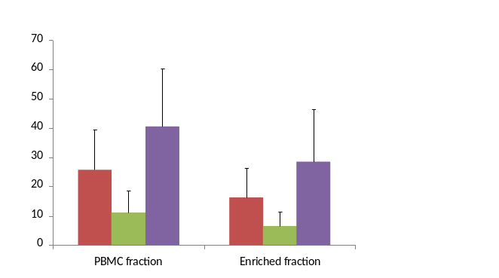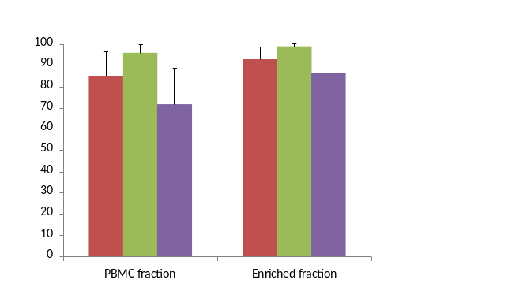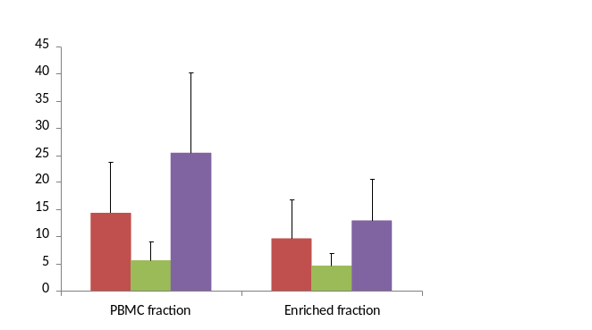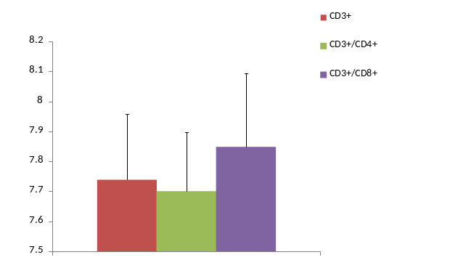Figure 8.12. The mean telomere restriction fragment lengths (mTRFs; D) and the proportions of KLRG1+ (A), CD57+ (B) and CD28+ (C) cells in the CD3+, CD3+/CD4+ and CD3+/CD8+ lymphocyte subsets of the PBMC, T cell-enriched, CD4+ T cell-enriched and CD8+ T cell-enriched fractions. All values are mean ± SD. Statistically significant differences from the CD3+ lymphocyte subset are indicated by * (p<0.05) or ** (p<0.01) and statistically significant differences from the CD3+/CD4+ lymphocyte subset are indicated by # (p<0.05) or ## (p<0.01). Subjects were mixed gender (25 males, 2 females) aged 21-60 years.
% KLRG1+ cells
% CD28+ cells
**
##
**
##
**
**
A
**
**
**
*
##
##
% CD57+ cells
B
**
**
##
**
**
##
C
mTRF length (kbp)
##
*
D
8.3.6. Individual breakdown of telomere length data
The individual mTRF of the CD3+, CD4+ and CD8+ T cell-enriched fractions of the PBMCs from healthy subjects are presented in figure 8.13.

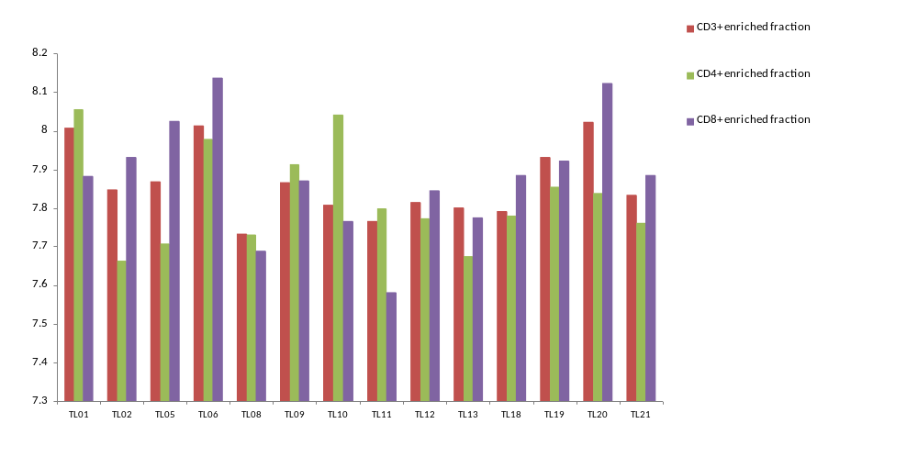
Telomere length (kbp)
A

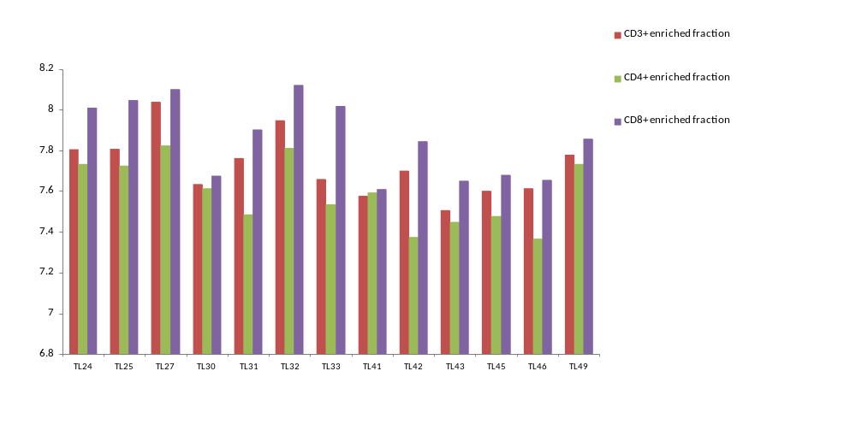
B

Telomere length (kbp)

Figure 8.13. The mTRFs in the CD3+, CD4+ and CD8+ T cell-enriched fractions from PBMCs of human subjects.

8.4. Discussion

The aims of this study were to investigate the relationship between the proportion of KLRG1+, CD57+ and CD28- cells in CD3+, CD3+/CD4+ and CD3+/CD8+ lymphocyte subsets and mean telomere restriction fragment length (mTRF), and to compare the mTRFs of the CD3+, CD4+ and CD8+ lymphocyte subsets in peripheral blood.

8.4.1. Preferential loss of KLRG1+ cells due to the enrichment process
This study provides evidence that the reliability of the negative enrichment of CD3+, CD4+ and CD8+ T lymphocytes from isolated human PBMCs is undermined by a preferential loss of KLRG1+ cells due to the enrichment process. There were smaller proportions of KLRG1+/CD57+, KLRG1+/CD57- cells in the CD4+ T lymphocyte subset of both the CD3+ and CD4+ T cell-enriched fractions compared to isolated PBMCs but no differences in the proportion of KLRG1-/CD57+ cells. Furthermore, there was a smaller proportion of KLRG1+/CD28+ and KLRG1+/CD28- cells and a larger proportion of KLRG1-/CD28+ cells in the CD4+ T lymphocyte subset of both the CD3+ and CD4+ T cell-enriched fractions compared to isolated PBMCs. Similar results were noted with the co-expression of KLRG1 and CD57, and KLRG1 and CD28 in the CD8+ T lymphocyte subpopulations although there was no significant difference between the proportion of KLRG1+/CD28+ cells pre and post enrichment in this subset.

This preferential cell loss is likely to be due to the antibodies used in the enrichment process (section 8.2.2.2.), and not due to impurities (see figure 8.1) or cell death as the viability of all the enriched samples was > 95% in all cases. The cell-surface antigen, CD56, is expressed on NK cells and on a small proportion of T cells. CD56 is expressed on a subset of T cells (Ohkawa et al., 2001; Chapter 3) and as an antibody to CD56 is in each of the enrichment kit antibody cocktails, the CD56+ T cells will be lost during the enrichment process. It may be that this population of cells also expresses KLRG1, which would result in some KLRG1+ T cells being removed during the enrichment process. Indeed, CD56+ T cells are highly cytotoxic and have limited proliferative ability (Ohkawa et al., 2001), characteristics consistent with KLRG1+ T cells (Voehringer, Koschella and Pircher, 2002). A study to investigate the proportion of CD3+/CD56+ cells expressing KLRG1 would shed further light on this. It would be interesting to find out if this preferential cell loss is limited to this particular brand of enrichment kit as previous studies have used magnetic enrichment to isolate cell populations for telomere length measurements (Weng et al., 1995; Bruunsgaard et al., 1999; Robertson et al., 2000; Mariani et al., 2003). Although these studies showed good post-enrichment purity, it is unclear whether or not they monitored changes in the proportion of lymphocyte subsets pre and post enrichment.

8.4.2. Relationship between mTRF and cell surface markers of senescence in CD4+ and CD8+ T cell subset populations
KLRG1+, CD57+ and CD28- have been suggested as cell surface profiles of senescent T cells as they define cells that have a long replicative history and are unable to proliferate in response to antigenic challenge (Bruunsgaard et al., 1999; Voehringer, Koschella and Pircher, 2002; Brenchley et al., 2003; Ouyang et al., 2003; Simpson et al., 2007a; 2008). In addition, CD57+ and CD28- T cells have shortened telomeres compared to CD57- and CD28+ T cells (Bruunsgaard et al., 1999; Brenchley et al., 2003). Furthermore, KLRG1+/CD57+ and KLRG1+/CD28- cells have been shown to accumulate in the CD8+ T lymphocyte subset with age (Chapter 5) and have been suggested to more accurately define a population of senescent cells than KLRG1, CD57 or CD28 expression alone (Voehringer, Koschella and Pircher, 2002; Brenchley et al., 2003; Ibegbu et al., 2005; Chapter 5). As such, considering the preferential loss of KLRG1+ cells as a result of the enrichment process includes large losses of KLRG1+/CD57+ and KLRG1+/CD28- cells it is likely that a significant proportion of senescent cells with critically shortened telomeres would be missing from the isolated cell fractions. In terms of telomere measurement studies this would result in an mTRF that is longer than the actual respective non-enriched T lymphocyte subset mTRF. In light of this, questions can be raised as to the reliability of previous studies that have measured mTRFs from magnetically enriched cell fractions.

In addition to this, shorter leukocyte telomere lengths are correlated with higher cardiovascular (CV) risk (Brouilette et al., 2003; Nakashima et al., 2004; Starr et al., 2007; van der Harst et al., 2007). This study suggests that mTRF measurement of T lymphocyte subsets enriched by the methods here would be inappropriate in predicting CV risk, as the mTRFs would suggest lower levels of CV risk than there actually are.

Previous studies have shown telomere shortening with age in leukocytes, PBMCs and CD3+, CD4+ and CD8+ T lymphocytes (Vaziri et al., 1993; Weng et al., 1995; Robertson et al., 2000; Valenzuela and Effros, 2002; Mariana et al., 2003; Valdes et al., 2005; Kilpatrick et al., 2008). This study confirmed that telomere shortening with age occurs in CD3+, CD4+ and CD8+ T lymphocyte subsets isolated from PBMCs, consistent with an accumulation of senescent CD4+ and CD8+ T lymphocytes with ageing. The loss of KLRG1+ cells due to the enrichment process is likely to reduce the correlation between age and mTRF, and so it would be expected that the r values for the correlations would be lower than those of previous studies (Robertson et al., 2000; Valenzuela and Effros, 2002; Mariana et al., 2003; Vaziri et al., 1993; Weng et al., 1995; Valdes et al., 2005; Kilpatrick et al., 2008). However, the r values for the correlations of age with mTRFs of the CD3+, CD4+ and CD8+ T cell-enriched fractions (-0.676, -0.515 and -0.447 respectively) were similar to those of previous studies looking at telomere length in leukocytes, PBMCs and CD8+ T lymphocytes (Iwama et al., 1997; Mariani et al., 2003; Valdes et al., 2005). However, the Valdes study included obese subjects and smokers, groups that have shorter mTRFs than control groups (Valdes et al., 2005) which would be likely to reduce the r value for the correlation. Vaziri et al., (1992) investigated the relationship between leukocyte mTRF and age in subjects ranging from 0-107 years old. The r value for this correlation was -0.83, indicating a much stronger relationship between age and mTRF than in this study. It may be that had the enrichment process not removed a large proportion of KLRG1+ cells then the r values for the correlations in the current study would be higher. However, the higher r value seen in the Vaziri study is likely to be a result of the inclusion of subjects at extreme age group ranges, whereas the youngest and oldest subjects in this study were 21 and 60 years old respectively. Regardless, this study showed that mTRFs measured from enriched T lymphocyte subset fractions can provide statistically significant correlations with age. Furthermore, these correlations are of comparable strength to studies using PBMC or whole leukocyte fractions, but using much lower subject numbers.

Previous studies have shown T cells expressing CD57 or lacking the expression of CD28 at the cell surface to have shortened telomeres and define a senescent phenotype (Bruunsgaard et al., 1999; Brenchley et al., 2003). Although recent evidence has suggested KLRG1 expression on T cells to define a population of senescent cells (Voehringer et al., 2001; Voehringer, Koschella and Pircher, 2002; Ouyang et al., 2003), a link between mTRF and KLRG1 expression on T cell subsets has not been established.

The proportions of KLRG1+, CD57+ and CD28- cells in the CD4+ T cell-enriched fraction were negatively correlated with mTRF, supporting previous studies of telomere length relationship with T cells expressing CD57 and CD28 (Bruunsgaard et al., 1999; Brenchley et al., 2003), and suggesting that KLRG1 is expressed on CD4+ T cells with shortened telomeres. This conclusion is further supported by the data showing KLRG1 co-expression with CD57 or CD28. The proportion of KLRG1+/CD57+ and KLRG1+/CD57- cells in the CD4+ T cell subset were negatively correlated with mTRF, and while they were not significantly correlated, the p values (p = 0.084 for both) suggest that these correlations may be significant in a larger subject group. There was no significant correlation between mTRF and the proportion of KLRG1-/CD57+ cells in the same lymphocyte subset, and in this instance the p value (p = 0.136) suggests that this correlation may not be significant in a larger subject group.

KLRG1+/CD57- cells have been suggested as a pre-senescent memory T cell population that up-regulate CD57 to become KLRG1+/CD57+ cells when they enter a state of senescence (Ibegbu et al., 2005; Sarkar et al., 2008; Chapter 5). As such, a memory cell expressing KLRG1 on the cell surface would continue to undergo telomere shortening until the Hayflick limit at which point it would become senescent, concurrently up-regulating CD57. Therefore the KLRG1+/CD57+ cell population would be expected to have shorter telomeres than the KLRG1+/CD57- population which would have a larger diversity of telomere lengths related their history of cell division. However, the strength of the correlations between mTRF and the proportion of KLRG1+/CD57- or KLRG1+/CD57+ cells did not appear to reflect this. Considering the proportions of these two cell types in the CD4+ T cell subset were equal after enrichment, and represent only ~2% of the lymphocyte subset, they are unlikely to have much influence on the overall mTRF. However, in the pre-enriched sample the KLRG1+/CD57+ and the KLRG1+/CD57- populations made up ~5% and ~10% of the CD4+ T cell subset respectively, and it would be interesting to see if enrichment-caused losses in these larger cell populations would impact on the mTRF of the CD4+ T cell subset. The lack of a significant correlation between mTRF and the proportion of KLRG1-/CD57+ cells was surprising as it was shown to be a cell type not proportionally diminished by the loss of cells due to the enrichment process, and previous work has suggested CD57+ cells to have shortened telomeres (Brenchley et al., 2003). It could be that the expression of CD57 on the cell surface of CD4+ T cells may not define cells with shortened telomeres, as Brenchley et al., (2003) only showed CD8+/CD57+ T cells to have shorter telomeres than their CD57- counterparts. Alternatively, the KLRG1-/CD57+ phenotype may define a population of cells that have undergone telomere independent senescence (Chen et al., 2001), and as such would not have undergone telomere shortening, so no correlation between larger proportions of these cells and mTRF would be expected.

The negative correlation of KLRG1+/CD28- and positive correlation of KLRG1-/CD28+ cells in the CD3+/CD4+ lymphocyte subset of the CD4+ T cell-enriched with mTRF is consistent with previous work showing CD28- cells to have shortened telomeres compared to CD28+ cells in the CD4+ T cell subset (Bruunsgaard et al., 1999) and with the hypothesis of KLRG1 as a T cell marker of cellular senescence (Voehringer, Koschella and Pircher, 2002; Ouyang et al., 2003). The negative correlation of KLRG1+/CD28+ cells in this subset supports previous work that suggested KLRG1 expression on T cells to be a more reliable marker of senescence than CD28 due to the inability of KLRG1+/CD28+ T cells to proliferate (Voehringer, Koschella and Pircher, 2002).

There were no significant correlations between mTRF and KLRG1+/CD57+, KLRG1+/CD57-, KLRG1-/CD57+, KLRG1+/CD28+, KLRG1+/CD28- and KLRG1-/CD28+ cells in the CD3+/CD8+ lymphocyte subset of the CD8+ T cell-enriched fraction. These data may suggest that CD8+ T lymphocytes that are KLRG1+, CD57+ or CD28- represent cells that have undergone telomere independent senescence. However, this is contrary to Brenchley et al., (2003) who showed investigated telomere length and CD57 expression on CD8+ T lymphocytes. However, care must be taken as Brenchley et al., (2003) only performed telomere length analysis on 4 subjects, and as such these data may not be a true reflection the relationship between CD57 and telomere length in this T lymphocyte subset.

8.4.3. Comparison of the mTRFs of the CD3+, CD4+ and CD8+ T lymphocyte subsets
There are contradictory reports on the mTRFs of the CD4+ and CD8+ T lymphocyte populations. Palmer et al., (1997) and Rufer et al., (1998) have shown the CD8+ T lymphocyte subset population to have longer mTRFs, whereas Son et al., (2000) have shown CD4+ T lymphocyte subset population to have longer mTRFs. There was a greater proportion of KLRG1+, CD57+ and CD28- cells in the CD8+ T cell subset compared to both the CD3+ and CD4+ T cell subsets. In combination with the greater replication kinetics of the CD8+ T cells compared to CD4+ T cells (Foulds et al., 2002) and their loss of the ability to up-regulate telomerase much sooner into their replicative life-span (Valanzuela and Effros, 2002) it was hypothesised that the CD8+ T cell subset would also have a significantly shorter mTRF. However, the results showed that the CD8+ T cell subset had a significantly longer mTRF than the CD3+ and CD4+ T cell subsets. There may be three possibilities for these results. Firstly, the loss of senescent cells due to the enrichment process may have a much greater effect on the CD8+ compared to the CD4+ T cell subset as there are fewer CD8+ T cells in the peripheral blood, of which a greater proportion are KLRG1+, CD57+ and CD28-. However, the CD8+ T cell subset still had a larger proportion of KLRG1+, CD57+ and CD28- cells than the CD3+ and CD4+ T cells subsets after the enrichment process. Alternatively, the results may indicate that the CD8+ T cell population contains a much greater proportion of cells that have undergone telomere independent senescence than the CD4+ T cell subset. This would result in a large proportion of cells expressing cell surface markers of senescence but having relatively long telomeres. However, previous work has shown CD57+ and CD28- cells in the CD8+ T cell subset to have shortened telomeres (Bruunsgaard et al., 1999; Brenchley et al., 2003). However, as previously discussed, Brenchley et al., (2003) analysed only 4 subjects, which may not be truly representative of the relationship between CD57 expression and telomere length in CD8+ T lymphocytes. Thirdly, the longer mTRF of the CD8+ T cell subset may be due an accumulation of quiescent T lymphocytes that are awaiting clearance through apoptosis. These cells would not be a senescent population and as such would have up-regulated telomerase expression resulting in telomere maintenance. Indeed, Brenchley et al (2003) showed that some CD8+/CD57+ cells are prone to apoptosis, a characteristic consistent with a quiescent cell population, but inconsistent with a senescent T cell population (Kaneko et al., 1996; Posnett et al., 1999; Spaulding, Guo, and Effros, 1999). An investigation into the level of telomerase expression in this cell population would clarify this.

In conclusion, due to the preferential loss of KLRG1+ cells as a result of the enrichment process, it is difficult to draw any definitive conclusions regarding the difference in telomere lengths between the T cell subsets. Further work to establish a reliable method of T cell subset isolation is required before differences in the telomere lengths of CD4+ and CD8+ T cell subsets can be adequately investigated. Furthermore, it appears that the expression of KLRG1, CD57 and CD28 may define different mechanisms of senescence depending upon which T lymphocyte subset population they are expressed. In addition, this study also shows that the telomere lengths in T lymphocyte subset populations differ significantly, adding to the already considerable diversity in telomere length between different cell types of within the leukocyte population (Palmer et al., 1997; Rufer et al., 1998; Mariani et al., 2003). Considering that whole blood leukocyte telomere length may be used as a predictive measure of disease e.g. cardiovascular disease (Brouilette et al., 2003; Nakashima et al., 2004; Matthews et al., 2006; van der Harst et al., 2007), these data suggest that telomere length measurements of isolated T cell subsets could provide a much more accurate predictive measure, and as such perhaps contribute to early detection of disease.

CHAPTER 9

General Discussion

The studies comprising this thesis investigated the frequency of senescent T lymphocytes with exercise, obesity and ageing. Data was gathered from a variety of human subjects and the analysis of cell surface phenotypes was conducted using two, three and four colour flow cytometry. Where telomere length analysis was performed, T lymphocyte fractions were physically isolated and the relationship between telomere length and cell surface phenotype was assessed.

9.1. Aims of the project

The aim of this thesis, as stated in Chapter 1, was to address the dearth of information regarding the accumulation of senescent T lymphocytes in states associated with immunosuppression, such as exercise, obesity and ageing, based on the cell surface expression of recently identified markers of senescence. To achieve this, the aims were subdivided as follows:

Aim 1: Investigate the reliability of the sole use of CD8 expression as a cell surface marker of CD8+ T lymphocytes (Chapter 3).

Aim 2: Investigate the level of expression of single cell surface markers of senescence on lymphocyte subsets of a controlled male population (Chapter 4).

Aim 3: Investigate the co-expression of cell surface markers of senescence on T lymphocyte subsets with age (Chapter 5).

Aim 4: Investigate the impact of six months intensive exercise on the co-expression of cell surface markers of senescence on T lymphocyte subsets (Chapter 6).

Aim 5: Investigate the co-expression of cell surface markers of senescence on T lymphocyte subsets with obesity (Chapter 7).

Aim 6: Investigate the relationship between the level of co-expression of cell surface markers of senescence and telomere length in T lymphocyte subsets (Chapter 8).

9.2. Cell surface phenoytyping of senescent T lymphocyte subsets

Previously, studies have used the sole expression of CD8 to identify a CD8+ T lymphocyte subset (Mazzeo et al., 1998; Gannon et al., 2001, 2002; Krzywkowksi et al., 2001; van der Pompe et al., 2001; Vider et al., 2001; Ibfelt et al., 2002; Ouyang et al., 2003; Simpson et al., 2006). However, in Chapter 3, a significant proportion of CD8+ lymphocytes were shown to be a population of natural killer (NK) cells expressing CD56 and lacking the expression of the pan-T lymphocyte marker, CD3. Other studies had previously recognised this limitation, and used gating around the CD8^{bright} lymphocyte population in attempt to exclude this population of CD8+ NK cells (Gannon et al., 2001, 2002; Ouyang et al., 2003; Simpson et al., 2007a). Although this population has been shown to be a pure T lymphocyte population (Simpson et al., 2007a), Chapter 3 confirmed that this method excludes a population of CD3+/CD8^{dim} lymphocytes constituting ~10% of the CD3+/CD8+ lymphocyte population. As such, the omission of this subset could impact on the analysis of cell surface antigens on CD8+ T lymphocytes.

Analysis of the proportion of cells expressing the T lymphocyte cell surface markers of senescence, the killer cell lectin-like receptor G1 (KLRG1) and CD57, the classic memory and naïve cell markers CD45RA and CD45RO and the lymph node homing receptor CD62L was central to the investigations in this thesis. As all these cell surface proteins are known to be expressed on both NK and T cell populations (Warren and Skipsy, 1991; Frey et al., 1998; Tarazona et al., 2000; Voehringer et al., 2001; Brenchley et al., 2003), failure to accurately identify the whole T cell population would likely impact on the reliability of the reported frequencies of senescence and memory cells markers. Consequently, based on the findings in Chapter 3, each of the studies in this thesis used two colour flow cytometry to accurately identify the CD4+ and CD8+ T lymphocyte subsets, and the CD56+ NK cell subset where appropriate, based initially on the expression of CD3.

Chapter 4 used three colour flow cytometry to assess the proportion of CD4+ and CD8+ T lymphocytes and CD56+ NK cells expressing each of KLRG1, CD57, CD28, CD45RA, CD45RO and CD62L in a normative subject group. The subject group was designed to exclude factors such as gender, age, obesity, a sedentary lifestyle, life stress and smoking that are known to impact immunosenescence, and as such establish a normative level of expression of the aforementioned cell surface proteins. It was established that compared to the CD4+ T lymphocyte subset, the CD8+ T lymphocyte subset contained a larger proportion of KLRG1+ and CD57+ cells, phenotypes suggested to define T lymphocytes that have entered a senescent state (Voehringer, Koschella and Pircher, 2002; Brenchley et al., 2003). The larger proportion of these cells in the CD8+ T lymphocyte subset was consistent with previous studies (Voehringer, Koschella and Pircher, 2002; Mills, Karnik and Dillon, 2007; Simpson et al., 2008) and may be due the ability of CD4+ T lymphocytes to up-regulate the telomere lengthening enzyme, telomerase, further into their replicative lifespan than CD8+ T lymphocytes (Valanzuela and Effros, 2002) therefore avoiding telomere dependent senescence for longer. The loss of CD28 expression from the cell surface of T lymphocytes has been suggested to define a senescent population (Bruunsgaard et al., 1999). However, in Chapter 4, lower proportions of CD28+ cells were not noted in the CD8+ compared to the CD4+ T lymphocyte subset, as expected considering proportions of KLRG1+ and CD57+ cells in these subsets. This was contrary to previous data (Bruunsgaard et al., 1999) and may reflect the greater diversity of subjects in that study compared to that of the normative subject group in Chapter 4. However, correlations investigating the relationships between the proportions of KLRG1+, CD57+ and CD28- cells in the CD4+ and CD8+ T lymphocyte subsets in a large, diverse subject group indicated a much stronger negative correlation between the proportions of CD28- and CD57+ cells compared to the proportions of CD28- and KLRG1+ cells, suggesting a complex relationship between these cell surface phenotypes. Indeed, recent work has shown that some CD8+/CD28+ T lymphocytes are unable to replicate (Voehringer, Koschella and Pircher, 2002; Brenchley et al., 2003; Ibegbu et al., 2005), and that such a population also expresses KLRG1 (Voehringer, Koschella and Pircher, 2002). As such, the use of only one of these markers may be insufficient to accurately identify a senescent T lymphocyte population.

The proportions of CD45RO+ memory cells and CD62L+ cells were significantly lower in the CD8+ compared to the CD4+ T lymphocyte population, as previously reported (Simpson et al., 2008), and there was no difference in the proportion of CD45RA+ cells, between the CD4+ and CD8+ T lymphocyte subsets. These results appear inconsistent with the reported description of CD45RA and CD45RO as reciprocal subsets of T lymphocytes (Bruunsgaard et al., 1999) and with the shedding of CD62L from the cell surface of naïve T lymphocytes, along with down-regulation of CD45RA, upon activation (Wroblewski and Hamann, 1996). However, CD45RA expression has been shown simultaneously with that of CD45RO on newly activated memory T lymphocytes (Visser, Lai and Poppema, 1993; Summers, O’Donnell and Hart, 1994) and effector memory cells late in their replicative lifespan (Hamann et al., 1997; Dunne et al., 2002). Indeed, subsets of CD8+/CD45RA+ T lymphocytes expressing KLRG1 (Voehringer, Koschella and Pircher, 2002) and CD57 (Brenchley et al., 2003) have been reported, suggesting that accurate identification of CD45RA+ naïve and memory T lymphocytes requires more complex cell surface phenoytyping.

Chapter 4 suggested that the use of KLRG1, CD57 or CD28 as a sole cell surface marker of senescence, and the use of CD45RA or CD45RO to distinguish between naïve and memory T lymphocytes, may not be reliable and may mask important subpopulations of CD4+ and CD8+ T lymphocytes. Indeed, the data suggest that in order to accurately identify a “truly senescent” population, four colour flow cytometry investigating the co-expression of KLRG1 with CD57, CD28, CD45RA and CD45RO would be required. In Chapter 5 and Chapter 7 it was shown that in cross sectional studies of ageing and obesity differences in the proportion of KLRG1+ or CD57+ cells between subject groups were actually differences in the proportion of KLRG1+/CD57+ cells, and not differences in the proportion of KLRG1+/CD57-, or KLRG1-/CD57+ cells. Furthermore, differences in the proportion of CD28+ cells between subject groups reflected differences in the proportion of KLRG1+/CD28- and KLRG1-/CD28+ cells, as no changes were noted in the proportion of KLRG1+/CD28+ cells. These data indicate that the sole use of KLRG1, CD57 or CD28 as markers of senescence on T lymphocyte subsets does indeed mask more complex subpopulations of cells, and significant differences in the proportions of senescent cell populations may be missed in studies that do not investigate the co-expression of these markers. Indeed, the use of four colour flow cytometry to investigate sub-populations of T lymphocytes was critical in identifying the specific loss of KLRG1+ cells during the T lymphocyte subset enrichment process in Chapter 8. Had the identification of senescent T lymphocytes been based on single cell surface marker expression of KLRG1, CD57, or CD28, it is likely that the specificity of the cell loss would not have been recognised.

In Chapter 5 and Chapter 7, the co-expression of KLRG1 with CD45RA or CD45RO was also investigated, and in Chapter 6, the co-expression of CD45RA and CD45RO was investigated. Considering CD45RA is expressed on both naïve and memory T lymphocytes, it should not be solely used to define a naïve or an effector memory phenotype. Indeed, the findings in Chapter 5 and Chapter 7 identify distinct subsets within the CD45RA population, based on the expression of KLRG1. Substantial populations of KLRG1+/CD45RA+, KLRG1+/CD45RA- and KLRG1-/CD45RA+ were isolated and significant differences between subject groups were noted, and these may correspond to functionally different cell types. Indeed, similar complexities were noted in the subpopulations of CD45RA based on CD45RO expression in Chapter 6. Whereas no changes over time were noted based on the sole expression of CD45RA on T lymphocyte subsets, when identifying a naïve cell population based on expression of CD45RA and lack of CD45RO expression, significant changes were evident, further supporting the used of multi-parameter flow cytometry to accurately identify naïve and memory phenotypes.

As such, it is clear that the use of four colour flow cytometry allowed a much more sensitive and subtle analysis of differences in the proportions of cells expressing markers of senescence in different subject groups and individuals throughout the scope of this thesis. Furthermore, it is suggested that basing identification of senescent populations on the single surface marker expression of KLRG1, CD57 or CD28 may be insufficient to observe significant changes in T lymphocyte subsets.

9.3. Ageing

Chapter 5 investigated the frequency of cells co-expressing KLRG1 with CD57, CD28, CD45RA or CD45RO in a group of younger and a group of older subjects. There was a greater frequency of KLRG1+ cells in the CD4+ T lymphocyte subset of the older subject group, a previously unreported finding. This may be a Treg population, which are known to accumulate with age (Rosenkranz et al., 2007) and express KLRG1 in mice (Beyersdorf et al., 2007). Furthermore, the older subject group had a greater frequency of KLRG1+/CD57+ and KLRG1+/CD28- cells in the CD8+ T lymphocyte subset than the younger subject group, suggesting an accumulation of senescent CD8+ T cells with age. The major finding of this study was that there appears to be an accumulation in senescent cells in older subjects and the differences in the frequency of cells expressing senescence markers are specific to only some subpopulations of KLRG1+ cells, and not a general increase in the proportion of all T cells expressing KLRG1.

Cytotoxic T lymphocytes play an important role in influenza immunity (Gioia et al., 2008) and the accumulation of senescent cells in the elderly appears to impact on the ability to respond adequately to influenza vaccination (Saurwein-Teissl et al., 2002; Xie and McElhaney, 2007). An increase in a clonally expanded population of CD8+/CD28- cells that are capable of IFN-γ (Saurwein-Teissl et al., 2002), but not granzyme B production (Xie and McElhaney, 2007) has been shown to be present in older individuals with lower antibody responses to the influenza vaccine. Over the next twenty years, the population of the western world will increase substantially in density and age, potentially doubling the number of people at serious risk from influenza (Glezen, 2006). This is likely to cause a significant impact on the health and economy of the western world. Any increased understanding of the role of cell mediated immunity to the influenza virus and the role of senescent T lymphocytes could help lead to improved vaccine development, allowing greater preventative measures to be taken.
9.4. Exercise

Chapter 6 investigated changes in the frequency of CD4+ and CD8+ T lymphocytes co-expressing KLRG1 with CD57 or CD28, and CD45RA with CD45RO in triathletes during six months training for an iron man competition. The study showed a significant increase in the frequency of KLRG1+/CD57+ cells in both the CD4+ and CD8+ T lymphocyte subsets accompanied by increases in the frequency of CD45RA+/CD45RO+ memory cells and decreases in the CD45RA+/CD45RO- naïve cells in the CD4+ T lymphocyte subset and changes in the frequency of CD45RA+/CD45RO+ and CD45RA-/CD45RO+ memory cells in the CD8+ T lymphocytes subsets. Although decreases in the frequency of naïve cells and increases in the frequency of memory cells in the CD4+ T lymphocyte subset have been observed with intense periods of training (Baum, Liesen and Enneper, 1994; Weiss et al., 1995; Hack et al., 1997), the accumulation of senescent T lymphocytes is a novel finding. It may be that is due to the cumulative effect of the regular “spikes” in oxidative stress associated with acute intense bouts of exercise (Niess et al., 1996; Vider et al., 2001; Shin et al., 2008), which are a feature of intense periods of training for competition. An accumulation of senescent T lymphocytes during periods of high-intensity training may lead to immune suppression contributing to the well documented increased incidences of upper respiratory tract infections in elite athletes before competition (Davis et al., 1997; Nieman et al., 1997; Tollier et al., 2005; Spence et al., 2007; Murphy et al., 2008). As such, in the future, attempts to reduce infection in elite level athletes training for competition could target increases in the level of senescent T lymphocytes. This could allow athletes to train harder, and perform better in competition in the long run. However, the mechanisms of the accumulation of senescent T cells with high intensity exercise need to be investigated.

9.5. Obesity

Chapter 7 investigated the frequency of cells co-expressing KLRG1 with CD57, CD28, CD45RA or CD45RO in a group of lean and a group of obese subjects. There was a greater frequency of CD57+ and CD28- cells in the CD8+ T lymphocyte subset of the obese subject group, which reflected a greater frequency of KLRG1+/CD57+ and KLRG1+/CD28- cells although the latter fell short of statistical significance. In addition, there was a greater frequency of CD45RO+ cells in the CD8+ T lymphocyte subset of the obese subject group suggesting an accumulation of memory cells with obesity. These data suggest an accumulation of senescent CD8+ T lymphocytes in obese individuals, a novel finding that ties in with the immunosuppression associated with obesity. There are two likely mechanisms by which obesity may impact on the level of immunosenescence. The increased levels of oxidative stress associated with obesity (Epel et al., 2004; Valdes et al., 2005) may lead to an increased rate of telomere attrition (Sitte, Saretzki and von Zglinicki, 1998; von Zglinicki, Pilger, and Sitte, 2000) or senescence via telomere independent mechanisms (Chen et al., 2001). Alternatively, leptin produced by adipocytes has been shown to trigger activation and proliferation of circulating T lymphocytes (Lord et al., 1998, 2002; Martίn-Romero et al., 2000), possibly increasing the rate at which telomere shortening occurs, leading to increased senescence with obesity. Indeed, plasma leptin levels have been positively correlated with telomere shortening (Valdes et al., 2005).

9.6. Telomeres

Chapter 8 investigated the previously unrecognised relationship between KLRG1 expression on T lymphocyte subsets and telomere length. Most telomere length measurements are performed on whole leukocyte or isolated peripheral blood mononuclear cell (PBMC) populations. These are however, heterogeneous populations of cells with different functional characteristics and as such may have very different telomere dynamics. Indeed, previous studies of leukocyte and PBMC populations have shown high levels of diversity in telomere length (Iwama et al., 1998; Epel et al., 2004; Valdes et al., 2005). As such, physical isolation of T lymphocyte subsets could provide much more accurate data on telomere length and the relationship between telomere length and the expression of cell surface markers of senescence. A major technical finding of this study was that the commercial T lymphocyte subset enrichment kit led to a preferential loss of KLRG1+ cells from all the enriched fractions (CD3+, CD4+ and CD8+ T lymphocyte fractions). This is a concern as KLRG1 expression on T lymphocytes defines a cell population incapable of proliferation in response to mitogenic stimulation and as such may have resulted in unreliable data from previous functional studies on cell populations isolated in a similar manner (Weng et al., 1995; Bruunsgaard et al., 1999; Robertson et al., 1999; Mariani et al., 2003).

Analysis of telomere length with cell surface markers of senescence showed negative correlations with the proportion of KLRG1+ and CD57+ cells and a significant positive correlation with the proportion of CD28+ cells in the CD4+ T lymphocyte subset, suggesting that in this T lymphocyte subset KLRG1+ cells did indeed have shorter telomeres than KLRG1- cells. This conclusion was further supported by the negative correlation of telomere length with the proportion of KLRG1+/CD28- cells and the positive correlation of telomere length with KLRG1-/CD28+ cells in the CD4+ T lymphocyte subset. These relationships were not seen in the CD8+ T lymphocyte, perhaps suggesting distinct differences in the mechanism of senescence between the two subsets, or perhaps distinct mechanisms of expression of KLRG1, CD57 and CD28. Indeed, these possibilities are supported by the data showing the CD8+ T lymphocyte subset to have a significantly longer mean telomere length than the CD4+ T lymphocyte subset despite have a significantly greater proportion of KLRG1+, CD57+ and CD28- cells.

This study also showed a significant negative correlation between telomere length and age in the CD3+, CD4+ and CD8+ T lymphocytes subsets with comparable r values to previous studies on isolated leukocyte and PBMC populations (Iwama et al 1998; Valdes et al., 2005) but with a much smaller sample size and age range. This suggests that telomere measurements on isolated T lymphocyte subsets to be a more sensitive technique than using whole leukocyte or PBMC populations.

9.7. Diversity of cell surface markers of expression

Previous studies have shown a high level of diversity in both telomere length and the expression of cell surface markers of senescence on blood leukocytes (Iwama et al., 1998; Voehringer, Koschella and Pircher, 2002; Ouyang et al., 2003; Epel et al., 2004; Valdes et al., 2005). Telomeres are susceptible to oxidative damage which can cause single strand breaks in the telomeric DNA (Petersen, Saretzki, and von Zglinicki, 1998) triggering cellular senescence through either accelerated telomere attrition (Sitte, Saretzki and von Zglinicki, 1998; von Zglinicki, Pilger, and Sitte, 2000) or telomere independent mechanisms (Chen et al., 2001). One reason for the diversity in the previous studies may have been the inclusion of individuals with heightened states of oxidative stress resulting from obesity, a sedentary lifestyle, life stress and smoking. Alternatively, this diversity may reflect a predisposition of some individuals in the population to premature senescence. An accumulation of T lymphocytes with a senescent cell surface phenotype is associated with the immune risk phenotype (IRP) which has been shown to be predictive of mortality and increased susceptibility to infection and CVD (Ferguson et al., 1995; Wikby et al., 1994; Strindhall et al., 2007). Furthermore, there appears to be a hereditary component in telomere length (De Meyer et al., 2007; Kimura et al., 2008), and a natural diversity in telomerase activity between individuals (Iwama et al., 1998). In light of this, Chapter 4 investigated the diversity in the cell surface markers of expression in a population controlled for factors such as age, gender, obesity, health (mental and physical) and smoking, that are known to be associated with telomere length diversity within the population (Vaziri et al., 1993; Weng et al., 1995; Valenzuela & Effros, 2002; Epel et al., 2004; Valdes et al., 2005; Cherkas et al., 2008). Despite the controlled nature of this study, a high level of diversity was noted in frequency of the cell surface markers of senescence KLRG1+, CD57+, CD28+ and of memory (CD45RO) and naïve (CD45RA) cells in the CD4+ and CD8+ T lymphocyte populations. These data may suggest that there is a naturally high level of diversity within the population, reflecting the genetic component in telomere length and telomerase activity previously mentioned. Furthermore, the level of diversity in the CD8+ T lymphocyte population was greater than that in the CD4+ T lymphocyte population, perhaps due to the greater replication kinetics of CD8+ T lymphocytes (Foulds et al., 2002) and the ability of CD4+ T lymphocytes to up-regulate telomerase further into their replicative lifespan (Valanzuela and Effros, 2002).

The high level of diversity and the differences between the CD4+ and CD8+ T lymphocyte subsets were also noted in Chapter 5, Chapter 6, Chapter 7, and Chapter 8. Furthermore, there appeared to be higher levels of diversity compared to controls in the older subject group (Chapter 5) and the obese subject group (Chapter 7). T lymphocytes from older subjects will have undergone more rounds of clonal expansion than younger subjects, and T lymphocytes from obese subjects will have been subjected to higher levels of oxidative stress. Therefore, if there were individuals predisposed to premature senescence within these subject groups then the greater stress on their telomeres may have resulted in a greater accumulation of senescent cells in these individuals compared to non-predisposed individuals in the same subject group. This could lead to greater diversity in these subject groups compared to the control subject groups.

In Chapter 7, the accumulation of senescent T cells with obesity was suggested to play a role in the increased level of immunosuppression and cardiovascular diseases in obese individuals. However, the high level of diversity within the obese group may reflect the existence of a metabolically healthy but obese (MHO) group in the population. Such a group has previously been identified and shown to have a metabolically healthy profile including high levels of insulin sensitivity and a clinically normal lipid and inflammation profiles (Brochu et al., 2001; Karelis et al., 2005; Stefan et al., 2008). These individuals are not subject to the same immunosuppression and cardiovascular risk as obese individuals with metabolic disorder (Meigs et al., 2006). In fact, studies have shown dietary interventions with these individuals to have a negative impact on their level of health (Perseghin, 2008). As such, the “blanket treatment” of obesity by health care professionals may be inappropriate both economically and in terms of health. It may be that genetic predisposition to premature T cell senescence could be a component in determining whether or not an obese individual is metabolically healthy. Early identification of these MHO individuals possibly by senescent phenoytyping could be very important in reducing the expenditure on obesity management for those that are not at risk from metabolic syndrome, and ensuring that they get the most appropriate medical advice to prevent unnecessary and detrimental interventions.

9.10. Future work

As shown in Chapter 5, Chapter 6, Chapter 7 and Chapter 8, the relationships between the cell surface markers of expression KLRG1, CD57 and CD28 are more complex than previously thought. The sole expression of KLRG1 or CD57 or the lack of CD28 expression has previously been suggested to define senescent cells. However, four colour flow cytometry showed there to be substantial sub-populations of KLRG1+ cells based on the expression or lack of expression of CD57 or CD28. Although differences in the proportions of these sub-populations were noted between subject groups in Chapter 5 and Chapter 7, their relationship with senescence is not clearly defined. In light of this, it is suggested that future studies address the following research questions:

- Are there functional differences between the KLRG1 sub-populations in terms of proliferative ability, cytokine production and apoptosis resistance?
- Is there an “order of expression” within these sub-populations? For example, KLRG1-/CD57-, KLRG1+/CD57-, KLRG1+/CD57+, KLRG1-/CD57+, or do they represent separate populations derived from a common phenotype?
- What are the mechanisms that trigger up-regulation or down-regulation of particular proteins where appropriate?

Chapter 7 showed obese subjects to have greater proportion of KLRG1+/CD57+ cells in the CD8+ T lymphocyte subset than lean subsets. Currently, the mechanisms by which this may occur are not known. However, both heightened levels of oxidative stress and the role of leptin in obesity are candidates. Future research in this area should attempt to address the following research questions:

- Do adipocyte-stimulated increases in the level of oxidative stress result in premature T cell senescence?
- Do physiological doses of leptin in obesity cause activation and proliferation of T lymphocytes, resulting in premature senescence. If so, what is the mechanism of activation?

Chapter 8 showed negative correlations between telomere length and the proportion of KLRG1+, CD57+ and CD28- cells in the CD4+ but not the CD8+ T lymphocyte subset. Furthermore, the CD8+ T lymphocyte subset had a significantly longer mean telomere length than the CD4+ T lymphocyte subset, despite having a significantly larger proportion of KLRG1+, CD57+ and CD28- cells. Consequently, future research in this area should attempt to address the following research question:

- Does the CD8+ T lymphocyte population have a greater proportion of cells with activated telomerase than the CD4+ T lymphocyte population?
- Does the cell surface expression of KLRG1, CD57 and the lack of expression of CD28 define telomere dependent senescence in CD4+ T lymphocytes and telomere independent senescence in CD8+ T lymphocytes?

9.11. Limitations of flow cytometry

The use of flow cytometry in conjunction with specific monoclonal antibodies is a powerful tool in the identification of subtle populations of leukocytes. However, care should be taken as a single blood sample from a subject provides merely a static measurement, a “snapshot”, of what is a very dynamic system. The circulation of the peripheral blood-borne T lymphocyte population occurs perhaps once every 24 hours, and the composition of this population can change significantly as a result of illness, exercise and stress levels. Furthermore, the memory T cell population itself is maintained in a dynamic state, with a balanced level of proliferation and cell death, in a healthy individual. Although these limitations should be considered, their impact can be, and were, significantly marginalised through careful scientific methodological approaches.

9.12. Clinical implications

The findings of this project demonstrate that T cell senescence is significantly increased with ageing, obesity and high-intensity exercise. However, the identification of senescent T lymphocytes based on the expression of established cell surface markers of senescence is more complex than previously thought, and may even define different mechanisms of senescence dependent upon which T lymphocyte subset they are expressed. A greater understanding of the physiological relevance of this could ultimately lead to widespread screening programmes to identify those at risk of CVD and influenza, allowing earlier interventions or preventative measures. Indeed, the ability to identify these susceptible individuals would allow a more person-specific approach to prevention and treatment of disease, avoiding the potentially harmful “blanket approach” in prescribing intervention strategies for non-specific groups of “at risk” individuals. In the long term, if possible, screening of the population based on the frequency of senescent T lymphocytes could help to improve overall health of the public in general.

Xie D & McElhaney J. (2007). Lower GrB+CD62L^{high}CD8 T_{cm} effector lymphocyte response to influenza virus in older adults is associated with increased CD28^{null} CD8 T lymphocytes. Mechanisms of Ageing and Development 128 392-400.

Yan H, Kuroiwa A, Tanaka H, Shindo M, Kiyonaga A & Nagayama A. (2001). Effect of moderate exercise on immune senescence in men. European Journal of Applied Physiology 86 105-111.

Yang L, Froio RM, Sciuto TE, Dvorak AM, Alon R & Luscinskas FW. (2005). ICAM-1 regulates neutrophil adhesion and transcellular migration of TNF-alpha-activated vascular endothelium under flow. Blood 106 584-592.

Yoshida R, Nagira M, Kitaura M, Imagawa N, Imai T & Yoshie O. (1998). Secondary lymphoid-tissue chemokine is a functional ligand for the CC chemokine receptor CCR7. The Journal of Biological Chemistry 273 7118-7122.

Zanni F, Vescovini R, Biasini C, Fagnoni FF, Zanlari L, Telera A, Di Pede P, Passeri G, Pedrazzoni M, Passeri M, Franceschi C & Sanson C. (2003). Marked increase with age of type 1 cytokines within memory and effector/cytotoxic CD8+ T cells in humans: a contribution to understand the relationship between inflammation and immunosenescence. Experimental Gerontology 38 981-987

Zarkesh-Esfahani H, Pockley G, Metcalfe RA, Bidlingmaier M, Wu Z, Ajami A, Weetamn AP, Strasburger CJ & Ross RJM. (2001). High-Dose Leptin activates human leukocytes via receptor expression on monocytes. The Journal of Immunology 167 4593-4599.

Zhou X, Perez F, Han K & Jurivich DA. (2006). Clonal senescence alters endothelial ICAM-1 function. Mechanisms of Aging and Development 127 779-785.

Zola H, Swart B, Nicholson I, Aasted B, Bensussan A, Boumsell L, Buckley C, Clark G, Drbal K, Engel P, Hart D, Horejsí V, Isacke C, Macardle P, Malavasi F, Mason D, Olive D, Saalmueller A, Schlossman SF, Schwartz-Albiez R, Simmons P, Tedder TF, Uguccioni M & Warren H. (2005). CD molecules 2005: human cell differentiation molecules. Blood 106 3123-3126.

Appendix 1

Table of CD antigens; their expression, function and alternative designations.
CD antigen | Cellular expression | Function | Other names
CD3 | Thymocytes, T cells | Required for cell surface expression of and signal transduction by the TCR | T3
CD4 | Thymocyte subsets, Th1 and Th2 cells, monocytes and macrophages | Co receptor with MHC class II | T4, L3T4
CD8 | Thymocyte subsets, cytotoxic T cells | Co receptor for MHC class I | T8, Lyt2,3
CD11b | Granulocytes, monocytes, NK cells | Binds CD54 | Mac-1
CD14 | Monocytes, macrophages, granulocyte | Lipopolysaccharide binding protein receptor
CD16 | Natural Killer cells, neutrophils, macrophages | Mediates phagocytosis and antibody-dependent cell-mediated cytotoxicity | FcγIII
CD19 | B lymphocytes | B cell activation. Binds CD21 and CD81 | B4
CD25 | Activated T and B cells, Tregs | Binds IL-2 for simulation to proliferate | IL-2R
CD27 | T cells, NK cells, some B cells | Co-stimulator for T and B cells. Binds CD70
CD28 | T cell subsets, activated B cells | Activation of naïve T cells, receptor for co-stimulatory signal, binds CD80 and CD86. linked to telomerase expression | Tp44
CD31 | Monocytes, platelets, granulocytes, T cell subsets, endothelial cells | Adhesion molecule mediating both leukocyte-endothelial and endothelial-endothelial interactions | PECAM-1
CD34 | Endothelial progenitors, vascular endothelial cells, mast cells | Binds CD62L, facilitates diapedesis tethering of T cells to endothelial cell surface
CD36 | Platelets, monocytes/macropahges, endothelial cells | Scavenger receptor for oxidised low-density lipoprotein. Phagocytosis. Platelet adhesion. | GPIIIb, GPIV
CD41 | Platelets, megakaryocytes | Platelet aggregation | GPIIb
CD44 | Leukocytes, erythrocytes | Mediates adhesion of leukocytes | Hermes antigen, Pgp-1
CD45 | All nucleated haemopoietic cells | Leukocyte common antigen
CD45RA | B cells, naïve and some memory T cells, monocytes, NK cells | Isoforms of CD45 containing the A exon
CD45RO | T cell subsets, B cell subsets, NK cells, monocytes, macrophages | Isoform of CD45 containing none of the A, B or C exons
CD53 | leukocytes | Signal transduction | MRC OX44
CD56 | NK cells | Adhesion molecule | NKH-1
CD57 | NK cells, subsets of T cells, B cells and monocytes | Oligosaccharide found on many cell-surface glycoproteins | HNK-1, Leu-7
CD62L | B cells, T cells, monocytes, NK cells | Leukocyte adhesion molecule, mediates rolling interactions with endothelium | L-selectin,
CD66 | Granulocytes | Adhesion molecule
CD80 | Activated B cells, Dendritic cells, macrophages | Costimulatory, ligand for CD28 + CTLA-4 | B7.1
CD81 | Lymphocytes | Forms B cell co receptor with CD19 and CD21 | TAPA-1
CD86 | B cells, monocytes, dendritic cells, some T cells | Costimulatory, ligand for CD28 + CTLA-4 | B7.2
CD94 | T cell subsets, NK cells | Binds MHC class I | KP43
CD95 | Wide variety of cells, distribution not fully known | Binds TNF-like Fas ligand, induces apoptosis | Apo-1, Fas
CD123 | Monocytes, megakaryocytes | Binds IL-3 | IL-3 Rα
CD127 | Bone marrow lymphoid precursors, pro-B cells, mature T cells, monocytes | IL-7 receptor | IL-7R
CDw197 | T cell subsets, dendritic cells | Trafficking of T and B cells to lymphoid organs | CCR7
CD235a | Erythrocytes | Prevents red cell aggregation | Glycophorin A

Appendix 2

IMag Buffer solution

- 1 Litre sterile H₂O (Baxter, UK)
- 5g Bovine Serum Albumin (Sigma-Aldritch, UK)
- 9ml stock 10% NaN₃ solution (Sigma-Aldritch, UK)
- 832mg EDTA (Sigma-Aldritch, UK)
Appendix 3

Standard Curve Construction

 | SD1 | SD2 | SD3 | SD4 | SD5 | SD6
Add | 50μl DNA | 150μl* | 150μl* | 150μl* | 150μl* | 150μl*
Water | 300μl | 150μl | 150μl | 150μl | 150μl | 150μl
Total | 350μl | 300μl | 300μl | 300μl | 300μl | 300μl
Total Left | 200μl | 150μl | 150μl | 150μl | 150μl | 300μl

*Serial dilutions: These marked 150μl aliquots come from the previous dilution. i.e. the 150μl added to SD2 will be from the 350μl total in SD1, leaving 200μl left over.

 | 1 in 2 serial dilution
SD1 | 200ng
SD2 | 100ng
SD3 | 50ng
SD4 | 25ng
SD5 | 12.5ng
SD6 | 6.25ng

Appendix 4

TrisEDTA Buffer

To construct 200mls of 10mM Tris-HCl, 0.1mM EDTA, pH 7.5:

Tris-HCl (FW: 157.61) | EDTA (FW: 372.24)
157.61g in 1L = 1M,  15.761g in 1L = 0.1M (100mM),  1.5761g in 1L = 10mM,  0.15761g in 100ml = 10mM,  0.31522g in 200ml = 20mM. | 372.24g in 1L = 1M,  37.224g in 1L = 0.1M,  0.037g in 1L = 0.1mM,  0.0037g in 100ml = 0.1mM,  0.0074448g in 200ml = 0.1mM.

The masses of each compound were weighed out accurately and added to 200ml of DEPC treated pure H₂O. To adjust the solution to pH 7.5, 10M NaOH and 1M HCl were added to the 200ml solution while mixing with a magnetic stirrer and measuring the pH change with a pH meter. The resultant pH 7.5 solution was aliquoted and stored in a 4ºC fridge.

Appendix 5

Master Mix table

 | Master mix | Telomere samples |  |  | Master mix | 36B4 samples
Component Amount |  | no of tubes |  | Component Amount |  | no of tubes
 |  | ? |  |  |  | ?
10x buffer | 5 | ?*5 |  | 10x buffer | 5 | ?*5
Mg2+ | 4 | ?*4 |  | Mg2+ | 4 | ?*4
dNTP | 1 | ?*1 |  | dNTP | 1 | ?*1
Forward primer | 1 | ?*1 |  | Forward primer | 1 | ?*1
reverse primer | 1 | ?*1 |  | Reverse primer | 1 | ?*1
Taq enzyme | 0.25 | ?*0.25 |  | Taq enzyme | 0.25 | ?*0.25
DTT | 2.5 | ?*2.5 |  | DTT | 2.5 | ?*2.5
Syber Green | 0.25 | ?*0.25 |  | Syber Green | 0.25 | ?*0.25
ROX | 1 | ?*1 |  | ROX | 1 | ?*1
H2O | 14 | ?*14 |  | H2O | 14 | ?*14
Total | 30 | ?*30 |  | Total | 30 | ?*30

PUBLICATIONS

Original articles

Simpson RJ, Florida-James GD, Cosgrove C, Whyte GP, Macrae S, Pircher H & Guy K. (2007). High-intensity exercise elicits the mobilization of senescent T-lymphocytes into the peripheral blood compartment in human subjects. Journal of Applied Physiology 103 396-401.

Campbell JP, Guy K, Cosgrove C, Florida-James GD, & Simpson RJ. (2007). Total lymphocyte CD8 expression is not a reliable marker of cytotoxic T-cell populations in human peripheral blood following an acute bout of high-intensity exercise. Brain, Behaviour and Immunity 22 375-380.

Simpson RJ, Cosgrove C, Ingram L, Florida-James GD, Whyte GP, Pircher H & Guy K. (2008). Senescent T-lymphocytes are mobilised into the peripheral blood compartment in young and older humans after exhaustive exercise. Brain, Behaviour and Immunity 22 544-551

Abstracts

Cosgrove C, Simpson RJ, Florida-James GD, Whyte GP & Guy K. (2007). KLRG1 and CD57 are expressed on a greater proportion of CD8+ T lymphocytes from older subjects compared to those from younger subjects. Immunology 120 66.

