7th One-Day Conference on the Teaching of Programming
Higher Education Academy-ICS

Progzoo: A Gentle Introduction to Programming

Andrew Cumming and Sally Smith
Napier University
1. Introduction
Here at Napier University, as elsewhere, introductory programming modules have suffered from low pass rates and poor student feedback (e.g. [1]). In 2004/2005 we changed our teaching and learning philosophy in an attempt to appeal to today’s instant results society.
Staying with the Java programming language, which is widely used on our undergraduate programmes, we moved from a two hour lecture to a one hour lecture followed immediately by a one hour practical session which enabled the students to try out the material covered in class. A further two hour practical was timetabled later in the week – allowing for the more traditional learner to come prepared. The content changed by having less emphasis on a sequential, holistic approach to offering a window on critical concepts[2], echoing much of today’s development work where systems integrators might not see or want to see the whole picture.
The practicals are based entirely online using a web interface and XML with a perl presentation engine. The website also hosts material for C# and C++ with perl, ruby and python being developed. The site is named Progzoo to reflect the notion of programming languages as exotic creatures to be viewed for pleasure.
Question design
The site is problem driven with very small hints and tips and lots of supporting code. Each topic has over 20 short exercises emphasising either a specific feature of the language (for example strings) or a programming concept (such as methods). An edit window is filled with some skeleton code – in the first few weeks this is simply a small subsection of the application – and the students type in their solutions. The run button activates the JVM and the site generates automated immediate feedback – giving an indication of how much of their application’s output was correct (as matched with the ideal solution) and highlighting any errors. The ideal solution is presented.
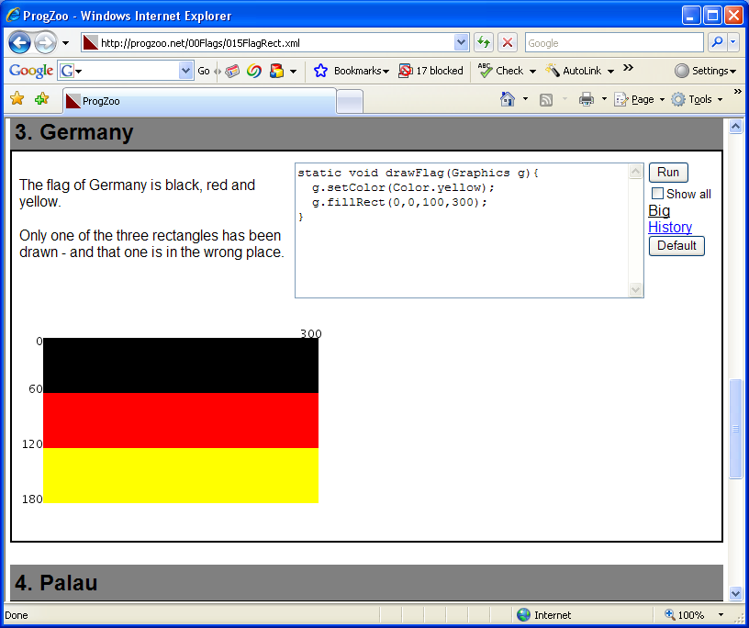

The large number of short programming exercises enable students to work independently most of the time, but collaborate in small doses.
The web mechanism does not permit interactive programs. A typical first tutorial problem might be "Prompt the user for two numbers and output the sum". There is no obvious way to allow this kind of interactive program over the web (without teaching CGI for example). However this restriction turns out to be less onerous than one might think. By ensuring that all input comes from pre-prepared sources a whole range of potential errors is avoided. The complications of writing interactive programs is simply put off until semester 2.
2. Advantages
The two main advantages of the website are the instant response the student receives and the ability to use program shells.
The instant hit is provided by comparing the output from the application with a model answer. In general the output is written to a file for comparison. In the example below the file is an image file.
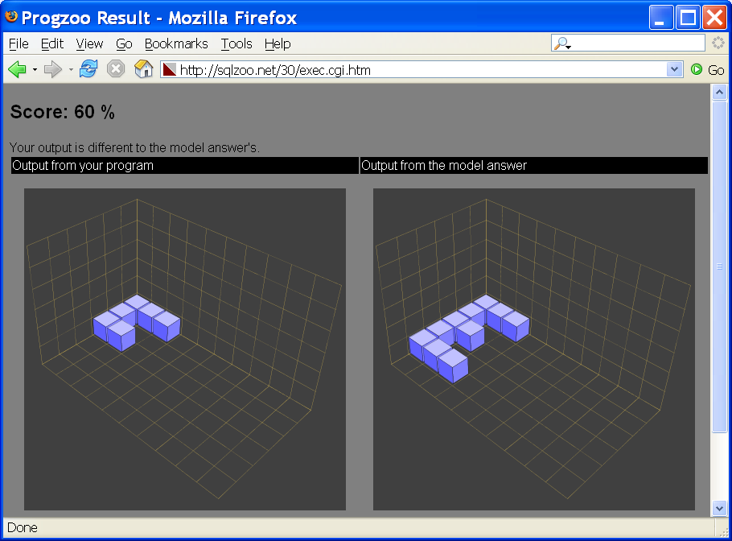
The use of program shells means functionality can be revealed at the appropriate time. There is no need to explain the overall structure with imports, classes and a static main method until the end of this introductory course, however the “show all” button can reveal this hidden code. Feedback from a student questionnaire indicates that over 70% of students feel positive about the course. More encouraging is the request from over 35% of students for additional programming language courses where in the past students had tried to plan their degrees to avoid further programming.
The module pass rate has improved from 60% in 2004/5 to 74% in 2005/6. Over 30% of students enrolled for the module in 2004/5 did not complete any assessments compared with only 14% in 2006.

3. Disadvantages
One knock on effect of this approach is that the semester two module which traditionally followed on and introduced classes and GUI programming had to be modified to ensure that all the gaps had been filled. It is also quite a leap in terms of development environment from the Progzoo website to the JBuilder IDE, however as their code gets increasingly complex there is a need for a powerful debugger and user interface design tools. The pass rate of this follow-on module was 67% in 2005/6.
The Sandbox
The system is inherently dangerous and possibly a vector for viruses and other malware. One of the first concerns for any web host is to ensure that external users cannot run arbitrary code on the server – yet this is precisely what we are attempting. A number of measures are taken to protect the server. For example, student code is executed inside a sandbox that contains "only" the JDK and data files required for a particular question. This is achieved using the unix command chroot, it ensures that even if the JDK is vulnerable to an exploit the process cannot escape from the sandbox. In addition, each process is given a limited amount of elapsed time and CPU time.
Queues
Technical issues include running 80 applications at once. A queue was introduced so that students could monitor the progress of their application – rather than indulge in futile repeated attempts to refresh. This was only an issue for the activity that takes place immediately after the lecture when all the students use the website at the same time.
In 2006/7 an approach was piloted which used this hour instead as a post practical surgery. The hour was timetabled after all the practical classes were complete and students could drop in with specific problems or just spend some more time completing the practical work. This was successful in offering additional support to the students who needed or wanted it.
4. Further Work
Wiki
Progzoo will be further tailored to the types of websites favoured by the student group by offering Wiki style advice on programming which will capture the essence of a FAQ facility while offering a more intuitive interface.
Question analysis
One advantage of a fully automated system is the data that can be gathered. The system can monitor the number of attempts at each question. This can support plagiarism detection but more interestingly can be used to monitor question difficulty. The questions can then be ranked or students can be given an indication of how long they might expect to spend on each question. This is useful when the questions get increasingly complex towards the end of the topic.

5. Conclusions
A fully integrated web-based learning resource has been introduced to support the teaching and learning of Java programming. Students are introduced to features of the language through a series of short questions with supporting hints and tips. This approach has increased pass rates and has increased overall interest in programming.

References

[1] MACAULAY, R. Thinking about our teaching. In ACM SIGCSE Bulletin
Volume 36 , Issue 2 (2004), 18-19

[2] ROBERTS, E et al. ACM Java Task Force. In Proceedings of the 37th SIGCSE technical symposium on Computer science education Houston, Texas, USA , 2006, 131-132

