A MINIMAL JERK PROSTHESIS CONTROL SYSTEM
Hill, S.S, Binnie, T.D, Gow, D.J
MEC 05 15-19th August 2005, Conference Proccedings, ISBN 1-55131-100-3

Primary Author: Stewart Scotland Hill
Other Authors: T. D Binnie, D. J. Gow*
Napier University, Edinburgh, 10 Colinton Road, Edinburgh, Scotland
*Rehabilitation Engineering Services, Lothian Primary Care Trust

Abstract:

Efficient prosthesis control is dependant on the user’s ability to control the desired movements of the prosthesis. Observed manifestations of jerk on a complete arm prosthesis can lead to difficulty in performing controlled movements, especially under load on gravity assisted downward movements.
The application of so called soft start and soft stop routines for controlling the velocity profile of the prosthesis joint through its rotational movement can go some way to reducing this effect. It is proposed that an adaptive velocity control system can be applied to the same prosthesis under the same test conditions and reduce the discernible jerk considerably.
This adaptive system monitors the change is angular velocity thus controlling the second and third derivatives of position. The implication of actively controlled angular velocity lends itself to minimize jerk, combined with reduced power consumption, and an increase in parts life and reliability. This control is applicable to all externally powered prosthetic limbs, regardless of user interface.

Introduction to Jerk
It is well known that the first derivative of position$\left(θ\right)$ with respect to time is velocity, and the second is acceleration. The third derivative is the rate of change of acceleration$\left(\overset{⃛}{θ}\right)$, known technically as jerk (jolt in English). Jerk is a vector but may also be used loosely as a scalar quantity because there is not a separate term for the magnitude of jerk, equivalent to speed as the magnitude of velocity. The unit of jerk is metres per second cubed (m/s³), although there is no universally agreement on a symbol for jerk.
In the field of prosthetics, the control of jerk can be seen in another dimension. That is, through controlling the rate of change of acceleration it is possible to smooth the profile of the arm as it moves trough the spectrum of its revolution.
Smoothed Velocity Profile Motor Control
A system with a feedback controller will drive the system to a state described by the input value. This desired value can be in term of position or of velocity. The combination of a motion controller and a drive actuator is referred to as an axis. A system which has more than one of these axes can be referred to as a complex motion control system. An example of such a system would be that of a complete prosthetic arm, where the shoulder, elbow, wrist and hand are all axes. Where position is the desired output of the control system, a movement from point A to point B dictates that at Point A the velocity should be 0, and at point B the velocity should be 0. Between point A and Point B there should be a velocity.

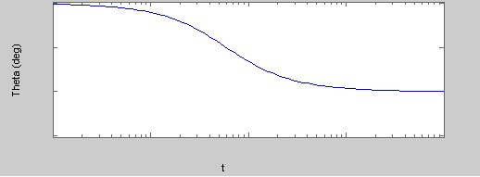
Figure 1. Change in Positon (θ) with respect to time (t).

A condition of moving between point A and Point B (Figure 1) will be that the velocity and the change in velocity be controlled. In this instance a velocity profile graph would produce a trapezoidal profile (Figure 2). The top level of the trapezoid is the maximum velocity. The total area under the profile is the distance moved, and the slopes are the maximum acceleration/deceleration allowed.

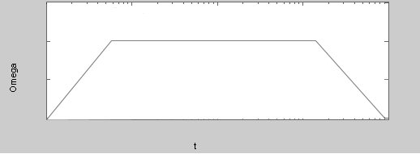
Figure 2. Trapezoidal Velocity (ω) with respect to time (t)

Jerk (m/s³), described as the rate of change in acceleration with respect to time, can be seen to manifest itself in the trapezoidal profile where changes in acceleration can be seen as sharp corners. To minimise the effects of jerk on the prosthesis, a method that generates a smoothed profile is presented.

Where:
$ω_{\text{max}}$ = maximum velocity
$α_{\text{max}}$ = maximum acceleration
$t_{\text{acc}}$ = acceleration time
$t_{\text{dec}}$ = deceleration time
$t_{\text{max}}$ = time at maximum velocity
$t_{\text{total}}$ = the total time in motion

It can be seen that, the initial acceleration from standstill can be generated using:

$ω(t)=A\text{.}t^{2}$ (1)
Where A is defined as:
$A=\frac{α_{\text{max}}}{2t_{\text{acc}}}$ (2)
Where t_{acc} is defined as:
$\text{tacc}=\frac{2ω_{\text{max}}}{α_{\text{max}}}$ (3)
By substitution
$A=\frac{α_{\text{max}}}{2(\frac{2ω_{\text{max}}}{α_{\text{max}}})}$ (4)

This gives the equation,

$A=\frac{α^{2_{\text{max}}}}{4ω_{\text{max}}}$ (5)
And therefore,

$ω(t)=\frac{α^{2_{\text{max}}}}{4ω_{\text{max}}}\text{.}t^{2}$ (6)
t(s)
tacc
ω_{max}

Figure 3. Acceleration from rest towards ω_{max} with respect to time (t)

This equation provides a exponential growth function from rest, but does not provide for smoothing toward the ω_{max} value. In order to perform the smoothing function towards ω_{max} , then a second equation must be applied. So this first equation is applied to the first half of the acceleration (t_{acc}). The conditional statement is made that if:
$t≤\frac{t_{\text{acc}}}{2}$ (7)
then
$ω(t)=\frac{α^{2_{\text{max}}}}{4ω_{\text{max}}}\text{.}t^{2}$ (8)

For t values greater than $t_{\text{acc}}/2$ the first equation can be used to find the second equation.
$ω(t)=ω_{\text{max}}−\frac{α_{{\text{max}}^{2}}}{4ω_{\text{max}}}(t_{\text{acc}}−t)^{2}$ (9)
This equation now gives the following response.

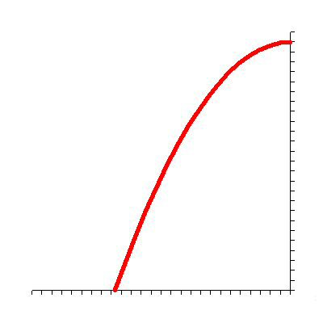
t(s)
ω_{max}
t_{acc}
$$\frac{t_{\text{acc}}}{2}$$

Figure 4. Acceleration from $t_{\text{acc}}/2$ towards ω_{max} with respect to time.

If t = t_{acc} then ω(t) would be equal to $ω_{\text{max}}$. Given that $ω_{\text{max}}$is an indefinite period of time controlled by the user, then the deceleration will come immediately after the suspension of the users desired motion.
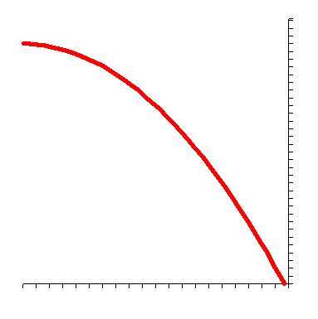
ω _{max}
t(s)
0
0

Figure 5. Deceleration from ω _{max} towards $t_{\text{acc}}/2$ Figure 6. Deceleration from $t_{\text{acc}}/2$ towards ω = 0.

The deceleration t_{dec} factor can be related to the acceleration factor. However a totally different value for deceleration can be used, thus the time for t_{acc} could be different in value to t_{dec}. This factor can be tailored to each user’s requirement, to minimise the amount of perceived over-run. Given that the human system is able to predict and adapt to the fact that there is a perceivable overrun, it is hoped that the human can accommodate for this constant factor. Each of the elements can be implemented as a separate function. The initial condition of zero velocity to $t_{\text{acc}}/2$ is assigned the tseg1 designation, similarly the element from $t_{\text{acc}}/2$ to $ω_{\text{max}}$ is designated as function: tseg2. It can be seen that these functions can only be used for a positive or forward velocity. An additional 4 tsegs allocations are made to describe the negative or reverse velocity.
By combining these segments with the appropriate logic and modelled in mathworks matlab. The armature resistance, rotor inertia and rotor inductance, and other characteristics of the motor can be encompassed in the simulation.
Hardware Implementation
The hardware takes the form of an embedded bus based communication system. The bus chosen was controller area network (CAN) bus [1,2]. This communication system takes user input signals from the prosthesis/user interface, and distributes these signals along the complete prosthetic arm. The positional transducer chosen was an absolute encoder, giving 128 positional states, equating to 2.851۫/step. Acceleration is measured by monitoring the rate of change of these positional states. Given the modelling of the motor response to voltage, it is possible to build a set of rules that describe the acceleration of the motor without having to actively monitor the step changes of the positional transducer.
Microcontroller

Drive
Circuit

Encoder
CAN
BUS
Motor
8 bit Positional Data

Figure 7. Hardware implementation of Minimal Jerk Control

Conclusions:
It can be seen on a practical level that this velocity profiling approach can reduce the effects of jerk. Moreover this represents a significant improvement for controlling the amount of momentum artefact that exhibits itself on the user. Not only does this approach increase the parts-life of the prosthesis, but it also simplifies control of the prosthesis by making movements more reliable and controlled.

References:
1. Hill, S.S, Binnie, T.D, Gow, D J “Control Strategies for The Edinburgh Modular Arm System”, EPSRC PREP Conference Proceedings (Posters), University of Exeter, UK, pp 21-20, 14th-16th April 2003,
2. Poulton, A.S, Hill, S, Binnie, T.D, Gow, DJ “Network Technologies for Intelligent Modular Prostheses”, ISEK Conference, Boston, 18th -21st June 2004.

