MAKING EFQM WORK AT THE MANUFACTURING LEVEL

G.C. MacKerron¹, J.M. Fernie¹ and R Masson¹

- School of Management, Napier University, Edinburgh.

ABSTRACT

Self-Assessment (SA) has gained international recognition as a methodology for identifying strengths and weaknesses across an organisation's activities and performance as part of their total quality management (TQM) activity. The European Foundation for Quality Management (EFQM) Excellence 2000 Model is widely adopted by organisations as a means of SA to enhance performance at all levels of an organisation. It has been argued that a major strength of the approach is an overall evaluation of activities and performance; this has avoided the lack of focus, especially on strategic issues, of other, usually independent improvement tools which are used within the operational/ manufacturing areas of organisations.
The majority of SA work has been focused at a strategic level. This paper shows how the approach may be enhanced to be of greater use and be more applicable within the operational/ manufacturing area, where the majority of continual improvement effort exists and which usually operates to shorter term parameters. The process is based on Grounded Theory, used to generate a set of relevant constructs or issues which are then reviewed, utilising a five-stage model of SA to determine the most appropriate departmental approach for self-assessment. The work was largely based on the customer-service department of a large manufacturing organisation. The study concluded that SA, within manufacturing areas, is not only possible, but it can deliver benefits to operational areas wishing to embrace SA below the strategic level by the utilisation of this new, holistic approach.

KEYWORDS: Self-Assessment, Continuous Improvement, Manufacturing

INTRODUCTION

It can be argued that, in today’s manufacturing environment, a strategy of continuous improvement is a pre-requisite for survival and growth. This concurs with Dyason and Kaye [1], amongst others, who identified competitive continuous improvement as a new business performance requirement alongside various quality-related factors (e.g. strategic quality management) identified by Bounds and York [2]. Sustaining continuous improvement is facilitated through regular self-assessment (SA) of activities and performance.
The European Foundation for Quality Management (EFQM) actively promote SA stating ‘the process allows the organisation to discern clearly its strengths and areas in which improvements can be made and culminates in planned improvement actions which are monitored for progress’ [3], a perspective endorsed by Azhashemi [4]. Van der Wiele [5] suggests that organisations should utilise SA as a means of undertaking an in-depth evaluation of their operations and activities and to compare these to best practice using, for example, the EFQM Excellence Model (EM) which is structured on 9 criteria and based on the premise that results are achieved through enablers, enhanced through innovation and learning, Figure 1.

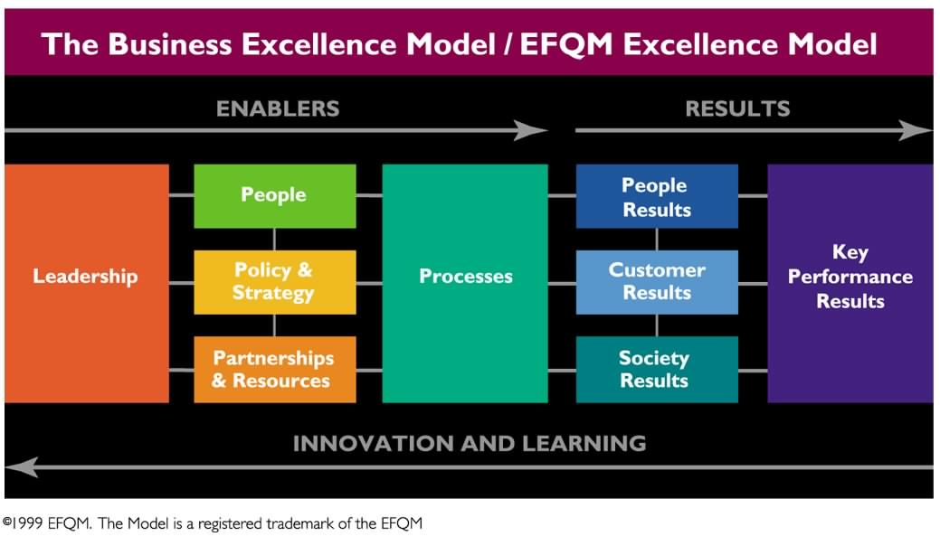
Figure 1. EFQM Excellence 2000 Model

Various SA methodologies exist, characterised by differing levels of process rigour (low to high) and evidence (opinion-based to evidence-based), each with its own pros and cons. Often organisations experienced in SA use a range of methods [6] but there is no single best way [7].
If the SA methodology is to lead to improved business performance, which several studies [6, 8, 9, 10] have suggested is the case, then awareness and adoption of various good practice elements, as identified by Conti [11], Hillman [12] and Oldfield [13], will help maximise a successful outcome.
Whilst the EM and SA methodologies have particular strengths, not least of which is its holistic approach, much of the research to date has focused on implementing SA at a corporate level [8, 14, 15, 16]. Whether it can operate at an operational or departmental level remains to be seen, yet, as Lascelles [17] and the EFQM [3] themselves point out, the EM must in the longer term be adopted by all levels within the organisation if it is truly to act as a framework for managing, analysing and improving any organisation’s performance.
Weaknesses in the SA methodology that have been identified [9, 10, 18] seem to revolve around it being a management driven process rather than a participative one involving all employees, and a process delegated within the organisation and thus remaining detached from those making the policy decisions. Both of these issues are even more pertinent to a scenario of applying the methodology at an operational or departmental level, which is the focus of the current paper based on a manufacturing organisation.
The department selected as the case department within the manufacturing organisation had no previous experience of SA although some disjointed, short-term improvement initiatives, mostly lacking in emphasis on ‘softer’ management issues, had been undertaken previously, the impact and effectiveness of which were unmeasured and therefore unknown.

2.0 METHODOLOGY
A qualitative approach, based on the principles of Grounded Theory [19], was utilised. The work comprised the development and application of a procedure to provide a customized SA tool, for application within the case department. The procedure was tested and validated by applying it to the case department. The first stage was to determine broad acceptability criteria against which the overall suitability of the new assessment method would be tested. These emerged from a series of meetings with the case department management and were influenced by management’s experience of previous improvement initiatives.
- Relevant and easy to apply to the department (while remaining consistent with the EM)
- Not to be time-consuming to apply.
- Must clearly identify strengths and areas for improvement (to facilitate action planning).
- Should be an evidence-based, not a perception-based, approach.
Research using Grounded Theory requires the use of Learning Activities that, in this case, included a literature review, and interviews in two additional organisations, neither of which used EM at a departmental level although that was a future intention. As such, both organisations were able to discuss what they saw as the key issues in ‘operationalising’ the EM at a departmental level. The interviews generated information on the perceptions and practices of SA in these two organisations, these acting as benchmarks. This work enabled the establishment, and validation, of an emergent theory from the research data obtained.
Care was taken to ensure that all staff within the case department in which the methodology was to be developed were involved in or consulted about the research. This was done through a series of departmental meetings involving all staff.
The data and results from the learning activities described above, were collated and distilled into a set of negative or positive constructs, or issues relevant to the case department, in order to determine their impact on the approach taken.
Negative Constructs:
- Assessment Driven by External Consultants; reduces ownership of the approach.
- EFQM Questionnaire Booklet; does not provide a factual assessment and does not assist the process of identifying areas for improvement.
- Poor Planning; creates confusion, de-motivates and reduces chances of success.
- Excessive List of Improvement Recommendations; de-motivates and obscures important issues.
Positive Constructs:
- Familiarity of the department with the concepts of TQM. Maximises the benefits of the assessment, interpretation of the model and the assessment’s findings.
Strong internal motivation for improvement; this enables SA to direct and motivate continuous improvement.
Trained Internal Assessors; facilitators to lead programmes ensures a valid and consistent assessment.
Employee Participation; enhances the process by increasing the amount of evidence contributed and integrating the process into the department / operation.
Customised Model criteria; ensures SA approach is relevant to department / operation.
Factual Assessment Approaches; delivers better results and allows action to be taken on the basis of objective evidence.
Identify Strengths and Areas for Improvement; assists improvement process.
Use of RADAR; encourages a more scientific approach to assessing performance.
Prioritisation of Actions & Recommendations; provides structure to the improvement process.
Outcomes Linked to Business/ Operating Plans; creates stronger links.
Communication of Results; creates awareness of process and ownership of results.

3.0 USING SELF-ASSESSMENT IN MANUFACTURING; A STAGED APPROACH

A holistic approach was developed which can be applied to any operational area in a manufacturing organisation. The approach involves the use of 5 stages. When using the approach, elements of the departmental negative and positive constructs mentioned earlier were brought together, and the acceptability criteria defined in the preliminary work used to verify the process. The development of this approach, using each stage, is shown below. This includes the related constructs and the work involved in the stage. As an example, at stage 1, the department must assess the relevance of SA to the culture of the department. The 5 stages developed are shown below;
Stage 1. TQM Culture - how relevant is SA to the departmental TQM culture?
Elements of the constructs used: Familiarity with concepts of TQM.
Internal motivation.
This stage was used to gauge the maturity of the department towards TQM and the relevance and need of SA towards this. Previous departmental quality initiatives suggested that the department was very familiar with concepts of TQM, and that assessment would be beneficial. Staff motivation for SA was strong.
Stage 2. Assessors - who is best suited to do the assessment?
Elements of the constructs used: Trained internal assessors.
Good employee participation.
Internal staff were trained, using a licensed assessor course. One trained assessor then carried out the actual assessment, using staff input where necessary.
Stage 3. Customised Model - customizing the model criteria to suit the departments’ needs.
Elements of the constructs used: Customised model criteria.
At this point there was a need to find the relevant SA approach to be used. This was done by reviewing one simple, perception-based approach (Questionnaire) and one evidence-based approach (Pro-forma) for one on the 9 EFQM Model criteria. The results were then compared to the acceptability criteria for the model, mentioned earlier. Prior to using the approaches, they were customised using phraseology applicable to the department and the personnel who would be involved in its use. For example, there was found to be the need to distinguish between internal and external customers. After this was completed, all of the acceptability criteria were met. A corresponding implementation and resource plan was drawn up. This is reviewed further in Stage 4.
Following this work, the chosen SA approach was use of a Pro-forma, for each of the 32 sub-criteria of the EFQM Model, to ensure factual data was gathered to aid measured, continual improvement. Some modifications to the 32 EFQM standard sub-criteria were made for the department under review to ensure all positive constructs contained were taken account of.
Typical amendments included reference to promotion of policy such as Health & Safety, reference to the department rather than an organisation, defining who a partner or customer actually is, or the deletion of sub-criteria or parts of them that were deemed irrelevant. On the whole, these amendments were relatively minor, but the understanding and relevance was greatly enhanced. This may not be the case when used in other departments or areas, where changes may be quite extensive. It was decided that this aspect would be reviewed after each time the Pro-forma is used, to take account of any comment, as part of general and on-going continuous improvement.
Stage 4. Assessment Approach - which assessment approach?
Elements of the constructs used: Factual assessment approach.
Identification of strengths and areas for improvement.
Use of RADAR
An effective plan prior to assessment.
The assessment approach deemed suitable for the department was developed from the pilot approaches described in step 3 (questionnaire and pro-forma) and incorporated information from the training undertaken. To meets the needs of the department, an objective and factual evidence-based approach for assessment was deemed optimal. To achieve this, the comprehensive assessment process employed in the EFQM Assessment Scorebook [14] was incorporated, to ensure a reasoned, evidenced-based assessment. This would be carried out through the use of data collection, categorisation of strengths and areas for improvement, and a judgement of excellence through the application of the EFQM scoring mechanism, RADAR, although the latter was a more secondary consideration. Indeed scoring is often best left from the initial usage of SA. The resultant approach then had to be rigorously tested to ensure it was comprehensible and applicable in context, and that it provided a basis for action.
To ensure success, a project plan was formulated. This identified the activities and resource required to undertake a successful assessment. Also included in the plan were key personnel who would need to be involved in the process. The plan was then communicated to all concerned as well as those not involved, within the department. The approach developed was practical, comprehensible and user-friendly.
The prescribed need for evidence gathering before carrying out the actual assessment augmented the integrity of the process and provided an objective foundation for decision-making. The link between the assessment process and the resulting systematic identification of strengths and areas for improvement provided a fair, effective and transparent assessment. The concise and prioritised list of recommendations generated, was found to aid the continuous-improvement action-planning process, to enable the department to focus on improvement activities and assist its progression to excellence.
Stage 5. Outcomes - using the assessment outcomes to best advantage
Elements of the constructs: Concise list of recommendations.
Prioritisation of actions/ recommendations.
Communication of results.
Outcomes linked to business plans.
Use of the approach in the department resulted in the emergence of key themes and issues which required to be addressed and improved. By associating issues with aspects of the EFQM Model, it became easier to prioritise these as well as to recommend areas for future improvement, which had been agreed by all involved in the process. The findings were then communicated through the use of group meetings, for further discussion and input and a formal report generated for use in follow-up work as well as subsequent assessments.
Assessment outcomes were fed back, to be used in business plans. A review of the assessment recommendations would be carried out during future department objective setting/ reviews, to ensure the new process and longer-term objective setting were fully intertwined.

4.0. CONCLUSIONS

Various conclusions and recommendations may be made that are specific to the case department. The approach that was developed:
was easily applied to the department itself
provided a high level of understanding of operational SA by staff
facilitated the learning of best practices
aided intra-departmental transfer of ideas
allowed for the incorporation of some existing improvement tools and methods
generated recommendations conducive to the department’s continuous improvement programme
The use of evidence-based rather than opinion-based SA methods was considered the most valuable approach. That said, scoring was thought to be useful but only in the context of future SA exercises and any benchmarking undertaken as part of that process.
As part of any early stage of development within the department, a process mapping exercise should be undertaken to identify key processes, and customer-supplier/partner links. Also recommended is the need for well-understood internal measures for key departmental results. Once awareness of the usefulness of the approach at the operational/departmental level grows, it is suggested that more emphasis be placed on measurement, assessment and review of strategy and processes to focus attention on the means of achieving better operational performance.
Finally, it is recommended that the approach be tried with other departments within the manufacturing organisation. The fact that the approach developed is generic in nature will greatly facilitate implementation of this, and is seen as its key strength. Overall, the process allows any department to determine its SA requirements and to evaluate and develop all aspects of SA to meet those requirements. There has been considerable interest in this research; interest in using SA and the EFQM Model at an operational level is seen by many to be the way forward in the pursuit of continual improvement, its management and the satisfaction of consumer needs.

5.0 REFERENCES

[1] M.D. Dyason and M.M. Kaye, Is there life after total quality management?(II), Quality World, 1993, Vol1, pp23-31.
[2] G. Bound, and L. Yorks et al, Beyond TQM Toward the Emerging Paradigm, London: McGraw-Hill, (1994).
[3] EFQM, Self-Assessment Guidelines for Companies, (EFQM Publications, Brussels, (1998).
[4] M.A. Azhashemi and S.K.M. Ho, Achieving Service Excellence: A new Japanese approach versus the European framework, Managing Service Quality, 1999, Vol.9, No.1, pp.40-46.
[5] T. Van Der Wiele B. Dale, and R. Williams, Business Improvement Through Quality Management Systems, Management Decision, 2000, Vol.38, No.1, pp.19-23.
[6] M. Finn, and L.J. Porter, TQM Self-Assessment in the UK, The TQM Magazine, 1994, Vol.6, No.4, pp.56-61.
[7] L. Porter, J. Oakland and K. Gadd, Unlocking Business Performance With Self-Assessment, Management Accounting, London,, 1998, Vol 5, pp55-72.
[8] J. Oakland, Winning Performance Through Business Excellence, Credit Control, Hutton, 1999, Vol 3, pp43-56.
[9] D. Longbottom, Self-Assessment Game Over?, Total Quality Management, Abingdon (1998).
[10] R. Mcadam and E. O’neill, Taking a critical perspective to the European Business Excellence Model using a balanced scorecard approach: a case study in the service sector, Managing Service Quality, 1999, Vol.9, No.3, pp.191-197.
[11] T. Conti, Building Total Quality: A Guide to Management, (Chapman and Hall, London).
[12] P.G. Hillman, Making Self-Assessment Successful, The TQM Magazine, 1994, Vol. 6 No.3, pp29-30
[13] H. Oldfield, Quality Awards, Quality World, 1998, pp. 22-23.
[14] EFQM, Model Scorebook, EFQM Publications, Brussels (1999).
[15] A. Arcelay, E. Sanchez and L. Hernanadez et al, Self-assessment of all the health centres of a public health, International Journal of Health Care Quality Assurance, 1999, Vol.12, No.2, pp.54-58.
[16] T. Sneddon, The Business Excellence Model: Will it Deliver?, Management Services, 1998, Vol2, pp56-70..
[17] D. Lascelles and R. Peacock, Self-Assessment for Business Excellence, (McGraw-Hill, London), 1st Edn, pp103-127, (1999).
[18] K.J. Zink and A. Schmidt, Practice and Implementation of Self-Assessment, International Journal of Quality Science, 1998,Vol.3, No.2, pp.147 - 170.
[19] B.G. Glaser and A. Strauss, The discovery of grounded theory, (Aldine, Chicago, (1990).

