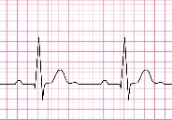**Figure 1**



No AF



Clinical benefits

Health economics

**+**

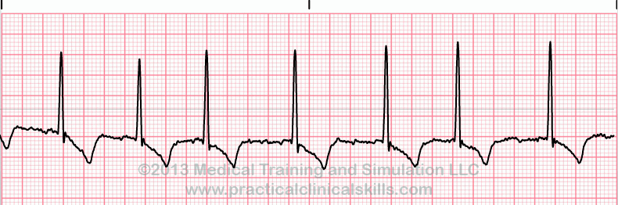

* Confirmed stroke / TIA  
  N=100
* No persistent AF

anticoagulation

* Discharge to community or inpatient care

Paroxysmal AF

* 7 days R-TEST  
  (1 lead ECG)

**Figure 3**

NHSH stroke/TIA population (n=609)

68% no persistent AF (n=415)

Paroxysmal AF incidence   
(5.9-8.4%; n=25-35)

No monitoring or treatment

R-Test monitor, anticoagulation treatment

4-11 secondary strokes/year

1-4 secondary strokes/year