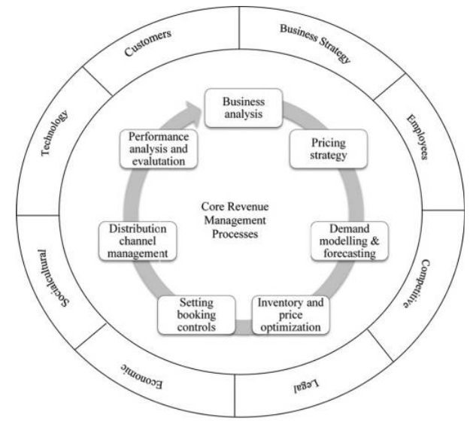

Figure 1. Framework for Hospitality Revenue Management
(Denizci Guillet & Mohammed, 2015, p. 529)

Figure 2. Word Cloud presentation of 50 most frequently used words by the interviewees
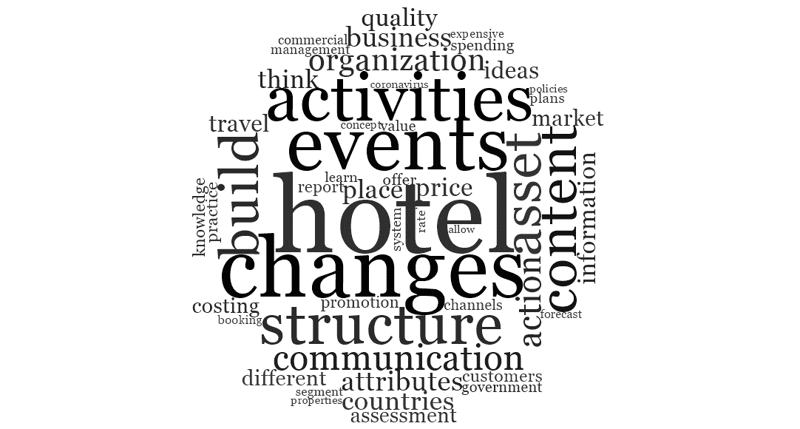

Figure 3. Example of marketing on hotel’s action towards Covid-19 (Source: Chan, 2020)
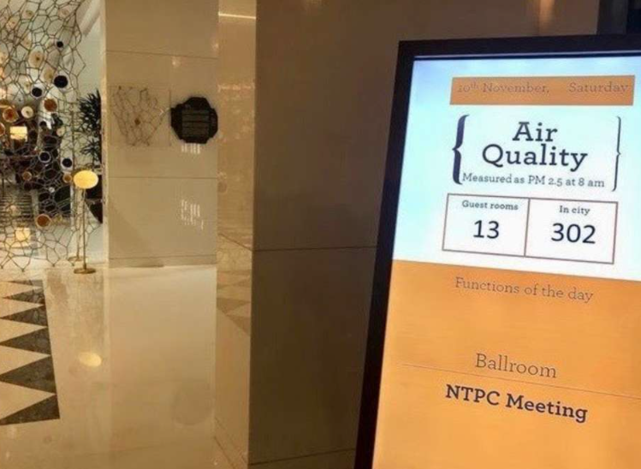

Figure 4. Banyan Tree Hotels Instagram post, September 2, 2020
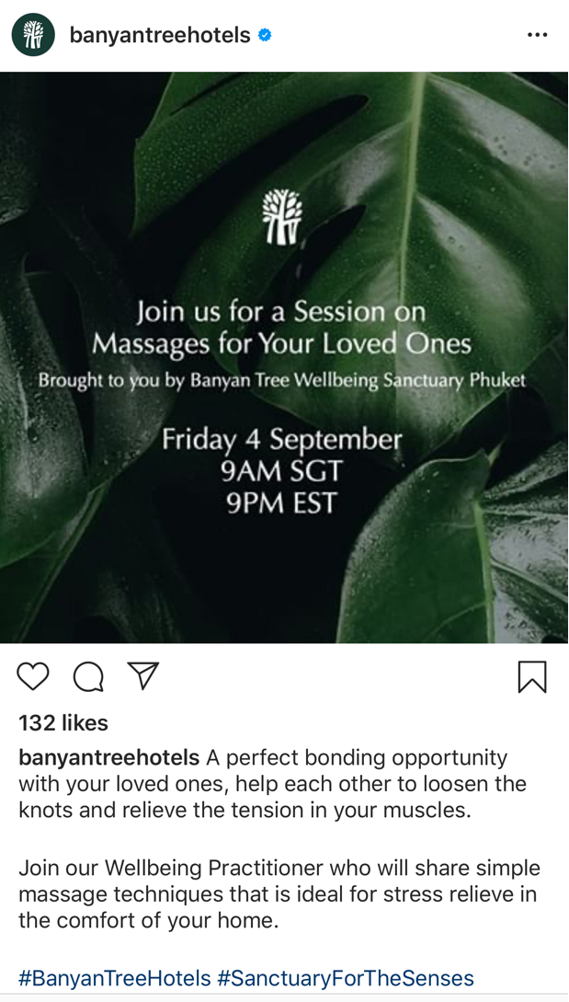

Figure 5. Marriott International Instagram post, May 14, 2020
