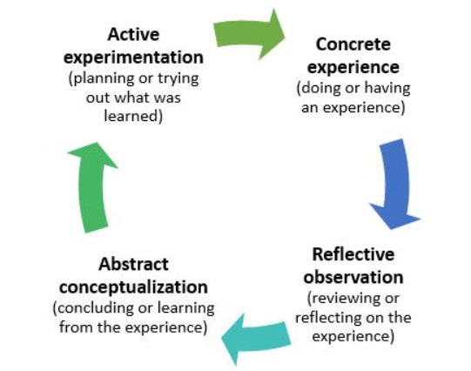
Figure 1: Kolb’s cycle of experiential learning (Kolb, 1984)

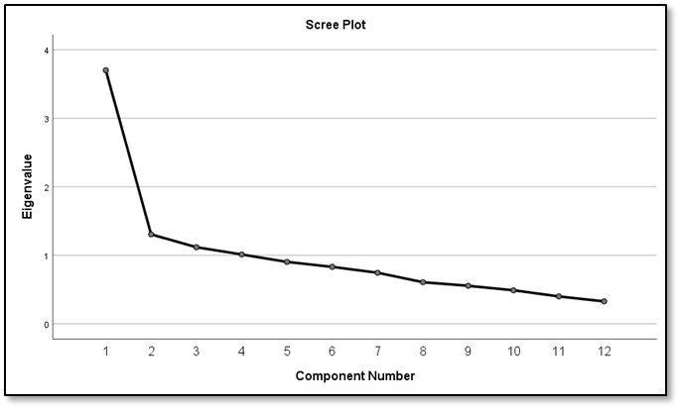

Figure 2: Scree plot for discipline-specific skills

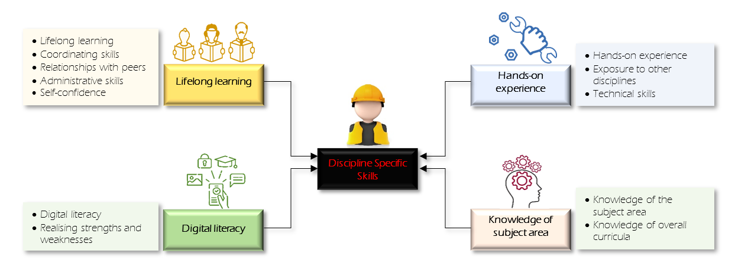
Figure 3: Four Discipline-specific skills clusters

