COMBINING OF RESULTS FROM VISUAL INSPECTION, NON-DESTRUCTIVE TESTING AND SEMI-DESTRUCTIVE TESTING TO PREDICT THE MECHANICAL PROPERTIES OF WESTERN HEMLOCK

Mike Bather¹, Dan Ridley-Ellis² and David Gil-Moreno³

ABSTRACT: Current methods of assessing the mechanical properties of in-situ timber are limited, particularly with regard to estimating bending strength and stiffness. The aim of this research is to combine non-destructive testing (NDT), visual inspection and the taking and testing of very small (micro) samples to make a better predictive model. The modulus of elasticity of 150 structural sized joists of Tsuga heterophylla was measured using acoustic resonance NDT, and knots were plotted, before testing to destruction in four point bending. The moisture content and density were then obtained and the ring width and the slope of grain of the broken joists recorded. Micro clear (6.5 mm diameter 91 mm long) specimens were taken from undamaged regions of tested joists and small clear (20 × 20 × 300 mm) specimens were taken from material adjacent in the tree. Both were tested to destruction in three point bending. The results are analysed statistically and it was found that in predicting properties of the structural sized joists: (i) the single measurement of dynamic stiffness was the best predictor of static stiffness; (ii) the averaged density from a pair of micro clear specimens was the best predictor of density and (iii) the combination of dynamic stiffness and visual inspection of knots was the best predictor of bending strength.
KEYWORDS: In-situ assessment, Semi-destructive testing, Visual grading, Acoustic NDT, Tsuga heterophylla

INTRODUCTION
The accurate structural assessment of in-situ timber is an important process that affects a substantial part of the construction industry. The unnecessary replacement of structural timber is neither economic nor sustainable and adversely affects the conservation of historically valuable structures, and the maintenance of old building stock still in service. Unfortunately, at present, it is difficult to accurately predict the mechanical properties of in-situ timber beams and posts [1, 2].
In the UK, visual grading of softwoods is generally carried out in accordance with BS 4978 [3] and this approach can also be used to predict the mechanical properties of in-situ timber. This is a conservative and imprecise approach that could possibly be improved by combining data from non-destructive testing (NDT) and semi-destructive testing (SDT) together with visual assessment and categorization.
In order to do this, a representative sample of timber specimens must be assessed and tested to destruction in order to establish a basis for prediction. This is generally not possible to do with historical, in-situ timber and so, for this study, testing has been carried out on new structural sized timber joists in conjunction with other testing and timber grading work being undertaken at Edinburgh Napier University. This removes some of the unknown factors encountered in inspection and allows a focus on the predictive power of inspection methods.
The work described here has been carried out as part of the first year of PhD research into the subject of combining NDT and SDT together with visual assessment. It is hoped that the output of the PhD research will be of use to practitioners assessing the mechanical properties of in-situ timber for change of use, renovation or repair.

MATERIALS TESTED
Joists sawn from 28 western hemlock trees (Tsuga heterophylla TSHT [4]) from three sites (Scotland, England and Wales) were made available for this research. From each log, nominally 50 × 100 mm × 3.1 m timber joists were cut from a 100 mm wide section (running diametrically across the log and enclosing the pith). Western hemlock is not currently a common plantation species in the UK, but is being assessed for possible greater planting. The key wood properties are similar to those of the UK’s major species: Sitka spruce (Picea sitchensis PCST) and Norway spruce (Picea abies PCAB). The diametric cutting pattern is not a normal industrial sawing pattern, and was done for scientific reasons (to investigate radial trends in wood properties). This has some consequences on the distribution of knots in this dataset, and, importantly, the direction of grain with respect to the width and depth (see 3.4).
In total, 150 joists were cut, seasoned, conditioned, inspected and tested. Small clear specimens were prepared from all of the logs and pairs of micro clear specimens were cored from the 68 joists from the site in Scotland.

METHOD

OVERVIEW OF TESTING
The joists were tested in four point bending in accordance with EN 408 [5] to determine the global modulus of elasticity (MOE) and the bending strength (modulus of rupture, MOR). The test span was 18 times the depth h (Figure 1). In accordance with EN 384 [6], the joists were tested with the region of the length assessed to be the weakest part placed centrally between the two loading points. This assessment was done by visual inspection.

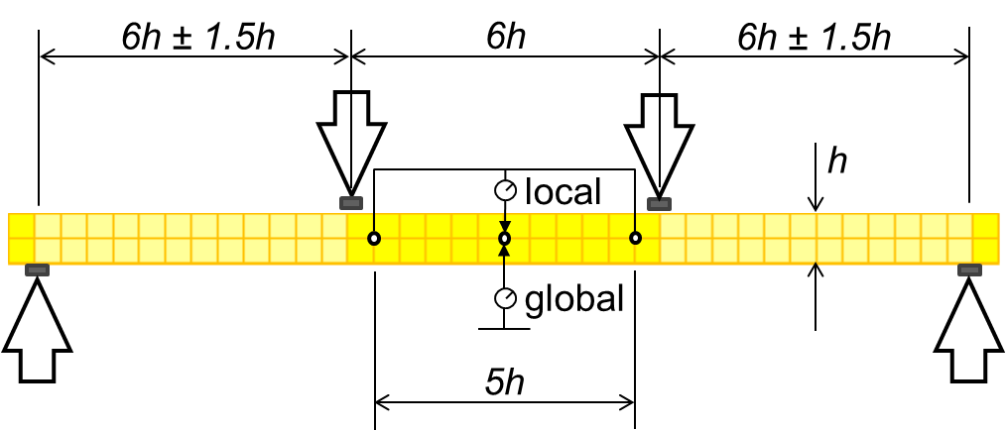
Figure 1. EN408 test arrangement (for beam of depth h)

After marking up the joists for the four point bending test, the knots within the pure bending zone (6h length between the two load points) were manually inspected and recorded using MiCROTEC Web Knot Calculator software [7], which enabled the management and analysis of manually measured knots with a web user interface.
Also prior to test, the dynamic modulus of elasticity (dynamic MOE) of the joists was obtained using a Brookhuis MTG 960 Timber Grader, which is a portable grading machine based on impact excitation. The machine measures the frequency of longitudinal resonance and combines it with density measured with a connected balance, and manually measured dimensions. The dynamic MOE calculation (Equation 1) is based on the Newton-Laplace formula.

[dynamic MOE]=[density]×[speed of sound]²  where  [speed of sound]= 2×[length]×[1st frequency] | (1)

After testing (using a Zwick Z050 machine at Edinburgh Napier University), density and moisture content were obtained in accordance with EN 408 [5] and EN 13183-1 [7] (oven dry method) using samples cut close to the bending failure position. Density and bending stiffness where subsequently adjusted to the reference 12% moisture content using EN 384 [6]. The k_{h} factor in EN 384 was not applied, and so MOR was not adjusted to 150 mm reference depth.
Both global and local MOE were measured in accordance with EN 408, but only the global MOE measurement is used in this analysis as the measurement is less prone to experimental error. This is the measurement based on central deflection of the whole test span (Figure 1). Measurements of each joist were adjusted to an equivalent ‘shear free’ MOE based on a linear correlation between the measured local MOE and global MOE of these 150 joists, given in Equation (2). The R² of this correlation is 0.88.

[shear free MOE]=1.2[global MOE]-1.5 (kN/mm²) | (2)

The results are summarised in Table 1 (in which no adjustments have been made for confidence resulting from sample size). For comparison, the ‘shear free’ MOE from the standard equation given in EN 384 is also listed (‘EN 384 E₀’). This tends to under predict the MOE when the average MOE is low [8], which is why Equation (2) is used in this analysis.

Table 1: Summary of full scale testing on 150 nominally 100×50 mm cross-section western hemlock joists
Property |  | Mean | 5th %ile | CoV
MOR | (N/mm²) | 38.5 | 19.3 | 31%
MOE | (kN/mm²)
Global |  | 8.47 | 5.75 | 22%
Local |  | 8.61 | 5.29 | 27%
Shear free |  | 8.61 | 5.37 | 26%
EN 384 E₀ |  | 8.32 | 4.80 | 29%
Density | (kg/m³) | 447 | 385 | 9%
MOE and density at 12% moisture content
5th percentile evaluated by ranking

The ring width (“rate of growth”) and the slope of grain of the fractured joists were measured broadly in accordance with EN 14081-1 [9], BS 4978 [3] and CP 112-2 [10].
Small clear specimens (20×20 mm x 300 mm) were cut from wood approximately one metre higher in the tree than the logs that were converted into joists. Each small clear was randomly assigned to a joist in the corresponding log. There was a randomly assigned small clear for 142 of the 150 joists. These small clears were tested in three point bending (span 280 mm) to obtain MOR, MOE and density in accordance with BS 373 [11]. The MOE and density measurements were adjusted to 12% moisture content reference in accordance with EN 384. The testing was conducted using a Tinius Olsen H5KT machine at Forest Research.
Micro clear specimens were also obtained (See 3.2). Since there is no European or British Standard directly relating to the testing of such micro specimens in bending, a testing set-up was developed to provide measurements which approximately correspond to those of the three point bending test of BS 373.

MICRO CLEAR SPECIMEN TESTING
Small full cross-section blocks were cut from the undamaged parts of a subsample of 68 of the fractured structural sized joists and pairs of micro clear specimens were cored from these blocks (approximately 6.5 mm diameter × 91 mm length along the grain). Figure 2 shows two micro clear specimens cored from a block cut from a structural sized joist. Where possible, the specimens were cored at locations 17 mm below the top (A) of the block and 17 mm above the bottom (B) from similar growth rings (because of the cutting pattern, the tangential direction of the rings was parallel to the joist depth). One of the 68 joists is missing micro clear B.

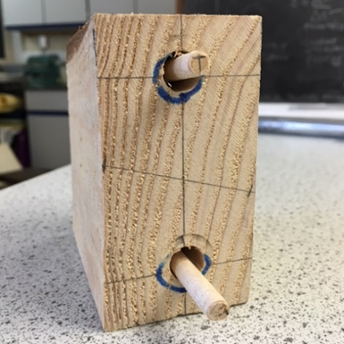
Figure 2: Two micro clear specimens cored from a block cut from a structural sized joist (specimen ‘A’ top, and ‘B’ bottom)

These were tested in three point bending (span 78 mm) using a testing rig adapted for the purpose. From the perspective of a practitioner investigating in-situ timber, the relatively quick creation of a standard sized very small test specimen (similar to a steel coupon) makes the use of cores attractive. Cutting specimens from in-situ timber is problematic and coring would be too. However, cores could potentially by obtained from small blocks cut from in-situ timber (possibly from the top) or from the ends of timbers where access (for a drill bit) can be gained. Very small specimens are sensitive to tiny dimensional differences and coring helps to minimise these variations.
In the test rig, the span to depth ratio and the sizes of the widths of the supports and the loading head were all chosen to create a similar distribution of elastic bending stresses in the micro clear specimens as is found in small clear specimens tested to BS 373. The rate of application of load (6.6 mm/minute) was the same as for the 2 cm standard in BS 373. Mechanical properties are calculated assuming a circular cross-section but no allowance has been made for differences in behaviour between sections with circular and rectangular cross-sections (which have a different distribution of bending and shear stress).
A span to depth (or diameter) ratio of 12 was adopted for the three point bending test giving a span of 78 mm, assuming a nominal 6.5 mm diameter cored specimen. The micro clear specimen was sized to extend (1×depth) 6.5 mm beyond the centre-line of each support giving an overall length of (14×depth) 91 mm. The overhangs at the supports are relatively slightly longer than the minimum overhangs of small clear specimens and are intended to accommodate tolerances in cutting and coring these very small pieces (Figure 3). The specimens were orientated so that the radial direction of the growth rings was parallel to the neutral axis.

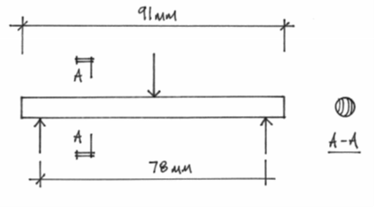
Figure 3: Dimensions of the micro clear bending test
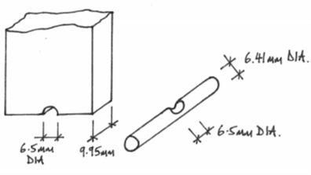
Figure 4: Loading head (left) and support detail (right) for micro clear tests

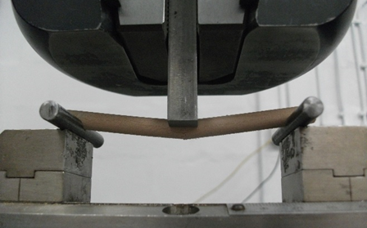
Figure 5: Three point bending of a micro clear specimen just after failure has occurred

Due to the small size of the micro clear specimens, it was decided to use the movement of the loading head of an Instron 5585H universal testing machine (at University of Bolton) as a basis for the calculation of the static MOE. Using this method requires close control of compressive deformation of the specimens at the support and the loading positions. Supporting the circular cored specimens on flat bearing surfaces would create very high local compressive stresses, in turn creating relatively high local deformation. Therefore curved bearing surfaces (to match the curved profile of the specimens) were created by forming 6.5 mm diameter cut-outs in the two support rods and in the loading head (Figure 4 and 5).
It was recognized from the outset that the testing of the micro clear specimens is sensitive to small local changes in the properties of the wood and to small dimensional changes in the specimens. It was decided to core pairs of specimens to try to control these issues (Figure 2).

VISUAL INSPECTION
BS 4978 [3] is the standard used in the UK for visual strength grading of softwood timber. In accordance with the standard, timber is graded as Special Structural (SS) and General Structural (GS). Timber with characteristics that does not meet the limits given in the standard is excluded from grading and is generally termed as Reject.
The visual grading considers knots, slope of grain, rate of growth, fissures, wane, distortion, resin pockets, insect damage, rot and decay. This research focuses on just the first three characteristics. As BS 4978 groups graded timber into just two visual grades and reject, this was considered to provide too imprecise a measurement for this research; so instead, the method of quantifying characteristics specified in the code is used and the data obtained is not categorised but used in its percentage or ratio form. Four ratios relating to knots were obtained:
- Total knot area ratio, tKNOT
- Margin knot area ratio, mKNOT
- Total knot area of a knot group, tKAR
- Margin knot area of a knot group, mKAR

The total knot area ratio (tKNOT) is the ratio at a section, of the sum of the projected cross-sectional areas of the knots present, to the cross-sectional area of the piece. Similarly, the margin knot area ratio (mKNOT) is that of the sum of the areas of those knots or portions of knots in the margins, to the cross-sectional area of the margins. The margin areas comprise the top and bottom quarters of any cross-section (as orientated with longest cross-section dimension vertical).
BS 4978 requires that knots should be included as part of the same cross-section if any parts of the knots or their associated grain disturbances overlap along the length of the piece of timber. The MiCROTEC software [7] used calculates values of the total knot area ratio of a knot group (tKAR) and the margin knot area ratio of a knot group (mKAR) based on an assumption that knots up to 150 mm apart are within influencing distance and are considered as a knot group. The KAR ratios are greater than KNOT ratios (as more knots are included cumulatively in the values).
Slope of grain was measured using a swivel handled scribe, generally in accordance with the requirements of EN 1310 [12] which recommends that a single face is assessed, thus giving a two-dimensional assessment of slope of grain. However an old British Standard CP 112 [10] considers a three-dimensional assessment of the slope of grain by measuring its angle on two faces and combining measurements. This second approach was adopted in order to give a more accurate assessment of the slope even though it was more time-consuming (CP 112 is still commonly used in building assessment in the UK, despite having been withdrawn as a standard in 1988).
To complement the general slope of grain, for which measurement is described in the code, the local slope of grain was also measured at the location of failure of the structural sized joists.
Rate of growth was measured broadly in accordance with BS 4978 [3], however, the code requires a line at least 75 mm long normal to the growth rings. Reference to Figure 6 shows that this is not possible (as each joist is only 50 mm wide). Additionally, reference to Figure 2 shows how the rate of growth varies even within a small specimen. Therefore, the rate was measured using a line estimated to best reflect the general rate of growth (always excluding the 50 mm diameter around the pith) at each end of the joist and averaged.

EFFECT OF JOIST LOCATION
The manner in which the joists used in this research were cut from the tree has a bearing on the number, distribution and orientation of knots within them and so limits this research. As can be seen in Figure 5, knots that grow out from the pith of a tree at any angle (from 0°to 360°) will be present in joist reference 1 (cut from a section containing the pith). In joist reference 2, only those knots extending from the pith within an angle of 127° will be present. This amounts to only 35% of the potential knots in joist reference 1 (if knots did not also reduce with cambial age). Moving away from the pith, the proportion of knots present in each joist reduces down to only 9% in joists reference 8 and 9, which are located furthest from the pith. A normal industrial cutting pattern would have a different distribution of knots and grain orientation, and a different proportion of radial positions represented in the sample.

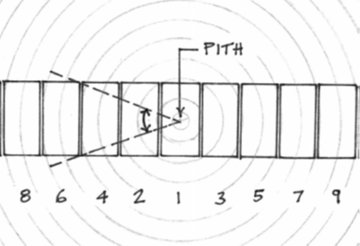
Figure 6: How the cutting pattern affects the growth rings in each joist and the amount and distribution of knots
Finally on completion of the testing, the power of the non-destructive testing (NDT, dynamic MOE) and semi-destructive testing (SDT, micro-clears) measurements and visual observations to predict the mechanical properties of the timber was then assessed both singly and then in combination using multiple regression analysis.

RESULTS AND DISCUSSION

INTRODUCTION TO RESULTS AND DISCUSSION
All values of density and MOE presented, have been adjusted in accordance with EN 384 to a reference value of 12% moisture content. MOR is not adjusted to a 150 mm reference depth (as is usual for EN 384) and statistical adjustments for sample size have not been applied.
The coefficient of determination, R² (the square of Pearson’s product moment coefficient) was calculated to give an initial measure of strength of the linear associations between several of the variables measured during the physical testing of all of the specimens so as to gauge the predictive usefulness of one variable in relation to another.
Generally, the relationship between the properties measured in the structural sized specimens with those of the small clear and micro clear specimens are considered in relation to the prediction of three key mechanical properties of the timber:
- Modulus of rupture (MOR)
- Modulus of elasticity (MOE)
- Density

MODULUS OF ELASTICITY FROM PHYSICAL MEASUREMENTS
The MOE of the structural sized joists presented is based on the global bending stiffness of the joists as measured in four point bending (in accordance with EN 408) and subsequently amended, making use of a regression analysis to convert to a ‘shear free’ value. The MOE of the small and micro clear specimens presented in the results has not been adjusted to a shear-free value. The mean values of the various MOE measurements are summarised in Table 2.
Table 2: Mean values of MOE from the different methods
Test type | Specimens | Mean MOE  (kN/mm²)
Full size (EN 408) | 150 | 8.61
MTG 960 (dynamic) | 150 | 10.1
Small clear (BS 373) | 142 | 7.16
Micro clear A | 68 | 7.59
Micro clear B | 67 | 7.88
Mean of micro clears A&B | 67 | 7.73

The correlation between density (no matter how measured) and the MOE was found to be weak (Figure 7 and Table 3). The best correlation was found with the sectional density of the structural sized joists (analogous to taking a full cross-section piece from in-situ timber) and amounts to R² of 0.32, which is slightly better than the R² of 0.22 for a single micro-clear (which is less destructive). The lack of correlation with the small clear density is likely a consequence of large variation of density and stiffness within a tree (remember the small clears come from the same tree, but do not match the joists in radial position). The poor correlation of stiffness with density is not unexpected for this species and age (in these data, stiffness increases with radial position, but density does not). Instead, stiffness is likely governed by micro-fibril angle (see e.g. [13]). In this case, knowing density provided no real useful information about the wood stiffness.

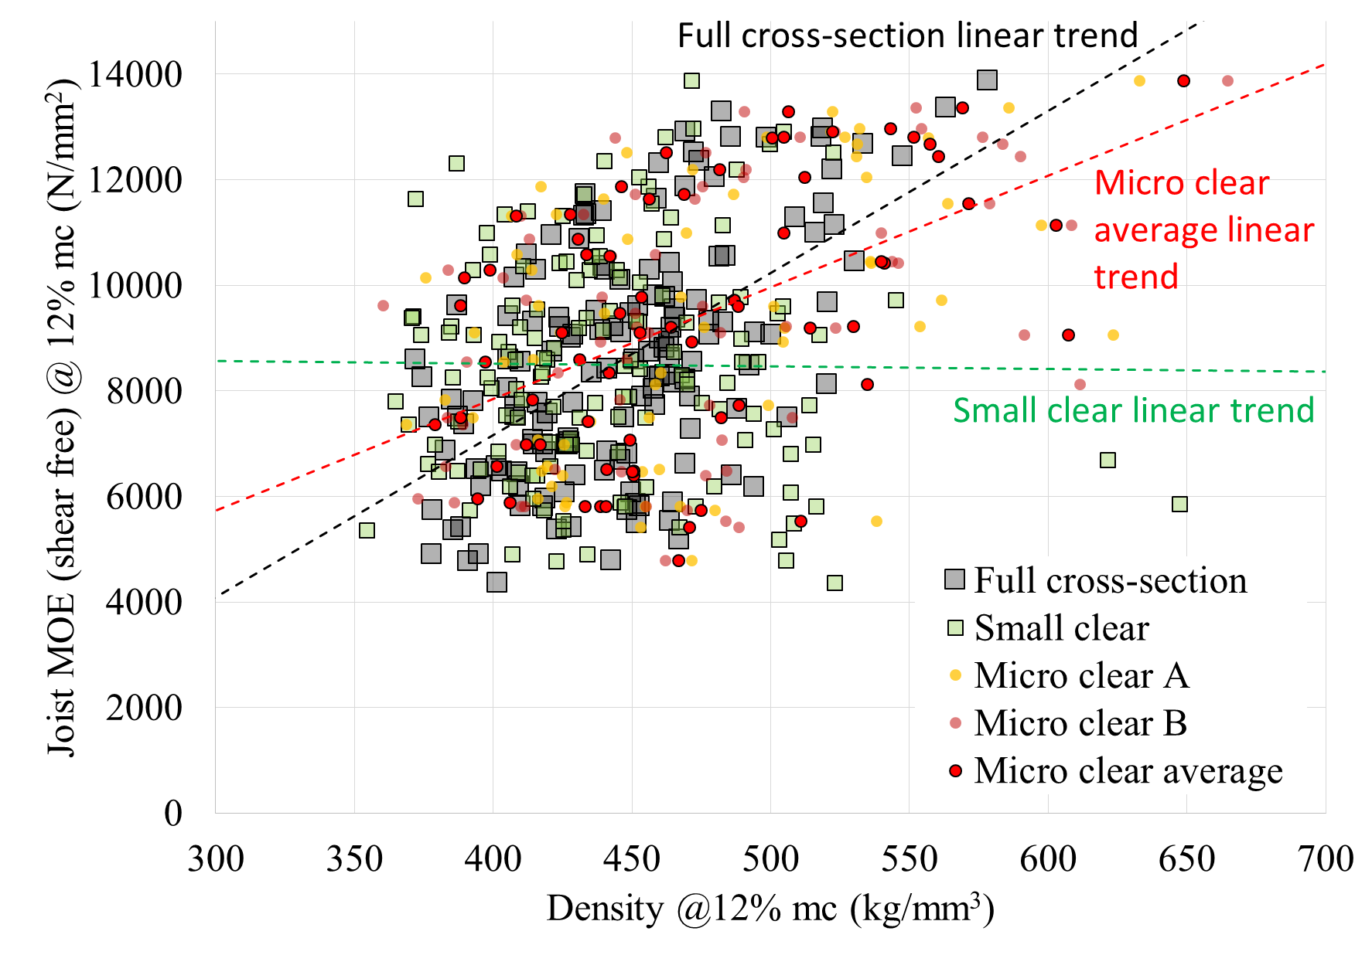
Figure 7: Scatter plot showing predictive density and static MOE of structural sized specimens
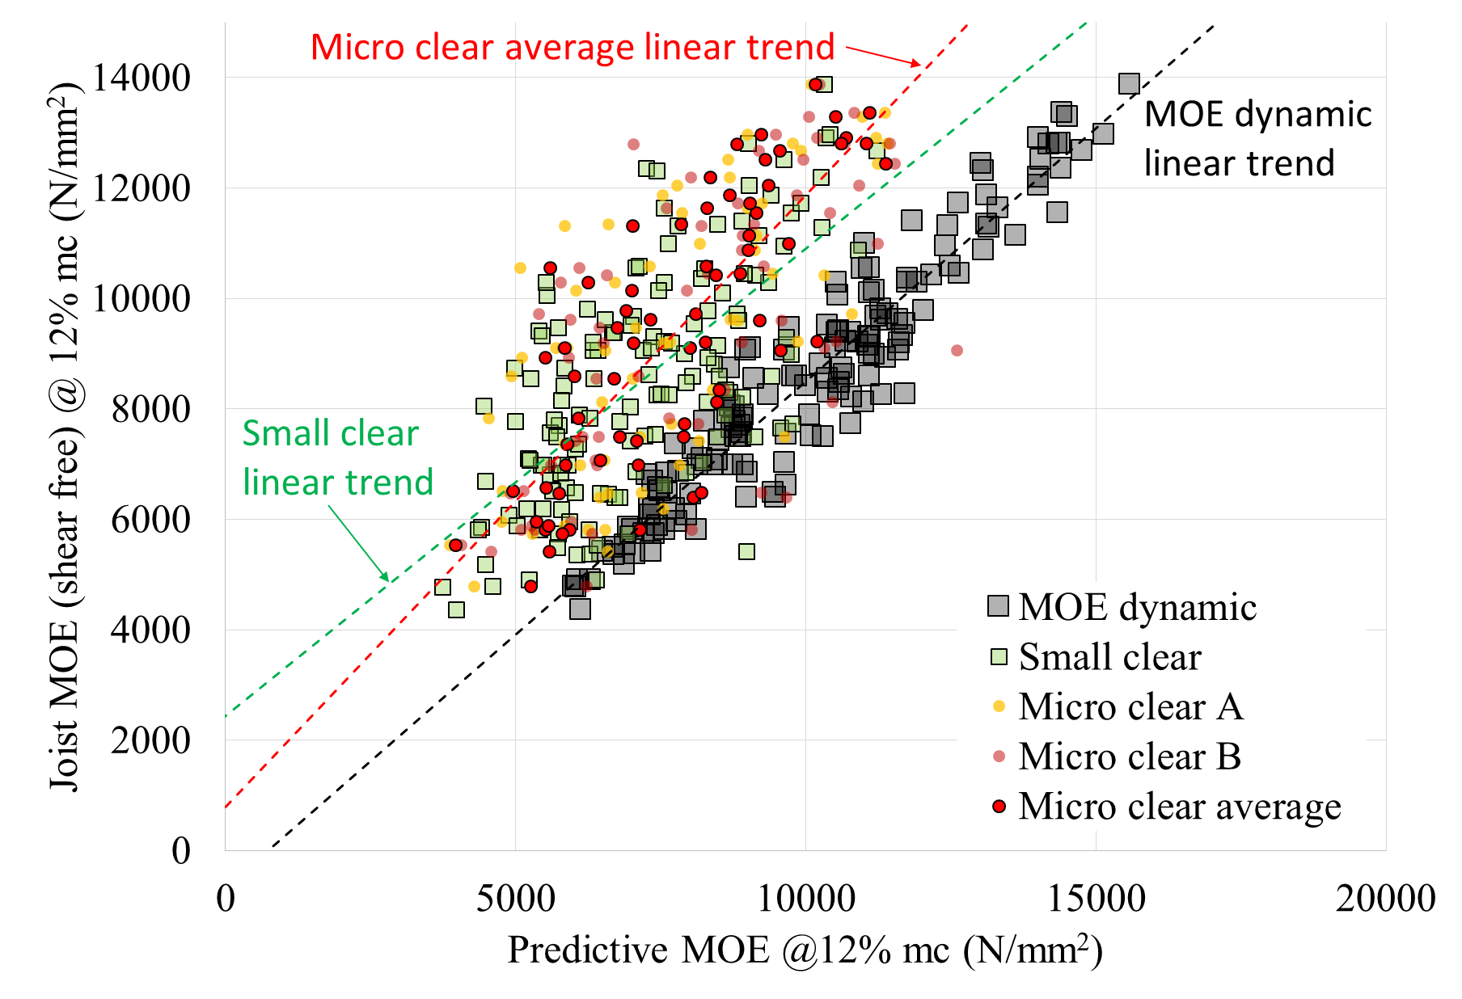
Figure 8: Scatter plot showing predictive MOE and static MOE of structural sized specimens
The MOE values measured from the testing of all of the micro clear and small clear specimens correlates with the tested structural sized joists only moderately (Figure 8 and Table 3), with the strongest correlation obtained by averaging pairs of values of micro clear specimens (R² is 0.61).
As expected, the correlation between the dynamic MOE and the static MOE of the structural sized joists (Figure 8 and Table 3) was found to be strong (R² is 0.90) with a tendency to be about 10% higher than the static MOE. When using the MTG to measure the dynamic MOE, each structural sized joist needs to be unrestrained enough to be free to vibrate longitudinally. This condition is rarely encountered in in-situ timber, but it could be used for timber that is removed during renovation. There are time-of-flight methods of measuring dynamic stiffness that could be used in-situ that may approach this predictive power, but they have not been checked in this study.

Table 3: Correlation summary for MOE
Property predicting MOE | Specimens | R²
Density @ 12% mc
Full cross-section | 150 | 0.32
Small clear | 142 | 0.00
Micro clear A | 68 | 0.22
Micro clear B | 67 | 0.23
Mean of micro clears A&B | 67 | 0.25
Stiffness @ 12% mc
Joist dynamic MOE | 150 | 0.90
Small clear | 142 | 0.45
Micro clear A | 68 | 0.50
Micro clear B | 67 | 0.42
Mean of micro clears A&B | 67 | 0.61

MODULUS OF RUPTURE FROM PHYSICAL MEASUREMENTS
The means of modulus of rupture are shown in Table 4. It can be seen that the MOR is generally higher, the smaller the specimen. It is to be expected that the small clears have higher strength than the full size joists, with their knots and other defects, but it is not so obvious why the micro-clears should be stronger than small clears. This could be a size effect, a testing effect, or a sampling effect.

Table 4: Mean values of MOR from the different methods
Test type | Specimens |  | Mean MOR  (N/mm²)
Full size (EN 408) |  | 150 | 38.5
Small clear (BS 373) |  | 142 | 67.6
Micro clear A |  | 68 | 94.1
Micro clear B |  | 67 | 96.4
Mean of micro clears A&B |  | 67 | 95.3

The correlation coefficients obtained from the results of the testing of the micro clear, small clear and structural sized specimens indicates substantial variability both between types of specimens and within types of specimens (Table 5 and Figures 9-11). The strongest correlation was found between the dynamic MOE and the modulus of rupture of the structural sized specimens (R² is 0.50).
In this instance, averaging the results from the micro specimens did little to increase correlation with the modulus of rupture of the full size joists, but it should be noted that the correlation (both MOE and MOR) for the micro clears from the top of the block (A), is considerably better than those from the bottom (B). This could be a random sampling effect, in which case taking an average of two micro clears would be better than just taking one. That said, the correlation between the MOR of the two micro clears taken from the same block is reasonable (R² is 0.45, Figure 12) and higher than the correlation for MOE (R² is 0.26).

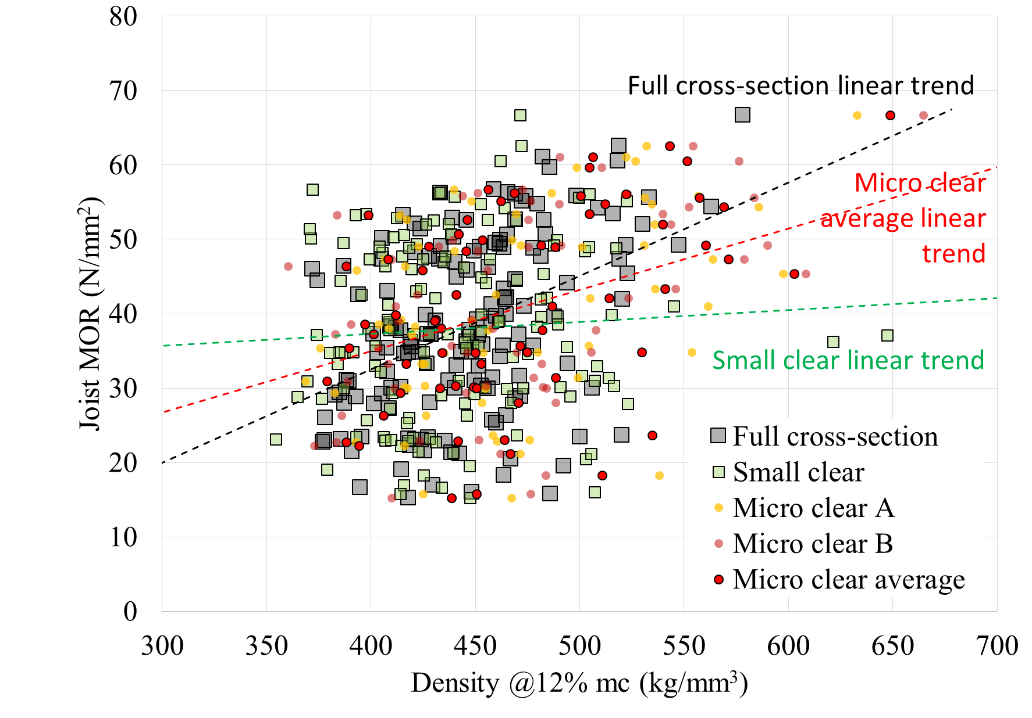
Figure 9: Scatter plot showing predictive density and MOR of structural sized specimens
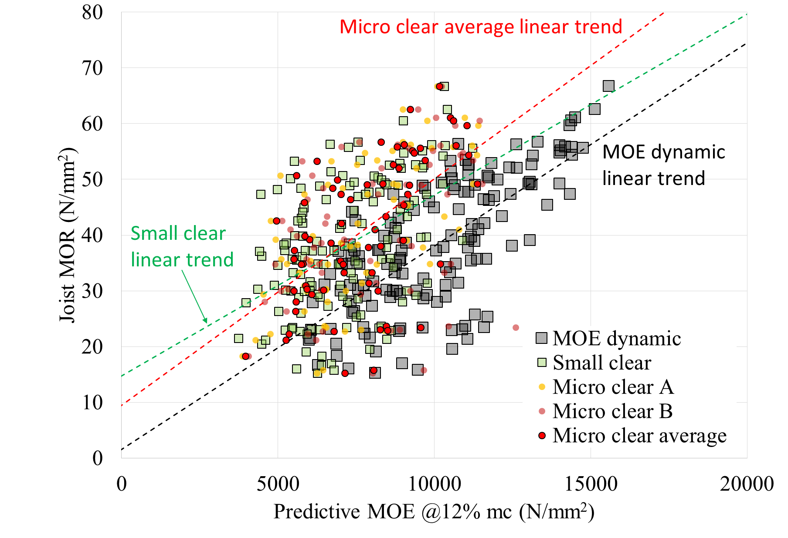
Figure 10: Scatter plot showing predictive MOE and MOR of structural sized specimens
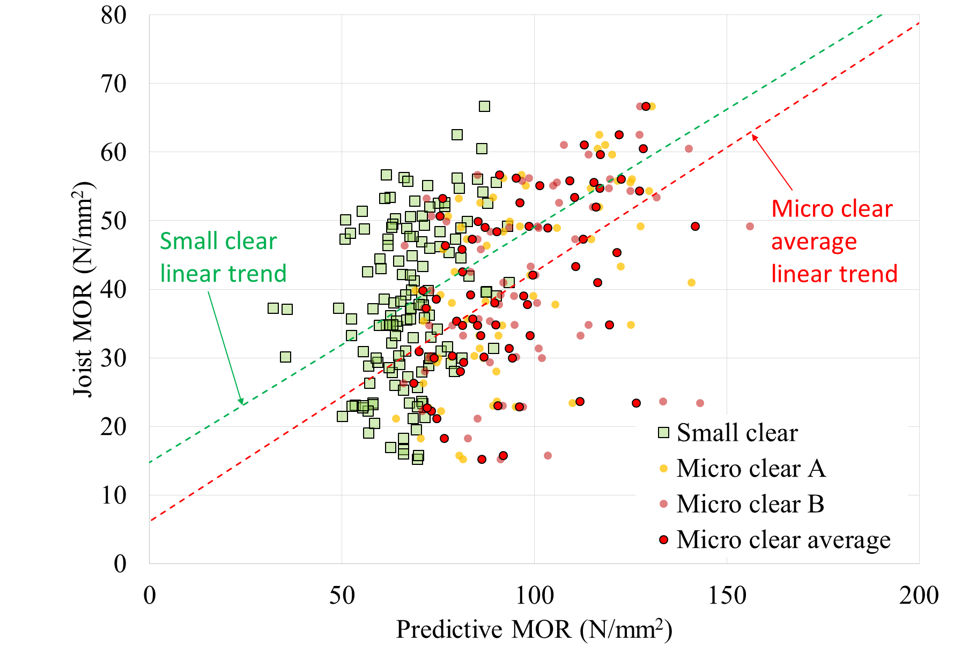
Figure 11: Scatter plot showing predictive MOR and MOR of structural sized specimens
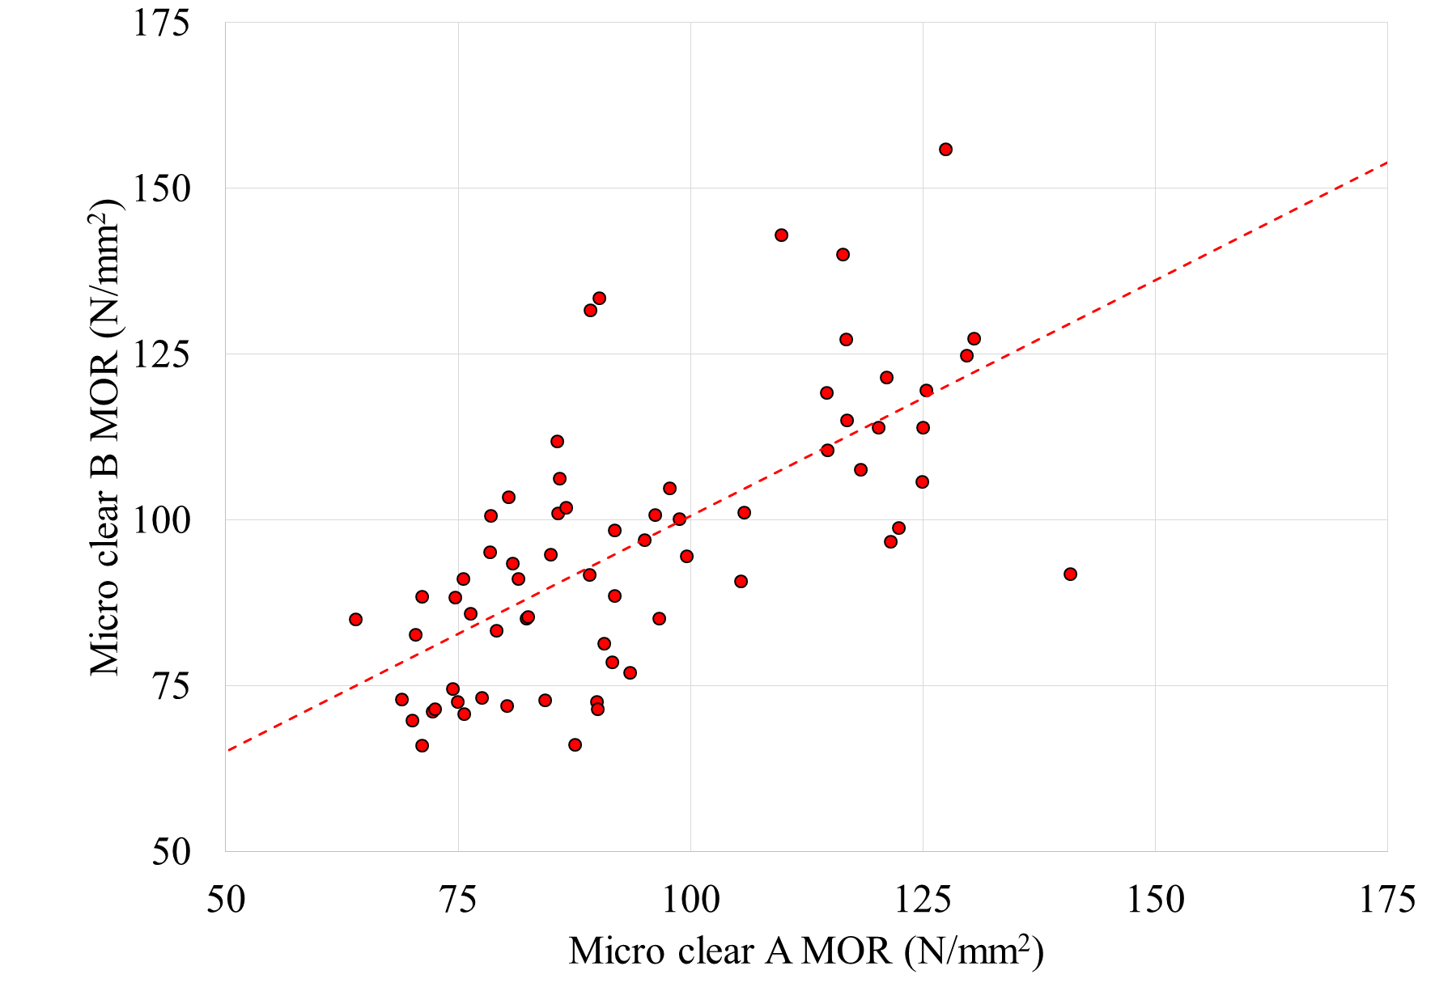
Figure 12: Scatter plot comparing MOR values from paired micro clears cored from blocks cut from the structural sized joists
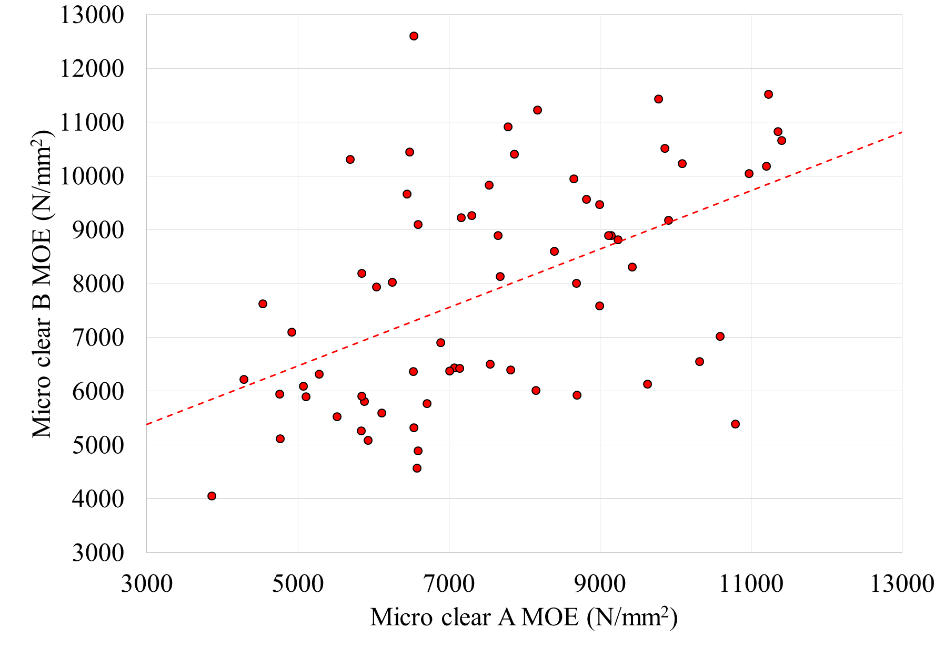
Figure 13: Scatter plot comparing MOE values from paired micro clears cored from blocks cut from the structural sized joists
The relationship of a single physical property of a joist (such as density or dynamic MOE) would not be expected to correlate very strongly with the modulus of rupture of joists that contains features such as knots and significant slope of grain, but the measurements of micro clear strength and stiffness appear to be more useful (in this case) than density for predicting MOR of the joists.

DENSITY FROM PHYSICAL MEASUREMENTS
The density of the structural sized joists presented is based on a section cut from the joist in accordance with EN 408 [5]. This cut section must be free from knots and resin pockets and so should closely resemble the wood present in the small clear specimens and the micro clear specimens (except for the inhomogeneity within the joist). Mean values of the densities are given in Table 6.
The value of density used as a basis for the correlation analyses presented in Table 7 is the density of the full cross-section sample cut from the joist near to the point of failure. The correlation of this density with that measured using the mass of the entire joist is strong (R² is 0.74) but not perfect due to the variation of density within the length of the joist.

Table 5: Correlation summary for MOR
Property predicting MOR | Specimens | R²
Density @ 12% mc
Full cross-section | 150 | 0.18
Small clear | 142 | 0.00
Micro clear A | 68 | 0.12
Micro clear B | 67 | 0.13
Mean of micro clears A&B | 67 | 0.15
Stiffness @ 12% mc
Joist dynamic MOE | 150 | 0.50
Small clear | 142 | 0.22
Micro clear A | 68 | 0.37
Micro clear B | 67 | 0.13
Mean of micro clears A&B | 67 | 0.31
MOR
Small clear | 142 | 0.10
Micro clear A | 68 | 0.33
Micro clear B | 67 | 0.14
Mean of micro clears A&B | 67 | 0.27

Table 6: Mean values of density from the different methods
Test type | Specimens |  | Mean density  (kg/m³)
Full size (EN 408) |  | 150 | 447
Small clear (BS 373) |  | 142 | 442
Micro clear A |  | 68 | 470
Micro clear B |  | 67 | 472
Mean of micro clears A&B |  | 67 | 472

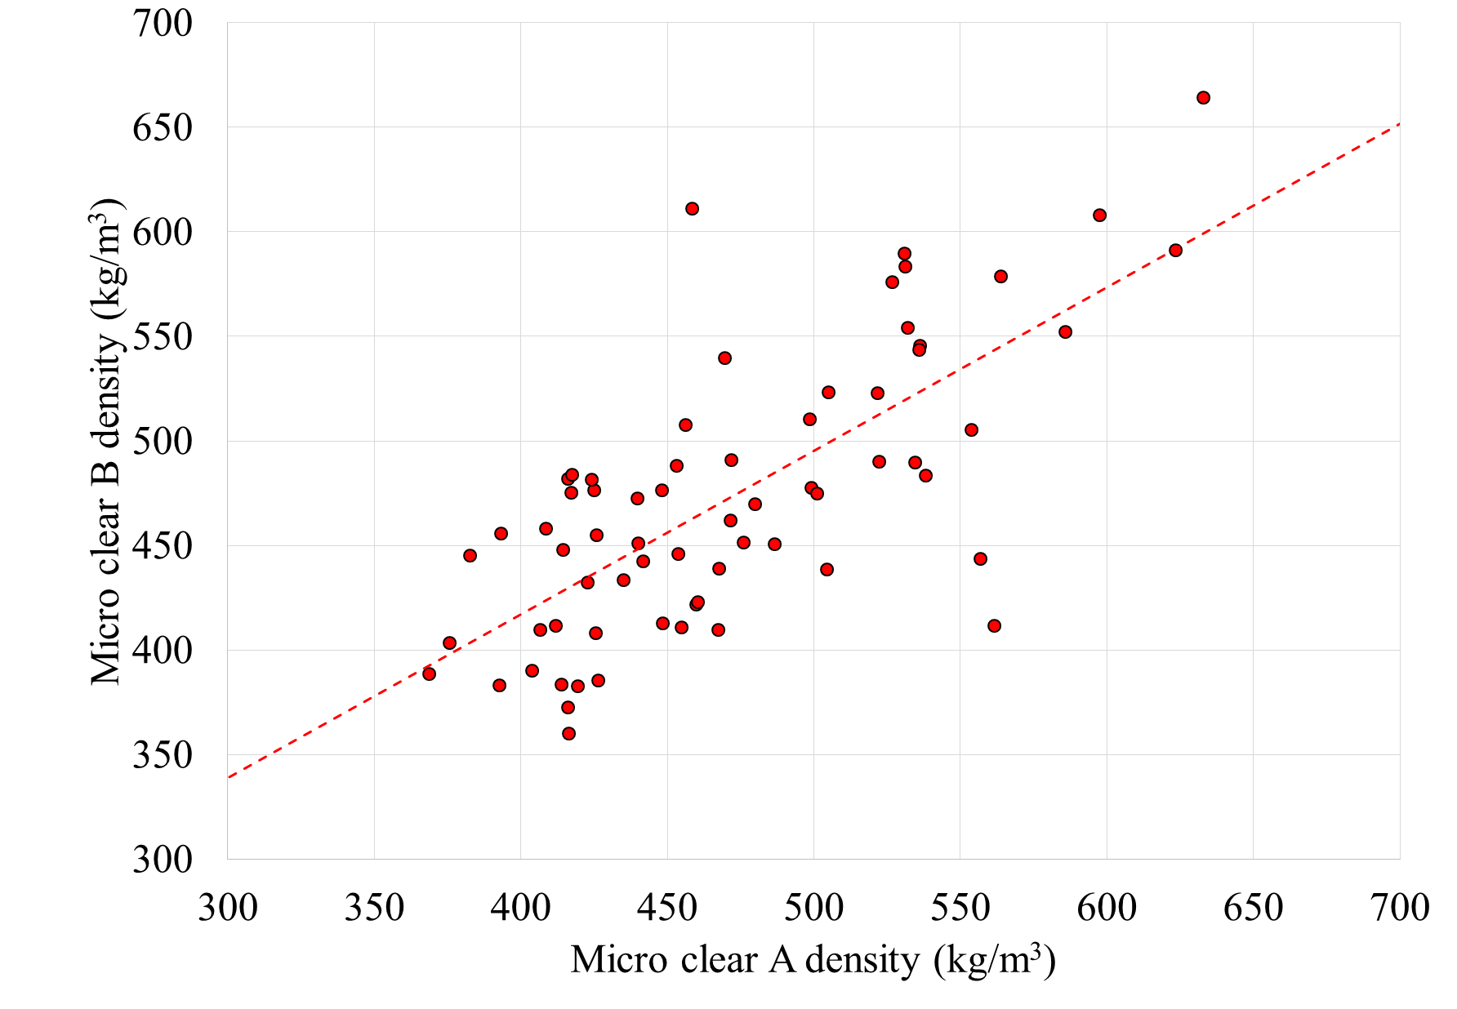
Figure 14: Scatter plot comparing density values from paired micro clears cored from blocks cut from the structural sized joists
The correlations associated with the small clear specimens (R² 0.10) and the micro clear specimens A and B (R² 0.53 and 0.68 respectively) show how the density of the wood varies from one location to another. Even the correlation of density between the micro clear specimens A and B (cores taken at the same position along the length of each joist, generally from similar growth rings and just a few millimetres from each other (Figure 2) only amounts to R² of 0.53 (Figure 14). From this it is apparent that the density of the wood in the joists varies considerably, which limits the potential of localised density sampling to represent density generally within the joists.
Where individual measurements can vary significantly, it is possible to reduce their ranges by simply taking a pair of measurements at any particular location. The average densities at a single location, gained from the pairs of micro clear specimens A and B, were also correlated with the sectional densities of the joists. The R² value of 0.70 indicates a similar level of correlation to that gained using the density measured using the mass of the entire structural sized joist and so a stronger correlation using other methods of measurement is unlikely.

Table 7: Correlation summary for density
Predicting joist density | Specimens | R²
Mass of complete joist | 150 | 0.74
Small clear density | 142 | 0.10
Micro clear A density | 68 | 0.53
Micro clear B density | 67 | 0.68
Mean of micro clears A&B | 67 | 0.70

VISUAL INSPECTION
It can be seen from Table 8 that the KNOT ratios, the local and general slope of grain values and the rate of growth values correlate only weakly with modulus of rupture and that the mKAR (R² 0.33) and tKAR (R² 0.29) were found to have the strongest association. Those knot parameters have similar correlation with joist MOE, but the rate of growth is better (R² 0.51). Rate of growth is the only parameter that has any correlation with the joist density, but it is only weak (R² is 0.22).
It is worth noting that the rate of growth, as ring width, has some correlation to cambial age in this dataset (R² is 0.27) and cambial age has some correlation to MOR, MOE and density (R² of 0.24, 0.47, 0.16 respectively). The radial trend in both ring width and MOE probably explains why the correlation of rate of growth and MOE is as high as it is. Like many things related to visual characteristics, this would be species dependent.
The strongest correlations for each of MOR, MOE and density are shown in Figures 15 to 17.
In approximately half of the joists tested, failure was closely associated with the presence of a bottom edge knot, showing that the presence of knots in the bottom of the joists is directly related to their failure. It must be borne in mind that the mKAR ratios obtained from the MiCROTEC software include knots from both the top and bottom margin areas of the joists (which were randomly orientated with respect to the worst defect and the tension edge, as specified in EN 384). So this mKAR ratio may or may not be of relevance to the mode of failure and the strength of the joist. It is hoped that for in-situ timber by focussing attention on only the bottom margin, that a stronger correlation could be achieved (since in-situ, the loading condition is known, unlike for normal visual strength grading).

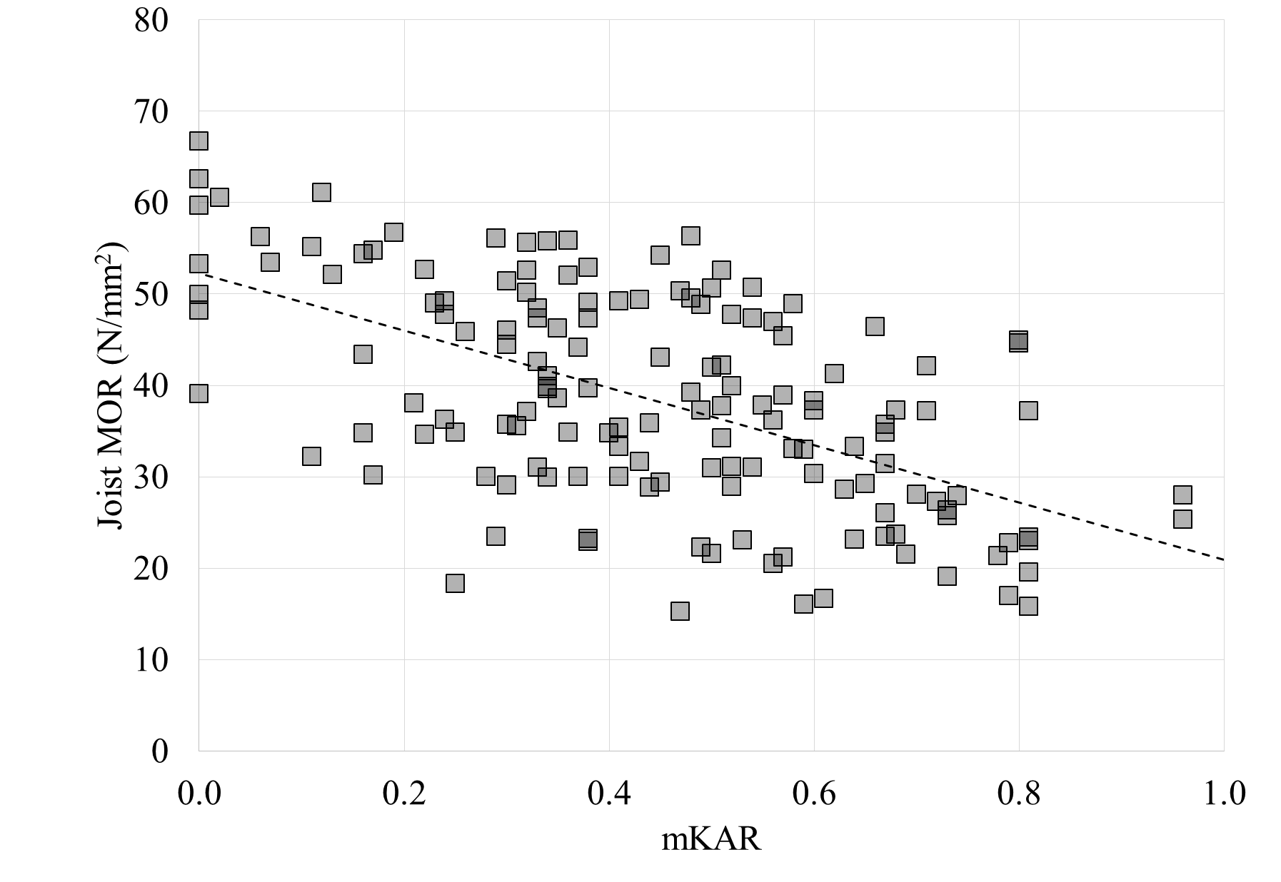
Figure 15: Scatter plot showing the relationship between the mKAR of the structural sized joists with MOR
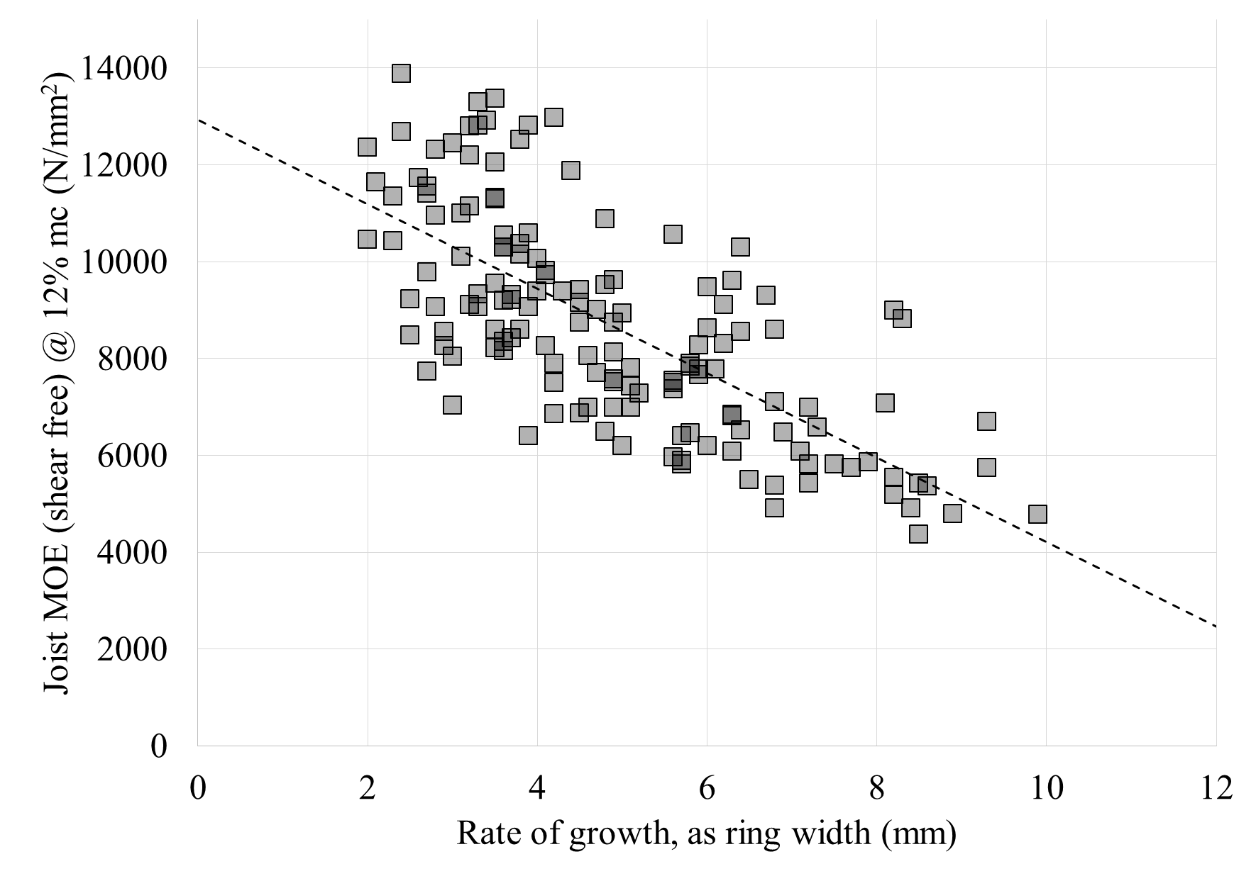
Figure 16: Scatter plot showing the relationship between the rate of growth of the structural sized joists with MOE
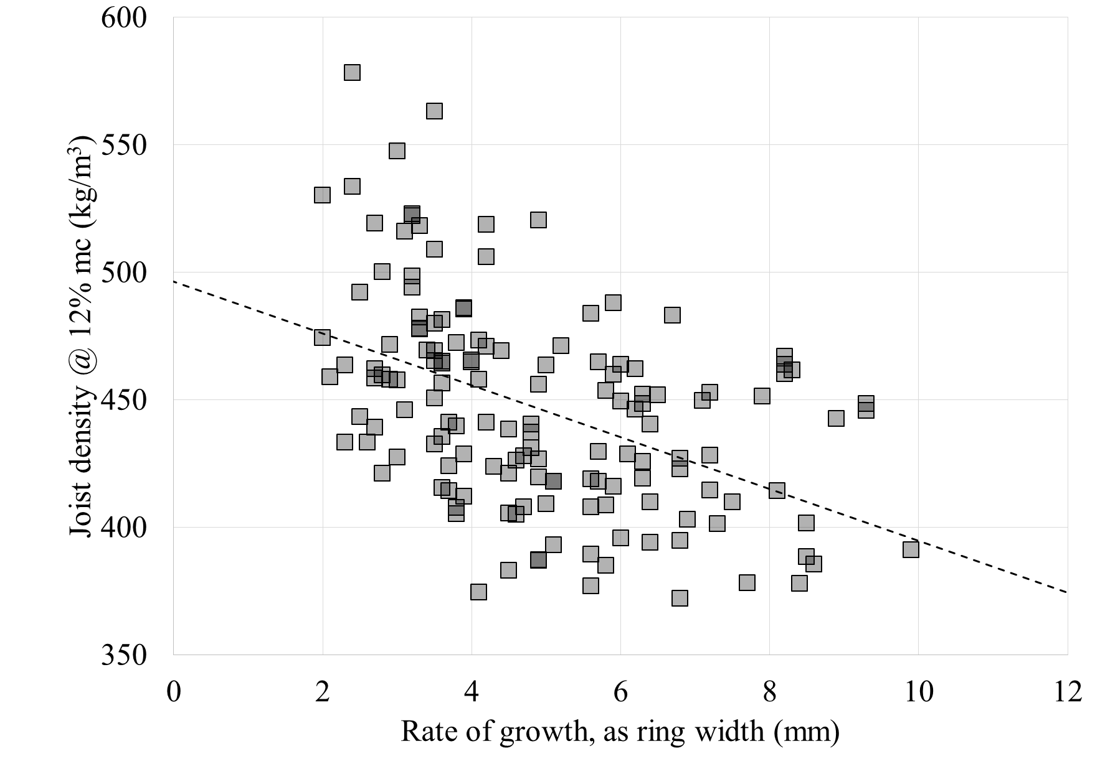
Figure 17: Scatter plot showing the relationship between the rate of growth of the structural sized joists with density

COMBINING RESULTS
Multiple regression is a statistical technique to assess the linear correlation of a group of variables to predict a single dependent variable. The results of the linear regression analyses and practical matters relating to practice were considered when composing the groups of measurements. For parity, the calculations presented here were done on the 66 joists for which there was complete micro clear and visual grading data.
The most useful combinations of measurements for predicting MOR of the joists are listed in Table 9. In this case, the dynamic MOE in combination with either tKAR or mKAR (adjusted R² 0.68) is superior to dynamic MOE alone (adjusted R² 0.59).

Table 8: Linear regression of visual characteristics and MOR, MOE and density of structural sized specimens
 | Specimens | R²
Property predicting MOR
Rate of growth | 146 | 0.21
Slope of grain local | 148 | 0.07
^ cross grain failure only | 40 | 0.26
Slope of grain general | 148 | 0.01
mKAR | 150 | 0.33
tKAR | 150 | 0.29
mKNOT | 150 | 0.24
tKNOT | 150 | 0.13
Property predicting MOE
Rate of growth | 146 | 0.51
Slope of grain local | 148 | 0.02
^ cross grain failure only | 40 | 0.23
Slope of grain general | 148 | 0.00
mKAR | 150 | 0.27
tKAR | 150 | 0.29
mKNOT | 150 | 0.15
tKNOT | 150 | 0.08
Property predicting density
Rate of growth | 146 | 0.22
Slope of grain local | 148 | 0.00
^ cross grain failure only | 40 | 0.02
Slope of grain general | 148 | 0.00
mKAR | 150 | 0.06
tKAR | 150 | 0.03
mKNOT | 150 | 0.04
tKNOT | 150 | 0.01

If dynamic MOE is not available, a reasonable prediction for strength can be obtained from tKAR and rate of growth (R² 0.56). A combination of tKAR with either average MOE or MOR of paired micro clears performs equally well (R² 0.55). The advantage of using micro clears and measuring their MOE (rather than strength) is that it could potentially be done on site with an impact resonance measurement.
The most useful combinations of measurements for predicting MOE of the joists are listed in Table 10. In this case, the dynamic MOE in combination with either tKAR or mKAR (adjusted R² 0.94) is, again, the best combination, but it is only trivially better than dynamic MOE alone (adjusted R² 0.92).
If dynamic MOE is not available, a reasonable prediction for stiffness can be obtained from tKAR, rate of growth and the average MOE of paired micro clears (R² 0.76). However, the combination of rate of growth with tKAR, tKNOT, mKAR or mKNOT is nearly as good (R² 0.72 to 0.66) and avoids the need to take the micro clears.

Table 9: Multiple regression for MOR of structural sized specimens
Combination | P | Adjusted R²
Dynamic MOE | 0.00 | 0.69
tKAR | 0.00
Dynamic MOE | 0.00 | 0.68
mKAR | 0.00
tKAR | 0.00 | 0.56
Rate of growth | 0.00
tKAR | 0.00 | 0.56
Average micro MOR | 0.00
tKAR | 0.00 | 0.55
Average micro MOE | 0.00
Dynamic MOE | 0.00 | 0.59
tKAR | 0.00 | 0.45
mKAR | 0.00 | 0.39
Average micro MOR | 0.00 | 0.30
Average micro MOE | 0.00 | 0.26
Rate of growth | 0.00 | 0.25

Table 10: Multiple regression for MOE of structural sized specimens
Combination | P | Adjusted R²
Dynamic MOE | 0.00 | 0.94
tKAR | 0.00
Dynamic MOE | 0.00 | 0.93
mKAR | 0.00
Rate of growth | 0.00 | 0.76
tKNOT | 0.00
Average micro MOE | 0.00
Rate of growth | 0.00 | 0.72
tKAR | 0.00
Rate of growth | 0.00 | 0.70
tKNOT | 0.00
Rate of growth | 0.00 | 0.67
mKAR | 0.00
Rate of growth | 0.00 | 0.66
mKNOT | 0.00
tKAR | 0.00 | 0.66
Average micro MOE | 0.00
mKAR | 0.00 | 0.57
Average micro MOE | 0.00
tKNOT | 0.00 | 0.57
Average micro MOE | 0.00
Dynamic MOE | 0.00 | 0.92
Rate of growth | 0.00 | 0.52
Average micro MOE | 0.00 | 0.48
tKAR | 0.00 | 0.37
mKAR | 0.00 | 0.31
mKNOT | 0.00 | 0.22
tKNOT | 0.00 | 0.15

The use of paired micro clears allows better prediction when dynamic MOE of the joist is not available, but may not be sufficiently better than visual measurements to warrant the taking of micro clears. It is probably that a time-of-flight acoustic method would perform in a similar way to the micro clears, being also a localised measurement of wood stiffness.

CONCLUSIONS
From the limited amount of testing completed, it can be seen that a mix of results from NDT, SDT and visual inspection provide the best predictors of the key mechanical properties of the Western hemlock tested. Of all of the visual measures, it is apparent that the tKAR is the most useful. Measures such as the general slope of grain and the rate of growth have, in this case, particularly weak predictive powers.
The measured value that best correlates with the shear free MOE of the structural sized joists is the dynamic MOE of the structural sized joists (R² is 0.90), but if it is not available, a combination of rate of growth and tKAR is reasonable (adjusted R² is 0.72).
The best correlation with the density of the structural sized joists is obtained from the averaged density of micro clear specimens A and B (R² is 0.70). This is probably equivalent to taking localised density measurements by several other methods, and really only limited by the variation of density within the joist.
Finally, the best correlation with the modulus or rupture of the structural sized joists is the multiple correlation using the dynamic MOE and either mKAR or tKAR (adjusted R² is 0.68), which performs better than dynamic MOE alone (adjusted R² is 0.59). If dynamic MOE is not available a combination of rate of growth and tKAR is reasonable (adjusted R² is 0.56).
The average stiffness of paired micro clears, in combination with tKAR, would allow better prediction of both joist MOE and MOR (adjusted R² 0.66 and 0.55 respectively) than could otherwise be achieved without both resonant dynamic MOE and rate of growth (which might be problematic to measure in situ). Since the micro clear is a localised measurement of wood stiffness it is could possibly be replaced with a time of flight acoustic stiffness (although obtaining a good value would also require an assessment of density for the calculation of stiffness from acoustic wave speed). Knowledge of the strength of the micro clear does not seem to add anything more than the MOE does, when combined with tKAR.
This work is limited to a minor species for the UK, Western hemlock. This species is widely used in construction elsewhere, but this UK plantation material may be of a different character (due to climate, forest management etc).
There is much further work that needs to be done in this field, for instance, further work could be done (in relation to in situ timber) focussing on the mKAR of just the bottom margin, where the key knots are located. This would be expected to improve further the predictive power of the measurements taken.
Additionally, the KAR and KNOT ratios in this research require all faces of the joist being assessed to be accessible. Although this is possible for joists in the laboratory it is often not possible for in situ timber. Therefore, it would be most helpful for practitioners if a different method of measuring knot ratios which focuses on the surface location and appearance of knots (perhaps similar to superseded UK code CP 112 [10]) could be developed. Finally, the potential for localised dynamic stiffness measurements in situ, combined with knot measurements, should be explored.

ACKNOWLEDGEMENT
The authors thank Forestry Commission Scotland, Cyfoeth Naturiol Cymru (Natural Resources Wales) and Scottish Forestry Trust for funding the research to obtain the joists and small clears used in this study. Stefan Lehneke and Steven Adams (Edinburgh Napier University) and Andrew Price (Forest Research) are thanked for help collecting the data.

REFERENCES
- Piazza, M. and Riggio, M.: Visual strength-grading and NDT of timber in traditional structures. Journal of Building Appraisal, 3:267–296, 2008.
- White, R. H. and Ross R. J.: Wood and timber condition assessment manual, second edition. General Technical Report FPL-GTR-234. U.S. Department of Agriculture, Forest Service, Forest Products Laboratory. Madison, Wisconsin, U.S., 2014.
- BS 4978: 2007+A1:2011. Visual strength grading of softwood – Specification. British Standards Institution.
- EN 13556:2003. Round and sawn timber – Nomenclature of timbers used in Europe. European Committee for Standardization.
- EN 408: 2010+A1:2012. Timber structures – Structural timber and glued laminated timber – Determination of some physical and mechanical properties. European Committee for Standardization.
- EN 384:2010. Structural timber. Determination of characteristic values of mechanical properties and density. European Committee for Standardization.
- MiCROTEC. Web Knot Calculator v2.2. http://knots.microtec.eu/
- Ridley-Ellis, D.: Impact of clause 5.3.2 in EN384:2010 on grading of timber - Report to UKTGC. Edinburgh Napier University, 18/5/2011. http://researchrepository.napier.ac.uk/9773/
- EN 14081-1: 2005+A1:2011 timber structures – Strength graded structural timber with rectangular cross section – Part 1: General requirements. European Committee for Standardization.
- CP 112-2: 1971. The structural use of timber. Part 2. Metric units. British Standards Institution.
- BS 373: 1957. Methods of testing small clear specimens of timber. British Standards Institition.
- EN 1310: 1997. Round and sawn timber – Method of measurement of features. European Committee for Standardization.
- Jozsa, L.A, Munro B.D. and Gorgon, J.R.: Basic wood properties of second-growth western hemlock. B.C. Ministry of Forests, Special publication Sp-38, ISBN 0–7726–3513–7, 1998.

ERRATA

Section 4.4, Page 8, 2nd paragraph, 4th line:
‘locations’ corrected to ‘location’

Section 4.5, Page 8, 2nd line of title of 2nd figure, Figure 16:
‘density’ corrected to ‘MOE’

Section 4.6, Page 9, 2nd paragraph, 6th line:
‘stength’ corrected to ‘strength’

Mike Bather, University of Bolton, UK, m.bather@bolton.ac.uk
Dan Ridley-Ellis, Edinburgh Napier University, UK, d.ridleyellis@napier.ac.uk ³ David Gil-Moreno, Edinburgh Napier University, UK d.gil-moreno@napier.ac.uk

