dr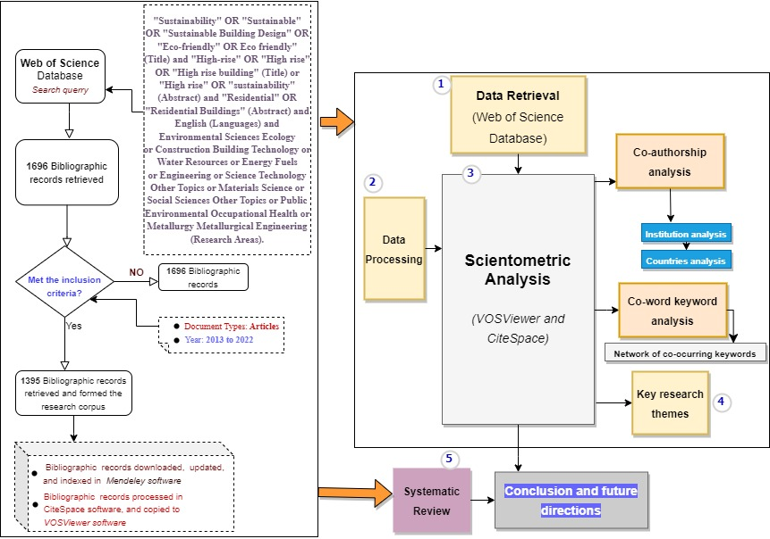
Fig. 1. Outline of research design

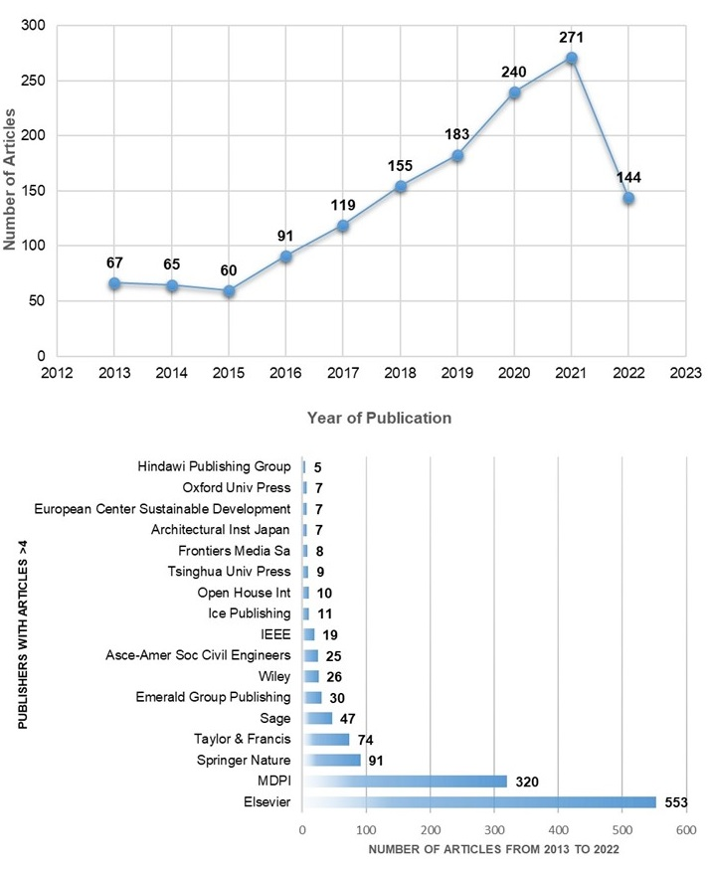 Fig. 2. Number of published articles and top publishers

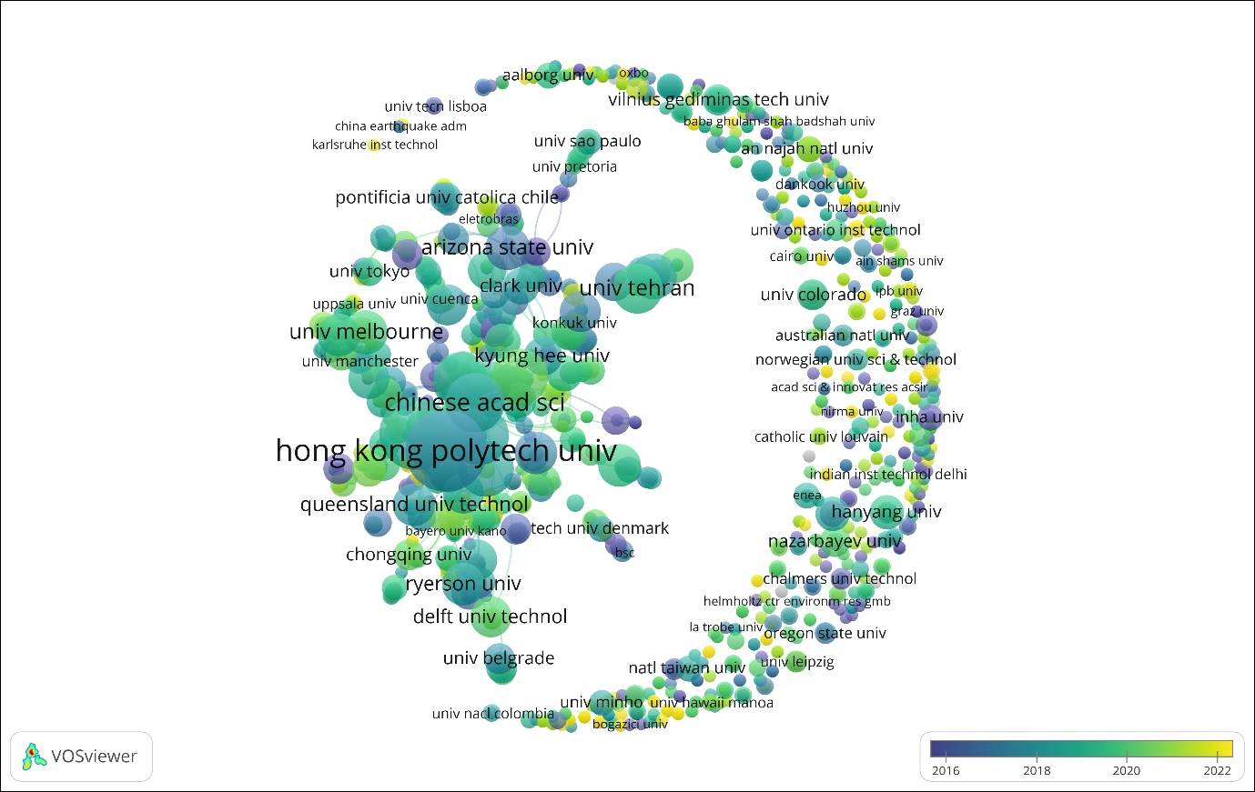
Fig. 3. Network of institutions

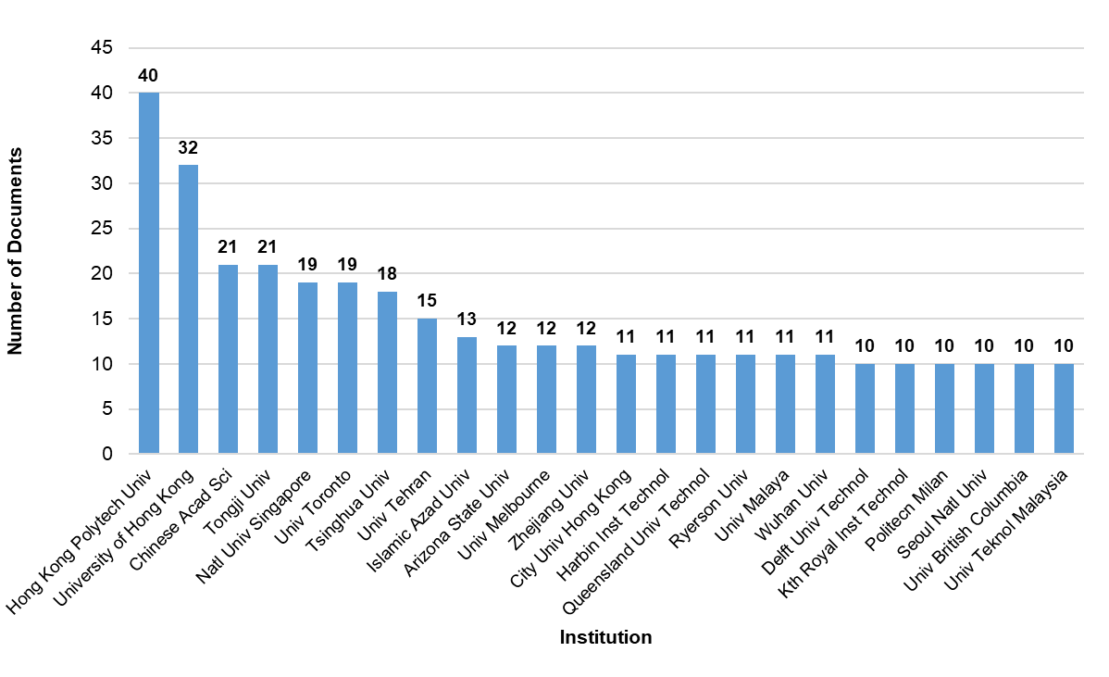
Fig. 4. Top 24 most productive institutions in the study

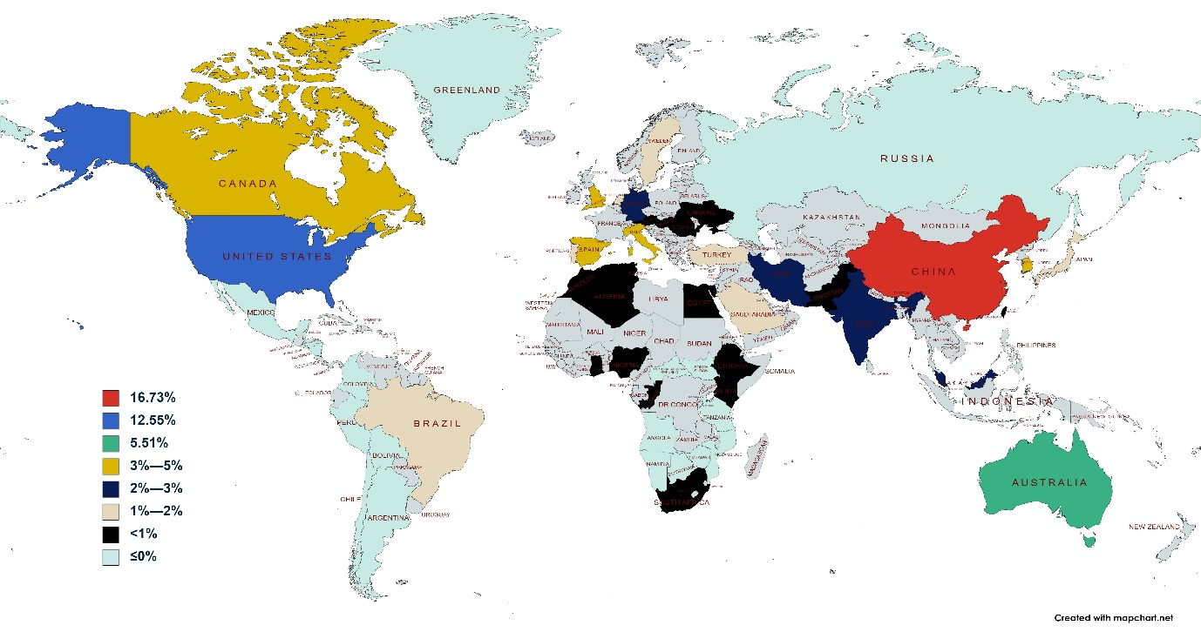
Fig. 5. Country representation of research activities on sustainability concepts in the development of (high-rise) residential buildings

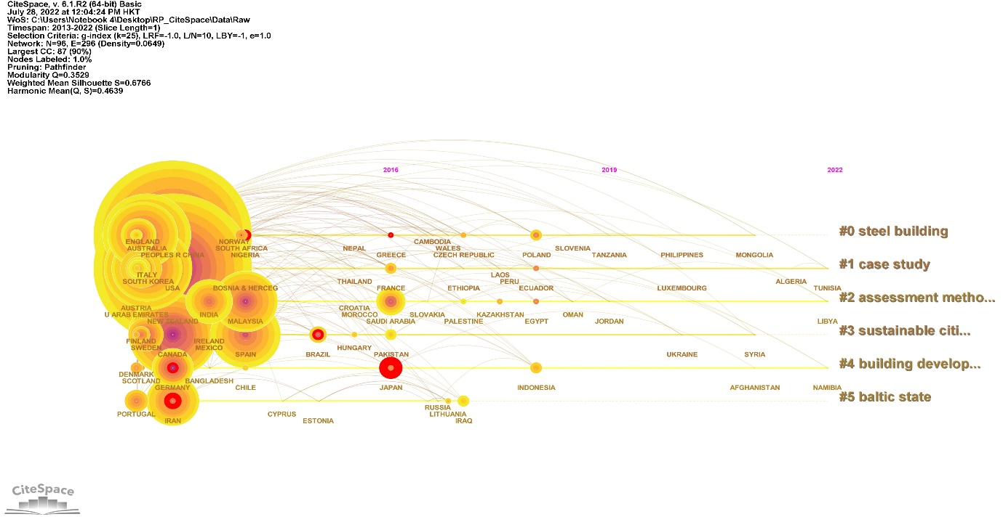
Fig. 6. Network of countries with corresponding clusters and timeline
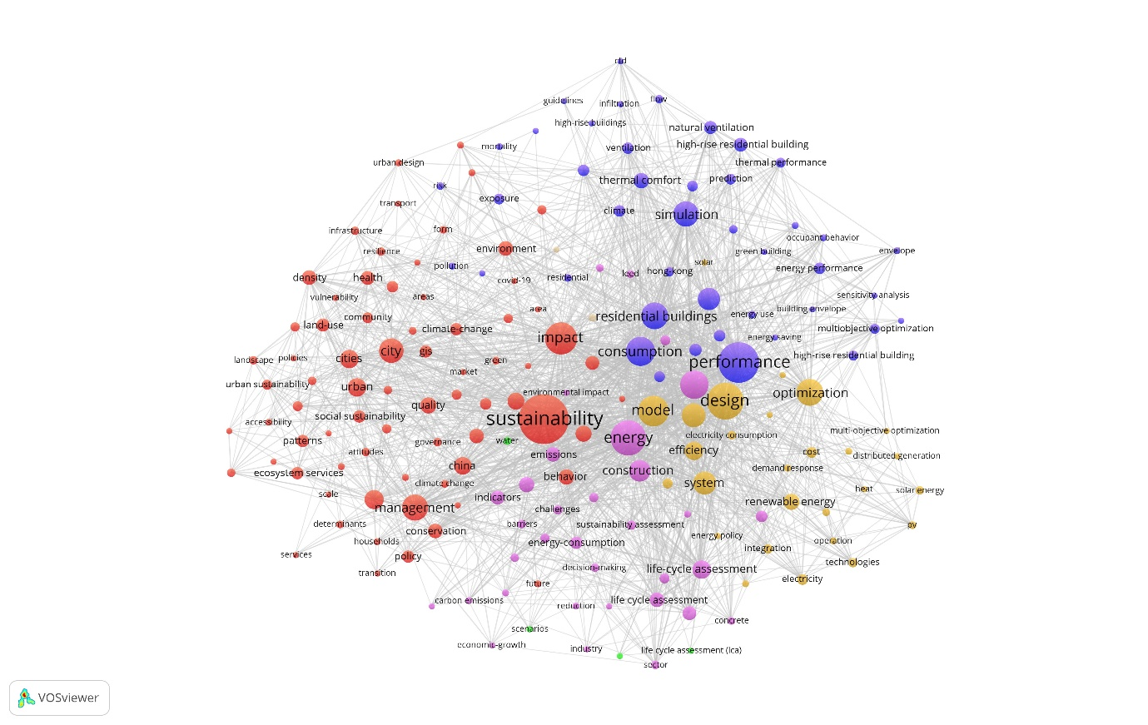
Fig. 7. Network of co-occurring keywords
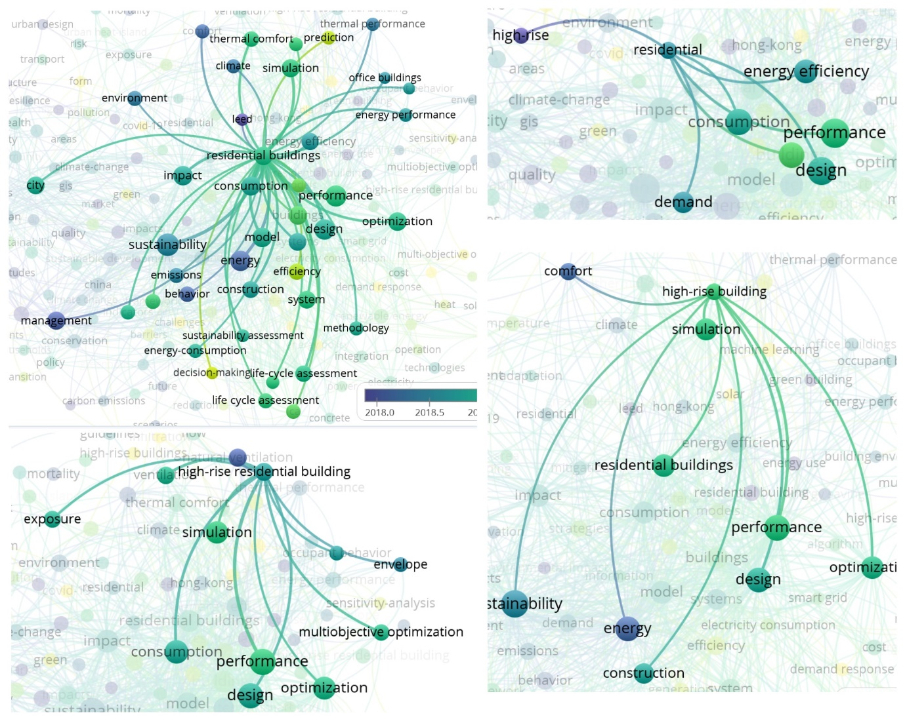 Fig. 8. Network of keywords associated with “Residential buildings”, “High-rise buildings” and “High-rise residential buildings”

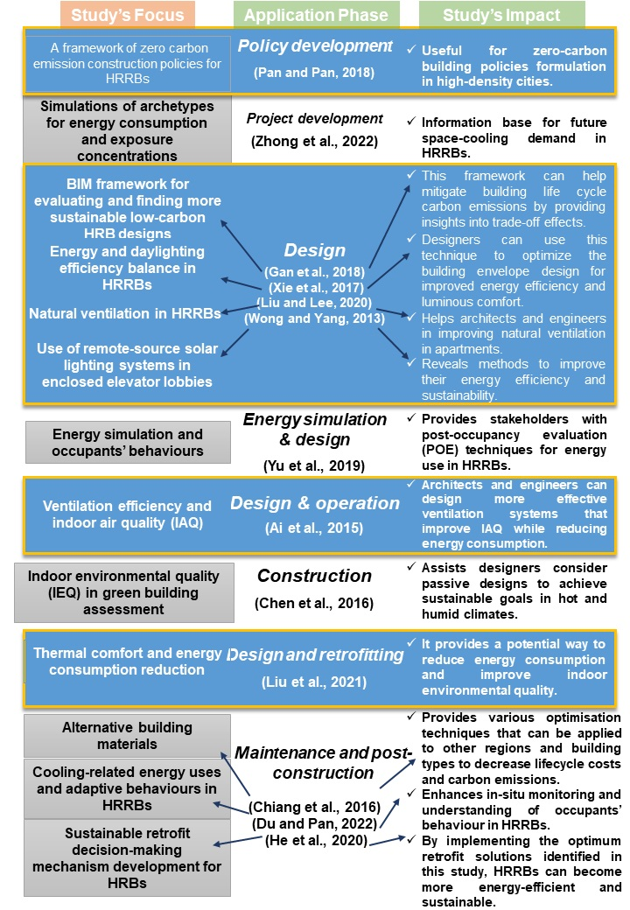
Fig. 9. Hong Kong's sustainable practices in HRRBs

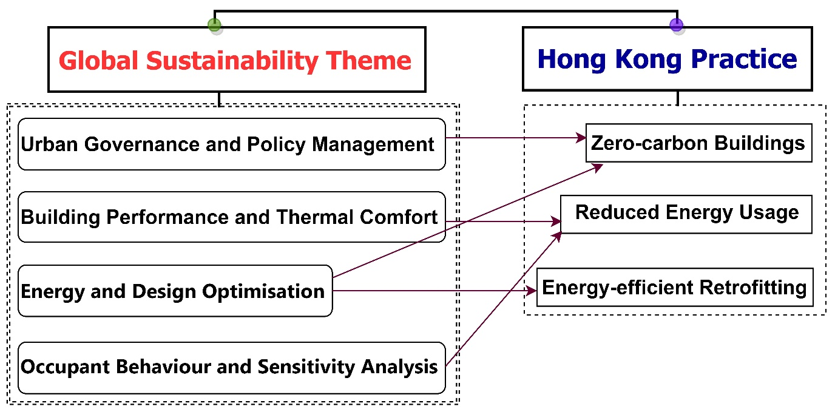
Fig 10. Interactions between the global and Hong Kong’s HRRB sustainability concepts

