**Global Application of Digital Twins and Virtual Reality in the Construction Industry: A Systematic Literature Review**

**Kayode O. Kazeem1, Timothy O. Olawumi2, Nirodha Fernando2**

*1 SPEED, The Hong Kong Polytechnic University, Hong Kong, China*

*2 School of Computing, Engineering and Built Environment, Edinburgh Napier University, United Kingdom*

**SUMMARY**

*When compared to a computer-generated environment with scenes and objects that appear real, virtual reality (VR) immerses the user in their surroundings. A DT is a virtual model created to represent a physical object accurately. The study aims to present results from a thorough literature review on a global overview of the digitisation of the construction industry, with a focus on DT and VR. Utilizing predetermined inclusion/exclusion criteria, relevant information from journal articles and other pertinent grey literature was systematically reviewed to find the practical applications of DT and VR using the PRISMA guideline. Planning, designing, managing, and constructing buildings utilized DT and VR technologies. Particularly, the collaboration between humans and robots, as well as the safety of workers on construction sites, have been improved by DT and VR.*

Word Count: 5476

Number of Figures: 5

Number of Table: 1

**Introduction**

While the construction industry is known to be a slow adopter of new technologies (Li and Liu, 2019), the trend can be said to be changing especially in the post Covid-19 era. In recent years, the construction industry has emphasized innovation and technology. Designers and contractors utilize building information modeling (BIM) during the design and planning phases to improve connectivity and efficiency (Daniotti *et al.*, 2022). For instance, the use of drones in construction has increased exponentially in recent years, making the construction industry one of the most rapid commercial adopters of this technology (Albeaino *et al.*, 2022). To address sustainability issues, new technologies, building materials, and energy sources are being developed (Lam *et al.*, 2022). Aside from planning and design, construction innovation is used to spot potential hazards and other issues, prioritising construction safety (Xi, 2022).

Generally, innovation and technology have the potential to significantly enhance the efficiency, safety, and sustainability of the construction industry. Virtual reality (VR) and digital twin (DT) have helped the construction sector achieve new levels of efficiency. While a DT is a virtual model intended to precisely represent a physical object, VR is a computer-generated environment with scenes and objects that appear real, immersing the user in their surroundings. According to Liu, Lather and Messner (2014), VR technology consists of a virtual environment and sensory input and has three main characteristics: interactivity, three-dimensionality, and real-time response to actions. Similarly, DT, whose original application was to address problems with aircraft maintenance and life prediction in a complex service setting (Liu *et al.*, 2022), is a digital representation of a physical object.

The pursuit of cutting-edge solutions and methods to guarantee better performance and accuracy, thereby lowering costs and modernizing production, is driving a paradigm shift in the architecture, engineering and construction (AEC) industry (Sidani *et al.*, 2021) and there has been an increased interest in evaluating general trends and various issues of construction 4.0 innovations literature in recent years. In the construction industry, DT and VR enhance efficiency, save costs, and ensure safety. Thus, many SRs have been conducted exploring these technologies. For instance, Wen and Gheisari (2020) summarized the results of forty-one research articles on VR's deployment and future research directions to facilitate communication in the construction industry. Safikhani *et al.* (2022) addressed the latest VR and BIM breakthroughs via a SR. Similarly, SR by Madubuike, Anumba and Khallaf (2022) focused on the development and implementation of DT in the construction industry. However, these studies have some limitations. Firstly, Madubuike, Anumba and Khallaf (2022) did not include related articles from the Scopus database. Also, SR by Opoku *et al.* (2021) on DT application in the construction industry only included twenty-two publications. The present study identified and combined the practical applications of DT and VR in the construction industry from eighty-two academic publications and retrieved from three different databases including Scopus. The study aims to conduct a SR of the existing literature on global digitisation of the construction industry, with an emphasis on practical applications of DT and VR.

**Method and Materials**

SR help us understand the best available evidence on a topic (Stern *et al.*, 2020). Unlike regular literature reviews, SR examine existing studies, assess scientific contributions, and synthesize relevant data (Olawumi *et al.*, 2022). In addition, SR conducts a structured review of the existing relevant literature to identify and discuss recent applications of the subject matter (Zhou and Gheisari, 2018). Hence, the identified approach is suitable to systematically organize findings on DT and VR applications in the AEC industry. To avoid inadequate reporting, this study utilized the five SR stages adopted by Gharbia *et al.* (2020): question formulation, study identification, studies screening, studies critical appraisal, and data extraction and synthesis of studies. This approach is parallel to the Preferred Reporting Items for Systematic Reviews (PRISMA) standards highlighted by Page *et al.* (2021) and was followed to achieve the study's aim. Figure 1 displays the PRISMA records selection flow chart used in this study.

In the present study, articles without practical validations such as case studies, use cases, applicable prototypes, etc. and non-dissertations were excluded. Also excluded were studies solely based on experiments, questionnaire surveys, scientometric analysis, reviews, university education, etc., or were unrelated to the building construction industry. Likewise, studies with focus on mining, education, machining, and art training were excluded. Non-English articles were also excluded. The study ensured the query was not limited to specific journals, and the date range was set to capture all relevant papers. Hence, the keywords and databases for this review has been carefully chosen to ensure its completeness. Scopus, Web of Science (WoS), and Google Scholar databases were explored since a single database could not include all the important and required articles relevant to the study (Madubuike, Anumba and Khallaf, 2022). Table 1 shows the search terms in the major databases consulted for this study. The research questions covered in this study include: (i) how are VR and DT used in the construction industry? (ii) In which phases of building construction have VR and DT been used? (iii) What are the future trends for VR and DT in building construction?

**Table 1**: Search terms used for studies’ identification in databases

|  |  |  |
| --- | --- | --- |
| **Database** | **DT** | **VR** |
| Scopus | ( title ( "digital twins" or "dt" ) and title-abs-key ( "construction" ) ) and ( limit-to ( pubstage , "final" ) ) and ( limit-to ( doctype , "ar" ) or limit-to ( doctype , "cp" ) or limit-to ( doctype , "ch" ) ) and ( limit-to ( subjarea , "engi" ) ) and ( limit-to ( language , "english" ) ) | ( title ( "virtual reality" or "vr" ) and title-abs-key ( "construction" ) ) and ( limit to ( subjarea , "engi" ) ) |
| WoS | "digital twin" (title) and "construction" (all fields) and article or proceeding paper (document types) and engineering civil or construction building technology or green sustainable science technology or architecture or automation control systems (web of science categories) | "virtual reality" or "vr" (title) and "construction" (all fields) and article or proceeding paper (document types) and engineering civil or construction building technology or green sustainable science technology or architecture or automation control systems (web of science categories) |

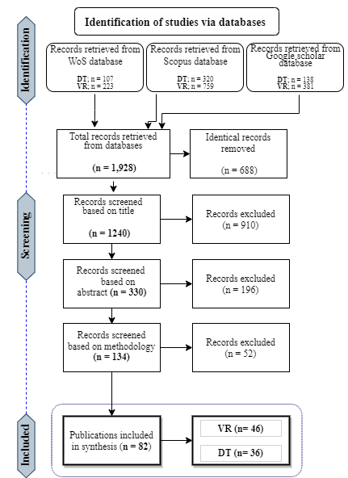

**Figure 1**: PRISMA systematic records selection flow diagram

**Results and Discussion**

This study included publications containing practical applications of DT and VR in the AEC industry. 63% of the 82 included publications are journal articles, 28% are conference papers, and the remaining 9% include dissertations and book sections. Figure 2 depicts the distribution of materials for the study's SR, while Figure 3 depicts the publishers and years of publication. Some of the items included lacked a publisher and were represented by 'N/A' (Not Applicable).

**Figure 2**: Distribution of publications for the study's SR

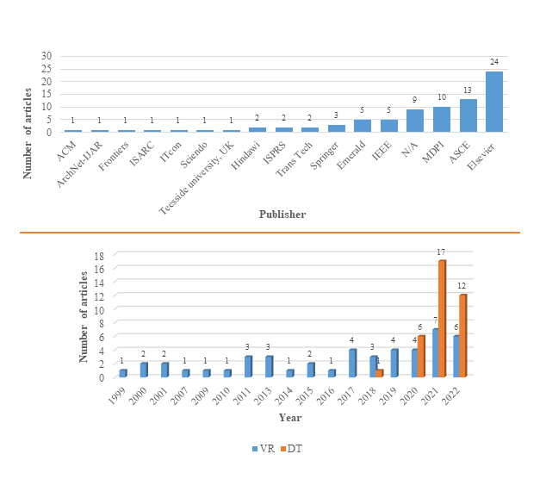

**Figure 3**: Publishers and years of publication of included materials

According to Schiavi *et al.* (2022), the common stages of development in the AEC industry include the planning and design phase, the construction phase and the facility management or operations phase. This study adopts this classification to explain the various applications of DT and VR in the AEC industry. Figure 4 summarises the overall applications of DT and VR as identified in this study.

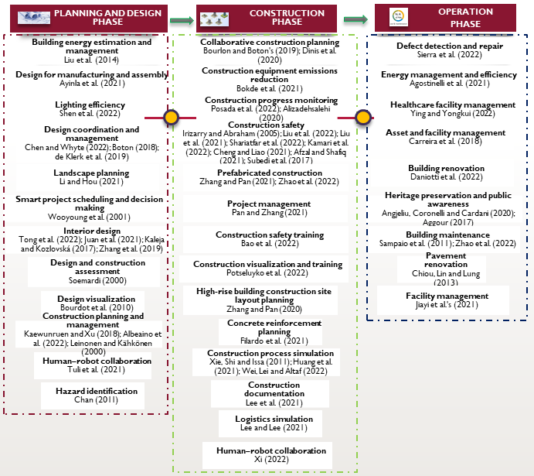

**Figure 4**: DT and VR applications across various phases

**Planning and design phase**

This phase identified three major clusters: simulations and assessments of specific aspects of construction projects; design, planning, and integration of technology into the construction process; and the application of technology in construction on a broader level, including human-robot interaction, project scheduling, retrofitting, and safety management. Each cluster is expatiated next.

*Building design and planning*

Tong *et al.* (2022) identified ways to combine the benefits of both BIM and VR in developing a design application that incorporates users' instant experience and feedback prior to construction. Meanwhile, Juan et al. (2021) created a VR-based user-oriented decision support system for interior design and decoration. This system also provided a systematic and comprehensive multiple-criteria optimization method. Also Kaleja and Kozlovská (2017) presented an innovative approach to interior design using virtual reality and other digital technologies. Furthermore, Zhang *et al.* (2019) noted that previous studies have limited their interior finishing materials evaluation criteria to quantitative indicators such as material energy performance; however, their study proposed a novel immersive virtual reality (IVR)-based approach for user-oriented interior finishing material selection that incorporated both visual aesthetics and traditional material performance. Meanwhile, Ayinla *et al.* (2021) developed an ontology knowledge structure representing offsite manufacturing (OSM) production workflow to aid the design, manufacture and assembling of fabricated components in building development. To address the challenges associated with design management few studies have maximized DT and VR. Remarkably, Chen and Whyte (2022) leveraged DT and a design structure matrix (DSM) to developed a framework that help designers understand design change propagation in complex engineering systems. Likewise, de Klerk *et al.* (2019) established a virtual reality environment in which architects and designers such as structural engineers can interact with and be supported by user-friendly mobile-based VR headsets that provide virtual immersion and simplified geometric information. A crucial aspect of interior design is product design. Products in this instance include furniture and associated components. Bourdot *et al.* (2010) developed a VR-based computer-aided design (CAD) framework to enable intuitive and direct 3D edition on CAD objects within virtual environments. Aside from interior design, VR has also been used in landscape design. To achieve cost-effective and efficient rural landscape construction, Li and Hou (2021) developed a 3D evaluation system for rural landscape planning.

*Construction management*

Wooyoung *et al.* (2001) developed a 4D-VR system that improves construction project scheduling and decision-making by increasing imagination through VR and defining the construction process through 3D visualization. Meanwhile, Liu, Lather and Messner (2014) explored the challenges and benefits of using VR tools in an energy retrofit project, as well as its potential application in building design and construction. The BIM execution plan and value-based decision-making framework was employed in this project. Human-robot interaction is gaining popularity in AEC industry. However, the interaction demands proper planning. Tuli *et al.* (2021) investigated human-robot interaction in a collaborative production environment, where actions are derived from human attention predicted from attention captured via sensors and their associated information mined from semantic ontologies. While construction site safety has improved, an unacceptable number of fatalities still occur each year (Irizarry and Abraham, 2005). Chan (2011) explored ways to promote hazard identification early in the design process in order to reduce hazardous working conditions and improve worker safety attitudes. Similarly, Albeaino *et al.* (2022) designed and developed ‘DroneSim’, a VR-based safety training system for human-drone interaction on construction sites. Leinonen and Kähkönen (2000) provided practical insights into how to balance the possibilities and challenges of virtual reality for construction planning and management through a case study.

*Construction simulations and assessments*

Kaewunruen and Xu (2018) study demonstrated the use of a Revit-based simulation of construction work for London's King's Cross station. The study focused on a specific BIM application in the context of railway station buildings, employing modeling simulation. Similarly, Shen *et al.* (2022) used DT to simulate tunnel lighting. Also, Soemardi's (2000) study described the possibility for providing information to engineers and builders for assessing the constructability of building construction methods via a VR-based design system. Collaboration is key in planning and design of building projects.

**Construction phase**

The construction phase is further subdivided into three themes: safety and risk management, real-time monitoring and data management, and construction planning and management. The sub-themes are detailed further below.

*Safety and risk management*

Liu *et al.* (2022) proposed an intelligent safety risk prediction framework for prefabricated construction hoisting. Meanwhile, Liu *et al.* (2021) also created a model for digital twin hoisting safety risk coupling. Subedi *et al.* (2017) developed a method for monitoring construction workers' postural behaviour during lifting operations and providing personalized feedback to encourage ergonomically safe lifting techniques. Furthermore, site layout planning (SLP) is a classic assignment problem for determining the location of temporary facilities and site logistics. Using VR technology, Zhang and Pan (2020) created a novel SLP tool for high-rise modular buildings.

*Real-time monitoring and data management*

On automated construction progress monitoring, Alizadehsalehi (2020) created a generic framework for automated construction progress monitoring by introducing a new integration method that incorporated DT and other digital technologies. Huang *et al.* (2021) investigated the feasibility of creating DTs of construction sites in near real-time. In addition, Wei, Lei and Altaf (2022) proposed an off-site construction DT model validated and evaluated using a case study with an off-site construction company in Edmonton, Canada. Posada *et al.* (2022) proposed a pipeline for automating nonlinear and time-dependent structural models using construction-site concrete maturity monitoring data. VR can be employed to provide construction workers with risk-free training on health and safety issues. Irizarry and Abraham (2005) presented a methodology for using VR technology to improve safety in steel erection. Xie, Shi and Issa (2011) validated the use of radio frequency identification (RFID) and VR simulations in steel construction projects.Meanwhile, Waugh *et al.*, (2007) detailed the process and workflow for capturing typical school building construction in an easy-to-use interface. Dinis *et al.* (2020) proposed a semi-automatic workflow for improved communication among building construction stakeholders, particularly non-professional counterparts. The integration of DT and VR with 5G technology is expected to facilitate the development of smarter, more efficient construction management systems.

*Construction planning and management*

Like other phases, DT technology has also been used to address construction safety concerns in the construction phase. Shariatfar et al. (2022) developed a DT framework equipped with low-cost audio sensors for advanced construction safety monitoring and management to address safety concerns. Also, Kamari et al. (2022) in their study analyzed safety risk imposed by jobsite debris to nearby built environments using geometric DTs and vision-based deep learning. Cheng and Liao (2021) explored how construction workers in the field can identify risks in order to avoid accidents and disasters in the field. Afzal and Shafiq (2021) created a VR-based framework to assist project teams in evaluating potential safety incidents throughout the project's execution, thereby reducing on-site risk. Bao *et al.* (2022) developed a cross-platform VR for real-time construction safety training. Potseluyko *et al.* (2022) developed a game-like interactive environment using BIM-based VR to enhance construction visualizations. Meanwhile, Zhang and Pan (2021) employed a real-life high-rise MiC project to validate an innovative and interactive tower crane layout planning VR-based framework. Lee *et al.* (2021) focused on the use of blockchain and DT to support accountable information sharing during construction. Similarly, Pan and Zhang (2021) focused on smart construction project management, with the use of DT and other digital technologies. Human-robot collaboration is also a trend in the construction phase. Xi (2022) investigated the path of integrating BIM, VR, and process-level DTs to enable human-robot partnerships in digitally-driven construction. Filardo *et al.* (2021)proposed using VR to visualize concrete reinforcement on-site, and also rebar layout sequencing via a 4D model.Bourlon and Boton's (2019) study centered on automating the integration of collaborative constructability analysis sessions using BIM models and intuitive simulations of the construction process. To address logistics issue associated with modular construction, Lee and Lee (2021) created a DT framework for real-time logistics simulation that can predict potential logistics risks and module arrival times. Meanwhile, Bokde *et al.* (2021) focused on developing and deploying a DT for construction emissions to track, monitor, and reduce emissions from construction site operations.

**Operations phase**

The operation phase encompasses studies on building maintenance and renovation, energy management, and historical buildings preservation. Defects are not uncommon to buildings whether in their exterior or interior. Sierra *et al.* (2022) developed an automated cognitive twin of a pavement structure using data from an unmanned aerial vehicle to facilitate defect detection and subsequent repair. Relatedly, the study of Chiou, Lin and Lung (2013) concentrated on pavement maintenance. It developed a VR-based digital pavement system (VRDPS) to adjust and rebuild design elevations used on the pavement in order to coordinate pavement reconstruction. Meanwhile, Sampaio *et al.* (2011) created a VR-based model to help with the maintenance of interior and exterior wall finishes. Zhao *et al.* (2022) developed a conceptual framework for the application of DT to revamp building operation and maintenance processes. Daniotti *et al.* (2022) in their study aimed to improve the efficiency of building renovations by utilizing a set of BIM-based DT tools.

Similarly, Carreira *et al.* (2018) examined the use of VR environments for maintenance tasks by improving a virtual facility representation in conjunction with the system's information management and control. Ying and Yongkui (2022) in their study provided a DT system architecture specifically designed for healthcare operations. From a multi-stakeholder perspective Jiayi *et al.'s* (2021) study presented a novel holistic system for building-level DT that integrates BIM data throughout the building life cycle. Also, Agostinelli *et al.* (2021) used a 3D data model integrated with the Internet of Things (IoTs), artificial intelligence (AI), and machine learning (ML) to investigates the potentials of DT-based approaches for achieving an intelligent optimization and automation system for residential district energy management. Angjeliu, Coronelli and Cardani (2020)developed a simulation model for DT applications in historical masonry buildings. Public awareness for the locals is crucial to heritage preservation of historical buildings. Aggour (2017) reported how the residents of Alexandria were persuaded on the importance of preserving their heritage buildings through VR by enhancing the participatory heritage conservation process. Figure 5 depicts a larger picture of DT and VR's potential applications in the global construction sector.

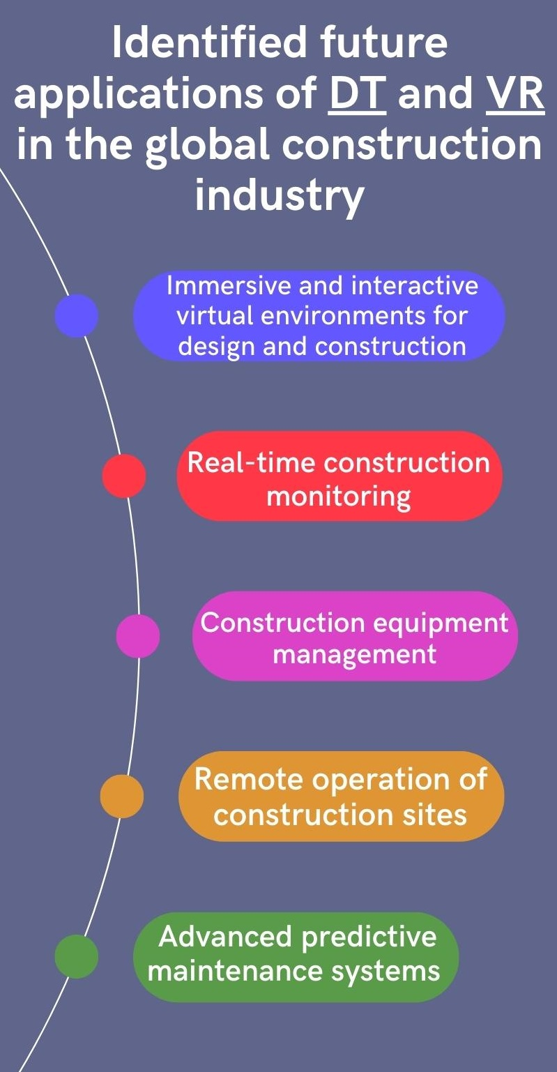

**Figure 5**: Future application of DT and VR in the construction industry

**Contributions to Knowledge and Practice**

Although Filardo *et al.(*2021) argued that not all construction approaches and methods are outdated and obsolete, recent innovations and disruptions in the AEC industry has enhanced the industry’s overall efficiency and productivity. Construction accidents are not uncommon. For example, in 2011, the construction industry in Hong Kong was responsible for 76% of all fatal accidents in the region (Chan, 2011). On the one hand, VR technology allows users to experiment with non-existent environments that have the properties and functionality of real-world environments (Leinonen and Kähkönen, 2000). In recent years, VR applications have moved from computers to mobile devices and tablet computers (Juan et al., 2021). On the other hand, DT has disrupted the area of asset monitoring and management. This research addresses the lack of a comprehensive analysis of DT and VR usage in the construction industry. The use of VR and DT in the construction sector has great potential for supporting efficient, safe, and sustainable construction operations throughout all phases of the construction process. The suggested impacts and contributions can assist guide future building industry research initiatives.

**Conclusions and limitations of the study**

The construction industry is reaching new levels of efficiency with the introduction of digital technologies. To achieve the study's aim, relevant electronic databases were examined in accordance with the PRISMA guidelines. To identify practical applications journal articles and other relevant grey literature were carefully examined. This study revealed that DT and VR technologies have been used in building planning, design, construction, and management to improve stakeholders' information sharing, human-robot collaboration, construction safety among other applications. As VR and DT technologies improve and become more accessible, they may be utilized to build more immersive and interactive virtual worlds for design and construction. Furthermore, the combination of VR and DT technologies with other emerging technologies like 5G is projected to accelerate the global development of smarter, more efficient construction management systems. Furthermore, combining VR and DT technologies with AI and ML is projected to enable the creation of powerful predictive maintenance systems capable of anticipating and preventing machinery failures and other difficulties. This study's scope is limited since it excludes studies with no practical applications. Future studies could focus on experiments and concept development in the literature.

**References**

Afzal, M. and Shafiq, M.T. (2021) ‘Evaluating 4D-BIM and VR for Effective Safety Communication and Training: A Case Study of Multilingual Construction Job-Site Crew’, Buildings, 11(8), p. 319.

Aggour, H. (2017) ‘Virtual Reality: Towards Preserving Alexandria Heritage By Raising the Awareness of the Locals’, International Journal of Architectural Research: ArchNet-IJAR, 11(3), p. 94.

Agostinelli, S. et al. (2021) ‘Cyber-Physical Systems Improving Building Energy Management: Digital Twin and Artificial Intelligence’, Energies, 14(8), p. 2338.

Albeaino, G. et al. (2022) ‘Working with Drones: Design and Development of a Virtual Reality Safety Training Environment for Construction Workers’, in Computing in Civil Engineering 2021. Reston, VA: American Society of Civil Engineers, pp. 1335–1342.

Alizadehsalehi, S. (2020) BIM/Digital Twin-Based Construction Progress Monitoring through Reality Capture to Extended Reality (DRX). Eastern Mediterranean University.

Angjeliu, G., Coronelli, D. and Cardani, G. (2020) ‘Development of the simulation model for Digital Twin applications in historical masonry buildings: The integration between numerical and experimental reality’, Computers & Structures, 238, p. 106282.

Ayinla, K. et al. (2021) ‘A semantic offsite construction digital Twin-Offsite Manufacturing Production Workflow (OPW) ontology’, in Second international workshop on semantic digital twins.

Bao, L. et al. (2022) ‘Cross-platform virtual reality for real-time construction safety training using immersive web and industry foundation classes’, Automation in Construction, 143(September), p. 104565.

Bokde, N.D. et al. (2021) ‘A digital twin framework for equipment emissions from construction site operations’, in Dawood, N., Rahimian, F.P., and Sheikhkhoshkar, M. (eds) Industry 4 . 0 Applications for Full Lifecycle Integration of Buildings. Middelsbrough, UK, pp. 31–42.

Bourdot, P. et al. (2010) ‘VR–CAD integration: Multimodal immersive interaction and advanced haptic paradigms for implicit edition of CAD models’, Computer-Aided Design, 42(5), pp. 445–461.

Bourlon, S. and Boton, C. (2019) ‘Automating the Integration of 4D Models in Game Engines for a Virtual Reality-Based Construction Simulation’, Lecture Notes in Computer Science (including subseries Lecture Notes in Artificial Intelligence and Lecture Notes in Bioinformatics), 11792 LNCS, pp. 123–132.

Carreira, P. et al. (2018) ‘Virtual reality as integration environments for facilities management’, Engineering, Construction and Architectural Management, 25(1), pp. 90–112.

Chan, G.K.C. (2011) The Use of Virtual Reality for Visualizing Construction Safety Management Process. The Hong Kong Polytechnic University.

Chen, L. and Whyte, J. (2022) ‘Understanding design change propagation in complex engineering systems using a digital twin and design structure matrix’, Engineering, Construction and Architectural Management, 29(8), pp. 2950–2975.

Cheng, Y.M. and Liao, H.Y. (2021) ‘Task-oriented VR Safety Training in Construction Falls’, in 2021 IEEE International Conference on Industrial Engineering and Engineering Management (IEEM). IEEE, pp. 1518–1525.

Chiou, C.R., Lin, J.D. and Lung, W.K. (2013) ‘The Application for the Virtual Reality in the Pavement Engineering’, Advanced Materials Research, 723, pp. 916–922.

Daniotti, B. et al. (2022) ‘The Development of a BIM-Based Interoperable Toolkit for Efficient Renovation in Buildings: From BIM to Digital Twin’, Buildings, 12(2), p. 231.

Dinis, F.M. et al. (2020) ‘Improving project communication in the architecture, engineering and construction industry: Coupling virtual reality and laser scanning’, Journal of Building Engineering, 30.

Filardo, M. M. et al. (2021) ‘Installing Reinforcement Rebars Using Virtual Reality and 4D Visualization’, in Lecture Notes in Civil Engineering. Springer Nature, Switzerland, pp. 1200–1216.

Gharbia, M. et al. (2020) ‘Robotic technologies for on-site building construction: A systematic review’, Journal of Building Engineering, 32(August), p. 101584.

Huang, Y. et al. (2021) ‘Towards Near Real-time Digital Twins of Construction Sites: Developing High-LOD 4D Simulation Based on Computer Vision and RTLS’, in Proceedings of the International Symposium on Automation and Robotics in Construction, pp. 248–255.

Irizarry, J. and Abraham, D.M. (2005) ‘Application of virtual reality technology for the improvement of safety in the steel erection process’, in Computing in Civil Engineering (2005). Reston, VA: American Society of Civil Engineers, pp. 1–11.

Jiayi, Y. et al. (2021) ‘Developing a Web-Based BIM Asset and Facility Management System of Building Digital Twins’, in Computing in Civil Engineering 2021, pp. 490–497.

Juan, Y.-K., Chi, H.-Y. and Chen, H.-H. (2021) ‘Virtual reality-based decision support model for interior design and decoration of an office building’, Engineering, Construction and Architectural Management, 28(1), pp. 229–245.

Kaewunruen, S. and Xu, N. (2018) ‘Digital Twin for Sustainability Evaluation of Railway Station Buildings’, Frontiers in Built Environment, 4(December), pp. 1–10.

Kaleja, P. and Kozlovská, M. (2017) ‘Virtual Reality as Innovative Approach to the Interior Designing’, Selected Scientific Papers - Journal of Civil Engineering, 12(1), pp. 109–116.

Kamari, M., Kim, J. and Ham, Y. (2022) ‘Analyzing Safety Risk Imposed by Jobsite Debris to Nearby Built Environments Using Geometric Digital Twins and Vision-Based Deep Learning’, Journal of Computing in Civil Engineering, 36(6).

de Klerk, R. et al. (2019) ‘Usability studies on building early stage architectural models in virtual reality’, Automation in Construction, 103(March), pp. 104–116.

Lam, Edmond W.M. et al. (2022) ‘Development of Sustainable Building Design in Hong Kong: Exploring Lean Capabilities’, in Water Resources Resilience for Small Island Developing States (SIDS). Trinidad and Tobago, pp. 160–169.

Lee, D. et al. (2021) ‘Integrated digital twin and blockchain framework to support accountable information sharing in construction projects’, Automation in Construction, 127, p. 103688.

Lee, D. and Lee, S. (2021) ‘Digital Twin for Supply Chain Coordination in Modular Construction’, Applied Sciences, 11(13), p. 5909.

Leinonen, J. and Kähkönen, K. (2000) ‘New construction management practice based on the virtual reality technology’, Proceedings of Construction Congress VI: Building Together for a Better Tomorrow in an Increasingly Complex World, 278, pp. 1014–1022.

Li, J. and Hou, T. (2021) ‘Application of Virtual Reality Technology in Analysis of the Three-Dimensional Evaluation System of Rural Landscape Planning’, Mathematical Problems in Engineering. pp. 1–16.

Li, Y. and Liu, C. (2019) ‘Applications of multirotor drone technologies in construction management’, International Journal of Construction Management, 19(5), pp. 401–412.

Liu, Y., Lather, J. and Messner, J. (2014) ‘Virtual Reality to Support the Integrated Design Process: A Retrofit Case Study’, in Computing in Civil and Building Engineering (2014). Reston, VA: American Society of Civil Engineers, pp. 801–808.

Liu, Z.-S. et al. (2022) ‘Digital Twin-Based Intelligent Safety Risks Prediction of Prefabricated Construction Hoisting’, Sustainability, 14(9), p. 5179.

Liu, Z. et al. (2021) ‘Digital Twin-Based Safety Risk Coupling of Prefabricated Building Hoisting.’, Sensors (Basel, Switzerland), 21(11), p. 3583.

Madubuike, O.C., Anumba, C.J. and Khallaf, R. (2022) ‘A REVIEW OF DIGITAL TWIN APPLICATIONS IN CONSTRUCTION’, Journal of Information Technology in Construction, 27, pp. 145–172.

Olawumi, T.O. et al. (2022) ‘Automating the modular construction process: A review of digital technologies and future directions with blockchain technology’, Journal of Building Engineering, 46(April 2021), p. 103720.

Opoku, D.G.J. et al. (2021) ‘Digital twin application in the construction industry: A literature review’, Journal of Building Engineering, 40.

Page, M.J. et al. (2021) ‘The PRISMA 2020 statement: an updated guideline for reporting systematic reviews’, BMJ, p. 71.

Pan, Y. and Zhang, L. (2021) ‘A BIM-data mining integrated digital twin framework for advanced project management’, Automation in Construction, 124(July 2020), p. 103564.

Posada, H. et al. (2022) ‘Closing the Gap Between Concrete Maturity Monitoring and Nonlinear Time-dependent FEM Analysis through a Digital Twin. Case Study: Post-tensioned Concrete Slab of an Office Building, Barcelona, Spain’, in Proceedings of the International Symposium on Automation and Robotics in Construction, pp. 215–222.

Potseluyko, L. et al. (2022) ‘Game-like interactive environment using BIM-based virtual reality for the timber frame self-build housing sector’, Automation in Construction, 142(July), p. 104496.

Safikhani, S. et al. (2022) ‘Immersive virtual reality for extending the potential of building information modeling in architecture, engineering, and construction sector: systematic review’, International Journal of Digital Earth, 15(1), pp. 503–526.

Sampaio, A.Z. et al. (2011) ‘Collaborative maintenance and construction of buildings supported on Virtual Reality technology’, in 6th Iberian Conference on Information Systems and Technologies (CISTI 2011), pp. 1–4.

Schiavi, B. et al. (2022) ‘BIM data flow architecture with AR/VR technologies: Use cases in architecture, engineering and construction’, Automation in Construction, 134(October 2021), p. 104054.

Shariatfar, M., Deria, A. and Lee, Y.C. (2022) ‘Digital Twin in Construction Safety and Its Implications for Automated Monitoring and Management’, Construction Research Congress 2022: Selected Papers from Construction Research Congress 2022, 2-B, pp. 591–600.

Shen, Y. et al. (2022) ‘Holistic digital-twin-based framework to improve tunnel lighting environment: From methodology to application’, Building and Environment, 224(September), p. 109562.

Sidani, A. et al. (2021) ‘Recent tools and techniques of BIM-Based Augmented Reality: A systematic review’, Journal of Building Engineering, 42(November 2020).

Sierra, C. et al. (2022) ‘Development of a Cognitive Digital Twin for Pavement Infrastructure Health Monitoring’, Infrastructures, 7(9).

Soemardi, B.W. (2000) ‘VR for Precast Concrete Constructability Analysis’, in Computing in Civil and Building Engineering (2000). Reston, VA: American Society of Civil Engineers, pp. 302–308.

Subedi, S. et al. (2017) ‘Virtual Reality-based Personalized Learning Environment for Repetitive Labor-intensive Construction Tasks’, in 53rd ASC Annual International Conference Proceedings, pp. 787–794.

Tong, W. et al. (2022) ‘Let Every Seat Be Perfect! A Case Study on Combining BIM and VR for Room Planning’, in 2022 IEEE Conference on Virtual Reality and 3D User Interfaces Abstracts and Workshops (VRW). IEEE, pp. 776–777.

Tuli, T.B. et al. (2021) ‘Knowledge-Based Digital Twin for Predicting Interactions in Human-Robot Collaboration’, in 2021 26th IEEE International Conference on Emerging Technologies and Factory Automation (ETFA ). IEEE, pp. 1–8.

Waugh, L.M. et al. (2007) ‘Virtual reality documentation of site status: Proof of concept’, in Proceedings of the Canadian Society for Civil Engineering Annual General Conference.

Wei, Y., Lei, Z. and Altaf, S. (2022) ‘An Off-Site Construction Digital Twin Assessment Framework Using Wood Panelized Construction as a Case Study’, Buildings, 12(5).

Wen, J. and Gheisari, M. (2020) ‘Using virtual reality to facilitate communication in the AEC domain: a systematic review’, Construction Innovation, 20(3), pp. 509–542.

Wooyoung, K. et al. (2001) ‘Visualized construction process on virtual reality’, in Proceedings Fifth International Conference on Information Visualisation. IEEE Computing Society, pp. 684–689.

Xi, W. (2022) Enabling Human-Robot Partnerships in Digitally-Driven Construction Work through Integration of Building Information Models, Interactive Virtual Reality, and Process-Level Digital Twins. University of Michigan.

Xie, H., Shi, W. and Issa, R.R.A. (2011) ‘Using rfid and real-time virtual reality simulation for optimization in steel construction’, Journal of Information Technology in Construction, 16(March 2010), pp. 291–308.

Ying, S. and Yongkui, L. (2022) ‘Digital Twin Aided Healthcare Facility Management: A Case Study of Shanghai Tongji Hospital’, in Construction Research Congress 2022, pp. 1145–1155.

Zhang, Y. et al. (2019) ‘User-centered interior finishing material selection: An immersive virtual reality-based interactive approach’, Automation in Construction, 106(June), p. 102884.

Zhang, Z. and Pan, W. (2020) ‘Virtual Reality Supported Site Layout Planning for Modular Integrated Construction of High-Rise Buildings’, Construction Research Congress 2020: Project Management and Controls, Materials, and Contracts - Selected Papers from the Construction Research Congress 2020, pp. 339–347.

Zhang, Z. and Pan, W. (2021) ‘Virtual reality supported interactive tower crane layout planning for high-rise modular integrated construction’, Automation in Construction, 130.

Zhao, J. et al. (2022) ‘Developing a conceptual framework for the application of digital twin technologies to revamp building operation and maintenance processes’, Journal of Building Engineering, 49, p. 104028.

Zhou, S. and Gheisari, M. (2018) ‘Unmanned aerial system applications in construction: a systematic review’, Construction Innovation, 18(4), pp. 453–468.

**Authors’ Biography**

**Mr Kayode O. Kazeem** is a research assistant at the Research Centre for Green Energy, Transport, and Building (RCGETB) at PolyU SPEED in Hong Kong, China, with interests in sustainable design, BIM and modular construction.

**Dr Timothy Olawumi** is an Assistant Professor at Edinburgh Napier University, United Kingdom. He is a Chartered Surveyor of the Royal Institution of Chartered Surveyors (UK), a registered member of the Green Building Council Nigeria, Hong Kong Green Building Council, BIMAfrica, Engineering Professors Council (UK), and the BuildingSMART International.

**Dr. Nirodha Fernando** BSc (Hons) QS, PhD, FHEA, MRICS, MAPM, AIQSSL is an experienced researcher and an academic, working as an Associate Professor in Quantity surveying at the School of Computing, Engineering & the Built Environment , Edinburgh Napier University, UK. She is a Chartered Quantity Surveyor with over 15 years’ experience in academia in Sri Lanka and the UK.