Power Consumption Analysis for Smarter Robotics via Industry 4.0 Methods and Technologies

Ryan Samson  School of Computing, Engineering and the Built Environment  Edinburgh Napier University  Ryan.Samson@napier.ac.uk |  | Keng Goh  School of Computing, Engineering and the Built Environment  Edinburgh Napier University  K.Goh@napier.ac.uk |  | Akshath Sankarraj  School of Computing, Engineering and the Built Environment  Edinburgh Napier University  40517059@live.napier.ac.uk
 | Alexandros Gkanatsios  School of Computing, Engineering and the Built Environment  Edinburgh Napier University  A.Gkanatsios@napier.ac.uk |  | Hongnian Yu (Corresonding Author)  School of Computing, Engineering and the Built Environment  Edinburgh Napier University  H.Yu@napier.ac.uk

Abstract— This paper examines the opportunities to apply industry 4.0 technology to practical applications, with a specific focus on sustainability and resource efficiency in industrial environments. The main objective of this paper is to design and implement a lab-based demonstrator that explores an industrial robotic arm's power consumption and energy efficiency from an Industry 4.0 perspective. The demonstration aims to highlight the potential benefits of horizontal and vertical integration of data, enabling improved information flow across industrial environments. A 6 degrees of freedom industrial robotic arm is programmed to assemble a 4-component product, and data is collected to analyse payload and operational speed effects on product assembly cycle time and energy consumption. The findings from this research lead to a discussion on how the data, which is typically confined within the robotic arm, can be unlocked to improve energy efficiencies through industry 4.0 methods and technologies. This, in turn, results in the development of smarter robotics with enhance energy efficiency.

Keywords— Industry 4.0, Power Consumption, Energy Efficiency, Resource optimisation, Industrial Robotics, Horizontal and Vertical Integration, Smart Manufacturing

Introduction
The industrial sector accounted for 169 Exajoules, representing 38% of the global final energy usage in 2021 [1]. Although a significant portion of energy consumption in the industrial sector is attributed to heavy industry and energy-intensive processes, the World Robotics Report highlights the sustained demand for robotics despite challenges like electronic components shortage and rising energy prices. With over 517 thousand robots installed around factories in 2021, the industry has been experiencing an annual growth rate of 31% year on year. However, the International Federation of Robotics (IFR) report predicts a decline in the growth rate in the future [2].
This paper aims to contribute to three out of five prominent trends identified by the IFR [3], namely energy efficiency, digital integration, and sustainability focus, through the upgrading or refreshing of existing machinery. By addressing these trends, the work presented in this paper aligns with the evolving needs of the industry and offers insights into leveraging these advancements for improved performance and environmental sustainability.
Industrial sectors consume a high percentage of energy. In this research, our application is on an Industry 3.0 (I3.0) technology, specifically an assembly robot, where Industry 4.0 (I4.0) techniques to harness motor data are used to improve energy efficiency. We showcase that the use of I4.0 methods and technologies has the potential for existing and new manufacturing machinery to operate at increased levels of efficiency.
With a growing need to reduce the resource waste, industrial environments are actively seeking opportunities to improve their operations, resulting in a reduction in waste and cost. Increasing connection of industrial equipment brought around with the fourth industrial revolution will enable a greater and more valuable communication through the value chain, enabling optimisation [4].
In factories where robots are deployed, the integration of I4.0 technologies such as Internet of Things (IoT), Cyber-Physical Systems (CPS), Cloud computing and Data analytics [5-9] has been proving to enhance the capabilities of I3.0 assembly robots. By incorporating these I4.0 technologies, robots gain smart features such as increased connectivity for collaborative capabilities, intelligent decision-making, and advanced perception. This integration enables industrial robots to achieve higher productivity, improved quality, enhanced safety, and greater efficiency in manufacturing environments.
Horizontal integration refers to the seamless coordination and collaboration of different components, processes, or systems within a manufacturing environment. This research uses the opportunity to analyse power consumption of a robot as a platform to discuss vertical and horizontal integration in the context of I4.0. It demonstrates how this data can be turned into information used at various stages in a smart environment, exemplifying the practical application of horizontal integration.
Many articles focused on the energy consumption of industrial robots concentrate on predicting energy consumption through the development of simulation models [10]. In their literature review, Brossog & Bornschlegl [10] discovered the numerous methods to reduce energy consumption in industrial robots. These methods primarily focus on optimizing operating parameters, scheduling operations, and developing energy-efficient motion planning. However, they acknowledge that implementing these methods presents challenges due to the technical intricacies of the robotics control systems, especially those that not originally designed to accommodate such functionalities. Consequently, further research and development are necessary to effectively apply these techniques in complex manufacturing systems.
In energy-consuming industrial environments, significant efforts have been made to achieve high levels of energy efficiency. Hhowever, traditionally, the design of robotic and automatic systems has not prioritized energy efficiency as an objective [11]. The research question addressed in this study is whether I4.0 technologies and methods can be harnessed to increase the energy efficiency of these machines retrospectively.
Energy efficient production processes can be realised through the utilization of I4.0 digital technologies. By incorporating intelligent features such as optimised AI control models have the potential to lower production time whilst simultaneously decreasing energy consumption [12].
Campo & Calatrava [13] developed and tested an open-source energy monitoring IoT solution in an industrial factory environment. The implementation of this contribution, which is open-source and applicable in an industrial environment, not only enables energy monitoring at machine or process level but also serves as a good guide for SMEs seeking to invest in I4.0 practices with limited knowledge and funding.
In a study conducted by Lima, Massote [14], a retrofit approach was presented, integrating I4.0 technologies into legacy machines with a specifical focus on energy monitoring. The significance of this approach lies in its alignment with the principles of sustainability, emphasizing the reuse of existing equipment. It raises an important question about the necessity of replacing legacy machines when the retrofit approach effectively allows us to harness the capabilities of I4.0 technologies. By considering this question, we can address Sustainable Development Goals (SDG), including waste reduction and energy conservation that would otherwise be associated with recycling machines. The importance of reusing equipment should be emphasised unless there are compelling reasons to replace old machines. If one of the key drivers for replacement is the incorporation of smart elements to enable superior operational efficiency, the solution of retrofitting with I4.0 technologies becomes even more compelling as it allows for optimised resource utilisation, aligning with SDGs.
With recent articles defining manufacturing sustainability as the conservation of energy [15], efforts towards monitoring and controlling energy usage not only enable cost reduction but also enhance competitiveness by aligning with customers' attitudes and support for sustainability [16]. Implementing measures to monitor and control energy consumption, manufacturing companies can achieve cost savings, demonstrate their commitments to reduce environmental impact, and meet the evolving demands of sustainability-minded customers.
Guerra-Zubiaga and Luong [17] conducted research on the effects of speed, acceleration, temperature and payload over 3 joints and joint gearbox of an industrial robot. The results indicated that speed and acceleration contribution to the majority of the power consumption of the first 3 joints from the base of the robot. The authors highlighted the importance of exploring other factors that contribute to the energy consumption and seeking options to minimise them. Building upon these findings and previous works in this field, our aim is to provide practical implementation data and explore techniques to minimise the energy consumption using technologies associated with the fourth industrial revolution.
This paper explores the potential opportunities for energy efficiency in industrial environments by harnessing I4.0 technology. While integrating I4.0 methods and technologies may be more straightforward in greenfield sites or new developments, this paper specifically focuses on achieving energy efficiency goals through I4.0 using existing legacy equipment. The objective of this study is to demonstrate the feasibility of collecting machine data for monitoring purposes with minimal disruption to plant operations. Additionally it also outlines a path for investigating and implementing I4.0 smart solutions that can effectively improve machine efficiency. The paper is structured as follows: Section II presents a I4.0 framework applied in this research. Section III introduces the demonstration platforms specification and data record architecture. Section III presents results and discussion to utilise technologies and methods of I4.0 to improve efficiency. Finally, Section IV concludes the paper.

Industry 4.0 Methods and Technologies
The aim of this work is to demonstrate the application of I4.0 methods and technologies to manufacturing equipment that originates from the third industrial revolution. The paper proposes using I4.0 techniques to increase connectivity and integrate CPS and data analytics into the equipment. These techniques are presented within a framework, as depicted in Figure 1. By leveraging technology advancements in I4.0, the aim is to explore the potential benefits and opportunities for enhancing the performance and capabilities of legacy equipment. This is done in order to better prepare industrial environments for the current and the future landscape of manufacturing.
The initial stage of this project introduces the proposed setup, showing the current operation of the robot (Figure 1 - Plant Floor). The focus is on creating a closed loop system that can be connected to cloud infrastructure (Figure 1 - Resource Planning). This connection allows for real time information to be transmitted and executed on powerful data analytics platforms.

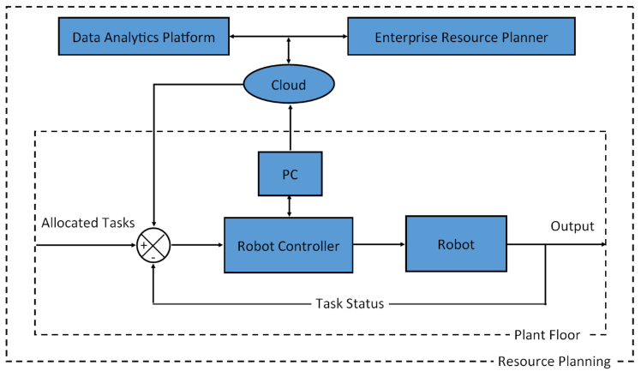
Figure 1. Data Flow from Robot to Cloud-Based Data Analytics Platform and ERP for Real-Time Monitoring and Decision-Making.

The setup illustrated in Figure 1 not only facilitates feedback from data analytical platforms to enhance the system’s functionalities mentioned earlier, but also provides real-time information from plant floor resources at the enterprise level. This real-time information empowers decision-makers with valuable insights, enabling them to make informed and data-driven decisions to optimize processes, improve efficiency, and drive overall performance in their operations.
The subsequent section of the paper reports on the equipment and experiment configuration, followed by data recording and analysis of the process performed at the plant floor level. This work represents the early stages of our research, and lays the foundations for future application of I4.0 methods and technologies. The objective is to demonstrate the increased system performance and efficiency derived from implementing these approaches.

Experiment Configuration
In this section, the technical details regarding hardware and software used for the experiment are presented along with the experimental setup.

Robot Arm Technical Specifications
The hardware setup includes a Mitsubishi RV-2FB-D industrial assembly robot as shown in Figure 2a. This robots features a vertical serial joint linkage structure, enabling precise and efficient operations in assembly processes. With six degrees of freedom, it enables the robot to operate with a high level of manoeuvrability and flexibility. The platform has a payload capacity of 2kg, making it suitable for various lightweight assembly tasks. The robot exhibits a position repeatability of +/- 0.02mm, ensuring consistent and accurate positioning. Equipped with an AC servo system and regenerative braking on all axes, the system is designed to enhance energy efficiency. The robot has a maximum reach of 504mm, allowing it to access different areas within the assembly environment. The operational range of each axis is 480, 240, 160, 400, 240, and 720 degrees (J1 to J6). The robot operates at a maximum composite speed of 4955 mm/s, enabling efficient execution of assembly operations.

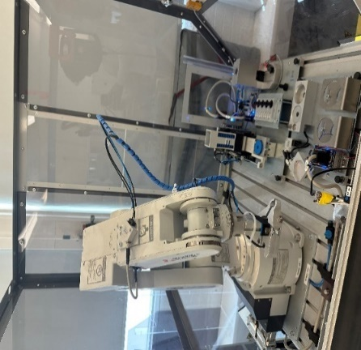 | 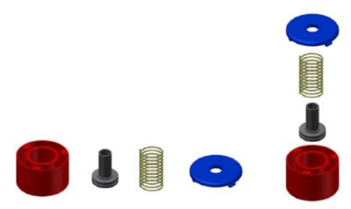
(a) | (b)
Figure 2. Experimental setup, Mitsubishi RV-2FB-D industrial assembly robot (a) and exploded-view of four component assembly task (b)

The assembly process involves four components: a cylinder, piston, spring, and retaining cap, shown in Figure 2b. The industrial robot is programmed using the original equipment manufacturer (OEM) software, Melfa basic, which is a text-based software language, enabling precise control over the assembly process.
Currently, this robotic arm is situated within an assembly station serving a flexible manufacturing process. The system operates by receiving the individual components, conducting quality checks, and subsequently assembling them using the robotic arm. The assembled pistons are then either stored in a warehouse or sent to the distribution centre for further sorting. This paper aims to demonstrate the potential benefits of full integration with Cyber-physical systems (CPS), one of the key technological pillars and building blocks of I4.0, to optimise the manufacturing process by enabling insights to disturbances and varying conditions [18].

Experimental Set-up
During all the experiments, for consistency, the robotic arm follows a pre-programmed trajectory. The process starts by picking up a cylinder from the conveyor and placing it within the robot assembly cell. Subsequently, the robot moves to collect a piston from the pallet and inserts it into the cylinder. Next, the robot retrieves a spring and places it inside the cylinder. Finally, the robot collects the cylinder cap, identifies the orientation, and then fits it onto the cylinder. Once the assembly is complete, the robot picks up the finishes component and delivers it back to the conveyor.
As I4.0 awareness increases, organizations have the option to upgrade their existing legacy equipment with low-cost solutions that enable integration with I4.0 principles. This approach allows organizations to benefit from the advantages of I4.0 without the need to invest in entirely new machines [19]. However, to ensure successful implementation and maximise the potential benefits of the upgrade, various levels of expertise are required due to the nature and complexity of the task.
As parts of robot maintenance, authorised personal gather operational data to assess the robot's performance and identify any potential faults or unusual behaviour. In this study, we explore the possibility of utilising this existing information locked inside legacy equipment, eliminating the need for additional calibration and setup to avoid costs associated with introducing new devices solely for data capture. The maintenance data includes motor current data for each joint (J1 to J6), as shown in Figure 3. The users can choose the sample rate depending on the desired resolution of information from the machine.
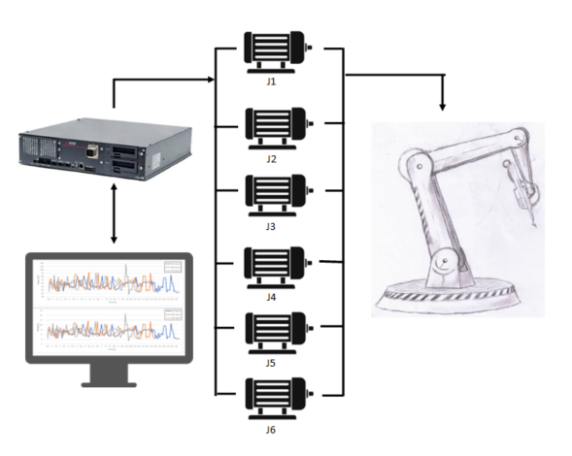
Figure 3. Block diagram illustrating the information flow and components of the experimental setup, including the 6 motors, controller, and PC for data monitoring and analysis.

To derive meaningful insights from this data, we selected a sample rate of 140Hz. By using the current (in Amperes Root Mean Square - ARMS), motor voltages, and sample period, we calculated the instantaneous power consumption since the previous sample period. This calculation helps in converting the raw data into valuable information about the robot's power usage.

Results and Discussion

Motor performance, including power consumption, is known to vary with temperature [20]. To ensure that differences in power consumption were primarily attributed to intentional variations in speed rather than temperature fluctuations, a temperature range of ±3 degrees Celsius was maintained across the three datasets for motor joint J1. Similarly, for motor joint J2, a temperature range of ±3 degrees Celsius was maintained, and so on for motor joints J3 to J6. This approach allows for consistent temperature within each dataset for the respective motor joint, ensuring that any observed differences in power consumption were primarily influenced by the intentional variations in speed rather than temperature fluctuations among the different datasets. This approach enhances the reliability and validity of the power consumption analysis in relation to different speeds and weights. However, it also imposes a limitation on the study by restricting the exploration of temperature effects. Monitoring the impact of temperature on power consumption could provide further insights and potentially reveal additional efficiency improvements.
Within an hour-long dataset for each speed variation, it was found that a total of 12 minutes of data met the temperature criteria for the joints. The results presented in Figures 4 to 6 are derived from this specific 12-minute window, where the motor joint temperature conditions were within the desired range.
The study focuses on examining the impact of operational speed on power consumption. One of the primary factors an assembly robot speed would be altered is for the rate of product output. The maximum speed of the robot used in this test was 4966mm/s, for the purpose of this test the speed values the robot operates were chosen at 50, 60 and 70% of this maximum speed value. Figure 4 displays the data from a counter which outputs a momentary digital signal of 1 when new component has been successfully assembled. The data shows that at 70% speed operation, the time to assemble one component is 10.5s followed by 13.2s (60%) and 16s (50%).

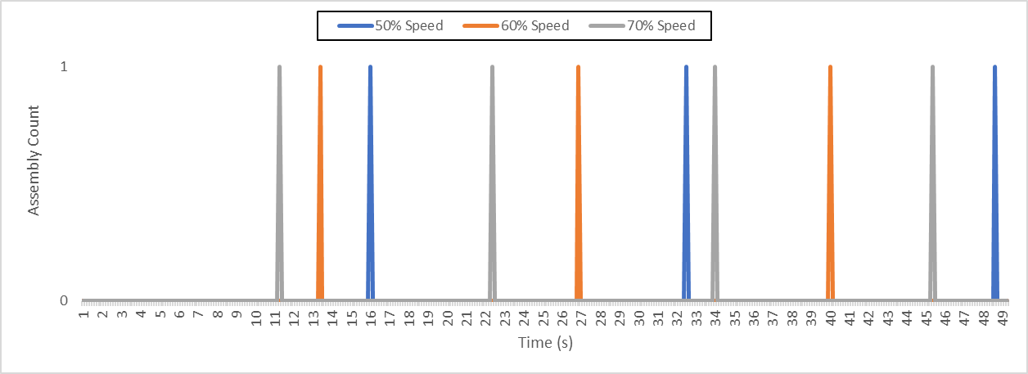
Figure 4. Product output rate at varying operational speeds

The data presented in Figure 5 provides insights into the impact of operational speed on power consumption. The variations in instantaneous power consumption are displayed in both watts and joules. By increasing the robot operational speed from 50% to 60% there is a 16.72% decrease in energy consumption, from 60% to 70% operation speed there is 11.79% decrease in energy consumption. The findings suggest that due to the higher operational speed and lower operational time, the energy consumed per component assembled decreases with faster robot operation.

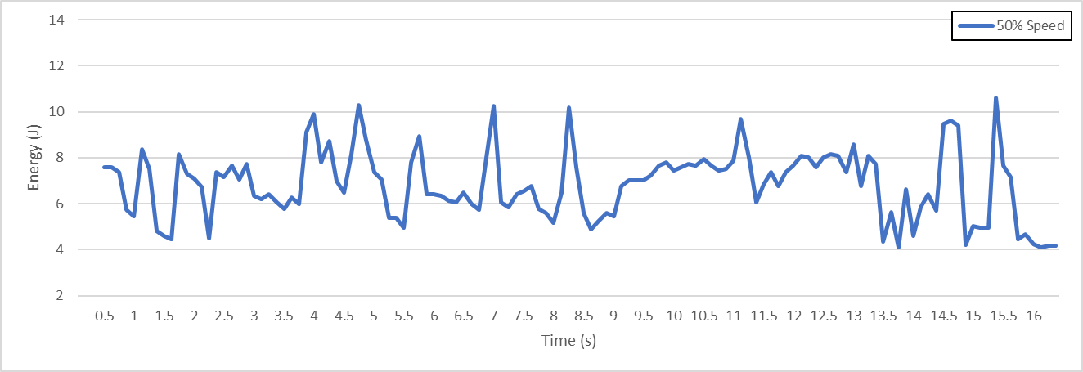
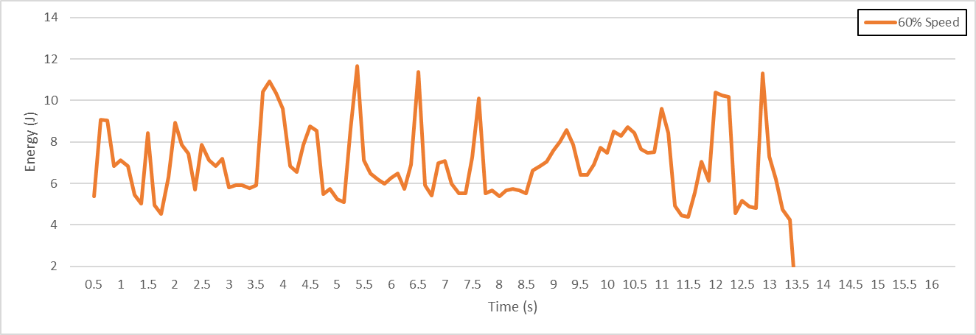
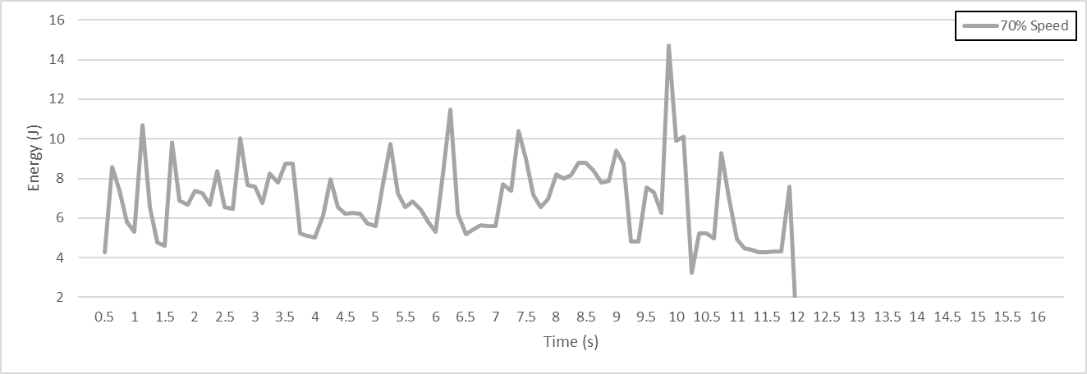
Figure 5. Power and Energy consumption for one product assembly at varying robot operational speeds

Additionally, the study examined the impact of different weights on the energy consumed by the robotic arm. Figure 5 illustrates the recorded data from the robot while operating with varying weighted assemblies, including payloads of 250g, 500g, and 900g. The robot's movements during these tests were consistent with the previous experiments, however the operational speed and the payload were increased. The bar chart in Figure 6 provides a comparison of power consumption for different loads and speeds.
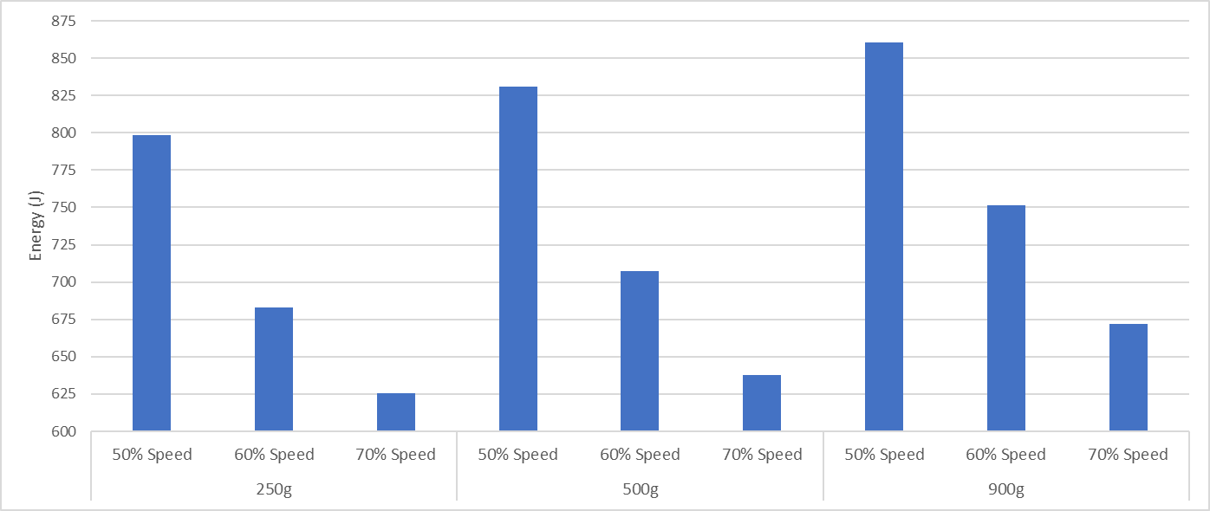
Figure 6. Energy Consumption of the Robot assembly at varying speed and loads

The data analysis in this study considered two key elements of the assembly robot task: component weight and operational speed. Since the robot handles components that can have varying weights due to design differences, and its operational speed can vary based on task completion time, these two factors were considered in the data analysis process.
The weight aspect in robotics assembly can serve as a valuable smart manufacturing element by incentivising engineers and designers to reduce weight through quantifying energy consumption based on weight margins. By analysing the relationship between weight and energy consumption and regeneration levels during assembly, designers can use this smart tool to aim for optimal weight that maximises efficiency.
I4.0 plays a crucial role in integrating various elements across the product line, connecting designers with manufacturers and others key stakeholders along the product line. This collaboration fosters a harmonious approach towards creating energy-efficient solutions. By leveraging the power of I4.0 technologies, such as connectivity and data analytics, designers and manufacturers can work together to optimise energy consumption and enhance overall system efficiency in the assembly process.
During the development of smart robotic platforms based on robot learning and artificial intelligence (AI), the acquisition of data from physical machines is preferred over relying solely on performing tests and data acquisition via simulation platforms. However, there are both advantages and disadvantages associated with this approach. On the positive side, obtaining real operational data from a physical machine allows for a more accurate representation of the robot's performance. However, there are challenges involved, such as the manual requirement to set up the robot for repeatable testing, the need for large amounts of data, and safety concerns related to repeated setup [21], this is perhaps also the reason that there are many simulation models used to predict the energy consumption of industrial robots [10]. This paper proposes a platform that incorporates I4.0 technologies, aiming to address these challenges, enabling smoother testing of a physical robots with AI applications to enable smart robotic platforms.

Conclusion
The research presented in this paper focuses on analysing the energy consumption characteristics of an industrial robotic arm during the assembly of a component. The main focus is to highlight the available information at the machine or plant level and demonstrate how an I4.0 framework can be used to plan and deploy optimised processes.
Optimising machine cycle times and achieving good operational equipment effectiveness is important in many industrial environments. With a large push towards resource effectiveness, driven by SDGs, which calls for minimising the consumption of valuable resources, we look towards I4.0 methods and technologies that can help achieve this without negatively impacting production.
The dataset presented in this paper, along with temperature information, can serve as input for an algorithm to enable the robot to adjust its speed and movement for optimal efficiency. While this optimisation can be achieved locally at the machine, the objective of this paper is to provide an example where I4.0 methods and technologies are applied to existing operational technology, contributing to the empirical research on I4.0 and showcasing the development of a system within the I4.0 smart manufacturing domain. This work aims to support industry practitioners in comprehending and implementing the principles of I4.0.
The work complete in this research paper adds to the existing literature for advancing the field of robotics, smart manufacturing, and I4.0. The main contributions of this work includes (1) a practical perspective on understanding the energy requirements and efficiency of robotics in a manufacturing setting. (2) examining the power consumption of the robotic arm within the context of I4.0, this work demonstrates the application of advanced technologies, data analytics, and intelligent systems to optimize energy usage and enhance the performance of manufacturing processes. (3) This research contributes to the development of smart manufacturing by exploring how power consumption analysis can make the robotic arm smarter. This analysis provides valuable insights into energy optimization, cost reduction, and efficiency improvement, enabling the advancement of intelligent and interconnected manufacturing systems. (4) This study investigates practical techniques for industries aiming to adopt I4.0 technologies and improve their manufacturing processes. By understanding the power consumption patterns of the robotic arm, manufacturers can make informed decisions about energy management, resource allocation, and predictive maintenance strategies. The I4.0 methods and technologies investigated helps to make this data, beforehand locked in the machine, now accessible. (5) Finally this study investigates the potential for horizontal and vertical integration. The integration of power consumption analysis and horizontal integration highlights the potential for leveraging energy insights to optimize the coordination and interoperability of interconnected systems within a manufacturing environment, aligning with the principles of I4.0 and further clarifying horizontal integrations.
A Flexible Manufacturing System's (FMS) overall power consumption can differ based on the system and the production procedures it is intended to support. Robots, conveyor belts, material handling systems, and other pieces of machinery frequently make up FMSs along with other forms of machinery. Each machine uses a different amount of electricity depending on its size, power rating, and usage habits, among other things. In a manufacturing setting, with the vast amount of machinery, the impact of this research acts as building block to visualise the possibilities that can be made by connecting other equipment with the same mindset, creating a fully connected, smart system that has the information, provided from data to be able to make an element more efficient, that could be energy, time, reduce machine failure possibilities.

References

- EIA. Industry Sectorial Overview. 2022; Available from: https://www.iea.org/reports/industry.
- IFR. World Robotics Report: 'All-Time High' with Half a Million Robots Installed in one Year. 2022; Available from: https://ifr.org/ifr-press-releases/news/wr-report-all-time-high-with-half-a-million-robots-installed.
- IFR. Top 5 Robot Trends 2023. 2023 16 February 2023; Available from: https://ifr.org/ifr-press-releases/news/top-5-robot-trends-2023#downloads.
- Mohamed, N., J. Al-Jaroodi, and S. Lazarova-Molnar. Industry 4.0: Opportunities for Enhancing Energy Efficiency in Smart Factories. in 2019 IEEE International Systems Conference (SysCon). 2019.
- Voigtlander, F., et al. 5G for Robotics: Ultra-Low Latency Control of Distributed Robotic Systems. 2017. IEEE.
- Wang, S.Y., et al., Cloud-assisted interaction and negotiation of industrial robots for the smart factory. Computers & Electrical Engineering, 2017. 63: p. 66-78. DOI: 10.1016/j.compeleceng.2017.05.025.
- Vladareanu, L., et al. Robot Digital Twin towards Industry 4.0. in 21st IFAC World Congress on Automatic Control - Meeting Societal Challenges. 2020. Electr Network.
- Tsai, Y.T., et al., Utilization of a reinforcement learning algorithm for the accurate alignment of a robotic arm in a complete soft fabric shoe tongues automation process. Journal of Manufacturing Systems, 2020. 56: p. 501-513. DOI: 10.1016/j.jmsy.2020.07.001.
- Tantawi, K.H., et al. Advances in Industrial Robotics: From Industry 3.0 Automation to Industry 4.0 Collaboration. in 4th Technology Innovation Management and Engineering Science International Conference (TIMES-iCON). 2019. Bangkok, THAILAND.
- Brossog, M., M. Bornschlegl, and J. Franke, Reducing the energy consumption of industrial robots in manufacturing systems. The International Journal of Advanced Manufacturing Technology, 2015. 78: p. 1315-1328.
- Carabin, G., E. Wehrle, and R. Vidoni, A Review on Energy-Saving Optimization Methods for Robotic and Automatic Systems. Robotics, 2017. 6(4): p. 39. DOI: 10.3390/robotics6040039.
- Ghobakhloo, M. and M. Fathi, Industry 4.0 and opportunities for energy sustainability. Journal of Cleaner Production, 2021. 295: p. 16. DOI: 10.1016/j.jclepro.2021.126427.
- Campo, G.d., et al. IoT Solution for Energy Optimization in Industry 4.0: Issues of a Real-life Implementation. in 2018 Global Internet of Things Summit (GIoTS). 2018.
- Lima, F., A.A. Massote, and R.F. Maia. IoT Energy Retrofit and the Connection of Legacy Machines Inside the Industry 4.0 Concept. in IECON 2019 - 45th Annual Conference of the IEEE Industrial Electronics Society. 2019.
- Moldavska, A. and T. Welo, The concept of sustainable manufacturing and its definitions: A content-analysis based literature review. Journal of Cleaner Production, 2017. 166: p. 744-755. DOI: https://doi.org/10.1016/j.jclepro.2017.08.006.
- Rosen, M.A. and H.A. Kishawy, Sustainable Manufacturing and Design: Concepts, Practices and Needs. Sustainability, 2012. 4(2): p. 154-174. DOI: 10.3390/su4020154.
- Guerra-Zubiaga, D.A. and K.Y. Luong, Energy consumption parameter analysis of industrial robots using design of experiment methodology. International Journal of Sustainable Engineering, 2021. 14(5): p. 996-1005. DOI: 10.1080/19397038.2020.1805040.
- Rojas, R.A. and E. Rauch, From a literature review to a conceptual framework of enablers for smart manufacturing control. International Journal of Advanced Manufacturing Technology, 2019. 104(1-4): p. 517-533. DOI: 10.1007/s00170-019-03854-4.
- Zambetti, M., et al., Enabling servitization by retrofitting legacy equipment for Industry 4.0 applications: benefits and barriers for OEMs. Procedia Manufacturing, 2020. 48: p. 1047-1053. DOI: https://doi.org/10.1016/j.promfg.2020.05.144.
- Luu, P.T., et al., Electromagnetic and Thermal Analysis of Permanent-Magnet Synchronous Motors for Cooperative Robot Applications. IEEE Transactions on Magnetics, 2020. 56(3): p. 1-4. DOI: 10.1109/tmag.2019.2942939.
- Liu, Z., et al., Robot learning towards smart robotic manufacturing: A review. Robotics and Computer-Integrated Manufacturing, 2022. 77: p. 102360. DOI: https://doi.org/10.1016/j.rcim.2022.102360.

