Home Automation: HMM based fuzzy rule engine for ambient intelligent smart space
Gopal Singh Jamnal  School of Computing  Edinburgh Napier University  Edinburgh, UK | Xiaodong Liu  School of Computing  Edinburgh Napier University  Edinburgh, UK | Lu Fan Payfont Ltd.  Edinburgh, UK

Abstract—In this paper, we proposed a new type of decision-making system to achieve the intelligent goal for automated smart environments. The artificial intelligence techniques are used as building blocks to understand inhabitant activity patterns and to fuse the information to a central inference engine for taking appropriate actions by executing fuzzy rules to communicate and control various home appliances. We proposed a novel CASH (cognitive automated smart home) architecture, based on the Hidden Markov Model and the fuzzy rule based system. The Hidden Markov Model and fuzzy rules are well equipped to address the spatio-temporal activity pattern recognition problem and to trigger appropriate task execution rules.

Keywords— home automation; rule mining; smart home; artificial intelligence; expert system; cyber physical system.

Introduction
The rapid use of interconnect network objects sensor, RFID, BSN are in trend as a technology known as cognitive IoT. Artificial intelligence provides foundation as build blocks to design automated IoT systems. The aim of an ambient intelligent system is to provide comfortable assisted living to inhabitants. Scientific work has been done in ambient intelligent space such as Care-lab, CASAS, Grator-Tech HIS, aware home, iDorm and MavHome projects, the process of activity recognition is subdivided into four part as (i)sensing, (ii)data-preprocessing, (iii)data modelling for feature extraction (iv)feature selection [1]. Similarly, IBM Watson, researching into identifying inhabitants preference, activity patterns to provide a customized digital assistant for granting access and controlling various appliance to automated tasks[2].
For recognizing inhabitant activity patterns in smart home scenario, Hidden Markov Model plays a key role. HMM is a generative probabilistic model used for identifying hidden states<s1,s2,..,sn> from given observation sequences<o1,o2,..on>[3]. Furthermore, [1] suggested that observable state sequence(st1) at time t , depends only on the current state(st), irrespective of previous state (st-1).During HMM training we tend to find optimal state sequence with higher probability of Pr(S|O) known as most likelihood pattern. As an iterative trend, HMM require re-estimation of input parameters (transition and emission matrix), Baum-welch algorithm work well here as solution. As a result, such re-adjusted parameters increase the probability of finding optimal state sequence. At a later stage, Viterbi algorithm works to find most likelihood patterns.
Furthermore, for task executions adaptive fuzzy rules have been applied. The rule based system represents the human expert’s knowledge, encoded in set of rules that tell system what to do and what to accomplish in different situation as set of if-then statements(if p – then q: p→q)[4].

Cash (cognitive automated smart home) framework

The proposed CASH architecture, works in two components: (i) recognizing inhabitant activity, (ii) task execution through fuzzy rule engine. In component (i), embedded sensors capture activity sequences of inhabitants and identify Hidden patterns of activities. While in component (ii), fuzzy rule adaptation applied and identified likelihood pattern link up with rule engine for task execution.
Figure 1. The proposed CASH (cognitive automated smart home) architecture.
In the use case scenario, we placed 9 sensors capturing light, motion, noise inside a studio flat. These sensors are well programmed with Arduino Uno Wi-Fi micro-controller and placed appropriately inside bedroom, living room and kitchen area. Hidden Markov model analyze datasets to identify daily routine activity sequences of inhabitant. HMM trained over captured data sets for multiple time to obtain most likelihood pattern of activity sequence. Pattern and take them into practice to control various appliances inside home for providing a comfortable automated living to inhabitant. As human activity are overlapped and fuzzy in nature, therefore applying fuzzy rules is right solution to the problem.

smart home test environment

Table 1. Sensor’s digital state for activity labeling
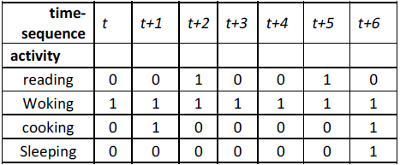
The nine sensors, capturing motion, light and noise were placed in living room, kitchen and bedroom areas. Every sensor has given a unique ID for data interpretation. The motion sensors, track inhabitant mobility so placed in center and light sensor placed in the corner area while sound sensor placed near by TV set. All sensors are connected to three Arduino UNO Wi-Fi microcontroller as access point.
In CASH framework, fuzzy rules linked up with activity patterns as <antecedent> and <consequent> manner. In table 2, various rules defined to automate appliances in smart home for providing a comfort living for inhabitants. Those fuzzy rules provide <consequent> interface for inference engine such as IF (likelihood pattern identified) THEN trigger (R1, R2, R3…. Rn).
Table 2. Automated tasks as fuzzy rules.
We used 250 observed sequence as data sets over three days from 01/01/2017 to 03/01/2017, which are labelled based on each activity type. The training set and testing set have been divided into 180 and 70 sets respectively. Matlab 2016 version were used for experiments, furthermore 180 observed activity datasets have been labelled into four main activities. Initial transition and emission matrix have been defined based on prior knowledge base. Afterwards, using Matlab’s hmmestimate and hmmtrain methods, Baum-welch algorithm applied for further re-estimation of transition and emission probability matrix parameters and train system with new parameters. Matlab experiments trained the system over 180 observed sequences. Finally, hmmviterbi methods used to apply Viterbi algorithm to identify most likelihood activity sequences. Using 80 testing activity datasets, system achieve 79% of accuracy, shown in fig. 2. as Matlab simulation result.
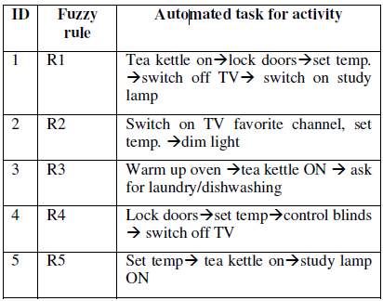
Fig. 2. HMM likelihood activity sequence compares to observedsequence.

CONCLUSION
This paper proposed a new type of CASH (Cognitive Automated Smart Home) architecture to provide comfort inhabitant daily life by understanding their needs and activity intention proactively. We embraced the knowledge base from traditional context aware pervasive computing and combined them with the Cognitive Internet of things technologies in modern era. Furthermore, the building block of CASH architecture is well equipped with artificial intelligence machine learning algorithms of Hidden Markov Model and fuzzy rules-based system to recognized pattern in daily activity living and execute required task via device controller in proactive manner. Moreover, CASH framework, can be applied in elderly health care system, smart classrooms, and smart spaces for automated environment

References

[1] G. Jamnal and X. Liu, “A Cognitive-IoE Approach to Ambient-intelligent Smart Home.”
[2] “IBM Watson IoT.” [Online]. Available: https://www.ibm.com/internet-of-things/.
[3] M. R. Hassan, K. Ramamohanarao, J. Kamruzzaman, M. Rahman, and M. Maruf Hossain, “A HMM-based adaptive fuzzy inference system for stock market forecasting,” Neurocomputing, vol. 104, no. July 2016, pp. 10–25, 2013.
[4] C. Grosan and A. Abraham, “Rule-Based Expert Systems,” Intell. Syst., vol. 17, pp. 149–185.

