Urban ponds as an aquatic biodiversity resource in modified landscapes
Running head: Macroinvertebrate biodiversity in urban aquatic ecosystems
Type of paper: Primary Research Article
Hill, M. J.¹, Biggs, J.², Thornhill, I.³, Briers, R. A.⁴, Gledhill, D. H.⁵, White, J. C.¹, Wood. P. J.¹ and Hassall, C.⁶
¹Centre for Hydrological and Ecosystem Science, Department of Geography, Loughborough University, Loughborough, Leicestershire, LE11 3TU, UK
²Freshwater Habitats Trust, Bury Knowle House, Headington, Oxford, OX3 9HY
³University of Birmingham, Edgbaston, Birmingham, B15 2TT, UK
⁴School of Life, Sport and Social Sciences, Edinburgh Napier University, Edinburgh, UK
⁵Ecosystems & Environment Research Centre, School of Environment and Life Sciences, Peel Building, University of Salford, Salford, Greater Manchester M5 4WT, UK
⁶School of Biology, University of Leeds, Woodhouse Lane, Leeds, LS2 9JT, UK
Author for correspondence
Christopher Hassall
School of Biology
University of Leeds
Woodhouse Lane
Leeds
LS2 9JT, UK
Tel: 00 44 (0)113 3435578
Email: c.hassall@leeds.ac.uk
Keywords: urban, city, ecology, freshwater, aquatic, biodiversity, biotic homogenisation, conservation, invertebrate.
Abstract
Urbanization is a global process contributing to the loss and fragmentation of natural habitats. Many studies have focused on the biological response of terrestrial taxa and habitats to urbanization. However, little is known regarding the consequences of urbanization on freshwater habitats, especially small lentic systems. In this study we examined aquatic macroinvertebrate diversity (family and species level) and variation in community composition between 240 urban and 784 non-urban ponds distributed across the UK. Contrary to predictions, urban ponds supported similar numbers of invertebrate species and families compared to non-urban ponds. Similar gamma diversity was found between the two groups at a family level, and while at a species level gamma diversity was higher in non-urban ponds, this difference was not statistically significant. The biological communities of urban ponds were markedly different to those of non-urban ponds and the variability in urban pond community composition was greater than that in non-urban ponds, contrary to previous work showing homogenisation of communities in urban areas. Positive spatial autocorrelation was recorded for urban and non-urban ponds at 0-50 km (distance between pond study sites) and negative spatial autocorrelation was observed at 100-150 km, and was stronger in urban ponds in both cases. Ponds do not follow the same ecological patterns as terrestrial and lotic habitats (reduced taxonomic richness) in urban environments; in contrast they support high taxonomic richness and contribute significantly to regional faunal diversity. Individual cities are complex structural mosaics which evolve over long periods of time and are managed in diverse ways, promoting the development of a wide-range of environmental conditions and habitat niches in urban ponds which can promote greater heterogeneity between pond communities at larger scales. Ponds provide an opportunity for managers and environmental regulators to conserve and enhance freshwater biodiversity in urbanized landscapes whilst also facilitating key ecosystem services including storm water storage and water treatment.
Introduction
Land use change has been predicted to be the greatest driver of biodiversity change in the 21st century (Sala et al., 2000). The conversion of natural landscapes to urban areas represents a common land use transition, and is a significant process contributing to the loss of freshwater habitats and the degradation of those that remain, placing considerable pressure on native flora and fauna (McKinney, 2002). The fragmentation of natural habitats and development of uniform landscapes in urban areas has been demonstrated to cause the biotic homogenization of flora and fauna through: 1) the decline and exclusion of native species through land use modification (and associated anthropogenic pressures); and 2) the introduction and establishment of non-native invasive species through habitat disturbance and human introductions (McKinney, 2006; Grimm et al., 2008; Shochat et al., 2010). Previous research has demonstrated that high levels of urbanization reduce macroinvertebrate and macrophyte species richness (e.g. in urban streams, Roy et al., 2003; Walsh et al., 2005) to the point where urban environments are viewed as ‘ecological deserts’; although at moderate levels of urbanization greater diversity has been recorded for plant communities (McKinney et al., 2008). In recent decades, significant improvements to the physical, chemical and ecological quality of urban freshwater ecosystems have been made in economically developed nations reflecting the decline in industrial developments, improved waste water treatment, and more effective environmental legislation (e.g., The Water Framework Directive in Europe; EC, 2000 and The Water Act 2007 in Australia; Commonwealth of Australia, 2007). Although there have been significant improvements to the quality of many urban aquatic habitats, the number of water bodies in urban areas has declined over the past century (Wood et al., 2003; Thornhill, 2013). Commercial and residential developments are expanding in urban areas to keep pace with population growth (66% of global urban population are predicted to live in urban areas by 2050; United Nations, 2014) at the expense of urban green spaces (Dallimer et al., 2011). Such losses of green/blue space are likely to place significant pressure on remaining urban freshwaters to support native flora and fauna and may lead to substantial shifts in the diversity and composition of species in urban areas (Fitzhugh & Richter, 2004; McKinney, 2006).

Ponds are ubiquitous habitat features in both urban and non-urban landscapes. In non-urban landscapes ponds have been demonstrated to support greater regional diversity of flora and fauna compared to rivers and lakes (Davies et al., 2008). This biodiversity value may result from spatial and temporal diversity in pond environmental variables (Hassall et al., 2011; Hassall et al., 2012), which create a highly heterogeneous “pondscape” of habitats that provide a diverse array of ecological niches. Ponds have been acknowledged as providing important network connectivity across landscapes, acting as “stepping stones” that facilitate dispersal (Pereira et al., 2011). Within urban areas, ponds provide a diverse array of habitats and occur in a wide range of forms including garden ponds (Hill & Wood, 2014), sustainable urban drainage systems (SUDS; Briers, 2014; Hassall & Anderson, 2015), industrial, ornamental and park ponds (Gledhill et al., 2008; Hill et al., 2015), recreation and angling ponds (Wood et al., 2001), and nature reserve ponds (Hassall, 2014) which typically display heterogeneous physicochemical conditions (Hill et al., 2015). Urban ponds are almost always of anthropogenic origin and often demonstrate different environmental characteristics to non-urban (semi-natural/agricultural) ponds; urban ponds commonly have concrete margins, a synthetic base, reduced vegetation cover, lower connectivity to other waterbodies, and are subject to run off from residential and industrial developments which can greatly increase the concentration of contaminants (Hassall, 2014). While the definition of a “pond” versus a “lake” is still very much debated, a general rule is that ponds are standing water bodies <2ha in size. Urban ponds are frequently much smaller (closer to 1-5m² for garden ponds) but show a large variation in size (>10ha for park lakes). For a discussion of the definitions of ponds and lakes, we refer the reader elsewhere (Hassall, 2014; Appendix 1 in Biggs et al., 2005). Despite the considerable anthropogenic pressures on urban ponds, recent studies have demonstrated that ponds located within an urban matrix can provide important habitats for a wide range of taxa including macroinvertebrates (Hassall, 2014; Goertzen & Suhling, 2015; Hill et al., 2015) and amphibians (Hamer et al., 2012). In addition many support comparable diversity to surrounding non-urban ponds (Hassall & Anderson, 2015) and also provide a wide range of ecosystems services in urban areas to offset the negative impacts of urbanization (Hassall, 2014). However, these patterns are inconsistent, and other studies have reported a lower diversity of macroinvertebrate and floral taxa in urban ponds reflecting the greater isolation of pond habitats (Hitchings & Beebee, 1997) and management practices designed for purposes other than biodiversity (e.g., emergent vegetation removal, Noble & Hassall, 2014).

While there has been increasing research interest in the biodiversity and ecosystem services of urban ponds across Europe (Hassall, 2014; Jeanmougin et al., 2014; Goertzen & Suhling, 2015), the question remains as to whether urban ponds can provide similar levels of biodiversity to that recorded in ponds in the wider landscape. Few studies have compared urban pond faunal communities with non-urban pond communities (see Hassall & Anderson, 2015) and no known studies have examined urban pond macroinvertebrate diversity at a national scale. Furthermore, there are a series of ecological patterns within cities (e.g., reduced taxonomic diversity, biotic homogenization, increase in non-native and invasive taxa) that have been described in terrestrial systems (particularly birds, butterflies, and plants: McKinney, 2008) but these have not been tested in aquatic ecosystems. This study provides a comparative analysis of environmental characteristics and macroinvertebrate communities contained within >1000 UK ponds, including ponds located in a number of cities and towns across the UK and non-urban ponds that cover a wide range of non-urban habitats including; nature reserves, agricultural land (pasture and crop), meadows, woodland and other wetlands. We test the following hypotheses: (i) urban ponds support lower macroinvertebrate richness and diversity (family and species level) than non-urban ponds, as would be predicted from the greater anthropogenic stressors in urban areas; (ii) urban macroinvertebrate communities would be more homogeneous than non-urban communities at a family and species scale, due to the greater similarity of urban habitats as has been reported for terrestrial taxa; and (iii) urban pond communities demonstrate stronger spatial structuring at smaller scales than non-urban communities, through reduced connectivity, dispersal and gene flow.
Methodology
Data Management
The UK covers a total area of 242,495 km² and has a population of approximately 64.6 million inhabitants. Over 6.8% of the UK land mass is classified as urban and approximately 80% of the population resides in urban areas (defined as areas >20ha containing >20,000 people, UKNEA, 2011). Aquatic macroinvertebrate community data from 230 urban and 607 non-urban ponds and environmental data from 240 urban ponds and 784 non-urban ponds in the UK were collated from 12 previous studies (Table 1). The spatial distribution of the studied urban and non-urban ponds is displayed in Figure 1.
Figure 1 - Map of Great Britain showing the locations of the surveyed urban (light grey circles) and non-urban (dark grey circles) ponds.
Reference Number  Table 1 – Summary table of the geographic scale, sampling methodology and taxonomic resolution of contributing studies. | Geographic Scale | Aquatic macroinvertebrate Sampling Methodology | Taxonomic Resolution | Taxa Included | Reference
1 | UK wide | Individual ponds sampled for 3 minutes in spring, summer and autumn using a sweep sample technique. Sampling time was divided between the mesohabitats recorded in each pond. | Species, except for Oligochaeta, Diptera and small bivalves | Aquatic macroinvertebrates (water mites, zooplankton and other micro-arthropods were not included) | Biggs et al., 1998
2 | Dunfermline, Fife, Scotland | Individual ponds were sampled annually between 2007-2011 in the summer following the methods of the National Pond Survey. | Species, except for Oligochaeta, Ostracoda and Diptera | Aquatic macroinvertebrates | Briers, 2014
3 | Leicestershire, UK | Individual ponds were sampled over spring, summer and autumn seasons. Sampling time was proportional to surface area, up to a maximum of three minutes. Sampling time designated to each pond was divided between the mesohabitats recorded. | Species, except for Diptera, Oligochaeta, Hydrachnidiae and Collembola | Aquatic macroinvertebrates (zooplankton and other micro arthropods were not included) | Hill et al., 2015
4 | West Yorkshire, UK | Individual ponds were sampled during the summer and autumn, following the guidelines of the National Pond Survey. In addition, soft benthic samples were taken using an Eckman Grab. | Species, except Ostracoda, Copepoda and Diptera | Aquatic macroinvertebrates | Wood et al., 2001
5 | Bradford, UK | Individual ponds were sampled for 3 minutes in the summer. Sampling time was divided between the mesohabitats present. | Family level | Aquatic macroinvertebrates (presence of fish and amphibians noted) | Noble & Hassall, 2014
6 | Birmingham, UK | Individual ponds were sampled for 3 minutes in the spring and summer, following the guidelines of the National Pond Survey. | Species, except Diptera, Sphaeriidae and Oligochaeta | Aquatic macroinvertebrates | Thornhill, 2013
7 | Halton, UK | Individual ponds were sampled twice per year (summer and autumn) for 2 years. Samples were taken from all available mesohabitats using a standard pond net until no new species were recorded. | Species | Aquatic macroinvertebrates, Aquatic macrophytes, Amphibians | Gledhill et al., 2008
8 | North West England | Samples were taken from all available mesohabitats using a standard pond net until no new species were recorded. Logs and debris was lifted to look for macroinvertebrates located beneath. | Species except Diptera, and Oligochaeta which were not examined. | Aquatic macroinvertebrates, Aquatic macrophytes, Amphibians | Pond life Project, 2000
9 | Leeds, UK | Individual ponds were sampled for 3 minutes in the summer. Sampling time was divided between the mesohabitats present. | Family level | Aquatic macroinvertebrates | Moyers & Hassall unpub.
10 | UK wide | Individual ponds were sampled for 3 minutes in spring, summer and autumn using a sweep sample technique. Sampling time was divided between the mesohabitats recorded in each pond. | Species, except for Oligochaeta, Diptera and small bivalves | Aquatic macroinvertebrates (water mites, zooplankton and other micro-arthropods were not included) | FHT Realising Our Potential Award dataset unpub.
11 | UK wide | Individual ponds sampled for 3 minutes in spring, summer and autumn using a sweep sample technique. Sampling time was divided between the mesohabitats recorded in each pond. | Species, except for Oligochaeta, Diptera and small bivalves | Aquatic macroinvertebrates (water mites, zooplankton and other micro-arthropods were not included) | FHT Temporary Ponds dataset unpub.
12 | Leeds, UK | Individual ponds were sampled for 3 minutes in the summer. Sampling time was divided between the mesohabitats present. | Family level | Aquatic macroinvertebrates | Barber & Hassall unpub.

Data collection methodologies employed by the majority of contributing studies (Table 1) broadly followed the standardized guidelines of the National Pond Survey (Biggs et al., 1998) including a 3 minute sweep sample divided between the mesohabitats present (Studies 1, 2, 3, 4, 5, 6, 9, 10, 11 and 12; Table 1). The other studies also sampled for aquatic macroinvertebrate taxa in all available mesohabitats, but sampling was undertaken until no new species were recorded (studies 7 and 8). The majority of studies were sampled across two or three seasons (studies 1, 3, 4, 6, 7, 10 and 11; Table 1) although five studies were only sampled during the summer months (studies 2, 5, 8, 9 and 12; Table 1). Environmental data recorded from pond sites varied between studies, but always included a common core of variables that were used in the comparative analysis: pond area, pH, percentage coverage of emergent macrophytes, percentage pond shading, and altitude. Ponds were categorized as urban or non-urban based on whether they were located within developed land use areas (DLUAs) – a landscape designation used by the UK-based Ordnance Survey to delineate urban and non-urban sites. We provide a comparison between our binary categorisation and two other measures of ‘urbanness’ (proportion of urban land use in a 1km buffer, and distance from urban land use areas) in the Supplementary Information (Part 1). We acknowledge that the definition of an urban pond is complex. Indeed, a previous attempt to define a typology of urban ponds concluded that these sites comprise a diverse array of different habitat types (Hassall, 2014). However, the intention with this study is to evaluate the aquatic biodiversity in urban areas, and to establish whether those urban sites are deserving of protection, value, and enhancement. Hence, rather than attempting to define the precise characteristics of an “urban pond”, we are focusing on the much more tractable issue of “ponds in urban areas”. Similarly, the definition of a “non-urban pond” for our purposes simply includes ponds outside of urban areas. Our non-urban pond dataset is concentrated in agricultural landscapes which in the UK are typically characterised by low tree cover and low surrounding botanical diversity, along with high inputs of nutrients and agricultural effluents. These ponds are likely to be subject to “benign neglect” (i.e. limited management) but this will vary across the ponds in the study. Urban ponds in this study encompass a broad spectrum of urban areas, from their location in densely populated areas (e.g., Birmingham: population >1million) to smaller urban towns (e.g., Loughborough: estimated population of 60000). The urban ponds chosen for investigation included ponds in domestic gardens, industrial ponds (old mill ponds), ornamental ponds located in urban parks and drainage ponds (e.g., sustainable urban drainage systems / stormwater retention ponds; see Hassall, 2014). The issue of the representative nature of UK cities compared to cities elsewhere (in Europe or the wider world) is less clear for ponds, since there has been limited study of these habitats using standardised methods (see Hassall, 2014, for a discussion and a range of biodiversity studies). It is likely that the range of urbanised areas incorporated in our study covers the range of different urban landscapes that are found in European cities, from millennia-old cities with an evolving land use pattern (e.g. London), to centuries-old industrial towns (e.g. Leeds, Manchester), to 20th century towns which have been designed and built de novo (e.g. Milton Keynes).

The faunal dataset was converted into a presence-absence matrix to ensure data provided by the 12 constituent studies were comparable and that any sampling bias was reduced. Abundance data may yield additional insights into variation in biomass and evenness among ponds, and we might expect greater biomass and evenness in non-urban sites where stressors are reduced and nutrient supply is greater. However, our primary goal within the present study is to investigate variation in taxonomic richness across the pond types. Two key methodological differences exist in the 12 studies. First, although most of the corresponding studies identified the majority of macroinvertebrate taxa to species level, each study also identified selected taxa (e.g., Diptera, Oligochaeta, Copepoda and Ostracoda) at higher taxonomic levels (Table 1). The influence of a higher taxonomic resolution of identification for aquatic macroinvertebrates has been examined, primarily within lotic habitats (Monk et al., 2012; Heino, 2014). However, identification of macroinvertebrate taxa at family level has been shown to be appropriate to examine alpha, beta and gamma diversity in lentic systems (Le Viol et al., 2009; Mueller et al., 2013; Hassall & Anderson, 2015; Vilmi et al., 2016) and is the resolution used by a range of environmental monitoring indices (e.g., biological monitoring working party [BMWP] and predictive system for multimetrics [PSYM] scores; Environment Agency & Pond Conservation Trust, 2002) and legislation (e.g., The Water Framework Directive; EC, 2000) across Europe. However, to assess the sensitivity of results to taxonomic resolution we performed all analyses at two taxonomic levels: first, to incorporate as many sites as possible and to ensure faunal data was comparable across all studies, aquatic macroinvertebrate data were reclassified to family level and analysis was undertaken at this higher taxonomic resolution. Second, statistical analysis was also undertaken on a subset of urban (207 ponds) and non-urban ponds (578 ponds) where species level data was available.

The second methodological variation was in the amount of sampling effort applied to the sites: sampling effort was limited to 3 minutes in 10 of the studies (following standard UK sampling protocols) but two studies used exhaustive sampling until no more species were found. A preliminary analysis showed that, in fact, the sites sampled for 3 minutes found more taxa (average of 14.7 ± 0.4 SE families, n=392 sites; average of 30.0 ± 0.9 species, n=340) than sites sampled exhaustively (average of 13.6 ± 0.3 SE families, n=518 sites; average of 26.8 ± 0.6 species, n=518). However, this lower number of species in exhaustive samples is likely to result from those sites occurring in the north of England where the regional species pool may be smaller. As a result, we are confident that there is no substantial bias across the exhaustive and time-limited samples. Finally, to provide the strongest possible test of the biodiversity value of urban ponds, urban pond communities (at a family and species level) were compared to a subset of the non-urban ponds with degraded sites excluded (leaving n=571 non-urban ponds with family level data and 542 with species level data).

Statistical Analysis
Differences in environmental characteristics (pond area, percentage coverage of emergent macrophytes, pH, percentage pond shading and altitude) and aquatic macroinvertebrate communities at a family and species level between urban and non-urban ponds were examined. All analyses were carried out in the R environment (R Development Core Team, 2013). Prior to statistical analysis the data was screened to remove any missing values. Estimated gamma diversity was calculated using Chao2 estimator in the vegan package in R (Okansen et al., 2015). Mann-Whitney U tests were used to test for differences in alpha diversity (family and species richness) between urban and non-urban ponds. To account for the fact that there were different numbers of urban and non-urban sites, taxon accumulation curves were constructed by randomized resampling of sites without replacement using the specaccum function in vegan with 1,000 permutations per sample size. From these curves the mean number of families and species in each simulated group of sites and the standard error were calculated. Variability between urban and non-urban ponds in the environmental variables was tested using Mann-Whitney U tests. Differences between environmental variables and faunal community composition in urban and non-urban ponds were visualized using Non-Metric Multidimensional Scaling (NMDS) with the metaMDS function in the vegan package and were examined statistically using a ‘Permutational Analysis of Variance’ (PERMANOVA). Bray–Curtis dissimilarity was used to analyse the macroinvertebrate data and Euclidean distance used for the environmental data. Homogeneity of multivariate dispersions between the environmental data and macroinvertebrate communities from urban and non-urban ponds were calculated using the betadisper function in vegan and compared using an ANOVA. To test the spatial patterns of community structure in urban and non-urban ponds, a Mantel correlogram was constructed between the aquatic macroinvertebrate distance matrix (Euclidean) and the geographical distance for urban and non-urban ponds using the mantel.correlog function in the vegan package in R. Breaks among distance classes in the Mantel correlogram were defined in 50km intervals. The Mantel correlogram enables the identification of changes in the strength of correlation between faunal distance matrices and geographic distance matrices at different spatial scales (Rangel et al., 2010).

The relationship between macroinvertebrate assemblages and environmental variables (pH, percentage coverage of emergent macrophytes, percentage pond shading, altitude, location within urban area, and pond area) was examined using redundancy analysis (RDA) in the vegan package. A stepwise selection procedure (forward and backward selection) was employed to select the best model and environmental variables that significantly (p<0.05) explained the variance in pond macroinvertebrate assemblages using the ordistep function in vegan, which uses permutation-based significance tests (999 permutations).

Results
Urban and non-urban pond environmental characteristics
Comparisons between specific environmental variables in urban and non-urban ponds that are thought to influence diversity and composition showed that altitude (W=108179.5 p<0.01; Figure 2A) and pond shading (W=92965.5 p<0.01; Figure 2B) were significantly higher for urban ponds (mean altitude: 85.9 ± 3.7 masl; mean shading 22.89 ± 1.84 %) than non-urban ponds (mean altitude: 78.2 ± 2.8 masl; mean shading 19.61 ± 0.95 %), but the absolute differences between the pond types are small enough that they may be biologically insignificant (Table 2). pH was significantly higher for urban ponds (mean 7.44 ± 0.06SE) and demonstrated a greater variability compared to non-urban ponds (7.37 ± 0.16; W=37024 p<0.05; Figure 2C) although in both pond types pH was close to neutral. A total of 13% of non-urban ponds (66 ponds) recorded a pH <6.5, whilst only 4% of urban ponds (10 urban ponds) recorded a pH <6.5. In addition, pond area was on average 43% larger in non-urban ponds (2207 ± 139m²) compared to urban ponds (1546 ± 171m²; W=75154.5 p<0.01; Figure 2D). Emergent macrophyte coverage was significantly higher in non-urban ponds (33.10 ± 1.08%) compared to urban ponds (27.77 ± 1.87%; W=81695 p<0.01; Figure 2E) although the mean difference was <5%.
Figure 2: Comparison of environmental values between non-urban and urban ponds for (A) altitude, (B) shading, (C) pH, (D) pond area, and (E) emergent plant cover. Each dot represents a site, and dots are offset to illustrate multiple sites at the same value.

Aquatic macroinvertebrate diversity
Family-level gamma diversity was similar between urban (observed 96 families, Figure 3A) and non-urban ponds (observed 103 families, Figure 3B), and the Chao2 estimator produced results taking into account sample size that were not statistically different across the two pond types (urban: 108.2, 95% CI: 91.4-125.0 families; non-urban: 107.5, 95% CI: 99.7-115.3 families). At an alpha scale urban ponds (median richness = 13, range = 2-44) supported significantly greater macroinvertebrate family richness compared to non-urban ponds (median richness = 12, range = 2-38; W=20430.5 p<0.01) although median richness values were very similar between the pond types. Species-level gamma diversity was lower in urban (observed 403 species) than non-urban sites (observed 473 species), but the Chao2 estimator showed that there was no significant difference after controlling for the number of sites (urban: 496.6, 95%CI: 445.6-547.7 species; non-urban: 572.9, 95%CI: 520.2-625.7 species). No significant difference in alpha diversity between macroinvertebrate species was recorded between urban (median: 28) and non-urban ponds (median 26; W=17310 p=0.507).

Urban ponds demonstrated a greater variability in alpha diversity among individual ponds at a family and species level (Figure 3C, 3D). A total of 25 urban ponds (11% of total urban pond number) supported >25 macroinvertebrate families, whilst only 9 non-urban ponds (1.5% of total non-urban pond number) supported macroinvertebrate communities with >25 families. In addition, the greatest number of invertebrate families recorded was from an urban pond (46 taxa) and 5 of the 6 ponds with the greatest macroinvertebrate family richness were located in urban environments. A total of 9 families (Argulidae, Chaoboridae, Helodidae, Mesoveliidae, Neuroptera, Psychodidae, Ptychopteridae, Simuliidae and Stratiomyidae) and 66 taxa at species level (Zygoptera: 3 taxa, Trichoptera: 9 taxa, Crustacea: 2 taxa, Gastropoda: 9 taxa, Ephemeroptera: 1 taxa, Hemiptera: 11 taxa, Coleoptera: 9 taxa, Diptera: 12 taxa, Annelid: 2 taxa, Tubellaria: 4 taxa, Megaloptera: 1 taxa, Neuroptera: 1 taxa, Colembolla: 1 taxa and Cladocera: 1 taxa) were unique to urban ponds. However, no taxon recorded as unique to either urban or non-urban ponds was recorded in >10% of the total pond dataset and so it is likely that these are simply rare taxa that were recorded by chance rather than true “specialists” in either group of habitats. See Table S1 for family-level prevalence and Table S2 for species-level prevalence in the two groups of ponds.
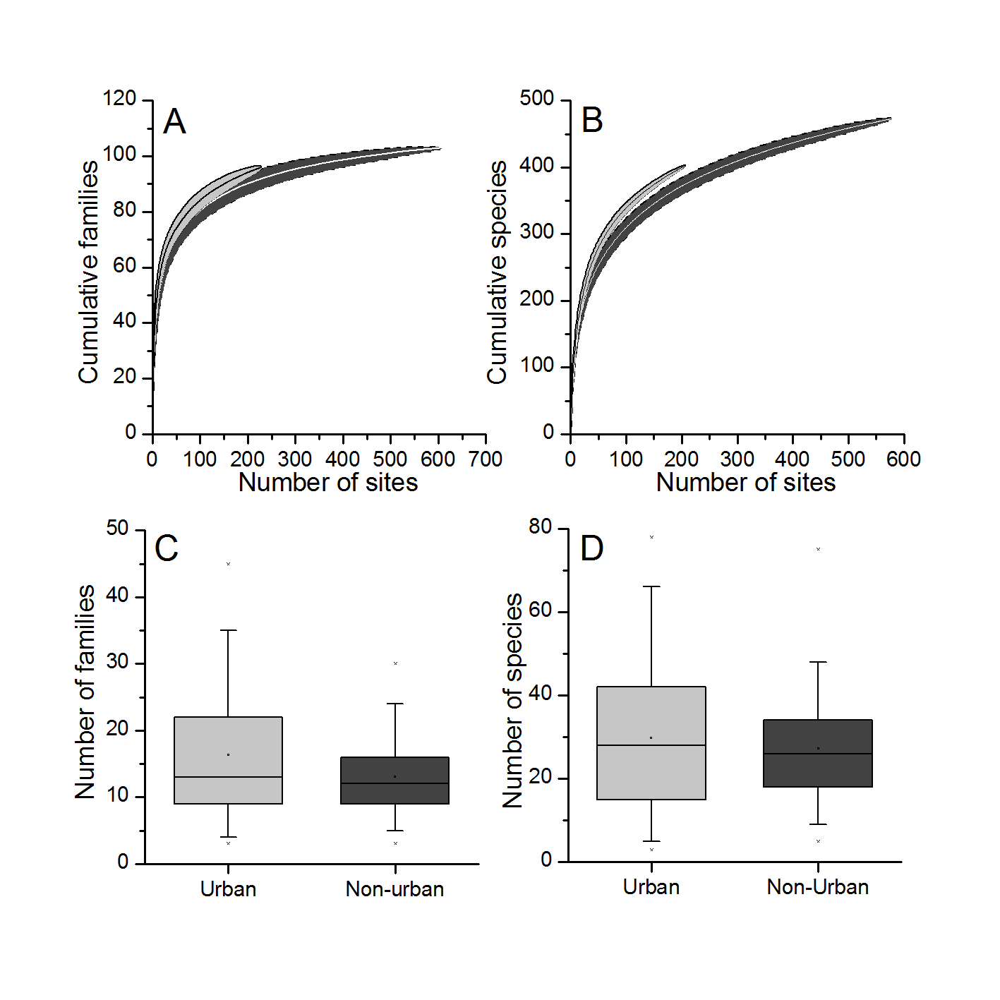
Figure 3: Species accumulation curves of family richness (A) and species richness (B): grey area with black line = urban ponds, black area with white line = non-urban ponds, and median macroinvertebrate family richness (C) and species richness (D) for urban and non-urban ponds. Boxes show 25th, 50th, and 75th percentiles and whiskers show 5th and 95th percentiles.

When non-urban ponds designated as degraded were removed and the macroinvertebrate diversity in the remaining ponds was compared to urban ponds, alpha diversity was significantly greater in urban ponds (median: 13; W=18057 p<0.01) than the higher quality non-urban ponds (median: 12) at a family level, although mean and median richness values were similar between the pond types (see Supplementary Information Part 2). There was no significant difference in alpha diversity (W=14653.5 p=0.358) at the species level between urban ponds (median: 28) and higher quality non-urban ponds (median: 25). Estimated gamma diversity for higher quality non-urban ponds at a family (98.7) and species scale (575.1) was marginally higher compared to gamma diversity when all non-urban ponds were considered.

Chironomidae, Tipulidae, Crangonyctidae and Oligochaeta had a greater frequency of occurrence in urban ponds, whilst Gyrinidae, Hydrophilidae and Notonectidae displayed a greater occurrence in non-urban ponds (Figure 4; for complete data see Tables S7 and S8 for family and species level prevalence, respectively). Macroinvertebrate families that score highly within biological monitoring surveys of ponds and other waterbodies (e.g., PSYM and BMWP) such as Phryganeidae, Leptoceridae, Libellulidae and Aeshnidae occurred at similar frequencies in the urban and non-urban ponds (Figure 4). Crangonyctidae were present in 49.0% of urban ponds and only 29.0% of non-urban ponds. All specimens of this family from the species-level dataset were the North American invasive Crangonyx pseudogracilis. A similar pattern is also seen in the species-level dataset with the invasive New Zealand mud snail, Potamopyrgus antipodarum, being found in 21.3% of urban ponds and 9.5% of non-urban ponds.
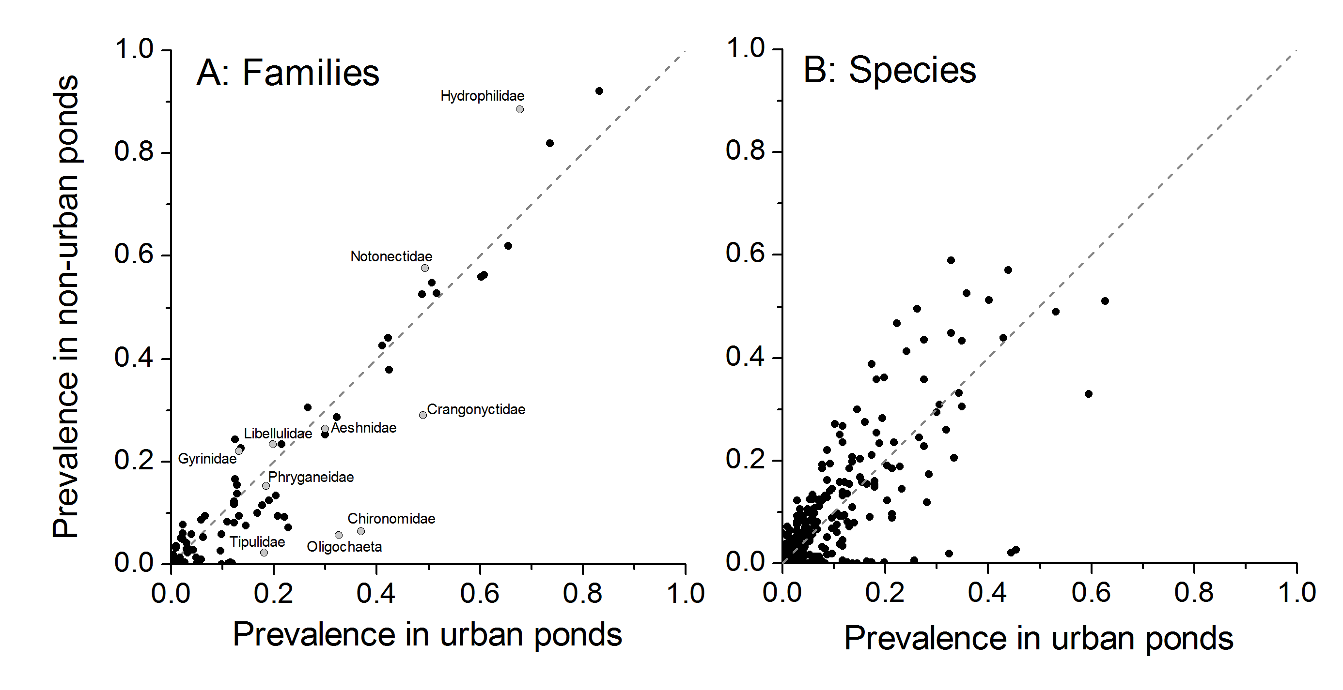
Figure 4: Prevalence of aquatic macroinvertebrate families (A) and species (B) in urban and non-urban ponds. Macroinvertebrate families listed in text are presented as grey circles and have been named (see Table S1 and Table S2 for raw data).

Community Heterogeneity
Multivariate dispersion for environmental characteristics were significantly lower in non-urban ponds (median distance: 1116) than urban ponds (median distance: 1978; F=5.774 p<0.05, Figure 5A). PERMANOVA showed that there was a small but significant difference between environmental characteristics (R²=0.03 p<0.001) and faunal communities at a family (R²=0.09 p<0.001) and species level (R²=0.03 p<0.001). A relatively clear distinction between aquatic macroinvertebrate community composition in urban and non-urban ponds was observed at the family and species level within the NMDS ordination (Figure 5B, C). Among faunal communities, multivariate dispersion was significantly higher at the family (median distance - urban: 0.451, non-urban: 0.406; F=27.584 p<0.01) and species scale (median distance - urban: 0.579, non-urban: 0.550; F=17.626 p<0.01) for urban ponds compared to non-urban ponds.
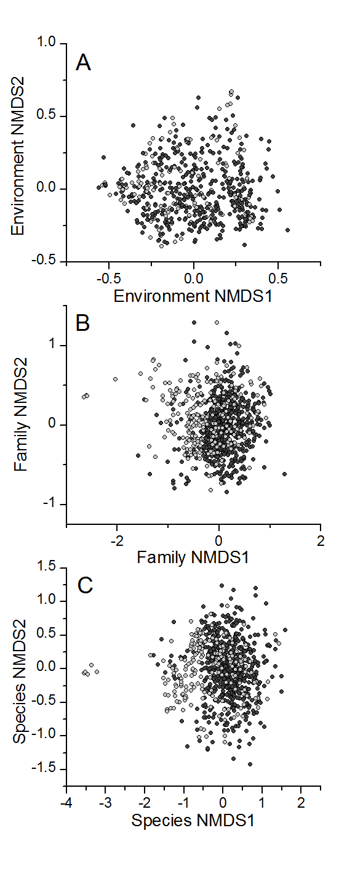
Figure 5: Non-metric multidimensional scaling plots of variation in (A) environmental variables, (B) aquatic macroinvertebrate families and (C) aquatic macroinvertebrate species from urban and non-urban ponds (light grey symbols = urban ponds and dark grey symbols = non-urban ponds).

There was significant positive spatial autocorrelation for urban (r=0.31 p<0.01) and non-urban ponds (r=0.17 p<0.01) at the family level for the smallest distance class (0-50 km), indicating that those ponds in close geographical proximity have similar macroinvertebrate community compositions (Figure 6A). At middle distance classes (distance class three: 100-150 km) urban and non-urban ponds demonstrated a significant negative Mantel spatial autocorrelation, although this effect was weak for non-urban ponds (urban: r=-0.18 p<0.01, non-urban: r=-0.05 p<0.01) (Figure 6A). At larger distances spatial autocorrelation declined in strength for urban and non-urban ponds. The same analyses carried out on species-level data showed similar spatial patterns, but with stronger positive correlation at shorter distances (0-50km, urban: r=0.45, p<0.01; non-urban: r=0.27, p<0.01) and stronger negative correlation at middle distances (100-150km, urban: r=-0.29, p<0.01; non-urban: r=-0.08, p<0.01; Figure 6B).

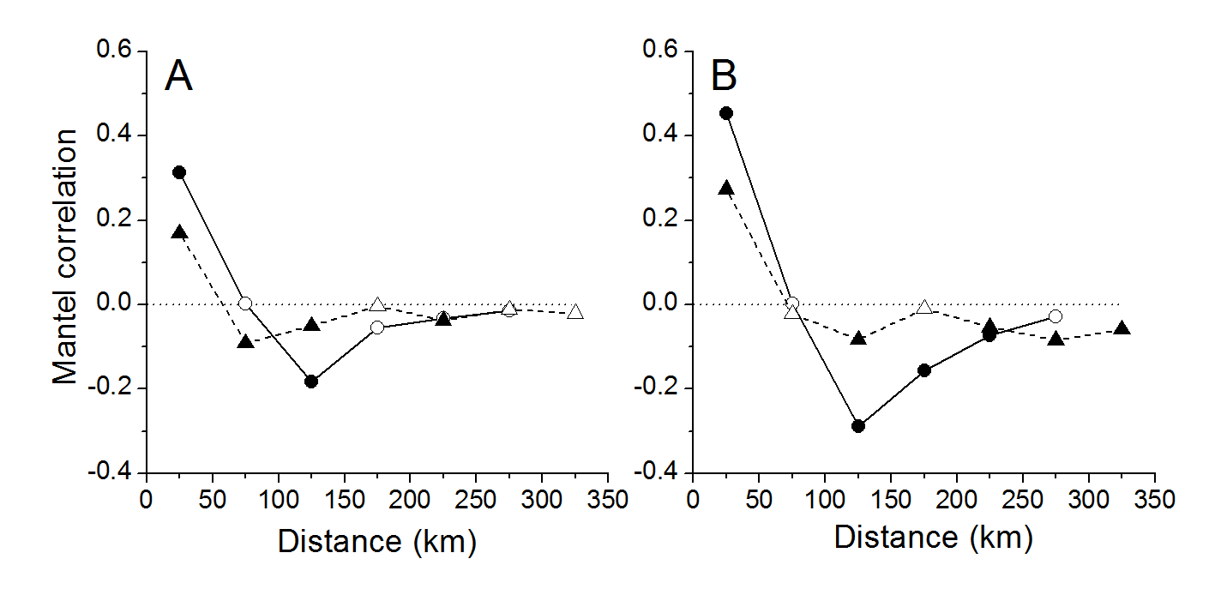
Figure 6 - Mantel correlogram for presence-absence macroinvertebrate data at (A) family and (B) species level along 50 km distance intervals (distances between pond study sites). Triangles = non-urban sites, circles = urban sites. Filled symbols indicate statistically significant Mantel correlations.

Macroinvertebrate - environment relationships
Redundancy Analysis (RDA) of the pond macroinvertebrate family community data and environmental parameters highlighted clear differences between urban and non-urban ponds (Figure 7A). The RDA axes were highly significant (F=3.06 p<0.001, Adjusted R²=0.02), explaining 3.8% of the variation in family assemblage on all constrained axes (Table 2A). Stepwise selection of environmental parameters identified four significant physicochemical variables correlated with the first two RDA axes: altitude, emergent macrophytes (all p<0.05), surface area and location within urban area (both p<0.01) (Figure 7A; Table 2A). RDA indicated that urban and non-urban pond invertebrate communities were separated on the first and second axes along gradients associated with pond surface area and emergent macrophyte cover (Figure 7A). Non-urban ponds were characterized by a greater pond area and emergent macrophyte cover, whilst urban ponds were associated with smaller surface areas and less emergent macrophytes (Figure 7). RDA of pond macroinvertebrate species community data showed similar patterns: urban and non-urban ponds were strongly separated along the first RDA axis, with significant effects of urbanisation, pond area, altitude, and shading on community structure (Figure 7B, Table 2B). However, in both RDA analyses the explanatory power of the models was very low (Table 2).
Table 2 - Summary statistics for redundancy analysis of macroinvertebrate community data at (A) family-level and (B) species-level, with significant explanatory environmental parameters
A: Eigenvalues for constrained axes in family-level RDA
 | RDA 1 | RDA 2 | RDA 3 | RDA 4 | RDA 5 | RDA 6
Eigenvalues | 0.198 | 0.056 | 0.033 | 0.018 | 0.015 | 0.006
Proportion Explained (%) | 2.3 | 0.66 | 0.38 | 0.21 | 0.17 | 0.06
Cumulative Proportion Explained (%) | 2.3 | 2.96 | 3.34 | 3.55 | 3.72 | 3.78
Adjusted R² | 0.02
Significant Environmental Variables
 | Df | F | P
Emergent Macrophytes | 1 | 1.62 | 0.02
Altitude | 1 | 2.03 | 0.015
Pond Area | 1 | 2.25 | 0.01
In Urban | 1 | 9.05 | 0.005

B: Eigenvalues for constrained axes in species-level RDA
 | RDA 1 | RDA 2 | RDA 3 | RDA 4
Eigenvalues | 0.250 | 0.128 | 0.076 | 0.064
Proportion Explained (%) | 1.02 | 0.55 | 0.32 | 0.28
Cumulative Proportion Explained (%) | 1.02 | 1.52 | 1.84 | 2.1
Adjusted R² | 0.01
Significant Environmental Variables
 | Df | F | P
Percentage pond shaded | 1 | 1.37 | 0.04
Area | 1 | 1.64 | 0.02
Altitude | 1 | 2.17 | 0.01
In Urban | 1 | 3.23 | 0.005

Discussion
Urban freshwater diversity
This is the first study to provide a large scale, inter-city approach to test the biological response of entire pond macroinvertebrate communities to urbanization. The results provide a contrast with previous work on terrestrial and lotic habitats which has shown greater fragmentation, reduction in habitat quality (e.g., pollution/contaminant build up), alterations to biogeochemical cycles, higher air surface temperatures, increased disturbance frequencies, proliferation of non-native taxa, biotic homogenization and an overall decline in biological richness in urban areas (e.g., McKinney, 2002; McKinney, 2006; Grimm et al., 2008). The ecological consequences of urbanization for ponds do not appear to follow the same patterns identified elsewhere for terrestrial habitats.

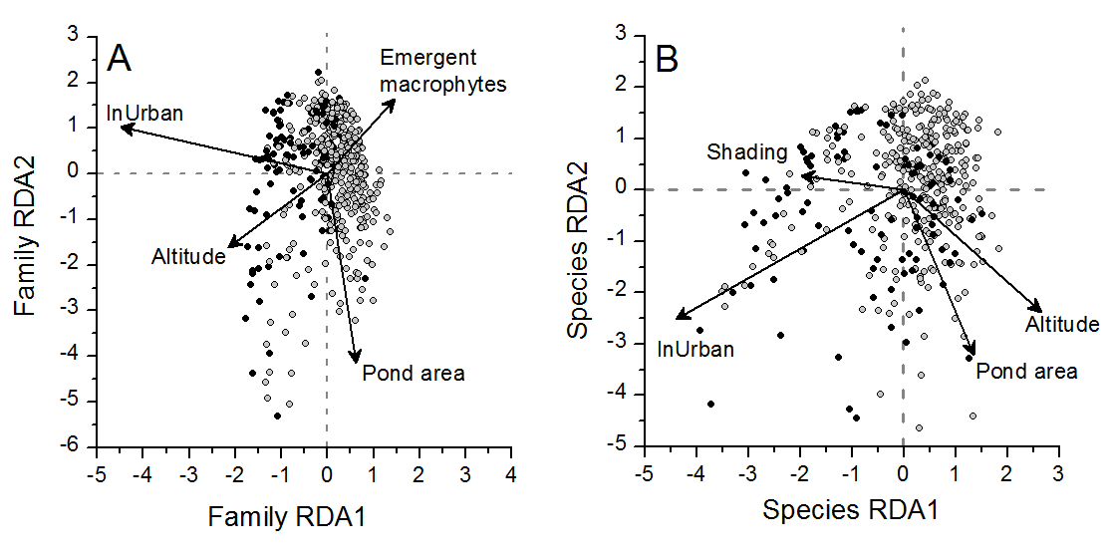
Figure 7 - RDA site plots of (A) family-level and (B) species-level macroinvertebrate communities recorded from the urban and non-urban pond types studied across the UK. Only significant environmental parameters are presented. Dark grey circles = urban ponds, light grey circles = non-urban ponds.

Urban ponds and non-urban ponds support similar alpha diversity of aquatic macroinvertebrates at a family and species level (reject hypothesis 1) and estimated gamma diversity was similar at a family level, although non-urban ponds recorded higher estimated gamma diversity at a species scale. These findings are consistent with a recent study of terrestrial invertebrates that showed comparable levels of diversity of particular indicator groups inhabiting birch trees (Betula pendula) between urban and agricultural areas (Turrini and Knop, 2015). However, an analysis of the same dataset showed a homogenization of arboreal invertebrates within urban areas (Knop, 2016), consistent with other terrestrial ecosystem studies (McKinney, 2008) but not with our data for freshwater macroinvertebrates. The lack of agreement in ecological patterns between ponds (which, in this study, show similar patterns of diversity across urban boundaries) and lotic/terrestrial habitats (which tend to show reduced faunal richness with increasing urbanisation) in cities may reflect the ability of pond communities to recover relatively quickly from temporary anthropogenic disturbance (Thornhill, 2013). This resilience is supported by the high dispersal abilities of many semi-aquatic invertebrates (Goertzen & Suhling, 2015). Despite commonly occurring in clusters, ponds are discrete habitats with small catchment areas (Davies et al., 2008) and disturbance in one pond or its catchment has little impact on others in the network cluster, whilst a single disturbance event in, for example, a river system would impact an entire reach (Thornhill, 2013). Aside from rare taxa, there were few families that showed a different prevalence between urban and non-urban ponds, including indicator taxa with high BMWP scores (indicative of high water quality). However, there was also a higher prevalence of Oligochaeta and Chironomidae in urban ponds which is consistent with historical disturbance and subsequent recolonization by disturbance tolerant taxa, and higher prevalence of the invasive C. pseudogracilis and P. antipodarum in urban ponds supports previous findings that urban ecosystems favour the establishment of invasive species (Shochat et al., 2010).

We propose two potential explanations, which are not mutually exclusive, for the similarity between urban and non-urban pond biodiversity. First, it has been estimated that 80% of ponds in the wider UK landscape are in a degraded state (Williams et al., 2010). Hence non-urban ponds and urban ponds may be suffering from high levels of degradation leading to the similar alpha diversities recorded. Second, intensive management in cities may actually promote biodiversity. Whilst many ponds in non-urban areas (e.g., agricultural land) are left unmanaged, neglected, and at late successional stages (Hassall et al., 2012; Sayer et al., 2012), ponds in urban areas are often managed (primarily for purposes other than biodiversity) and a wide-range of successional stages are maintained. Furthermore, in many cases community groups (e.g., pond warden schemes) monitor and manage large numbers of urban ponds for the benefit of ecological communities, improving their habitat/water quality and promoting high biological richness (Boothby, 1995; Hill et al., 2015). Results from the present study show that urban areas have the potential to become reservoirs of freshwater biodiversity rather than “ecological deserts” (Hassall & Anderson, 2015). However, it should be noted that diversity was highly variable in this study at both a family and species level of taxonomic resolution and previous research has demonstrated that some urban ponds can be of low ecological quality if anthropogenic stressors such as eutrophication are allowed to persist (Noble & Hassall, 2014).

Urban ponds were also characterized by contrasting values of some environmental parameters to non-urban ponds. As expected, urban ponds were smaller than non-urban ponds reflecting the high level of competition and the economic value of urban land. Lower emergent macrophyte coverage was recorded in urban ponds compared to non-urban ponds which reflects their primary function for flood water storage/water treatment and the management practices undertaken to achieve this (Le Viol et al., 2009). Reduced emergent macrophyte cover in urban areas may also be the result of public perceptions of pond attractiveness (clean, open water and surrounding vegetation mown; Nassauer, 2004) which pond amenity managers aim to replicate, or other management practices for amenity purposes such as angling or boating (Wood et al., 2001). Urban ponds were significantly more shaded than non-urban ponds, which is most likely the result of urban ponds location within high density, built environments providing significant additional artificial shading to that provided by trees. In addition, reduced shading of non-urban ponds may be because many non-urban ponds were located in landscapes naturally free of shading (trees) including wetland meadows and the low numbers of trees in British agricultural landscapes where many non-urban ponds are situated (however high levels of pond shading from trees has been recorded in some UK agricultural areas: Sayer et al., 2012).

Community heterogeneity
Small but significant differences in faunal communities (family and species) were observed between urban and non-urban ponds in this study (reject hypothesis 2). Differences (albeit subtle) in community composition found in the present study contrast with the findings of Hassall and Anderson (2015) and Le Viol et al. (2009) and suggest that, rather than simply matching non-urban ponds for diversity, at greater spatial scales urban ponds contribute as much to the regional biodiversity pool as non-urban ponds. The higher community dissimilarity among urban ponds may reflect the different levels of disturbance and diverse management practices (reflecting their primary function e.g., flood alleviation, biodiversity, amenity), as well as general pond characteristics such as small catchments which result in highly heterogeneous environmental conditions (greater environmental multivariate distances than non-urban ponds) even in ponds that are in close proximity (Davies et al., 2008). The high physicochemical heterogeneity and management variability provides a wide range of environmental conditions and niches for faunal communities to exploit.

Significant positive spatial autocorrelation at the smallest distance class and significant negative spatial autocorrelation at medium distances suggest that: 1) ponds within individual cities have similar communities which reflect similar city-region environmental characteristics; and 2) ponds at greater spatial distances from one another in different cities have increasingly dissimilar communities reflecting the high variability in environmental (Heino & Alahuhta, 2015) and historical factors (Baselga, 2008; Heino & Alahuhta, 2015) among cities. Spatial patterns of management may influence geographical variation in community structure to a greater extent than landscape connectivity, making it difficult to evaluate our third hypothesis. However, we demonstrate stronger spatial structuring of urban communities at finer spatial scales, which would be expected under lower connectivity. Greater connectivity in non-urban landscapes enhances species movement leading to weaker spatial structuring at finer spatial scales in non-urban ponds. Hence our observations support our third hypothesis, but further work is needed to evaluate the consequences of spatial patterns of management. Historically, urban environments were highly degraded (biologically and physicochemically) but significant improvements to urban freshwater quality have been achieved in recent decades despite urban sprawl and intensification (Vaughan & Ormerod, 2012). Therefore, it is possible that cities are still being recolonized by aquatic taxa from different regional species pools using different dispersal routes, creating a dynamic pattern of communities.

Models describing the variation in macroinvertebrate community composition exhibited little explanatory power (3.8% of variance in community composition was explained), as has been found in previous analyses (Hassall et al., 2011). This finding suggests that there are other important environmental drivers of community composition that were not included in the final community model. Water chemistry and spatial (connectivity) data were not included in this model due to those data not being available for all sites, although these variables have been demonstrated in other studies to be an important influence of urban pond communities (Gledhill et al., 2008; Briers, 2014). An alternative explanation may lie in the small island effect, which states that at small spatial scales species-area relationships break down (SIE; Lomolino & Weiser, 2001; Hassall et al., 2011). Idiosyncratic, stochastic processes in smaller ponds exert large effects compared to the processes that drive species-area relationships in larger freshwaters and decouple relationships between community structure, richness and environmental parameters (Hassall et al., 2011).

Conservation implications
Urban ponds support relatively high alpha and gamma diversity comparable to non-urban ponds. A lack of monitoring of urban freshwaters (particularly ponds that are excluded from the EU Water Framework Directive) may be hiding considerably more diversity such that urban planners fail to identify high biodiversity sites (Hassall, 2014). There is a need for a concerted, comparative, empirical approach to freshwater management that incorporates biodiversity as well as other ecosystem services alongside social and political considerations. Fundamental to the conservation of ponds is an integrated landscape approach that recognizes the need for networks of ponds (Boothby, 1997). Hence the prioritization of ponds for conservation will need to take into account the location relative to other sites, requiring a complementary approach that creates new habitats, improves degraded habitats, and conserves those habitats that are already in good quality. Changes in the management of ponds more generally has led to change in the environmental conditions within and around these habitats, such as the reduction in riparian tree management around agricultural ponds which has consequences for light, oxygen, and temperature (Sayer et al., 2013).

The use of reconciliation ecology (Rosenzweig, 2003) as a management approach could provide the dual benefit of meeting societal requirements and the conservation of flora and fauna in areas subject to land-use change and urbanization. Reconciliation ecology acknowledges that humans are modifying the landscape to meet their needs (food resource, waste removal, economic) and provides ways to modify and diversify anthropogenic habitats to improve/support biological diversity whilst maintaining the effectiveness of the habitats’ primary functions (Rosenzweig, 2003). Urban ponds are well suited to reconciliation ecology as many are sites of high diversity (Hassall, 2014) and even small changes to current management strategies in urban freshwaters (e.g., the planting of native macrophytes in amenity ponds; Hill et al., 2015) are likely to significantly augment biodiversity in urban landscapes. Reconciliation ecology as a management approach could provide a key framework to support the future conservation of biological communities within urban environments and sustainable urban communities (Chester & Robson, 2013; Rosenzweig, 2003; Ahern, 2011). Cities are highly complex, multifunctional landscapes designed primarily for anthropogenic use yet they still support considerable aquatic diversity and represent scientifically and ecologically important habitats. Given the recent drive for sustainable urban communities, this study has demonstrated that urban ponds can provide a multifunctional role supporting considerable macroinvertebrate biodiversity whilst performing key ecosystem services (e.g., amenity, water treatment, angling, storm water alleviation).

Acknowledgements
The authors would like to thank the various organizations who provided resources for the datasets included in this study: the EU Life Program funded the PondLife Project. RB would like to thank the Carnegie Trust for the Universities of Scotland. MH would like to acknowledge Leicestershire County Council and the private land owners that granted access to their land. CH is grateful for support from a Marie Curie International Incoming Fellowship within the 7th European Community Framework Programme. DG would like to thank Halton Borough Council for support and access to pond sites and IT is grateful for the support from the Natural Environment Research Council and The James Hutton Institute.
References
Ahern, J. (2011) From fail-safe to safe-to-fail: sustainability and resilience in the new urban world. Landscape and Urban Planning, 100, 341-343.
Baselga, A. (2008) Determinants of species richness, endemism and turnover in European longhorn beetles. Ecography, 31, 263-271.
Biggs, J., Fox, G., Whitfield, M. and Williams, P. (1998). A guide to the methods of the National Pond Survey, Pond Action: Oxford.
Biggs J, Williams P, Whitfield M, Nicolet P, and Weatherby A. (2005) 15 years of pond assessment in Britain: results and lessons learned from the work of Pond Conservation. Aquatic Conservation: Marine and Freshwater Ecosystems, 15, 693-714.
Boothby, J. (1997) Pond conservation: towards a delineation of pondscape. Aquatic Conservation: Marine and Freshwater Ecosystems, 7, 127-132.
Boothby, J., Hull, A. P. and Jeffreys, D. A. (1995) Sustaining a threatened landscape: farmland ponds in Cheshire. Journal of Environmental Planning and Management, 38, 561-568.
Briers, R. A. (2014) Invertebrate communities and environmental conditions in a series of urban drainage ponds in Eastern Scotland: implications for biodiversity and conservation value of SUDS. Clean - Soil, Air, Water, 42, 193-200.
Chester, E. T. and Robson, B. J. (2013) Anthropogenic refuges for freshwater biodiversity: Their ecological characteristics and management. Biological Conservation 166, 64-75.
Commonwealth of Australia. 2007. Water Act 2007.
Dallimer, M., Tang, Z., Bibby, P. R., Brindley, P., Gaston, K. J. and Davies, Z. G. (2011) Temporal changes in green space in a highly urbanized region. Biology Letters, 7, 763-766.
Davies, B, R., Biggs, J., Williams, P., Whitfield, M., Nicolet, P., Sear, D., Bray, S. and Maund, S. (2008) Comparative biodiversity of aquatic habitats in the European agricultural landscape. Agriculture, Ecosystems and Environment, 125, 1-8.
EC (2000) Directive 2000/60/EC of the European Parliament and of the Council of 23 October 2000 establishing a framework for Community action in the field of water policy, 22/12/2000. Official Journal 327/1: 1-73.
Environment Agency and Ponds Conservation Trust. (2002) A guide to monitoring the ecological quality of ponds and canals using PSYM. PCTPR, Oxford.
Fitzhugh, T. W. and Richter, B. D. (2004) Quenching urban thirst: growing cities and their impacts on freshwater ecosystems. BioScience, 54, 741-754.
Gledhill, D. G., James, P. and Davies, D. H. (2008) Pond density as a determinant of aquatic species richness in an urban landscape. Landscape Ecology, 23, 1219-1230.
Goertzen, D. and Suhling, F. (2015) Central European cities maintain substantial dragonfly species richness – a chance for biodiversity conservation. Insect Conservation and Diversity, 8, 238-246.
Grimm, N. B., Faeth, S. H., Golubiewski, N. E., Redman, C. L., Wu, J., Bai, X. and Briggs, J. M. (2008) Global change and the ecology of cities. Science, 319, 756-760.
Hamer, A. J., Smith, P. J. and McDonnell, M. J. (2012) The importance of habitat design and aquatic connectivity in amphibian use of urban stormwater retention ponds. Urban Ecosystems, 15, 451-471.
Hassall, C. and Anderson, S. (2015) Stormwater ponds can contain comparable biodiversity to unmanaged wetlands in urban areas. Hydrobiologia, 745, 137-149.
Hassall, C. (2014) The ecology and biodiversity of urban ponds. Wiley Interdisciplinary Reviews: Water, 1, 187-206.
Hassall, C., Hollinshead, J. and Hull, A. (2011) Environmental correlates of plant and invertebrate species richness in ponds, Biodiversity and Conservation, 20, 3189-3222.
Hassall, C., Hollinshead, J. and Hull, A. (2012) Temporal dynamics of aquatic communities and implications for pond conservation, Biodiversity and Conservation, 21, 829-852.
Heino, J. (2014) Taxonomic surrogacy, numerical resolution and responses of stream macroinvertebrate communities to ecological gradients: are the inferences transferable among regions? Ecological Indicators, 36, 186-194.
Heino, J. and Alahuhta, J. (2015) Elements of regional beetle faunas: faunal variation and compositional break points along climate, land cover and geographical gradients. Journal of Animal Ecology, 84, 427-441.
Hill, M. J. and Wood, P. J. (2014) The macroinvertebrate biodiversity and conservation value of garden and field ponds along a rural - urban gradient. Fundamental and Applied Limnology, 185, 107-119.
Hill, M. J., Mathers, K. L. and Wood, P. J. (2015) The aquatic macroinvertebrate biodiversity of urban ponds in a medium sized European town (Loughborough, UK). Hydrobiologia, 760, 225-238.
Hitchings, S. P. and Beebee, T. J. C. (1997) Genetic substructuring as a result of barriers to gene flow in urban Rana temporaria (common frog) populations: implications for biodiversity conservation. Heredity, 79, 117-127.
Jeanmougin, M., Leprieur, F., Lois, G. and Clergeau, P. (2014) Fine scale urbanization effects Odonata species diversity in ponds of a mega city (Paris, France). Acta Oecologica, 59, 26-34.
Knop, E. (2016) Biotic homogenization of three insect groups due to urbanization. Global Change Biology, 22: 228–236. Le Viol, I., Mocq, J. Julliard, R. and Kerbiriou, C. (2009) The contribution of motorway stormwater retention ponds to the biodiversity of aquatic macroinvertebrates. Biological Conservation, 142, 3163-3171.
Lomolino M. V. and Weiser M. D. (2001) Towards a more general species–area relationship: diversity on all islands, great and small. Journal of Biogeography, 28, 431–445.
McKinney, M. L. (2002) Urbanization, biodiversity and conservation. Bioscience, 52, 883-890.
McKinney, M. L. (2006) Urbanization as a major cause of biotic homogenization. Biological Conservation, 127, 247-260.
McKinney, M. L. (2008) Effects of urbanization of species richness: a review of plants and animals. Urban Ecosystems, 11, 161-176.
Monk, W. A., Wood, P. J., Hannah, D. M., Extence, C., Chadd, R. and Dunbar, M. J. (2012) How does macroinvertebrate taxonomic resolution influence ecohydrological relationships in riverine ecosystems. Ecohydrology, 5, 36-45.
Mueller, M., Pander, J. and Geist, J. (2013) Taxonomic sufficiency in freshwater ecosystems: effects of taxonomic resolution, functional traits and data transformation. Freshwater Science, 32, 762-778.
Nassauer, J. I. (2004) Monitoring the success of metropolitan wetland restorations: cultural sustainability and ecological function. Wetlands, 24, 756-765.
Noble, A. and Hassall, C. (2014) Poor ecological quality of urban ponds in northern England: causes and consequences. Urban Ecosystems: 1-14.
Oksanen, J., Blanchet, F.G., Kindt, R., Legendre, P., Minchin, P. R., O'Hara, R.B., Simpson, G.L., Solymos, Stevens, H.H. and Wagner, H. 2015. Vegan: Community Ecology Package. R package version 2.3-1. [Accessible at http://CRAN.R-project.org/package=vegan].
Pereira, M., Segurado, P. and Neves, N. (2011) Using spatial network structure in landscape management and planning: A case study with pond turtles. Landscape and Urban Planning, 100, 67-76.
Pond Life Project. (2000) A landscape worth saving: Final report of the pond biodiversity survey of North West England. Pond Life Project: Liverpool.
R Development Core Team. (2013) R: A Language and Environment for Statistical Computing. R Foundation for Statistical Computing, Vienna, Austria.
Rangel, T. F., Diniz-Filho, J. A. F. and Bini, L. M. (2010) SAM: a comprehensive application for spatial analysis in macroecology. Ecography, 33, 46-50.
Rosenzweig, M.L. (2003) Reconciliation ecology and the future of species diversity. Oryx, 37, 194-205.
Roy, A. H., Rosemond, A. H., Paul, M. J., Leigh, D. S. and Wallace, J. B. 2003. Stream macroinvertebrate response to catchment urbanization (Georgia, USA). Freshwater Biology, 48, 329-346.
Sala, et al. (2000) Global biodiversity scenarios for the year 2100. Science, 287, 1770-1774.
Sayer, C.D., Andrews, K., Shiland, E., Edmonds, N., Edmonds-Brown, R., Patmore, I., Emson, and D., Axmacher, J. (2012) The role of pond management for biodiversity conservation in an agricultural landscape. Aquatic Conservation, 22, 626-638.
Sayer, C.D., Shilland, E., Greaves, H., Dawson, B., Patmore, I.R., Emson, E., Alderton, E., Robinson, P., Andrews, K., Axmacher, J.A. and Wiik, E. (2013) Managing British ponds – conservation lessons from a Norfolk farm. British Wildlife, 25, 21-28.
Shochat, E., Lerman, S. B., Anderies, J. M. Warren., P. S., Faeth, S. H. and Nilon, C. H. (2010) Invasion, competition, and biodiversity loss in urban ecosystems. Bioscience, 60, 199-208.
Thornhill, I. A. G. (2013) Water quality, biodiversity and ecosystem functioning in ponds across an urban land-use gradient in Birmingham, UK. PhD Thesis, University of Birmingham: UK.
Turrini T. and Knop, E. (2015) A landscape ecology approach identifies important drivers of urban biodiversity. Global Change Biology, 21, 1652-1667.
UKNEA, (2011) The UK National Ecosystem Assessment Technical Report. UNEP-WCMC, Cambridge.
United Nations, (2014) World Urbanization Prospects: the 2014 revision. United Nations: New York.
Vaughan, I. P. and Ormerod, S. J. (2012) Large-scale, long-term trends in British river macroinvertebrates. Global Change Biology, 18, 2184–2194.
Vilmi, A., Maaria Karjalainen, S., Nokela, T., Tolonen, T. and Heino, J. 2016. Unravelling the drivers of aquatic communities using disparate organismal groups and different taxonomic levels. Ecological Indicators, 60, 108-118.
Walsh, C. J., Roy, A. H., Feminella, J. W. and Cottingham, P. D. (2005) The urban stream syndrome: current knowledge and the search for a cure. Journal of the North American Benthological Society, 24, 706-723.
Williams, P., Biggs, J., Crowe, A., Murphy, J., Nicolet, P., Meatherby, A. and Dunbar, M. (2010) Countryside survey report from 2007, Technical report No 7/07 Pond Conservation and NERC/Centre for Ecology and Hydrology, Lancaster.
Wood, P. J., Greenwood, M. T., Barker, S. A. and Gunn, J. (2001) The effects of amenity management for angling on the conservation value of aquatic invertebrate communities in old industrial mill ponds. Biological Conservation, 102, 17-29.
Wood, P.J., Greenwood, M. T. and Agnew, M. D. (2003) Pond biodiversity and habitat loss in the UK. Area, 35, 206-216.

