Running Head: CO-CREATION OF VALUE

Title: Co-creation of value: Understanding the assessment of vulnerability across Law Enforcement and Public Health

Jennifer Murray^{1*}, Inga Heyman¹, Andrew Wooff², Nadine Dougall¹, Liz Aston², Iniobong Enang¹

1. School of Health and Social Care, Mental Health Theme, Edinburgh Napier University, Sighthill Campus, Sighthill Court, Edinburgh, EH11 4BN, Scotland.
2. School of Applied Sciences, Criminology Subject Group, Edinburgh Napier University, Sighthill Campus, Sighthill Court, Edinburgh, EH11 4BN, Scotland.

Word count (exc. figures/tables): 162 words, excluding Infographics 1 and 2, table legends, figure legend, cover page, and references. Includes two tables and one figure.

*Requests for reprints should be addressed to Dr Jennifer Murray, School of Health and Social Care, Mental Health Theme, Edinburgh Napier University, Sighhill Campus, Sighthill Court, Edinburgh, EH11 4BN, Scotland (e-mail: J.Murray2@napier.ac.uk).

Acknowledgement: This project was funded by a Scottish Institute for Policing Research (SIPR) Police Community Relations Collaborative Project Grant, with an event hosted by The Scottish Government.

Summary
As police contact has and continues to increase with people who are considered vulnerable, it is essential to establish a better understanding of what it means for a person to be vulnerable. To best assess whether someone is vulnerable, some form of definition or at least conceptualisation of the meaning is needed, and, as vulnerability and working with people who are vulnerable on the front line will encompass both a policing and health perspective, co-creation at the point of identifying shared areas for exploration and shared definitions are essential. The current research, presented in Infographics 1 and 2, describe research carried out to first identify the five co-created priority areas for Law Enforcement and Public Health research in Scotland and, second, to take one of these forward (a focus on vulnerability) to develop a shared understanding of this across the professional groups. This research is presented as an update to an article published in the SIPR Annual Review (Murray et al., 2018).

Infographic 1. The five priority areas identified for Law Enforcement and Public Health research in Scotland. Published: Murray et al. (2018)
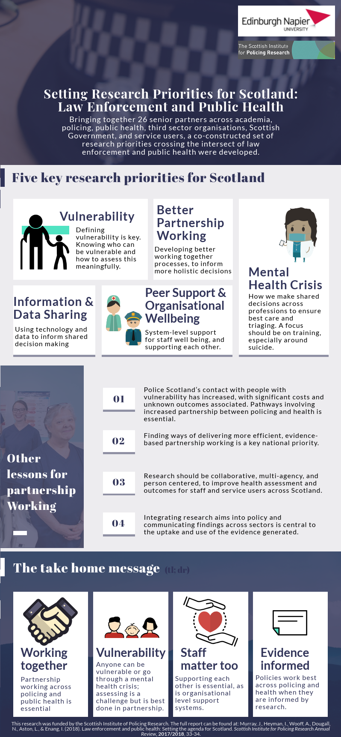
Infographic 2. Identifying a shared understanding of vulnerability across Law Enforcement and Public Health literature. Published: Enang et al. (2019).
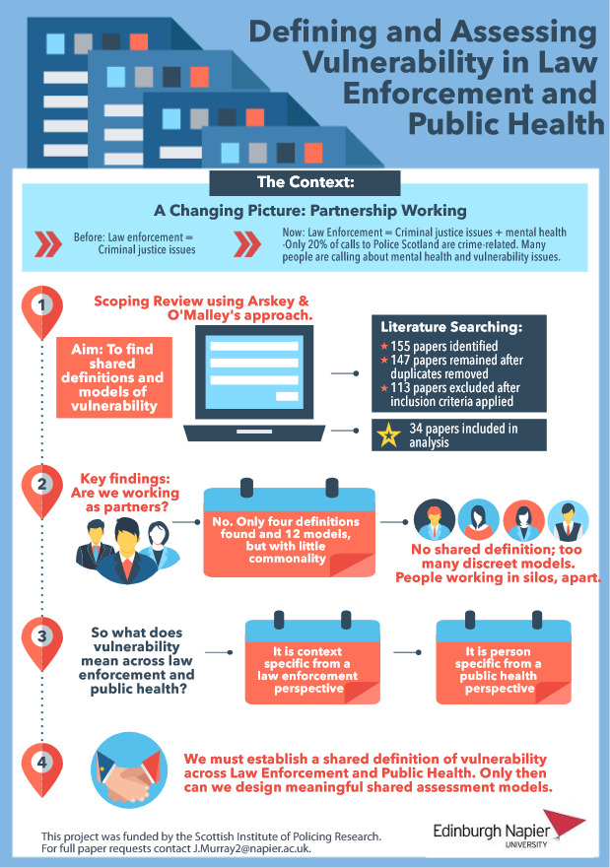

References:
Enang, I., Murray, J., Dougall, N., Wooff, A., Heyman, I., & Aston, E. (2019). Defining and Assessing Vulnerability within Law Enforcement and Public Health Organisations: A Scoping Review. Health & Justice. 7: 2.

Murray, J., Heyman, I., Wooff, A., Dougall, N., Aston, L., & Enang, I. (2018). Law enforcement and public health: Setting the agenda for Scotland. Scottish Institute for Policing Research Annual Review, 2017/2018, 33-34.

