Title
Alternative Models of Disorders of Traumatic Stress Based on the New ICD-11 Proposals

Running title
Models of Disorders of Traumatic Stress

Authors
Mark Shevlin¹
Philip Hyland²
Thanos Karatzias^{3,4}
Claire Fyvie⁴
Neil Roberts⁵
Jonathan I Bisson⁶
Chris R. Brewin⁷
Marylene Cloitre^{8,9}

Affiliations
¹Ulster University, School of Psychology, Derry, UK
²National College of Ireland, School of Business, Dublin, Ireland
³Edinburgh Napier University, Faculty of Health, Life and Social Sciences, Edinburgh, UK
⁴NHS Lothian, Rivers Centre for Traumatic Stress, Edinburgh, UK
⁵Psychology and Counselling Directorate, Cardiff and Vale University Health Board, Cardiff, UK.
⁶Cardiff University, School of Medicine, Cardiff, UK
⁷University College London, Clinical, Education & Health Psychology, London, UK
⁸New York University, School of Medicine, USA
⁹National Center for PTSD, Veterans Affairs Palo Alto Health Care System, Palo Alto, CA, USA

³Address for Correspondence:
Prof. Thanos Karatzias, Edinburgh Napier University, Sighthill Campus, Sighthill Court, Edinburgh EH11 4BN, Scotland UK,Tel. (+44) (0) 131 455 5345, Email.t.karatzias@napier.ac.uk

Alternative Models of Disorders of Traumatic Stress Based on the New ICD-11 Proposals

Abstract
Objective Although there is emerging evidence for the factorial validity of the distinction between Posttraumatic Stress Disorder (PTSD) and Complex PTSD (CPTSD) proposed in ICD-11, such evidence has been predominantly based on using selected items from individual scales that describe these factors. We have attempted to address this gap in the literature by testing a range of alternative models of disorders of traumatic stress using a broader range of symptoms and standardised measures. Method Participants in this cross-sectional study were a sample of individuals who were referred for psychological therapy to a National Health Service (NHS) trauma centre in Scotland (N=195). Participants were recruited over a period of 18 months and completed measures of stressful life events, DSM-5 PTSD, emotion dysregulation, self–esteem, and interpersonal difficulties. Results Overall, results indicate that a structural model incorporating six first-order factors (re-experiencing, avoidance of traumatic reminders, sense of threat, affective dysregulation, negative self-concept, and disturbances in relationships) and two second order factors (PTSD and Disturbances in Self-Organization [DSO]) was the best fitting. The model presented with good concurrent validity. Childhood trauma was found to be more strongly associated with DSO than PTSD. Conclusions Our results are in support of the ICD-11 proposals for PTSD and CPTSD.
Keywords Posttraumatic Stress Disorder (PTSD), Complex PTSD (CPTSD), Disorders of Traumatic Stress, ICD-11

Significant Outcomes
- A structural model incorporating six first-order factors and two second order factors (PTSD and DSO) provided the best fit to the data
- Results are in support of the ICD-11 proposals for CPTSD
Limitations
- Sample consisted predominantly of people who had experienced childhood psychological trauma or been multiply traumatised in childhood and adulthood.
- A number of possible alternative symptoms in the tested models that are highly prevalent in trauma populations, such as borderline symptoms and dissociation, were not considered.

Introduction
Two ‘sibling disorders’ have been proposed for ICD-11: Posttraumatic Stress Disorder (PTSD) and Complex PTSD (CPTSD) [1]. The organizing principles for the ICD-11 revisions were that diagnoses should be consistent with clinicians’ mental health taxonomies, limited in the number of symptoms included, and based on distinctions important for management and treatment [2]. The ICD-11 model of PTSD includes symptoms reflecting three clusters: (1) Re-experiencing of the trauma in the present, (2) avoidance of traumatic reminders, and (3) a persistent sense of threat that is manifested by increased arousal and hypervigilance. These symptoms define PTSD as a response characterized by some degree of fear or horror related to a specific traumatic event. In contrast, the symptom profile of CPTSD includes the core PTSD symptoms plus additional symptoms that identify ‘disturbances in self-organization’ (DSO) which may result from sustained, repeated, and multiple forms of traumatic exposures. There are three DSO symptom categories: (1) affective dysregulation, (2) negative self-concept, and (3) disturbances in relationships. Thus, the ICD-11 proposals contain two logically distinct elements: A structural description of PTSD and CPTSD involving two groups of three factors, and new content concerning the key symptoms. This study addresses the structural element of the proposals.
There have been numerous factor analytic studies that have provided evidence for this conceptualisation of PTSD and CPTSD. Support for the three-factor structure of PTSD is a necessary prerequisite for the validity of the CPTSD model. Confirmatory factor analytic studies using different measures (e.g., Clinician Administered PTSD Scale, Harvard Trauma Questionnaire, PTSD Checklist for DSM-5) with various clinical and community samples (e.g., survivors of childhood trauma, refugees, traumatic injury survivors admitted to hospital, bereaved parents) have provided evidence in support of this structure [3-6]. Furthermore, there is evidence that indicators of DSO are also best explained in terms of the three correlated factors described in ICD-11, based on data from adult survivors of childhood institutional abuse [7] and treatment-seeking victims of interpersonal violence ranging from prolonged childhood abuse to adult single-incident traumas [8]].
The ICD-11 proposes that CPTSD is multi-dimensional and hierarchical; that is that the three symptom clusters defining PTSD can be explained by a higher order ‘PTSD’ factor, and that affective dysregulation, negative self-concept, and disturbances in relationships can be explained by a higher order ‘DSO’ factor. It would also be expected that these superordinate PTSD and DSO factors would be positively correlated. Hyland et al. [9] tested this hypothesis using data from a large sample of treatment-seeking adult victims of childhood sexual abuse and found that, of four alternative models tested, the ICD-11 model was the best fitting, and the PTSD and DSO factors were strongly correlated (r = .81). Tay et al. [10] also reported acceptable fit for a multi-dimensional solution with the six correlated first-order factors based on data from West Papuan refugees. However, a model with two second order factors was not tested in this research.
To date, the extant research evidence appears to support the construct validity of the ICD-11 model of CPTSD. However, a salient limitation of all previous studies has been the ad hoc approach to the measurement of the three DSO dimensions that comprise the CPTSD diagnosis. The absence of a specific measure of ICD-11 CPTSD symptomatology has meant that previous studies have had to rely on the selection of items from pre-existing scales such as the Brief Symptom Inventory (BSI; [11]) and the Trauma Symptom Checklist (TSC; [12]) in order to capture the proposed DSO symptoms. Although this approach offered a viable method of assessing the structure of CPTSD, such an approach fails to recognise and capture the dimensional nature of the three DSO constructs of affective dysregulation, negative self-concept, and disturbances in relationships. An alternative approach to modelling the DSO constructs, and by extension testing the structural validity of the proposed CPTSD construct, is through the use of dimensional measures that can more accurately capture the continuous distribution of scores on each DSO dimension. Specifically, in the current study PTSD symptoms were measured using the PTSD Checklist for DSM-5 (PCL-5 [13]) while affective dysregulation was assessed using the Difficulties in Emotional Regulation Scale (DERS [14]), negative self-concept by (low scores on) the Rosenberg Self-Esteem Scale (RSES [15]) and disturbances in relationships using the Inventory of Interpersonal Problems (IIP [16]).
Effectively, therefore, this study tested the structural proposals for CPTSD contained in ICD-11 independently of the specific symptomatology content proposals. It was predicted that the model with six first-order factors and two second-order factors (PTSD and DSO) would be well-fitting, and would fit better than alternative models that were not both multi-dimensional and hierarchical. Furthermore, the concurrent validity of the ICD-11 model was tested by estimating the associations between the first- and second-order PTSD and DSO factors with scores reflecting exposure to childhood trauma. To be consistent with the ICD-11 proposals it was predicted that childhood trauma would be more strongly associated with DSO than PTSD.

Method
Participants and procedure
Participants in this study were individuals who were referred by general practitioners, psychiatrists or psychologists for psychological therapy to a National Health Service (NHS) trauma centre in Scotland. All 230 new patients over the 18 month recruitment period were sent a letter and invited to complete a set of standardised measures. Twenty-two did not respond and 13 provided unusable data due to large amounts of missing responses, which resulted in a final sample size of 195. Ethics approval for the study was sought by the NHS Lothian Committee.
The mean age of the sample was 41 years (SD = 12.4) and there were more females (65.1%) than males. Most of the sample were born in the United Kingdom (88.7%) and of these most were from Scotland (79%). The highest level of academic attainment was varied: school (38.5%), College (30.2%), and University (30.2%). Approximately one third of the sample was in employment (full-time 20.2%, part-time 13%), 38.9% were unemployed, 7.3% were retired, and 5.7% were in voluntary work (15% reported ‘None of these’). Almost half of the sample were single (48.2%), 22.3% were married, 12.4% were divorced, 9.8% were co-habiting, and 7.3% indicated ‘Other’. Most participants were either living with a partner or with their family (41%), 34.7% were living alone (and 24.4% reported ‘Other’).
Measures
PTSD Checklist for DSM-5 (PCL-5: [13])
The PCL-5 is a 20-item self-report measure that assesses the 20 DSM-5 symptoms of PTSD. Initially the PCL-5 assesses Criterion A with the following instructions, “This questionnaire asks about problems you may have had after a very stressful experience involving actual or threatened death, serious injury, or sexual violence. It could be something that happened to you directly, something you witnessed, or something you learned happened to a close family member or close friend. Some examples are a serious accident; fire; disaster such as a hurricane, tornado, or earthquake; physical or sexual attack or abuse; war; homicide; or suicide. First, please answer a few questions about your worst event, which for this questionnaire means the event that currently bothers you the most.” The scale instructions are, “Keeping your worst event in mind, please read each problem carefully and then circle one of the numbers to the right to indicate how much you have been bothered by that problem in the past month”. Participants respond using a 5-point Likert scale, ranging from "Not at all" (0) to "Extremely" (4). Symptom cluster severity scores are calculated for Intrusions (5 items), Avoidance (2 items), Negative alterations in cognitions and mood (7 items), and Alterations in arousal and reactivity (6 items). For the purposes of the current study only selected items from the Intrusions (B2, B3, and B4), Avoidance (C1 and C2), and Arousal (E3 and E4) clusters were selected in order to capture the ICD-11 PTSD symptom profile. The scale can be used to generate a self-report DSM-5 diagnosis using a cut-point of 38. Studies have reported acceptable psychometric properties of the PCL-5 scores in non-clinical [17] and trauma-exposed samples [18]. Wilkins et al. [19] provide a comprehensive review of the psychometric evaluation of earlier versions of the PCL. Reliability estimates (composite reliability) of the Intrusion (.70) and Arousal (.78) item scales were moderate but lower for Avoidance (.50).
Difficulties in Emotional Regulation Scale (DERS [14])
The DERS is a standardised 36-item measure of emotion regulation involving not just the modulation of emotional arousal, but also the awareness, understanding, and acceptance of emotions, and the ability to act in desired ways regardless of emotional state. It provides six subscales including ‘Non-acceptance of emotional responses’, ‘Difficulties in engaging in goal directed behaviour’, ‘Impulse control difficulties’, ‘Lack of emotional awareness’, ‘Limited access to emotional regulation strategies’ and ‘Lack of emotional clarity’. Participants are asked to indicate how often the items apply to themselves, with responses ranging from ‘Almost never’ (1) to ‘Almost always’ (5). In this study the mean scores on the ‘Impulse control difficulties’ and ‘Lack of emotional awareness’ scales were used. The DERS subscales have been found to be unidimensional [20] and the reliability of the scales was high in this sample; ‘Impulse control difficulties’ (.89) and ‘Lack of emotional awareness’ (.83).
Rosenberg Self-Esteem Scale (RSES [15])
The RSES consists of 10 Likert-type scale items designated to assess positive and negative evaluations of self. Respondents indicate their level of agreement ranging from 1 (strongly disagree) to 4 (strongly agree). Thus, the possible total score can range from a minimum of 10 to a maximum of 40, with higher scores reflecting more positive evaluations of self. Based on data from 16,998 participants across 53 nations a score of less than 26 was considered to represent low self-esteem [21]. The RSES has been found to be unidimensional [22] and the reliability of the scale scores was high in this sample (.89).
Inventory of Interpersonal Problems - Short Circumplex Form (IIP [16])
The Inventory of Interpersonal Problems - Short Circumplex Form (IIP) is a 32-item self-report measure of interpersonal difficulties and consists of 8 subscales (Domineering, Vindictive, Cold, Socially Avoidant, Non-assertive, Exploitable, Overly Nurturant, and Intrusive) with responses based on a 5-point Likert scale ranging from ‘Almost never’ (1) to ‘Almost always’ (5). In this study the ‘Socially Avoidant’ and ‘Cold’ scales were used. In a large sample of university students the mean scores for the Socially Avoidant’ and ‘Cold’ subscales were 1.18 and 1.09 respectively [23]. The subscale have been found to be unidimensional [24] and the reliability of the scales was high; ‘Socially Avoidant’ (.85) and ‘Cold’ (.87).
Childhood Trauma Questionnaire (CTQ [25])
The CTQ is a 28-item self-report questionnaire that assesses exposure to range of different childhood traumas. The scale produces five subscales, each with five items: Emotional Abuse, Physical Abuse, Sexual Abuse, Emotional Neglect, and Physical Neglect. Items are responded to using a 5-point scale ranging from “never true” (1) to “very often true” (5) which produces possible scores 5 to 25 for each trauma subscale. The reliability of the scales was high in this sample; Emotional Abuse (.90), Physical Abuse (.85), Sexual Abuse (.97), Emotional Neglect (.92), Physical Neglect (.83).
The Life Events Checklist (LEC [26])
The LEC is a 17-item self-report measure designed to screen for potentially traumatic events in a respondent's lifetime. The LEC assesses lifetime exposure to 16 traumatic events (e.g., Natural disaster, Physical assault, Life threatening illness/injury) and the 17th item, “Any other very stressful event/experience”, can be used to indicate exposure to a trauma that was not listed. For each item, the respondent checks whether the event ‘Happened to me’ (1), ‘Witnessed it happening to somebody else’ (2), ‘Learned about it happening to someone close to me’ (3), ‘Part of my job’ (4), ‘Not sure it applies’ (5), ‘Doesn't apply to my experience’ (6). In order to create a summed total to represent the number of different life events that has been experienced the items were recoded into binary variables with ‘Happened to me’ responses being coded as 1 and all other responses coded as 0. This produced a single ‘Total traumas’ variable with possible scores ranging from 0 to 16; item 17 was not included as the nature of the trauma could not be identified.
Analysis
The latent structure of CPTSD was tested using confirmatory factor analysis (CFA). PTSD symptoms were measured using 7 items from the PCL-5 that measure each of the ICD-11 PTSD symptoms clusters. Item level analysis for the DSO variables (Emotional Regulation Scale, the Rosenberg Self-Esteem Scale, and the Inventory of Interpersonal Problems) was not appropriate given the large number of items and the modest sample size. In order to ensure that each DSO latent variable had multiple indicators, thereby controlling for measurement error, the models were specified using item parcels. Item parcelling is a method by which individual items for a construct are combined into a small number of ‘parcels’ that can then be used as observed variables in the CFA. Items can be parcelled in different ways, for example, an 8 item scale (Q1 to Q8) could be parcelled into two observed variables by taking the sum or average of the first four and last four items (e.g. Parcel 1 = Sum Q1 to Q4, Parcel 2 = Sum Q5 to Q8), using odd/even numbered items (e.g. Parcel 1 = Sum Q1, Q3, Q5, Q7; Parcel 2 = Sum Q2, Q4, Q6, Q8), or random allocation (e.g. Parcel 1 = Sum Q1, Q2, Q5, Q8; Parcel 2 = Sum Q3, Q4, Q6, Q7). Matsunaga [27] provides a comprehensive overview on the benefits, and potential limitations, of using item parcels in latent variable modelling. Table 1 provides details on the PCL items that were used and how the items for all the DSO measures were parcelled.
Table 1 about here
The choice of DERS and IIP subscales was made to be consistent with the indicators previously used to measure the affective dysregulation and disturbances in relationships factors (see [28, 29]). In addition, the affective dysregulation dimension has been considered to represent both emotional hyperactivation and deactivation, and the DERS ‘Impulse control difficulties’ and ‘Lack of emotional awareness’ subscales reflect these dimensions respectively. Ford et al. [30] noted that two important aspects of the disturbances in relationships construct are difficulties in sustaining relationships and difficulty in maintaining emotional engagement; the ‘Socially Avoidant’ and ‘Cold’ subscales form the IIP were used to reflect these aspects.
Seven alternative models were specified (see Figure 1) and tested. Model 1 is a one factor model where all PTSD and DSO items load on a single latent variable. Model 2 is a correlated six factor model (Intrusion, Avoidance, Arousal, Affective dysregulation, Negative self-concept, and Disturbances in relationships). Model 3 replaced the factor correlations in Model 2 with a single second-order factor representing CPTSD. Model 4 specified two correlated second-order factors (PTSD and DSO) to explain the covariation among the six first-order factors; Re-experiencing, Avoidance, and Threat loaded on the PTSD factor and Affective dysregulation, Negative self-concept, and Disturbances in relationships loaded on the DSO factor. Model 5 and 6 tested the hypotheses that there was (1) no hierarchical structure for the PTSD items but a hierarchical structure for the DSO items (Model 5), and (2) no hierarchical structure for the DSO items but a hierarchical structure for the PTSD items (Model 6). Model 7 proposed that all the PTSD and DSO items loaded on two correlated first-order factors. For all models the error variances were uncorrelated.
Each model was specified and estimated in Mplus 7.1 [31] using robust maximum likelihood estimation (MLR: [32]) which has been shown to produce correct parameter estimates, standard errors and test statistics [33]. The MLR estimator is appropriate when the data are interval, such as the DSO item parcel variables, or ordinal with more than 3 categories [34]. The proportion of missing data for all study variables ranged from 0 to 3.6%, with a mean of 1.84%. For the confirmatory factor analysis this was handled using all available information which is the default when the MLR estimator is used [31]. Goodness of fit for each model was assessed with a range of fit indices including the chi-square (χ²), the comparative fit index (CFI; [35]) and the Tucker-Lewis Index (TLI; [36]). A non-significant χ² and values greater than .90 for the CFI and TLI were considered to reflect acceptable model fit. Additionally, the Root Mean Square Error of Approximation (RMSEA; [37]) was reported, where a value less than .05 indicated close fit and values up to .08 indicated reasonable errors of approximation [38]. The same cut-off values can be used for the Standardised Root Mean Square Residual (SRMR: [38]). The Bayesian Information Criterion (BIC; [39]) was also used to assess the relative fit of the models. The model with the lowest BIC was considered to be the better model, and a difference greater than 10 was considered to be indicative of a ‘significant’ difference [40]. When the best model was identified factor scores were calculated [41] and these were correlated with the criteria variables.

Results
Sample Characteristics
The prevalence of DSM-5 PTSD, based on a cut-off score over 38 on the PCL-5, was high at 88.2% and did not differ by gender (male = 92.6%, female = 85.8%, χ² (1) = 1.98, p > .05). Medication had been prescribed to 67.5% of the sample. The participants also reported exposure to multiple traumatic events. The median number of traumas reported using the Life Events Checklist was 5 (25th percentile = 3, 75th percentile = 7, IQR = 4) and there was no significant differences between males and females (median test (1) = .07, p > .05). Only a small number (4.6%) reported exposure to a single traumatic event; 71.8% of the sample reported experiencing between three and eight traumatic events. Descriptive statistics for the main study variables are presented in table 2.
Table 2 about here
The mean scores on the PTSD items were all above the scale midpoint of 2 (‘Moderately’ bothered by symptom), and many closer to, or above, 3 (‘Quite a bit’ bothered by symptom) and there were no significant gender differences. The mean scores for the ‘Impulse’ and ‘Clarity’ subscales of the DERS were approximately 3, and this corresponds to the rating emotional difficulties “About half the time”. Males scored significantly higher on the ‘Clarity’ subscale, and the effect size was small to moderate (Cohen’s d = .34). The mean scores for the Rosenberg Self-esteem Scale were lower than the cut-off score that indicates ‘low’ self-esteem and there were no significant gender differences. The mean scores on the ‘Socially avoidant’ and ‘Cold’ subscales were higher than the non-clinical norms, and males scored significantly higher and the effect size was moderate (Cohen’s d = .44). The mean scores on the CTQ, using the classification developed by the scale’s authors [25], represented ‘moderate to severe’ levels of emotional abuse (females significantly higher but in same category, effect size small to moderate, Cohen’s d = .34) and physical abuse, and ‘Slight to moderate’ levels of emotional neglect and physical neglect. Females scored significantly higher than males on the sexual abuse scale, and the effect size was moderate (Cohen’s d = .48); females scored in the ‘Severe to extreme’ category and males in the ‘moderate to severe’ category. Endorsement rates for any item (score > 1) from the CTQ subscales indicated that any experience of childhood trauma was also high: Emotional Abuse 84.6%, Physical Abuse 63.8%, Sexual Abuse 53.3%, Emotional Neglect 79.8%, and Physical Neglect 68.6%.
Confirmatory Factor Analysis
The fit statistics for the seven models of PTSD and CPTSD are presented in Table 3.
Table 3 about here
Although the chi-square statistics were statistically significant this should not lead to the rejection of the models as the power of the chi-square test is positively related to sample size [41]. Models 2, 3 and 4 met the criteria for acceptable model fit based on the CFI, TLI, and RMSEA, and additionally these models also had the lowest values for the SRMR. These were the best fitting models and the BIC indicated that Model 4 was better than Models 2 and 3; the difference between the BIC values for Model 2 and 3 was small (ΔBIC = 3.676), but the differences between the BIC for Model 4 and Model 2 (ΔBIC = 27.482), and between Model 4 and Model 3 (ΔBIC = 23.807) were larger and greater than 10 which is considered to be indicative of a ‘significant’ difference. Therefore Model 4 should be considered the best model. The factor loadings for Model 4 are presented in Table 4.
Table 4 about here
The second-order factor loadings for the PTSD factor (Re-experiencing = .94, Avoidance = .81, Threat = .70) and the DSO factor (Affective Dysregulation = .79, Negative Self-Concept = -.89, Disturbances in relationships = .90) were all high and statistically significant (p < .05). The correlation between the PTSD and DSO factor was .72 (p < .05). The correlations between the factor scores derived from Model 4 and the criteria variables are presented in Table 5.
Table 5 about here
PTSD/CPTSD Correlations
The childhood trauma scores were positively associated with factor scores for all first order factors and magnitude of the correlations were quite similar for both the PTSD and DSO variables, although the (absolute) correlations were generally higher for the DSO variables. The differences were larger for the emotional and physical neglect variables. For the second-order factor scores the correlations were higher for DSO than PTSD, although the differences in the magnitude of the correlations were small.
Overall results indicate that Model 4 with six first-order factors and two second order factors (PTSD and DSO) was the best fitting model. The model presented with good concurrent validity. Childhood trauma was also found to be more strongly associated with DSO than PTSD.

Discussion
Emerging evidence assessing the factorial validity of ICD-11 proposals for CPTSD has provided support for both a six-factor correlated model [10] and second-order hierarchical model [9]. A limiting factor of existing studies is the use of selected items from individual scales that describe these factors. We have attempted to address this gap in the literature by testing a range of alternative models of CPTSD using standardised measures that more effectively capture the dimensional nature of the three DSO factors. Overall results indicate that a model with six first-order factors and two second order factors (PTSD and DSO) was the best fitting model, with good concurrent validity. The fit of this model to the data was considered acceptable based on established criteria for assessment of model fit [43]. Our results add to an emerging evidence base which supports a second-order hierarchical model of the structure of CPTSD (e.g., [9]) when using validated measures and are in support of the ICD-11 proposals for CPTSD. Unlike Tay et al. [10], in the present study childhood trauma was found to be more strongly associated with DSO than PTSD. Thus, CPTSD symptomatology compared with PTSD symptomatology in the current sample is consistent with the theoretical basis of CPTSD that exposure to childhood abuse increases the likelihood of a CPTSD, rather than a PTSD, response [1, 23].
Nevertheless our study contained a number of limitations. Our sample consisted predominantly of people who had experienced childhood psychological trauma or had been multiply traumatised in childhood and adulthood. The present and previous research [28] have indicated that childhood and multiple traumatisation are risk factors for CPTSD [1]. Therefore, our findings require replication with larger samples exposed to different types of traumatic events. A further limitation of this study is that we have not considered a number of possible alternative symptoms in our models that are highly prevalent in trauma populations, such as borderline symptoms and dissociation. Also, the measures used as indicators of DSO were not time referenced, whereas the PCL-5 items used are based on how the participants felt in the last month. Finally, RSES has been developed as a measure of global self-esteem and not as measure of negative self–concept following exposure to a traumatic event as per ICD-11 definition.
The relationship of dissociation to ICD-11 PTSD and CPTSD remains unknown. Dissociation has been described as an adaptive response to overwhelming peri-traumatic negative affect such as fear or horror (e.g., [44]). Events occurring in childhood tend to be more overwhelming because children are less capable of organizing their responses to traumatic experiences coherently [45]. Thus, dissociation may be more likely to fit a CPTSD profile rather than a PTSD profile, because CPTSD predominantly results from chronic, sustained, and multiple types of traumatic exposures of interpersonal and childhood nature. DSM–5 [46] describes a dissociative subtype comprised of two symptoms (i.e., derealization and depersonalization) and it would be of interest to compare in future research the DSM–5 PTSD dissociative subtype to ICD-11 CPTSD in diverse trauma populations.
The relationship between BPD and CPTSD has been explored in a few studies (e.g., [28]). It has been suggested that CPTSD can be distinguished from BPD by the nature of the constellation of symptoms and by differences in the risk for self-harm. For example, BPD does not require the presence of a traumatic event which is required in CPTSD. Furthermore, BPD is strongly characterized by fear of abandonment, shifting identity, and frequent suicidal behaviours. In CPTSD, the fear of abandonment is not a requirement of the disorder and self-identity is consistently negative rather than shifting [47]. More recent evidence suggests that four symptoms can clearly distinguish BPD from CPTSD; frantic efforts to avoid abandonment, unstable sense of self, unstable and intense interpersonal relationships, and impulsiveness [28]. However, further research is required on the association between BPD and CPTSD symptomatology.
Our findings have a number of implications for research, practice, and policy. The ICD-11 proposals for PTSD and CPTSD create a need to further understand the biopsychosocial aetiological factors of complex traumatic stress reactions. There is emerging evidence, including the present study, that childhood traumatic life events are more closely related to complex traumatic stress reactions but the pathways that lead to certain traumatic stress reactions, and the role of protective factors, remain unknown. This information is essential for the conceptualisation and development of interventions to reverse traumatic impact. The findings that traumatic stress can be economically explained in terms of two higher order latent factors can simplify clinical practice with regards to assessing and treating individuals with traumatic stress. Nevertheless, it is important to emphasise that these findings support the proposals of ICD-11 with regard to the structure of traumatic stress conditions whereas further work is required to confirm the nature of the specific symptoms that comprise each factor. Our results suggest that screening for both PTSD and CPTSD in traumatised populations should be routine practice. There is adequate evidence for the treatment of PTSD but less so for CPTSD. The treatment of a unique CPTSD disorder may require alternative clinical interventions to the standard evidence-based methods of treating PTSD as per DSM-5 definitions [47]. Multiphase therapeutic interventions have been developed for both adult [48] and child [49] CPTSD populations, however, further research is required on the effectiveness and acceptability of interventions for CPTSD.

References
1. Maercker A, Brewin CR, Bryant RA, Cloitre M, et al.Proposals for mental disorders specifically associated with stress in the ICD-11. Lancet 2013; 381(9878):1683–1685.
2 .Reed GM. Toward ICD-11: Improving the clinical utility of WHO's international classification of mental disorders. Prof Psychol-Res 2010; 41:457–464.
3. Forbes D, Lockwood E, Creamer M, Bryant RA, McFarlane AC, Silove D, O’Donnell M. Latent structure of the proposed ICD-11 post-traumatic stress disorder symptoms: Implications for the diagnostic algorithm. Brit J Psychiat 2015; 206:245–251.
4. Hansen M, Hyland P, Armour C, Shevlin M, Elklit A. Less is more? Assessing the validity of the ICD-11 model of PTSD across multiple trauma samples. Eur J Psychotraumatol 2015; 6:28766.
5. Tay AK, Rees S, Steel Z, Tam N, et al. Six-year trajectories of post-traumatic stress and severe psychological distress symptoms and associations with timing of trauma exposure, ongoing adversity and sense of injustice: a latent transition analysis of a community cohort in conflict-affected Timor-Leste. BMJ Open 2016; 6 doi: 10.1136/bmjopen-2015-01020.
6. Glück TM., Knefel M, Tran US, Lueger-Schuster B. PTSD in ICD-10 and proposed ICD-11 in elderly with childhood trauma: prevalence, factor structure, and symptom profiles. Eur J Psychotraumatol. 2016 Jan 21; 7:29700. doi: 10.3402/ejpt.v7.29700
7. Knefel M, Lueger-Schuster B. An evaluation of ICD-11 PTSD and complex PTSD criteria in a sample of adult survivors of childhood institutional abuse. Eur J Psychotraumatol 2013; 4 22608, doi: http://dx.doi.org/10.3402/ejpt.v4i0.22608.
8 .Cloitre M, Garvert DW, Brewin CR, Bryant RA et al. Evidence for proposed ICD-11 PTSD and complex PTSD: a latent profile analysis. Eur J Psychotraumatol 2013; 4 10.3402/ejpt.v4i0.20706. http://doi.org/10.3402/ejpt.v4i0.20706
9. Hyland P, Shevlin M, Elklit A, Murphy J, et al. An Assessment of the Construct Validity of the ICD-11 Proposal for Complex Posttraumatic Stress Disorder. Psychol Trauma 2016; http://dx.doi.org/10.1037/tra0000114
10. Tay, AK, Rees S, Chen J, Kareth M, Silove D. The structure of post-traumatic stress disorder and complex post-traumatic stress disorder amongst West Papuan refugees. BMC Psychiatry 2015, 15:111.
11.Derogatis, LR. BSI Brief Symptom Inventory. Administration, Scoring, and Procedures Manual. 4th ed. Minneapolis, MN: National Computer Systems, 1993.
12.Briere J, Runtz M. The Trauma Symptom Checklist (STC- 33): Early data on a new scale. J Interpers Violence 1989; 4 :151–163.
13.Weathers FW, Litz BT, Keane TM, Palmieri PA, et al. The PTSD Checklist for DSM-5 (PCL-5). Scale available from the National Center for PTSD at http://www.ptsd.va.gov/professional/assessment/adult-sr/ptsd-checklist.asp 2013.
14.Gratz KL, Roemer L. Multidimensional assessment of emotion regulation and dysregulation: Development, factor structure, and initial validation of the difficulties in emotion regulation scale. J Psychopathol Behav Assess 2004; 26(1): 41-54.
15.Rosenberg M. Society and the adolescent self-image. Princeton, NJ: Princeton University Press, 1965.
16.Soldz S, Budman S, Demby A, Merry J. A short form of the inventory of interpersonal problems circumplex scales. Assessment 1995; 2: 53-63.
17.Conybeare D, Behar E, Solomon A, Newman MG, et al.The PTSD Checklist-Civilian Version: reliability, validity, and factor structure in a nonclinical sample. ‎J. Clin. Psychol 2012; 68(6): 699-713.
18.Konecky B, Meyer EC, Kimbrel NA, Morissette SB. The structure of DSM-5 posttraumatic stress disorder symptoms in war veterans. Anxiety Stress Coping 2015; 16 :1-10.
19.Wilkins KC, Lang AJ, Norman SB. Synthesis of the Psychometric Properties of the PTSD Checklist (PCL) Military, Civilian, and Specific Versions. ‎Depress. Anxiety 2011; 28(7): 596–606.
20. Neumann A, van Lier PA, Gratz KL, Koot HM. Multidimensional assessment of emotion regulation difficulties in adolescents using the Difficulties in Emotion Regulation Scale. Assessment 2010; 17: 138-149.
21. Schmitt DP, Allik J. Simultaneous administration of the rosenberg self-esteem scale in 53 nations: exploring the universal and culture-specific features of global self-esteem. J Pers Soc Psychol 2005; 89(4): 623–642 .
22. Marsh H W, Scalas FL, Nagengast, B, Longitudinal tests of competing factor structures for the Rosenberg Self-Esteem Scale: Traits, ephemeral artifacts, and stable response styles. Psych Ass 2010; 22(2): 366-381.
23. Barkham M. The IIP-32: A short version of the Inventory of Interpersonal Problems. Brit J Clin Psychol 1996; 35(1): 21-35.
24. McEvoy PM, Burgess MM, Page AC, Nathan P, Fursland A. Interpersonal problems across anxiety, depression, and eating disorders: A transdiagnostic examination. Brit J Clin Psychol 2013: 52: 129-147.
25.Bernstein DP, Fink L. Childhood Trauma Questionnaire: A retrospective self-report Manual, San Antonio, TX: The Psychological Corporation, 1998.
26. Gray MJ, Litz BT, Hsu JL, Lombardo TW. Psychometric properties of the Life Events Checklist. Assessment 2004; 11:330–341.
27. Matsunaga M. Item parcelling in structural equation modelling: A primer. Commun Methods Meas. 2008; 2: 260-293. doi: 10.1080/19312450802458935
28.Cloitre M, Garvert DW, Brewin CR, Bryant RA, Maercker A. Evidence for proposed ICD-11 PTSD and complex PTSD: a latent profile analysis. Eur J Psychotraumatol. 2013; 15:4 doi: 10.3402/ejpt.v4i0.20706.
29.Cloitre M, Garvert DW, Weiss B, Carlson EB. Distinguishing PTSD, Complex PTSD, and Borderline Personality Disorder: A latent class analysis. Eur J Psychotraumatol 2014; 5 doi:10.3402/ejpt.v5.25097.
30.Ford JD, Courtois CA. Complex PTSD, affect dysregulation, and borderline personality disorder. Borderline Personality Disorder and Emotion Dysregulation, 2014; 1:9. doi: 10.1186/2051-6673-1-9.
31.Muthén, LK, Muthén B.O. MPlus user’s guide. 7th ed. Los Angeles, CA: Muthén & Muthén., 1998–2013.
32.Yuan K, Bentler PM. Three Likelihood-Based Methods for Mean and Covariance Structure Analysis With Nonnormal Missing Data. Sociol. Methodol 2000; 30:167-202.
33.Rhemtulla M, Brosseau-Liard PE, Savalei V. When can categorical variables be treated as continuous? A comparison of robust continuous and categorical SEM estimation methods under suboptimal conditions. Psychol Methods 2012; 17: 354–373.
34. Beauducel A, Herzberg PY. On the performance of maximum likelihood versus means and variance adjusted weighted least squares estimation in CFA. Struct Equ Modeling 2006; 13: 186-203. doi: 10.1207/s15328007sem1302_2
35.Bentler PM. Comparative fit indexes in structural models. Psychol. Bull 1990; 107(2): 238-246.
36.Tucker LR, Lewis C. The reliability coefficient for maximum likelihood factor analysis. Psychometrika 1973; 38:1-10.
37.Steiger JH. Structural model evaluation and modification: An interval estimation approach. Multivariate Behav Res 1990; 25: 173-180.
38.Jöreskog KG, Sörbom D. LISREL V: Analysis of Linear Structural Relationships by the Method of Maximum Likelihood. Chicago: National Educational Resources, Inc. 1981.
39.Schwarz G. Estimating the dimension of a model. Annals of Statistics 1978; 6:461– 464.
40.Raftery A. Bayesian model selection in social research. ‎Sociol. Methodol 1995; 25:111-163.
41. Muthén BO. Mplus Technical Appendices; Appendix 11. Los Angeles, CA: Muthén & Muthén. (1998-2004).

42. Tanaka JS. “How big is big enough?” Sample size and goodness of fit in structural equation models with latent variables. Child Dev. 1987; 58: 134-146.
43.Kline RB. Principles and Practice of Structural Equation Modeling. New York: Guilford Press, 2001.
44.Briere J. Child Abuse Trauma: Theory and Treatment of the Lasting Effects. Newbury Park, CA: Sage. 1992.
45.Van der Kolk BA. Child abuse and victimization. Psychiatric Annals 2005, 35: 376–8.
46.American Psychiatric Association. Diagnostic and statistical manual of mental disorders .5th ed. Arlington, VA: American Psychiatric Publishing, 2013.
47.Cloitre M, Courtois CA, Charuvastra A, Carapezza R. Treatment of complex PTSD: Results of the ISTSS expert clinician survey on best practices. J Trauma Stress 2011; 24(6):615–627.
48.Ford JD. Complex PTSD: research directions for nosology/assessment, treatment, and public health. Eur J Psychotraumatol. 2015; 6: 27584. doi: 10.3402/ejpt.v6.27584.
49.Connor DF, Ford J D, Arnsten AF, Greene CA. An update on posttraumatic stress disorder in children and adolescents. ‎Clin. Pediatr. 2015; 54(6): 517–528.

Table 1. Description of Measures, Items and Item Parcels Used in CFA of Complex PTSD.
Symptom Cluster | Measure | Items/Parcels | Items/Example Items
Re-experiencing | PCL-5 Intrusion scale | Re1 = PCL Intrusion item 2 | Repeated, disturbing dreams of the stressful experience?
 |  | Re2 = PCL Intrusion item 3 | Suddenly feeling or acting as if the stressful experience were actually happening again (as if you were actually back there reliving it)?
 |  | Re3 = PCL Intrusion item 4 | Feeling very upset when something reminded you of the stressful experience?
Avoidance | PCL-5 Avoidance scale | Av1 = PCL Avoidance item 6 | Avoiding memories, thoughts, or feelings related to the stressful experience?
 |  | Av2 = PCL Avoidance item 7 | Avoiding external reminders of the stressful experience (for example, people, places, conversations, activities, objects, or situations)?
Sense of Threat | PCL-5 Arousal scale | Th1 = PCL Arousal item 17 | Being “superalert” or watchful or on guard?
 |  | Th2 = PCL Arousal item 18 | Feeling jumpy or easily startled?
Affective Dysregulation | Difficulties in Emotional Regulation Scale | AD1 = Mean of DERS ‘Impulse’ subscale | When I’m upset, I lose control over my behaviours.  I experience my emotions as overwhelming and out of control.
 |  | AD2 = Mean of DERS ‘Clarity’ subscale | I have difficulty making sense out of my feelings.  I have no idea how I am feeling.
Negative Self-concept | Rosenberg Self-esteem Scale | NSC1 = Sum of Rosenberg items 1, 3, 5, 7, 9 | On the whole, I am satisfied with myself.
 |  | NSC2 = Sum of Rosenberg items 2, 4, 6, 8, 10 | At times I think I am no good at all.
Disturbances in Relationships | Inventory of Interpersonal Problems | DR1 = Mean of IIP ‘Socially avoidant’ subscale | It is hard for me to introduce myself to new people.  It is hard for me to socialise with other people.
 |  | DR1 = Mean of IIP ‘Cold’ subscale | It is hard for me to feel close to other people.  I keep people at a distance too much.

Table 2. Descriptive Statistics for Main Study Variables.

Measure | Male | Female | Total
PTSD
Re1 (PCL item 2) | 2.50 (1.33) | 2.63 (1.36) | 2.58 (1.35)
Re2 (PCL item 3) | 2.27 (1.40) | 2.48 (1.43) | 2.41 (1.42)
Re3 (PCL item 4) | 3.04 (0.99) | 3.22 (1.02) | 3.15 (1.01)
Av1 (PCL item 6) | 3.11 (1.07) | 3.20 (1.01) | 3.17 (1.03)
Av2 (PCL item 7) | 2.97 (1.09) | 2.97 (1.19) | 2.97 (1.15)
Th1 (PCL item 17) | 3.14 (1.04) | 2.93 (1.37) | 3.01 (1.27)
Th2 (PCL item 18) | 2.85 (1.24) | 2.86 (1.29) | 2.86 (1.27)
DSO
DERS ‘Impulse’ subscale | 2.92 (.99) | 2.76 (1.11) | 2.81 (1.07)
DERS ‘Clarity’ subscale | 3.13* (.76) | 2.84* (.91) | 2.94 (0.88)
Rosenberg Self-esteem Scale | 20.73 (5.02) | 21.33 (6.22) | 21.12 (5.81)
IIP ‘Socially avoidant’ subscale | 2.73 (1.00) | 2.66 (1.11) | 2.69 (1.07)
IIP ‘Cold’ subscale | 2.38* (1.04) | 1.88* (1.23) | 2.06 (1.19)
Childhood Trauma
CTQ: Emotional abuse | 12.66* (6.40) | 15.06* (6.70) | 14.19 (6.67)
CTQ: Physical abuse | 10.95 (5.91) | 10.50 (5.90) | 10.67 (5.89)
CTQ: Sexual abuse | 10.08* (7.22) | 13.78* (8.25) | 12.44 (8.07)
CTQ: Emotional neglect | 12.77 (6.34) | 13.89 (6.17) | 13.48 (6.24)
CTQ: Physical neglect | 8.92 (4.93) | 9.88 (5.04) | 9.53 (5.01)

Note: * mean difference between males and females significant using t-test (p < .05). PCL = PTSD Checklist for DSM-5; DERS = Difficulties in Emotional Regulation Scale; IIP = Inventory of Interpersonal Problems; CTQ = Childhood Trauma Questionnaire.

Table 3. Fit Statistics for the Alternative Models of CPTSD.
Model | BIC | Chi-square (df) | RMSEA (90% CI) | CFI | TLI | SRMR
1 | 8111.841 | 278.422 (65)* | .130 (.114-.146) | .724 | .669 | .086
2 | 7985.026 | 90.142 (50)* | .064 (.042-.085) | .948 | .919 | .043
3 | 7981.351 | 129.12 (59)* | .078 (.060-.096) | .909 | .880 | .063
4 | 7957.544 | 101.524 (58)* | .062 (.041-.082) | .944 | .924 | .046
5 | 7986.494 | 145.498 (61)* | . 084 (.067-.102) | .891 | .860 | .055
6 | 7984.353 | 143.132 (61)* | .083 (.065-.101) | .894 | .864 | .053
7 | 8012.836 | 186.324 (64)* | .099 (.083-.116) | .842 | .807 | .061
Note: * p < .05; df = degrees of freedom; BIC = Bayesian Information Criteria; CFI = Comparative Fit Index; TLI = Tucker Lewis Index; RMSEA = Root-Mean-Square Error of Approximation; SRMR = Standardised Root Mean Residual.
Table 4. Standardised First-order Factor Loadings for Model 4 of CPTSD.
Variable | Re | Av | Th | AD | NSC | DR
Re1 | .685
Re2 | .601
Re3 | .673
Av1 |  | .484
Av2 |  | .605
Th1 |  |  | .717
Th2 |  |  | .883
AD1 |  |  |  | .747
AD2 |  |  |  | .731
NSC1 |  |  |  |  | .866
NSC2 |  |  |  |  | .864
DR1 |  |  |  |  |  | .848
DR2 |  |  |  |  |  | .748

Note: All loading statistically significant (p < .05). Re = Re-experiencing, Av = Avoidance, Th = Sense of threat, AD = Affective Dysregulation, NSC = Negative Self Concept, DR = Disturbances in Relationships.

Table 5. Pearson Correlations between Model 4 Factor Scores and Trauma Variables.
Model 4 Factor scores | CTQ: Emotional abuse | CTQ: Physical abuse | CTQ: Sexual abuse | CTQ: Emotional neglect | CTQ: Physical neglect | Total LEC scores
Re-experiencing | .300 | .272 | .308 | .245 | .254 | .244
Avoidance | .295 | .266 | .292 | .241 | .248 | .224
Threat | .245 | .219 | .231 | .195 | .200 | .241
Affective Dysregulation | .344 | .304 | .342 | .319 | .316 | .307
Negative Self-Concept | -.408 | -.358 | -.403 | -.378 | -.360 | -.295
Disturbances in Relationships | .306 | .266 | .305 | .287 | .266 | .274
2nd Order - PTSD | .318 | .287 | .321 | .264 | .270 | .261
2nd Order - DSO | .373 | .328 | .371 | .344 | .329 | .304
Note: All correlations significant (p < .05); This factor loading is negative as self-esteem reflects positive self-evaluation and the DSO factor is scored in a negative direction.

Figure 1. Alternative Factor Models of the PTSD and DSO Variables.
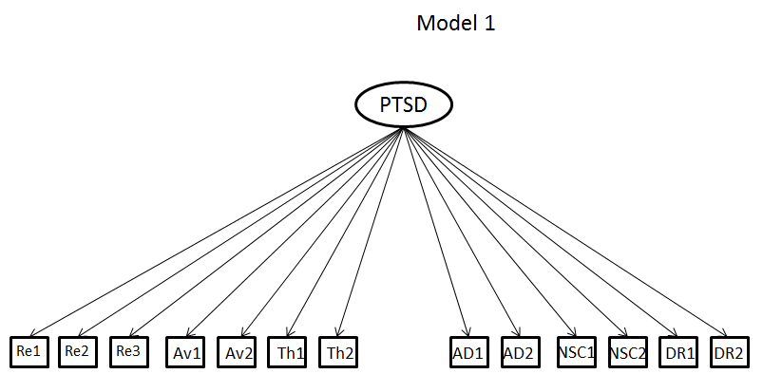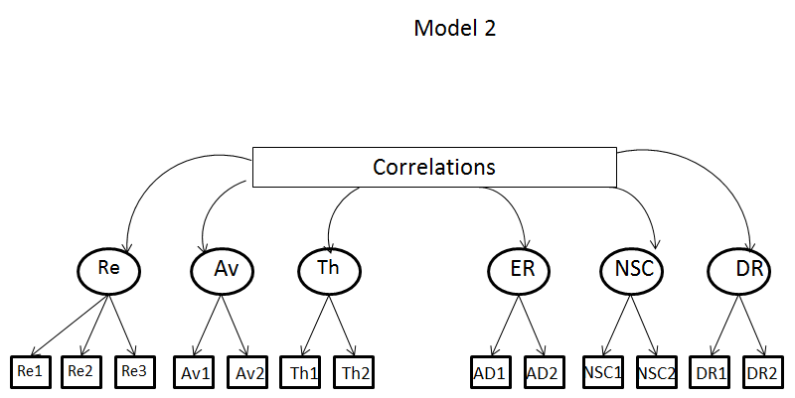
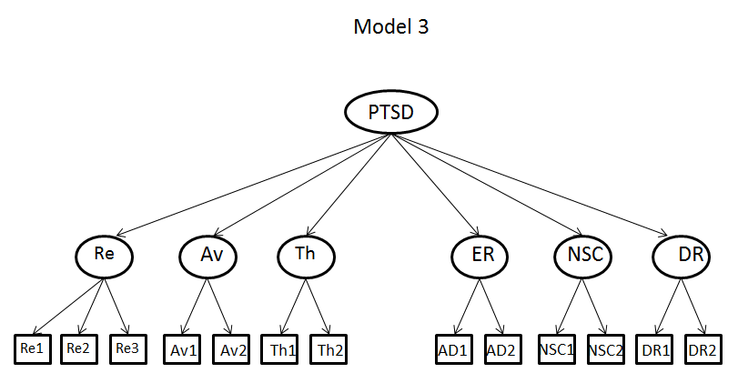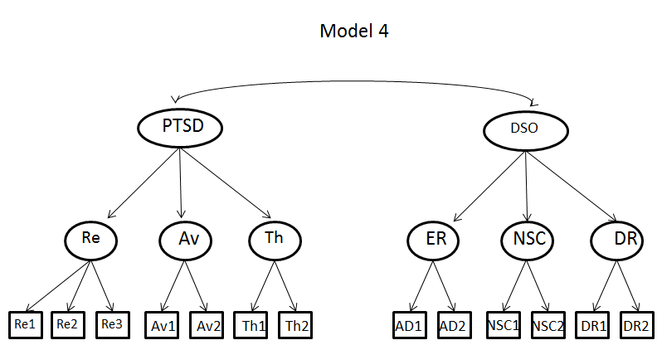

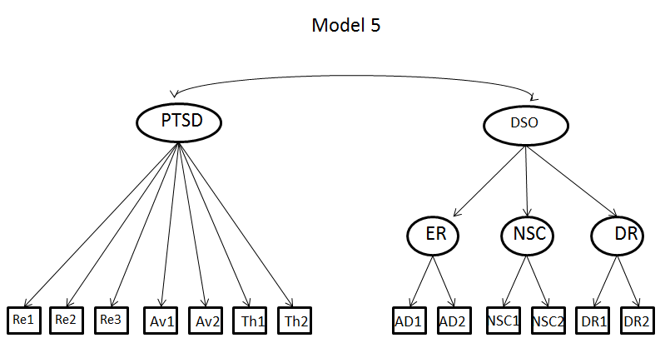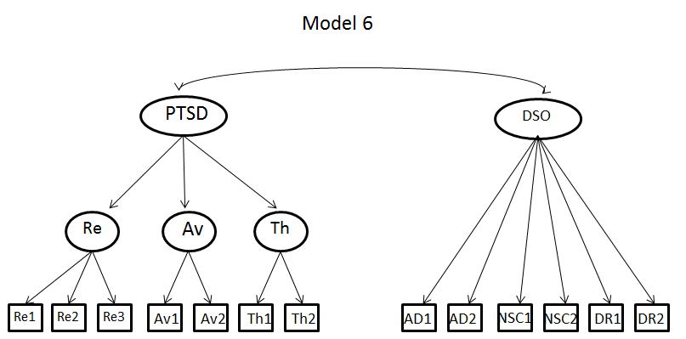

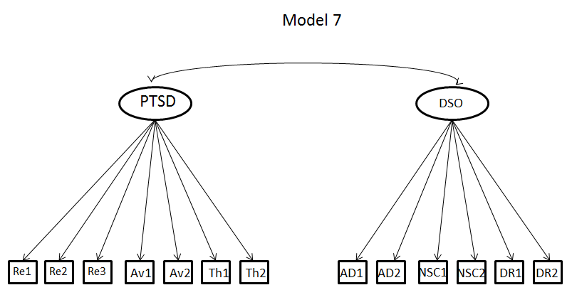
Note: Re1, Re 2, Re 3 = PCL Re-experiencing items 2, 3, 4; Av1, Av2 = PCL Avoidance items 6, 7; Th1, Th2 = PCL Threat items 17, 18; AD1 = Mean of DERS ‘Impulse’ subscale; AD2 = Mean of DERS ‘Clarity’ subscale; NSC1 = Sum of Rosenberg items 1, 3, 5, 7, 9; NSC2 = Sum of Rosenberg items 2, 4, 6, 8, 10; DR1 = Mean of IIP ‘Socially avoidant’ subscale; DR2 = Mean of IIP ‘Cold’ subscale.

This factor loading is negative as self-esteem reflects positive self-evaluation and the DSO factor is scored in a negative direction.

