The embedded intelligence of smart cities: urban life, citizenship and community

Mark Deakin¹ and Alasdair Reid¹
¹School of Engineering and Built Environment, Edinburgh Napier University, Scotland

ABSTRACT

This paper reviews Mitchell’s thesis on the transition from the city of bits to e-topia. The review finds it wanting and suggests the problems encountered with the thesis rest with the lack of critical insight e-topia offers into the embedded intelligence of smart cities. It also suggests the difficulties, which the thesis experiences in accounting for the embedded intelligence of smart cities raise serious questions about whether the e-topia demonstrators that digitally-inclusive regeneration platforms stand on are progressive. In particular, whether the demonstrators these platforms stand on are progressive in embedding the intelligence that cities need for them to be smart in not only bridging the digital divide in urban life, but also overcoming any adverse effect, which the inequalities and degradation of such exclusion have on the sense of citizenship and community they in turn construct.

Keywords: embedded intelligence, smart cities, urban life, citizenship, community, e-topia demonstrator, digitally-inclusive regeneration platforms

INTRODUCTION

Mitchell’s (1995) book on the City of Bits sets out a vision of urban life literally done to bits. Mitchell’s (1999) subsequent book on e-topia provides the counter-point to this vision of urban life and scenario whereby the city is not in bits, but a place where it all comes together. As Mitchell (2004) also goes on to state in: Me++: the Cyborg self and the Networked City, all this coming together is possible because “the trial separation of bits and atoms is now over” and this “post-AD 2000 dissolution of the boundaries between the virtual and physical”, is what makes everything worth playing for (p.3). Worth playing for because this coming together of the virtual and physical is something that not only needs to be integrated into the networks of urban life, but citizenship which it also embeds as the intelligence required to make cities smart (ibid).

CONCERNS WITH THE STATUS OF MITCHELL’S THESIS

While this thesis on the “coming together” of the virtual and physical and dissolution of the boundaries between cyber and meat space is compelling, it has to be recognised there are a number of concerns surrounding the status of the intelligence currently being embedded to make cities smart.

These concerns relate to the ability of the thesis to cope with what Mitchell refers to as: “ancient concerns” surrounding the ecology and equity of urban development and sustainability of the lean, mean and green strategy advanced to explain information society’s process of dematerialisation (what is referred to as the shedding of atoms). Here the concern rests not so much with the utopian legacy of such a vision, but the tendency the thesis has to repeat the mistakes of the past by failing to acknowledge that techno-topian solutions of this kind leave cities without the means by which to deal with the equity of such developments.

As Graham and Marvin (2001) note, these failings are significant, because they leave the thesis open to the criticism of being yet another kind of environmental determinism, which in this instance ends up splintering the experience of urban life and sense of citizenship that e-topia aims to bring together. How Mitchell counters such criticism is instructive and reveals a lot about the thesis’ ultimate objective. For while e-topia is seen to mark a break with the past, dis-embedding “insitu” practices, churning everything up and turning things around, what emerges out of this is perceived as being integrated back into an increasingly carbon-based experience of urban life and silicate-permeated sense of citizenship that serve to embed the intelligence of smart cities.

THE LANDSCAPE THIS PAPER TARGETS, AIMS TO STAKEOUT AND OCCUPY

Unfortunately, the only instruction we get from Mitchell on this reintegration appears in a statement on the materiality of the e-topia thesis found in Me++: The Cyborg-self and the Networked City. Here, Mitchell suggests, it is not virtual versus physical, or cyber versus meat space that is significant, but the intelligence being embedded everywhere, which is the critical factor in cities becoming smart.

Given the instruction Mitchell gives on the embedded intelligence of smart cities is not particularly insightful, the landscape this paper targets, aims to stakeout and occupy, is the middle ground between the high-level issues surrounding the Me++ of the Cyborg-self and those experiences of urban life where it all comes together. That is, where it all comes together as a sense of citizenship, which gets bottomed out as an emerging discourse on the embedded intelligence of smart cities.

The outcome of this discourse is a platform of services able to build bridges between the experience of urban life and sense of citizenship, which otherwise remains divided and in that respect, unresponsive to the public’s call for greater, more extensive and higher levels of participation. In particular, the public’s call for greater, more extensive and higher levels of participation that are scaled-up and resized into an experience of urban life, which lifts the sense of citizenship onto a new stage. Onto a new stage that has the wherewithal to reach out, extend into, consult with and include deliberations between members of communities on decisions taken in their name.

TAKING THE EMBEDDED INTELLIGENCE OF SMART CITIES FULL CIRCLE

From this vantage point, it becomes possible to take the paper’s investigation into the embedded intelligence of smart cities full circle and answer the questions Mitchell’s thesis on e-topia raise.

These are answered by outlining the experience of urban life and sense of citizenship, as communities shall come to know them! That is to say, as a completely new landscape, which seeks to sustain the urban life of citizens through the land-use planning, property development, design and construction of places, qualified in terms of the ecological integrity and equity of the communities making up this resizing. That resizing of communities into recombinant spaces, which are no longer alien, but now familiar enough for the public to participate in constructing because the decisions taken about the design of their urban neighbourhoods have a bearing on the future.

Such a representation of e-topia turns attention away from the electronic spaces of urban places and towards the critical role which the conversations, dialogues and discourses of urban life play in not only creating the norms, rules and expectations of citizenship, but multi-scalar resizing that communities are also subject to. This achieves what Mitchell makes clear is needed in his reference to Bretch’s comments on the role of “the radio as an apparatus of communication” (Mitchell, 2004). In particular, the need for the type of bi-lateral flow of information and multi-channeled communication, Mitchell (2005) believes to be the basis of the collaborative platforms, consensus building, equity, ecological integrity and democratic renewal, which is required for citizenship to resize communities as the recombinant spaces of urban neighbourhoods that embed the intelligence of smart cities.

This provides what Mitchell (2005) refers to as:
“..a strategy that draws upon the lessons of the internet [which], is to think of [the platform] as a communal resource, like the old village commons, or the land available to the squatter community. [Because this means] anyone can use it as long as they follow a few rules….”(p.56).

This in turn teaches us to build such platforms on what Mitchell (2005) calls:
“The viral propagation of web links and email lists to support grass roots campaigning which are not constrained by distance. Blogs and online forum which substitute highly interactive discussion for the broadcasting of packaged messages” (ibid: p.74).

While this all points towards a strategy for the development of a collaborative platform, the lack of attention it pays to either the social or cultural capital of such structures, means the statement made about building consensus on the multi-scalar resizing of communities as recombinant spaces, is only concerned with the ecology and not the equity of any such development. This in turn means Mitchell’s statement on the “strategy”, tends to give out the wrong message. For while the message conveyed suggests it is relatively easy to construct such a platform and build the respective services, the experience of urban life teaches us this is anything but the case. Anything but the case in the sense the digital divide persists and both the social and cultural capital needed for citizenship to bridge the inequalities of such degradations are not available for low-income communities to access.

Indeed, it would appear that if we were to adopt this strategy, the lives of the urban poor and dispossessed would run the risk of remaining side-lined in a citizenship systematically excluded from any multi-scalar resizing of community and recombinant spaces this constitutes. This is because for low income communities trapped in the social inequalities and ecological degradation of a digital divide, the challenge they face is even greater, as such spaces do not embed intelligence needed for cities to be smart. This aside, an instructive account of how these inequalities can be overcome is reported on by Deakin and Allwinkle (2006, 2007) and set out in Deakin (2009a, 2009b; 2010, 2012). The rest of this paper shall outline the findings of this research and set out how the urban life and citizenship of low income communities can overcome the degradation of such divisions and embed the intelligence of smart cities.

THE DESIGN SOLUTION

To order to meet this aim, vis-à-vis embed the intelligence that cities need in order to be smart in servicing the type of urban life which is required for the citizens of low income communities to access such attributes, the research is designed to:
- evaluate the user needs and technical requirements of such intelligent systems;
- assess five leading city portals with the potential to develop such qualities;
- review of learning and knowledge-transfer services these leading city portals offer citizens;
- benchmark these services against the knowledge transfer needs and capacity building requirements of citizens;
- select the semantic web technologies able to meet the cultural and social needs of such capacity building requirements and as the natural language of a knowledge management system (KMS) underpinned by a digital library;
- integrate the aforesaid into a platform of digitally-inclusive regeneration able to govern the citizenship and multi-scalar resizing of community as the recombinant spaces of urban neighbourhoods;
- represent the recombinant spaces, multi-scalar resizing of communities and citizenship this intelligence embeds in smart cities.

Figure 1 illustrates this design solution. As can be seen, it takes the embedded intelligence of smart cities full circle, by designing a solution themed around the generation of digitally-inclusive platforms as online services embedding the intelligence of urban life, citizenship and community in smart cities. This solution corridor prioritizes urban life as the main challenge and experience to be presented as a set of online services. It in turn focuses attention on the user needs and technical requirements of a platform servicing the urban life and sense of citizenship this relates to as a manifestation of the e-topia thesis (see cell 1).

Figure 1 mirrors this representation by turning attention to the development of citizen-led governance services. In particular, those providing access to online consultation and deliberations as exercises in the co-design of services for resizing communities as the recombinant spaces of urban neighbourhoods (see cell 2). Figure 1 also goes on to render these online service developments as an e-topia demonstrator and digitally-inclusive regeneration platform assembled to embed the intelligence of urban life, citizenship and community in smart cities (see cell 3).

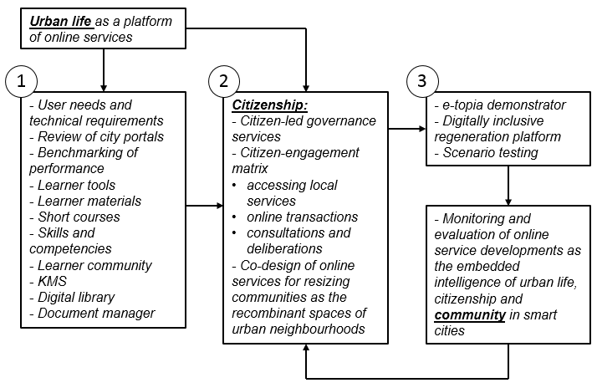

Figure1: The design solution
Source: complied from Campbell and Deakin (2005) and Deakin (2010)

This design solution draws upon the findings of three research and technical development (R&TD) projects, funded by the European Commission (EC) under Framework 5 and 6. These are IntelCities, Intelligent Cities and SmartCities. Learning from What Works and SURegen also support these projects and draw upon funding from the United Kingdom’s Research Councils. Funding for these R&TD projects came from Economic and Social Research Council (ESEC) and Engineering and Physical Sciences Research Council (EPSRC). Curwell et al. (2005) and Paskaleva (2011) report on the findings of the firdt and second R&TD projects. Deakin (2010, 2012 and 2014) reports on the outcomes on the third. Deakin and Al Waer (2011) also provide a synopsis of the first three R&TD projects. Deakin et al. (2012) and Deakin (2013, 2014) does the same for the findings of the fourth and fifth.

In capturing the scientific value of these projects, this paper takes instruction from Mitchell’s (2005: 56 and 74) call for parsimony and suggestion such a critical synthesis can be best achieved by following a “few rues” and “packaging the messages”. That is, by following a few rules and packaging the messages to communicate, not so much the technical, but social and cultural significance of those innovative features, which the online service developments represent. This serves to leave many of the technical innovations making up the core infrastructure of this development in the back-office and foreground the social and cultural significance of the online services they develop as the middleware to meet the front-end user expectations.

The risk of not focussing on the technical innovations underpinning the core infrastructures is that we fail to account for the hardware supporting these developments. However, balanced against this is the opportunity the design solution also offers to scrutinize them in terms of how they are being applied to represent urban life as a set of online services supporting the development of citizen-led governance services. That is by way of a citizen-engagement matrix and through the co-design of online services governing the resizing of communities as recombinant spaces. This not only discounts the risk of any failure to focus on technical innovations, but also goes a considerable way to take Mitchell’s thesis on e-topia full circle as a practical application.

As no such development takes place in a vacuum, Figure 2 lists the literature, which support the urban life and citizenship components of the design solution adopted. This list serves to verify the authenticity of the research design adopted for developing the urban life and citizenship components of the thesis.

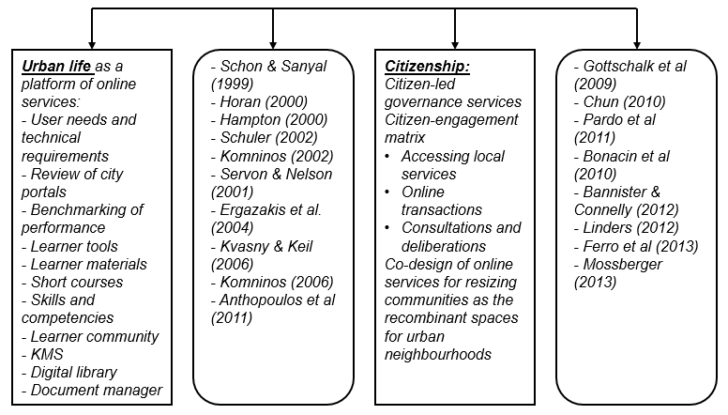

Figure 2: Supporting literature on urban life and citizenship

What this reveals is that, while the urban life and citizenship components of the online service developments, are dealt with by Komninos (2002, 2006) and both Chun (2010) and Prado (2011), it is their co-design, which still remains under-represented and critical synthesis that remains outstanding. This is what the rest of this paper turns attention to in terms of the core infrastructure and service enhancements supporting these integrations. As such, it does what Bannister and Connolly (2012) ask of such “high-minded” projects in the sense they:
“…resist the tendency to embrace the latest technological developments before older ones have been fully exploited or in some cases even fully understood”. (211)

But instead move towards such an understanding by:
“developing the ability to discern when a technology or concept is no longer of value and should be abandoned and when a task needs to be finished properly… [by] putting in place structures which can sustain them” (p.225).

The discerning nature of this research design, not only resists any temptation to embrace the latest technological developments for the reason they are new, or abandon them, because they a old, but instead goes on to put the structures in place (core infrastructure and service enhancements), to fully understand them. Something this paper achieves, by way of a critical synthesis that incorporates the digital library, e-learning and semantically interoperable knowledge management system, which underpin the e-topia demonstrator and that support the innovative co-design features through which citizen-led governance services develop as key components of a digitally-inclusive regeneration platform.

INNOVATIVE FEATURES OF THE ONLINE SERVICE DEVELOPMENTS

Figure 3 draws specific attention to the review and benchmarking of the city portals and citizen-led enhancements these proto-type the development of as online services. This draws particular attention to developments organized and grouped together in accordance with the requirements of a pre-specified, but evolving set of citizen-led governance services for envisioning e-topia. The overriding objective of these front-end service enhancements is the evolution of a citizen engagement matrix from which to learn about the available governance services and whose knowledge management underpins a library of material on the digitally-inclusive regeneration that supports the semantic interoperability of a Document Manager (DM).

In particular, that DM which is able to perform Ontology-based Annotation by:
- capturing, storing, indexing and (re)distributing the learning materials, skill packages and training manuals as governance services;
- extending this to include the formal semantics (metadata, knowledge) for the retrieval and extraction of the said materials, packages and manuals;
- offering access to the extensive range of products stored as knowledge objects in the digital library and available for extraction by those managing the development of the middleware as a platform for pooling the said services together.
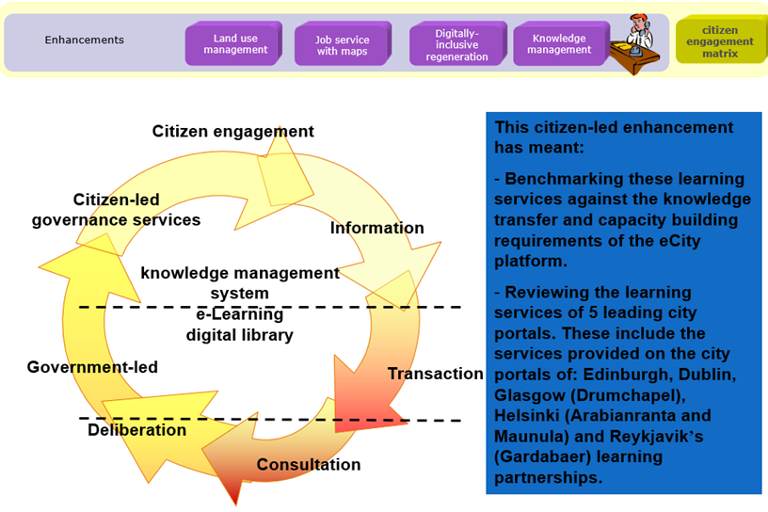
Figure 3: Citizen-led enhancements
Source: adapted from Campbell and Deakin and Deakin (2010)

Figure 4 illustrates the n-tier orientated service architecture developed to represent these citizen-led governance services as an engagement matrix and DM able to envision e-topia as set of core interoperable infrastructure services. Here Semantic Web technologies, allow data uploaded by the KMS (as information available from the system’s DM) to render knowledge products, codified in ways that not only correspond to documents (web pages, images, audio clips, etc. as the internet currently does), but more pre-defined objects, such as people, places, organisations and events deposited in the digital library. Using a pre-defined ontology of this type, the DM allows multiple relations between objects to be created.

At present this integration is mainly technical, concerning the software developments needed to host such services and meet the semantics of the platform’s e-learning needs, knowledge transfer requirements and capacity building commitments (see Figure 5).

E-TOPIA DEMONSTRATOR

This integration currently takes the form of an e-topia demonstrator, showing in session-managed logic, how the platform accesses the extensive pool of citizen-led governance services located in the back-office and uses the intelligence embedded in the middleware to deliver advanced e-Citizenship courses on the consultative needs and deliberative requirements of co-design service developments. This provides a real time demonstration of the platform’s capacity to be ‘SMART’ in developing the semantically-rich content needed for the middleware to begin cultivating the socially-inclusive consultations and participatory deliberations of urban regeneration programmes.

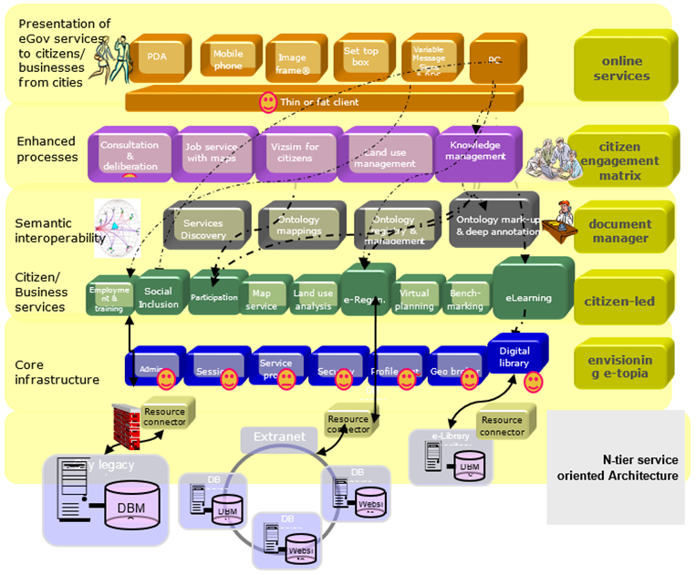

Figure 4: N-tier online service developments
Source: Deakin (2009a)

These enhanced processes of consultation and deliberation also have the advantage of offering citizens multi-channel access to such governance services, bundled together as digitally-inclusive regeneration platforms for bringing about a multi-scalar resizing of communities. This goes a long way to:
- uncover the business logic needed to base the intelligence-driven (re)organisation of cities on and standards required to benchmark the performance of the platform against;
- provide the performance-based measures needed to assess whether any of the plans cities have to develop such governance services (over the platform) possess the embedded intelligence (the learning, knowledge-based competencies and skills) required to support such developments;
- also provide the means to evaluate if the planning of such developments build the capacity - learning, knowledge-based competencies and skills - needed to support such actions.

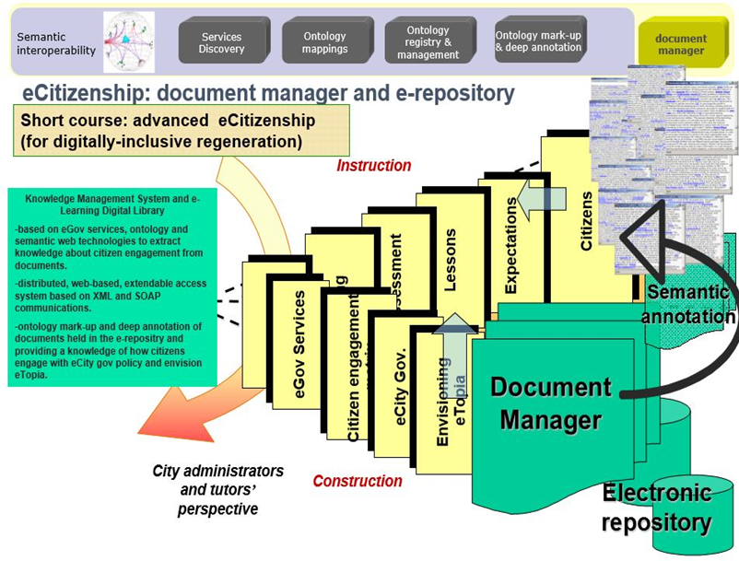

Figure 5: Document manager and e-repository
Source: Campbell and Deakin (2005) and Deakin (2012)

In addition to developing semantically interoperable services, the platform also evaluates how well they perform. This has meant co-designing three e-topia demonstrator storylines, where typical learners use the digital platform to query, consult and deliberate on the development of urban regeneration programmes.

The three storylines developed cover the following scenarios:
- accessing local services in neighbourhoods subject to regeneration;
- carrying out online transactions related to the use of land;
- consultations and deliberations about the safety and security issues underlying the governance of urban regeneration programmes.

The third scenario storyboards two citizens who are keen to discover what governance services the eCity platform offers them to learn about how they can help tackle crime in their urban neighbourhood (Lombardi et al. 2009; Deakin et al. 2011; Deakin 2012). This learning material demonstrates the ways in which citizens can use the platform to not only learn about what they can do to tackle crime, but gain knowledge of how their participation in this multi-scalar resizing of communities provides the recombinant spaces for the development of safe and secure urban neighbourhoods.

Knowledge of this multi-scalar resizing is based as much on the human as machine-driven computation of digitally inclusive regeneration platforms. Digitally inclusive regeneration platforms whose library of documents and knowledge objects, possess the intelligence these embed as the signs, signals and codes, which are smart in generating safe and secure urban neighbourhoods that cut the incidence of crime in cities. Signs, signals and codes, whose web-sites, texts, video clips, news releases, bulletins, routine monitoring and evaluations, not only reconfigure such spaces as urban neighbourhoods, but services, whose experience of urban life and sense of citizenship now have the intelligence for cities to be smart in securing crime free zones.

This demonstrates how the platform can be used by citizens to not only learn about what communities can do to tackle crime, but gain a knowledge of how their participation in such initiatives provides the opportunity for urban neighbourhoods to secure crime free zones. This also helps members of the community query the developments they have a particular interest in and use these services to obtain the information needed. This way it becomes possible to access a wide range of data sets from the City administration (such as policy documents and strategies), but most importantly, exploit the potential this information offers for them to interact with other like-minded people as members of a community sharing the same interest. In this way, it subsequently becomes possible to develop a web page and host it on the platform, setting out the community’s concerns and encouraging others in the urban neighbourhood to join them in deliberating how the City should secure crime free zones.

These citizen-centric developments are valuable because they provide the means to address the criticisms of the services currently available on city portals and offer an opportunity for the emerging developments to meet the learning needs, knowledge transfer requirements and capacity building commitments of a digitally-inclusive regeneration. However, if the full significance of these innovations is to be appropriated, this integration needs to progress and requires the e-Learning platform, KMS and DM developed for such purposes, to not only be interoperable across the middleware, but compatible with all of the urban life experiences which the platform captures, makes sense of and channels to citizens at the front-end. The way the platform aims to achieve this is particularly innovative, because the community it constructs offers a strategy for them to be smart in consolidating the underlying learning aspirations of city portals as a KMS supporting a digital library that has previously remained beyond the reach of those which involve themselves in the design of crime-free zones.

CONCLUSIONS

This paper has conducted an extensive review of e-topia and found the problems encountered with Mitchell’s thesis rest with the lack of critical insight it offers into urban life, citizenship and community. While problematic in itself, this paper identifies that if the difficulties experienced with e-topia were only methodological they may be manageable, but they run deeper than this and relate to more substantive issues, which surround the trajectory of Mitchell’s thesis.

The paper suggests this is a critical insight of some significance. For it not only raises questions about whether the digitally-inclusive regeneration platforms e-topia demonstrators currently stand on are a progressive force for change, but if the intelligence they also embed is merely a way for the electronically enhanced governance services under development in smart cities to reproduce the status quo? Something that in turn begs the question as to whether the attempts, which are underway to deploy the thesis, will prove counter-productive. That is fail, because e-topia is unable to do anything more than add to the inequality of the ecological destruction, which is already divisive.
In substantive terms, this goes very much against the grain, arguing the embedded intelligence of smart cities puts us on the verge of a new environmental determinism. Not only because the scenario this advances ends up sidestepping such concerns, but for the reason that in methodological terms, the vision it offers ends up replacing the social inequalities, ecological degradation and divisions of urban life, with a citizenship whose environmental determinism throws a veil over the impact which all of this has on the plight of low-income communities.

The strategy advocated by this paper does not stand on any such misappropriation of urban life, citizenship or community. This is avoided by turning the tables and agreeing that while words offer the possibility of bringing what all of this symbolizes back together, being seen to turn things around, lies not so much with the words, as semantic interoperability of the ontology on which the embedded intelligence of smart cities rest. While critically insightful, this statement still runs the risk of under-representing the challenge any such ontology-driven rendering of the knowledge-base poses. For this not only needs to stand on a set of core interoperable infrastructures, but intelligent solution that founds urban life as a set of citizenship-led governance services, whose semantic web serves to document the evolving ontology of an engagement matrix which oversees access to online transactions, consultations and deliberations.

Bundled together in this way, the e-topia demonstrator reported on in this paper, acts as a digitally-inclusive regeneration platform, whose citizen-centric developments are able to bring about a multi-scalar resizing of low income communities as a reconfiguration which manifests itself as the recombinant spaces of safe and secure urban neighbourhoods. Safe and secure urban neighbourhoods that embed the intelligence cities need for such crime free zones to be smart in not only bridging divisions in urban life, but also capitalizing on this in a way that meets the equity and ecological-integrity requirements of citizens as members of low income communities.

REFERENCES

Anthopoulos, L.G., Gerogiannis, V.C. and Fitsilis, P. (2011) Supporting the Solution Selection for a Digital City with a Fuzzy-based Approach. KMIS, 355-358.

Bannister, F. and Connolly, R. (2012). Forward to the past: Lessons for the future of e-government from the story so far. Information Polity,17 (3/4), 211-226.

Bonacin, R., Melo, A. Simoni, C. and Baranauskas, M. (2010). Accessibility and interoperability in e-government systems: outlining an inclusive development process. Universal Access in the Information Society, 9 (1), 17-33.

Brecht, B. (1932) The Radio as an Apparatus of Communication, in John G. Hanhardt, ed., Video Culture: A Critical Investigation Rochester, N.Y.: Visual Studies Workshop Press.

Campbell, F. and Deakin, M. (2005) Cities as leading examples of the digitally-inclusive knowledge society. In: International Conference on Making Knowledge Work, 25-28 October 2005, University of Stirling, United Kingdom.

Chun, S.A., Shulman, S., Sandoval, R. and Hovy, E. (2010) Government 2.0: Making connections between citizens, data and government. Information Polity, 15 (1), 1

Curwell, S., Deakin, M., Cooper, I., Paskaleva-Shapira, K., Ravetz, J. and Babicki, D. (2005) Citizens' expectations of information cities: implications for urban planning and design. Building Research & Information, 33 (1), 55-66.

Deakin, M. (2009a) The IntelCities Community of Practice: The eGov Services Model for Socially-Inclusive and Participatory Urban Regeneration Programs, in Reddick, C. ed., Handbook of Research on e-Government, Hershey, IGI Publishing.

Deakin, M. (2009b) A community-based approach to sustainable urban regeneration, Journal of Urban Technology, 16 (1), 191-212.

Deakin, M. (2010) Review of City Portals: The Transformation of Service Provision under the Democratization of the Fourth Phase, in Reddick, C. ed. Politics, Democracy and e-Government: Participation and Service Delivery, IGI Publishing, Hershey.

Deakin, M. (2011) The embedded intelligence of smart cities, International Journal of Intelligent Buildings, 3 (2), 198-197.

Deakin, M. (2011) The IntelCities CoP for the capacity-building, co-design, monitoring and evaluation of eGov services, Journal of Urban Technology, 18 (2), 17-38.

Deakin, M. (2012) Intelligent cities as smart providers: CoPs as organizations for developing integrated models of eGovernment Services, Innovation: The Journal of Social Research, 23 (2), 98-114.

Deakin, M. ed. (2013) Smart Cities: Governing, Modeling and Analysing the Transition. Taylor and Frances, Abingdon.

Deakin, M. (2014) From the City of Bits to E-Topia: Space, Citizenship and Community as Global Strategy, International Journal of E-Adoption, 6 (1), 16-33.

Deakin, M. and Allwinkle, S. (2006) The IntelCities Community of Practice, International Journal of Knowledge, Culture and Change Management, 6 (2), 155-162.

Deakin, M. and Allwinkle, S. (2007) Urban regeneration: the role networks, innovation and creativity play in building successful partnerships, Journal of Urban Technology, 17, (1), 77-91.

Deakin, M. and Al Waer, H. (2011) From intelligent to smart cities. Intelligent Buildings International, 3 (3), 140-152.

Deakin, M., Lombardi, P., & Cooper, I. (2011). The IntelCities community of practice: the capacity-building, co-design, evaluation, and monitoring of e-government services. Journal of Urban Technology, 18 (2), 17-38.

Ergazakis. K., Metaxiotis, K. and Psarras, J. (2004) Towards knowledge cities: conceptual analysis and success stories. Journal of Knowledge Management, 8, 5-15.

Ferro, E., Loukis, E.N., Charalabidis, Y. and Osella, M. (2013) Policy making 2.0: From theory to practice. Government Information Quarterly, 30 (4), 359-368.

Gottschalk, P. (2009) Maturity levels for interoperability in digital government. Government Information Quarterly, 26 (11), 75-81.

Graham, S. and Marvin, S. (2001) Splintering Urbanism, London: Routledge.

Hampton, K.N. and Wellman, B. (2000) Examining community in the digital neighborhood: early results from Canada’s wired suburb. In Digital cities. Springer Berlin Heidelberg.

Horan, T. (2000) Digital Places: Building Our City of Bits, Washington DC: Urban Land Institute.

Komninos, N. (2002) Intelligent cities: innovation, knowledge systems, and digital spaces. London/New York, Taylor & Francis.

Komninos, N. (2006) The architecture of intelligent cities: Integrating human, collective and artificial intelligence to enhance knowledge and innovation. In Intelligent Environments, 2006. IE 06. 2nd IET International Conference.

Kvasny, L. and Keil, M. (2006) The challenges of redressing the digital divide: A tale of two US cities. Information systems journal, 16 (1), 23-53.

Linders, D. (2012) From e-government to we-government: Defining a typology for citizen coproduction in the age of social media. Government Information Quarterly, 29 (4), 446-454.

Lombardi, P., Cooper, I., Paskaleva, K. and Deakin, M. (2009) The challenge of designing user-centric e-services: European dimensions, in Information Resources Management Association ed. Electronic Services: Concepts, Methodologies, Tools and Applications (3 Volumes), IGI, Hershey.

Mitchell, W. (1995) City of Bits: Space, Place, and the Infobahn, Cambridge, MA: MIT Press.

Mitchell, W. (1999) e-topia: Urban Life, Jim--But Not as We Know it, Cambridge, MA: MIT Press.

Mitchell, W. (2004) Me ++: the Cyborg-self and the Networked City, Cambridge Massachusetts, MA: MIT Press.

Mitchell, W. (2005) Placing Words: Symbols, Space, and the City, Cambridge, MA: MIT Press.

Mossberger, K., Wu, Y. and Crawford, J. (2013) Connecting citizens and local governments? Social media and interactivity in major US cities. Government Information Quarterly, 30 (4), 351-358.

Pardo, T.A., Nam, T. and Burke, G. (2011) E-government interoperability: Interaction of policy, management, and technology dimensions. Social Science Computer Review.

Paskaleva, K.A. (2011) The smart city: A nexus for open innovation? Intelligent Buildings International, 3 (3): 153-171

Servon, L. J., & Nelson, M. K. (2001). Community Technology Centers: Narrowing the Digital Divide in Low‐Income, Urban Communities. Journal of Urban Affairs, 23 (3‐4), 279-290.

Schuler, D. (2002) A pattern language for living communication. In PDC, 51-61.

This article is a revised version of two previous papers by Deakin (2011, 2014) examining the embedded intelligence of smart cities and transition from the city of bits to e-topia.

