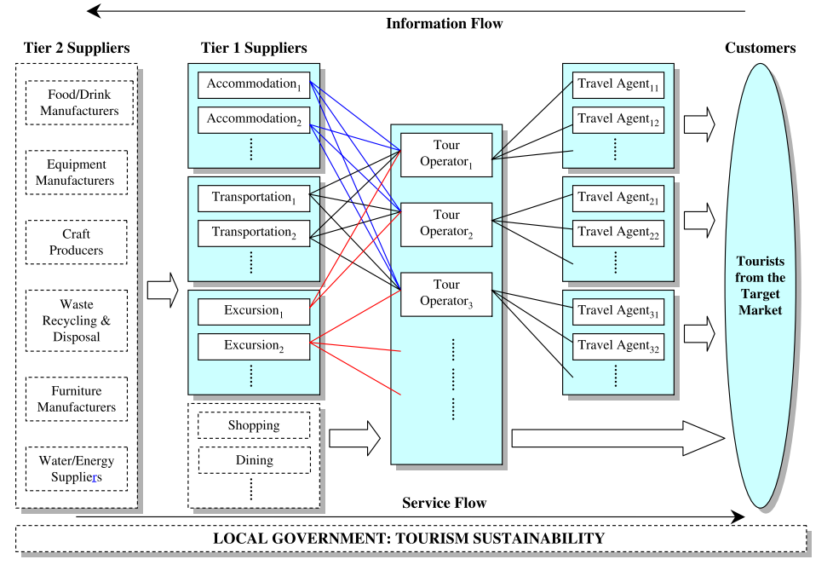
Supplement Figure 1: Typical TSC for a Destination
Source: Zhang et al. (2009, p. 353)

Supplement Table 1. Participants’ Profiles
Participants | Current Company (TA or Cruise) | Department | Title/Grading | Total Years of Cruise Product | Interviewee Location
Interviewee 1 | TA | Cruise Product | Manager | 2 | China
Interviewee 2 | TA | Owner | Co-founder and CEO | 2 | China
Interviewee 3 | Cruise | Revenue | Analyst | 1 | HK
Interviewee 4 | Cruise Shipbuilding Company | GM | GM | 4 | Travel between HK and China
Interviewee 5 | Cruise | Sales | Manager | 4 | HK
Interviewee 6 | TA | GM | GM | 19 | HK
Interviewee 7 | TA | Cruise Product | Supervisor | 6 | HK
Interviewee 8 | Cruise | Revenue | Analyst | 3 | HK
Interviewee 9 | Cruise | Finance | VP/Director | 8 | HK
Interviewee 10 | TA | Cruise Product | Manager | 10 | HK
Interviewee 11 | Cruise | Sales | Manager | 18 | HK
Interviewee 12 | TA | MICE Sales | Assistant Manager | 9 | HK
Interviewee 13 | TA | Sales | Manager | 18 | HK
Interviewee 14 | Cruise Consultancy | Consultant/Sales | Owner | 20 | China
Interviewee 15 | Cruise | Revenue | Director | 7 | China
Interviewee 16 | TA | Cruise Product | Manager | 8 | HK
Interviewee 17 | Cruise | Sales (Direct channel) | Manager | 3 | China
Interviewee 18 | Cruise | Sales | Manager | 8 | HK
Interviewee 19 | Cruise | Marketing | VP/Director | 6 | HK
Interviewee 20 | Cruise | Revenue | Manager | 5 | China
Interviewee 21 | TA | Owner | Co-founder and CEO | 25 | China
Interviewee 22 | TA | Cruise Product | General Manager (Finance) | 20 | HK
Interviewee 23 | Cruise | Onboard Revenue | Manager | 5 | China

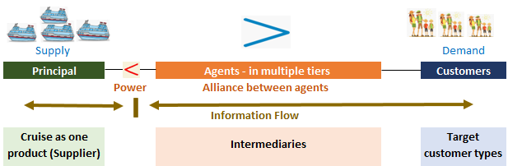
Supplement Figure 2: Imbalance of Power between Principals and Agents in China

